Fig. 1 The principal component analysis (PCA) among the percentage of individual ¹³C-PLFAs (G+, G-, GB, Actinomycetes, and Fungi) derived from glucose and priming effect (PE). Wheat monoculture, WS0; wheat-soybean rotation, WS1; wheat-soybean-soybean rotation, WS2; wheat-soybean-soybean-soybean rotation, WS3; soybean monoculture, S; maize monoculture, MS0; maize-soybean rotation, MS1; maize-soybean-soybean rotation, MS2.
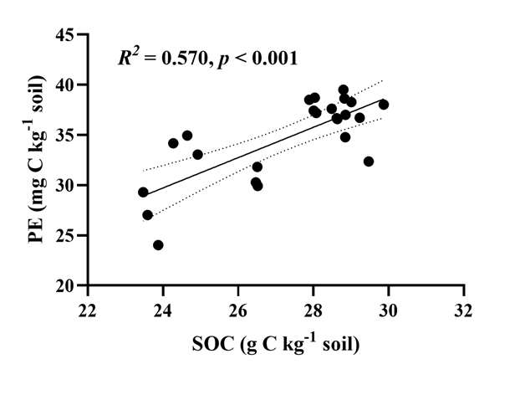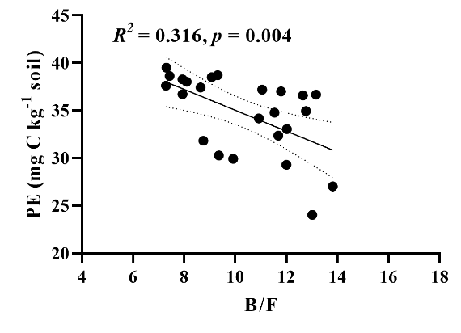
Fig. 2 Relationships of priming effect (PE) with soil organic carbon (SOC) and the ratio of bacteria to fungi (B/F).

Table 1 The basic properties of soil used in this study. (mean ± SE, n=3)
Treatment | crop | SOC  (g kg⁻¹) | TN  (g kg⁻¹) | C/N ratio | δ¹³C  (‰)
WS0 | wheat | 23.65 ±0.12 f | 2.16±0.04 ab | 10.95±0.24 c | -23.72
WS1 | wheat | 28.70 ±0.07 b | 2.11±0.04 abc | 13.60±0.25 b | -23.73
WS2 | soybean | 24.61±0.19 e | 2.20±0.05 a | 11.18±0.33 c | -23.69
WS3 | soybean | 28.80±0.40 ab | 2.00±0.04 cd | 14.40±0.10 a | -24.21
S | soybean | 27.98±0.04 c | 2.06±0.01 bcd | 13.61±0.12 b | -23.86
MS0 | maize | 26.50±0.01 d | 1.87±001 e | 14.17±0.10 ab | -23.00
MS1 | maize | 29.37±0.26 a | 2.03±0.04 cd | 14.47±0.14 a | -23.22
MS2 | maize | 28.70±0.11 b | 1.99±0.02 d | 14.44±0.11 a | -23.67
Note: Different lowercase letters showed significant differences in soils of different long-term soybean rotation systems (p<0.05). Wheat monoculture, WS0; wheat-soybean rotation, WS1; wheat-soybean-soybean rotation, WS2; wheat-soybean-soybean-soybean rotation, WS3; soybean monoculture, S; maize monoculture, MS0; maize-soybean rotation, MS1; maize-soybean-soybean rotation, MS2.
Table 2 The PLFA compositions (G+, G-, general bacteria, fungi and actinomycetes) and total PLFAs in soils with glucose addition of wheat-soybean rotations and maize-soybean rotations at day 21. (Mean ± SE, n=3)
Soil | Treatment | Total PLFAs  (nmol g⁻¹) | G+  (nmol g⁻¹) | G-  (nmol g⁻¹) | Fungi  (nmol g⁻¹) | Actinomycetes  (nmol g⁻¹) | General Bacteria  (nmol g⁻¹) | B/F
WS0 | Control | 34.11±1.40 de | 11.92±0.39 | 7.54±0.38 | 2.17±0.08 | 6.21±0.24 | 6.27±0.31 | 11.86±0.13 bc
 | Glucose | 36.53±0.27 bcde | 12.62±0.30 | 7.78±0.07 | 2.14±0.06 | 6.74±0.09 | 7.25±0.06 | 12.94±0.52 a
WS1 | Control | 35.27±1.19 cde | 12.30±0.51 | 7.30±0.19 | 2.05±0.06 | 6.64±0.21 | 6.97±0.24 | 12.95±0.18 a
 | Glucose | 36.13±2.47 bcde | 12.34±0.76 | 7.77±0.63 | 2.31±0.22 | 6.47±0.46 | 7.23±0.46 | 11.90±0.54 bc
WS2 | Control | 30.87±2.65 e | 10.32±0.71 | 6.70±0.78 | 1.86±0.28 | 5.67±0.47 | 6.32±0.44 | 12.77±0.83 ab
 | Glucose | 38.57±0.73 bcd | 13.01±0.36 | 8.31±0.06 | 2.34±0.03 | 6.96±0.13 | 7.94±0.21 | 12.53±0.40 ab
WS3 | Control | 51.93±3.37 a | 14.42±1.00 | 14.23±0.91 | 5.14±0.33 | 8.94±0.52 | 9.20±0.61 | 7.36±0.05 f
 | Glucose | 54.95±2.95 a | 15.43±0.91 | 14.93±0.78 | 5.49±0.27 | 9.15±0.46 | 9.95±0.55 | 7.34±0.05 f
S | Control | 35.55±0.14 cde | 11.82±0.01 | 6.47±0.18 | 2.14±0.07 | 6.45±0.07 | 7.51±0.17 | 12.60±0.41 ab
 | Glucose | 41.65±0.46 b | 13.72±0.20 | 9.30±0.05 | 2.77±0.03 | 7.28±0.17 | 8.58±0.07 | 11.42±0.19 c
MS0 | Control | 34.58±2.65 de | 10.99±0.79 | 8.12±0.72 | 2.75±0.27 | 6.16±0.52 | 6.56±0.37 | 9.39±0.26 d
 | Glucose | 40.99±1.04 bc | 12.91±0.29 | 9.99±0.30 | 3.40±0.14 | 6.99±0.18 | 7.69±0.14 | 9.01±0.20 d
MS1 | Control | 33.41±1.96 de | 10.57±0.53 | 7.92±0.52 | 2.79±0.16 | 5.84±0.31 | 6.30±0.47 | 8.89±0.14 de
 | Glucose | 37.12±4.59 bcd | 11.74±1.33 | 8.87±1.23 | 3.10±0.48 | 6.14±0.75 | 7.26±0.80 | 9.05±0.30 d
MS2 | Control | 54.99±2.32 a | 15.84±0.61 | 14.38±0.69 | 5.11±0.21 | 9.70±0.41 | 9.97±0.41 | 7.87±0.01 f
 | Glucose | 56.73±1.37 a | 16.42±0.42 | 15.05±0.32 | 5.26±0.15 | 9.49±0.27 | 10.52±0.22 | 7.99±0.05 ef
Note: Different letters in the same column represent significant differences among soils for each parameter (p<0.05). Wheat monoculture, WS0; wheat-soybean rotation, WS1; wheat-soybean-soybean rotation, WS2; wheat-soybean-soybean-soybean rotation, WS3; soybean monoculture, S; maize monoculture, MS0; maize-soybean rotation, MS1; maize-soybean-soybean rotation, MS2.

