Supplementary information (Figures and Legends)

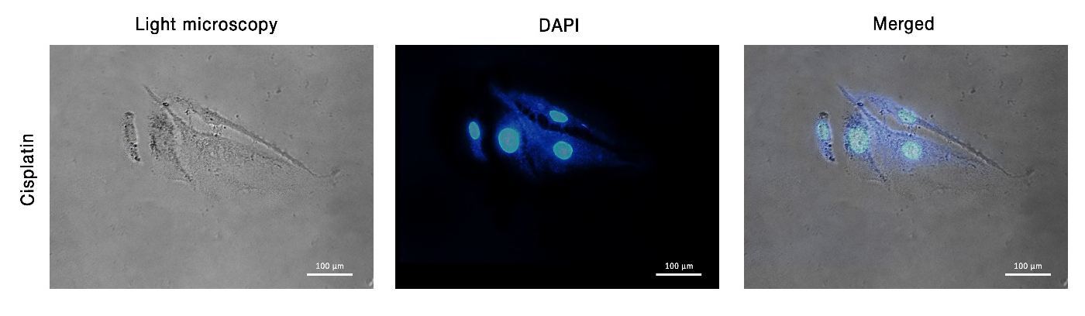
Supplementary Figure 1. PGCCs originate in daughter cells through bursting. Although budding is a common way of generating daughter cells by PGCCs, we occasionally observed that a PGCC break-down into several smaller cells by bursting. Nuclei are stained with DAPI.

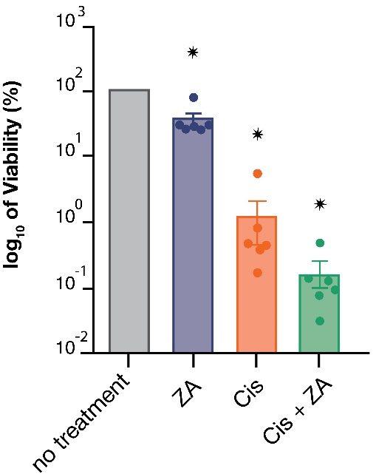

Supplementary Figure 2. Zoledronic acid declines the viability of PGCCs surviving after cisplatin treatment. Measurement of cell viability by trypan blue staining indicates the reduction of cisplatin-survived PGCCs; * p-value < 0.01

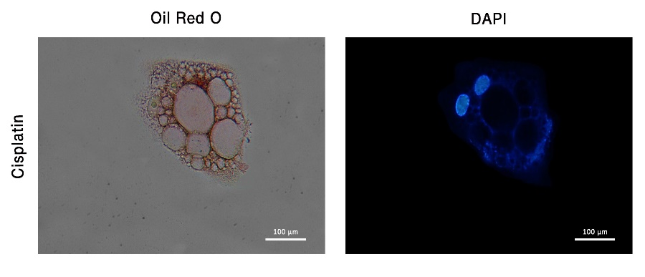

Supplementary Figure 3. Cytoplasmic vacuoles have distinct content from nuclei and lipid droplets. Cisplatin-induced PGCCs were stained with Oil Red O and DAPI, none of which could stain the cytoplasmic vacuoles augmented after cisplatin treatment.

