Supplementary information:

LncRNA LNCGM1082-mediated NLRC4 activation resists against infection by intracellular bacteria
Yunhuan Gao³, Yazheng Yang³, Jianmei Wei³, Jianmei Yue³,Ya Wang³, Qianjing Zhang³, Mengli Jin³, Rong Wang³, Xiaorong Yang³, Junqi Zhang⁴, Xinqi Liu⁴, Yuan Zhang³ and Rongcun Yang^{1,2,3}

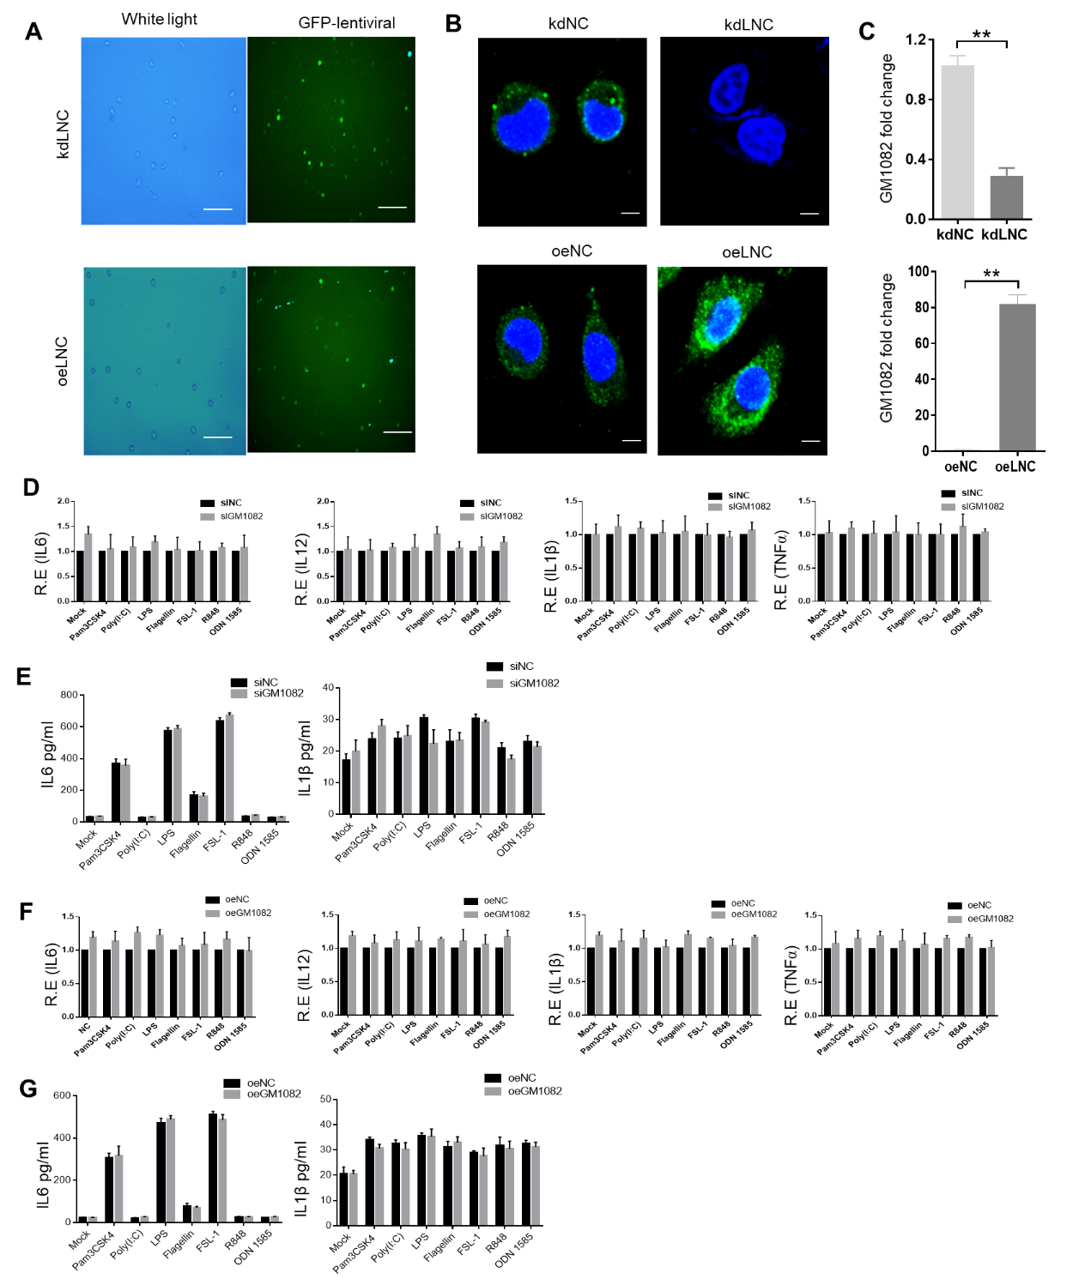
Fig. S1 LNCGM1082 did not affect production of cytokines in macrophages after exposed to different Toll-like receptor ligands. A Fluorescence microscopy of LNGGM1082 shRNA letiviruses (kdLnc) and LNGGM1082 lentiviruses (oeLnc) transduced mouse macrophages. Green (GFP), shRNA or LNCGM1082 lentiviruses. Rule bar=100µM. B RNA-FISH of LNCGM1082 in LNGGM1082 shRNA letiviruses (kdLnc) and LNGGM1082 lentiviruses (oeLnc) transduced mouse macrophages. Rule bar=2.5µM. C qRT-PCR of LNCGM1082 in LNGGM1082 shRNA letiviruses (kdLnc) and LNGGM1082 lentiviruses (oeLnc) transduced mouse macrophages. D QRT-PCR of inflammatory cytokines IL-6, IL-12a, IL-1β and TNF-α in wt (siNC) and LNCGM1082 shRNA (siGM1082) transfected macrophages, which were stimulated by different Toll like receptor ligand. R. E, relative expression. E ELISA analysis of IL6, IL-1β in the supernatants of control (siNC) and LNCGM1082 shRNA (siGM1082) transfected macrophages, which were stimulated by different Toll like receptor ligands. F QRT-PCR of IL-6, IL-12a, IL-1β and TNF-α in control (oeNC) and exogenous LNCGM1082 (oeGM1082) transfected macrophages, which were stimulated by different Toll like receptor ligands. R. E, relative expression. G ELISA analysis of IL-6 and IL-1β in the supernatants of control (oeNC) and exogenous LNCGM1082 (oeGM1082) transfected macrophages, which were stimulated by different Toll like receptor ligands. The macrophages were isolated from the peritoneal cavity of thioglycollate-treated mice. Two side Student’s t-test. **, p < 0.01.

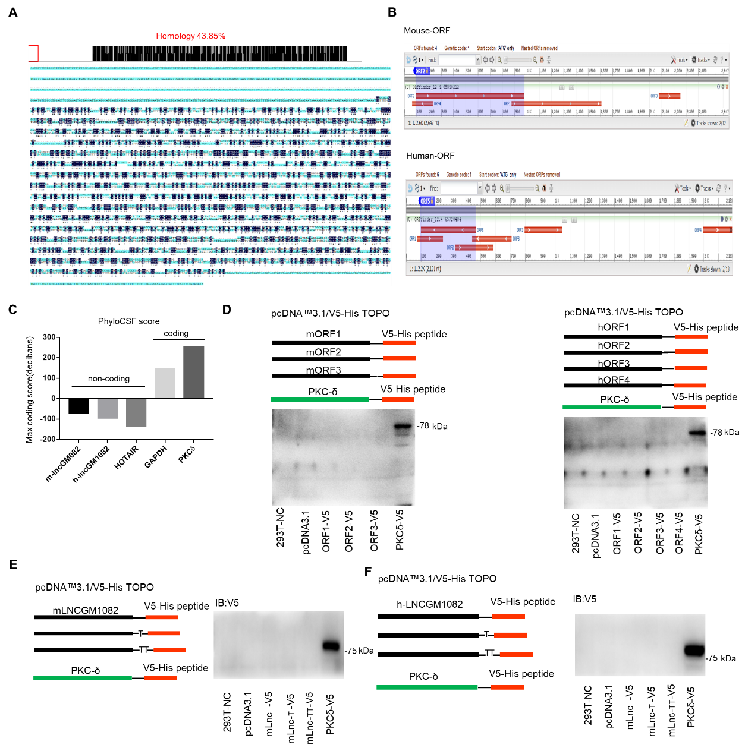

Fig. S2 Characteristics of LNCGM1082. A Comparison of LNCGM1082 nucleic acid sequences in mice and humans. B ORF of mouse (mouse ORF) or human (human ORF) LNCGM1082 using ORF Finder. C Coding potency of LNCGM1082 sequence was analyzed using PhyloCSF. Hotair, a control non-coding gene. GAPDH and PKCδ, control coding genes. Scores above 0 suggested there had a coding potential, whereas scores below 0 represented no coding potential. D Immunoblotting of V5-tagged mouse (left) and human (right) LNCGM1082 ORF transfected HEK293T cells. E-F Immunoblotting of V5-tagged mouse (E) /human (F) LNCGM1082 transfected HEK293T cells. Different LNCGM1082 ORFs or full-length LNCGM1082 were cloned into pcDNA3.1 with N-terminal start codon ATG and C-terminal V5 tag, and then these plasmids subsequently were transfected into HEK293T cells separately, and after 48 hours, immunoblotting was used to detect the flag-tagged protein. PKCδ with V5 tag, a positive control.

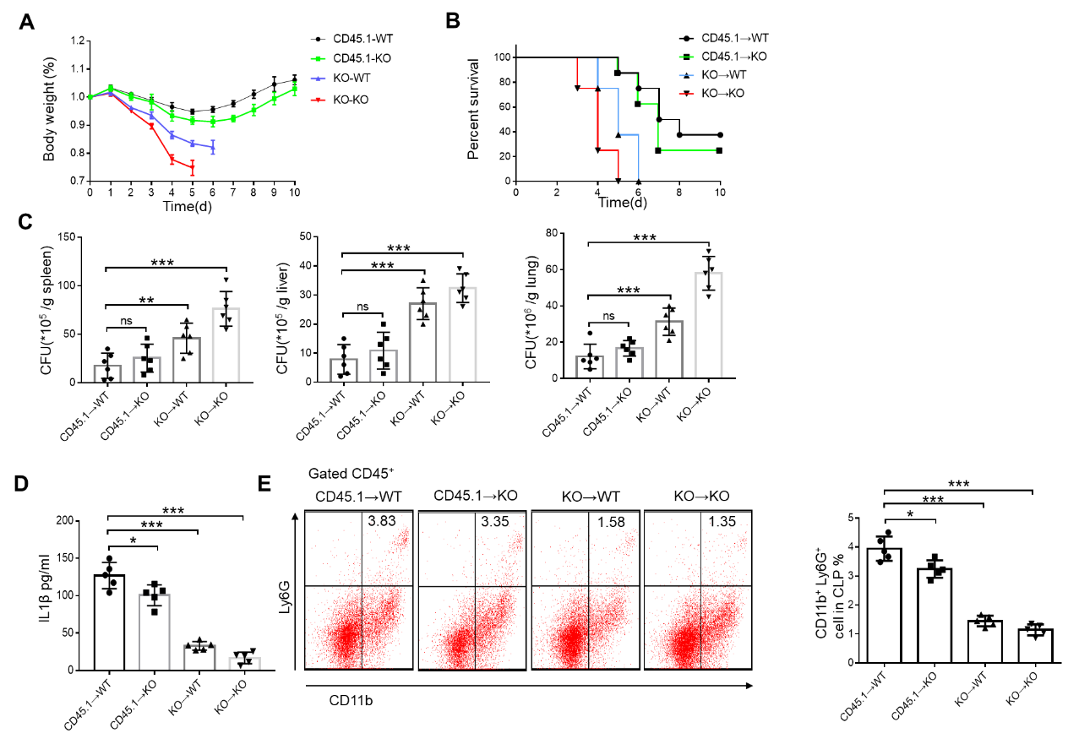
Fig. S3 Sensitivity to S.T infection depends on LNCGM1082. A Body weight of bone marrow transplanted mice after S. T infection. B Survival of bone marrow exchanged mice after S. T infection. C Bacterial burden in the spleen, liver and lung of bone marrow exchange mice after S. T infection. D ELISA analysis of IL-1β in the blood collected from bone marrow exchanged mice after S. T infection. E Flow cytometry of neutrophils (CD11b⁺Ly6G⁺) from intestinal lamina propria cells of bone marrow exchanged mice after S. T infection. % CD11b⁺ Ly6G⁺ neutrophils were compared (n=5). CD45.1-WT, bone marrow cells from CD45.1 were transplanted into CD45.1 mice; CD45.1-KO, bone marrow cells from CD45.1 were transplanted into LNCGM1082-/- mice; KO-WT, bone marrow cells from LNCGM1082-/- mice were transplanted into CD45.1 mice; KO-KO, bone marrow cells from LNCGM1082-/- mice were transplanted into LNCGM1082-/- mice. Analysis of variance test in a; Wilcoxon’s test in b; Two side Student’s t-test in C-E. n.s., not statistically signiﬁcant; *, p < 0.05; **, p < 0.01; ***, p <0.001

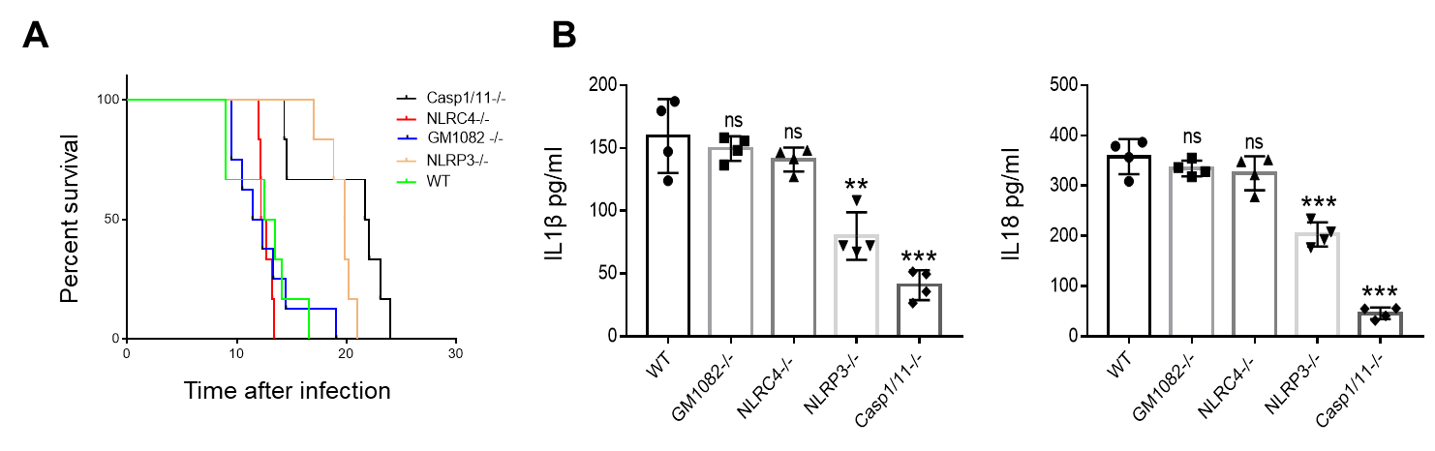
Fig. S4 LNCGM1082-/- mice are different from other mice in sensitivity to LPS. A Survival of WT, LNCGM1082-/-, NLRP3-/-, Caspase-1/11-/- and NLRC4-/- mice after intraperitoneal injection LPS (52mg/kg). B ELISA of IL-1β and IL-18 in the blood of WT, GM1082-/-, NLRP3-/-, caspase- 1/11-/-, and NLRC4-/- mice on day 2 after injected intraperitoneally with LPS (20mg/kg). Wilcoxon’s test in a; Two side Student’s t-test in B. n.s., not statistically signiﬁcant; **, p < 0.01; ***, p <0.001

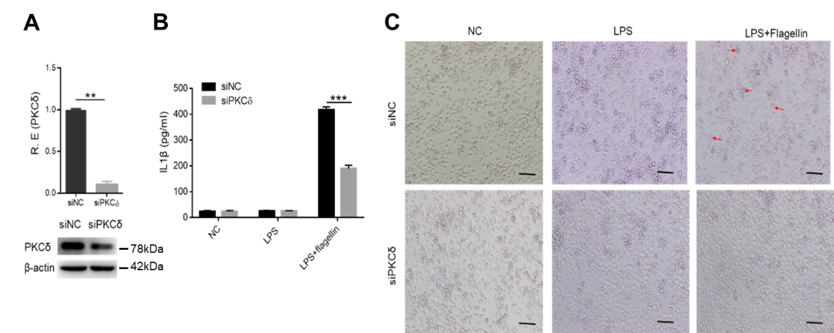

Fig. S5 Silencing PKCδ reduces IL-1β production and macrophage pyroptosis. A qRT-PCR of PKCδ after silencing PKCδ. B ELISA of IL-1β in the supernatants of macrophages after silencing PKCδ. C Images of the macrophages under light microscopy after silencing PKCδ. Scale bar, 40 μM. The arrows indicate pyroptotic cells. Student’s t-test in A and B, mean ±SD. **, p < 0.01; ***, p <0.001

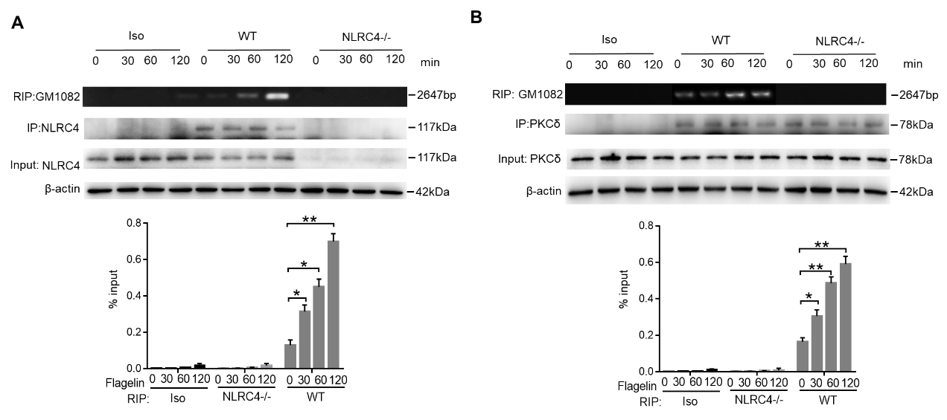
Fig. S6. Binding of LNCGM1082 with NLRC4 and PKCδ is dependent on the concentration of flagellin. A-B RIP in the macrophages after exposure to flagellin. Cell lysates of WT and NLRC4-/- macrophages with normal rabbit IgG, NLRC4 or PKCδ antibodies. Immunoprecipitation was analyzed by qRT-PCR to exam enrichment efﬁciency of LNCGM1082. Two side Student’s t-test. *, p < 0.05; **, p < 0.01
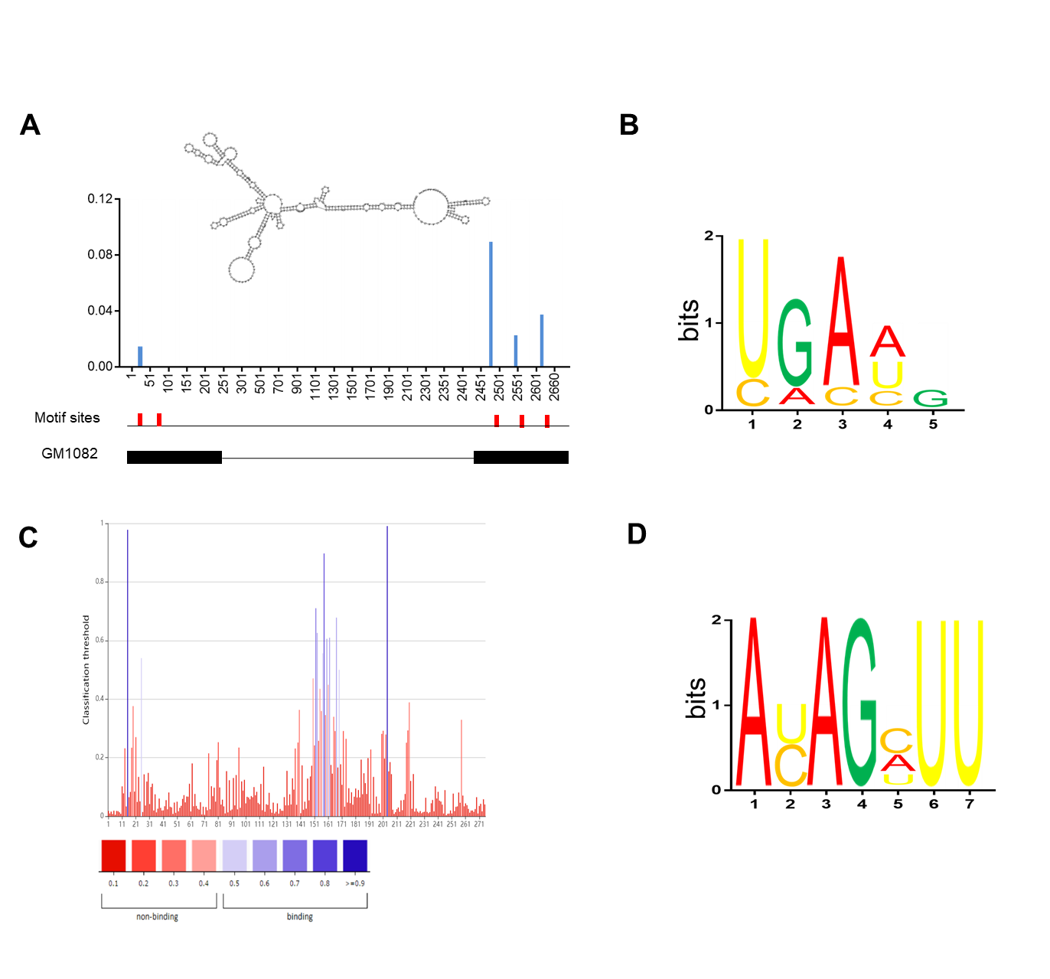
Fig. S7 LNCGM1082 structures and binding sites in LNCGM1082. A Predicted structure of LNCGM1082(RNA fold) with motifs (red). The iCLIP truncation track showed the positions of iCLIP cDNA truncations at lncRNA with peak height corresponding to the cDNA counts. The position of motifs sites was shown below the iCLIP cDNA truncation. B Sequence logo of NLRC4 recognition motif generated by MEME analysis of LNCGM1082 sequence read clusters. C Binding site between PKCδ and LNCGM1082 predicted using RNAInter software (http://www.rna-society.org/raid/home.html). D Sequence logo of PKCδ recognition motif generated by MEME analysis of LNCGM1082 sequence read clusters.

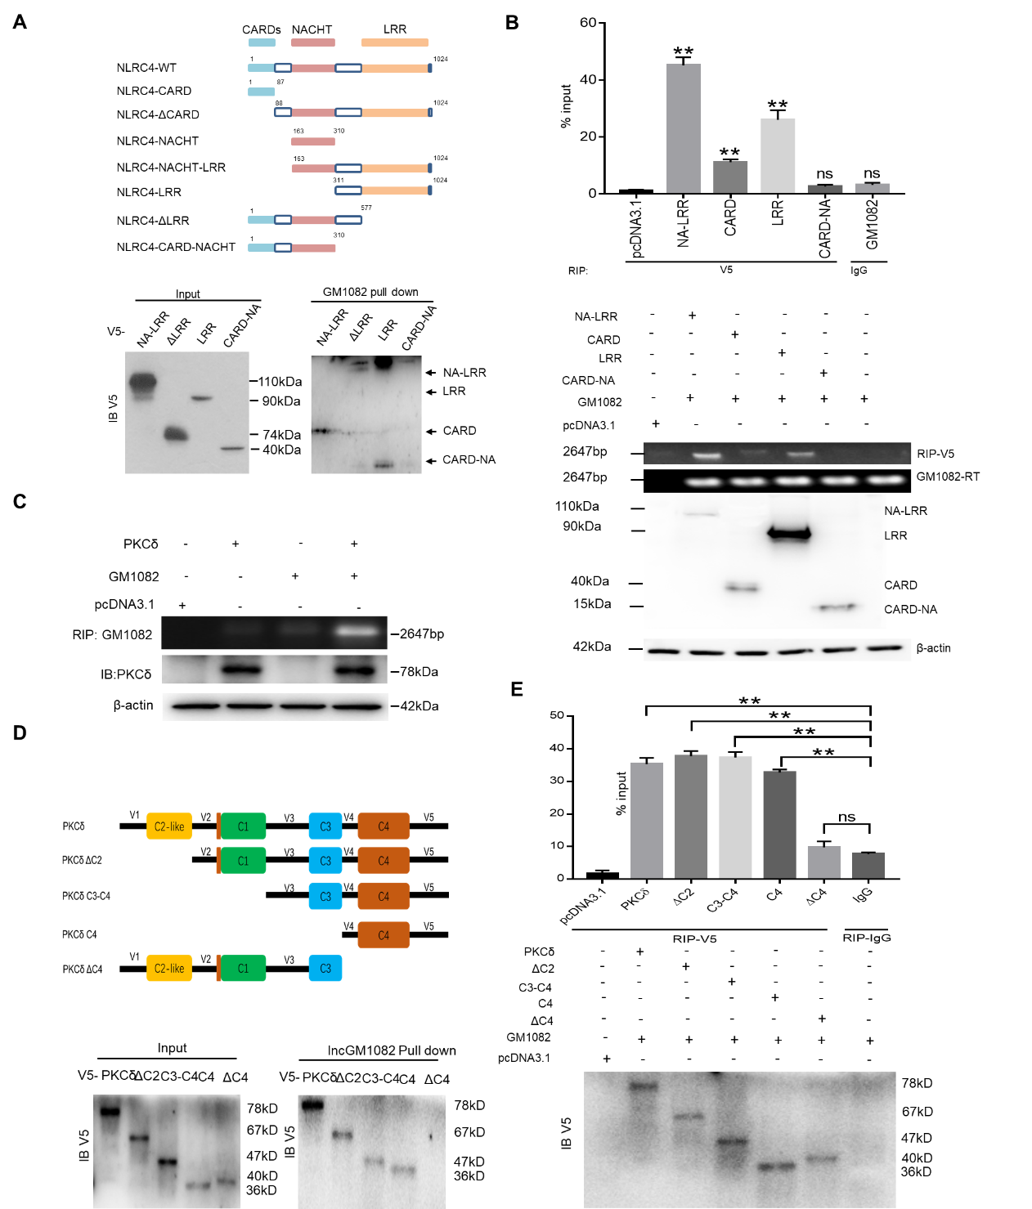
Fig. S8 Binding of NLRC4 is dependent on LRR domain. A Pull-down analyses using biotinylated LNCGM1082 in V5-tagged NLRC4 or NLRC4 derivatives transfected HEK293T cells. NLRC4 and its derivatives were cloned into pcDNA3.1/V5 to generate V5-tagged- NLRC4 and V5-tagged NLRC4 derivatives, and then individually transfected into HEK293T cells. B RIP analyses in V5-tagged NLRC4 derivatives and LNCGM1082 cotransfected HEK293T cells. RIP was performed using anti-V5 and then PCR for LNCGM1082. % input of LNCGM1082 was analyzed (lower). C RIP analyses in flag-tagged PKCδ derivatives and LNCGM1082 cotransfected HEK293T cells. RIP was performed using anti-flag antibody or control isotypic control (Iso). D Pull-down analyses using biotinylated LNCGM1082 in V5-tagged PKCδ or PKCδ derivatives transfected HEK293T cells. PKCδ and its derivatives were cloned into pcDNA3.1/V5 to generate V5-tagged- PKCδ and V5-tagged PKCδ derivatives, and then individually transfected into HEK293T cells. E RIP analyses in V5-tagged PKCδ derivatives and LNCGM1082 cotransfected HEK293T cells. RIP was performed using anti-V5 and then PCR for LNCGM1082. % input of LNCGM1082 was analyzed. Two side Student’s t-test in B and E. n.s., not statistically signiﬁcant; **, p < 0.01

Fig. S9 LNCGM1082 affects the oligomerization of ASC and speck formation. Immunostaining of ASC in WT and LNCGM1082-/- macrophages after stimulation with LPS plus different concentration of flagellin. Red, ASC; Blue, nuclei. Scale bar, 5 μM.

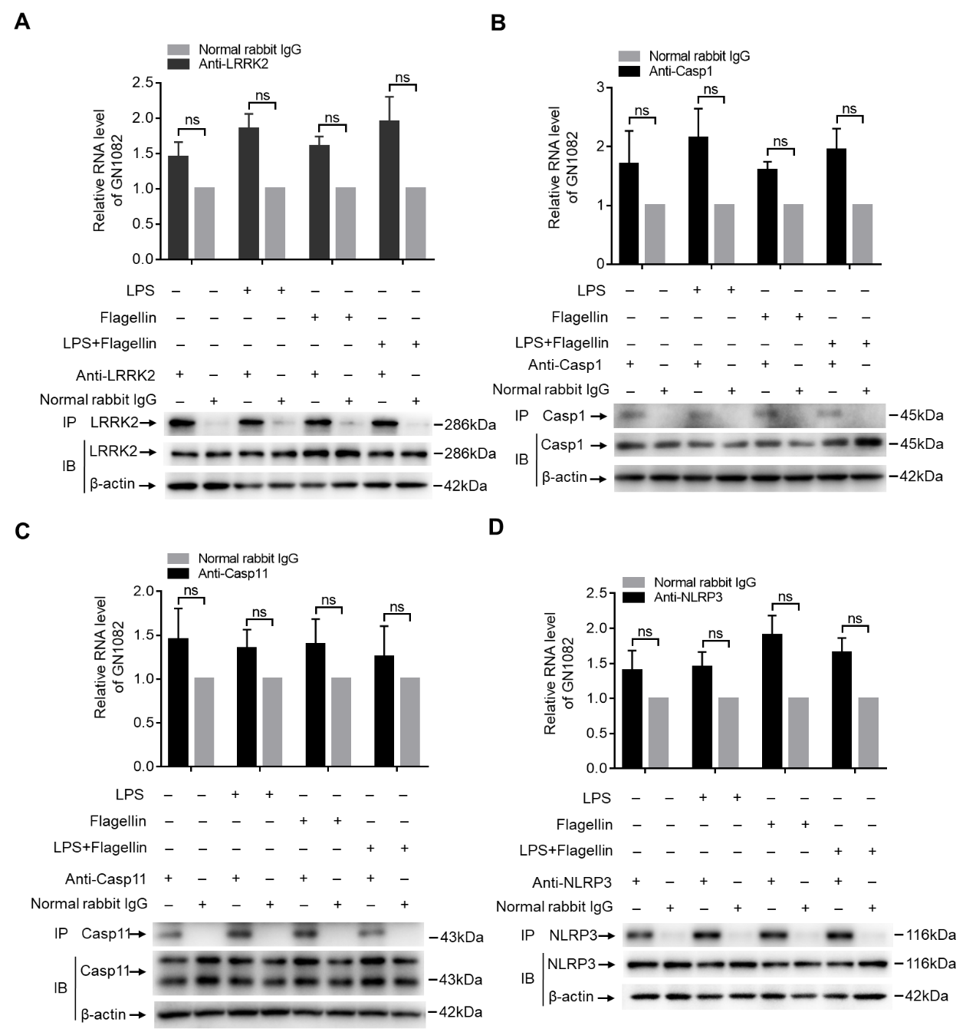
Fig. S10 LNCGM1082 does not bind with LRRK2, caspase-1, caspase-11 or NLRP3. A RIP in the macrophages after exposed to flagellin. Cell lysates of the macrophages were incubated with normal rabbit IgG, LRRK2 antibody. B RIP in the macrophages after flagellin transfection. Cell lysates of the macrophages were incubated with normal rabbit IgG, caspase-1 antibody. C RIP in the macrophages after flagellin transfection. Cell lysates of the macrophages were incubated with normal rabbit IgG, caspase-11 antibody. D RIP in the macrophages after flagellin transfection. Cell lysates of the macrophages were incubated with normal rabbit IgG, anti NLRP3 antibody. Immunoprecipitation was analyzed by qRT-PCR to exam enrichment efﬁciency of LNCGM1082. Two side Student’s t-test. n.s., not statistically signiﬁcant.

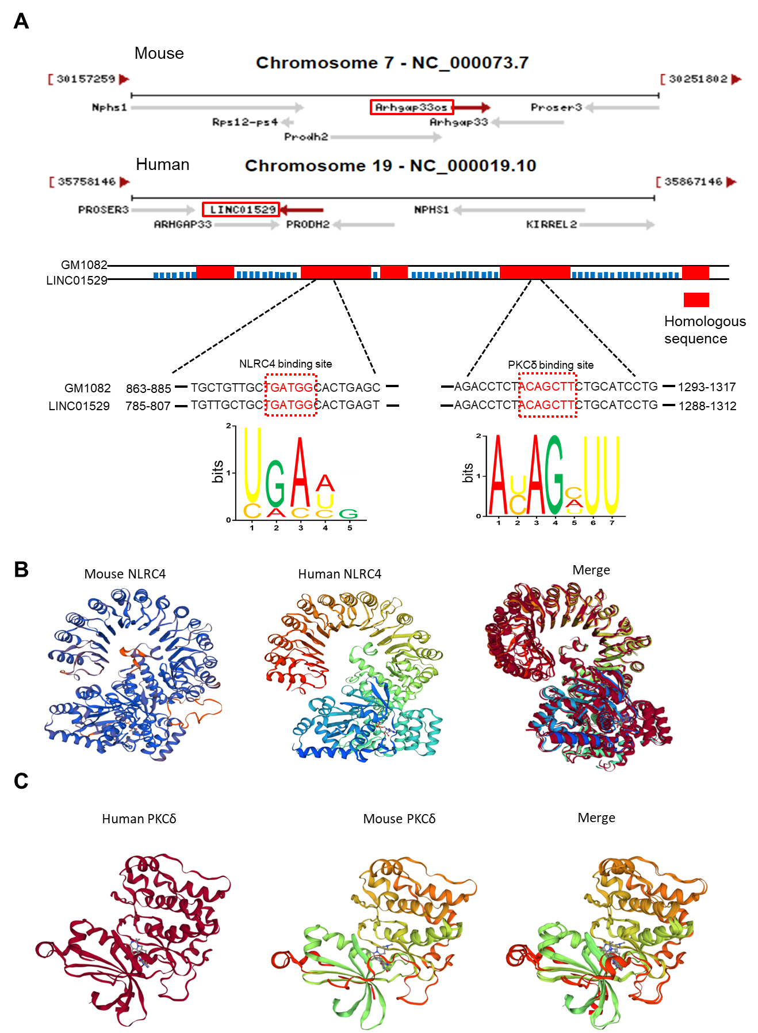
Fig. S11 Structure comparing of LNCGM1082, NLRC4 and PKCδ. A NLRC4 and PKCδ protein binding motifs in LNCGM1082. We used NCBI database to query the LNCGM1082 locus, and perform sequence comparison to find out homologous sequences and use MEME software (https://meme-suite.org/meme/) to analyze the NLRC4 and PKCδ protein binding motifs. B Crystal structure of mouse and human NLRC4 in the auto-inhibited conformation. Mouse NLRC4 structural coordinates were from the protein data bank (PDB accession number 4KXF). We used SWISS-MODEL software to model the protein crystal structure of human NLRC4 and compare the homology (https://swissmodel.expasy.org). C Crystal structure of mouse and human PKCδ in the auto-inhibited conformation. Mouse PKCδ structural coordinates are from the protein data bank (PDB accession number 3UGI). We used SWISS-MODEL software to model the protein crystal structure of human PKCδ and compare the homology (https://swissmodel.expasy.org/).

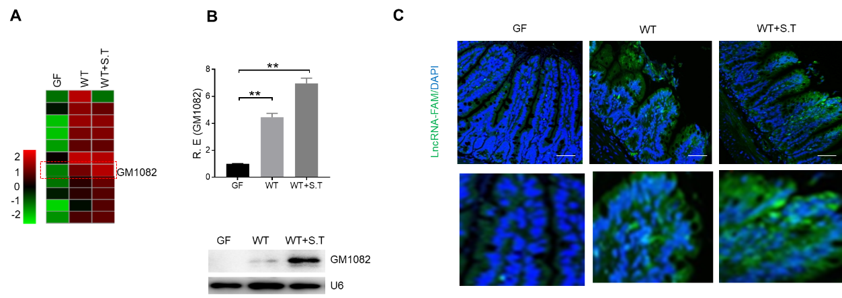
Fig. S12 LNCGM1082 expression is induced by S. Typhimurium. A LncRNA microarray of mouse intestinal epithelial cells after S. Typhimurium infection. Mouse intestinal epithelial cells were isolated and lncRNA expression was then evaluated using a microarray by Beijing Capitalbio Technology Co., Ltd.. The R software (v.2.13.0) platform was applied to analyze the microarray data, and the LIMMA (linear regression model) package was used to statistically analyze differentially expressed genes. B QRT-PCR and Northern blot of LNCGM1082 in intestinal epithelial cells. R. E, relative expression. C, Fluorescence in situ hybridization of LNCGM1082 in mouse intestinal epithelial cells. Green, GM1082. Blue, nuclei. Scale bar, 40 μM. GF, germ-free mice; WT, wild type mice; WT+S.T; Mice infected with S. Typhimurium. Two side Student’s t-test. **, p < 0.01.

Table S1．Reagents and oligoes used in this study.
REAGENT or RESOURCE | SOURCE | IDENTIFIER
Antibodies
β-Actin Antibody | Santa Cruz | Cat:sc-47778 RRID: AB_626632
Anti-NLRC4 Antibody | Thermo Fisher Scientific | Cat: PA5-72977 RRID: AB_2718831
Anti- Phospho-NLRC4 Antibody | Thermo Fisher Scientific | Cat: MA5-31846 RRID: AB_2787469
V5 Tag Monoclonal Antibody | Thermo Fisher Scientific | Cat:MA5-15253 RRID: AB_10977225
DYKDDDDK Tag Monoclonal Antibody | Thermo Fisher Scientific | Cat: MA1-91878 RRID: AB_1957945
Anti-PKCδ antibody | Proteintech | Cat: 19132-1-AP RRID: AB_10637263
Anti -IL1β antibody | Proteintech | Cat: 16806-1-AP RRID: AB_10646432
Anti-mouse GSDMD antibody | Abcam | Cat: ab209845 RRID: AB_2721254
Anti-human GSDMD antibody | Abcam | Cat: ab155233 RRID: AB_2736999
Anti-Caspase1 antibody | Proteintech | Cat: 22915-1-AP RRID: AB_2876874
Anti- Cleaved Caspase-1 antibody | Cell Signaling Technology | Cat：67314 RRID: AB_2714037
Anti-Caspase11 antibody | Cell Signaling Technology | Cat: 14340 RRID: AB_2728693
cleaved caspase-1 p20 (h297) antibody | Santa Cruz | Cat：sc-22163 RRID: AB_2228382
Anti-LRRK2 antibody | Abcam | Cat: ab133474 RRID: AB_2713963
Anti-NLRP3 antibody | Abcam | Cat: ab263899 RRID: AB_2889890
Anti-ASC antibody | Cell Signaling Technology | Cat：67824 RRID: AB_2799736
F4/80 (6A545) antibody | Santa Cruz | Cat:sc-71085 RRID: AB_1122717
APC-CD45 30-F11 | Biolegend | Cat:103112 RRID: AB_312977
FITC-CD11b M1/70 | eBioscience | Cat:11-0112-86 RRID: AB_464937
PE-Ly6G 1A8 | Biolegend | Cat: 127607 RRID: AB_1186104
Bacterial and Virus Strains
BL21 Chemically Competent cell | TransGen Biotech | Cat:CD901-01
DH5αChemically Competent cell | Tiangen Biotech | Cat:CD101-03
S. Typhimurium | ATCC | Cat: 14028
Chemicals, Peptides, and Recombinant Proteins
Recombinant Murine GM-CSF | PeproTech | Cat:315-03
Recombinant Murine M-CSF | PeproTech | Cat:315-02
HiPerFect Transfection Reagent | QIAGEN | Cat:301705
Pam3CSK4 | APExBIO | Cat: B5662
LPS (0111:B4) | Sigma | Cat: L2630
Poly(I:C) | APExBIO | Cat: B5551
FSL-1 | Invivogen | Cat: tlrl-fsl
R848 | Invivogen | Cat: tlrl-r848
ODN1585 | Invivogen | Cat: tlrl-1585
ATP | APExBIO | Cat: B3304
Nigericin | MedChemExpress | Cat: 28380-24-7
Flagellin | AdipoGen Life Sciences | Cat: AG-40B-0095
Poly(dA+dT)) | Invivogen | Cat: tlrl-patn
Polybrene | Millipore | Cat:sc-134220
Lipofectamine™ 3000 Transfection Reagent | Thermo Fisher Scientific | Cat:11668027
Trizol | Life technologies | Cat:15596018
Experimental Models: Cell Lines
HEK 293T | ATCC | N/A
Oligonucleotides for clone genes
Murine ORF1 FW | BGI | 5’-ATGGCACTGAGCCCCTCAGAG-3’
Murine ORF1 REV | BGI | 5’-CCTGGCAGGGAACCCAGGGTT-3’
Murine ORF2 FW | BGI | 5’-ATGGGGAGAACTCTGCTGGGC-3’
Murine ORF2 REV | BGI | 5’-CCTCTCTCACAGAGTGCAGCA-3’
Murine ORF3 FW | BGI | 5’-ATGGGGCTGGTATTTGGACCC-3’
Murine ORF3 REV | BGI | 5’-AGCCTGGGTCTTTTGGGTGCT-3’
Murine GM1082 FW | BGI | 5’-GGCATATCTGCATCTAGAATTCCA -3’
Murine GM1082 REV | BGI | 5’-GGGAACTTTCCATCTTCTTTGC -3’
Human ORF1 FW | BGI | 5’-ATGTGGCAGTCAGGTGGCGAC-3’
Human ORF1 REV | BGI | 5’-GGAGGACAGGGAGCCAGGCGG-3’
Human ORF2 FW | BGI | 5’-ATGTGCTACTGGCTGACCTTC-3’
Human ORF2 REV | BGI | 5’-CTCATCCTGGTGCCTTCCACA-3’
Human ORF3 FW | BGI | 5’-ATGGCACTGAGTCCCTCTGCA-3’
Human ORF3 REV | BGI | 5’-CCAGGCCTGGCTGCACCAGCT-3’
Human ORF4 FW | BGI | 5’-ATGGACCTGCTGGAGGAGATC-3’
Human ORF4 REV | BGI | 5’-TTTATCATTCTATTTCCTTTT-3’
Human GM1082 FW | BGI | 5’-ACTGCGCAGGCGCTGCGGGAG-3’
Human GM1082 REV | BGI | 5’-GCACTTTATCATTCTATTTCCTT -3’
Murine NLRC4 FW | BGI | 5’-ATGAACTTTATAAGGAACAAC -3’
Murine NLRC4 REV | BGI | 5’-AGCAGTCACTAGTTTAAAGGTG-3’
Human NLRC4 FW | BGI | 5’-ATGAATTTCATAAAGGACAATA-3’
Human NLRC4 REV | BGI | 5’-AGCAGTTACTAGTTTAAAAGCA-3’
Murine PKCδ FW | BGI | 5’-ATGGCACCCTTCCTGCGCATCT-3’
Murine PKCδ REV | BGI | 5’-AATGTCCAGGAATTGCTCAAAC-3’
Human PKCδ REV | BGI | 5’-ATGGCGCCGTTCCTGCGCATCG-3’
Human PKCδ REV | BGI | 5’-ATCTTCCAGGAGGTGCTCGAAT-3’
Murine NA-LRR (NLRC4) FW | BGI | 5’-GCCACCATGGCTATGCTCTGGGCCTCTGGGGGC-3’
Murine LRR (NLRC4) FW | BGI | 5’-GCCACCATGGCAGTGCTGGTACCTGATCAGG-3’
Murine ΔLRR (NLRC4) REV | BGI | 5’-AGCTTCAAATTCTTGGCTCAGG-3’
Murine CARD-NA (NLRC4) REV | BGI | 5’-GCACCTGGACTCCTGGATTTGG-3’
Murine ΔC2 (PKCδ) FW | BGI | 5’-ATGAAGGCTGAGTTCTGGCTGG-3’
Murine ΔC2 (PKCδ) REV | BGI | 5’- AATGTCCAGGAATTGCTCAAAC-3’
Murine C3-C4 (PKCδ) FW | BGI | 5’-ATGGGTATCAACCAAAAGCTCT-3’
Murine C3-C4 (PKCδ) REV | BGI | 5’- AATGTCCAGGAATTGCTCAAAC-3’
Murine C4 (PKCδ) FW | BGI | 5’-ATGGGCAGCTTTGGCAAGGTGC-3’
Murine C4 (PKCδ) REV | BGI | 5’- AATGTCCAGGAATTGCTCAAAC-3’
Murine ΔC4 (PKCδ) FW | BGI | 5’- ATGGCACCCTTCCTGCGCATCT-3’
Murine ΔC4 (PKCδ) REV | BGI | 5’- TTTGCCAAGTACTTTTTGGAAG-3’
Oligonucleotides for qRT-PCR
Murine GAPDH FW | BGI | 5’-TCAACGGCACAGTCAAGG-3’
Murine GAPDH REV | BGI | 5’-TACTCAGCACCGGCCTCA-3’
Murine GM1082 FW | BGI | 5’-GCTTGCAGAGCACTCGGTAC-3’
Murine GM1082 REV | BGI | 5’-CCAGACGGTTGGAATTGGAT-3’
Murine PKCδ FW | BGI | 5’-CCTTCTCGGTGGACTGGTGG-3’
Murine PKCδ REV | BGI | 5’-AACGGGGATAGTGTGGTGTG-3’
Murine IL1β FW | BGI | 5’-TCGCAGCAGCACATCAACAAG-3’
Murine IL1β REV | BGI | 5’-GAAGGTCCACGGGAAAGACAC-3’
Murine IL6 FW | BGI | 5’-AGACTTCCATCCAGTTGCCTT-3’
Murine IL6 REV | BGI | 5’-TTCTCATTTCCACGATTTCCC-3’
Murine IL12 FW | BGI | 5’- GAGCACTCCCCATTCCTACT-3’
Murine IL12 REV | BGI | 5’- GCACCTTTCTGGTTACACCC -3’
Murine TNFα FW | BGI | 5’-GCCCAGACCCTCACACTCAGA-3’
Murine TNFα REV | BGI | 5’-TAGACAAGGTACAACCCATCG-3’
Human GAPDH FW | BGI | 5’- TCAAGAAGGTGGTGAAGCAGG-3’
Human GAPDH REV | BGI | 5’- AGCGTCAAAGGTGGAGGAGTG-3’
Human GM1082 FW | BGI | 5’- CCCAACTGTCCCCTCACTCAC-3’
Human GM1082 REV | BGI | 5’- GCTTCCTCAAACTGTTCCGCA-3’
Human IL1β FW | BGI | 5’- GGCAATGAGGATGACTTGTTC-3’
Human IL1β REV | BGI | 5’- TGCTGTAGTGGTGGTCGGAGA-3’
Murine Gm8883 FW | BGI | 5’-GTCTTGTGTGTGCTAGCTCTCT-3’
Murine Gm8883 REV | BGI | 5’-CTGTCCTGGAACTCACTCTGTA-3’
Murine Efcab8 FW | BGI | 5’-TGTGCCTACTGCTCTTCTTCCC-3’
Murine Efcab8 REV | BGI | 5’-TGCCTCCTTCTCAAACACCTTC-3’
Murine Meg3 FW | BGI | 5’-TTGAAATAAAGGAGTGACAGA-3’
Murine Meg3 REV | BGI | 5’-CCCAGAATAAGATGAGCAGAA-3’
Murine BC021767 FW | BGI | 5’-AGCAGGGAGGGAACATTATGG-3’
Murine BC021767 REV | BGI | 5’-TGAGAGTAAAGCAGCAAGGCA -3’
Murine 1500009C09Rik FW | BGI | 5’-TTCTGTTCCCATCTCTGTTGC-3’
Murine 1500009C09Rik REV | BGI | 5’-GGTGAGCGGGGCTGATCTATA-3’
Murine Gm5468 FW | BGI | 5’-TTGCTTGTTCTGCTTCGTCCT-3’
Murine Gm5468 REV | BGI | 5’-CCTTTGGCATTCGTCTCCCTA-3’
Murine Gm5105 FW | BGI | 5’-CAGAGAGCGTGGTAGAGGATT-3’
Murine Gm5105 REV | BGI | 5’-GGAAGAGACAAAGGGGGACAT-3’
Murine Speer5-ps1 FW | BGI | 5’-ACAAGCAAGAAGCAGTTTGAG-3’
Murine Speer5-ps1 REV | BGI | 5’-GCTGGGCAGGTTACGATAGAA-3’
Oligonucleotides used in Northern blot
T7- Murine GM1082 -F | BGI | 5’-CTGTGAGAGAGGATGAGGAAG-3’
T7- Murine GM1082-R | BGI | 5’-TAATACGACTCACTATAGGGCTGTAGAGGTCTGAGGTAGTGG -3’
T7-U6 RNA-F | BGI | 5’-GTGCTCGCTTCGGCAGCACATATAC-3’
T7-U6 RNA-R | BGI | 5’-TAATACGACTCACTATAGGGAAAAATATGGAACGCTTCACGAATT-3’
Probes used in the RNA-FISH
Murine/Human GM1082-FAM | BGI | 5’-FAM-CTGTAGAGGTCTGAGGTAGTGG -3’
NC-FAM | BGI | 5’-FAM-CGGGAGCCTAGGAAGTGCATCTTTC-3’
sgRNA used in this study
Human GM1082 for Exon 1 FW | BGI | 5’-CACCGCAGGCGCTGCGGGAGGCCAC -3’
Human GM1082 for Exon 1 REV | BGI | 5’-AAACGTGGCCTCCCGCAGCGCCTGC-3’
Human GM1082 for Exon 8 FW | BGI | 5’-CACCGCTGCTATGATCTCCTCCAGC-3’
Human GM1082 for Exon 8 REV | BGI | 5’-AAACGCTGGAGGAGATCATAGCAGC-3’
siRNAs used in this study
Murine GM1082 | Ribobio | 5’-CCTACAACAGCAGTTCTCATACTAT-3’
Murine Meg3 | Ribobio | 5’-GAGGGAGTGATAGAGAGTAACAATA-3’
Murine BC021767 | Ribobio | 5’-GGCAACTGTTGATACAGGTTCTAAA-3’
Murine Gm5468 | Ribobio | 5’-CCTGTAGTGGTTAATGCTATCAATT-3’
Murine Speer5-ps1 |  | 5’-CCAGCGTCCACAATCTTCCTTGGAT-3’
Murine PKCδ | Ribobio | 5’-CATCCTAGGTGAAGCTGGGTCACAT -3’
Other
Ampicillin | Sigma | Cat: BP021
Vancomycine | Sigma | Cat: V2002
Neomycin sulfate | Sigma | Cat: N6386
Metronidazole | Sigma | Cat: M3761
DMEM | Gibco | Cat:11965118
FBS | Gibco | Cat:10099141
HBSS | Gibco | Cat:14170161
Percoll | Solarbio | Cat: P8370
pcDNA™3.1/V5-His TOPO® TA  Expression Kit | Invitrogen | Cat: K4800-40
Pierce™ Magnetic RNA-Protein  Pull-Down Kit | Thermo Fisher Scientific | Cat:20164
DIG Northern Starter Kit | Roche | Cat:12039672910
Pierce™ Protein G Agarose | Thermo Fisher Scientific | Cat: 20397
LDH Assay Kit | Abcam | Cat: ab102526

