WHO-COVID-19-global-data

Latest reported counts of cases and deaths

Step 1:
In your local directory, create the directory : C:\nature-labs\who\who-ds2
mkdir -p C:\nature-labs\who\who-ds2

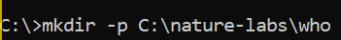
Step 2:
Navigate the below link of WHO dataset
Download the CSV file format of gcloud_Daily_cases_and_deaths_by_date_reported_to_WHO,csv
Download link
https://drive.google.com/file/d/10hIJNv7zeKmd5vAzBWgCqs8suiLh9VGa/view?usp=sharing

Result:
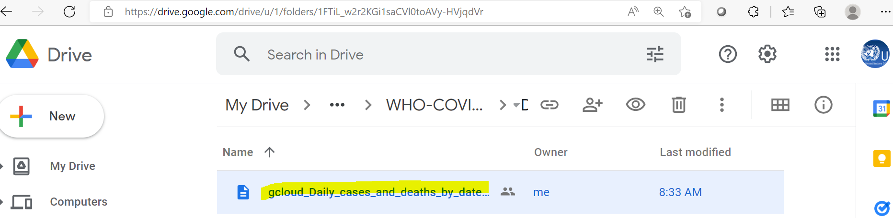

Download the file: gcloud_WHO_COVID_19_global_data.csv and save the file in below directory
C:\nature-labs\who
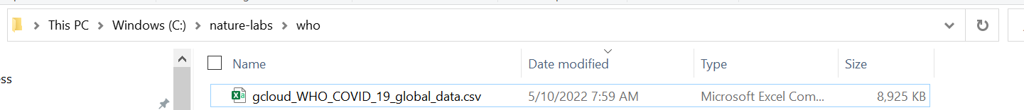

Step 2:

Download the code
https://drive.google.com/file/d/1ZwhyqP2I0Wep9Ccmxka666BKTG1maLcN/view?usp=sharing
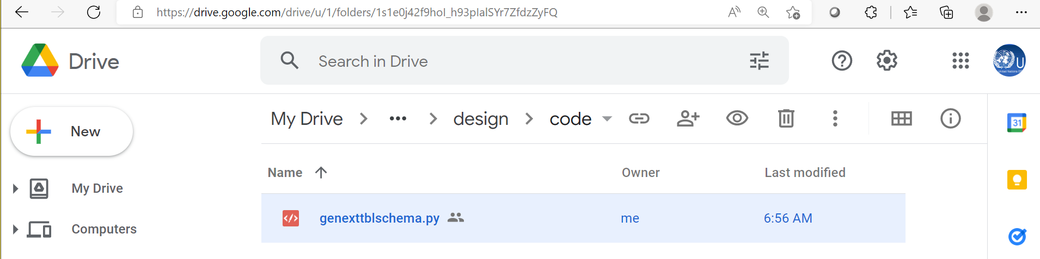
Result:

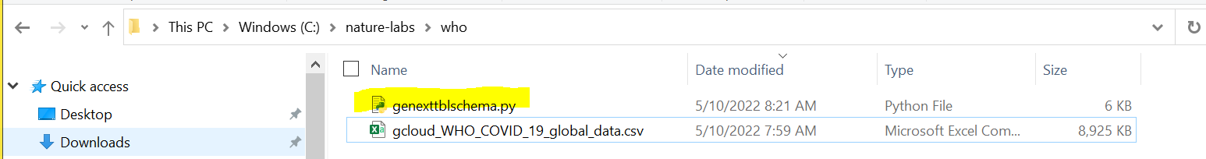

dir genexttblschema.py

Result:

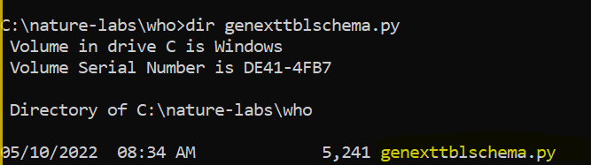

Download the gcloud_Daily_cases_and_deaths.csv
Download Link
https://drive.google.com/file/d/10hIJNv7zeKmd5vAzBWgCqs8suiLh9VGa/view?usp=sharing
Save in c:\nature-labs\who directory
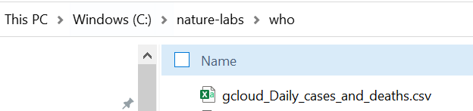
Check the data in c:\nature-labs\who directory
Type the below command in c:\nature-labs\who directory
dir gcloud_Daily_cases_and_deaths.csv

Result
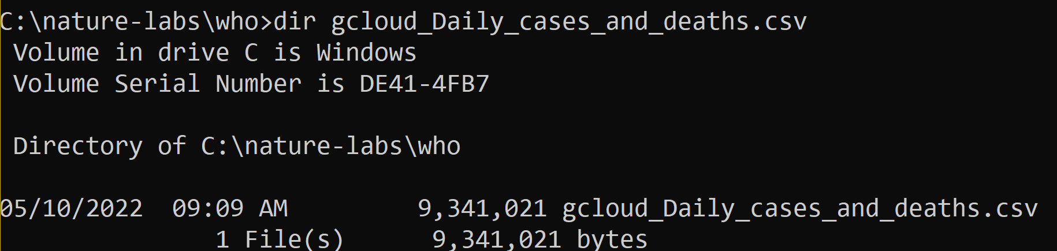
There should be two files in c:\nature-labs\who directory
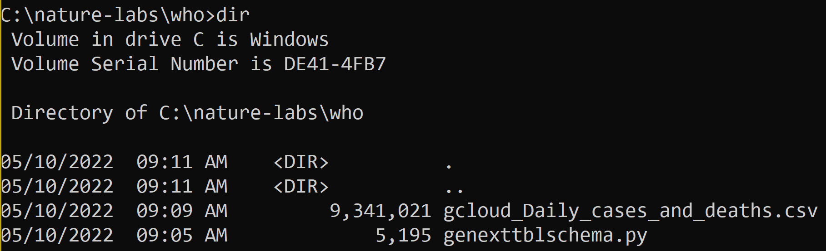

Step 3:
Execute python genexttblschema.py
python genexttblschema.py

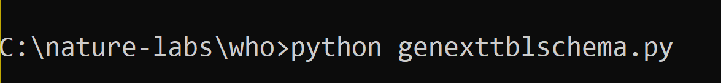

Result
