Supplementary table 1: List of plasmids used in this study:

Plasmid | Description | Reference
pQacR-Q2 | Parent addgene plasmid. QacR genetic circuit with eYFP as reporter | ¹
pRolR | Genetic circuit plasmid with RolR and eGFP | This work
pRolR-TetA | Genetic circuit plasmid with RolR and eGFP and TetA as reporters | This work
pCAQ101 | pRolR-TetA carrying RolR variant CAQ101 | This work
pCAQ102 | pRolR-TetA carrying RolR variant CAQ102 | This work
pCAQ103 | pRolR-TetA carrying RolR variant CAQ103 | This work
pCAQ104 | pRolR-TetA carrying RolR variant CAQ104 | This work
pCAQ54 | pRolR-TetA carrying RolR variant CAQ54 | This work
pCAQ105 | pRolR-TetA carrying RolR variant CAQ105 | This work
pCAQ106 | pRolR-TetA carrying RolR variant CAQ106 | This work
pCAQ107 | pRolR-TetA carrying RolR variant CAQ107 | This work
pCAQ108 | pRolR-TetA carrying RolR variant CAQ108 | This work
pCAQ310 | pRolR-TetA carrying RolR variant CAQ310 | This work
pCAQ313 | pRolR-TetA carrying RolR variant CAQ313 | This work
pCAQ318 | pRolR-TetA carrying RolR variant CAQ318 | This work
pCAQ406 | pRolR-TetA carrying RolR variant CAQ406 | This work
pCAQ407 | pRolR-TetA carrying RolR variant CAQ407 | This work
pCAQ408 | pRolR-TetA carrying RolR variant CAQ408 | This work
pCAQ411 | pRolR-TetA carrying RolR variant CAQ411 | This work
pCAQ414 | pRolR-TetA carrying RolR variant CAQ414 | This work
pCAQ429 | pRolR-TetA carrying RolR variant CAQ429 | This work
pCAQ431 | pRolR-TetA carrying RolR variant CAQ431 | This work
pCAQ.Comb.1 | pRolR-TetA carrying RolR variant CAQ.Comb.1 | This work
pCAQ.Comb.2 | pRolR-TetA carrying RolR variant CAQ.Comb.2 | This work
pCAQ.Comb.3 | pRolR-TetA carrying RolR variant CAQ.Comb.3 | This work
pCAQ.Comb.4 | pRolR-TetA carrying RolR variant CAQ.Comb.4 | This work
pCAQ.Comb.5 | pRolR-TetA carrying RolR variant CAQ.Comb.5 | This work
pMC2 | pRolR-TetA carrying RolR variant MC2 | This work
pMC3 | pRolR-TetA carrying RolR variant MC3 | This work
pCA2 | pRolR-TetA carrying RolR variant CA2 | This work
pCA3.1 | pRolR-TetA carrying RolR variant CA3.1 | This work
pCA3.2 | pRolR-TetA carrying RolR variant CA3.2 | This work
pCA3.3 | pRolR-TetA carrying RolR variant CA3.3 | This work
pCA3.4 | pRolR-TetA carrying RolR variant CA3.4 | This work
pLD2 | pRolR-TetA carrying RolR variant LD2 | This work
pLD3.1 | pRolR-TetA carrying RolR variant LD3.1 | This work
pLD3.2 | pRolR-TetA carrying RolR variant LD3.2 | This work
pHMV3 | pRolR-TetA carrying RolR variant HMV3 | This work
pPCA3 | pRolR-TetA carrying RolR variant PCA3 | This work
pBB94 | pCAS-G418 | ²
pBB95 | pCAS-Hyg | ²

Supplementary table 2: List of generation 2 and 3 RolR variants:
Name | Generation | Molecule | Sequence
DMN2 | 2 | Dopamine | L93I L142F
MC2 | 2 | Methyl catechol | S110F L111S L142Y
PCA2.1 | 2 | Protocatechuate | L93I L142F
PCA2.2 | 2 | Protocatechuate | L111V L114I L142Y
PCA2.3 | 2 | Protocatechuate | L142S G143F A146W
PCA2.4 | 2 | Protocatechuate | G90R L114I L142F
EPI2.1 | 2 | Epinephrine | L93I L142F
EPI2.2 | 2 | Epinephrine | V89Y D94N L142F G143F A146S
EPI2.3 | 2 | Epinephrine | G90N L142F
EPI2.4 | 2 | Epinephrine | S110F L111S L142Y
LD2 | 2 | L-DOPA | V89Y D94N L142F G143F A146S
CA2 | 2 | Caffeic acid | S110F L111S L142Y
CAQ3 | 3 | Catechol | S110G M139L L142f
MC3 | 3 | Methyl catechol | 110F 111S 113L L142Y
LD3.1 | 3 | L-DOPA | L111V L114I M139K L142Y
LD3.2 | 3 | L-DOPA | 90V 114I 130R 142Y
HMV3 | 3 | Homovanillic acid | L142S G143F A146W D165G
CA3.1 | 3 | Caffeic acid | S110G L142F T171A
CA3.2 | 3 | Caffeic acid | S110G L142F A167V
CA3.3 | 3 | Caffeic acid | S110G L142N G143N A146Y
CA3.4 | 3 | Caffeic acid | S110G L142F
PCA3 | 3 | Protocatechuate | 90V 114I 130R 142Y

Supplementary table 2 Sequences of variants identified in the second and third generation with the molecules they were evolved towards. Second generation variants highlighted in yellow were used as a template for random mutagenesis, yielding generation 3 variants.

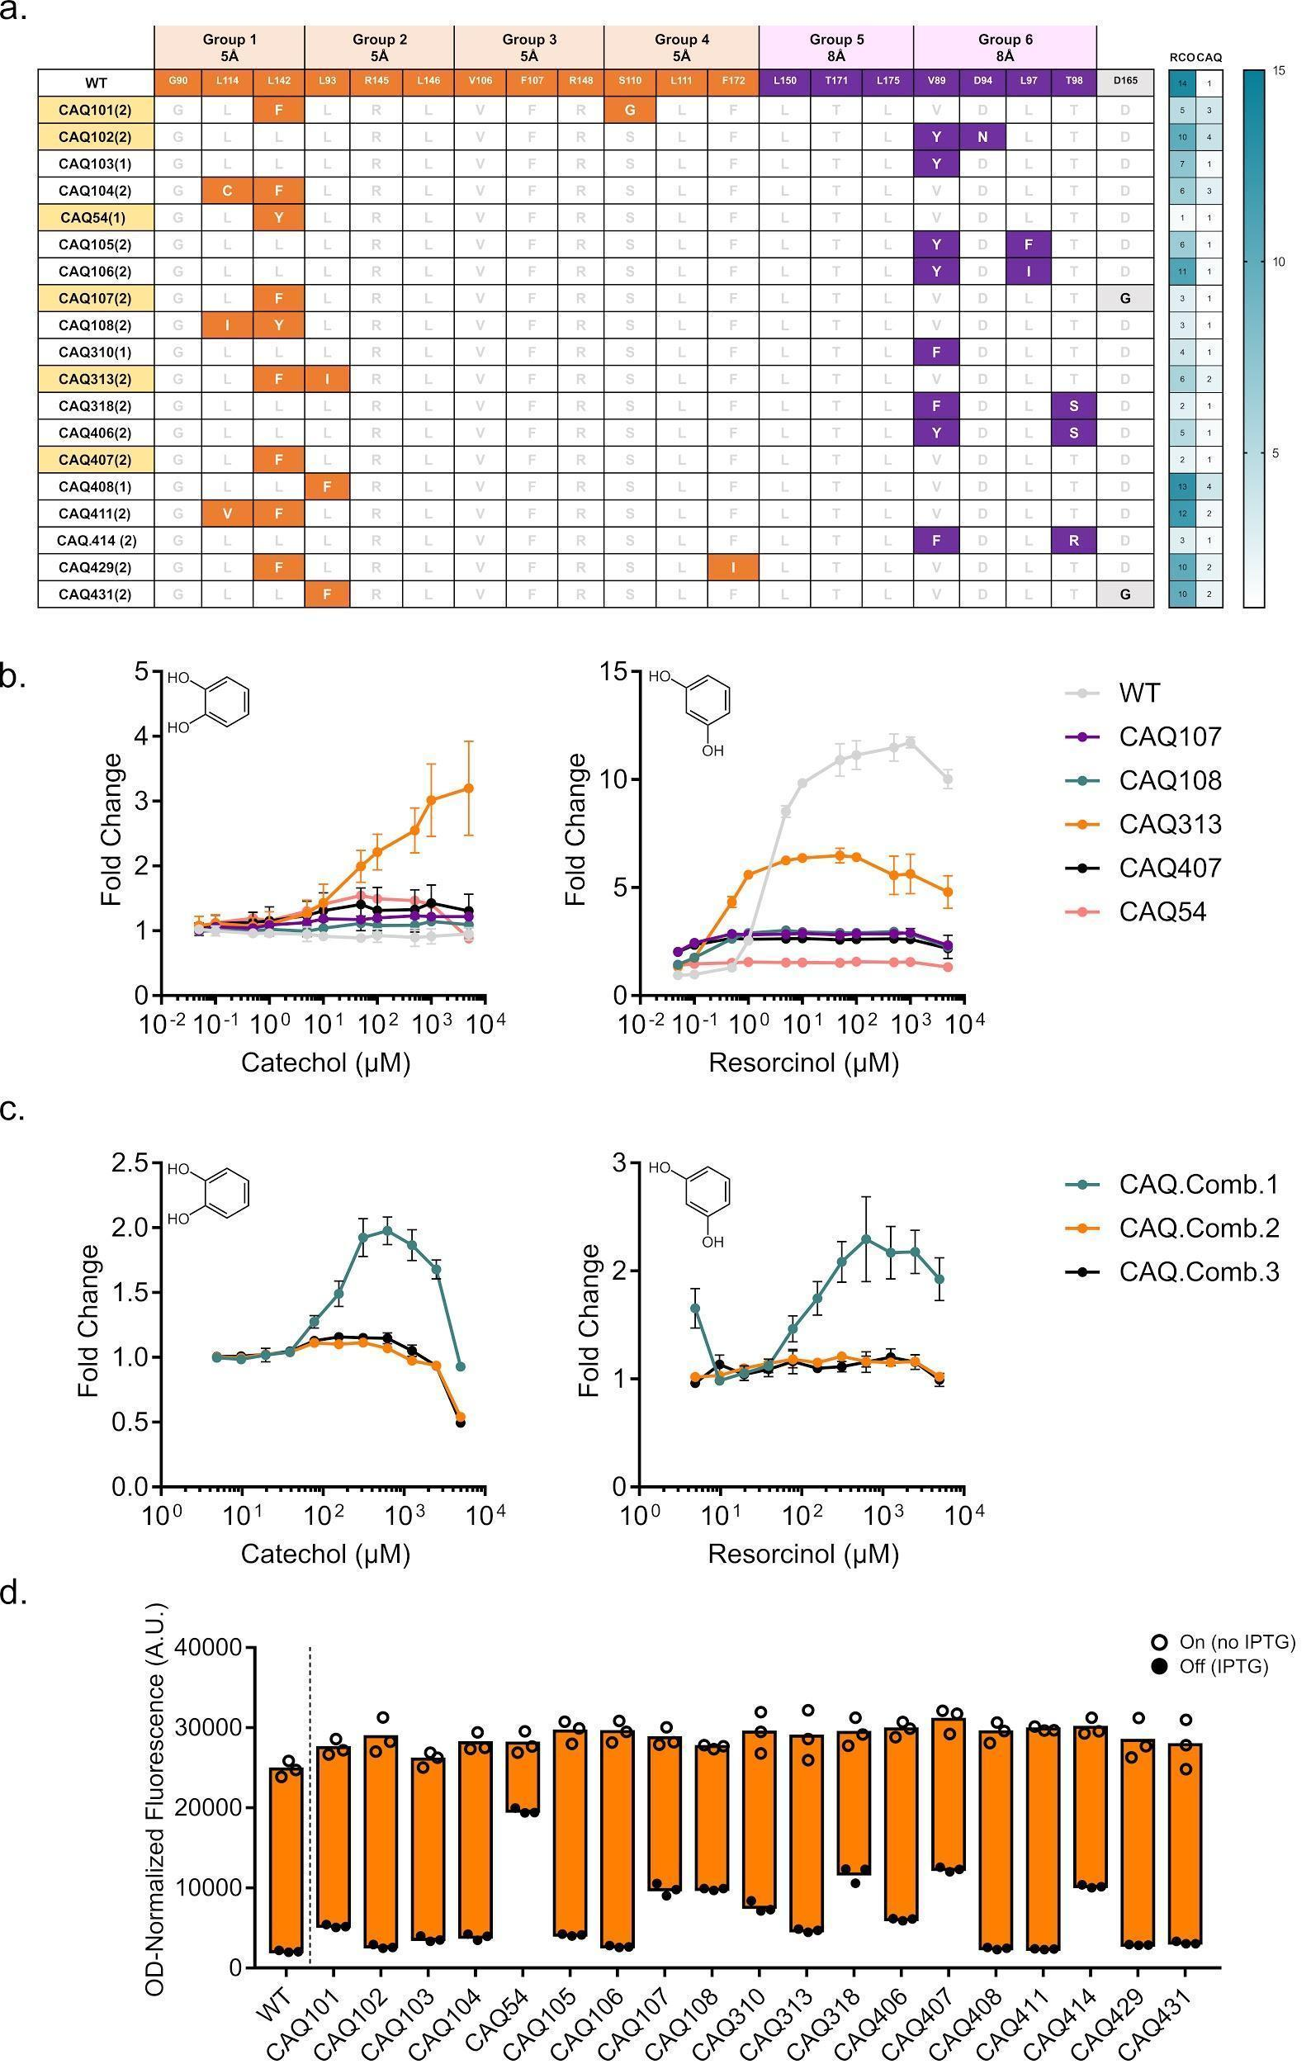
Supplementary Figure 1. Continued first generation variant hits towards catechol. a Table depicting identified variants responsive to catechol, their substitutions coloured according to group, and their response towards resorcinol and catechol. b Dose response curves of the remaining variants compared to WT RolR with catechol (left panel) and resorcinol (right panel). c Dose response curves of the combinatorial variants with resorcinol (left panel) and catechol (right panel). d Dynamic range of WT RolR and all identified variants.

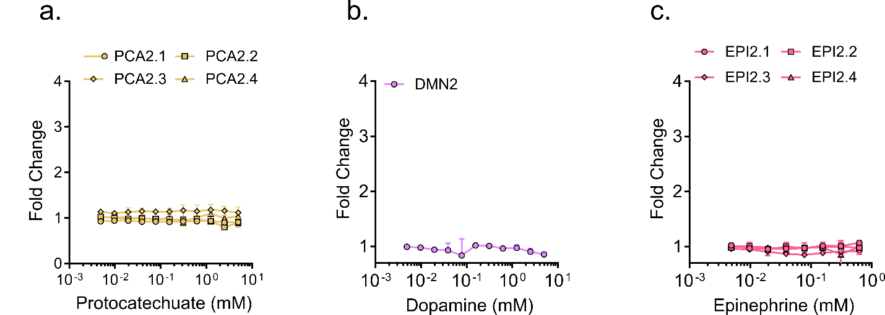

Supplementary Figure 2. Dose response curves for identified second generation variant(s). Dose response curves for variants identified in the second generation of mutagenesis towards protocatechuate (a), dopamine (b), and epinephrine (c).

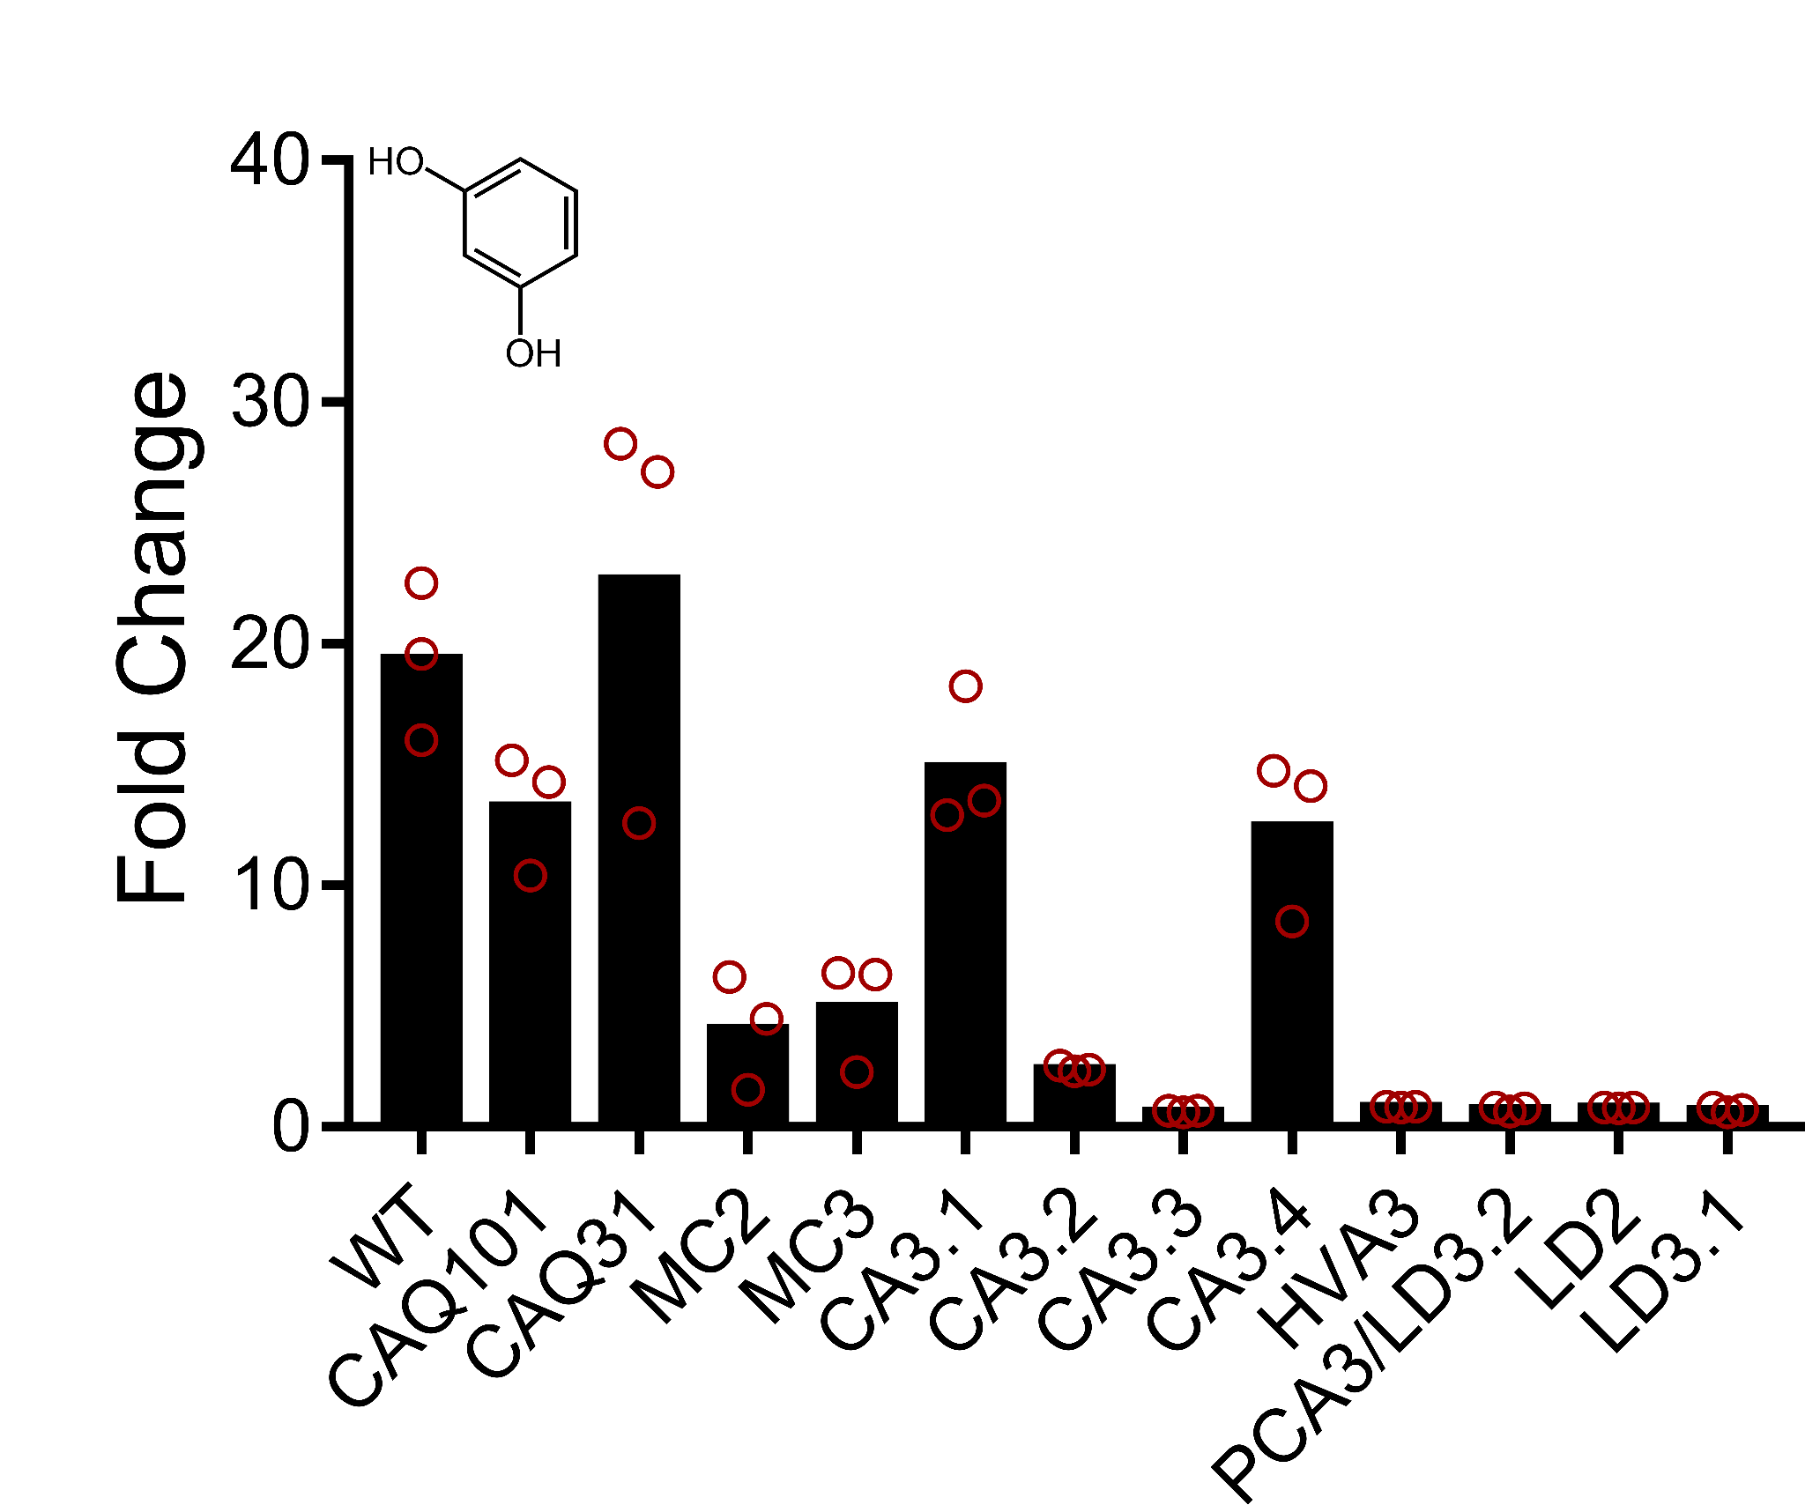

Supplementary Figure 3. RolR variant response to resorcinol. Fluorescence fold-change response of RolR variants to resorcinol.

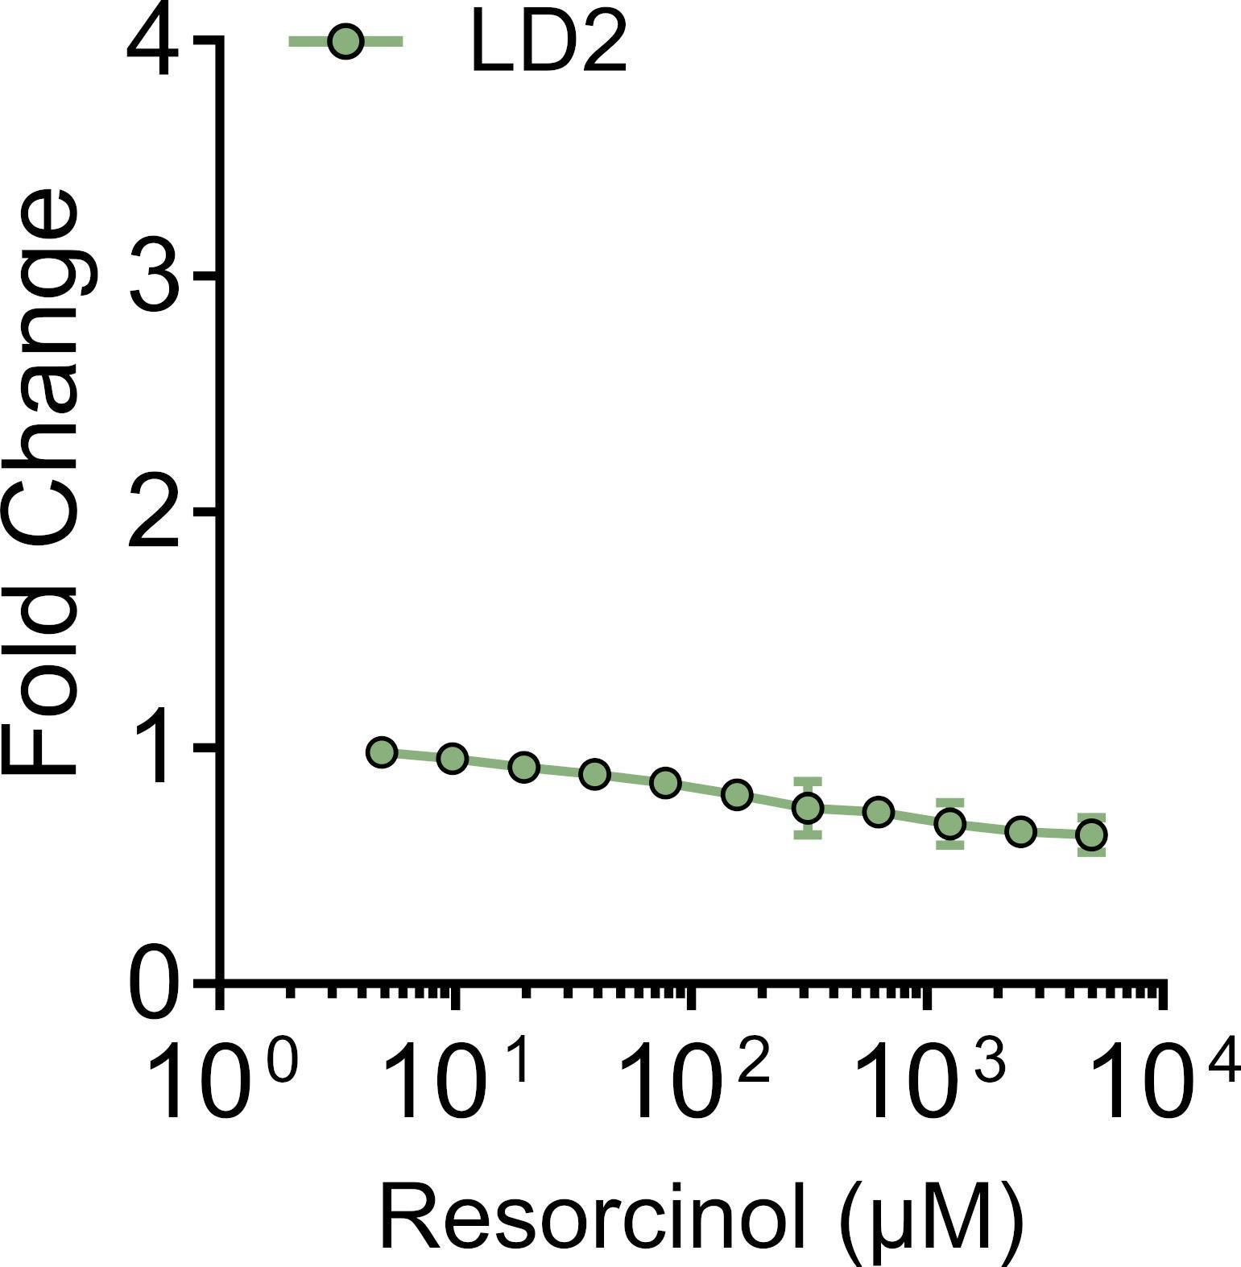

Supplementary Figure 4. Dose response curves for identified second generation variant(s). Dose response curve for variant LD2 with resorcinol.

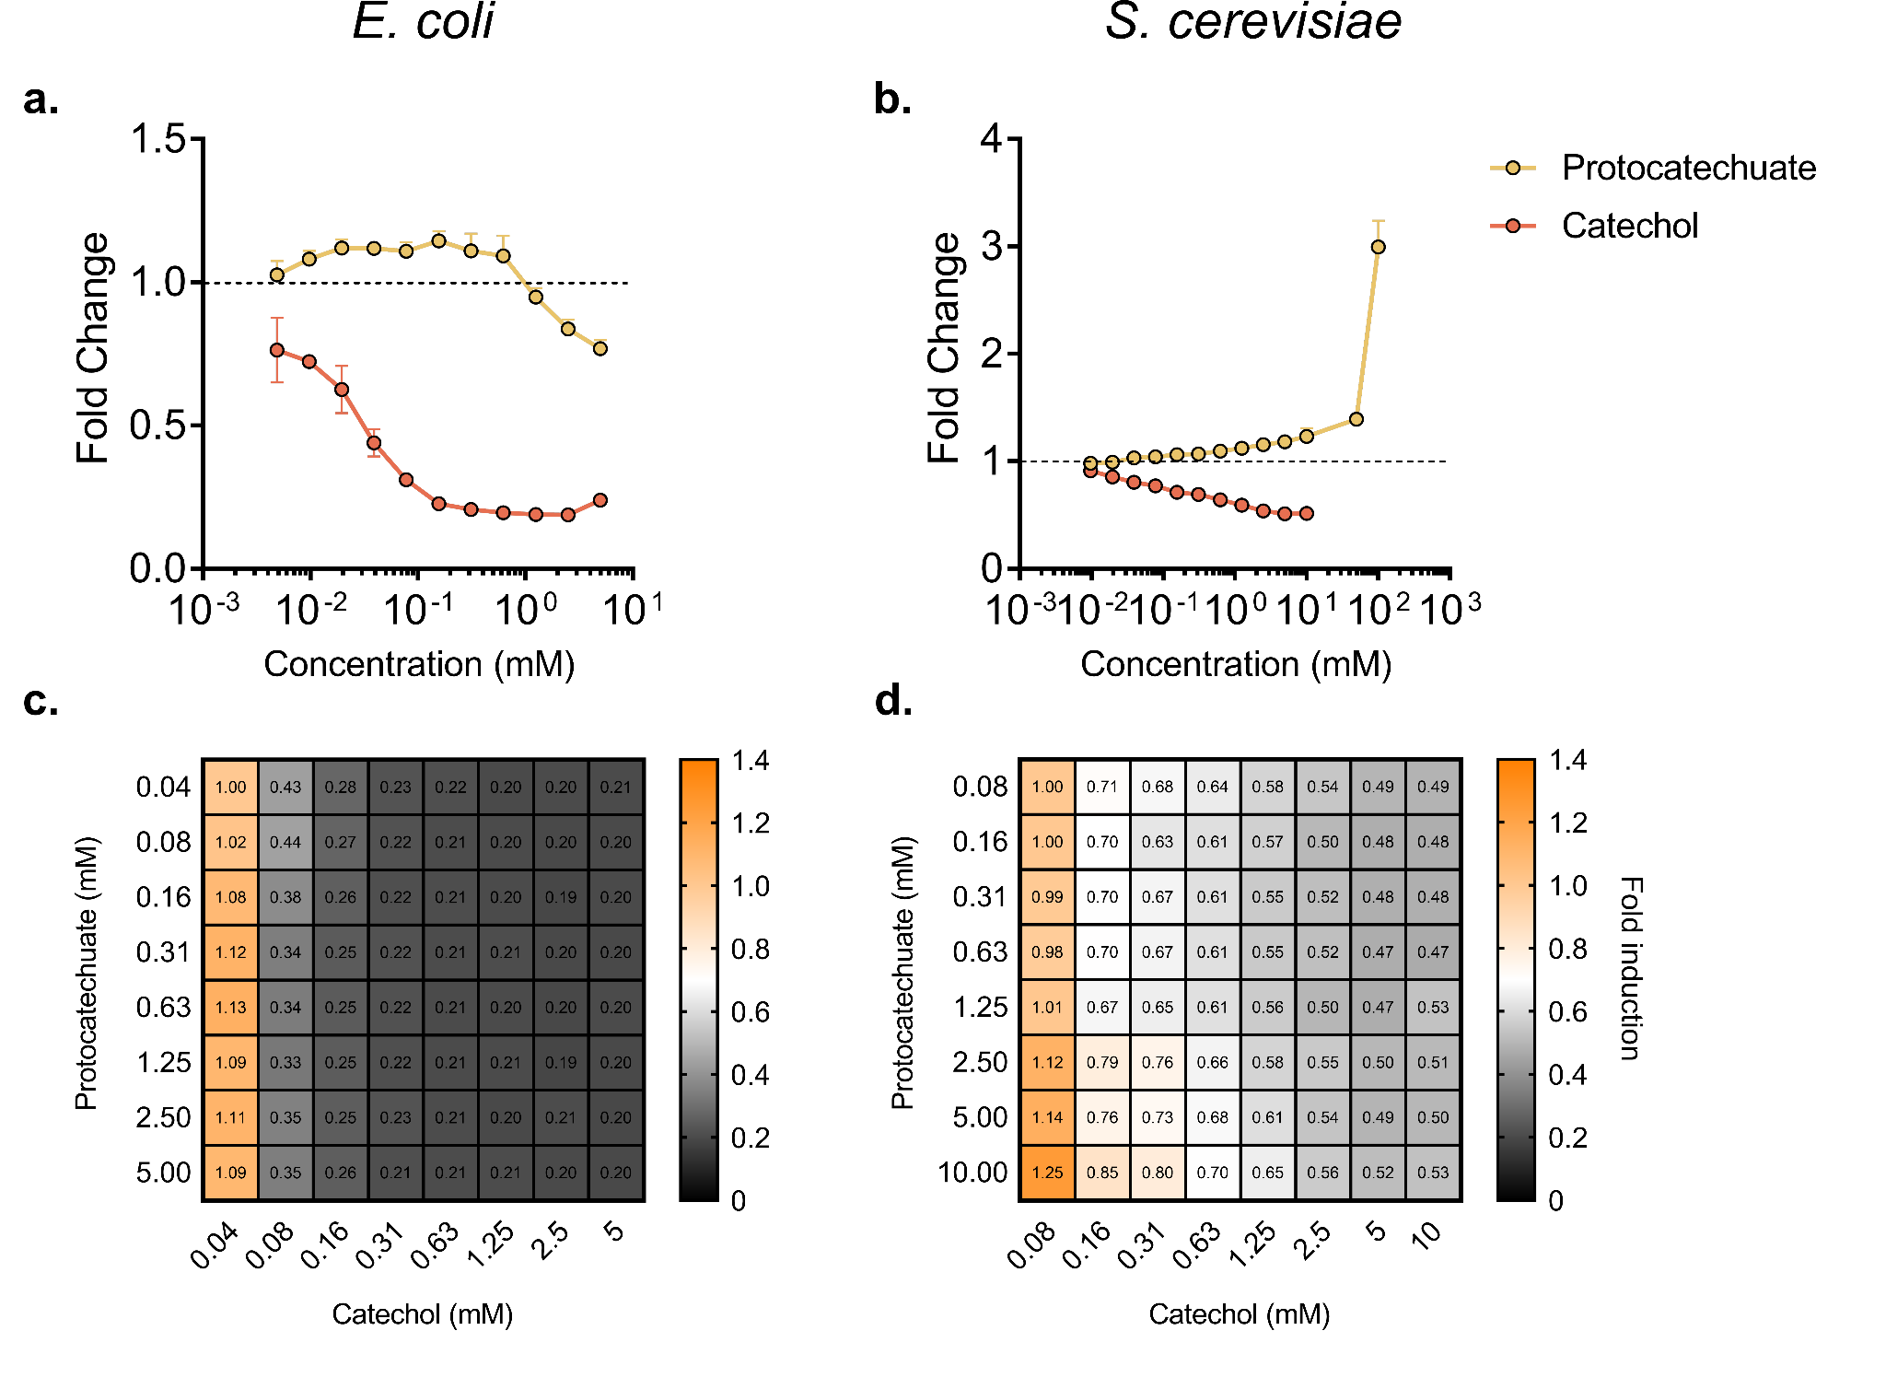

Supplementary Figure 5. Engineering a tri-stable aTF with function towards catechol and protocatechuate. Dose response curve of sensor PCA3 with catechol superimposed with that of protocatechuate in E. coli (a) and S. cerevisiae (b). GFP fluorescence after titrating different concentrations of catechol and protocatechuate in E. coli (c) and S. cerevisiae (d).

Supplementary references:
1. Nielsen, A. A. K. et al. Genetic circuit design automation. Science (80-. ). 352, (2016).
2. Bean, B. D. M., Whiteway, M. & Martin, V. J. J. The MyLo CRISPR-Cas9 Toolkit: A Markerless Yeast Localization and Overexpression CRISPR-Cas9 Toolkit. bioRxiv 2021.12.15.472800 (2021) doi:10.1101/2021.12.15.472800.

