Supporting Information

Tailoring polymer electrolyte for high-voltage solid-state Li metal batteries working at ultra-low temperatures

Zhuo Li^{1,#}, Rui Yu^{1,#}, Suting Weng², Zhiyong Li¹, Qinghua Zhang², Xuefeng Wang^{2,3,}*, Xin Guo^{1,}*

1. State Key Laboratory of Material Processing and Die & Mould Technology, School of Materials Science and Engineering, Huazhong University of Science and Technology, Wuhan 430074, P. R. China.

2. Laboratory of Advanced Materials and Electron Microscopy, Institute of Physics, Chinese Academy of Science, Beijing 100190, P. R. China

3. Tianmu Lake Institute of Advanced Energy Storage Technologies Co. Ltd., Liyang, Jiangsu 213300, P. R. China

#Z. Li and R. Yu contributed equally to this work.

* Corresponding authors:
E-mail: xguo@hust.edu.cn (X. Guo), wxf@iphy.ac.cn (X. Wang)

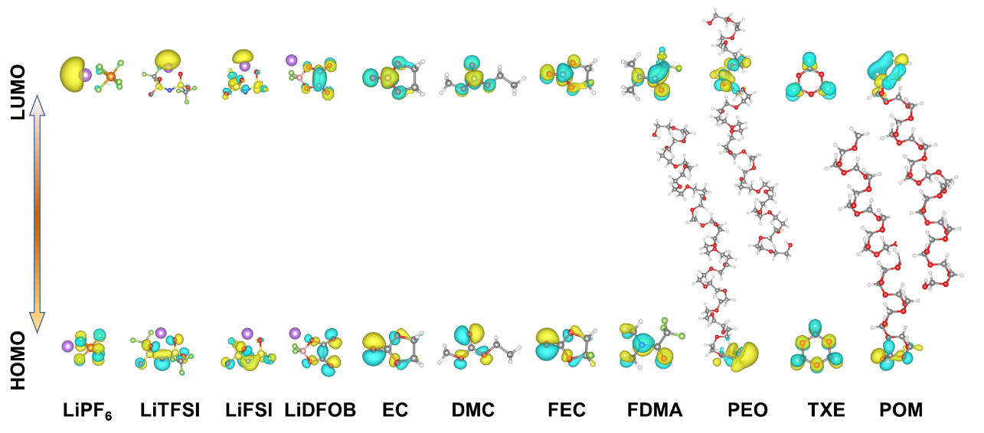
Fig. S1. HOMO and LUMO energy levels of commonly used solvents, Li salts and polymers.

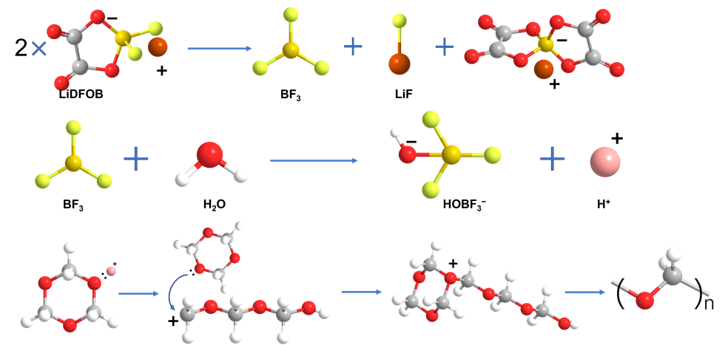
Fig. S2. Polymerization mechanism of TXE monomers induced by LiDFOB.

As shown in Fig. S2, LiDFOB firstly decomposes into LiF, BF₃ and lithium bis(oxalato)borate (LiBOB) on the surface of lithium metal with the aid of alkaline lithium.^{1,2} BF₃ is known as a strong Lewis acid, and also a critical initiator for polymerization,³ which enables the polymerization to proceed smoothly. Namely, in the precursor solution, BF₃ combines with trace water to form H⁺(HOBF₃)⁻, inducing TXE monomers to convert into reactive oxonium ions via fast protonation, and the repetitious interposition of TXE monomers into oxonium ions, which leads to the polymer chain growth. As the polymer grows to a certain degree, trace H₂O attacks oxonium ions and terminates the current chain growth with a nucleophilic substitution. High–molecular weight linear-chain polymer polydioxolane (POM) is then acquired. Consequently, a homogeneous polymer-based electrolyte is eventually established via the combination of the polymer framework (POM) with FDMA.

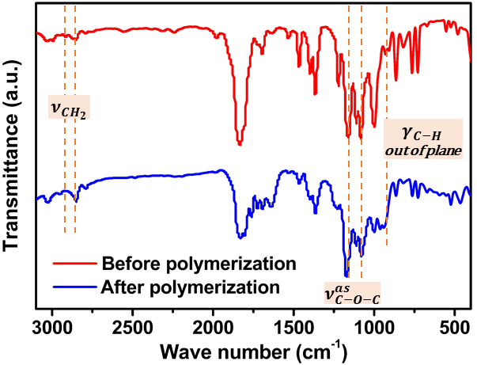
Fig. S3. Structure characterization of the polymer electrolyte by FTIR before and after polymerization.

As shown in Fig. S3, after the polymerization, the doublet absorption peaks attributed to the anti-symmetric vibration mode of -O-C-O- group (TXE) shift from 1159.84 and 1082.2 cm⁻¹ to 1174.71 and 1078.94 cm^{–1}, respectively. In addition, the missing of C-H out of the plane vibration at 928.56 cm⁻¹ and the shift of absorption peaks from 2851.9 and 2922.6 cm⁻¹ to 2850.7 and 2939.1 cm⁻¹, respectively, which are resulted from the -CH₂- stretching mode, also validate that TXE is successfully polymerized to POM.

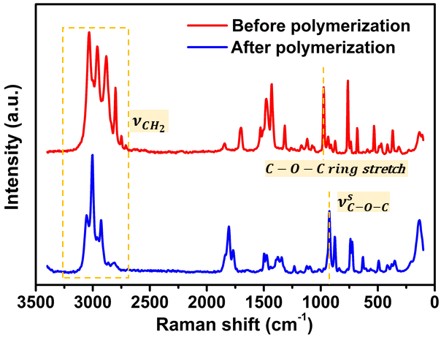
Fig. S4. Raman spectra of the polymer electrolyte before and after polymerization.

The result of Raman characterization is consistent with the finding of the FTIR spectra in Fig. S3. After the polymerization, the signal (973 cm^{–1}) belonging to the C-O-C ring stretching is missing. In addition, new peak (920 cm^{–1}) associated with the C-O-C symmetric stretching appears. And peaks belonging to the CH₂ symmetric stretching shift from 2802, 2884, 2960 and 3032 cm^{–1} to 2822, 2929, 3005 and 3051 cm^{–1}, respectively, indicating the successful polymerization of TXE.

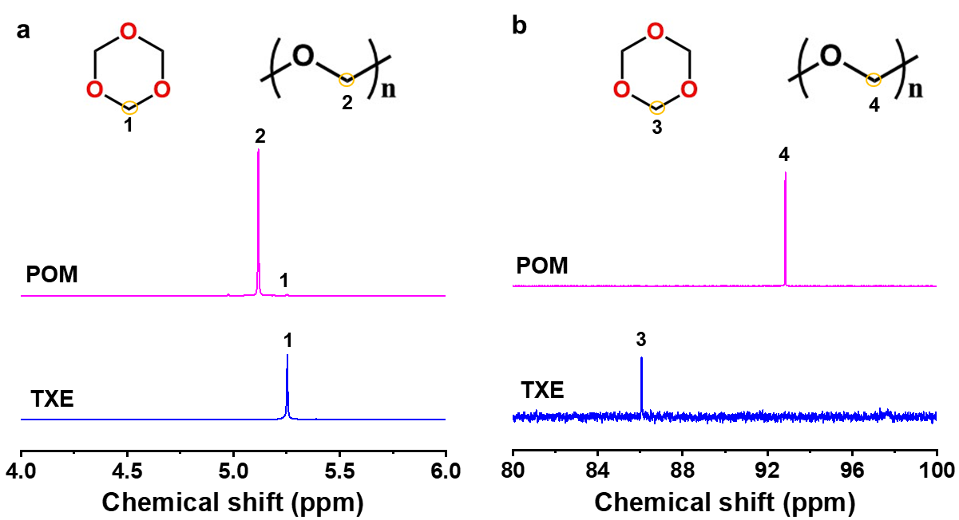
Fig. S5. NMR spectra of TXE and POM polymers: a. Hydrogen, b. carbon.

After the polymerization reaction, new hydrogen and carbon peaks were observed, which are in accordance with the structure of POM (Fig S5), demonstrating that the TXE is completely polymerized and transformed to POM.

Fig. S6. Mass spectrometry of the polymer electrolyte after polymerization.

After the polymerization reaction, the polymer shows an average molecular weight of ~1800 (Fig. S6), indicating the successful polymerization of TXE (with a molecular weight of ~90).

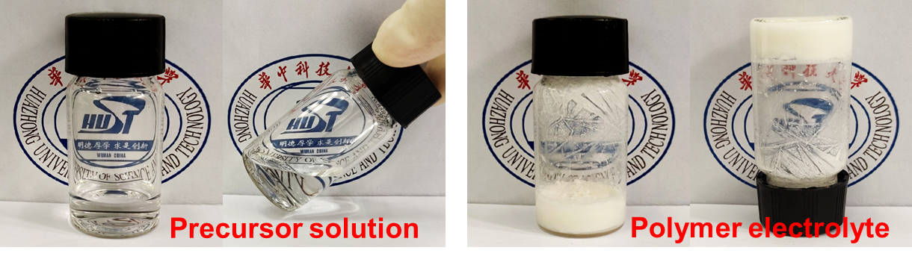
Fig. S7. Optical images of the precursor and the polymer electrolyte.

As shown in Fig. S7, the original flowable liquid solution of TXE-FDMA-FEC-LiDFOB precursor turns into a solid-like electrolyte with immovable and stretchy characteristics, indicating that polymerization has taken place in the electrolyte.

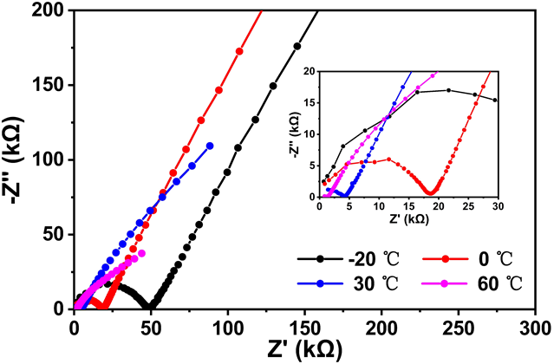
Fig. S8. EIS curves of the polymer electrolyte at different temperatures.

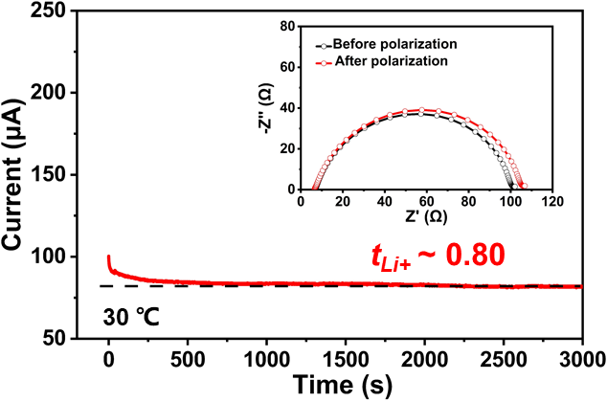
Fig. S9. Chronoamperometry profile of the polymer electrolyte at 30 °C, inset is the Nyquist plots before and after chronoamperometry.

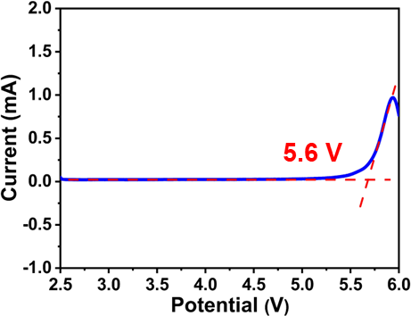
Fig. S10. Positive linear sweep voltammogram (LSV) of Li||Pt cell to gauge the oxidation stability of the polymer electrolyte.

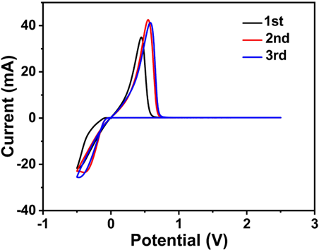
Fig. S11. Cyclic voltammetry (CV) curves of the polymer electrolyte in Li||Pt cell.

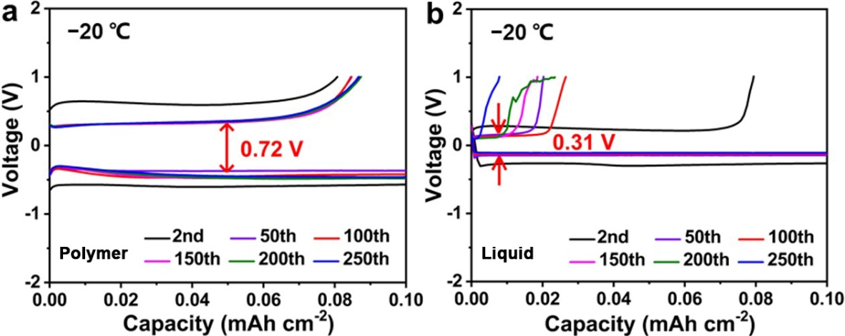
Fig. S12. Voltage profiles for Li plating/stripping on Cu working electrode for both electrolytes cycled in Li||Cu cells: a. polymer electrolyte, b. liquid electrolyte.

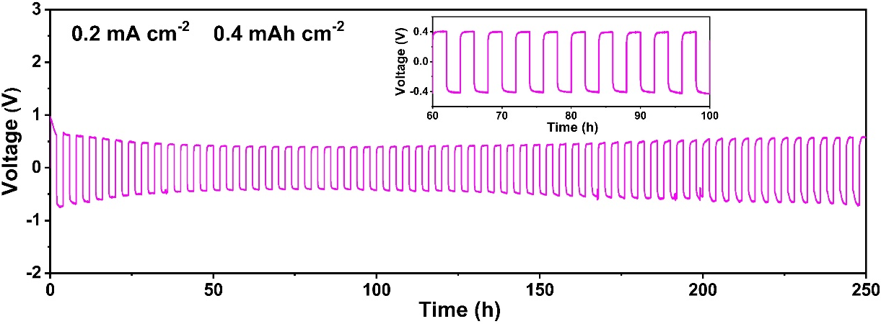
Fig. S13. Galvanostatic cycling of the polymer electrolyte in symmetric Li||Li cell with 50 μm Li foil at a high capacity of 0.4 mAh cm⁻² (0.2 mA cm⁻²) and at −20 °C.

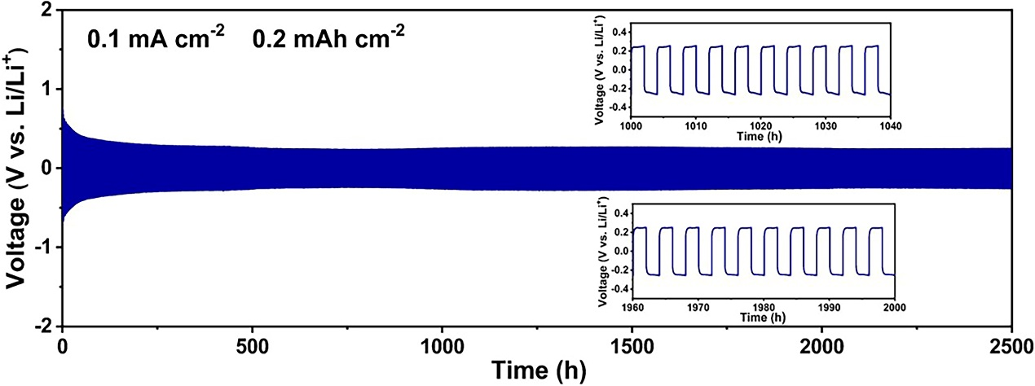
Fig. S14. Galvanostatic cycling of the polymer electrolyte in symmetric Li||Li cell using 250 μm Li foil at −20 °C.

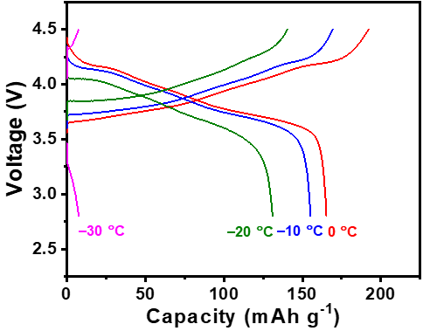
Fig S15. Charge-discharge profiles of the liquid electrolyte in Li||NCM811 cell at different temperatures.

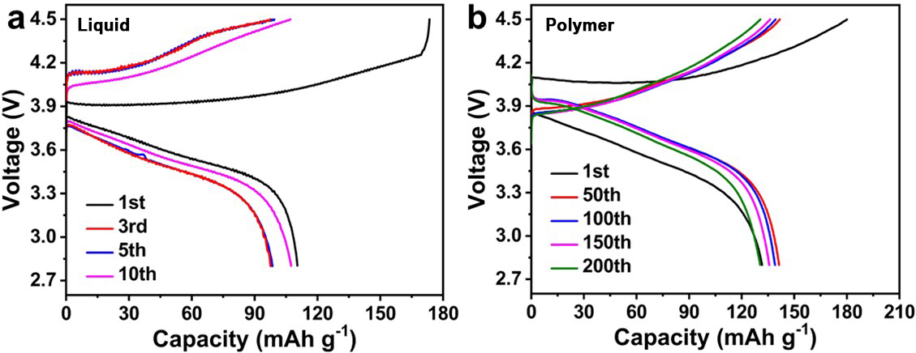
Fig. S16. Typical charge-discharge voltage profiles of both electrolytes in Li||NCM811 cells at −20 °C: a. liquid electrolyte, b. polymer electrolyte.

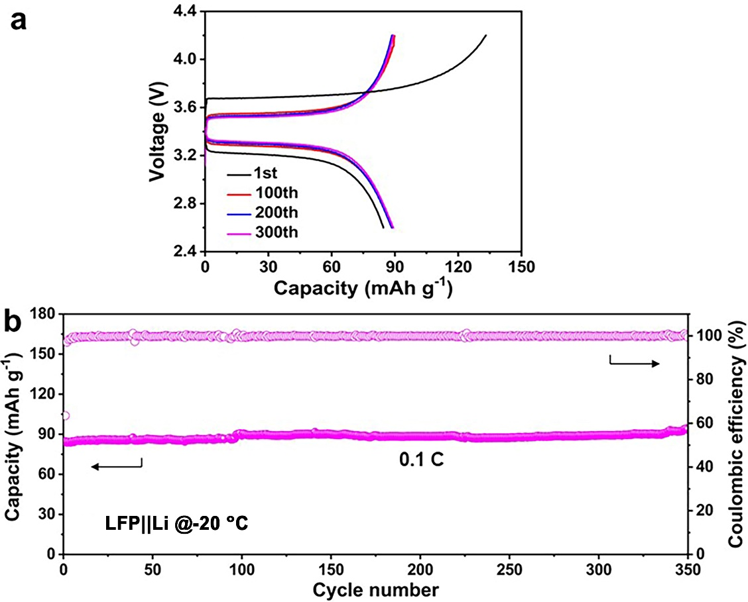
Fig. S17. Electrochemical performances of the polymer electrolyte in Li||LFePO₄ cell at –20 °C: a. charge-discharge profiles, b. cycling performances.

Fig. S18. Typical charge-discharge voltage profiles of the polymer electrolyte in Li||NCM811 pouch cell at −30 °C.

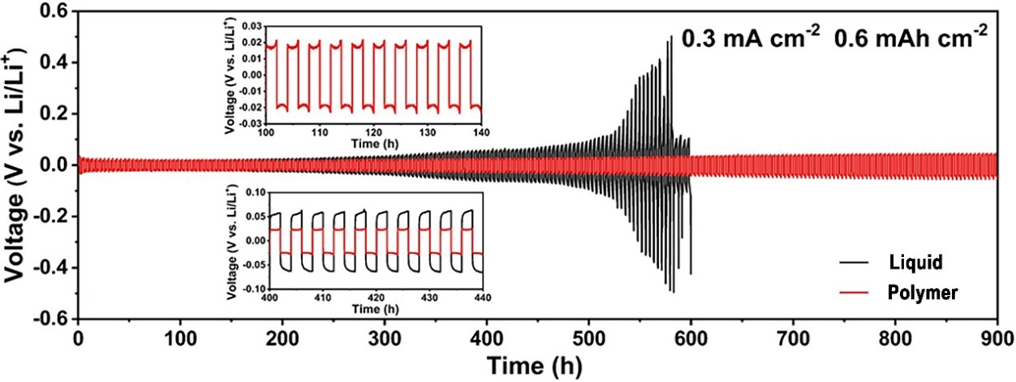
Fig. S19. Galvanostatic cycling of the polymer electrolyte in symmetric Li||Li cell with 50 μm Li anode at 30 °C; data for the liquid electrolyte are plotted for comparison.

As shown in Fig. S19, in the reference electrolyte system, an obvious but gradual increase in voltage is observed after 250 cycles at room temperature; in comparison, the cell with the polymer electrolyte exhibits very stable cycling for more than 900 h.

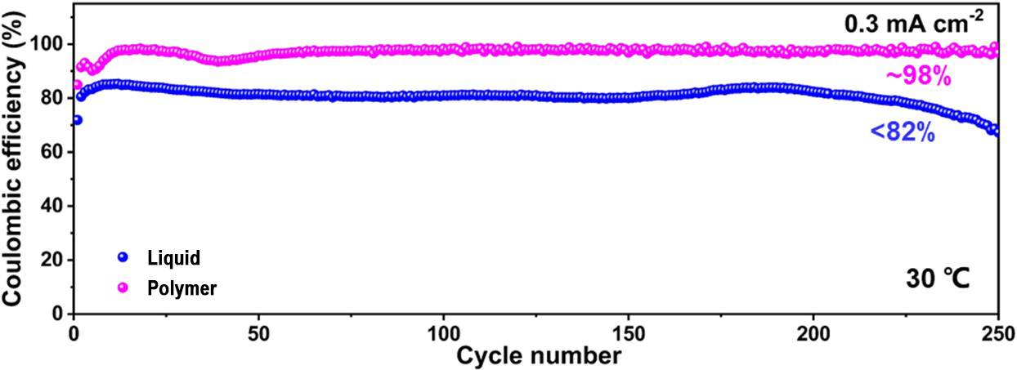
Fig. 20. Coulombic efficiency of the polymer electrolyte in Li||Cu cell with 50 μm Li anode at 30 °C; data for the liquid electrolyte are plotted for comparison.

As shown in Fig. S20, in the reference electrolyte system, the Li Coulombic efficiency is lower than 82% and fades quite quickly at room temperature; in sharp contrast, the Li||Cu cell with the polymer electrolyte shows stable cycling with a much higher Coulombic efficiency of ~98%.

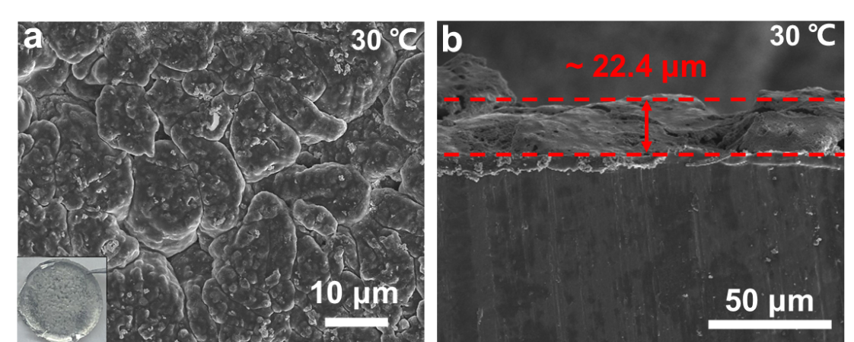
Fig. S21. Morphologies of Li deposited at 30 °C: a. Surface, b. cross-section.

At room temperature, large and more compact granular Li particles with a size of ~10 microns are observed in the polymer system, as shown in the SEM image (Fig. S21a); the deposited layer is only ~22.4 μm in thickness (Fig. S21b), indicating minimized Li loss and volumetric expansion.

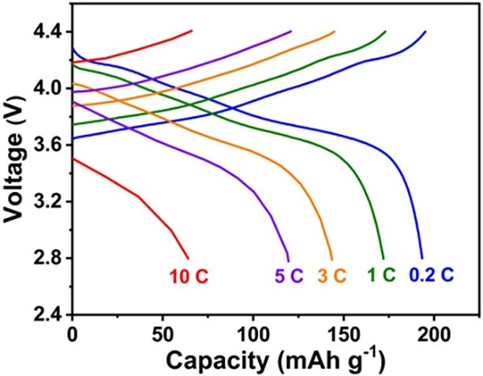
Fig. 22. Charge-discharge voltage profiles of the liquid electrolyte in Li||NCM811 cell at different rates.

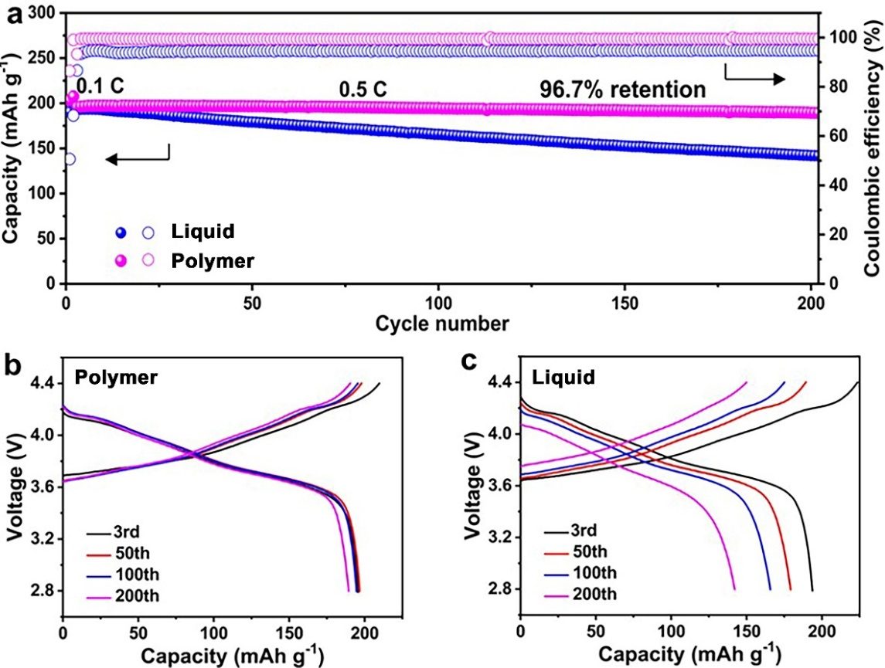
Fig. S23. Battery performances of both electrolytes in Li||NCM811 cells at 30 °C: a. Cycling performances, b,c. corresponding charge-discharge profiles of the polymer electrolyte (b), and the liquid electrolyte (c).

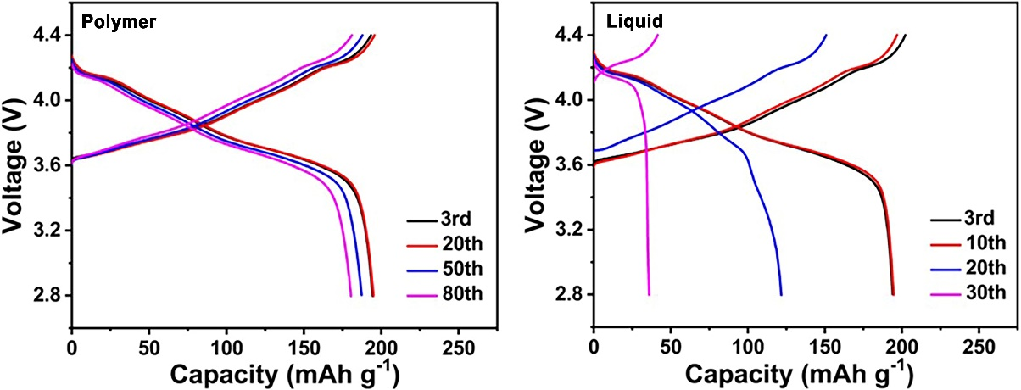
Fig. S24. Charge-discharge voltage profiles of both electrolytes in Li||NCM811 cells at 30 °C under practical conditions: a. Polymer electrolyte, b. liquid electrolyte.

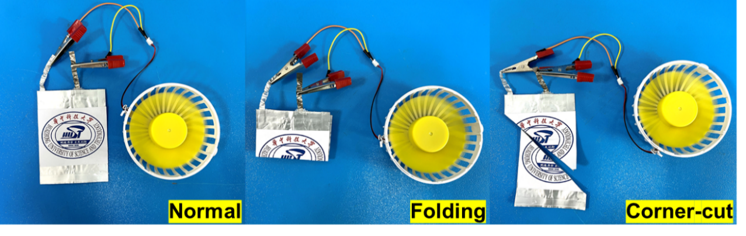
Fig. S25. Li||NCM811 pouch cells using the polymer electrolyte are powering an electric fan under normal, folding, and corner-cut conditions.

Electrolytes | Operation temperature | Cathodes | Cut-off Voltage |  | Performance | References
Poly(VC) | 25 °C | LiNi_{0.8}Co_{0.1}Mn_{0.1}O₂ |  | 4.3 V | ~150 mAh g⁻¹, 100 cycles, 93% retention | ⁴
Poly(DOL) | 25 °C | LiNi_{0.6}Co_{0.2}Mn_{0.2}O₂ |  | 4.3 V | ~153 mAh g⁻¹, 60 cycles, 80% retention | ⁵
Poly(DOL) | 25 °C | LiFePO₄ |  | 4.0 V | ~95 mAh g⁻¹, 700 cycles | ⁶
Poly(DOL) | −20 °C | S |  | 2.8 V | ~700 mAh g⁻¹, 60 cycles | ⁷
Poly(DOL) | 15 °C | LiFePO4 |  | 4 V | 118 mAh g⁻¹, 1200 cycles, 87.2% retention | ⁸
Poly(DOL) | −20 °C | LiNi_{0.8}Co_{0.1}Mn_{0.1}O₂ |  | 4.3 V | 109 mAh g⁻¹, 100 cycles | ⁹
Poly(TXE) | −10 °C | LiFePO₄ |  | 4.3 V | 0.3 C, ~158 mAh g⁻¹  200 cycles, 88% | ¹⁰
PTFEMA | 0 °C | LiFePO₄ |  | 3.9 V | ~86 mAh g⁻¹, 1 cycle | ¹¹
Poly(VEC) | −15 °C | LiFePO₄ |  | 4.0 V | ~100 mAh g⁻¹, 1 cycle | ¹²
Poly(TEGDA) | −10 °C | LiFePO₄ |  | 4 V | 114 mAh g⁻¹, 50 cycles | ¹³
Poly(TXE) | −20/−30 °C | LiFePO₄ |  | 4 V | ~95 mAh g⁻¹, 350 cycles, −20 °C | This work
Poly(TXE) | −20/−30 °C | LiNi_{0.8}Co_{0.1}Mn_{0.1}O₂ |  | 4.5 V | ~150 mAh g⁻¹, 200 cycles, −20 °C | This work
 |  |  |  |  | ~75 mAh g⁻¹, >10 cycles, −30 °C | This work
Table S1. Cell performances of some typical polymer-based electrolytes.

Rerfences:
1. Zhou, L., Li, W., Xu, M. & Lucht, B. Investigation of the Disproportionation Reactions and Equilibrium of Lithium Difluoro(Oxalato) Borate (LiDFOB). Electrochem. Solid-State Lett. 14, A161 (2011).
2. Liu, Q., et al. Long-cycling and safe lithium metal batteries enabled by the synergetic strategy of ex situ anodic pretreatment and an in-built gel polymer electrolyte. J. Mater. Chem. A 8, 7197-7204 (2020).
3. Cui, Y., et al. High Performance Solid Polymer Electrolytes for Rechargeable Batteries: A Self-Catalyzed Strategy toward Facile Synthesis. Adv. Sci. 4, 1700174 (2017).
4. Ma, Q., et al. Formulating the Electrolyte Towards High-Energy and Safe Rechargeable Lithium-Metal Batteries. Angew.Chem. Int. Ed. 60, 16554-16560 (2021).
5. Zhao, C.Z., et al. Rechargeable Lithium Metal Batteries with an In-Built Solid-State Polymer Electrolyte and a High Voltage/Loading Ni-Rich Layered Cathode. Adv. Mater. 32, 1905629 (2020).
6. Zhao, Q., Liu, X., Stalin, S., Khan, K. & Archer, L.A. Solid-state polymer electrolytes with in-built fast interfacial transport for secondary lithium batteries. Nat. Energy 4, 365-373 (2019).
7. Xiang, J., et al. A flame-retardant polymer electrolyte for high performance lithium metal batteries with an expanded operation temperature. Energy Environ. Sci. 14, 3510-3521 (2021).
8. Chen, Y., Huo, F., Chen, S., Cai, W. & Zhang, S. In-Built Quasi-Solid-State Poly-Ether Electrolytes Enabling Stable Cycling of High-Voltage and Wide-Temperature Li Metal Batteries. Adv. Funct. Mater. 31, 2102347 (2021).
9. Yu, J., et al. In Situ Fabricated Quasi-Solid Polymer Electrolyte for High-Energy-Density Lithium Metal Battery Capable of Subzero Operation. Adv. Energy Mater. 31, 2102932 (2021).
10. Wu, H., et al. LiDFOB Initiated In Situ Polymerization of Novel Eutectic Solution Enables Room‐Temperature Solid Lithium Metal Batteries. Adv. Sci. 7, 2003370 (2020).
11. Yu, L., et al. Monolithic Task‐Specific Ionogel Electrolyte Membrane Enables High‐Performance Solid‐State Lithium‐Metal Batteries in Wide Temperature Range. Adv. Funct. Mater. 32, 2110653 (2021).
12. Lin, Z., et al. A wide-temperature superior ionic conductive polymer electrolyte for lithium metal battery. Nano Energy 73, 104786 (2020).
13. Li, Z., et al. Nonflammable quasi-solid electrolyte for energy-dense and long-cycling lithium metal batteries with high-voltage Ni-rich layered cathodes. Energy Storage Mater. 47, 542-550 (2022).

