SUPPLEMENTARY INFORMATION
Lead (Pb) uptake by the hyperaccumulator Vetiveria zizanioides: Uncovering the role of phytocomponents of root exudates and extracts on the chemotactic response of rhizospheric bacteria
Anamika Kushwahaª, Nidhi Hansª, Balendu Shekher Giri^{b}, Eldon R. Rene^{c} and Radha Raniª*

ª Department of Biotechnology, Motilal Nehru National Institute of Technology Allahabad, Teliyarganj, Prayagraj-211004, Uttar Pradesh, India
^{b} Department of Chemical Engineering and Technology, Centre of Advanced Study, Indian Institute of Technology (Banaras Hindu University), Varanasi 221005, India
^{c} Department of Environmental Engineering and Water Technology, IHE Delft Institute for Water Education, 2611AX Delft, The Netherlands

*Corresponding author
Dr. Radha Rani,
Department of Biotechnology,
Motilal Nehru National Institute of Technology Allahabad, Teliyarganj,
Prayagraj - 211004, Uttar Pradesh, India.
Tel: +91-532-2271240; Fax: +91-532-2271200
E-mail: radharani@mnnit.ac.in; raadharaani1982@gmail.com

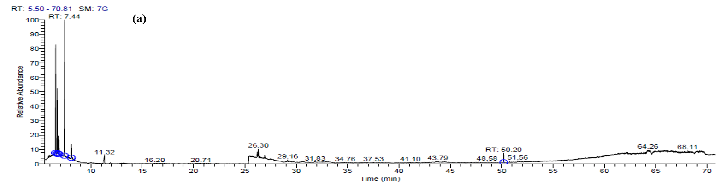
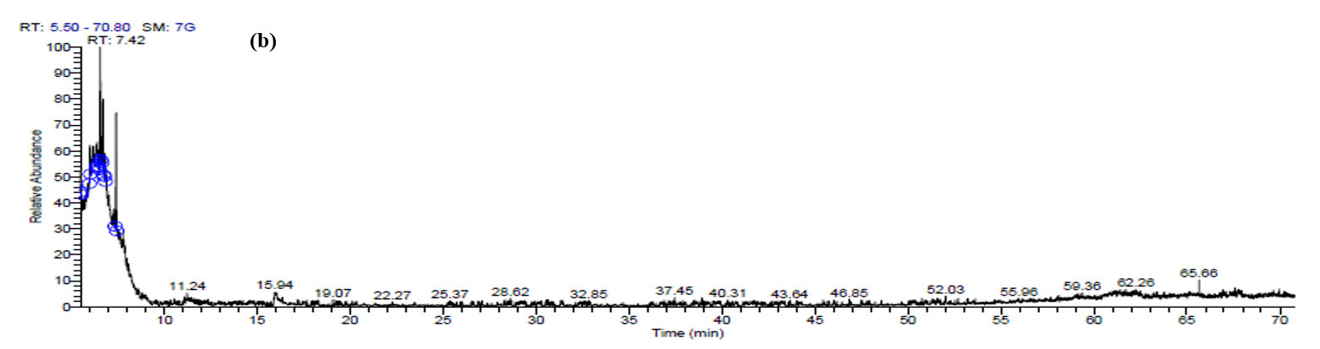
(b)
Fig S1: GC-MS chromatogram of root exudates: (a) in the absence of lead and (b) in the presence of lead (100 mg kg⁻¹)
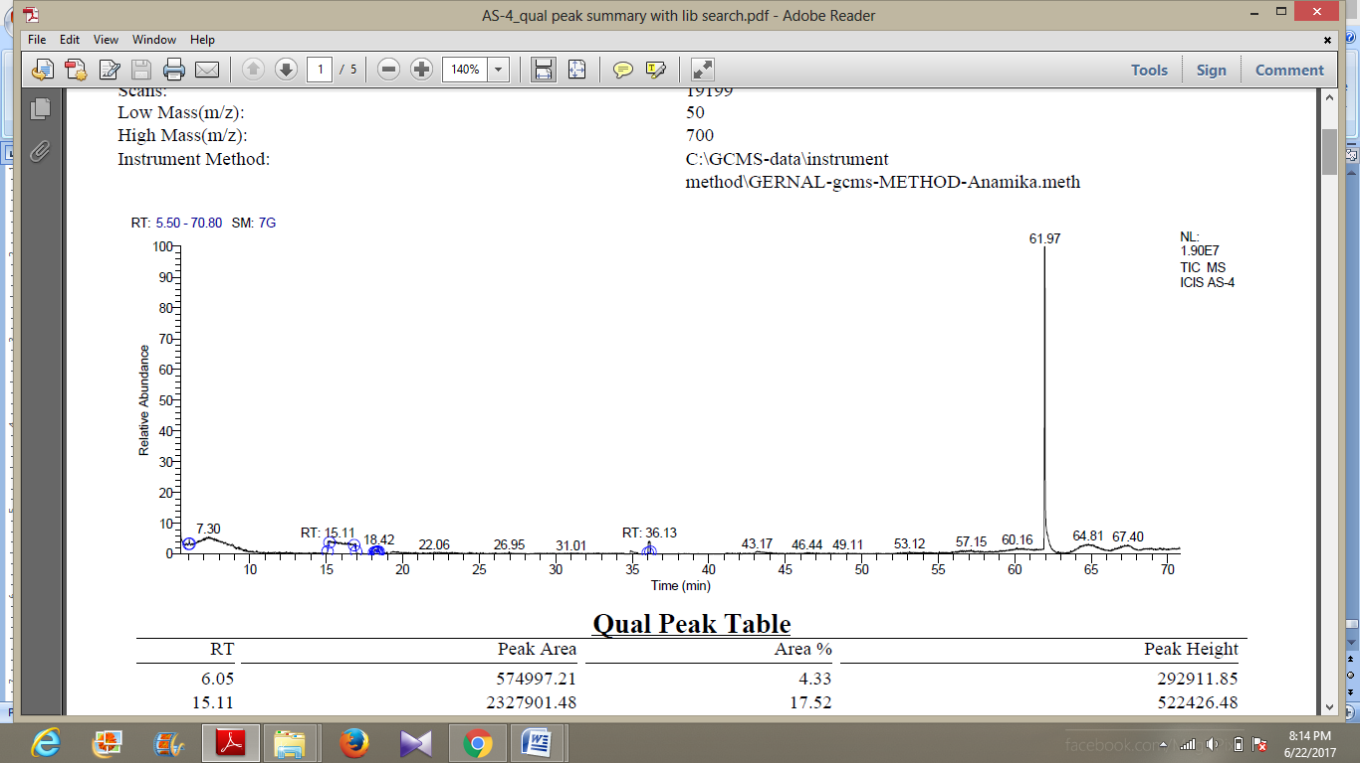
(a)
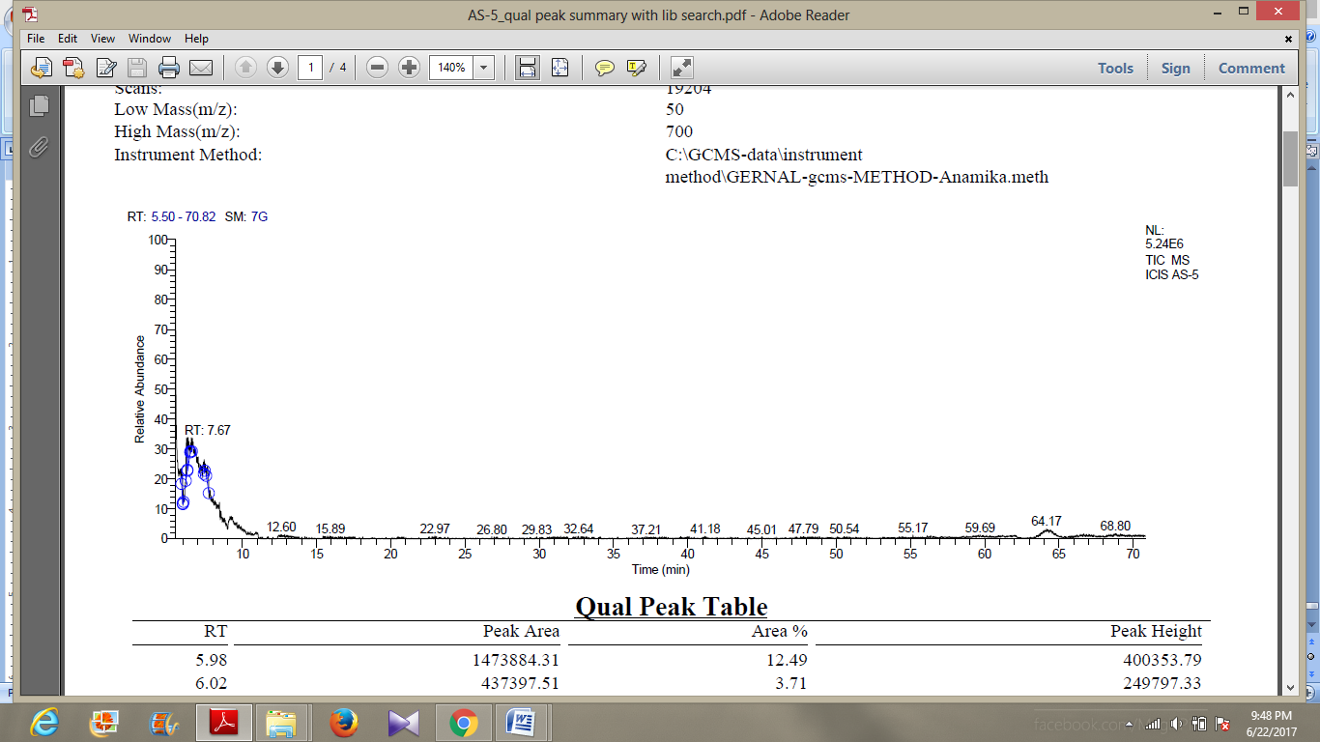
(b)
Fig S2: GC-MS chromatogram of root extracts: (a) in the absence of lead, and (b) in the presence of lead at 100 mg kg⁻¹

