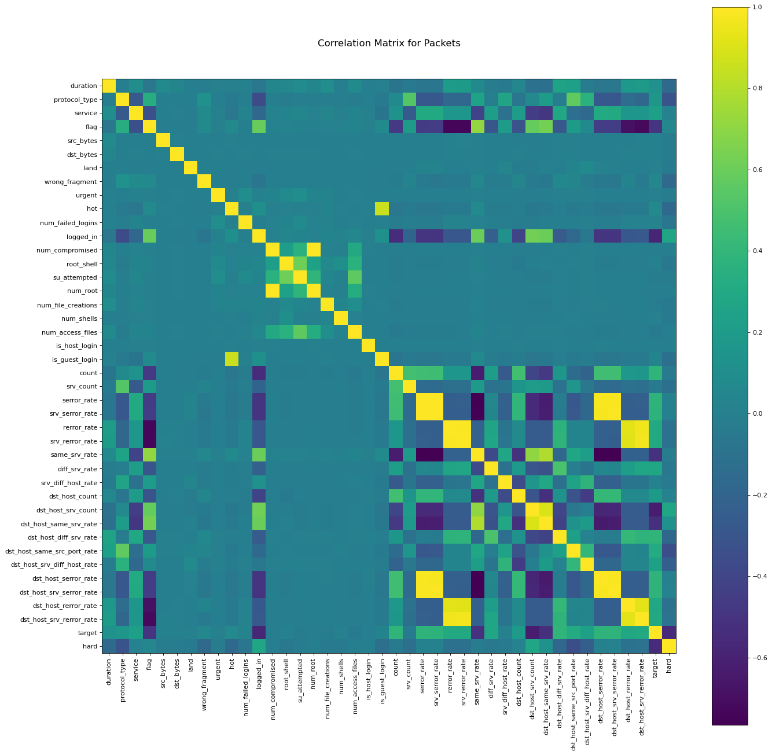
Appendix A

Appendix A. Correlation Matrix of 43 Attributes

