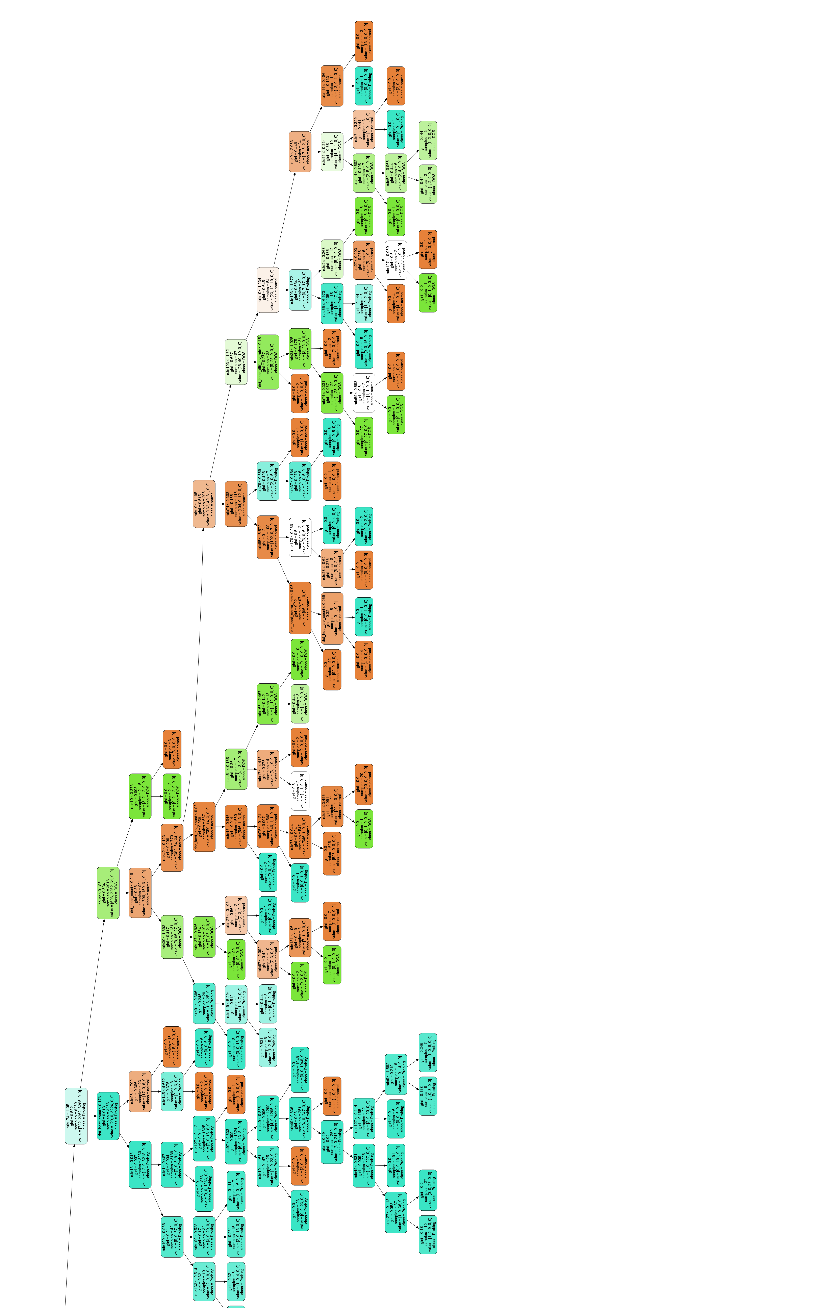
Appendix D
Appendix D. (a) ANFIS-enhanced CART tree. The rules are fuzzy rules by ANFIS.
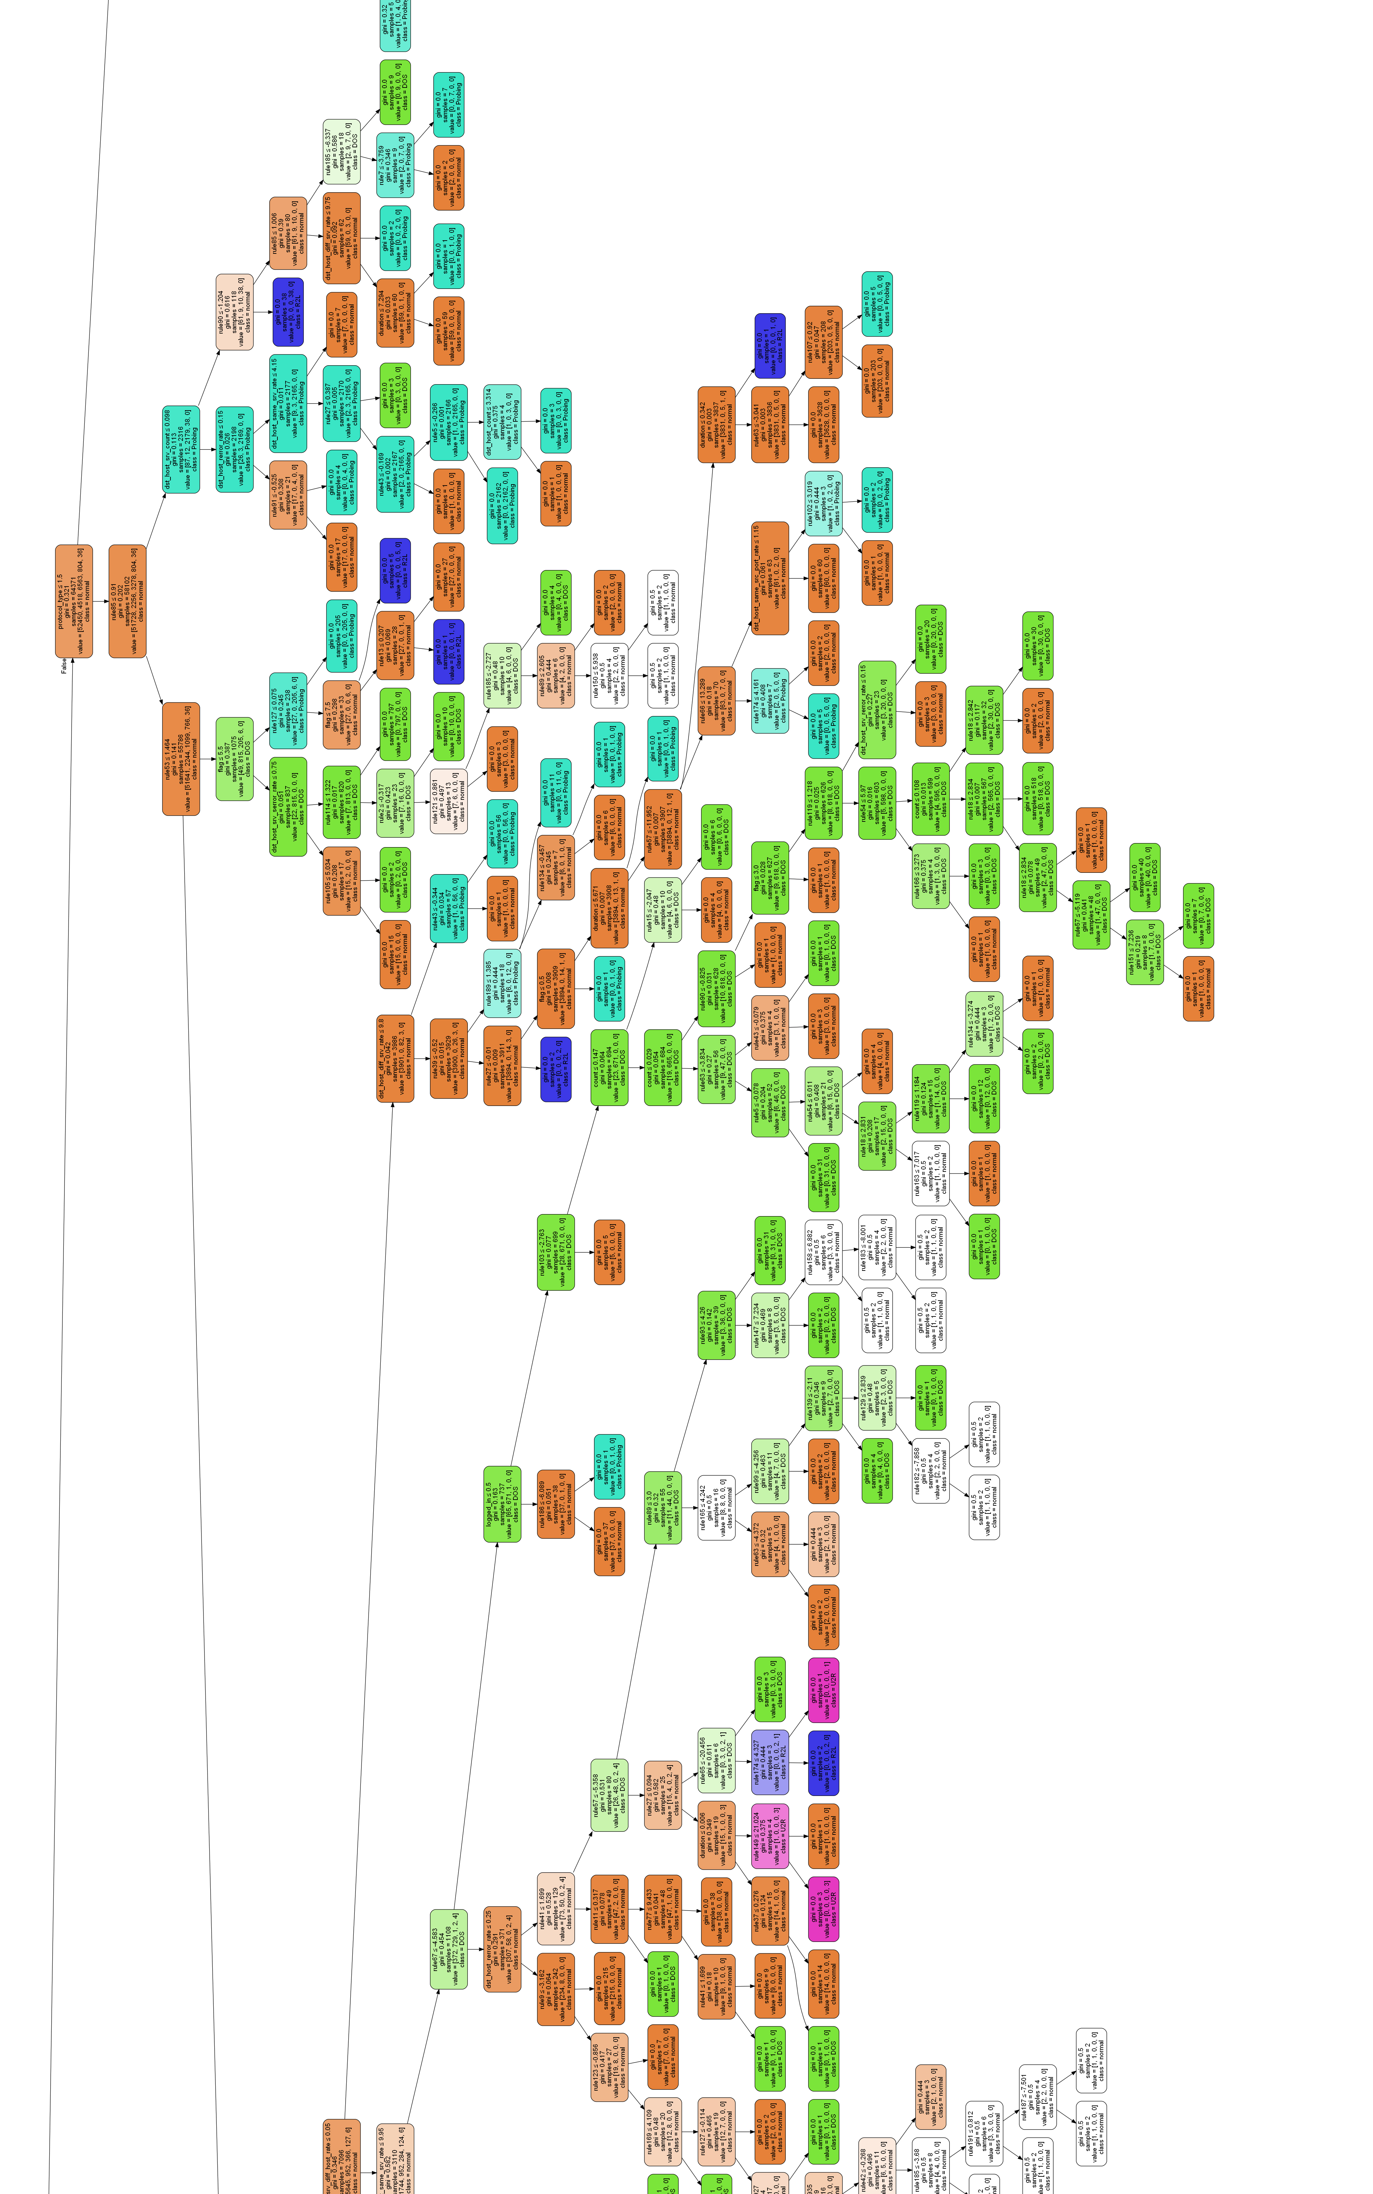
Appendix D. (b) ANFIS-enhanced CART tree. The rules are fuzzy rules by ANFIS.

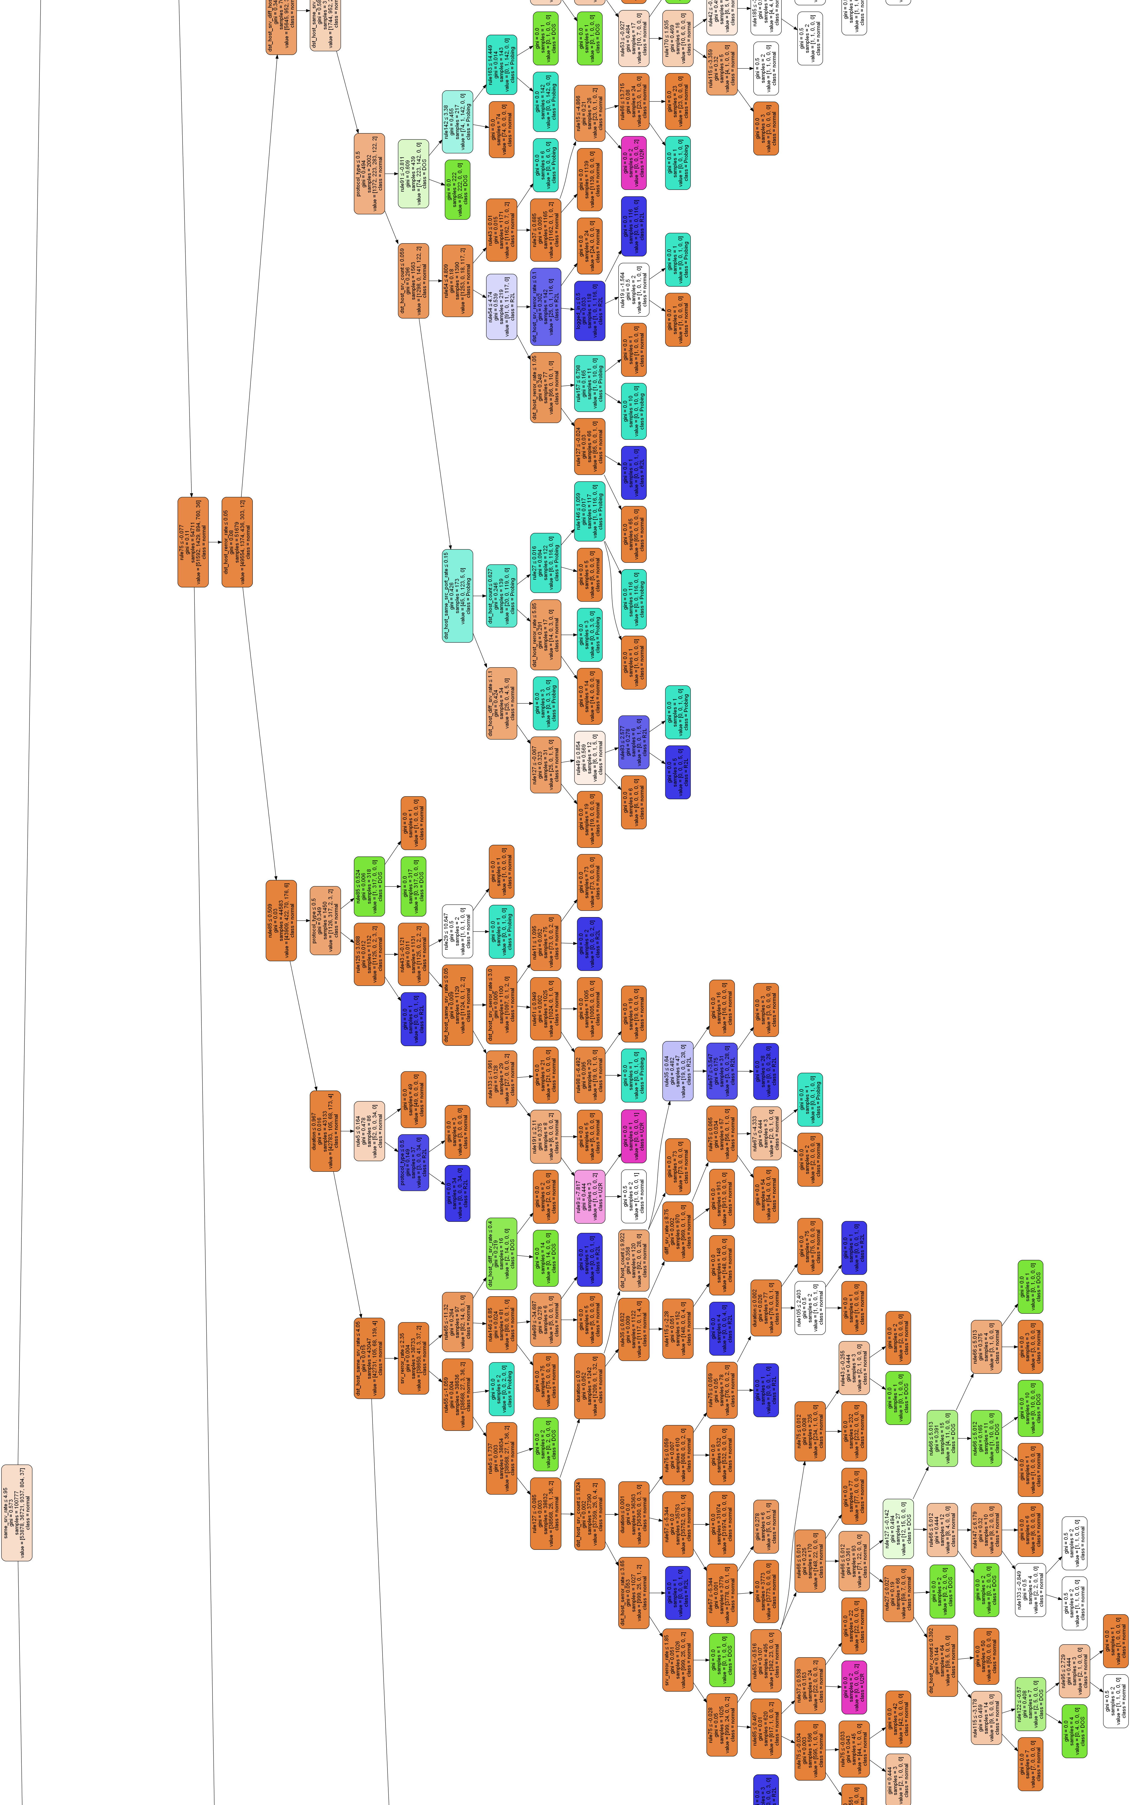
Appendix D. (c) ANFIS-enhanced CART tree. The rules are fuzzy rules by ANFIS.

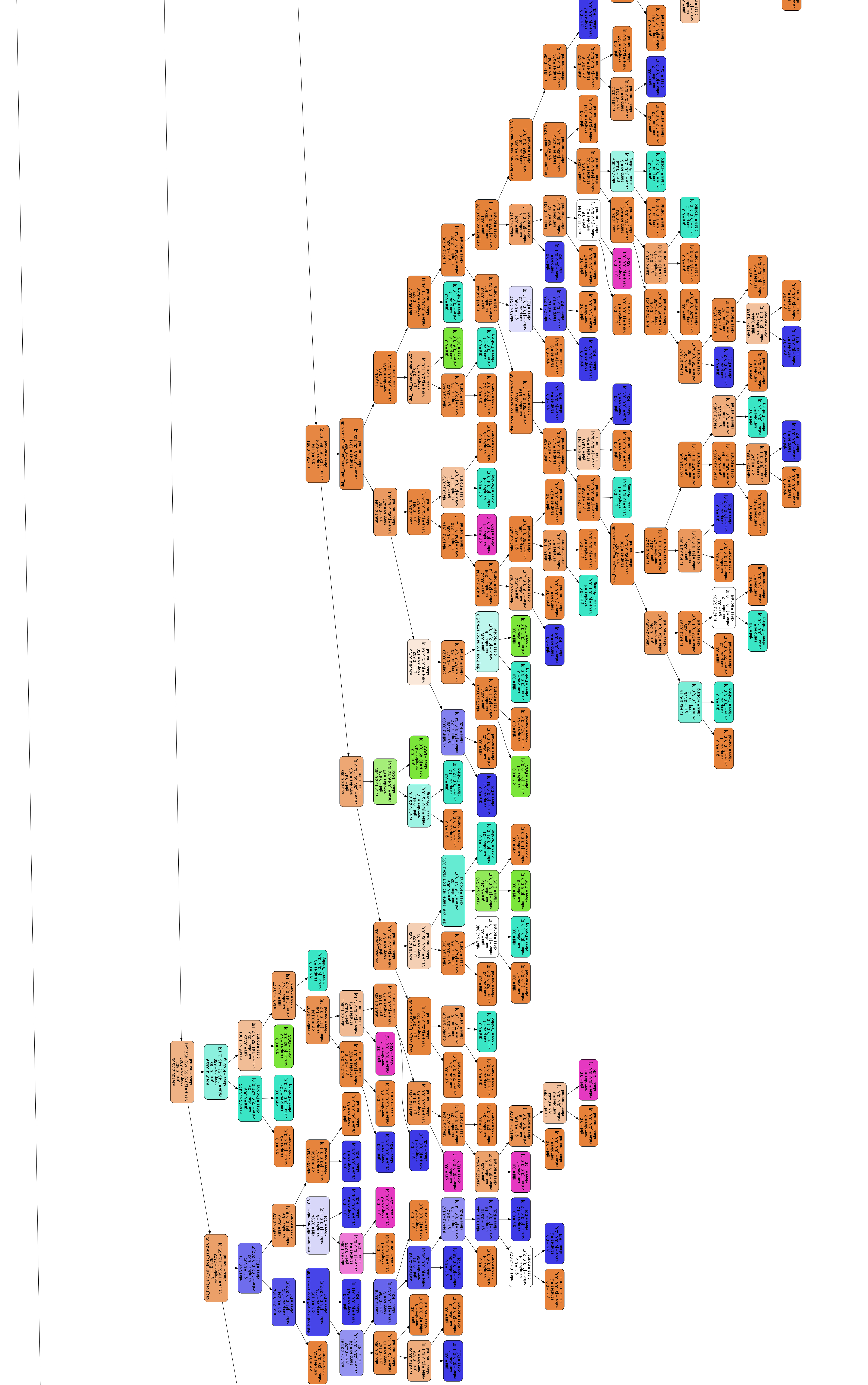
Appendix D. (d) ANFIS-enhanced CART tree. The rules are fuzzy rules by ANFIS.
Appendix D. (e) ANFIS-enhanced CART tree. The rules are fuzzy rules by ANFIS.

