Supplementary Information
Supplementary Figure 1
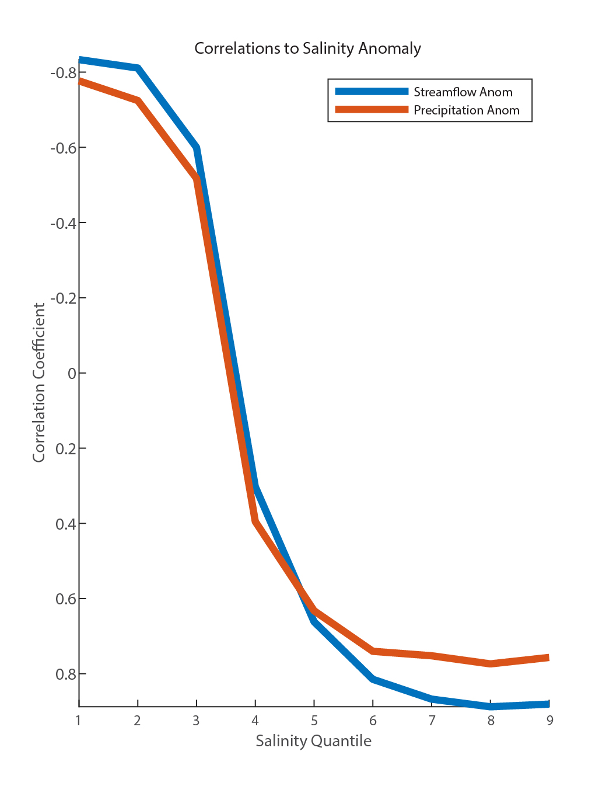
Correlation coefficients of streamflow anomaly (blue) and precipitation (orange) to each quantile of JFM salinity anomaly. Note the strongest correlations in both cases is to the freshest quantile of salinity, and the weakest to the saltiest.

Supplementary Figure 2
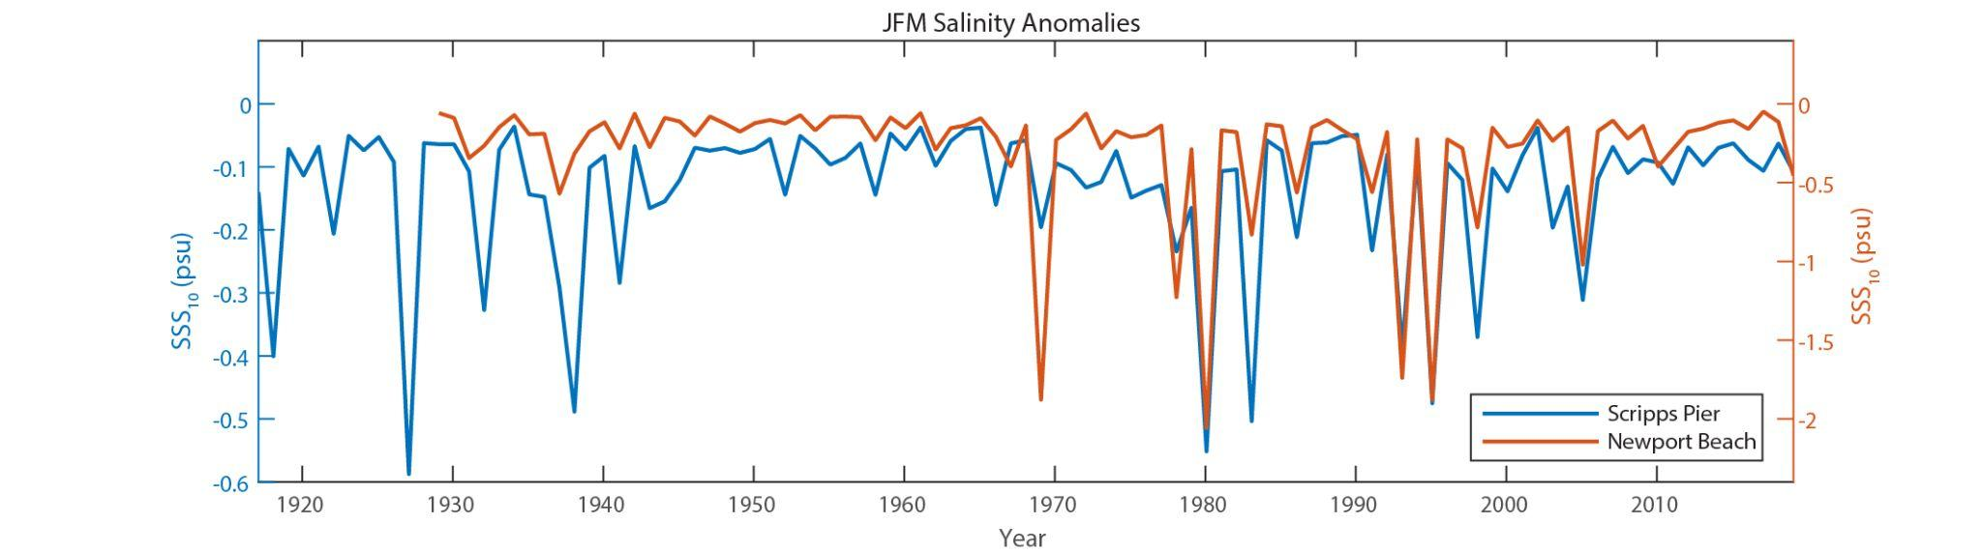
The JFM salinity anomaly from Newport Beach pier shows a similar pattern to that seen at Scripps Pier. This data validates the Scripps Pier record findings, and suggests that the La Jolla record likely reflects precipitation levels over a broader southern California coastal region.

Supplementary Figure 3
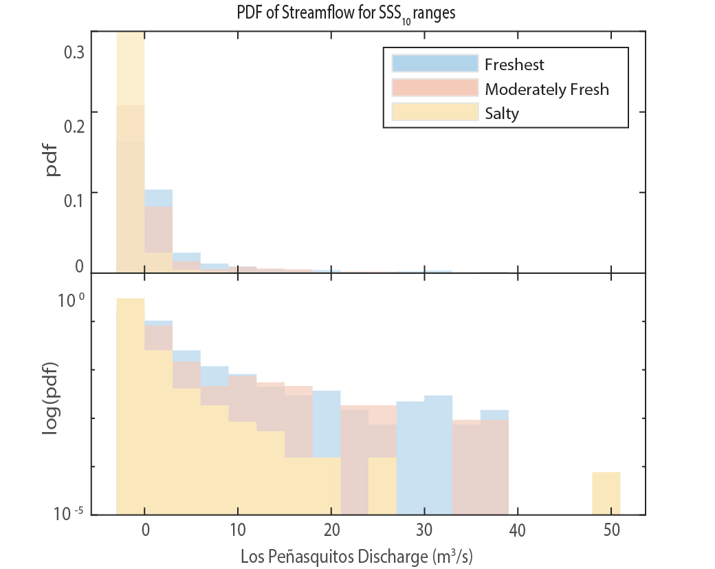
Probability density function histogram of JFM Los Peñasquitos streamflow daily anomaly divided up by fresh years (blue; SSS₁₀ < -0.35 psu; n = 5 years/ 451 days), moderately fresh years (pink; -0.35 psu < SSS₁₀ < -0.2 psu; n = 4 yrs/ 360 days), and salty years (yellow; SSS₁₀ > -0.2 psu; n = 48 yrs/ 4333 days) between 1965 to 2021. The binning algorithm is Sturges’ rule. Evenly scaled y-axis on top and log scaled y-axis on bottom illustrate overall trend and the extreme tail respectively.

