Gas-phase fragmentation of single atom incorporated Co₅MS₈(PEt₃)₆⁺ (M=Mn, Fe, Co, Ni) nanoclusters

Habib Gholipour-Ranjbar^{a#}, Deepika^{b#}, Puru Jena^{b*}, and Julia Laskin^{a*}
ªDepartment of Chemistry, Purdue University, West Lafayette, IN, 47906 USA
^{b}Department of Physics, Virginia Commonwealth University, Richmond, VA, 23284, US

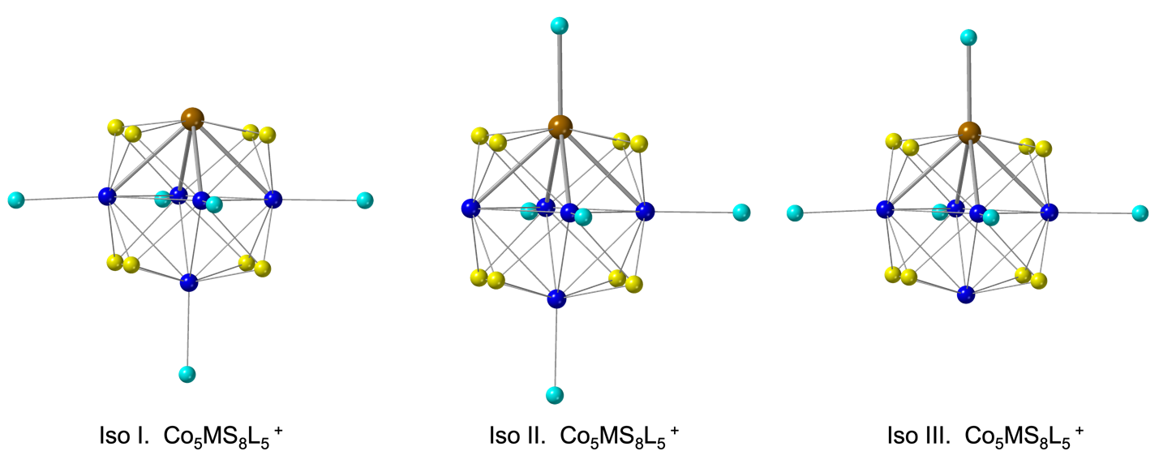

Table S1. The optimized ground state energy of the possible isomers to determine the preferred detachment of the first ligand from the Co₅MS₈L₅⁺ (M= Fe, Mn, and Ni) cluster. All the energy values are in eV units.
Cluster | Iso. I | Iso. II | Iso. III
Co₅FeS₈L₅⁺ | -656.23475 | -655.91349 | -655.64593
Co₅MnS₈L₅⁺ | -657.39058 | -657.23622 | -657.04396
Co₅NiS₈L₅⁺ | -652.92398 | -652.76503 | -652.75992
Figure S1. The optimized ground state geometry of the possible isomers to determine the preferred detachment of the first ligand in the formation of Co₅MS₈L₅⁺ (M = Fe, Mn, or Ni) cluster. The energy values of the isomers are provided in Table S1. The organic part of the ligand (P-Et3) is not shown for the clarity. Co, S, P, M atoms are represnted by navy-blue, yellow, cyan, and brown colors, respectively.

