Supporting information
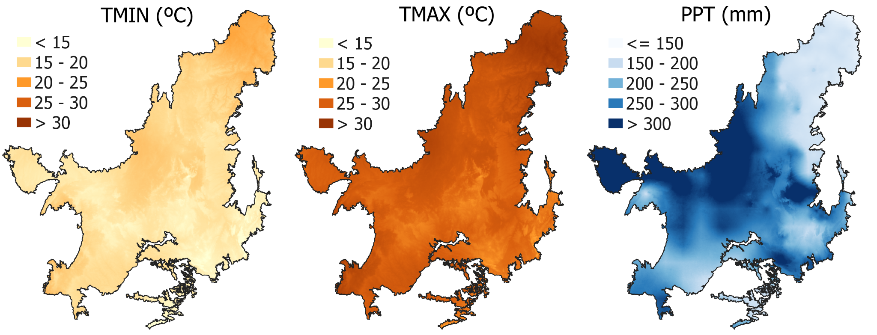
S1 Fig. Maps of climate variables in the Cerrado, obtained from the Terraclimate database, and used to model carbon stocks in the pasture areas of the Biome. (TMIN - Minimum temperature; TMAX - Maximum temperature; PPT - Precipitation; For illustration, we used data from December/2017).

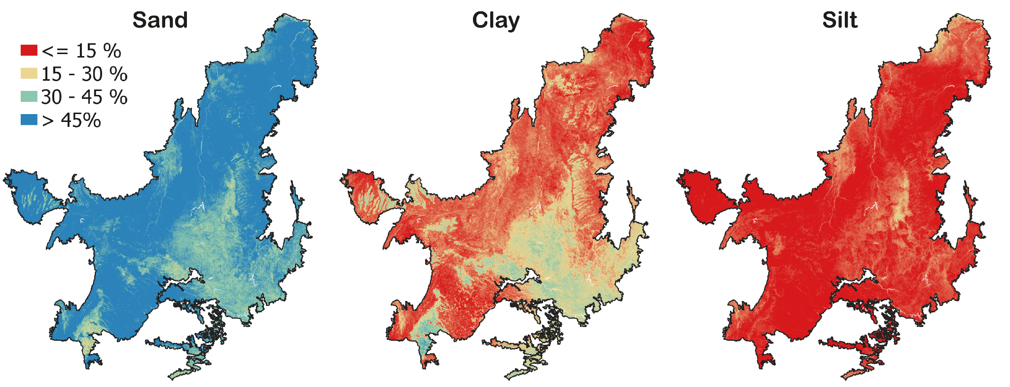
S2 Fig. Soil texture maps in the Cerrado, obtained from the SoilGrids database and used to model carbon stocks in the pasture areas of the Biome. Density and acidity (Ph) maps were obtained on the same basis.
S1 Table. Location and soil characteristics in the 0-20 cm layer of the sites used in the calibration and validation process of the century model to represent pasture areas in the Cerrado.
State | Municipalities | Pasture age  (years) | Carbon  MgC/ha⁻¹ | Sand  (%) | Silt  (%) | Clay  (%) | Density  (g/cm³) | p.H | Annual precipitation  (mm)
MT | Barra do Garças | 27 | 33.45 | 59.50 | 19.00 | 21.50 | 1.4 | 6.0 | 1242.38
GO | Bom Jardim | 28 | 20.29 | 85.25 | 10.00 | 4.75 | 1.7 | 5.6 | 1242.38
TO | Campos Lindos | 11 | 21.07 | 87.38 | 2.60 | 10.03 | 1.5 | 5.6 | 1501.25
TO | Cariri do Tocantins | 27 | 32.33 | 59.98 | 8.13 | 31.90 | 1.2 | 5.0 | 1191.67
MA | Estreito | 11 | 46.19 | 38.00 | 14.25 | 47.75 | 1.5 | 5.8 | 1394.34
GO | Goiás | 19 | 38.71 | 61.50 | 21.25 | 17.25 | 1.4 | 5.9 | 1452.23
MA | Pastos Bons | 20 | 45.39 | 44.75 | 10.25 | 45.00 | 1.5 | 5.7 | 1018.31
TO | Rio dos Bois | 11 | 25.28 | 78.13 | 4.63 | 17.25 | 1.3 | 4.9 | 1387.41
MA | Sucupira do Riachão | 23 | 40.50 | 55.50 | 9.50 | 35.00 | 1.3 | 4.7 | 1018.31
GO | Água Fria de Goiás | >35 | 51.31 | 7.50 | 37.75 | 54.75 |  |  | 1132
MA | Balsas | >35 | 27.67 | 77.50 | 2.75 | 19.75 |  |  | 1242
MT | Barra do Garças | >35 | 31.64 | 67.00 | 11.00 | 22.00 |  |  | 968
BA | Barreiras | >35 | 29.31 | 80.75 | 7.00 | 12.25 |  |  | 863
PI | Bom Jesus Piauí | >35 | 23.65 | 63.50 | 22.00 | 14.50 |  |  | 830
GO | Campinorte | >35 | 30.70 | 60.00 | 11.50 | 28.50 |  |  | 1398
GO | Cocalzinho | >35 | 41.01 | 54.00 | 16.00 | 30.0 |  |  | 1398
TO | Conceição | >35 | 46.14 | 20.50 | 35.00 | 44.50 |  |  | 1333
GO | Cristalina | >35 | 48.86 | 11.50 | 22.50 | 66.00 |  |  | 1148
GO | Edéia | >35 | 37.33 | 54.25 | 15.75 | 30.00 |  |  | 1325
GO | Flores de Goiás | >35 | 40.92 | 25.25 | 25.50 | 49.25 |  |  | 1145
GO | Hidrolândia | >35 | 56.03 | 44.50 | 19.00 | 36.50 |  |  | 1325
GO | Monte Alegre | >35 | 38.22 | 62.50 | 17.25 | 20.25 |  |  | 1317
GO | Montes Claros | >35 | 32.71 | 71.75 | 12.75 | 15.50 |  |  | 1242
GO | Nova Crixás | >35 | 27.68 | 62.50 | 9.00 | 28.50 |  |  | 1452
TO | Nova Olinda | >35 | 25.93 | 56.50 | 27.25 | 16.25 |  |  | 1452
GO | Mundo Novo | >35 | 21.68 | 68.25 | 11.25 | 20.50 |  |  | 1501
GO | Pirenópolis | >35 | 38.80 | 49.75 | 16.75 | 33.50 |  |  | 1398
GO | Rianápolis | >35 | 31.95 | 60.50 | 17.75 | 21.75 |  |  | 1398
GO | Rio Verde | >35 | 35.24 | 27.50 | 22.25 | 50.25 |  |  | 1303
BA | São Desidério | >35 | 22.61 | 70.75 | 4.50 | 24.75 |  |  | 863

S2 Table. Modified parameters in Century to simulate conventional pasture management in the Cerrado biome
 | Default of model | Pasture conventional management
Crop.100 file
PRDX(1) : potential aboveground monthly production for crops (g C m⁻²) | 0,3 | 0.3
PPDF(1) : optimum temperature for production for parameterization | 30 | 22
CFRTCN(1): maximum fraction of C allocated to roots under maximum nutrient stress | 0.4 | 0.3
CFRTCN(2): minimum fraction of C allocated to roots with no nutrient stress | 0.25 | 0.25
CFRTCW(1): maximum fraction of C allocated to roots under maximum water stress | 0.6 | 0.4
CFRTCW(2): minimum fraction of C allocated to roots with no water stress | 0.2 | 0.1
Tree.100 file
PRDX(1): potential aboveground monthly production for crops (g C m⁻²) | 0.5 | 0.26
Fonte: Silva 2019.

