SUPPLEMENTARY DATA

Cytotoxic flavokawain B inhibits the growth and metastasis of hepatocellular carcinoma through the suppression of UCK2-mediated downregulation of the STAT3/Hif-1α/VEGF signalling pathway

Ibrahim Malami^{1,7}*, Alhasan Muhammad Alhasan², Adamu Ahmed Adamu³, Muhammad Bashir Bello^{4,7}, Aliyu Muhammad⁵, Mustapha Umar Imam^{6,7}

¹Department of Pharmacognosy and Ethnopharmacy, Faculty of Pharmaceutical Sciences, Usmanu Danfodiyo University Sokoto, Nigeria.
²Department of Pharmaceutical and Medicinal Chemistry, Faculty of Pharmaceutical Sciences, Usmanu Danfodiyo University Sokoto, Nigeria.
³Department of Pharmacology and Therapeutics, College of Health Sciences, Usmanu Danfodiyo University Sokoto, Nigeria.
⁴Department of Veterinary Microbiology, Faculty of Veterinary Medicine, Usmanu Danfodiyo University Sokoto, Nigeria.
⁵Department of Biochemistry, Faculty of Life Sciences, Ahmadu Bello University, Zaria.
⁶Department of Medical Biochemistry, Faculty of Basic Medical Sciences, College of Health Sciences, Usmanu Danfodiyo University Sokoto, Nigeria.
⁷Centre for Advanced Medical Research and Training, Usmanu Danfodiyo University Sokoto, Nigeria.

*corresponding author: ibrahim.malami@udusok.edu.ng; 0000-0001-9271-6927

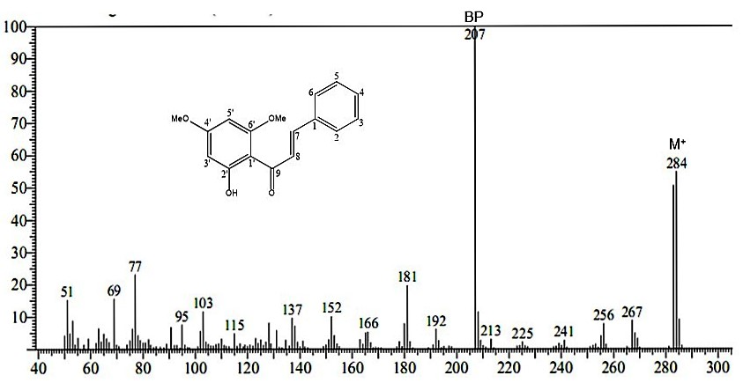
Supplementary Figure 1: DIMS spectrum of FKB

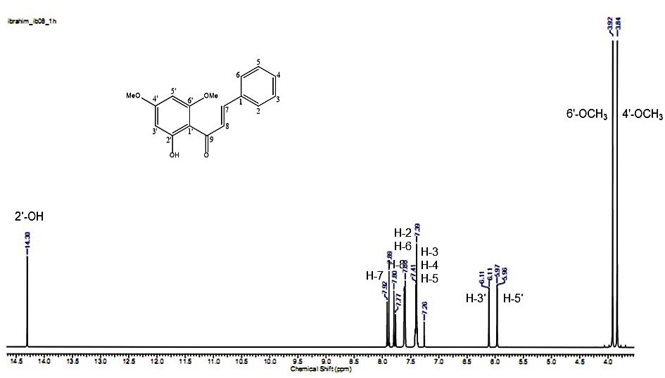
Supplementary Figure 2: Complete ¹H NMR spectrum of FKB

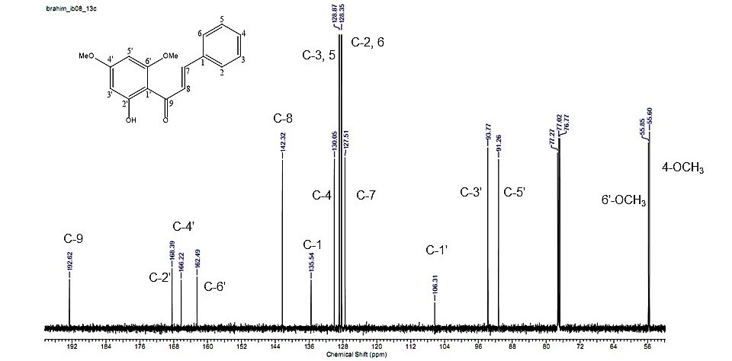
Supplementary Figure 3: Complete ¹³C NMR spectrum of FKB

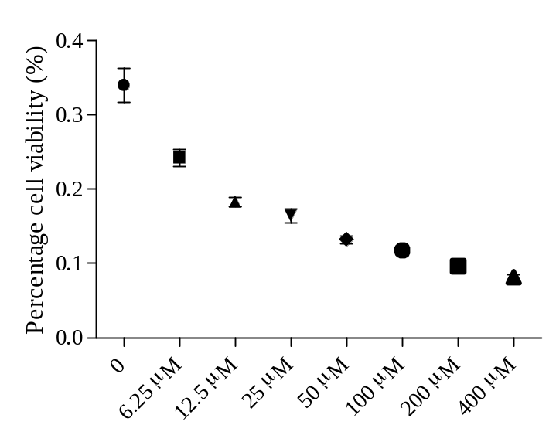
Supplementary Figure 4. A graphical representation of percentage viability of HepG2 cells exposed to 5FU at increasing concentrations. IC₅₀ was extrapolated from the dose-response inhibition curve after 72 h exposure.

Supplementary Table 1. The gene-specific sequences used for PCR amplification.
Gene | Primer | Sequences (5´- 3´) | Annealing Temp. (°C) | Accession number
UCK2 | Forward | CGGCGAGCCCTTCCTTATAG | 60 | NM_012474
UCK2 | Reverse | ATTGTCAAAGGCATCCGGGT | 60 | NM_012474
STAT3 | Forward | ACCAGCAGTATAGCCGCTTC | 60 | NM_001384988
STAT3 | Reverse | GCCACAATCCGGGCAATCT | 60 | NM_001384988
VEGF | Forward | TTGCTGCTCTACCTCCAC | 60 | NM_001025366
VEGF | Reverse | AATGCTTTCTCCGCTCTG | 60 | NM_001025366
Hif-1α | Forward | CCTAACGTGTTATCTGTCGC | 55 | NM_181054
Hif-1α | Reverse | GTCAGCTGTGGTAATCCACT | 55 | NM_181054
GAPDH | Forward | GTCTCCTCTGACTTCAACAGC | 55 | NM_001256799
GAPDH | Reverse | ACCACCCTGTTGCTGTAGCCAA | 55 | NM_001256799

