Remanufacturing Perovskite Solar Cells and Modules – a Holistic Case Study

Dmitry Bogachuk*†, Peter van der Windt†, Lukas Wagner, David Martineau, Stephanie Narbey, Anand Verma, Jaekeun Lim, Salma Zouhair, Markus Kohlstädt, Andreas Hinsch, Samuel D. Stranks, Uli Würfel, Stefan Glunz*
† These authors contributed equally to this work
*Corresponding authors

Supporting Information

Supplementary Note 1

Due to the early stages of technological readiness of PSCs, there is no scientific consensus on how (encapsulated) PSMs should look like. The aim of the PV module encapsulation is to impede moisture and oxygen ingress, provide high light transmission (when it is at the front side), a good mechanical adhesion to the substrate and a high resistance to degradation. Ideally, the encapsulation should also allow for easy recycling. Even though polymer-film encapsulation has shown promising results in keeping water and moisture out of PSCs, the technique is largely unproven on larger scales, so only encapsulation with a glass back-sheet is considered in our study.²⁴ Although ethylene-vinyl acetate (EVA) is traditionally used as encapsulant in PV modules, a byproduct of EVA decomposition is acetic acid, which degrades the perovskite absorber layer.^{25–27} The most notable alternatives, with good moisture protection, are ionomers and thermoplastic olefins (TPO), of which the latter offer better adhesion and superior transmittance.^{26,28} Additionally, contrary to EVA which forms adhesion via cross-linking bonds, TPOs contain thermo-reversible bonds between the encapsulant and glass which can be broken upon thermal treatment. In theory, modules equipped with TPO encapsulants should therefore also be easier to remanufacture than modules with EVA.²⁸ In addition to the TPO, an edge seal is required to retard moisture ingress from the sides, for which a polyisobutylene (PIB)-based edge seal with desiccant is used in this study. Alternative edge seals exist, but PIB-based edge seals have been traditionally used in other PV technologies and provide superior moisture and oxygen ingress protection.^{29–32}

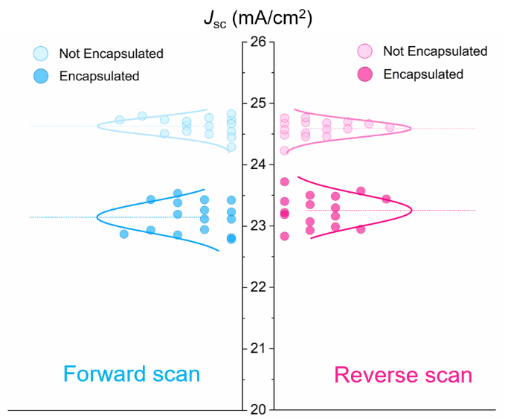
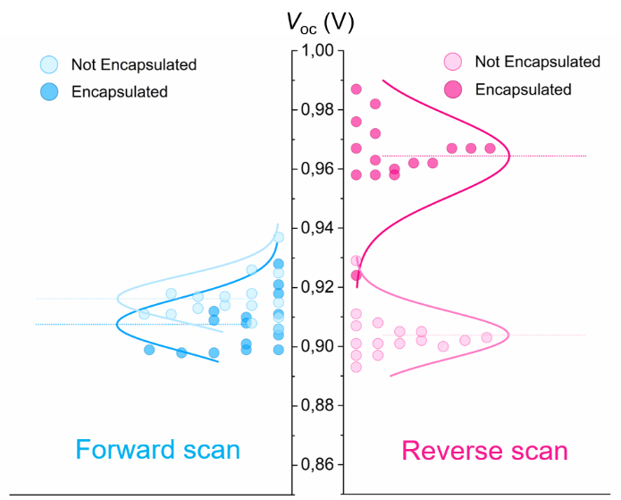
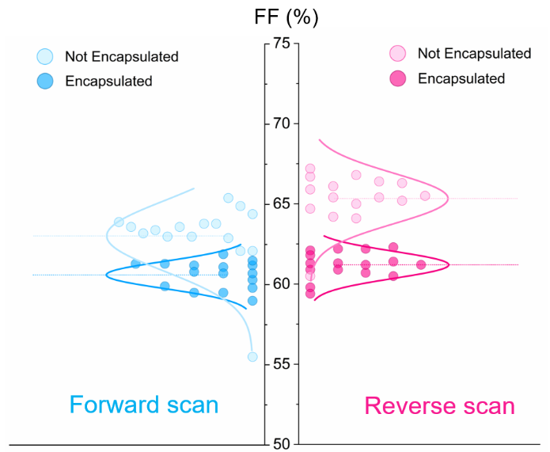
Figure S 1: Open-circuit voltage (V_{oc}), Short-circuit current (J_{sc}) and fill factor (FF) of manufactured devices before and after encapsulation (i.e. same devices), obtained from forward and reverse J-V sweeps

Life Cycle Assessment

In order to accurately report the environmental impacts of perovskite solar module (PSM) production, recycling and remanufacturing, an ex-ante (predictive) life cycle assessment (LCA) is conducted in this paper. This LCA is based on the PSM production process as done at Solaronix SA (described above). As this production process is currently only done at small scales (10x10 cm² modules), however, the material and energy flows used for the LCA presented here are based on a conceptual model of industrial production of PSMs, predominantly comprising data on machinery used for other PV production systems (e.g. CdTe and c-Si). Correspondingly, the presented data rely on some assumptions about energy and material use, explained in section 1.4. Still, this is assumed to more accurately depict environmental impacts of PSM recycling and remanufacturing in a real-life setting, as sufficient waste streams for viable recycling and remanufacturing practices can only be achieved upon industrial production. Further, PSM LCAs based on lab-scale production are often based on the linear extrapolation of energy and material flows of lab-scale processes (e.g. spin coating), which are not viable for industrial production and have high energy and material losses. ^{1,2}

Scope definition

The life cycle assessment conducted in this paper follows the LCA guidelines provided by the IEA PVPS.³ It is a 3rd order LCA, where all processing and transport during the life cycle (from raw material extraction to EoL) is considered, including capital equipment and infrastructure.⁴ A schematic of the reference system and its boundaries can be seen in the Fig. S2.
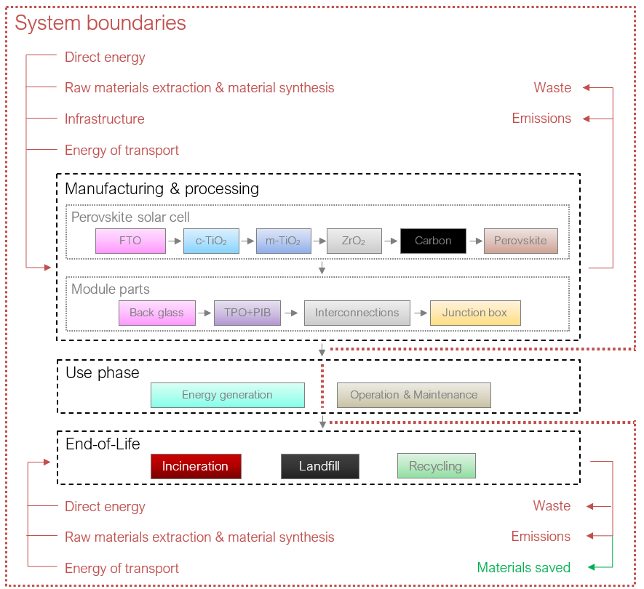
Figure S 2: Defined boundaries of system considered in the life cycle assessment (LCA)

For the capital goods used in the production of PSMs in this study, data from other technologies (e.g. inventory data for a c-Si plant) are used, as no data exist for PSM production. This means that data on the production of specific machinery (these are not the same for different PV systems) may not be entirely accurate, but such inputs are generally found to be negligible in PV LCAs.^{5,6} Transport is considered here as it can contribute significantly to the overall environmental impacts of a system. It may be especially important to differentiate between EoL scenarios, as recycling or remanufacturing facilities are usually less abundant than incineration or landfill locations, and the extra distance travelled is often found to be one of the critical parameters for the environmental viability of recycling.^{7,8}
For the use phase, only the generated energy (adjusted for solar irradiance when compared) is considered, as generally no significant impacts from operation and maintenance are observed. ^{7,9–11} For PSMs specifically, there are concerns of (toxic) lead iodide (PbI₂) leakage during the use phase, but possible impacts have been found to not show up in LCAs, even when it is assumed that all PbI₂ leaks into the soil (or water) during the lifetime.¹² Balance of System (BoS), e.g. inverters, cabling and mounting (in this work: slanted-mount) systems are also included in this study, as they often have a significant contribution to the overall environmental impacts of PV systems.³ To stress the effects of PSM recycling, however, the environmental impact comparison of PSMs with and without recycling will also be shown without the impacts of BoS. EoL of BoS parts were not considered, as these are removed from the module before EoL treatment of PV modules and have separate waste streams¹³ that are considered outside of scope for PSM EoL.

Functional unit

As the future lifetime of PSMs (and how recycling would affect this) is currently uncertain, the results here are mainly reported per kilowatt peak (kWp) in the main text. Still, for comparison with other technologies, 1 kWh should ideally be used as the functional unit.³ Correspondingly, the impacts are also reported per production of 1 kWh of alternating current (AC) electricity with different estimates for the lifetimes and efficiencies of recycled, remanufactured and virgin devices.

Indicators

The environmental profile typically includes a number of different indicators, namely:
- Global warming potential (GWP)
- Ozone depletion potential (ODP)
- Ionizing radiation potential (IRP)
- Ozone formation potential (OFP)
- Fine particulate matter formation potential (PMFP)
- Terrestrial acidification potential (TAP)
- Freshwater eutrophication potential (FEP)
- Marine eutrophication potential (MEP)
- Terrestrial ecotoxicity potential (TEP)
- Marine ecotoxicity potential (MEP)
- Abiotic depletion potential (ADP)
- Abiotic depletion potential – fossil fuels (ADPF)
- Human toxicity potential, cancer (HTPc)
- Human toxicity potential, non-cancer (HTPnc)
- Freshwater ecotoxicity potential (FETP)

Assumptions

Location and year

The (theoretical) location of this study is Fraunhofer ISE in Freiburg im Breisgau (Germany). Thus, the production of PSMs is assumed to take place in Freiburg im Breisgau. Correspondingly, the background processes (e.g. electricity mix and chemicals produced) are modelled using regional, e.g. Germany or Europe (RER) LCI data, unless the production site is known to be somewhere else. When not available, global market processes were used. Additionally, the solar irradiance of Freiburg im Breisgau (1429.2 kWh/m²/y, based on an optimal tilt¹⁴) was used to calculate the energy yield. The background data used are from the year 2021 (or as recent as possible), as determining the environmental impacts of PSM production with current background processes (instead of a future electricity mix) allows for more accurate comparison to reference PV technologies.

System performance

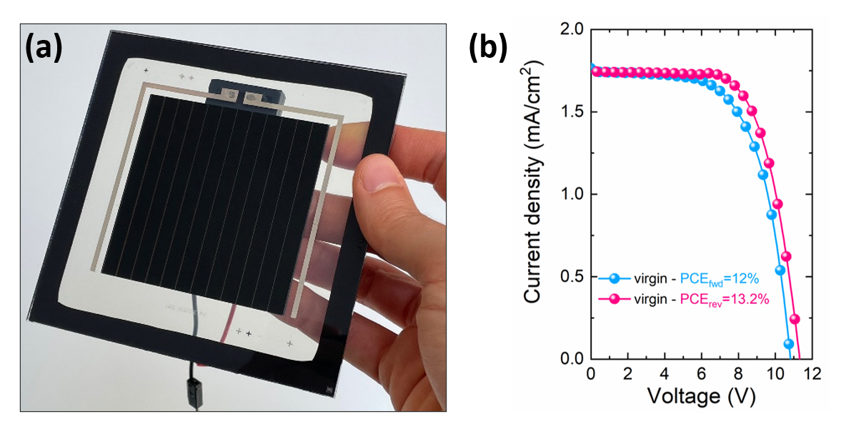
Figure S 3: (a) Photograph of a perovskite solar module encapsulated with TPO and PIB, having a JV-characteristics depicted in (b) with a PCE of 13.2% and 12% in reverse and forward scans respectively.

The PCE used for virgin (non-remanufactured) CPSMs produced by Solaronix SA in this study is 13.2%, as obtained from the JV-measurements (Fig. S14). As the production system is based on a conceptual model of industrial PSM production, the lifetime should reflect that of a product viable for market introduction. Here, we estimate a lifetime of 15 years for the reference module, which is thought to be a lifetime at which PSM power generation can be cost-competitive with other PV technologies.^{15–17} The PSM is considered to be monolithically interconnected (through laser scribing) with an active area or Geometric Fill Factor (GFF) of 88.7% (leading to a total module efficiency of 11.71%). Although the CPSM manufactured in this work (Fig. S3) have a GFF of 93.4%, we expect this value to be lower with an increase in device area. Therefore the GFF used in the LCA is based on the assumption that industrially produced modules will have a cell width of 4.9 mm (for n-i-p architectures with 10 Ω sheet resistance), which is found to achieve a good balance between geometrical losses (dead area) and resistive losses (series resistance goes up when the cell area is increased).^{18–21} Additionally, a P2 scribe is with a width of 150 µm is considered, which should give enough safety margin to avoid too narrow scribes (leading to increased series resistance) and avoid high series resistances due to incomplete scribing.²² Resistive losses from the P1 and P3 scribe should already be negligible for widths of 10 µm,²² but a conservative estimate of 25 µm is used here, with safe areas (areas introduced between the p1, p2 and p3 scribes to reduce the risk of misalignment) of 50 µm each, giving a total dead area width of 300 µm. Including an edge seal width of 1.2 cm on each side (this provides moisture protection compatible with 25-year module lifetimes²³) and a module size of 1.2x0.6m, this gives a GFF of 88.7%.
As PSMs are not commercially produced yet, Degradation Rate (DR) and Performance Ratio (PR) were obtained from other PV systems and background data. The PR is measured as the ratio of average AC output compared to the rated output of a solar panel and is comprised of many different losses. In this research, a PR of 0.846 is assumed, with the individual losses (and assumptions) from Table S1. The DR is assumed to be such that the efficiency of the PSMs assessed here decline linearly to 80% of their rated power (DC, not including losses) at the end of its lifetime, which is the typical guarantee offered by manufacturers of commercial PV systems.^{24,25} It is sometimes found that degradation does not happen linearly^{26,27} and more empirical research would be needed for PSM systems specifically. Still, an approximately linear decline in efficiency is deemed an accurate predictor,²⁸ because most of the degradation tends to come from short circuit current (J_{sc}) losses from encapsulant discoloration, which follows a linear pattern.²⁹ Over the whole lifetime (including DR), the PR of the reviewed system here is then 0.7614. This is also assumed for the comparison with CIGS. For c-Si modules, a lifetime PR of 0.85 is assumed, based on its warranty.¹¹ The comparison with c-Si in this report entails c-Si Passivated Emitter and Rear Cells (PERC) specifically, as this technology makes up the bulk of c-Si market share³⁰.

Table S1. Parameters and contribution of the different losses to the total loss and PR.
 |  | Source | Comment
Soiling loss | 4% | ³¹ | Average on rooftops in Germany
Inverter loss | 2% | ^{25,32}
Mismatch and Dc cabling loss | 0.90% | ²⁵
Shading loss from other panels | 0% | ³³ | Typically, no panel shading losses on rooftops.
AC and transformer loss | 2.20% | ²⁵
Availability loss  (maintenance etc.) | 1.00% | ²⁵
Temperature loss | 5% | ^{34,35} | Based on an average temperature coefficient of a-si, CIGS and CdTe thin film and a nominal operating temperature of 45 ºC (STC is 25 ⁰C)
Total | 15.40% |  | PR 0.846

The lifetimes of BoS parts are based on ²⁴, and are considered the same for all PV technologies mentioned in this report (Perovskite and c-Si), irrespective of lifetime of the module. They are 15, 30 and 30 years for inverters, slanted mount (rooftop) installation and cabling, respectively. In order to provide a fair comparison between technologies, the background parameters (e.g. irradiation, BOS lifetimes) of the c-Si impacts shown in this paper have all been corrected to match the parameters of the PSM LCA presented here.

Based on the processes considered within the scope of LCA, the environmental profile of the CPSMs has been constructed in Fig. S3.

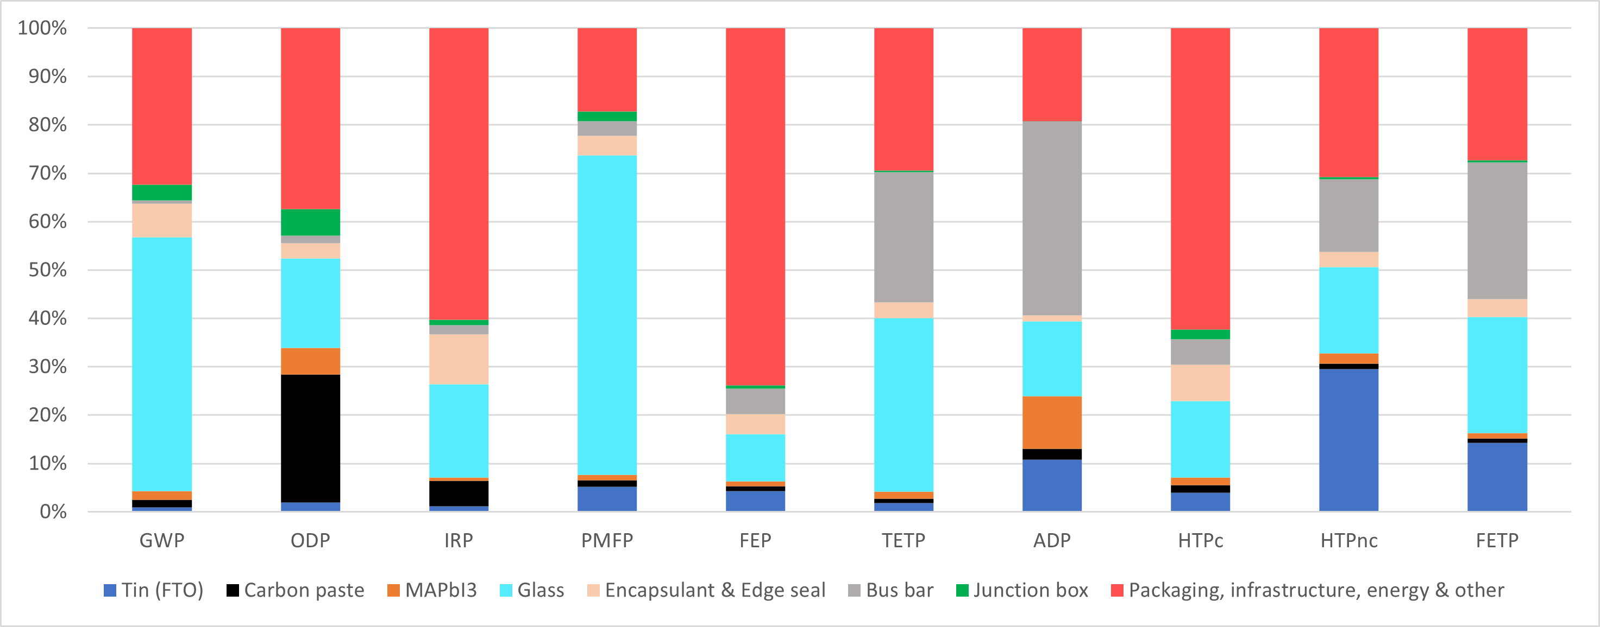
Figure S 4: Environmental profile of CPSMs, showing the contribution of each component to each environmental indicator, discussed earlier.

As mentioned in the main manuscript, here we consider the GWP of the module per kW_{p} as the main environmental indicator. The environmental profile was assessed based on the data from IPCC 2011, gwp 100a, V1.03 databases.

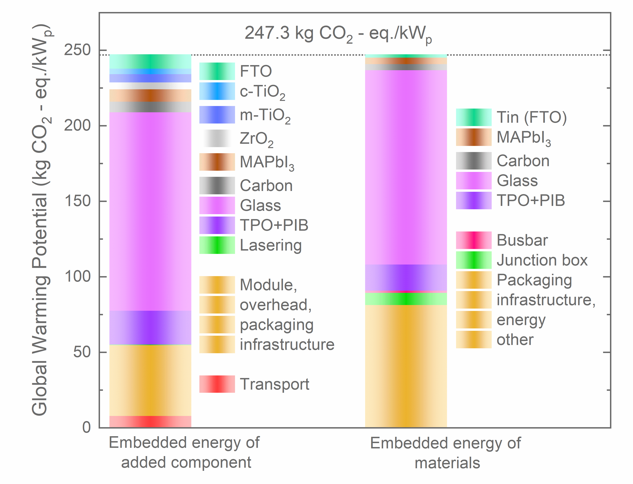
Figure S 5: Distribution of component contribution to the total GWP of a PV module

Fig. S4 demonstrates the distribution of individual contributions of embedded energy of each added module component and materials in the total GWP of the CPSM. Yielding complementary information to Fig. 1c of the main manuscript.
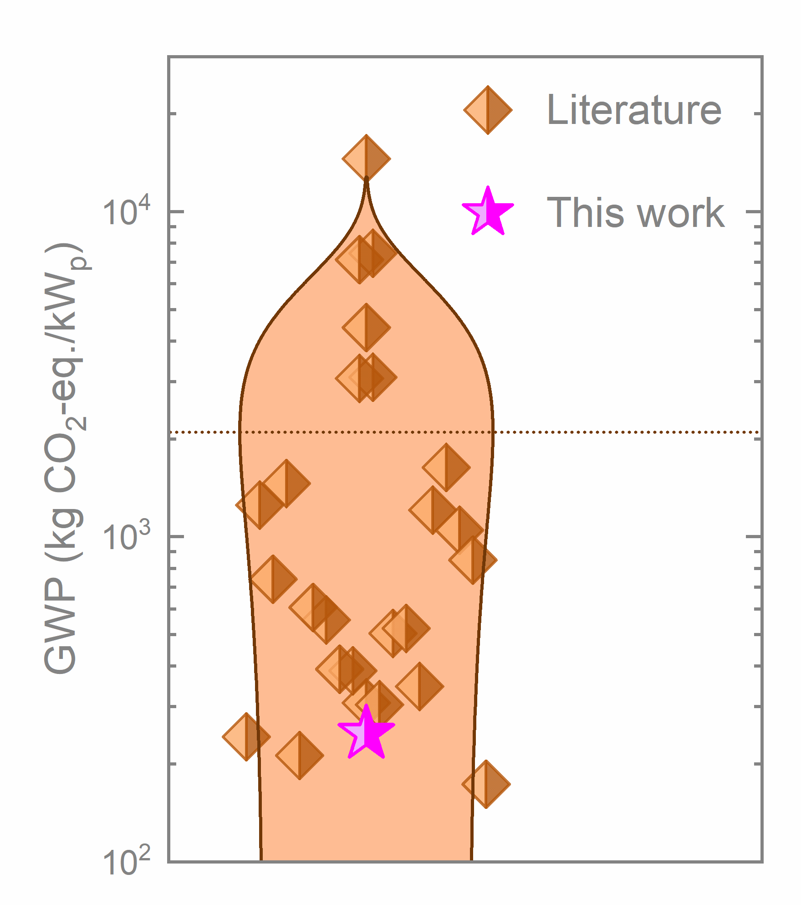
Figure S 6: Calculated GWP based on LCA reports of perovskite PV modules in literature³⁶ in comparison to this work

Energy and Material Assumptions
As mentioned, the LCIs of background processes were mostly obtained from Ecoinvent v3.7. When no specific data on production processes or transport was available, the market activities were selected, which comprise the consumption mix of a certain product or process and include average transport distances. Electricity used for small-scale production processes are assumed to be low voltage, while medium voltage is assumed for larger scale chemical industry and for industrial PSM manufacturing.

Chemicals
For many chemicals, no readily available LCI data exists. These LCIs were constructed with the help of patents and literature review. However, these often describe processes on a very small scale, which typically deviates from how chemicals are industrially produced. As such, small scale syntheses tend to be energy and cost inefficient.^{37–39} Accordingly, the production of these chemicals were theoretically scaled up using assumptions provided by Piccinno et al.³⁸ The most important calculations from this framework are discussed below.
Regarding materials, a 20% decrease in solvent use (when there are no fundamental limitations to using less solvent) are assumed when only data on lab-scale production is available. To estimate the energy consumption per kg of chemicals produced, a series of equations is used. Typically, for these equations, different parameters (such as diameter and thermal conductivity of reactors) are required. Estimates of these parameters are provided in ³⁸, and depend on the size of the reactor. For processes with no specific data availability on such parameters, a 1000 L reactor is assumed in this study based on their recommendations.
The energy to heat reactions is calculated based on the energy to reach the reaction temperature (Q_{heat}), energy to compensate for eventual heat losses (Q_{loss}), and the heating efficiency (η_{heat}). Q_{heat} is calculated as follows:
$$\begin{aligned}Q_{heat}=C_{p}*m_{mix}*\left(T_{r}-T_{0}\right)\#\left(1\right)\end{aligned}$$
with C_{p} as the specific heat capacity (J/kg*K), m_{mix} the mass of the mixture, and T_{r} and T₀ as the reaction temperature and the ambient temperature (20 ºC) respectively. For Q_{loss} the following equation is used:
$$\begin{aligned}Q_{loss}=A*\frac{k_{a}}{s}*\left(T_{r}-T_{out}\right)*t\#\left(2\right)\end{aligned}$$
with A as the surface area of the reactor, k_{a} the thermal conductivity of the insulation material, s the thickness of insulation and t the reaction time. All these data are dependent on the size of the reactor used for the reaction, but unless otherwise mentioned, a 1000 L reactor is used with A 5.899 m², k_{a} 0.042 W/m*K and s 0.075 m (rate of heat loss per kelvin of 3.303 mW/K/L) . The default η_{heat} is 75%, and the formula to calculate the total heating energy is then:
$$\begin{aligned}Q_{react}=\frac{Q_{heat}+Q_{loss}}{η_{heat}}\#\left(3\right)\end{aligned}$$
Additionally, if certain solvents or chemicals are known to evaporate in the reaction, the enthalpy of evaporation (∆H_{vap}) is also added (divided by η_{heat}).
Drying is typically used to vaporise the remainder of wet fraction that has not been removed in the previous steps and is often necessary to purify products. It is similar to the heating step, but often takes place in an oven instead of a reactor. The energy needed is calculated as follows:
$\begin{aligned}Q_{dry}=\frac{C_{p, liq}*m_{liq}*\left(T_{boil}-T_{0}\right)+∆H_{vap}*m_{vap}}{η_{dry}}\#\left(4\right)\end{aligned}$
with C, m and ∆H_{vap} denoting the specific heat capacity, mass and the enthalpy of evaporation of the liquids to be evaporated respectively. η_{dry} can vary a lot but is assumed to be 80% (including heat recovery) in the chemical industry.
The energy for distillation is difficult to estimate, and may vary a lot depending on the specific reaction and solvents used,³⁹ so for distillation steps a default 1.53 kg of steam per kg is assumed, based on an average of empirical values.⁴⁰
Many reactions are stirred (or homogenised) as well. To estimate the stirring energy, the following equation is used: $$\begin{aligned}E_{stir}\left(J\right)=\frac{N_{p}*ρ_{mix}*N^{3}*d^{5}*t}{η_{stir}}\#\left(5\right)\end{aligned}$$
with N_{p} the type of stirrer (dimensionless, specific to the type of impeller), $ρ_{mix}$ the density to the reaction mixture (often estimated), N the rotational velocity of stirring and d the diameter. In the default (1000L) reaction, N_{p}, N and d are assumed to be 0.79 (axial flow), 1.1417 L/s and 0.373 m respectively.
For filtration and centrifugation, it is mentioned that the energy use can vary widely (from 1 to 10 Wh per kg of dry material).³⁸ As these energy requirements are sufficiently low and often insignificant compared to the heating energy, the upper value of 10 Wh per dry material is used in this study.
Lastly, reaction mixtures are often transferred (pumped) between different reactors, which is typically done through pipes. Piccinno et al. provide calculations to calculate the exact energy requirements for this,³⁸ but these are deemed too extensive given the lack of exact data on pumping and the small contribution of pumping energy to the total. As such, a default energy of 55 J/kg is used for pumping, assuming that all liquid mass is transferred once throughout its reaction (if no specific data is known) based on.⁴¹
Vacuum drying is not included in the framework presented by Piccinno et al.,³⁸ as the energy is typically difficult to quantify and case specific.⁴² Here, the power use from vacuum drying is approximated using the following equations (based on rotary piston vacuum pumps, which is often the vacuum pump of choice in the chemical industry:⁴³
$$\begin{aligned}P (kW)=4.242*SF^{1.088} \#\left(6\right)\end{aligned}$$
where SF denotes the size factor of the vacuum pump, calculated as follows:
$$\begin{aligned}P \left(kW\right)=\frac{2.2*ṁ}{p}\#(7)\end{aligned}$$
with ṁ as the mass flow rate (kg/h) of the gas to be evacuated and p as the operating pressure (mmHg).^{41,44} A standard leak rate (air back into the vacuum chamber) of 10⁻⁶ Pa/m³/s is assumed.⁴⁵ This calculation only holds for low vacuum (>1 mbar), however. For higher vacuum, the energy requirements are based on the nominal power of a middle-sized vacuum pump.⁴⁵ Cooling and freezing are also not included in the framework by Piccinno et al.³⁸ Cooling and freezing energy are therefore calculated based on the temperature difference needed and the specific heat capacity (J/kg/K) of the reaction mix, with a Coefficient Of Performance (COP) of 1.43 and 2.28 for cooling and freezing respectively.⁴⁶
Typically, reaction mixtures are filtered before a final (vacuum) drying step. The leftover moisture content (to calculate the drying energy with) in these reaction mixtures is assumed to be 25%, based on data of an industrial chemical filter press.
When no information on the synthesis of specific chemicals was available, the average energy use per kg product of a big chemical production site (Gendorf) are used based on⁴⁷ (2.76 MJ/kg, 2.06 MJ/kg and 0.24 MJ/kg for natural gas, electricity and steam respectively).⁴⁸
Reaction yields were obtained from literature where possible, and assumed to be 95% when no data is available, based on Ecoinvent standards.⁴⁹ Fugitive emissions (release of gases during reactions) are difficult to quantify and their amount may vary, but are typically low.^{50–52} As a conservative estimate (when no process data is available), 0.2% fugitive emissions are assumed for any chemical that is heated above its evaporation temperature, while the remainder of solid and liquid waste is assumed to go to water, based on ^{47,53}. Hazardous substances (according to the list by the Environmental Protection Agency, EPA⁵⁴ or substances that may be contaminated are assumed to go to hazardous waste incineration. Gaseous by-products are usually scrubbed off (and sometimes recovered) in chemical reactions,^{55–57} so these were modelled as such (taking into account the extra inputs for scrubbing).
Solvents used in the production of chemicals are also considered to be incinerated, as no data specific product data is available and the energy requirements for solvent recovery are product specific and can vary widely.^{38,39} As the materials used (and the faith of solvents) in PSC production are not estimated to have very large relative environmental impacts based on previous LCAs^{58–60}, hazardous waste incineration is used as a conservative estimate.³⁸
Lastly, specialty chemicals (e.g. PbI₂ & MAI) are assumed to be produced in relatively large quantities (at least per kg, as opposed to per gram or less, which is sometimes assumed, e.g. in ⁶¹) and then stored, as this is generally done and more economical for chemical manufacturers.^{37,62,63} Specifically, these special chemicals are considered to be produced using the parameters associated with the smallest reactors in the processes described in the framework by Piccinno et al.³⁸ Compared to the default assumptions (1000L reactor), this entails a higher rotational velocity of stirring (N) of 3.052 L/s, higher heat loss per Kelvin of 7.12 mW/K/L and a lower η_{heat} of 72%. Further assumptions and calculations are described per (type of) precursor below. Additional, specific assumptions can be found in the LCIs per product in the Supplementary Excel Table.
PbI₂ & MAI
The LCIs for PbI₂ in previous literature were found to often not include extra purification steps.^{60,61,64} These studies likely underestimate the impacts of Pb-based precursors, as the purification step (vacuum drying) is found to be necessary for good device performance. Wakamiya et al.⁶⁵ found that even 0.1% water content in PbI₂ samples already reduced the efficiency of their devices from 10% to 5.23%, while other papers have also reported the necessity of Pb_{x} purification to produce efficient PSCs (e.g.^{66–69}).
The identified PbI₂ synthesis routes used in other researches often use a similar principle and are based on precipitation reactions^{66–68,70,71}, which is likely also used industrially (at least by Sigma-Aldrich to produce PbCl₂)⁷². The general principle for these reactions is that two solutions of soluble salts (with water) are mixed and heated (to roughly 100 ºC) to make the product more soluble, after which the solution is cooled down and the desired product precipitates (due to its low solubility). The PbI₂ needs to fully dissolve during this reaction, in order to induce recrystallization and produce good quality PbI₂ crystals.⁶⁶ It is not known which exact precursors chemical manufacturers use to make PbI₂, but the high energy requirements of heating water for these reactions (and subsequent purification) are found to dominate the environmental impacts. Thus, the LCIs of PbI₂ presented here likely serve as a good approximation, even if the precursors used by chemical manufacturers are different.
For the purification of the PbI2, a high vacuum is needed of around 0.27 mbar^{65,67,69}. The energy requirements are based on the nominal power of a middle-sized vacuum pump.⁴⁵
The LCI for PbI₂ here assumes a reaction between lead nitrate and potassium iodide, as this is found to produce high quality crystals (better than when lead oxide is used) [530]. The LCI is based on the synthesis described by Schlessinger⁷⁰ (95% yield based on potassium iodide), which is also roughly used in most perovskite publications^{66,73,74} and is found to deliver perovskite layers with similar quality to pre-bought PbI₂.⁶⁷
For MAI the syntheses reported in the literature generally describe more or less the same synthesis. Roughly, the precursors (a combination of methylamine and hydroiodic acid) are mixed and stirred for 2h at 0 ºC, evaporated at 50 ºC for 1h, then recrystallised using diethyl ether and dried at 60 ºC in a vacuum oven for anywhere between 8 to 24 hours. This general procedure is e.g. reported in ^{75–82}. As such, this procedure (16 hours vacuum as an average of the reported numbers at 1.33 mbar), with a yield of 97%.⁶⁹, is assumed to be used in the production of these chemicals. None of the mentioned papers report how much diethyl ether is used for recrystallisation, so 5 ml per gram product is assumed for MAI^{83–85} based on amounts typically used in the chemical industry.⁸⁶

Carbon Paste
The carbon paste used at ISE is purchased from Solaronix SA (Switzerland). The composition of the carbon paste used is not entirely certain, as it is based on a safety datasheet of the Elcocarb B/SP carbon paste of Solaronix SA, which only lists ingredients with error margins. The carbon black to graphite ratio in the paste is also not mentioned, so a weight ratio of 1:2.6 graphite: carbon black is assumed, as this provides optimal conductivity.⁸⁷ No energy is assumed to make the carbon paste.

Solvent Incineration
Ecoinvent has no specific LCI data available for the incineration (with energy recovery) of different solvents (only one generic “spent solvent” process), even though the energy content of solvents may vary widely. As such, individual solvent incineration processes were created for each of the solvents used in this study (for background and foreground processes). The Ecoinvent process assumes an average energy content of 21.7 MJ/kg lower heating value (LHV).⁸⁸ The individual solvent incineration processes in this study were made by altering the generic solvent using the difference between LHVs of the individual solvent and the LHV of the average solvent. 60% of this difference was then added as (extra) steam output, as in Germany waste facilities are typically located near chemical industry, where steam is supplied to manufacturers right away, with an efficiency of roughly 60%.⁸⁹ For example, for ethanol, with an LHV of 26.7 MJ/kg, this means that ((26.7/21.7)*0.6 =) 3 MJ of steam is additionally supplied.

Encapsulation Materials
Besides the chemicals, LCIs were compiled for the edge seal (PIB) and encapsulant (TPO) materials used in this study. TPO is made of a majority polyproplene (PP) or high molecular weight polyethylene (HMWPE) that are co-extruded with some additives to provide extra strength.^{90–92} For PV encapsulation specifically, it is found that the TPO used is often HMWPE-based.^{93–95} The exact composition of TPO encapsulation materials are uncertain, but spectroscopy showed that the amount of additives is very low, and the vast majority of the material consists of polyethylene.⁹⁶ Thus, the LCI used for TPO encapsulant in this study consists of only HMWPE.
The edge seal is mostly PIB-based, but also has a desiccant in it, that binds eventual water that ingresses in from the sides. ⁹⁷ This desiccant can be a molecular or a reactive sieve, of which the latter typically provides better water protection^{23,98,99}. As such, it is here assumed that the PIB-based edge seal uses a reactive sieve, specifically Calcium Oxide (CaO), based on ⁹⁷ and ¹⁰⁰. The CaO content is assumed to be 22.5%, based on averages from ¹⁰⁰ and ¹⁰¹.
The LCI for (fossil) isobutylene in ¹⁰² is used here. Polyisobutylene is created by cooling isobutylene to -100 ºC and using lewis acids to initiate the reaction.^{103,104}. The amount and type of lewis acids could not be found but, as they are only used as catalysts, their impacts are assumed negligible and only the energy to cool to -100 ºC is considered here. PIB is not vulcanised^{105,106}.
Energy assumptions
Besides the material inputs, the energy flows of the manufacturing processes needed to be identified. Most of the energy inputs were obtained from previous LCAs and equipment data. The specific assumptions are mentioned in the individual LCIs constructed here. The largest energy consumption often comes from the heating steps. The power consumption here is based on the hourly power consumption of conveyor belt ovens and their throughput, mostly based on the Calipso LT 8lane ACD conveyor furnace from Meyer Burger. The consumption is only stated at 100 ºC, 200 ºC and 850 ºC, so the power consumption is linearly interpolated for the m-TiO₂ (450 ºC) heating step. This seems to be a fair assumption, given the small difference in power consumption between 100 ºC (20 kW) and 850 ºC (30 kW, both 14.1 long conveyor furnaces). The conveyor furnaces can be from 4.7 (heating length) to 35 m long, and different lengths (and different power consumption per m² processed) are here assumed (see Supplementary Excel Table), depending on the heating time required (e.g. longer furnace assumed for m-TiO₂ curing, which takes 30 minutes.
Some PSM manufacturing equipment also use compressed dry air (e.g. screen printing and annealing), which is often produced on location. The associated electricity use may vary, but here an average power consumption is assumed of 0.124 kWh per m³ compressed air (6 bar).

Glass
The FTO coating takes place at a glass factory. Most of the energy consumption in APCVD is from heating (substrate and precursors). For FTO (in-line) the glass is still hot from the float glass process, from which waste heat is used to heat the precursors (confirmed through e-mail communication with Pilkington, T. Braun, April 16, 2021). This energy is already included in the float glass Ecoinvent process, so only the power to deliver and deposit precursors is considered for the FTO coating.
The process is already widely done industrially, so the same LCI is used for lab-scale and industrial production. The cleaning and cutting processes are different however, and these are assumed to be optimised for larger scale manufacturing.
For (FTO) glass cutting, there are some cutting losses (often related to different glass size orders), that typically range between 0 and 10%. For industrial production, a conservative estimate of 5% are assumed. Electricity consumption for glass cutting is estimated at 0.029 kWh (including compressed air) per kg.
One glove box per manufacturing line is considered necessary to prepare and store perovskite precursor solution (and store PIB, which requires a nitrogen atmosphere). The precursor solution is assumed to use a DMF:DMSO molar ratio of 7:3, as this is roughly the ratio found to provide the best device performance for MAPbI₃.
Encapsulation
The encapsulation is assumed to be 800 µm thick (2x400 µm thick sheets on top of one another) as this should provide sufficient moisture and oxygen ingress protection. The PIB-based edge seal has roughly the thickness of the encapsulant plus the PSC stack (~802 µm) and a width of 1.2 cm (after lamination, during which it expands), which is shown to provide good moisture protection. The encapsulation process is quite energy intensive, as it requires heating, (low) vacuum and cooling steps. The electricity use is estimated from equipment data, where a power consumption of 93 kW is mentioned for a throughput of 46 modules of max 2.3x1.4 m (~148 m²), which translates to 0.63 kWh/m². The encapsulation equipment can be customised to different module sizes. Here, a 20% increase in energy consumption is estimated as a conservative estimate of encapsulation of 0.6x1.2m modules (smaller equipment tends to be less energy efficient). Note that the throughput of 46 modules is based on polyolefin elastomer. Due to the lack of cross-linking agents in TPO, the throughput could probably be higher than that of POE (and the electricity consumption further reduced), but this throughput is assumed as a conservative estimate.

Manufacturing Stage
The energy use of the theoretical industrial manufacturing process are mostly based on machines used in current PV lines of other technologies, such as c-Si, and CdTe. Solvents evaporated during the process are modelled as emissions to air. MUEs are based on literature data.
Table S2. MUEs for the different deposition techniques used in PSM manufacturing.
Process | MUE | Comment
CVD | 10%
Spray pyrolysis | 39.50%
Screen printing | 95% | Conservative, 99%
Slot-die coating | 95% | Conservative, up to 99%

Overhead and Workspace
The overhead electricity (for the industrial production line) includes the electricity for heating, ventilation (also to get rid of any process vapours), air-conditioning and lighting. The total workspace is firstly estimated, then the space needed for equipment is based on product data. Then, on each outer end of the manufacturing line, 3 m length is added, while between tools of a manufacturing line, 4m distance is assumed for handling (e.g. loading and offloading). To the calculated area, 10% (each) is added for support, logistic and administration areas, and another 15% is added for facility area. The electricity use is then estimated as 120 Wh/m²/h and 50 Wh/m²/h for heating, ventilation, air-conditioning, and lighting in the manufacturing area and in the support, logistics, administration, and facility areas respectively.
For the overhead electricity use, a factory of 2 lines of 90 MW production (~677000 m²/year, 88.2 m²/per hour, operation 7680 hours/year) is considered, based on the calculations shown in Supplementary Excel Table. Most notably, the rate limiting steps were the m-TiO₂ annealing (30 minutes) and encapsulation. For the encapsulation, 2 machines are considered per line, while for the m-TiO₂ annealing, a rather long conveyor belt oven is considered (35.2 m heating length). This conveyor oven has a throughput of 3200 wafers (0.166x0.166m) per hour, translating to 88.2 m²/h, which is considered as the (rate-limiting) throughput per line. The length of the conveyor oven could be further increased up to 50 m, but this would have diminishing results given that other processes would then start to limit the overall throughput. The overhead electricity calculation is shown in Supplementary Excel Table.
Table S3. Overhead electricity use calculation.
 | Area | Electricity per area | Electricity per hour | Electricity, per m² of PSM
 | m² | Wh/m²/h | kWh/h | kWh/m²
Heating, ventilation, and air-conditioning
Gross manufacturing area | 3838 | 100 | 384 | 2.18
Support, logistic, administration and facility areas | 1727 | 30.0 | 51.8 | 0.29
Lighting etc.
Gross manufacturing area | 3838 | 30.0 | 115 | 0.65
Support, logistic, administration and facility areas | 1727 | 20.0 | 34.5 | 0.19
Total | 5565 |  | 436 | 3.31

Recycling Life Cycle Assessment

To assess the recycling impacts of glass recycling (not re-use), the change in environmental impacts (relative to the production of a non-recycled PSM) are approximated through data on CdTe recycling that follow the “avoided burden” approach.²⁴ Specifically, the energy inputs (e.g. hammermilling, shredding, separating the parts) for CdTe recycling are used to model the additional impacts that come with recycling of glass,¹⁰⁷ while the avoided impacts from glass recycling are modeled through the materials and energy that are avoided by using recycled glass culets instead of raw materials to create virgin devices (Table S1 in ref. ²⁴). For transport, 100 and 578 km by lorry is assumed as distance to the collection point (where the module would be placed during its lifetime) and distance from collection point to recycling plant respectively, based on CdTe recycling.²⁴
The avoided burden approach is used here because no accurate data on the exact inputs of flat glass production could be found (which would be needed to follow the cut-off approach that is used for the recycling LCAs in the rest of the paper) and is estimated to be more accurate than using approximate data of glass production to adhere to the cut-off approach. The avoided burden of glass recycling in PSMs is adjusted based on the relative mass fraction of glass in CdTe modules and PSMs (93.2% for PSM, 96.3% for CdTe²⁴).

For the bulk recycling case, the change in environmental impacts is approximated through data of the avoided burden of CdTe bulk recycling, as no accurate data on the exact inputs of flat glass production could be found. The glass inputs for a “bulk recycled PSM” then consist of normal (13 kg) flat glass, uncoated, the avoided primary glass materials per m² and the recycling inputs. Even though this does not exactly follow the cut-off approach, it is assumed to be more accurate than approximated data of flat glass production and changes in energy inputs due to cullet use instead of using raw materials. The avoided burden of recycling PSMs is adjusted based on the relative mass fraction of glass in CdTe modules and PSMs (93.2% for PSM, 96.3% for CdTe). Only glass and copper are recycled. For the recycling inputs, only the electricity used for CdTe recycling is considered (not the chemicals, as these are used for absorber layer recycling specifically).

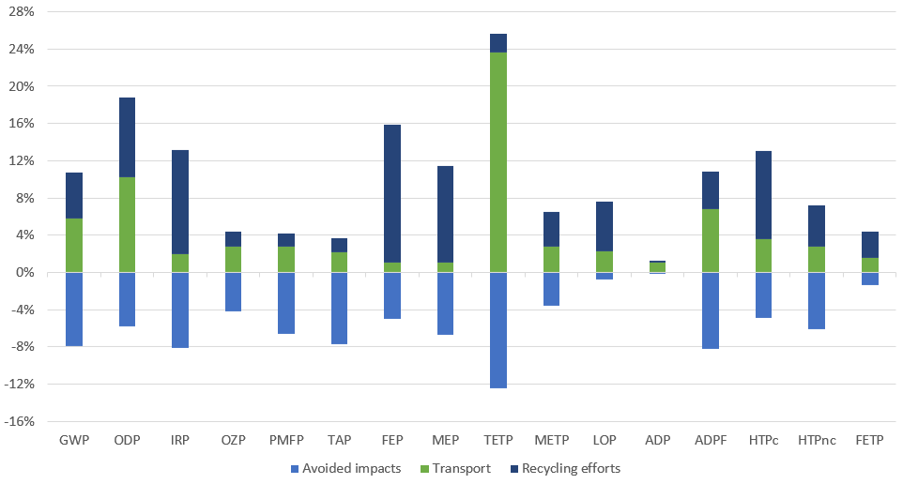

Figure S 7: Complete environmental impacts related to glass recycling, relative to the environmental impacts of the production of a PSM (0%).

Figure S 8: GWP related to “bulk” recycling, relative to the GWP of the production of a PSM (0%). The dashed line indicates the net impact.

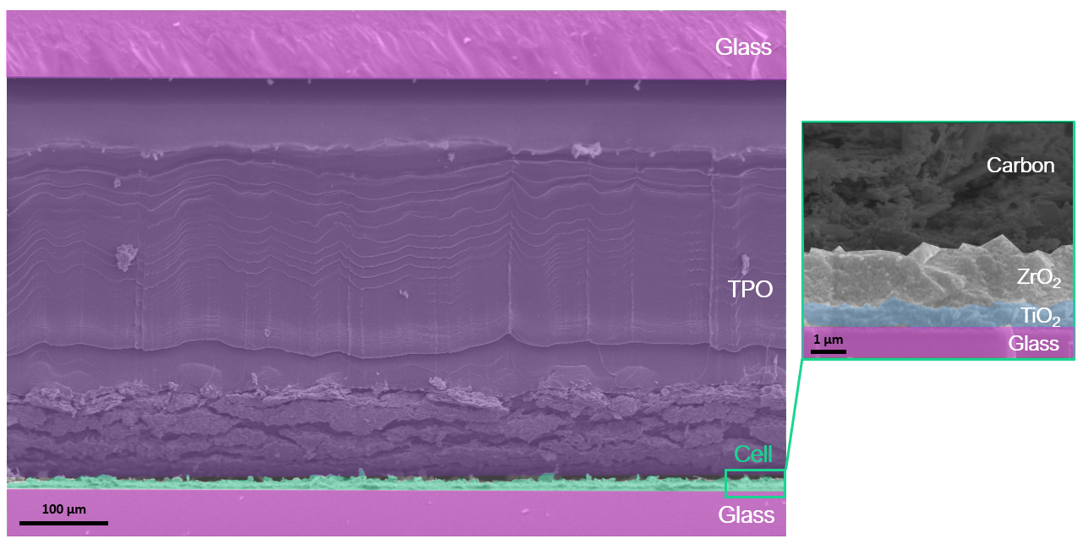
Figure S 9: Cross-sectional scanning electron microscope image (SEM) showing the structure of an encapsulated perovskite solar cell with carbon-based electrode. The color scheme also corresponds to the legend in Fig. S2 for enabling a clear link between a cell component and its environmental footprint.

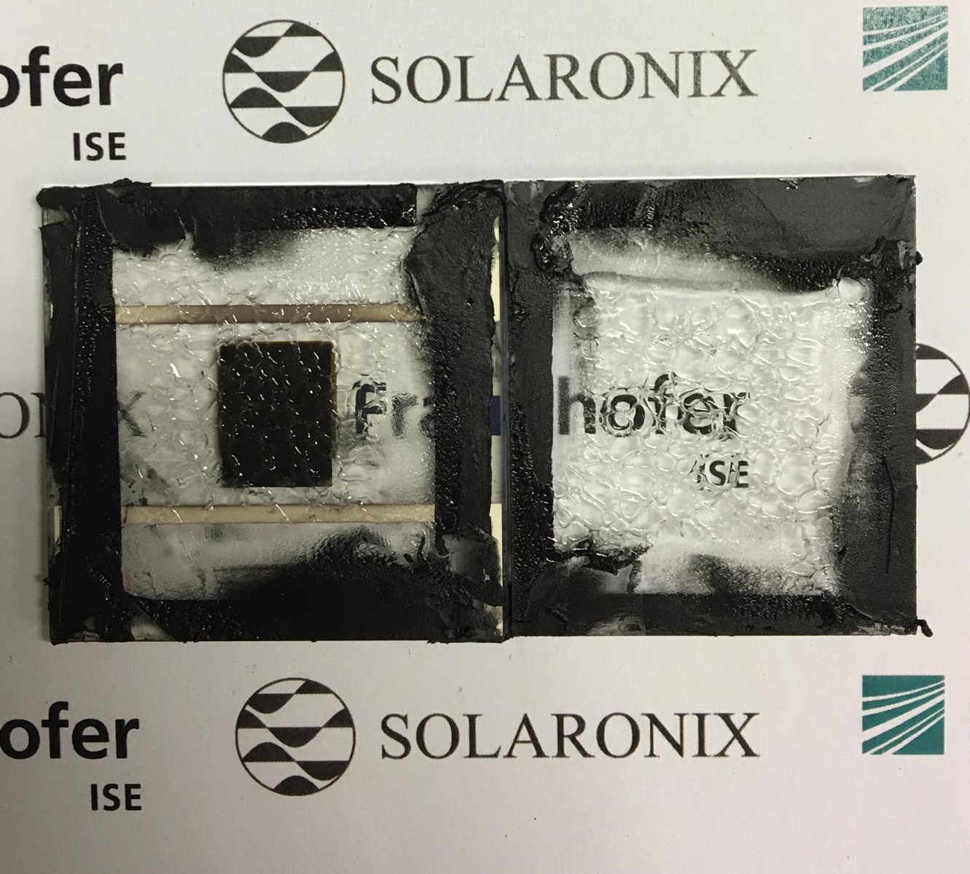
Figure S 10: Cell and back-glass with PIB and TPO after thermal-assisted separation

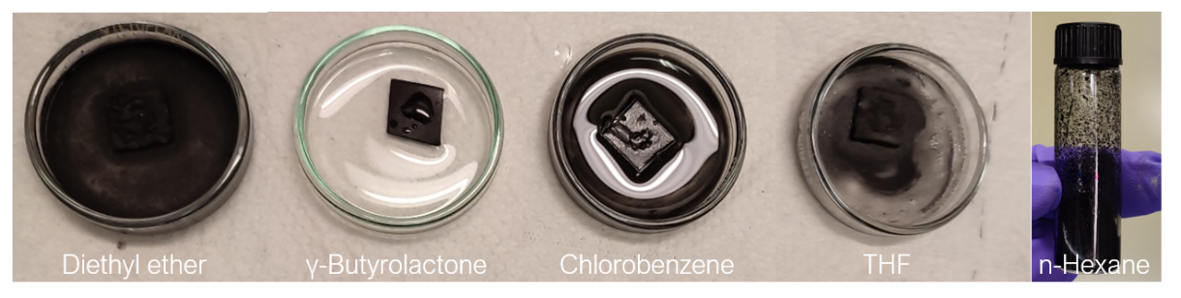
Figure S 11: Dissolution of PIB in screened solvents, none of which however could fully dissolve PIB, although we note that n-hexane exhibits the strongest dissolving capability

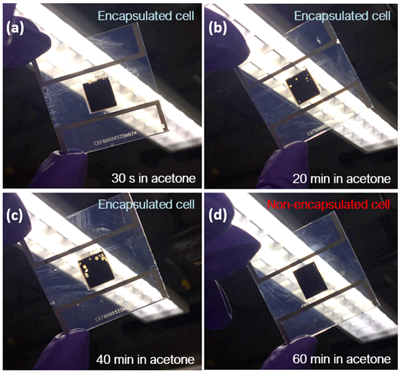
Figure S 12: Photographs showing the removal of carbon and perovskite under the influence of acetone present for different durations in encapsulated and a non-encapsulated cell

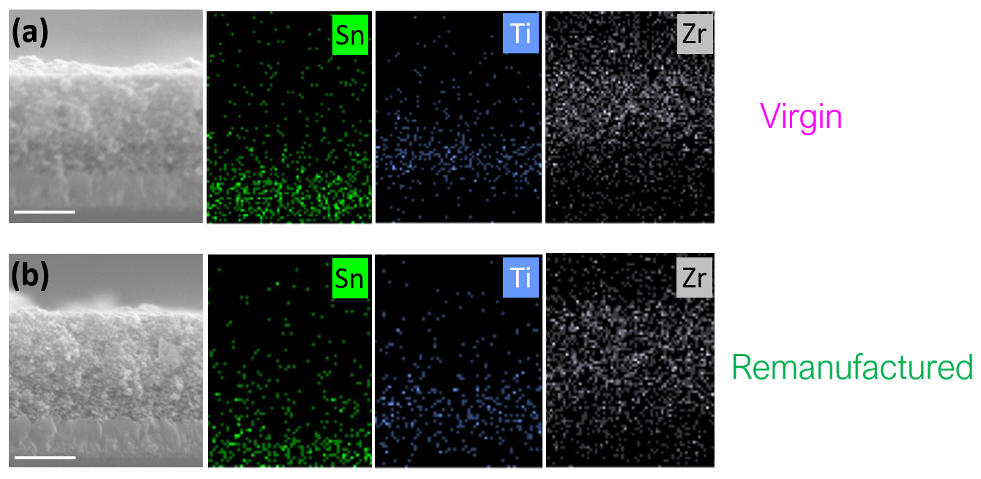
Figure S 13: SEM cross-sectional images of virgin (before remanufacturing) and remanufactured FTO/c-TiO₂/m-TiO₂/ZrO₂ stacks, as well as EDX maps of these cross-sections showing that the layer morphology and elemental composition remains unchanged before and after remanufacturing.

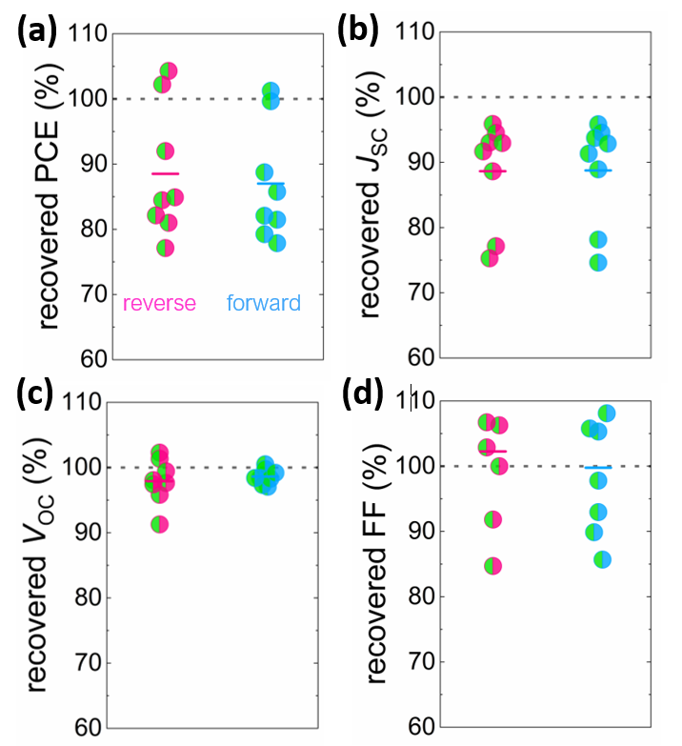
Figure S 14: Recovered (a) PCE, (b) J_{SC}, (c) V_{OC} and (d) FF after remanufacturing CPSCs, as measured from reverse and forward scans, relatively to the initial value (100%)

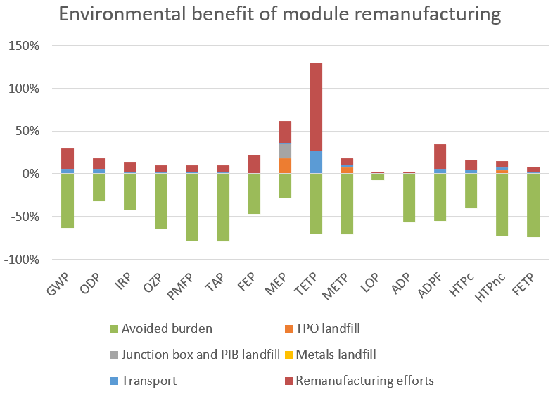
Figure S 15: Complete environmental impacts of the remanufactured PSM, relative to the virgin PSM (0%).

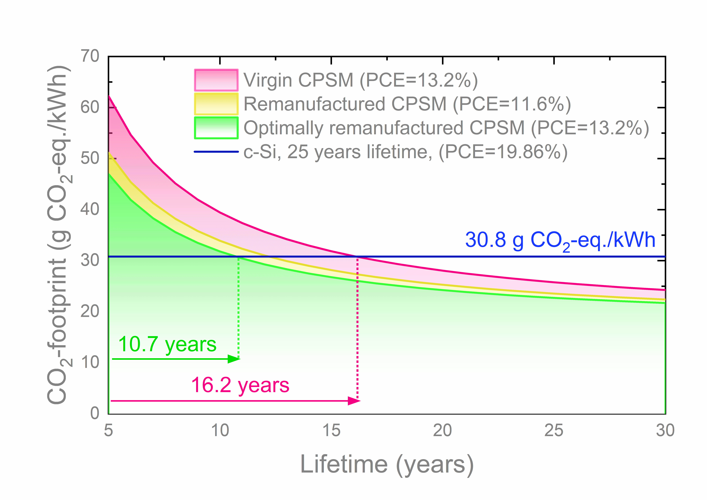
Figure S 16: CO₂-footprint of virgin and remanufactured CPSMs investigated in this work as a function of device lifetime in comparison to c-Si modules currently available on the market (as baseline)
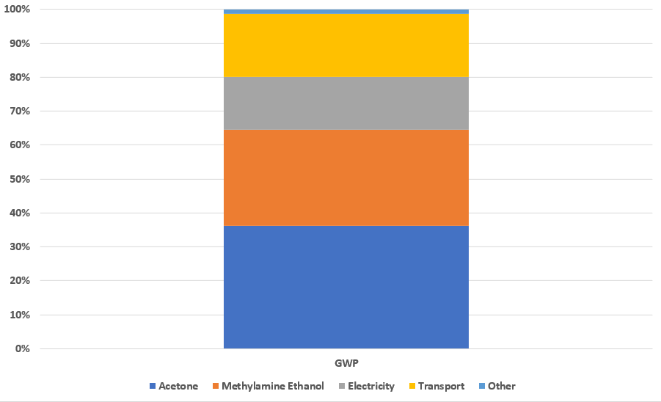
Figure S 17: Different contributions of the additional GWP originating from remanufacturing efforts, where solvents (acetone, methylamine and ethanol) account for more than 60% of it.

References
(1) Swartwout, R.; Hoerantner, M. T.; Bulović, V. Scalable Deposition Methods for Large‐area Production of Perovskite Thin Films. Energy Environ. Mater. 2019, 2 (2), 119–145. DOI: 10.1002/eem2.12043.
(2) Li, Z.; Klein, T. R.; Kim, D. H.; Yang, M.; Berry, J. J.; van Hest, M. F. A. M.; Zhu, K. Scalable fabrication of perovskite solar cells. Nat Rev Mater 2018, 3 (4). DOI: 10.1038/natrevmats.2018.17.
(3) Frischknecht, R.; Heath, G.; Raugei, M.; Sinha, P.; Wild-Scholten, M. de. Methodology guidelines on life cycle assessment of photovoltaic electricity.
(4) Mark Goedkoop, Michiel Oele, Jorrit Leijting, Tommie Ponsioen, Ellen Meijer. Introduction to LCA with SimaPro. https://​pre-sustainability.com​/​files/​2014/​05/​SimaPro8IntroductionToLCA.pdf.
(5) Chatzisideris, M. D.; Espinosa, N.; Laurent, A.; Krebs, F. C. Ecodesign perspectives of thin-film photovoltaic technologies: A review of life cycle assessment studies. Solar Energy Materials and Solar Cells 2016, 156, 2–10. DOI: 10.1016/j.solmat.2016.05.048.
(6) Amarakoon, S.; Vallet, C.; Curran, M. A.; Haldar, P.; Metacarpa, D.; Fobare, D.; Bell, J. Life cycle assessment of photovoltaic manufacturing consortium (PVMC) copper indium gallium (di)selenide (CIGS) modules. Int J Life Cycle Assess 2018, 23 (4), 851–866. DOI: 10.1007/s11367-017-1345-4.
(7) Lunardi, M.; Alvarez-Gaitan, J.; Bilbao, J.; Corkish, R. Comparative Life Cycle Assessment of End-of-Life Silicon Solar Photovoltaic Modules. Applied Sciences 2018, 8 (8), 1396. DOI: 10.3390/app8081396.
(8) Goe, M.; Gaustad, G. Estimating direct climate impacts of end-of-life solar photovoltaic recovery. Solar Energy Materials and Solar Cells 2016, 156, 27–36. DOI: 10.1016/j.solmat.2016.04.025.
(9) Stamford, L.; Azapagic, A. Environmental Impacts of Photovoltaics: The Effects of Technological Improvements and Transfer of Manufacturing from Europe to China. Energy Technol. 2018, 6 (6), 1148–1160. DOI: 10.1002/ente.201800037.
(10) Desideri, U.; Proietti, S.; Zepparelli, F.; Sdringola, P.; Bini, S. Life Cycle Assessment of a ground-mounted 1778kWp photovoltaic plant and comparison with traditional energy production systems. Applied Energy 2012, 97, 930–943. DOI: 10.1016/j.apenergy.2012.01.055.
(11) Müller, A.; Friedrich, L.; Reichel, C.; Herceg, S.; Mittag, M.; Neuhaus, D. H. A comparative life cycle assessment of silicon PV modules: Impact of module design, manufacturing location and inventory. Solar Energy Materials and Solar Cells 2021, 230, 111277. DOI: 10.1016/j.solmat.2021.111277.
(12) Gomez Trillos, J. C.; Brand, U.; Vogt, T. Life Cycle Assessment of Perovskite Tandem Solar Cells 2020.
(13) M. Lunardi, M.; Alvarez-Gaitan, J. P.; Chang, N. L.; Corkish, R. Life cycle assessment on PERC solar modules. Solar Energy Materials and Solar Cells 2018, 187, 154–159. DOI: 10.1016/j.solmat.2018.08.004.
(14) Solargis. “Global Solar Atlas”. https://​globalsolaratlas.info​/​map​?​c=​48.01542,7.814369,11&​s=​48.009219,7.876511&​m=​site.
(15) Cai, M.; Wu, Y.; Chen, H.; Yang, X.; Qiang, Y.; Han, L. Cost-Performance Analysis of Perovskite Solar Modules. Advanced science (Weinheim, Baden-Wurttemberg, Germany) 2017, 4 (1), 1600269. DOI: 10.1002/advs.201600269. Published Online: Sep. 15, 2016.
(16) Chang, N. L.; Yi Ho-Baillie, A. W.; Basore, P. A.; Young, T. L.; Evans, R.; Egan, R. J. A manufacturing cost estimation method with uncertainty analysis and its application to perovskite on glass photovoltaic modules. Prog. Photovolt: Res. Appl. 2017, 25 (5), 390–405. DOI: 10.1002/pip.2871.
(17) Song, Z.; McElvany, C. L.; Phillips, A. B.; Celik, I.; Krantz, P. W.; Watthage, S. C.; Liyanage, G. K.; Apul, D.; Heben, M. J. A technoeconomic analysis of perovskite solar module manufacturing with low-cost materials and techniques. Energy Environ. Sci. 2017, 10 (6), 1297–1305. DOI: 10.1039/C7EE00757D.
(18) Jung, E. H.; Jeon, N. J.; Park, E. Y.; Moon, C. S.; Shin, T. J.; Yang, T.-Y.; Noh, J. H.; Seo, J. Efficient, stable and scalable perovskite solar cells using poly(3-hexylthiophene). Nature 2019, 567 (7749), 511–515. DOI: 10.1038/s41586-019-1036-3. Published Online: Mar. 27, 2019.
(19) Galagan, Y.; Coenen, E. W. C.; Verhees, W. J. H.; Andriessen, R. Towards the scaling up of perovskite solar cells and modules. J. Mater. Chem. A 2016, 4 (15), 5700–5705. DOI: 10.1039/C6TA01134A.
(20) Rakocevic, L.; Gehlhaar, R.; Merckx, T.; Qiu, W.; Paetzold, U. W.; Fledderus, H.; Poortmans, J. Interconnection optimization for highly efficient perovskite modules. IEEE Journal of Photovoltaics 2016, 7 (1), 404–408.
(21) Castriotta, L. A.; Matteocci, F.; Vesce, L.; Cinà, L.; Agresti, A.; Pescetelli, S.; Ronconi, A.; Löffler, M.; Stylianakis, M. M.; Di Giacomo, F.; Mariani, P.; Stefanelli, M.; Speller, E. M.; Alfano, A.; Paci, B.; Generosi, A.; Di Fonzo, F.; Petrozza, A.; Rellinghaus, B.; Kymakis, E.; Di Carlo, A. Air-Processed Infrared-Annealed Printed Methylammonium-Free Perovskite Solar Cells and Modules Incorporating Potassium-Doped Graphene Oxide as an Interlayer. ACS applied materials & interfaces 2021, 13 (10), 11741–11754. DOI: 10.1021/acsami.0c18920. Published Online: Mar. 2, 2021.
(22) Di Giacomo, F.; Castriotta, L. A.; Kosasih, F. U.; Di Girolamo, D.; Ducati, C.; Di Carlo, A. Upscaling Inverted Perovskite Solar Cells: Optimization of Laser Scribing for Highly Efficient Mini-Modules. Micromachines 2020, 11 (12). DOI: 10.3390/mi11121127. Published Online: Dec. 20, 2020.
(23) Kempe, M. D.; Panchagade, D.; Reese, M. O.; Dameron, A. A. Modeling moisture ingress through polyisobutylene‐based edge‐seals. Prog. Photovolt: Res. Appl. 2015, 23 (5), 570–581.
(24) Stolz, P.; Frischknecht, R.; Wambach, K.; Sinha, P.; Heath, G. Life cycle assessment of current photovoltaic module recycling. IEA PVPS Task 12, International Energy Agency Power Systems Programme, Report IEA-PVPS T12 2017, 13, 2018.
(25) Jordan, D. C.; Kurtz, S. R.; VanSant, K.; Newmiller, J. Compendium of photovoltaic degradation rates. Prog. Photovolt: Res. Appl. 2016, 24 (7), 978–989. DOI: 10.1002/pip.2744.
(26) Huld, T.; Friesen, G.; Skoczek, A.; Kenny, R. P.; Sample, T.; Field, M.; Dunlop, E. D. A power-rating model for crystalline silicon PV modules. Solar Energy Materials and Solar Cells 2011, 95 (12), 3359–3369.
(27) Lia, F. de; Castello, S.; Abenante, L. Efficiency degradation of c-silicon photovoltaic modules after 22-year continuous field exposure. In 3rd World Conference onPhotovoltaic Energy Conversion, 2003. Proceedings of, 2003, Vol. 2; 2105-2108 Vol.2.
(28) Jordan, D. C.; Kurtz, S. R. Photovoltaic Degradation Rates-an Analytical Review. Prog. Photovolt: Res. Appl. 2013, 21 (1), 12–29. DOI: 10.1002/pip.1182.
(29) Jordan, D. C.; Silverman, T. J.; Sekulic, B.; Kurtz, S. R. PV degradation curves: non‐linearities and failure modes. Prog. Photovolt: Res. Appl. 2017, 25 (7), 583–591. DOI: 10.1002/pip.2835.
(30) European Commission. Joint Research Centre. Photovoltaics: technology development report 2020; Publications Office, 2020. DOI: 10.2760/827685.
(31) Khalifa, A.; Shafie, S.; Hasan, W. Z.; Lim, H. N.; Rusop, M.; Pandey, S. S.; Vats, A. K.; AlSultan, H. A.; Samaila, B. Comprehensive performance analysis of dye-sensitized solar cells using single layer TiO2 photoanode deposited using screen printing technique. Optik 2020, 223, 165595. DOI: 10.1016/j.ijleo.2020.165595.
(32) Fraunhofer ISE, PSE Projects GmbH. Photovoltaics report. https://​www.ise.fraunhofer.de​/​content/​dam/​ise/​de/​documents/​publications/​studies/​Photovoltaics-​Report.pdf.
(33) Mainzer, K.; Killinger, S.; McKenna, R.; Fichtner, W. Assessment of rooftop photovoltaic potentials at the urban level using publicly available geodata and image recognition techniques. Solar Energy 2017, 155, 561–573. DOI: 10.1016/j.solener.2017.06.065.
(34) First Solar. Series 6 - Module datasheet. https://​www.firstsolar.com​/-/​media/​First-​Solar/​Technical-​Documents/​Series-​6-​.
(35) Virtuani, A.; Pavanello, D.; Friesen, G. Overview of temperature coefficients of different thin film photovoltaic technologies. In 25th European photovoltaic solar energy conference and exhibition/5th World conference on photovoltaic energy conversion; pp 3–83.
(36) Vidal, R.; Alberola‐Borràs, J.-A.; Sánchez‐Pantoja, N.; Mora‐Seró, I. Comparison of Perovskite Solar Cells with other Photovoltaics Technologies from the Point of View of Life Cycle Assessment. Adv Energy Sustain Res 2021, 2 (5), 2000088. DOI: 10.1002/aesr.202000088.
(37) Geisler, G.; Hofstetter, T. B.; Hungerbühler, K. Production of fine and speciality chemicals: procedure for the estimation of LCIs. Int J Life Cycle Assess 2004, 9 (2), 101–113. DOI: 10.1007/BF02978569.
(38) Piccinno, F.; Hischier, R.; Seeger, S.; Som, C. From laboratory to industrial scale: a scale-up framework for chemical processes in life cycle assessment studies. Journal of Cleaner Production 2016, 135, 1085–1097. DOI: 10.1016/j.jclepro.2016.06.164.
(39) Bai, Y.; Muralidharan, N.; Li, J.; Essehli, R.; Belharouak, I. Sustainable Direct Recycling of Lithium‐Ion Batteries via Solvent Recovery of Electrode Materials. ChemSusChem 2020, 13 (21), 5664–5670. DOI: 10.1002/cssc.202001479.
(40) Capello, C.; Hellweg, S.; Badertscher, B.; Hungerbühler, K. Life-cycle inventory of waste solvent distillation: statistical analysis of empirical data. Environmental science & technology 2005, 39 (15), 5885–5892. DOI: 10.1021/es048114o.
(41) Parvatker, A. G.; Tunceroglu, H.; Sherman, J. D.; Coish, P.; Anastas, P.; Zimmerman, J. B.; Eckelman, M. J. Cradle-to-Gate Greenhouse Gas Emissions for Twenty Anesthetic Active Pharmaceutical Ingredients Based on Process Scale-Up and Process Design Calculations. ACS Sustainable Chem. Eng. 2019, 7 (7), 6580–6591. DOI: 10.1021/acssuschemeng.8b05473.
(42) Osipov, E.; Telyakov, E.; Ponikarov, S. Coupled Simulation of a Vacuum Creation System and a Rectification Column Block. Processes 2020, 8 (11), 1333. DOI: 10.3390/pr8111333.
(43) Green, D. W. Perry’s chemical engineers’. Handbook–seventh Edition–Sections 2008, 5–12.
(44) EQUIPMENT, PROCESS DESIGN OF VACUUM. Engineering Standard. Quest Technical Publication PUB 1993, 77385.
(45) Leybold. Dry Compressing Vacuum Pumps. https://​www.leyboldproducts.com​/​media/​pdf/​43/​39/​a0/​CP_​020_​Dry_​Compressing_​Vacuum_​Pumps_​EN.pdf.
(46) Goetzler, W.; Zogg, R.; Young, J.; Johnson, C. Energy Savings Potential and RD&D Opportunities for NonVapor-Energy Savings Potential and RD&D Opportunities for Non-Vapor-Compression Compression HVAC Technologies. https://​www.energy.gov​/​sites/​prod/​files/​2014/​03/​f12/​Non-​Vapor%20Compression%20HVAC%20Report.pdf.
(47) Althaus, H. J.; Chudacoff, M.; Hischier, R.; Jungbluth, N.; Osses, M.; Primas, A. Life cycle inventories of chemicals. Ecoinvent report 2007, 2.
(48) Gendorf Chemiepark. Unwelt Erklärung 2017. https://www.gendorf.de/-/media/Internet/chemiepark_gendorf_de/Downloads/Nachbarschaft/Umwelterklaerung_2017_final.ashx?la=de-DE https://www.gendorf.de/-/media/Internet/chemiepark_gendorf_de/Downloads/Nachbarschaft/Umwelterklaerung_2017_final.ashx?la=de-DE.
(49) Frischknecht, R.; Jungbluth, N.; Althaus, H.-J.; Hischier, R.; Doka, G.; Dones, R.; Heck, T.; Hellweg, S.; Wernet, G.; Nemecek, T. Overview and methodology. Data v2. 0 (2007). Ecoinvent report No. 1.
(50) Aden, N.; Stork, M.; Chang Kylee. Barriers, Challenges, and Opportunities for Chemical Companies to Set Science-Based Targets. https://​sciencebasedtargets.org​/​resources/​files/​SBTi-​Chemicals-​Scoping-​Document-​12.2020.pdf.
(51) Hassim, M. H.; Hurme, M.; Amyotte, P. R.; Khan, F. I. Fugitive emissions in chemical processes: The assessment and prevention based on inherent and add-on approaches. Journal of Loss Prevention in the Process Industries 2012, 25 (5), 820–829. DOI: 10.1016/j.jlp.2012.03.004.
(52) Mitchell Scientific, Inc., RTI International. Methods for Estimating Air Emissions from Chemical Manufacturing Facilities. https://​www.epa.gov​/​sites/​default/​files/​2015-​08/​documents/​ii16_​aug2007final.pdf.
(53) Hischier, R.; Hellweg, S.; Capello, C.; Primas, A. Establishing Life Cycle Inventories of Chemicals Based on Differing Data Availability (9 pp). Int J Life Cycle Assess 2005, 10 (1), 59–67. DOI: 10.1065/lca2004.10.181.7.
(54) US Environmental Protection Agency. Consolidated List of Lists under Consolidated List of Lists under EPCRA/CERCLA/CAA §112(r) (April 2022 Version). https://​www.epa.gov​/​system/​files/​documents/​2022-​04/​list_​of_​lists_​compiled_​april-​2022.pdf.
(55) Bazzanella, A.; Ausfelder, F. Low carbon energy and feedstock for the European chemical industry: Technology Study; DECHEMA, Gesellschaft für Chemische Technik und Biotechnologie eV, 2017.
(56) Dunn, A. L.; Payne, A.; Clark, P. R.; McKay, C.; Williams, G. D.; Wheelhouse, K.; Arendt, K.; Dixon, F.; Shilcrat, S. Process Safety in the Pharmaceutical Industry: A Selection of Illustrative Case Studies. J. Chem. Educ. 2021, 98 (1), 175–182. DOI: 10.1021/acs.jchemed.0c00115.
(57) Hur, J.; Moon, I. Novel Ethylene Oxide Gas Recovery System via Hydrolysis in the Dimethyl Carbonate and Monoethylene Glycol Production Process. Ind. Eng. Chem. Res. 2020, 59 (7), 3091–3096. DOI: 10.1021/acs.iecr.9b06344.
(58) Alberola-Borràs, J.-A.; Baker, J. A.; Rossi, F. de; Vidal, R.; Beynon, D.; Hooper, K. E. A.; Watson, T. M.; Mora-Seró, I. Perovskite Photovoltaic Modules: Life Cycle Assessment of Pre-industrial Production Process. iScience 2018, 9, 542–551. DOI: 10.1016/j.isci.2018.10.020. Published Online: Nov. 14, 2018.
(59) Espinosa, N.; Serrano-Luján, L.; Urbina, A.; Krebs, F. C. Solution and vapour deposited lead perovskite solar cells: Ecotoxicity from a life cycle assessment perspective. Solar Energy Materials and Solar Cells 2015, 137, 303–310.
(60) Gong, J.; Darling, S. B.; You, F. Perovskite photovoltaics: life-cycle assessment of energy and environmental impacts. Energy Environ. Sci. 2015, 8 (7), 1953–1968. DOI: 10.1039/C5EE00615E.
(61) Alberola-Borràs, J.-A.; Vidal, R.; Mora-Seró, I. Evaluation of multiple cation/anion perovskite solar cells through life cycle assessment. Sustainable Energy Fuels 2018, 2 (7), 1600–1609. DOI: 10.1039/C8SE00053K.
(62) Turton, R.; Bailie, R. C.; Whiting, W. B.; Shaeiwitz, J. A. Analysis, synthesis and design of chemical processes; Pearson Education, 2008.
(63) Calabrese, G. S.; Pissavini, S. From batch to continuous flow processing in chemicals manufacturing. AIChE journal 2011, 57 (4), 828–834.
(64) Khalifa, S. A.; Spatari, S.; Fafarman, A. T.; Baxter, J. B. Environmental Sustainability of Mixed Cation Perovskite Materials in Photovoltaics Manufacturing. ACS Sustainable Chem. Eng. 2020, 8 (44), 16537–16548. DOI: 10.1021/acssuschemeng.0c05619.
(65) Wakamiya, A.; Endo, M.; Sasamori, T.; Tokitoh, N.; Ogomi, Y.; Hayase, S.; Murata, Y. Reproducible fabrication of efficient perovskite-based solar cells: X-ray crystallographic studies on the formation of CH3NH3PbI3 layers. Chemistry Letters 2014, 43 (5), 711–713.
(66) Lee, C.; Shin, Y.; Jeon, G. G.; Kang, D.; Jung, J.; Jeon, B.; Park, J.; Kim, J.; Yoon, S. J. Cost-efficient, Effect of Low-Quality PbI2 Purification to Enhance Performances of Perovskite Quantum Dots and Perovskite Solar Cells. Energies 2021, 14 (1), 201. DOI: 10.3390/en14010201.
(67) Cohen, B.-E.; Gamliel, S.; Etgar, L. Parameters influencing the deposition of methylammonium lead halide iodide in hole conductor free perovskite-based solar cells. APL Materials 2014, 2 (8), 81502. DOI: 10.1063/1.4885548.
(68) Billstrand, B. M.; Bian, K.; Alarid, L. J.; Schunk, H. C.; Fan, H. Synthesis of Lead Iodide Perovskites for Solar Cell Application.
(69) Kyoto University. Method for producing high-efficiency perovskite solar cell.
(70) Schlessinger, G. G. Inorganic laboratory preparations; Chemical Publishing Company, 1962.
(71) Klein, E.; Lesyuk, R.; Klinke, C. Insights into the formation mechanism of two-dimensional lead halide nanostructures. Nanoscale 2018, 10 (9), 4442–4451. DOI: 10.1039/C7NR09564C.
(72) Sigma-Aldrich. Lead(II)-Chloride (99.999% trace metals basis) - Product description. https://​www.sigmaaldrich.com​/​DE/​de/​product/​aldrich/​203572.
(73) Surabhi, R.; Bhat, K.; Batra, A.; Chilvery, A.; Aggarwal, M. Synthesis, purification, crystal growth and characterization of Lead Iodide (PbI2) purified by a low-temperature technique. Advanced Science, Engineering and Medicine 2014, 6 (12), 1269–1273.
(74) Khalaph, K. A.; Shanan, Z. J.; Jafar, A. M.; Al-Attar, F. M. Structural and Optical Properties of PbI₂ Thin Films to Fabricate Perovskite Solar Cells. DDF 2020, 398, 140–146. DOI: 10.4028/www.scientific.net/DDF.398.140.
(75) Kim, H.-S.; Lee, C.-R.; Im, J.-H.; Lee, K.-B.; Moehl, T.; Marchioro, A.; Moon, S.-J.; Humphry-Baker, R.; Yum, J.-H.; Moser, J. E.; Grätzel, M.; Park, N.-G. Lead iodide perovskite sensitized all-solid-state submicron thin film mesoscopic solar cell with efficiency exceeding 9%. Sci Rep 2012, 2 (1), 591. DOI: 10.1038/srep00591. Published Online: Aug. 21, 2012.
(76) Cai, B.; Xing, Y.; Yang, Z.; Zhang, W.-H.; Qiu, J. High performance hybrid solar cells sensitized by organolead halide perovskites. Energy Environ. Sci. 2013, 6 (5), 1480. DOI: 10.1039/c3ee40343b.
(77) Kim, H.-S.; Lee, J.-W.; Yantara, N.; Boix, P. P.; Kulkarni, S. A.; Mhaisalkar, S.; Grätzel, M.; Park, N.-G. High efficiency solid-state sensitized solar cell-based on submicrometer rutile TiO2 nanorod and CH3NH3PbI3 perovskite sensitizer. Nano letters 2013, 13 (6), 2412–2417. DOI: 10.1021/nl400286w. Published Online: May. 16, 2013.
(78) Etgar, L.; Gao, P.; Xue, Z.; Peng, Q.; Chandiran, A. K.; Liu, B.; Nazeeruddin, M. K.; Grätzel, M. Mesoscopic CH3NH3PbI3/TiO2 heterojunction solar cells. Journal of the American Chemical Society 2012, 134 (42), 17396–17399. DOI: 10.1021/ja307789s. Published Online: Oct. 11, 2012.
(79) Heo, J. H.; Im, S. H.; Noh, J. H.; Mandal, T. N.; Lim, C.-S.; Chang, J. A.; Lee, Y. H.; Kim, H.; Sarkar, A.; Nazeeruddin, M. K.; Grätzel, M.; Seok, S. I. Efficient inorganic–organic hybrid heterojunction solar cells containing perovskite compound and polymeric hole conductors. Nature Photon 2013, 7 (6), 486–491. DOI: 10.1038/nphoton.2013.80.
(80) Snaith, H. J. Perovskites: The Emergence of a New Era for Low-Cost, High-Efficiency Solar Cells. J. Phys. Chem. Lett. 2013, 4 (21), 3623–3630. DOI: 10.1021/jz4020162.
(81) Noh, J. H.; Im, S. H.; Heo, J. H.; Mandal, T. N.; Seok, S. I. Chemical management for colorful, efficient, and stable inorganic-organic hybrid nanostructured solar cells. Nano letters 2013, 13 (4), 1764–1769. DOI: 10.1021/nl400349b. Published Online: Mar. 21, 2013.
(82) Im, J.-H.; Lee, C.-R.; Lee, J.-W.; Park, S.-W.; Park, N.-G. 6.5% efficient perovskite quantum-dot-sensitized solar cell. Nanoscale 2011, 3 (10), 4088–4093.
(83) Fujifilm. Methylammonium iodide:Laboratory Chemicals-FUJIFILM Wako Chemicals U.S.A. Corporation. https://​labchem-wako.fujifilm.com​/​us/​product/​detail/​W01W0113-​1826.html.
(84) Borun New Material. 99.5%FAI, CH(NH2)2I, Formamidinium Iodide manufacturers and suppliers in China. http://​www.chemborun.com​/​products/​99-​5-​FAI-​CH-​NH2-​2I-​Formamidinium-​Iodide-​2336269.html.
(85) American Elements. Methylammonium Bromide. https://​www.americanelements.com​/​methylammonium-​bromide-​6876-​37-​5.
(86) Ottoboni, S.; Shahid, M.; Steven, C.; Coleman, S.; Meehan, E.; Barton, A.; Firth, P.; Sutherland, R.; Price, C. J. Developing a Batch Isolation Procedure and Running It in an Automated Semicontinuous Unit: AWL CFD25 Case Study. Organic process research & development 2020, 24 (4), 520–539. DOI: 10.1021/acs.oprd.9b00512. Published Online: Mar. 26, 2020.
(87) Valastro, S.; Smecca, E.; Sanzaro, S.; Giannazzo, F.; Deretzis, I.; La Magna, A.; Numata, Y.; Jena, A. K.; Miyasaka, T.; Gagliano, A.; Alberti, A. Improved Electrical and Structural Stability in HTL-Free Perovskite Solar Cells by Vacuum Curing Treatment. Energies 2020, 13 (15), 3953. DOI: 10.3390/en13153953.
(88) Moreno Ruiz, E.; Valsasina, L.; Brunner, F.; Symeonidis, A.; FitzGerald, D.; Treyer, K.; Bourgault, G.; Wernet, G. Documentation of changes implemented in ecoinvent database v3. 3. Ecoinvent: Zürich, Switzerland 2016.
(89) K. Lehmphul. Thermal treatment. https://​www.umweltbundesamt.de​/​en/​topics/​waste-​resources/​waste-​disposal/​thermal-​treatment.
(90) Cohen, L. A.; Cavanaugh, T. J.; White, E. Acrylic/thermoplastic olefin composite; Google Patents, 2016.
(91) Das, T.; Roy, S. Heat sensing Thermoplastic Elastomer Based on Polyolefins for Encapsulation Applications. Thermoplastic elastomer-syntesys and application. Cina: Intech 2015, 95–113.
(92) Oreski, G.; Ottersböck, B.; Omazic, A. Degradation processes and mechanisms of encapsulants. In Durability and Reliability of Polymers and Other Materials in Photovoltaic Modules; Elsevier, 2019; pp 135–152.
(93) Lin, B.; Zheng, C.; Zhu, Q.; Xie, F. A polyolefin encapsulant material designed for photovoltaic modules: from perspectives of peel strength and transmittance. Journal of Thermal Analysis and Calorimetry 2020, 140 (5), 2259–2265.
(94) Barretta, C.; Oreski, G.; Feldbacher, S.; Resch-Fauster, K.; Pantani, R. Comparison of Degradation Behavior of Newly Developed Encapsulation Materials for Photovoltaic Applications under Different Artificial Ageing Tests. Polymers 2021, 13 (2). DOI: 10.3390/polym13020271. Published Online: Jan. 15, 2021.
(95) Adothu, B.; Costa, F. R.; Mallick, S. Damp heat resilient thermoplastic polyolefin encapsulant for photovoltaic module encapsulation. Solar Energy Materials and Solar Cells 2021, 224, 111024. DOI: 10.1016/j.solmat.2021.111024.
(96) Oreski, G.; Omazic, A.; Eder, G. C.; Voronko, Y.; Neumaier, L.; Mühleisen, W.; Hirschl, C.; Ujvari, G.; Ebner, R.; Edler, M. Properties and degradation behaviour of polyolefin encapsulants for photovoltaic modules. Prog. Photovolt: Res. Appl. 2020, 28 (12), 1277–1288. DOI: 10.1002/pip.3323.
(97) Kempe, M. D.; Nobles, D. L.; Postak, L.; Calderon, J. A. Moisture ingress prediction in polyisobutylene‐based edge seal with molecular sieve desiccant. Prog. Photovolt: Res. Appl. 2018, 26 (2), 93–101. DOI: 10.1002/pip.2947.
(98) Kempe, M. D.; Dameron, A. A.; Moricone, T. J.; Reese, M. O. Evaluation and modeling of edge-seal materials for photovoltaic applications. In 2010 35th IEEE Photovoltaic Specialists Conference (PVSC 2010):Honolulu, Hawaii, USA, 20 - 25 June 2010; IEEE: Piscataway, NJ, 2010; pp 256–261. DOI: 10.1109/PVSC.2010.5614463.
(99) Reese, M. O.; Dameron, A. A.; Kempe, M. D. Quantitative calcium resistivity based method for accurate and scalable water vapor transmission rate measurement. The Review of scientific instruments 2011, 82 (8), 85101. DOI: 10.1063/1.3606644.
(100) Becker, H.; Brucher, H.; Schott, N.; Rasal, R. Use of calcium oxide as a water scavenger in solar applications; Google Patents, 2012.
(101) Cao, J.; Herr, D. E. Radiation-curable desiccant-filled adhesive/sealant; Google Patents, 2008.
(102) S. Lassacher, K. Fazeni-Fraisl, and J. Lindorfer. OPTimized conversion of residual wheat straw to bio-ISObutene for bio based CHEMicals, Grant Agreement n° 744330 - Innovation Action-Demonstration. Project Deliverable D7.1 Full Life Cycle Assessment report of fossil isobutene reference process according to ISO 14040/14044 Document Classification Title Full Life Cycle Assessment report of fossil isobutene reference process according to ISO 14040/14044 Deliverable D7.1 Reporting Period: RP1 Date of Delivery foreseen in DoA.”.
(103) Aoshima, S.; Kanaoka, S. A renaissance in living cationic polymerization. Chemical reviews 2009, 109 (11), 5245–5287. DOI: 10.1021/cr900225g.
(104) Kostjuk, S. V.; Yeong, H. Y.; Voit, B. Cationic polymerization of isobutylene at room temperature. J. Polym. Sci. A Polym. Chem. 2013, 51 (3), 471–486. DOI: 10.1002/pola.26423.
(105) Drobny, J. G. 5-Electron Beam Processing of Commercial Polymers, Monomers, and Oligomers. Ionizing Radiation and Polymers 2013, 101–147.
(106) Kempe, M.; Korkmaz, K.; Postak, L.; Booth, D.; Lu, J.; Kotarba, C.; Rupert, L.; Molnar, T.; Aoki, T. Using a butt joint test to evaluate photovoltaic edge seal adhesion. Energy Science & Engineering 2019, 7 (2), 354–360.
(107) Giacchetta, G.; Leporini, M.; Marchetti, B. Evaluation of the environmental benefits of new high value process for the management of the end of life of thin film photovoltaic modules. Journal of Cleaner Production 2013, 51, 214–224. DOI: 10.1016/j.jclepro.2013.01.022.

