Supplemental Information

For

The role of c-Jun for beating cardiomycyte formation in prepared embryonic body

Supplemental Figures

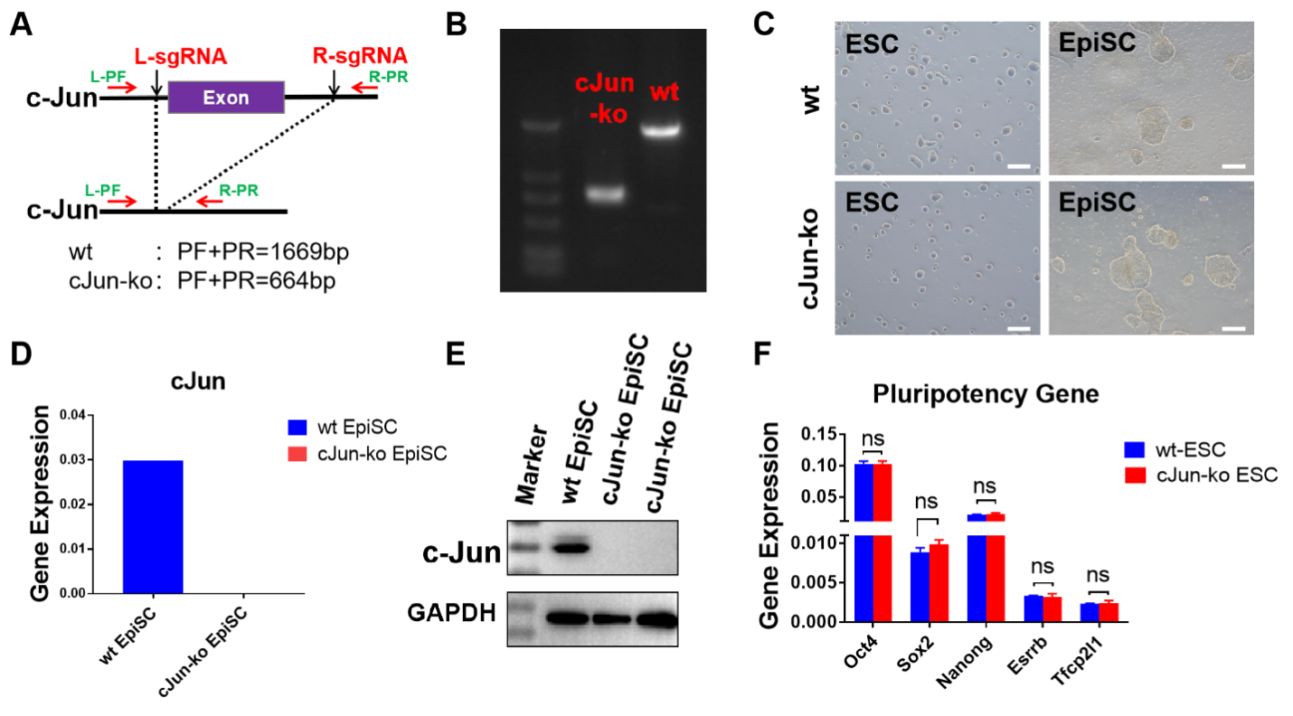
Supplemental Fig. 1. Construction and verification of c-Jun knockout (ko) mouse embryonic stem cells (mESCs). A. Schematic diagram for knocking out the c-Jun exon (Purple rectangle). The 2 sgRNAs are highlighted in red, while forward (PF) and reverse primers (PR), used to detect successful c-Jun gene deletion, are in green. B. Gel electrophoresis image demonstrating successful c-Jun gene deletion, with c-Jun-ko (664 bp) and wt (1669bp) alleles. DL2000 DNA Ladder is used. C. No difference in cell morphology was present between both wild-type (wt) and c-Jun-ko ESCs, as well as for ectodermal stem cells (EpiSCs). Scale Bar = 200 µm. D. RT-qPCR results for c-Jun gene expression between wt and c-Jun-ko groups. E. Western blots for c-Jun protein in wt and 2 c-Jun-ko clones of EpiSCs. GAPDH served as a loading control. F. Pluripotency gene expression levels for wt and c-Jun-ko ESCs determined by RT-qPCR. Data are mean ± SEM, n = 3, ns denotes no statistical significance.

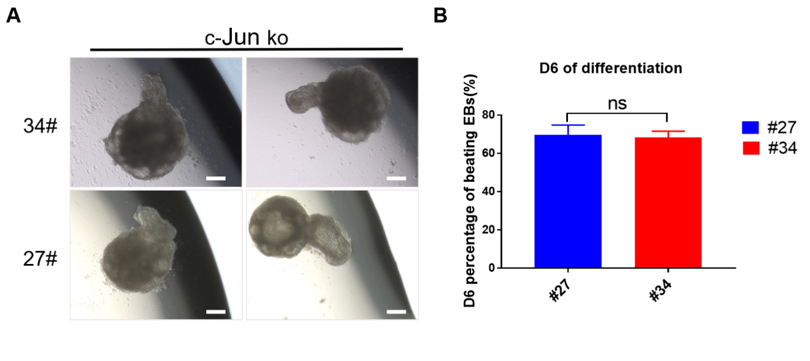
Supplemental Fig. 2. Two different clones of c-Jun knockout (ko) cells, #27 and #34, formed embryoid bodies (EBs) in Day 6 of differentiation. A. Both clones had the same morphological phenotype, with spontaneously beating cardiomyocytes within the convex bulges. Scale Bar = 200 µm. B. No statistically significant difference was found between the percentages of beating cells within the EBs of both clones on Day 6. Data are mean ± SEM, n = 3, ns denotes no statistical significance.

Supplemental Videos

Supplemental Video 1. Wild type embryoid body (EB) formed from mouse embryonic stem cells (mESC).


Supplemental Video 2. C-Jun knockout (ko) EB formed from mESCs, with bulging portion. Cells comprising the bulge portion appeared to rhythmically beat, indicating the presence of cardiomyocyte differentiation.

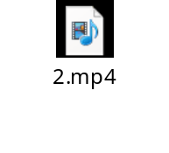
Supplemental Video 3. EB with mCherry⁺ c-Jun-ko and wt mESCs at 7/3 ratio in Day 6 after differentiation.

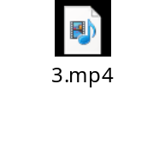
Supplemental Video 4. EB with mCherry⁺ c-Jun-ko and wt mESCs at 9/1 ratio in Day 6 after differentiation.


Supplemental Video 5. EB with mCherry⁺ c-Jun-ko mESCs in Day 6 after differentiation.



Supplemental Tables

Supplemental Table 1. Primer sequences used for RT-qPCR.
Primer | Forward | Reverse
GAPDH  c-Jun  Oct4  Sox2  Nanong  Esrrb  Tfcp2l1  Actc1  Actn2  Tnnt2  Gata4  Myh6  T  Flk-1  Fgf8  Sox17  Tm4sf2  Nestin  Sox1 | AACTTTGGCATTGTGGAAGGGCTCA  AAGATGGAAACGACCTTCTA  TAGGTGAGCCGTCTTTCCAC  AGGGCTGGGAGAAAGAAGAG  CTCAAGTCCTGAGGCTGAC  TTTCTGGAACCCATGGAGAG  GCTGGAGAATCGGAAGCTAGG  TCTGGCACCATACATTCTAC  GATGGCAATGTGAAGATGAC  GTGAGGAGGAGGAGAACA  CAGCAGCAGTGAAGAGAT  GAACACCAGCCTCATCAA  TCTCCAACCTATGCGGACAAT  TGGAGGAAGAGGAAGTGT  GCTCATTGTGGAGACCGATAC  CAGTATCTGCCCTTTGTGTA  CCAGTTGCTGCATGAACGAA  TCCCTTAGTCTGGAAGTGGCTA  GTGACATCTGCCCCCATC | TTGGCAGCACCAGTGGATGCAGGGA  GGTTACTGTAGCCGTAGG  GCTTAGCCAGGTTCGAGGAT  CCGCGATTGTTGTGATTAGT  TGAAACCTGTCCTTGAGTGC  AGCCAGCACCTCCTTCTACA  AAAACGACACGGATGATGCTC  AGGCACATTGAAGGTCTC  GGTGTGGAAGTTCTGGATAT  CTCTTCCGCTCTGTCTTC  GTCTGAGTGACAGGAGATG  TGCCTCCTCTACTTCTGT  TAGGTGGGCTGGCGTTATGA  GTCTGTCTGGCTGTCATC  TTGCTCTTGGCAATTA GCTTC  GCAATAGTAGACCGCTGAG  CACCAGATCATAACAG CCCTTCT  GGTGTCTGCAAGCGAGAGTT  GAGGCCAGTCTGGTGTCAG

