Synthesis and Application of Fe₃O₄@Graphene Oxide-Thiobarbituric Acid Based Binary Composite for Selective Removal of Cd(II) from Industrial Wastewater
Aminul Islam*, Hina Javed
Analytical Research Laboratory, Department of Chemistry, Aligarh Muslim University, Aligarh, India 202 002
*Corresponding author: aminulislam.ch@amu.ac.in

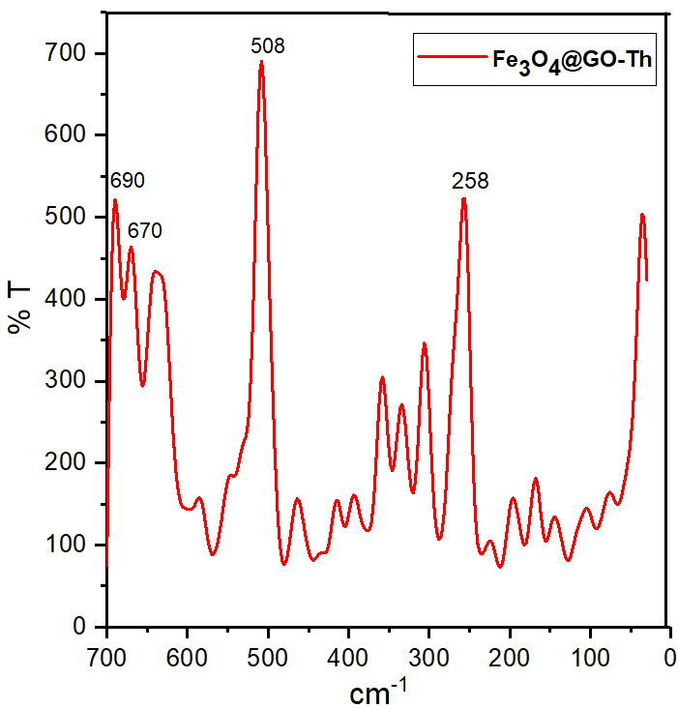

Fig. S1 Far IR spectrum of Fe₃O₄@GO-Th

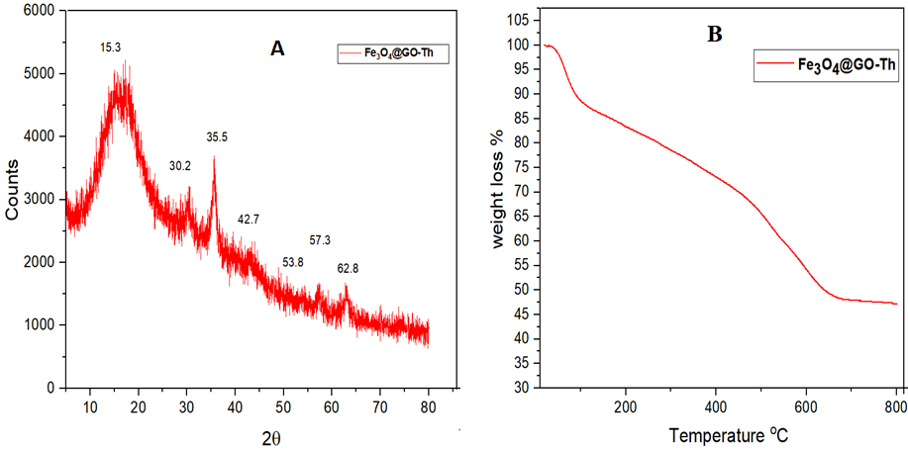
Fig. S2 A) XRD B) TGA of Fe₃O₄@GO-Th

Fig. S3 Effect of pH

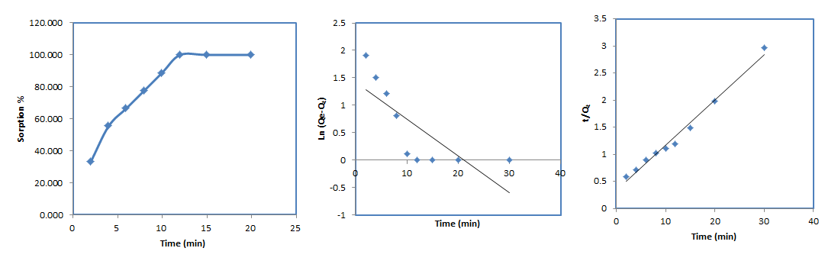Fig. S4 (A) Effect of contact time (B) pseudo first order (C) pseudo second order
C
B
A
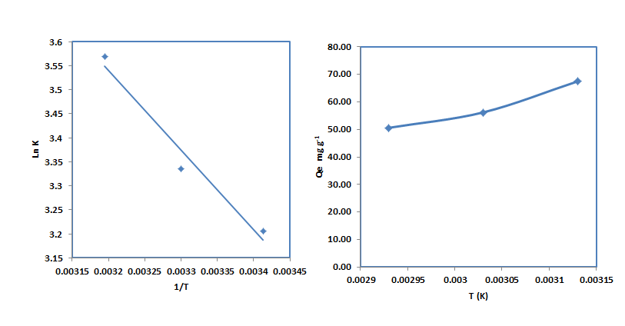
B
A
Fig. S5 A) Thermodynamic plot of Ln K Vs 1/T (K) (B) effect of temperature on sorption capacity of Cd(II)

Table S1 Summary of Kinetic parameters
Models | Parameters Values
Pseudo-first-order  $\ln\left(Qe-Q_{t}\right)=ln{ Q}_{e}-K_{1}$t | K₁ (min⁻¹) | 0.066
 | ªQ_{e (cal)} (mg g⁻¹) | 4.10
 | R² | 0.597
Pseudo-second-order  $$\frac{t}{Q_{t}}= \frac{1}{K_{2}{Q_{e}}^{2}}+ \frac{t}{Q_{e}}$$ | K₂ (g mg⁻¹ min⁻¹) | 0.02
 | ªQ_{e (cal)} (mg g⁻¹) | 11.93
 | R² | 0.984
Experimental data | ªQ_{e (exp)} (mg g⁻¹) | 10.11
Adsorbent dose 50 mg, Total volume 50 mL, pH = 5.6 Qe is Cd(II) adsorbed at equilibrium ; Q_{t}: Cd(II) adsorbed at time t; K₁: rate constant of pseudo-first order model, K₂: rate constant for pseudo-second-order model

Table S2A Summary of different forms of non-linear Isotherm model equations

Models | Nonlinear Forms | Parameters
Langmuir | $$q_{e}= \frac{q_{mL }K_{L}C_{e}}{1+K_{L}C_{e}}$$ | K_{L} | Langmuir isotherm constant (L mg⁻¹)
Langmuir | $$q_{e}= \frac{q_{mL }K_{L}C_{e}}{1+K_{L}C_{e}}$$ | q_{mL} | maximum monolayer adsorption capacity predicted by Langmuir isotherm (mg g⁻¹)
Freundlich | $$q_{e}= K_{F}C_{e}^{\frac{1}{n_{F}}}$$ | K_{F} | Freundlich isotherm constant ((mg g⁻¹) (L mg⁻¹)^{1/nF})
Freundlich | $$q_{e}= K_{F}C_{e}^{\frac{1}{n_{F}}}$$ | n_{F} | Freundlich model exponent
Jovanovic | $$q_{e}= q_{mJV}\{1-\exp\left(-K_{JV}C_{e}\right)\}$$ | K_{JV} | Jovanovic isotherm constant linked to the free energy of adsorption (L g⁻¹)
Jovanovic | $$q_{e}= q_{mJV}\{1-\exp\left(-K_{JV}C_{e}\right)\}$$ | q_{mJV} | Maximum monolayer adsorption  capacity predicted by Jovanovic  isotherm (mg g⁻¹)
Sips | $$q_{e}= \frac{K_{s}C_{e}^{β_{s}}}{1+α_{s}C_{e}^{β_{s}}}$$ | K_{S} | Sips isotherm constant related to  affinity constant (L g⁻¹)
Sips | $$q_{e}= \frac{K_{s}C_{e}^{β_{s}}}{1+α_{s}C_{e}^{β_{s}}}$$ | $$β_{s}$$ | Sips model exponent

Table S2B Statistical Error Analysis
Error functions | Abbreviations | Definitions
Hybrid fractional error function | HYBRID | $$\frac{100}{n-p}\sum_{i=1}^{n}{\left[\frac{{\left(q_{e,exp}-q_{e,cal}\right)}^{2}}{q_{e,exp}}\right]}i$$
Average relative error | ARE | $$\frac{100}{n}\sum_{i=1}^{n}{\left|\frac{q_{e,exp}-q_{e,cal}}{q_{e,exp}}\right|}i$$
Sum of absolute errors | EABS | $$\sum_{i=1}^{n}{\left|q_{e,exp}-q_{e,cal}\right|}i$$
Marquardt’s percent standard deviation | MPSD | $$100\sqrt{\frac{1}{n-p}\sum_{i=1}^{n}{{\left(\frac{\left(q_{e,exp-q_{e,cal}}\right)}{q_{e,exp}}\right)}^{2}}}i$$
Reduced chi square | Reduced χ² | $$\frac{1}{n-p}\sum_{i=1}^{n}{{\left(q_{e,exp-q_{e,cal}}\right)}^{2}} i$$
Residual root mean square Error | RMSE | $$\sqrt{\frac{1}{n-2}\sum_{i=1}^{n}{{\left(q_{e,exp}-q_{e,cal}\right)}^{2}}}$$

Table S3 Thermodynamic studies
Temperature (K) | ∆G (KJ mol⁻¹) | ∆H (KJ mol⁻¹) | ∆ S (J mol⁻¹.K⁻¹)
293 K | -7.80 | 13.81 | 73.65
303 K | -8.40
313 K | -9.28
Adsorbent dose 50 mg, Total volume 50 mL, pH = 5.6

