Supplementary Information

The Minimum Support Price and Procurement Policy

The MSP was first introduced as a risk-mitigation instrument to incentivize farmers to take up the risky Green Revolution HYV seeds in the 1960s (10). This was done primarily in the states of Punjab and Haryana, which had deep aquifers to provide assured irrigation necessary for the success of the HYV seeds. The farmers were promised that if prices fell due to overproduction because of using HVY seeds, the government would purchase their output at a predetermined MSP. In the 1960s, the Green Revolution was seen as necessary to provide food security for the people of India. Over time however, this single policy instrument has been used to achieve other goals even has agricultural production soared. These goals include risk-mitigation (by providing a price-floor), remunerative income for farmers (by keeping the price floor substantially high), and poverty (by providing the procured grains to the poor at near zero prices). The political economy of agriculture and poverty has set a vicious cycle in which the MSP has been continuously increased every year since inception (Supplementary Information, Fig. S2b) and is around 30–40% higher than market prices (52).

Although, the government of India announces a floor price for 23 crops, its enforcement is not uniform across crops or regions. Enforcement requires that whenever prices fall below the MSP, the government purchases the crop from the farmers at the MSP. Historically, this has happened primarily for rice and wheat. For the longest period, procurement was concentrated in Punjab and Haryana; only recently has procurement started in other states (53, 54). Even then the amount of public procurement in other states is minuscule compared to that in Punjab and Haryana. Madhya Pradesh is a notable exception (33); it started wheat procurement in 2008 and is now one of the largest procurers of wheat (Supplementary Information, Table S1).

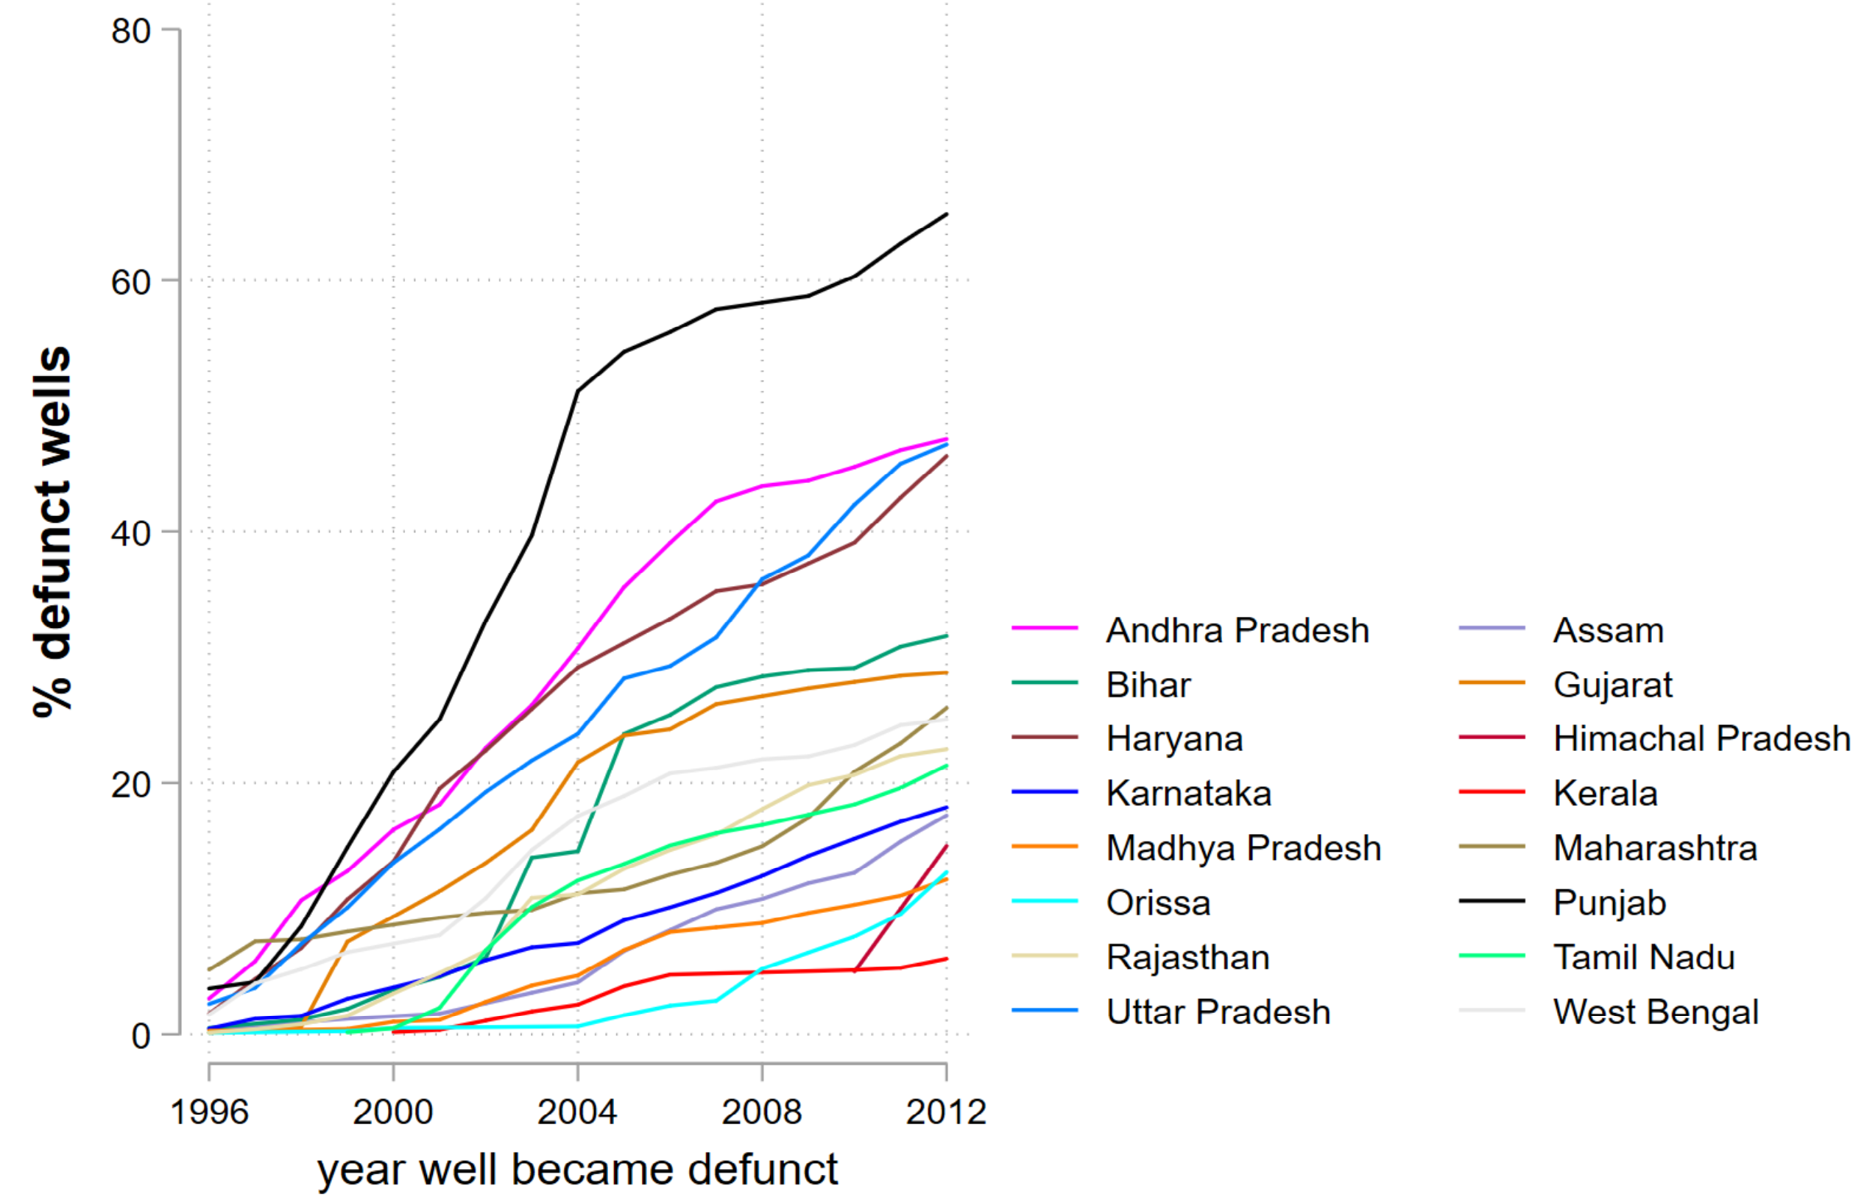

Fig. S1. Increase in defunct wells across states

Notes: The figure plots the percentage of wells that were defunct in any year of those that were active in 1996

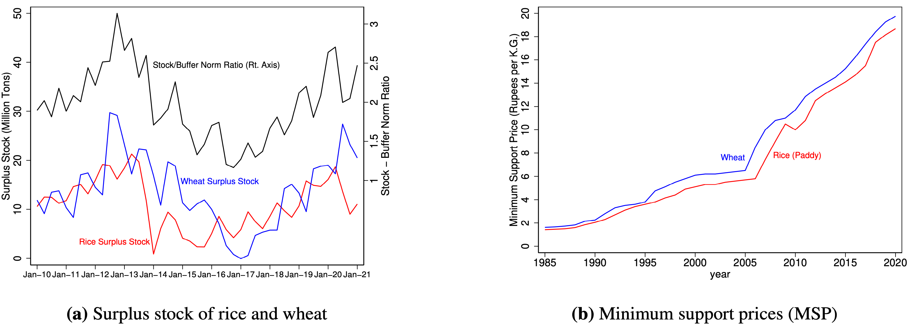

Fig. S2. Surplus Stock and Minimum Support Prices of Rice and Wheat

Notes: In panel (a) surplus stock is calculated as the excess stock over the norms set for strategic reserves. The black line (right y-axis) plots the ratio between the total stock of rice and wheat with government and buffer norms. Source: (a) Department of Food and Public Distribution, Ministry of Consumer Affairs, Government of India. (b) Database on Indian Economy, Reserve Bank of India.

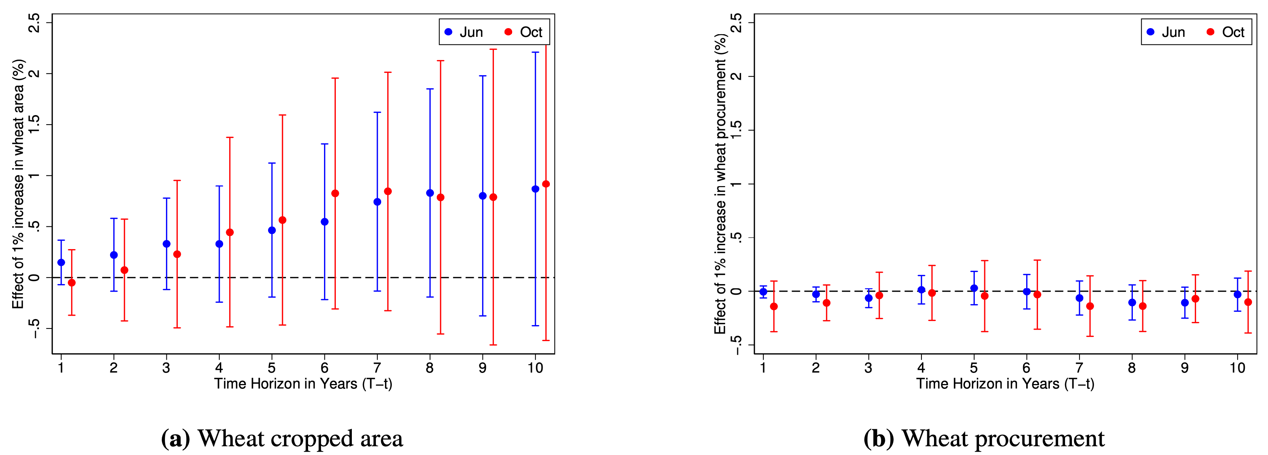

Fig. S3. Effects of producing and procuring wheat on groundwater depth in Punjab: 1981–2003.

Notes: The figures plot estimates from a regression of change in groundwater depth on log rice area (panel a) or log rice procurement (panel b). The unit of observation is a district×year. Each estimate is from a different regression where the percentage change in groundwater depth has been calculated over a different horizon. For example, the estimate at T = t + 4 is from a regression where the dependent variable is the percentage change in groundwater depth between t and t + 4. All regressions include district effects, year effects, AEZ-specific trends, net cropped area, population, cumulative precipitation until date T , and temperature as controls. 95% confidence intervals accounting for three year serial correlations within districts is represented by the bars. The blue estimates measure groundwater changes from readings taken pre-monsoon (June), and red estimates from readings taken post-monsoon (October).

Panel A: Procurement of Rice and Wheat in Million Tons
State |  | Rice |  |  |  |  |  | State |  | Wheat
State |  | 1986-87 |  | 1994-95 |  | 2015-16 |  | State |  | 1986-87 |  | 1994-95 |  | 2015-16
Punjab |  | 4.38 |  | 5.83 |  | 93.50 |  | Punjab |  | 6.48 |  | 7.29 |  | 10.34
Haryana |  | 0.68 |  | 1.43 |  | 28.61 |  | Haryana |  | 2.34 |  | 3.05 |  | 6.78
Uttar Pradesh |  | 1.02 |  | 0.73 |  | 29.10 |  | Uttar Pradesh |  | 1.60 |  | 1.41 |  | 2.27
Andhra P. |  | 1.47 |  | 4.02 |  | 43.36 |  | Rajasthan |  | 0.10 |  | 0.07 |  | 1.30
Telangana |  | n/a |  | n/a |  | 15.79 |  | Madhya P. |  | 0.00 |  | 0.00 |  | 7.31
Madhya P. |  | 0.46 |  | 0.76 |  | 8.49 |  | India |  | 10.54 |  | 11.87 |  | 28.09
Chattisgarh |  | n/a |  | n/a |  | 34.42
Orissa |  | 0.12 |  | 0.33 |  | 33.69
Tamil Nadu |  | 0.89 |  | 0.29 |  | 11.92
West Bengal |  | 0.05 |  | 0.15 |  | 15.68
Bihar |  | 0.00 |  | 0.00 |  | 12.23
India |  | 9.16 |  | 13.71 |  | 342.18
Panel B: Procurement of Rice and Wheat as % of Total Production
State |  | Rice |  |  |  |  |  | State |  | Wheat
State |  | 1986-87 |  | 1994-95 |  | 2015-16 |  | State |  | 1986-87 |  | 1994-95 |  | 2015-16
Punjab |  | 72.70 |  | 75.63 |  | 79.08 |  | Punjab |  | 68.56 |  | 53.80 |  | 64.34
Haryana |  | 43.94 |  | 63.99 |  | 69.02 |  | Haryana |  | 46.27 |  | 41.72 |  | 59.71
Uttar Pradesh |  | 13.52 |  | 7.01 |  | 23.28 |  | Uttar Pradesh |  | 9.84 |  | 6.23 |  | 8.92
Andhra P. |  | 22.32 |  | 43.38 |  | 57.91 |  | Rajasthan |  | 3.06 |  | 1.16 |  | 13.17
Telangana |  | n/a |  | n/a |  | 51.82 |  | Madhya P. |  | 0.00 |  | 0.00 |  | 41.32
Madhya P. |  | 10.99 |  | 11.74 |  | 23.94 |  | India |  | 23.79 |  | 18.05 |  | 30.44
Chattisgarh |  | n/a |  | n/a |  | 59.46
Orissa |  | 2.54 |  | 5.15 |  | 57.34
Tamil Nadu |  | 16.63 |  | 3.85 |  | 15.86
West Bengal |  | 0.58 |  | 1.23 |  | 9.83
Bihar |  | 0.00 |  | 0.00 |  | 20.38
India |  | 15.12 |  | 16.75 |  | 32.77

Table S1. Rice and Wheat Procurement

Sources: Agricultural Statistics of India and the Food Corporation of India

Notes: The states of Chhattisgarh, Jharkhand, and Uttarakhand were carved from Madhya Pradesh, Bihar, and Uttar Pradesh respectively in the year 2000. Telangana was carved from Andhra Pradesh in 2014. Thus, the data in 1986—87 and 1994—95 for Uttar Pradesh, Andhra Pradesh, and Madhya Pradesh include those of their child states.

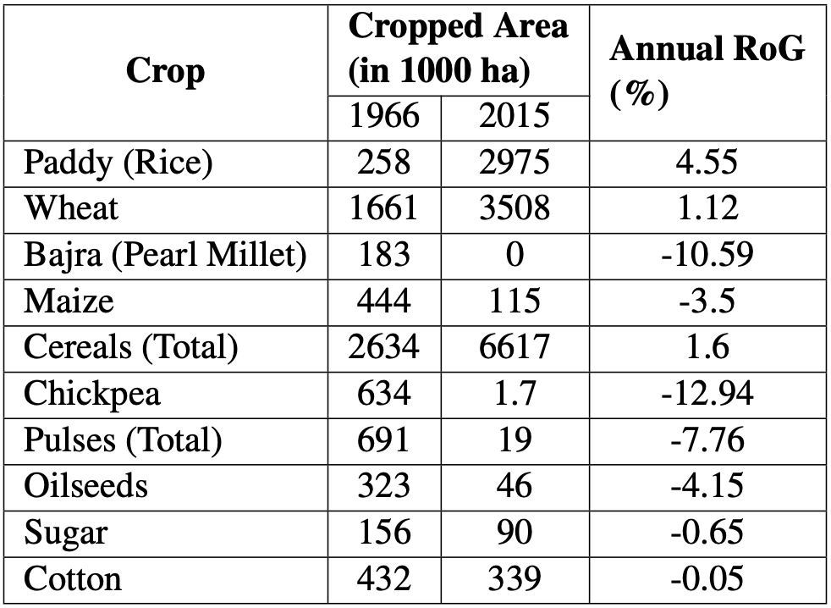

Table S2. Evolution of Crops in Punjab

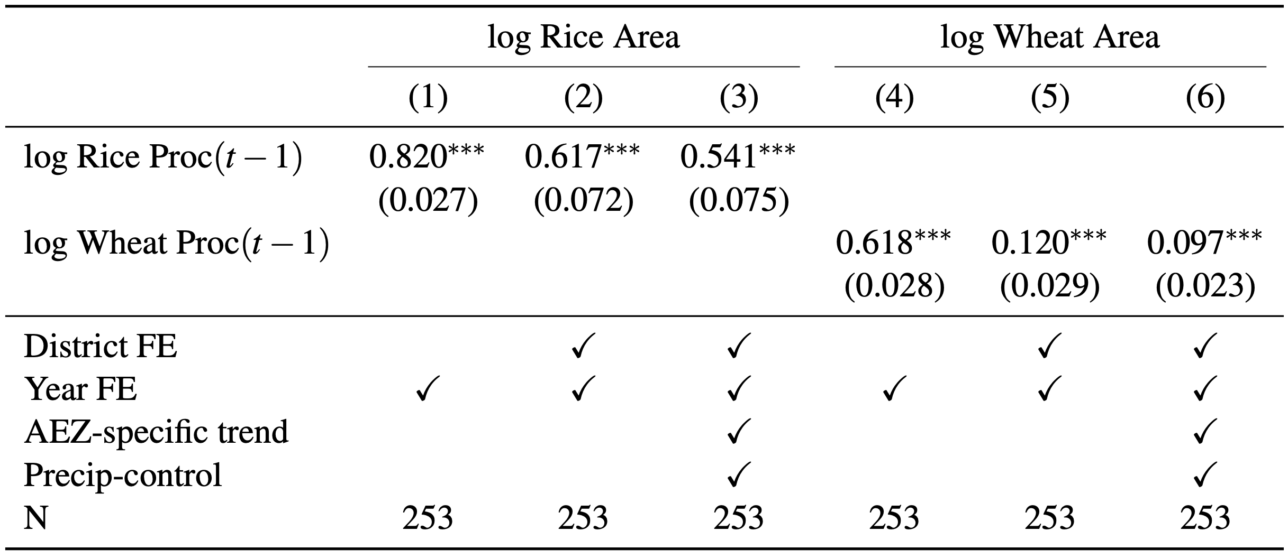

Table S3. Effects of Procurement on Cropped Area: Punjab 1981—2003
Notes: Each observation is a district×year. Newey-West standard errors with three period lags reported in parentheses. *p < 0.10, **p < 0.05, ***p < 0.01.

In cols 1 and 4, we use year fixed effects to control for unobserved time-varying macro shocks like global price volatility that could be correlated with procurement and production. In cols 2 and 5, we add district fixed effects to control for unobserved district-specific time-invariant factors like geography, topography, and proximity to markets that could affect rice output. In cols 3 and 6, we introduce additional controls for precipitation and AEZ-specific linear time trends. The later accounts for unobserved AEZ-specific time-varying factors like changes in socio-economic indicators. This rich set of controls helps us isolate the confounding factors that could influence production and be correlated with procurement, which facilitates a causal interpretation of our results.

Procurement increases cropped area for wheat by a much smaller magnitude. This is because in the rabi (spring) season wheat has already saturated the cropped area with little scope for expansion. Our preferred interpretation of the results for wheat is not that wheat procurement did not have an effect. Rather, it is the assured wheat procurement at MSP that prevented wheat from being replaced by other crops. This consistently high level of wheat production continues to deplete groundwater levels.

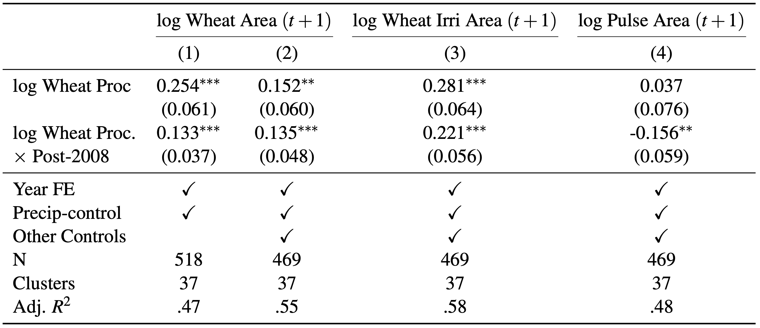

Table S4. Effects of Wheat Procurement on Production in Madhya Pradesh
Notes: Each observation is a district×year. Robust standard errors clustered at the district level reported in parentheses. Other controls include area under other crops and irrigated area in cols 2 and 4, and area under other crops in col 3. *p<0.10, **p<0.05, ***p<0.01.

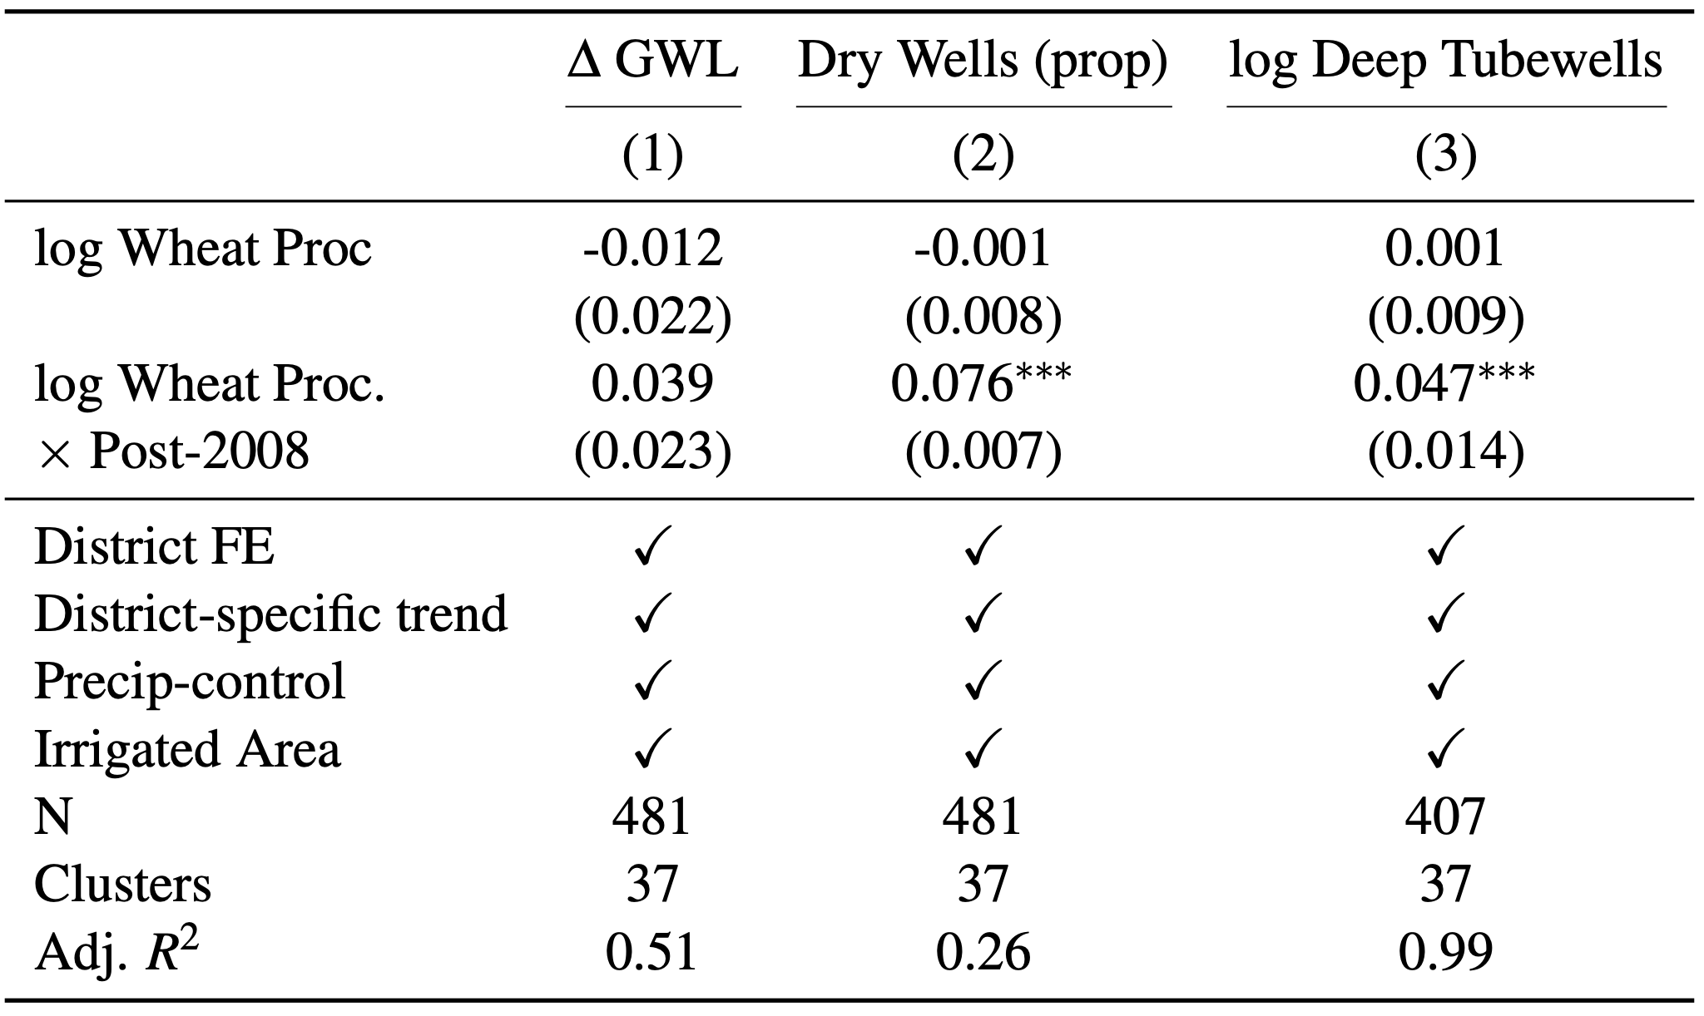

Table S5. Effects of Wheat Procurement on Groundwater Stress in Madhya Pradesh
Notes: Each observation is a district×year. Robust standard errors clustered at the district
level reported in parentheses. ∆GWL is the proportional change in groundwater depth between
November in year t-1 and May in year t. Dry wells are the fraction of monitoring wells that are dry in the months after the wheat harvest (June–September). *p < 0.10, **p < 0.05, ***p < 0.01.

