Supporting Information
Chemical and microbial composition of long-time steel rust layers in the South China Sea with a novel highly corrosive Desulfovibrio strain isolated from it
Xucheng Dong ^{a,b,c,d}, Xiaofang Zhai*^{a,b,d,e}, Yimeng Zhang ^{a,b,d}, Jing Yang ^{a,b,d}, Fang Guan ^{a,b,d}, Jizhou Duan*^{a,b,d}, Jiawen Sun ^{a,b,c,d}, Baorong Hou ^{a,b,d}
ª Key Laboratory of Marine Environmental Corrosion and Bio-fouling, Institute of Oceanology, Chinese Academy of Sciences, 7 Nanhai Road, Qingdao, 266071, P. R. China
^{b} Open Studio for Marine Corrosion and Protection, Pilot National Laboratory for Marine Science and Technology (Qingdao), 168 Wenhai Middle Road, Qingdao 266237, P. R. China
^{c} University of Chinese Academy of Sciences, 19 (Jia) Yuquan Road, Beijing 100039, P. R. China
^{d} Center for Ocean Mega-Science, Chinese Academy of Sciences, 7 Nanhai Road, Qingdao, 266071, P. R. China
e Sanya Institute of Oceanology, South China Sea Institute of Oceanology, Chinese Academy of Sciences, Zhenzhou Road, Sanya, 572000, China
E-mail: zhaixf@qdio.ac.cn, duanjz@qdio.ac.cn.
Table S1. EDS quantification data (at% of elements) in three rust layers
 | C | O | Fe | S | N | Al | Si | Ca | Na
IL | - | 58.28 | 37.31 | 1.88 | 1.52 | 0.41 | - | 0.6 | -
ML | - | 57.27 | 37.83 | 0.48 | 1.54 | 0.21 | - | 0.92 | 1.75
OL | 14.38 | 58.75 | 15.13 | 1.58 | 0.16 | 0.68 | 2.85 | 6.09 | 0.38

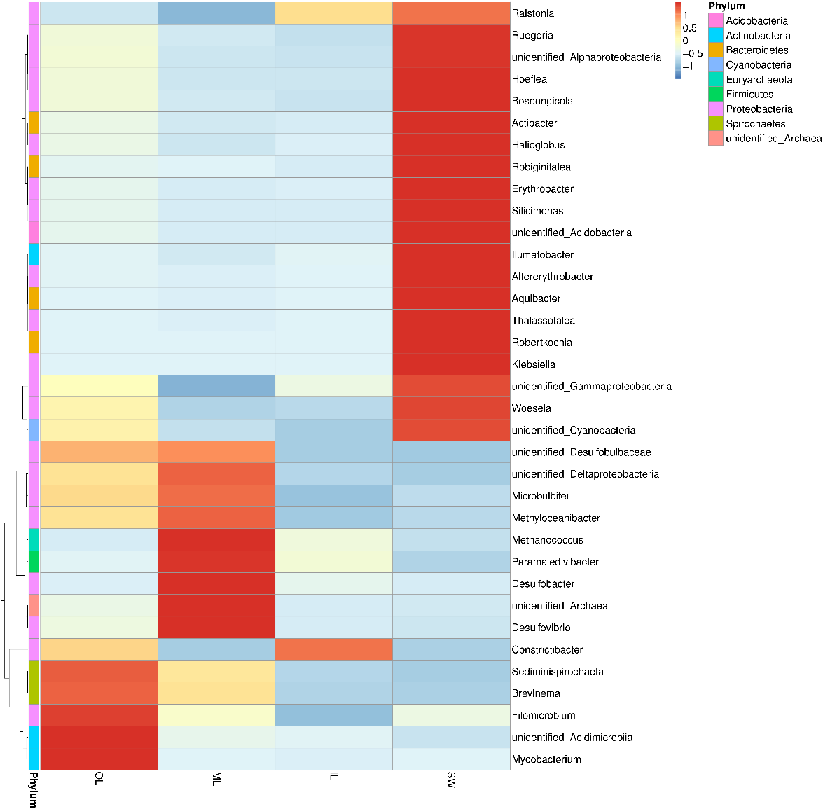
Fig. S1. The bacterial community distributions among the three rust layers and seawater at the genus level.
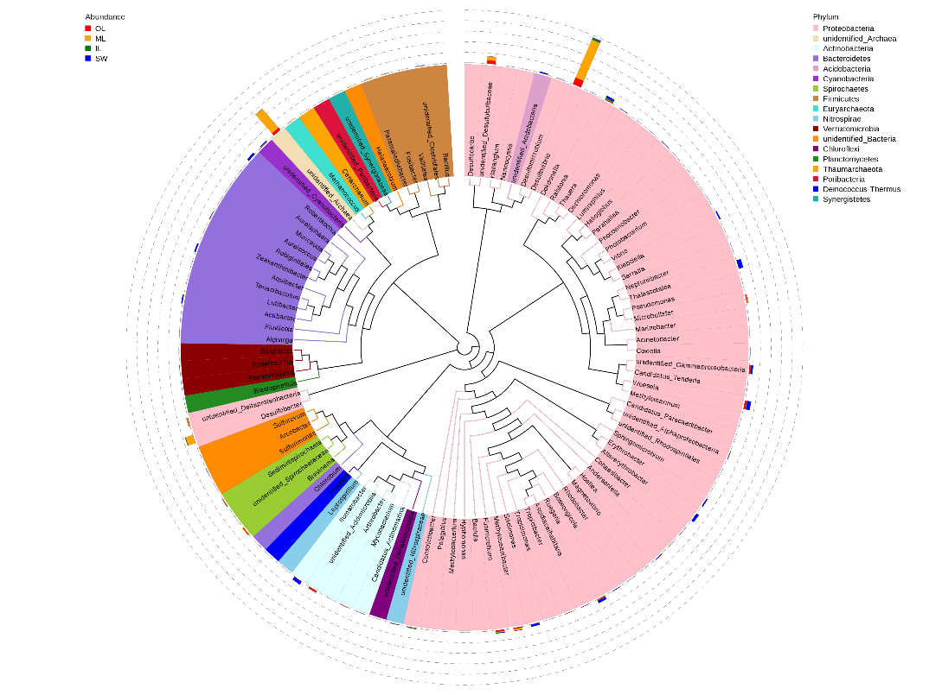Fig. S2. Relative abundances of bacterial 16S rRNA gene sequences from the three rust layers and seawater samples presented at the genus level. In order to further study the phylogenetic relationship of species at the genus level, the phylogenetic relationship of the representative sequences of the top 100 genus was obtained by multiple sequence alignment.

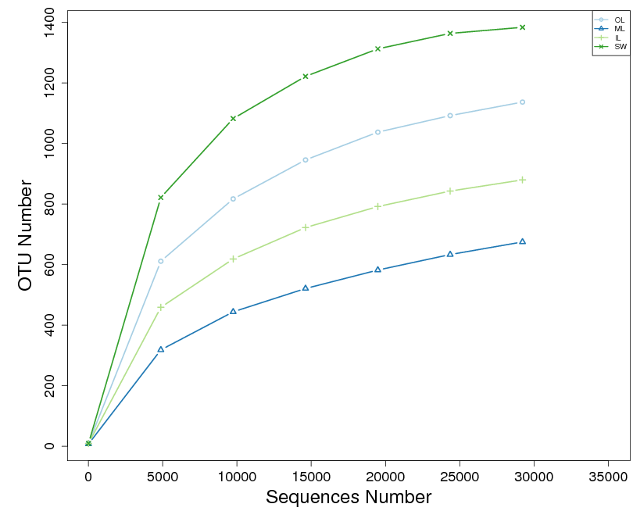
Fig. S3. Rarefaction curves of sequencing reads of 16S rRNA genes from the three rust layers and seawater samples for bacteria.

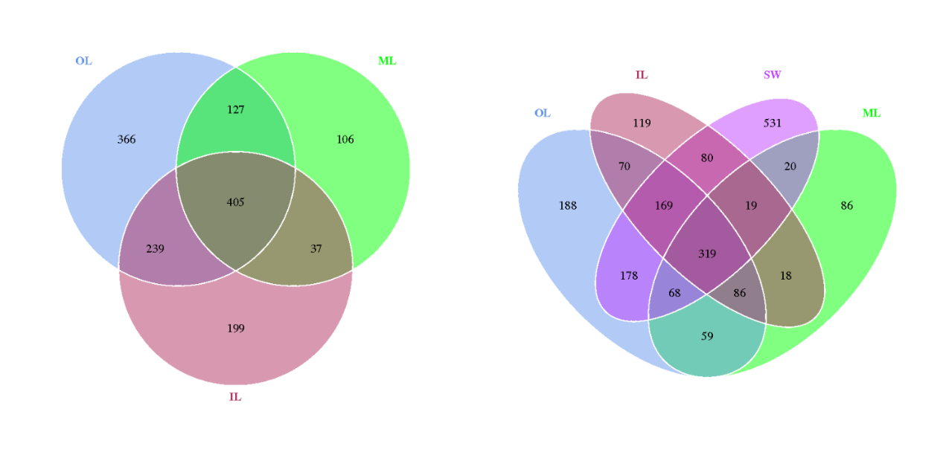
Fig. S4. Venn diagram of bacteria for three rust layers and seawater samples.
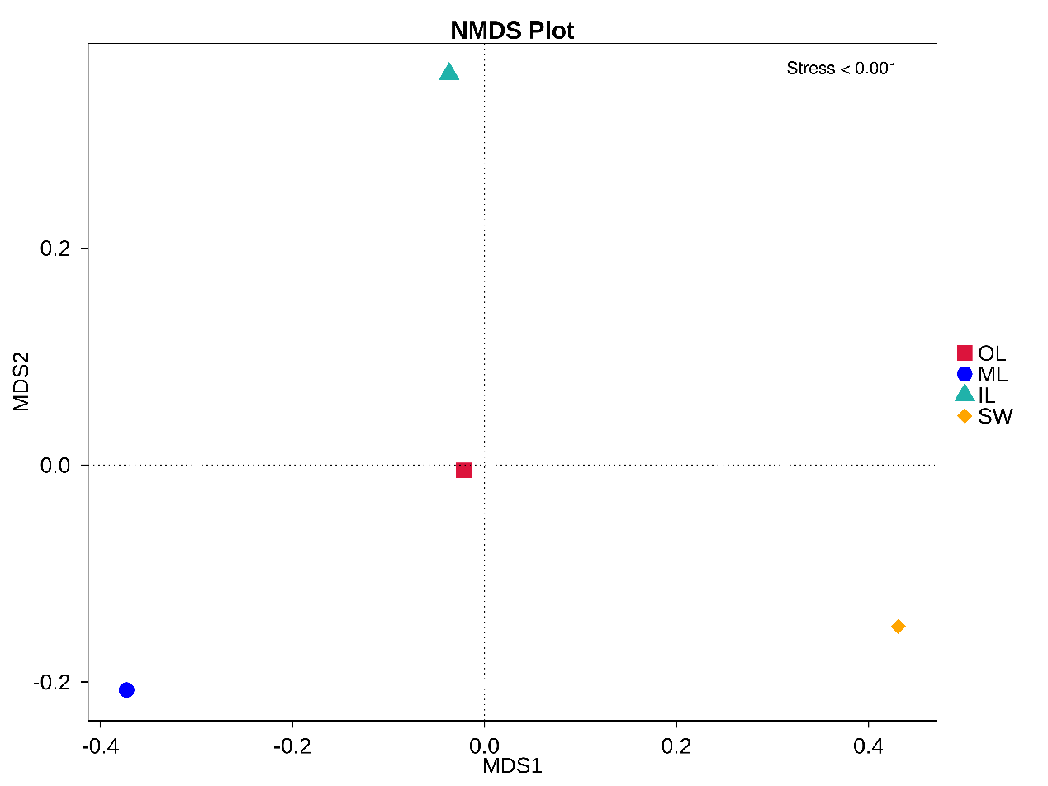Fig. S5. Nonmetric multidimensional scaling (NMDS) plot of Bray-Curtis distances between samples based on OTUs for bacteria.

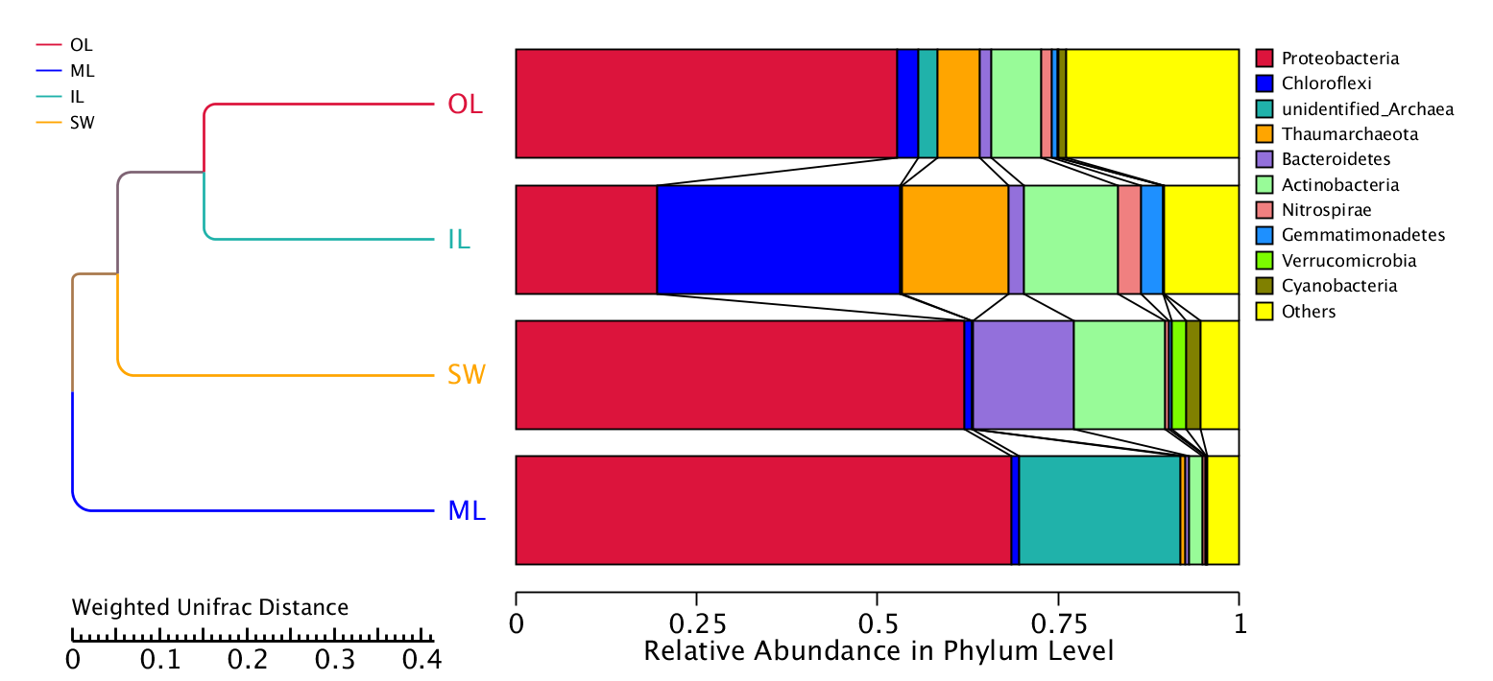
Fig. S6. Hierarchical cluster tree using the weighted pair-group method with arithmetic means (UPGMA) based on the weighted uniface distance for bacteria

