Metabolite profiling of Laminaria hyperborea using hydrophilic interaction liquid chromatography - mass spectrometry (HILIC-MS)

Loïc G. Carvalho^{1*}, Gordon McDougall², William Allwood², Julie Sungurtas², Susan Verrall², Derek Stewart^{2, 3}, Kirsty Neilson⁴, Marianne O'Byrne⁴

*Corresponding author: Loïc G. Carvalho, l.de-carvalho@abertay.ac.uk; ORCID: 0000-0002-8434-928X
1 – School of Applied Sciences, Division of Engineering and Food Science, University of Abertay, Kydd building, Bell Street, DD1 1HG Dundee, Scotland, UK.
2 –The James Hutton Institute, Environmental and Biochemical Sciences Department, DD2 5DA Dundee, Scotland, UK.
3 – Heriot Watt University, School of Engineering and Physical Sciences, Institute of Mechanical, Process and Energy Engineering, EH14 4AS Edinburgh, Scotland, UK.
4 – Marine Biopolymers Limited, KA8 9DJ Ayr, Scotland, UK.

Gordon McDougall ORCID: 0000-0002-2285-0124
William Allwood: 0000-0001-6433-2694
Susan Verrall: 0000-0003-4256-4034
Derek Stewart ORCID: 0000-0001-9838-4265

Supplementary Figures and Tables

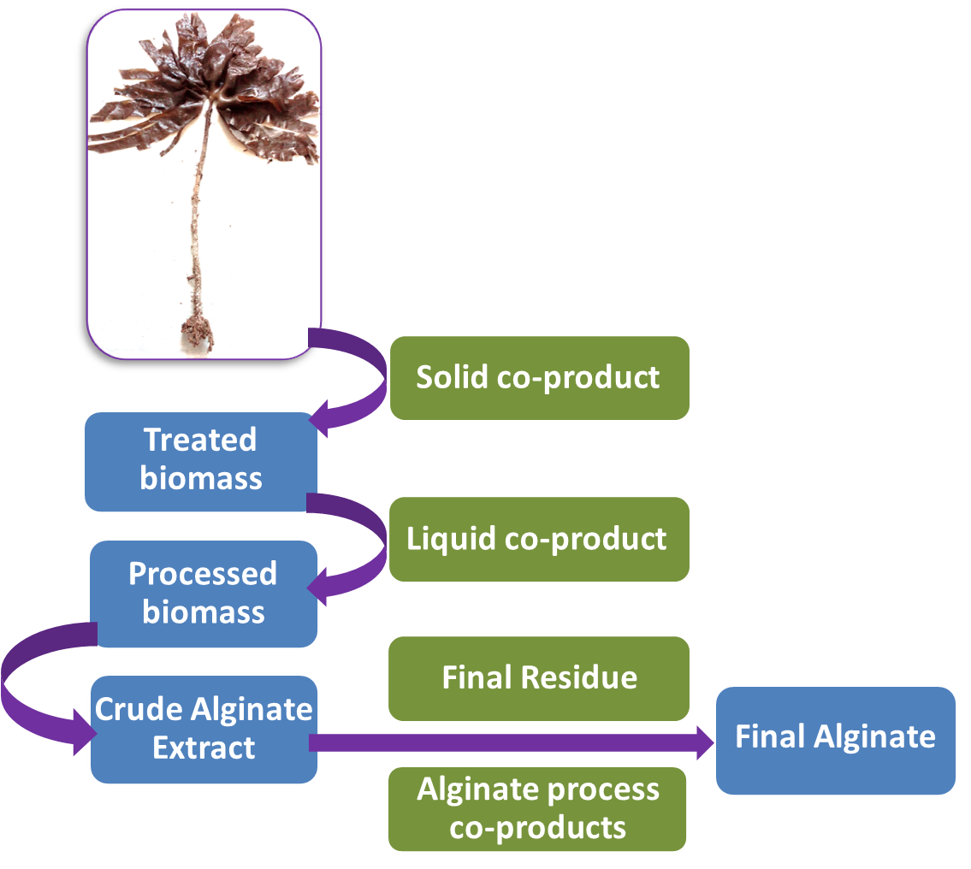
Fig. S1 The MBL alginate extraction process from L. hyperborea
From the whole seaweed along the production stream to high quality alginates (blue), four co-products are produced (green): Solid co-product (MBL SCP); Liquid co-product (MBL LCP); Alginates process co-product; Final residue.

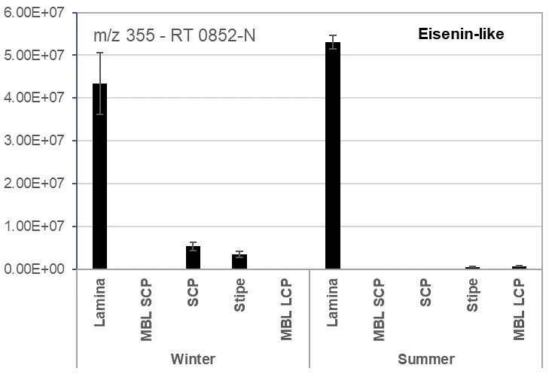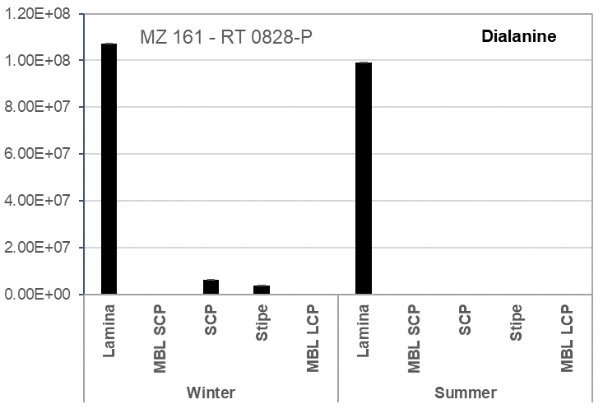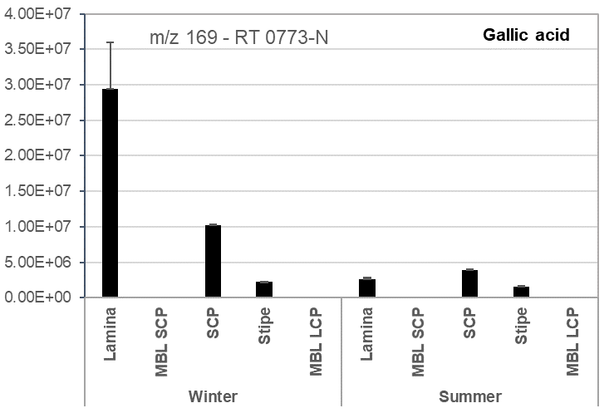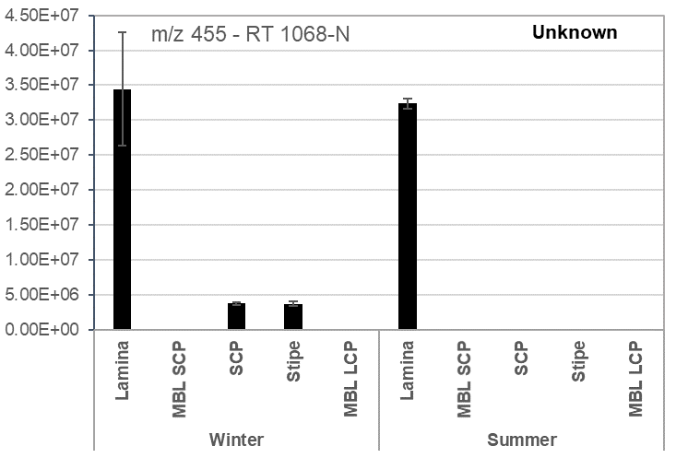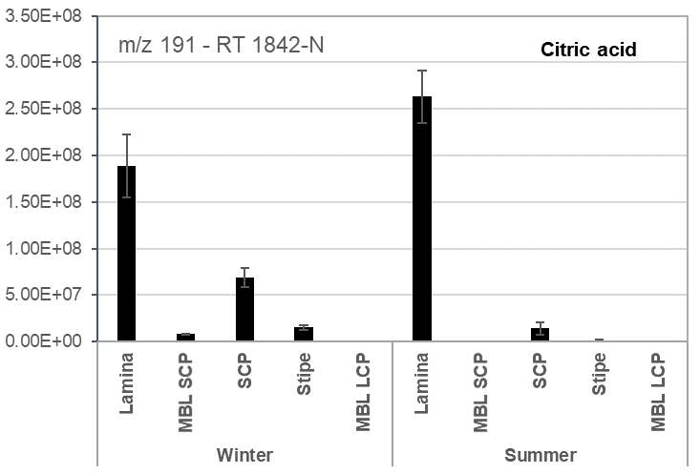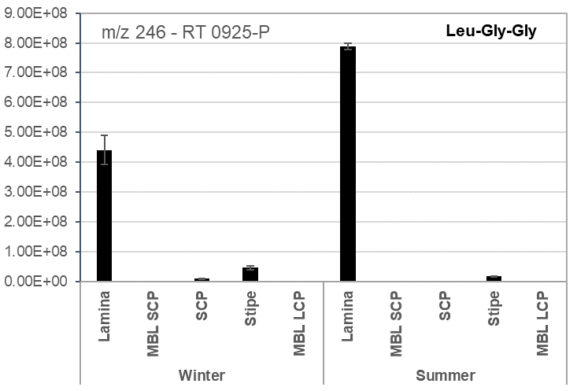

Fig. S2 Relative abundance of metabolites mainly abundant in Lamina

Components are labelled with putative identities, m/z values in positive (P) or negative (N) mode and retention time. All values are peak areas ± SE (n=3)

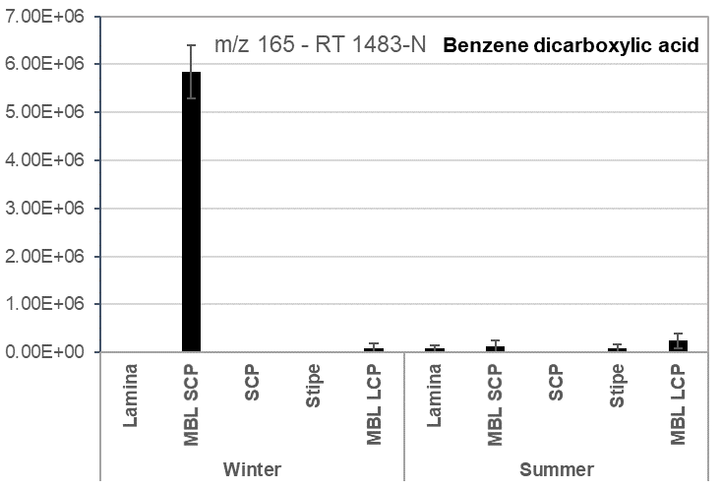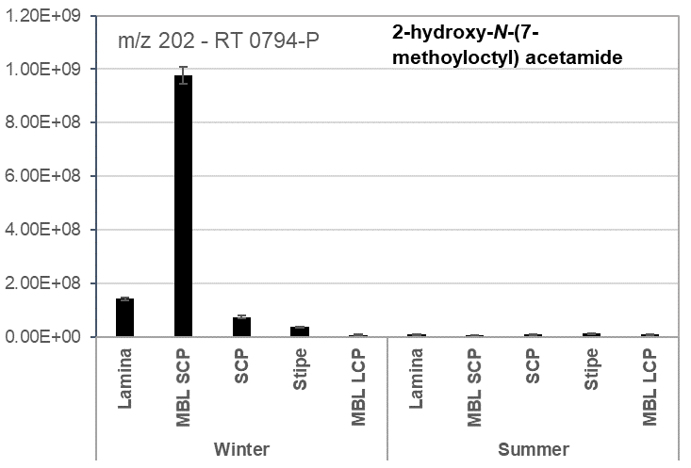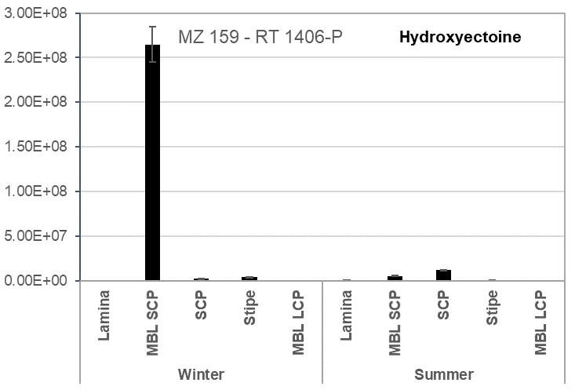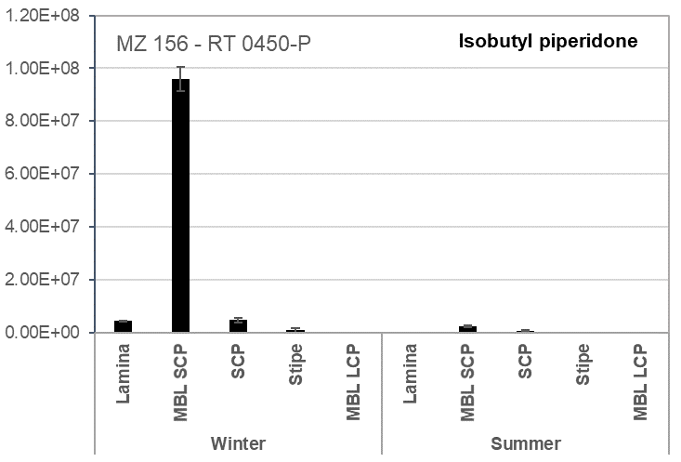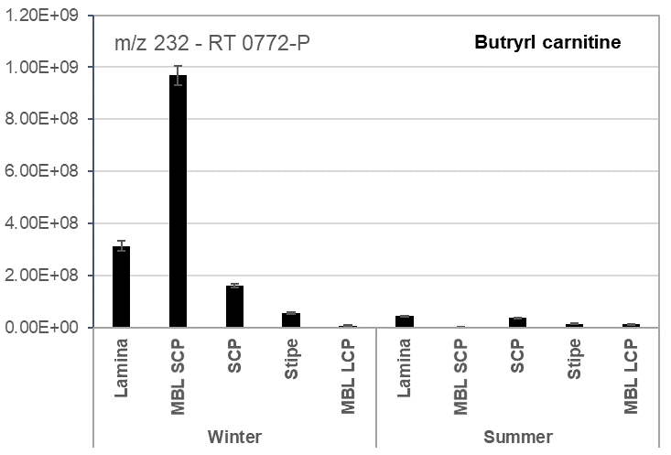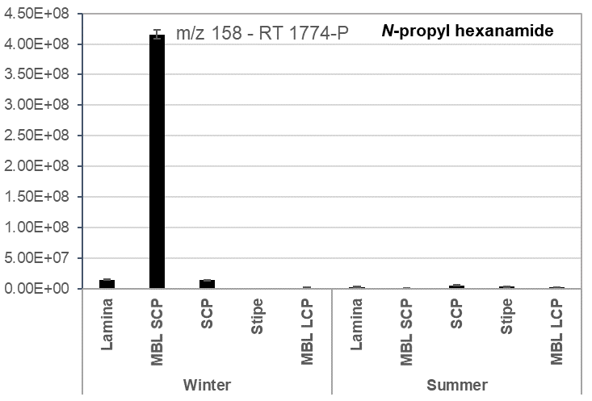Fig. S3 – Relative abundance of metabolites mainly abundant in MBL SCP. Components are labelled with putative identities, m/z values in positive (P) or negative (N) mode and retention time. All values are peak areas ± SE (n=3)

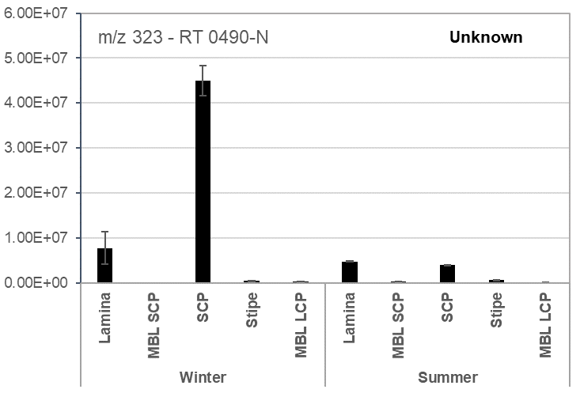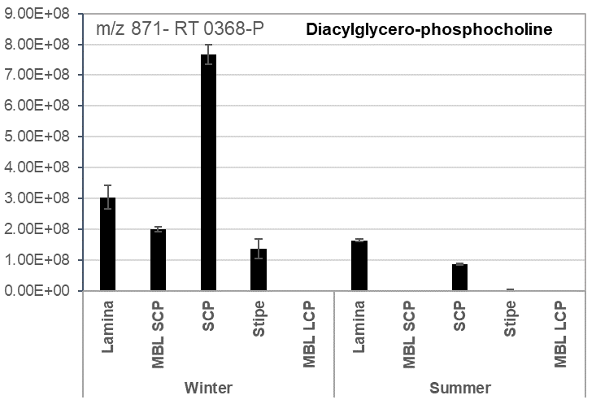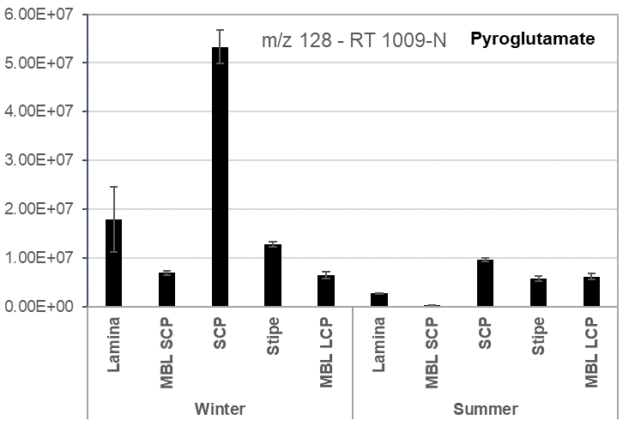
Fig. S4 – Relative abundance of metabolites, mainly abundant in SCP
Components are labelled with putative identities, m/z values in positive (P) or negative (N) mode and retention time. All values are peak areas ± SE (n=3)

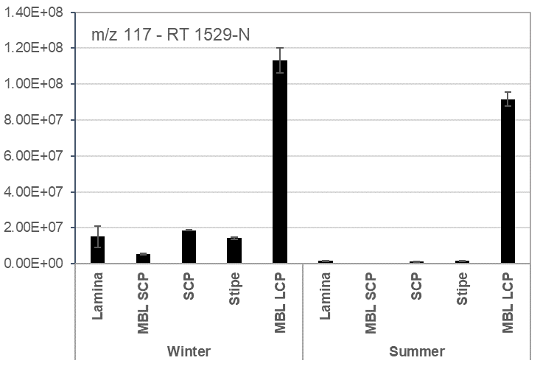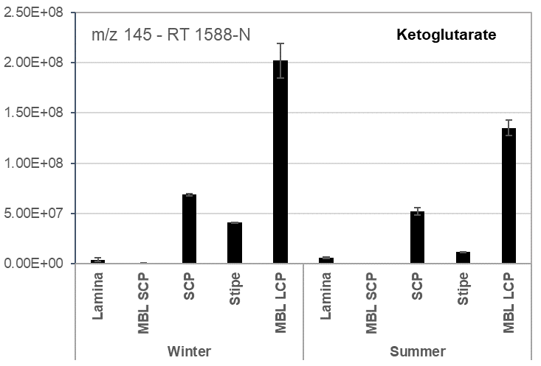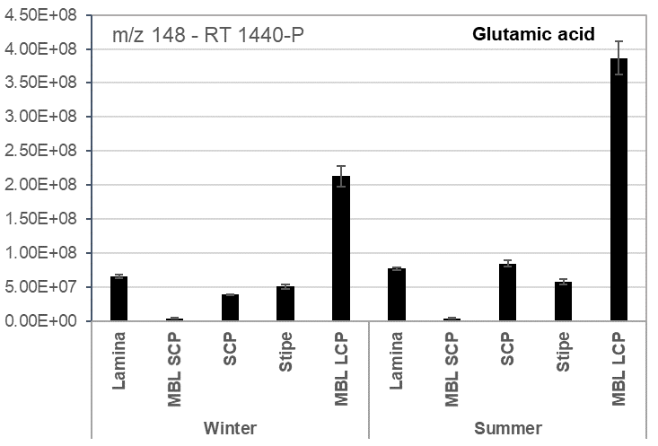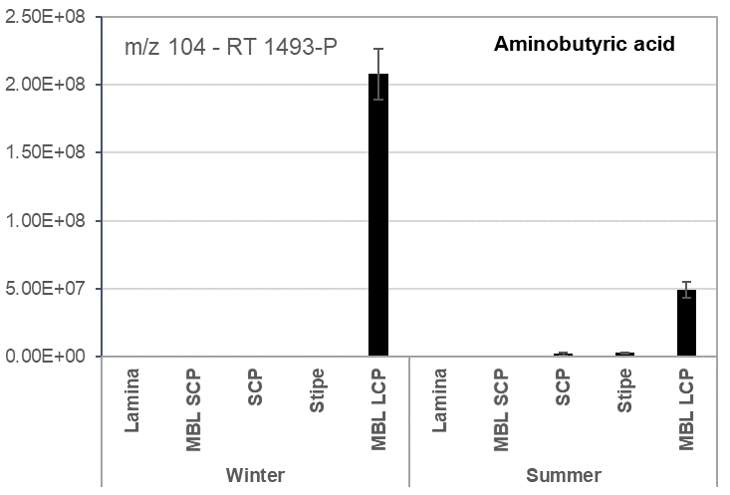

Fig. S5 Relative abundance of metabolites, mainly abundant in MBL LCP
Components are labelled with putative identities, m/z values in positive (P) or negative (N) mode and retention time. All values are peak areas ± SE (n=3)

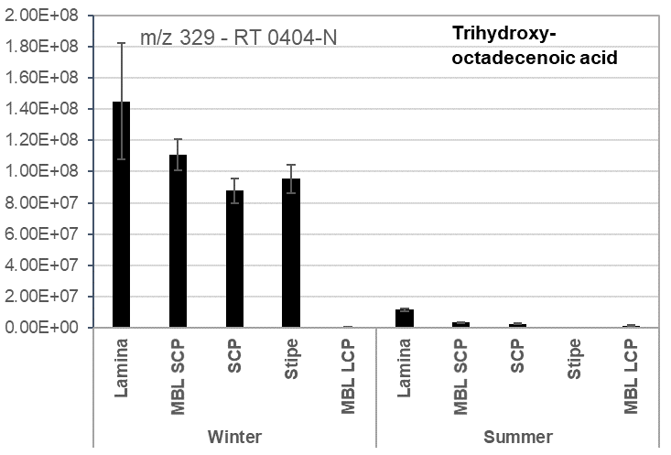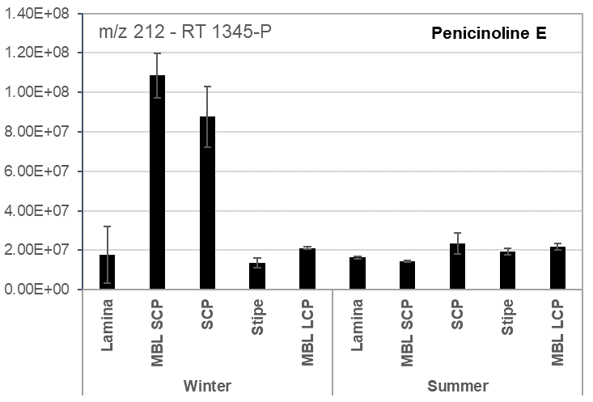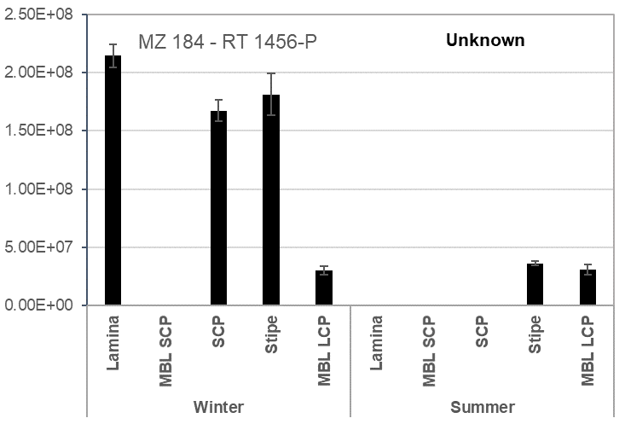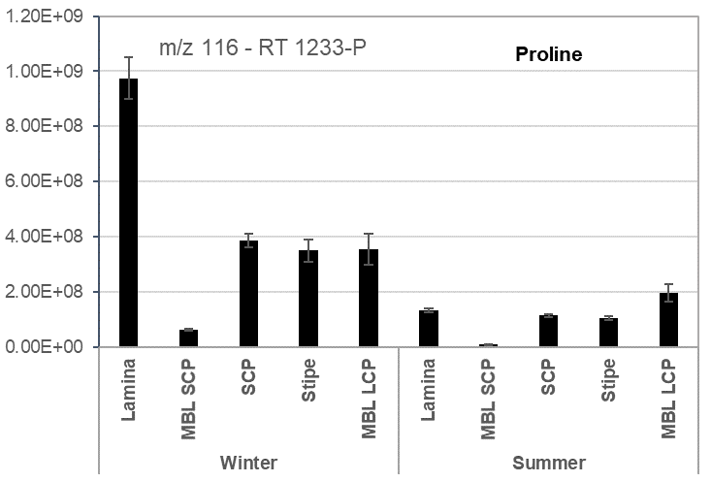

Fig. S6 Metabolites that differed in abundance between W and S
Components are labelled with putative identities, m/z values in positive (P) or negative (N) mode and retention time. All values are peak areas ± SE (n=3)

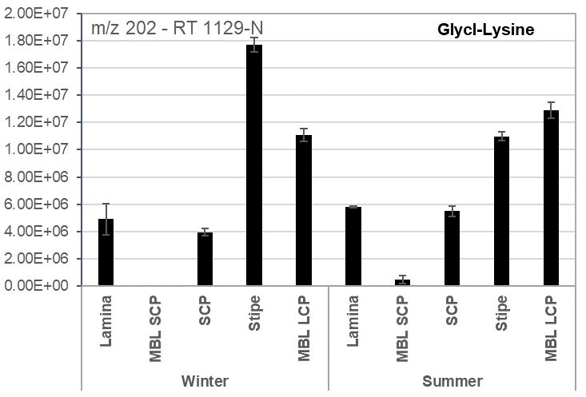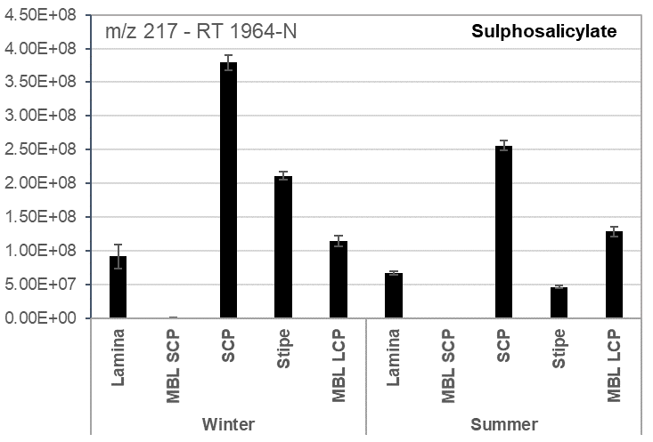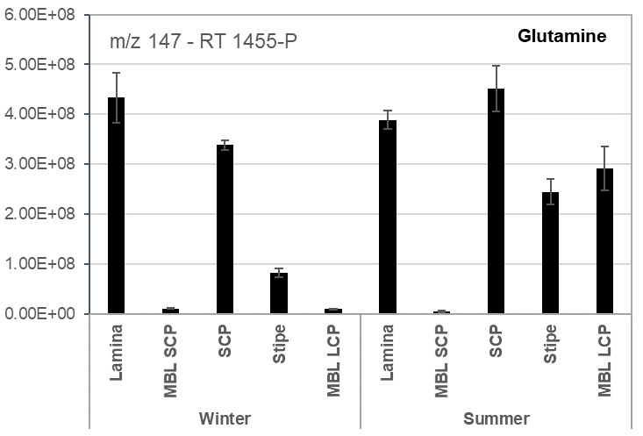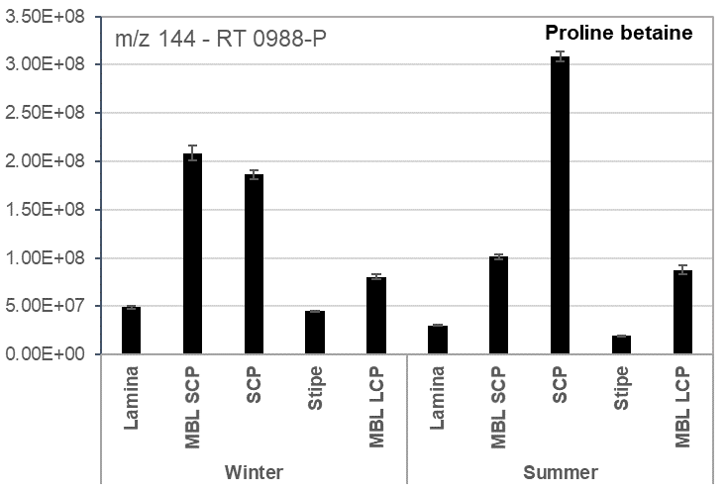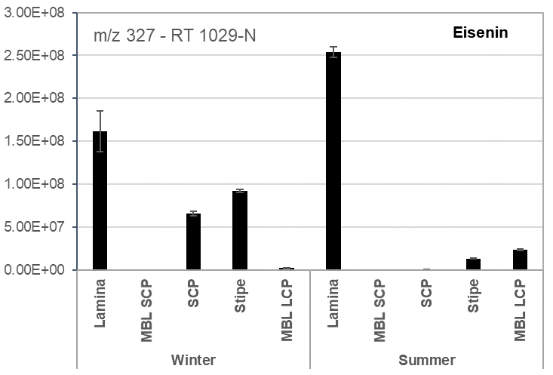 Fig. S7 Metabolites that showed differences in abundance between W and S but only in specific samples
Components are labelled with putative identities, m/z values in positive (P) or negative (N) mode and retention time. All values are peak areas ± SE (n=3)

Table S1 Dry weight yields of winter (W) and summer (S) extracts from L. hyperborea (mg g ⁻¹ DW and % DW)

Fractions | Samples | Winter |  | Summer
Fractions | Samples | mg g⁻¹ | % | mg g⁻¹ | %
MeOH | MBL SCP | 100.42 | 10.04 | 141.02 | 14.10
MeOH | SCP | 142.80 | 14.28 | 126.04 | 12.60
MeOH | Stipe | 100.99 | 10.10 | 222.13 | 22.21
MeOH | Lamina | 162.74 | 16.27 | 242.81 | 24.28
H₂0 | MBL SCP | 886.07 | 88.61 | 850.90 | 85.09

