SUPPLEMENTARY MATERIALS.
Leaving disturbance legacies conserves boreal conifers and maximizes net CO₂ absorption under climate change and more frequent and intense windthrow regimes.
Landscape Ecology
Wataru Hotta, Chihiro Haga, Junko Morimoto, Suzuki N. Satoshi, Takanori Matsui, Toshiaki Owari, Hideaki Shibata, Futoshi Nakamura.

Corresponding author: W. Hotta
Graduate School of Agriculture, Hokkaido University, Japan
E-mail: w-hotter97thank-you@eis.hokudai.ac.jp

S1. Validations
- Long-term dynamics of remnant forests
The simulation results of long-term biomass and species composition were validated by comparison with field-based data. The data from experimental plots of natural forestry were used for reference field-based data. Plots of conserved forests, where forest management has not been conducted for over 50 years, were extracted from experimental plots of natural forestry. Additionally, we checked each piece of raw data, and the data of plots where disturbances did not occur within the duration that data were available were finally used.
Regarding all plots, the LANDIS-II initial communities were created from the oldest measured data, and simulations were performed for the number of years for which measured data were available. Simulation results were validated by comparison with the newest measured data (Figure S1). In Plot IDs A, B, and C, which were located near treelines, the aboveground biomass growth and cohort establishment of Abies sachalinensis and Picea jezoensis were overestimated in the simulation. In Plot IDs D and H, the aboveground biomass growth and cohort establishment of Picea glehnii were overestimated in the simulation. However, the forest area near the treeline accounted for a very small proportion of the total landscape, and the aboveground biomass of P. glehnii accounted for only 2% of the total aboveground biomass of the landscape. Therefore, the impact of these factors on the overall result was considered to be very small.
- Dynamics of carbon stocks of dead wood and soils, net primary production (NPP), and net ecosystem production (NEP)
No data on dead wood and soil carbon stocks, NPP, or NEP changes were actually measured in the study landscape. Therefore, qualitative validation was conducted by comparison with data measured in other areas with similar climatic zones, stand structures, and dominant species.

Figure S1. Validation results of the long-term dynamics of aboveground biomass and species composition in undisturbed forests.

S2. Detailed explanation and limitations related to the selection of windthrow grids
Windthrow risk is influenced not only by stand age but also by the wind direction, wind intensity, diameter at breast height, tree height, forest structures, topography, and so on (Jalkanen & Mattila, 2000; Rich et al., 2007; Ruel et al., 1998). Previous studies have reported that the risk of windthrow is greater in individual trees with larger diameters at breast height or tree heights (Rich et al., 2007), and in stands that have homogeneous structures (Jalkanen & Mattila, 2000). However, predicting windthrow risk is very challenging because it varies greatly among regions and among windthrow events (Dobor et al., 2020). Because a detailed evaluation of windthrow risk is beyond the scope of the objectives of this study, the windthrow risk was determined only by the stand age. In addition, climate change is projected to increase the frequency and intensity of windthrow, but there is significant uncertainty in climate model predictions of windthrow event occurrence (Dobor et al., 2020). In this study, in addition to the current windthrow regime scenario based on past windthrow records in the study landscape, three hypothetical windthrow scenarios under climate change were prepared to evaluate the effects of changes in the windthrow regime on forest dynamics. Therefore, these windthrow regime scenarios are not directly linked to the climate scenarios.

References
Dobor, L., T. Hlásny, W. Rammer, S. Zimová, I. Barka, and R. Seidl. 2020. "Is Salvage Logging Effectively Dampening Bark Beetle Outbreaks and Preserving Forest Carbon Stocks?" Journal of Applied Ecology 57: 67–76.
Jalkanen, A., and U. Mattila. 2000. "Logistic Regression Models for Wind and Snow Damage in Northern Finland Based on the National Forest Inventory Data." Forest Ecology and Management 135: 315–30.
Rich, R., L.E.E. Frelich, and P. Reich. 2007. "Wind-Throw Mortality in the Southern Boreal Forest: Effects of Species, Diameter and Stand Age." Journal of Ecology 95: 1261–73.
Ruel, J.C., D. Pin, and K. Cooper. 1998. "Effect of Topography on Wind Behaviour in a Complex Terrain." Forestry: An International Journal of Forest Research 71: 261–5.

S3. Selection of climate scenarios and climate data inputs
Representative concentration pathway scenarios are scenarios that project greenhouse gas emissions (Intergovernmental Panel on Climate Change, 2013), and the future climate (temperature, precipitation, etc.) is projected based on these scenarios by using global climate models. Two representative concentration pathway scenarios were used in this study: RCP2.6 (the lowest emissions scenario developed with the goal of keeping the future temperature increase below 2°C) and RCP8.5 (the scenario in which current emissions continue). The same RCP scenarios have very different projections of future climate depending on the global climate model. In humid climate zones, temperature increase is believed to have a larger impact than precipitation change, and the results of temperature and precipitation projections for the region of interest in this study from five global climate models for RCP2.6 and RCP8.5 are shown in Figure S3.1. In this study, CSIRO-Mk3-6-0×RCP2.6, which has the smallest change in precipitation and temperature among RCP2.6, and GFDL-CM3×RCP8.5, which has the smallest change in precipitation and largest change in temperature among RCP8.5, were used for the future climate scenario to evaluate the impact of temperature increase. The temperature and precipitation changes up to 2100 for each scenario are shown in Figures S3.2 and S3.3. The Agro-Meteorological Grid Square Data (NARO) (Nishimori et al., 2019) was used for each future climate scenario.
To account for the spatial heterogeneity of climatic conditions, we first classified the 1-km resolution mesh climate data of the current climate anomalies into 10 clusters within the target region using the k-means method based on the monthly maximum temperature, monthly minimum temperature, and monthly precipitation. The monthly maximum temperature, monthly minimum temperature, and monthly precipitation were standardized. For each of these climate clusters, current and future climate data were spatially averaged and processed into input data.

References
Intergovernmental Panel on Climate Change. 2013. Climate Change 2013: The Physical and Science Basis. Cambridge, UK: Cambridge University Press.
Nishimori, M., Y. Ishigooka, T. Kuwagata, T. Takimoto, and N. Endo. 2019. "SI-CAT 1km-Grid Square Regional Climate Projection Scenario Dataset for Agricultural Use (NARO2017)." Journal of the Japan Society for Simulation Technology 38: 150–4.

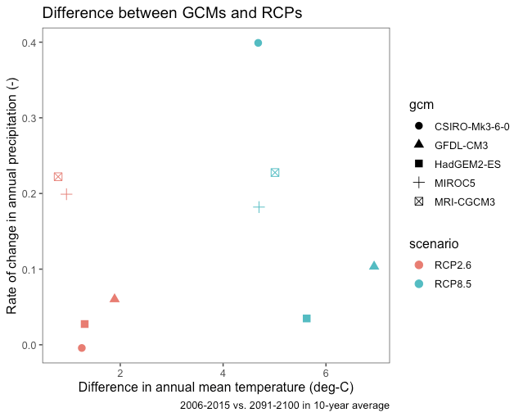
Figure S3.1. Differences in climate projections for each global climate model in RCP2.6 and 8.5.
The x-axis shows the increase in annual mean temperature (difference between the 2006-2015 average and the 2091-2100 average), and the y-axis shows the increase in annual precipitation (difference between the 2006-2015 average and the 2091-2100 average). The color of each point indicates the representative concentration pathway scenario, and the shape of each point indicates the global climate model.

Figure S3.2. Future temperature changes under each climate scenario in the study landscape.

Figure S3.3. Future precipitation changes under each climate scenario in the study landscape.

S4. Calculation of CO₂ emissions by factor
The CO₂ emissions by salvage logging (CE_{Salvage}) were estimated by multiplying the amount of dead wood carbon salvaged by an estimated CO₂ emission factor (Equation S4.1, Table S4).
CE_{Salvage} = C_{Salvaged} * Coefficient_{Salvage} Eqn S4.1
CE_{Salvage}: CO₂ emissions by salvage logging; C_{Salvaged}: the amount of dead wood carbon salvaged; Coefficient_{Type}: the estimated CO₂ emission factor of CO₂ emissions by salvage logging (Table S4).
CE_{Scarification} depends not on the amount of dead wood carbon but on the area scarified. CE_{Scarification} was calculated by multiplying the CO₂ emissions by the scarification per unit area by the windthrow area ratio of the total landscape (Table S4).
CE_{ManufactureLong-lived,} CE_{ManufactureShort-lived,} and CE_{ManufactureWoodenBoard} were estimated by multiplying the amount of dead wood carbon salvaged by the percentages allocated to each use and the estimated CO₂ emission factors (Equation S4.2, Table S4).
CE_{Type} = C_{Salvaged} * AR_{Type} * Coefficient_{Type} Eqn S4.2
CE_{Type}: CO₂ emissions of each type; C_{Salvaged}: the amount of dead wood carbon salvaged; AR_{Type}: the allocation ratio of total timber to each type use; Coefficient_{Type}: the estimated CO₂ emission factor of CO₂ emissions by each type (Table S4). Type: Manufacture Long-lived; Manufacture Short-lived; Manufacture Wooden Board.
Here, AR_{Long-lived} was defined as 0.7, and AR_{Short-lived} was defined as 0.3 (Ministry of Agriculture & Forestry and Fisheries, 2017). AR_{WoodenBoard} was set to 0.245 because it was assumed that all the scrap wood generated during the production process of long-lived products was used in the production of wooden boards (0.7 * (1–0.65) = 0.245; the yield ratio in manufacturing of long-lived products = 0.65). Other possible uses for scrap wood include paper pulp production. In this study, the use of wooden boards was considered to be the best way to utilize scrap wood as a long-lived product, so a scenario was set up in which all scrap wood was used in the production of wooden boards.
Wood products made from salvaged wood are gradually discarded, releasing CO₂ into the atmosphere. Suzuki et al. (2019) calculated the percentage of harvested timber remaining n years after it became a product. In this study, we estimated CO₂ emissions annually from wood products (Equation S4.4) using the formula for wood product retention rates (Equation S4.3) from Suzuki et al. (2019). Note that recycling or the landfill disposal of wood products once disposed of were not considered.
WPRR_{t} = AR_{Long-lived} * YR_{Long-lived} * exp(DR_{Long-lived} * t) +
AR_{WoodenBoard} * YR_{WoodenBoard} * exp(DR_{WoodenBoard} * t) +
AR_{Short-lived} * YR_{Short-lived} * exp(DR_{Short-lived} * t) … Eqn S4.3
CE_{WoodProductsDecomposed t} = C_{Salvaged} * (WPRR_{t-1} -WPRR_{t}) … Eqn S4.4
t: years since salvage logging (t ≥ 1); WPRR_{t}: wood products retention ratio in year t; AR_{Long-lived}: the allocation ratio of total timber to long-lived products (0.7; Ministry of Agriculture & Forestry and Fisheries, 2017); YR_{Long-lived}: the yield ratio in manufacturing long-lived products (0.65; Kamada & Ishiko, 1994); DR_{Long-lived}: the decomposition (disposal) rate of long-lived products (-0.0198; the estimated coefficient with a half-life of 35 years (Tsunetsugu & Tonosaki, 2012)); AR_{WoodenBoard}: the allocation ratio of total timber to wooden board (0.245); YR_{WoodenBoard}: the yield ratio in manufacturing wooden board (1.0); DR_{WoodenBoard}: the decomposition (disposal) rate of wooden board (-0.02773; the estimated coefficient with a half-life of 25 years (Tsunetsugu & Tonosaki, 2012)); AR_{Short-lived}: the allocation ratio of total timber to short-lived products (0.3; Ministry of Agriculture & Forestry and Fisheries, 2017); YR_{Short-lived}: the yield ratio in manufacturing short-lived products (1.0); DR_{Short-lived}: the decomposition (disposal) rate of short-lived products (-0.347; the estimated coefficient with a half-life of 2 years); CE_{WoodProductsDecomposed t}: CO₂ emissions by the disposal of wood products made from salvaged woods after t years.
Although CO₂ is also emitted from vehicles when transporting windfall trees, it has been noted that CO₂ emissions during transport are relatively small (Owari et al., 2011) and were excluded from this study.

References
Forestry Agency Wood Utilization Division. 2016. Wood Use Promotion and Energy Conservation CO₂ Emission Reduction Demonstration Project Report. https://www.rinya.maff.go.jp/j/riyou/mieruka/attach/pdf/kankyoukouken-5.pdf. (accessed 23 March 2022).
Hudiburg, T.W., B.E. Law, W.R. Moomaw, M.E. Harmon, and J.E. Stenzel. 2019. "Meeting GHG Reduction Targets Requires Accounting for All Forest Sector Emissions". Environmental Research Letters 14: 095005.
Kamada, S., and S. Ishiko. 1994. "Lumaber-Recovery Changes and their Main Causes According to the Statistics." Journal of the Hokkaido Forest Products Research Institute 8: 20–7.
Ministry of Agriculture, and Forestry and Fisheries. 2017. Mokuzai Jukyu Hyou [Wood Supply and Demand table]. http://www.maff.go.jp/j/tokei/kouhyou/mokuzai_zyukyu/. (accessed 23 March 2022).
Nambu, Y., T. Ikaga, H. Hondo, K. Kobayashi, and Y. Tsunetsugu. 2012. "Developing a LCA Database of Wood Materials." The AIJ Journal of Technology and Design 18: 269–74.
Owari, T., N. Kamata, T. Tange, M. Kaji, and A. Shimomura. 2011. "Effects of Silviculture Treatments in a Hurricane-Damaged Forest on Carbon Storage and Emissions in Central Hokkaido, Japan." Journal of Forestry Research 22: 13–20.
Suzuki, S.N., T. Tsunoda, N. Nishimura, J. Morimoto, and J.-I. Suzuki. 2019. "Dead Wood Offsets the Reduced Live Wood Carbon Stock in Forests Over 50 Years after a Stand-Replacing Wind Disturbance." Forest Ecology and Management 432: 94–101.
Tsunetsugu, Y., and M. Tonosaki. 2012. "Forestry and Forest Industry: Data, Theory and Simulation." In Outlook Study on the Forest, edited by Forestry and Forest Products Research Institute, 255–267. Tokyo: Japan Forestry Investigation Committee.

Table S4. CO₂ emission factor related to post-windthrow management
Type | Coefficients | References
Salvage | 0.0099 gC g-salvaged woods C⁻¹ | Forest agency wood utilization division (2016)
Scarification | 5 gC ha⁻¹ | Owari et al. (2011)
Manufacture Long-lived | 0.093 gC g-salvaged woods C⁻¹ | Nambu et al. (2012)
Manufacture Short-lived | 0.15 gC g-salvaged woods C⁻¹ | Hudiburg et al. (2019)
Manufacture Wooden Board | 0.14 gC g-salvaged woods C⁻¹ | Forest agency wood utilization division (2016)
*All coefficients assume direct emissions only.

S5. Sensitivity analysis of cumulative NFCB by the usage of scrap wood
Figure S5.1 shows how the cumulative NFCB changed whether the scrap woods produced in the manufacturing process of long-lived products were used for manufacturing wooden boards or pulps and wood chips. The cumulative NFCB was lower in the scenario in which scrap wood was used for manufacturing pulps and wood chips. Therefore, the scenario adopted for this study was that in which end products were used for wood board production and was the conservative scenario in the context of CO₂ emissions.

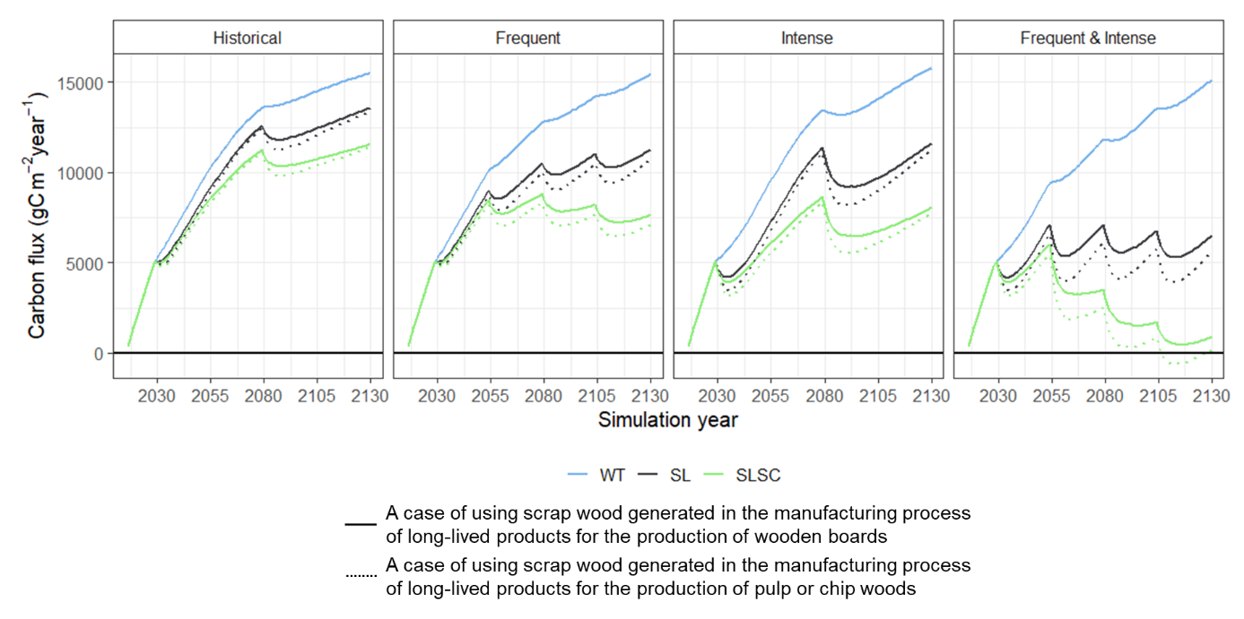
Figure S5.1. Changes in cumulative NFCB by the usage of scrap wood.

S6. Aboveground biomass of A. sachalinensis, Picea spp., Betula spp., Q. crispula, and S. senanensis in 2130.

Figure S6. Aboveground biomass of A. sachalinensis, Picea spp., Betula spp., Q. crispula, and S. senanensis in 2130. Rows and columns indicate climate scenarios and windthrow regime scenarios, respectively. The X-axis indicates post-windthrow management scenarios. WT: windthrow only; SL: salvage logging; SLSC: salvage logging and scarification.

S7. Sensitivity analysis of post-windthrow management-related CO₂ emissions and the NFCB associated with fuel decarbonization
Under the RCP2.6 scenario, the CO₂ emissions peaked in 2020 and declined to zero net anthropogenic CO₂ emissions in approximately 2073. The CO₂ emission factors used in this study were current values and did not assume changes in emission coefficients over the simulation period. Therefore, for the RCP2.6 scenario, a sensitivity analysis was conducted to determine how much the post-windthrow management-related CO₂ emissions and NFCB would change if the fossil fuel use rates were gradually reduced. For simplicity, the CO₂ emission factor was assumed to decrease linearly and monotonically from 2020 to 2073. For the coefficients listed in Supplementary materials S4: Table S4, the CO₂ emission coefficients were dynamically changed by multiplying by 43/53 for the 2030 windthrow, by 18/53 for the 2055 windthrow, and by 0 for the 2080 and 2105 windthrows. The post-windthrow management-related CO₂ emissions decreased significantly, especially at the timing of windthrow in 2055, 2080, and 2105. However, the CO₂ emissions from the disposal of products made from salvaged wood remained significant. As a result, the cumulative NFCB in SL and SLSC was larger than that in the RCP2.6 scenario, which did not account for anthropogenic CO₂ emission reductions but still differed significantly from WT. Even with the advance of decarbonization, leaving dead wood would be the optimal management action for conserving the carbon sink function of the forest sector.
Figure S7.1. CO₂ emissions related to post-windthrow management practices, manufacturing, and the disposal of products. Bar graphs indicate CO₂ emissions related to post-windthrow management in 2030, 2055, 2080, and 2105.

Figure S7.2. Chronological changes in the net forest sector carbon balance (NFCB) and cumulative NFCB.

