Supplementary Materials

Microtissue-Based Bioink as A Chondrocyte Micro-Shelter for DLP Bioprinting

Xinfang Xie^{1,2}, Shuang Wu^{1,2}, Shan Mou^{1,2}, Nengqiang Guo^{1,2}, Zhenxing Wang^{1,2}*, Jiaming Sun^{1,2}*

¹Department of Plastic Surgery, Union Hospital, Tongji Medical College, Huazhong University of Science and Technology, Wuhan 430022, China
²Wuhan Clinical Research Center for Superficial Organ Reconstruction, Wuhan 430022, China

*Corresponding authors. Email: benjamin.wzx@163.com (Zhenxing Wang); sunjm1592@sina.com (Jiaming Sun)

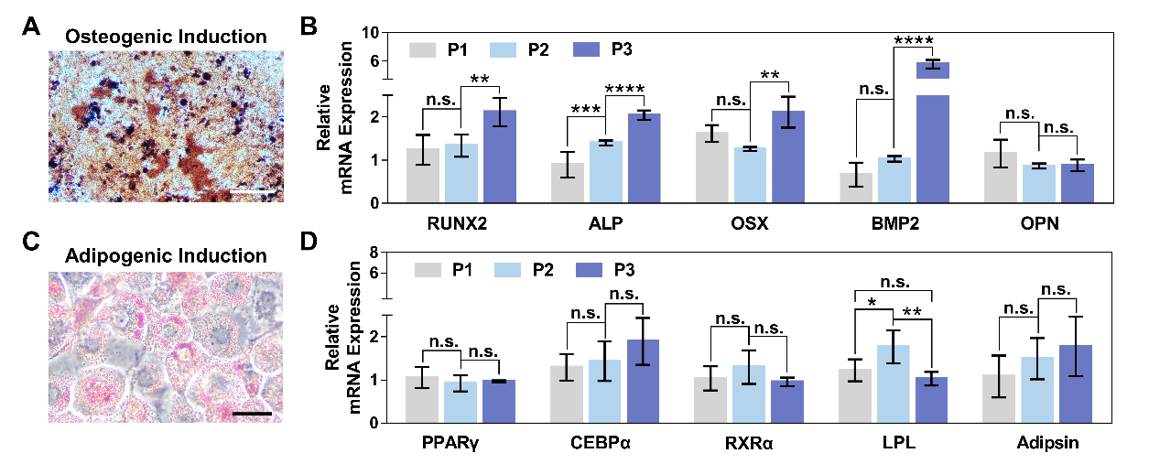
Fig. S1. Osteogenic and adipogenic differentiation of microtia chondrocytes. (A) Alizarin red S staining of microtia chondrocytes 14 days after osteogenic induction (scale bar: 50μm). (B) mRNA expression analysis of osteogenesis-related genes in P1, P2 and P3 microtia chondrocytes (**p<0.01, ****p<0.0001). (C) Oil Red O staining of microtia chondrocytes 21 days after adipogenic induction (Scale bar: 10μm). (D) mRNA expression analysis of adipogenesis-related genes in P1, P2 and P3 microtia chondrocytes (*p<0.05, **p<0.01).

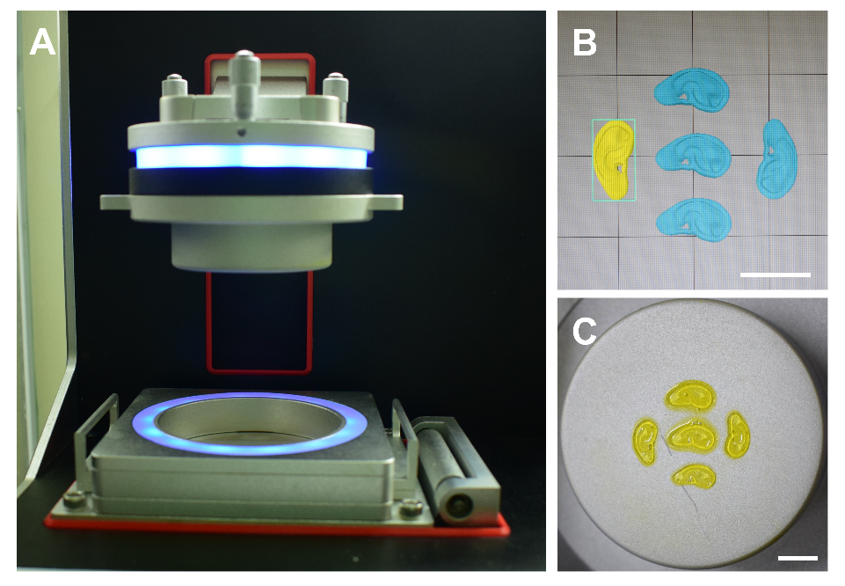
Fig. S2. (A) DLP bioprinter, (B) printed model and (C) finished product (scale bar: 10mm).

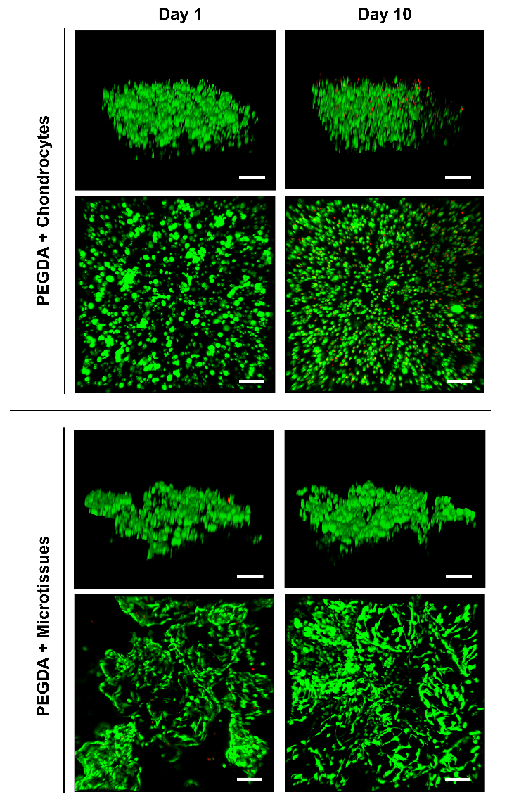
Fig. S3. Live/Dead staining images of PEGDA+Chondrocytes and PEGDA+Microtissues at day1 and day10 (scale bar: 100μm).

Table S1. Primer sequences used for qRT-PCR
Gene name | Gene symbol | Forward primer (5’-3’) | Reverse primer (5’-3’)
Glyceraldehyde-3-phosphate dehydrogenase | GADPH | TCAAGAAGGTGGTGAAGCAGG | TCAAAGGTGGAGGAGTGGGT
Collagen, type II α 1 | COL2A1 | TCCAGATGACCTTCCTACGC | GGTATGTTTCGTGCAGCCAT
Aggrecan | Aggrecan | TGAGCGGCAGCACTTTGAC | TGAGTACAGGAGGCTTGAGG
Elastin | Elastin | ACCTCTTAAGCCAGTTCCCG | CAGACACTCCTAAGCCACCA
Octamer transcription factor 4 | OCT4A | CAGCGACTATGCACAACGAG | AGAGTGGTGACGGAGACAGG
Nanog | NANOG | CCACCAGTCCCAAAGGCAAACAACC | CCCTGCGTCACACCATTGCTATTCT
Sex determining region Y-box 2 | SOX2 | CCAGGAGAACCCCAAGATGCACAAC | GACCCCGCTCGCCATGCTATT
Runt-related family transcription factor 2 | RUNX2 | GGCGGGTAACGATGAAAATT | GAGGCGGTCAGAGAACAAACTA
Alkaline phosphatase | ALP | GACAAACTGGGGCCTGAGATA | CTGACTTCCCTGCTTTCTTGG
Osterix | OSX | TCTCTGGACATGACACACCC | AGGGGAGCAAAGTCAGATGG
Bone morphogenetic protein 2 | BMP2 | TGCACCAAGATGAACACAGC | GTGGCAGTAAAAGGCGTGAT
Osteopontin | OPN | ACTGATTTTCCCACGGACCT | CTCCTCGCTTTCCATGTGTG
Peroxisome proliferator-activated receptor γ | PPARγ | AAGACCACTCCCACTCCT | ATCTCCACAGACACGACA
CCAAT enhancer binding proteins α | CEBPα | TGCCGGGAGAACTCTAACTC | TCGATGTAGGCGCTGATGTC
Retinoid X receptor α | RXRα | CTGCATTCTCCCATCAGCAC | CTGACGGGGTTCATAGGTGA
Lipoprteinlipase | LPL | GGACTTGGAGATGTGGACCA | TGCTGCTTCTTTTGGCTCTG
Adipsin | Adipsin | TGGGGCATAGTCAACCACG | AGTCACCCTTGCAGCTGTC

