﻿Supporting Information

Hybrid molecular graphene transistor as an operando and optoelectronic platform

Jorge Trasobares¹, Juan Carlos Martín-Romano¹, Muhammad Waqas Khaliq², Sandra Ruiz-Gómez², Michael Foerster², Miguel Ángel Niño², Patricia Pedraz¹, Yannick. J. Dappe³, Marina Calero de Ory⁴, Julia García-Pérez¹, María Acebrón¹, Manuel Rodríguez Osorio¹, María Teresa Magaz³, Alicia Gomez³, Rodolfo Miranda^{4,5}, Daniel Granados¹

Note 1. Electrochemistry 2
Note 2. Raman spectroscopy and optical image 5
Note 3. X-ray photoelectron spectroscopy 6
Note 4. Band diagram 9
Note 5. Density functional theory 10
Note 6. Platform fabrication: Optical, AFM and CAFM images of m-GFET device 12
Note 7. Electrical transport characteristics 13
Note 8. m-GFET electrical configuration 16
Note 9. X-ray absorption spectroscopy 17
Note 10. Photo response 18
References 19

Note 1. Electrochemistry

The ferrocene group is used both in electrochemistry (programable electrochemical rectifier¹) and molecular electronics (molecular diodes²). Cyclic Voltammetry (CV) is applied to quantify the molecular energy (E_{H}), surface coverage (Γ) and intermolecular ﻿coulombic interactions ﻿(φ), the shape of voltammograms is modulated by the molecular interactions^{3–5} where different molecular organizations due to surface roughness may lead to multiple CV peaks^{3,6}. Additionally, oxidation potentials are related with the ionization potentials and work function change (ΔΦ)^{7,8}.
Here the electrochemical characterization of the Au/SC₁₁Fc SAMs presents the representative one electron transfer anodic and cathodic waves. Considering an intermolecular distance of 0.8 Å and an ion pairing distance of 4.9 Å, we can extract an average value per molecule-molecule coulombic interaction of φ=18 meV (Equation 4 Theoretical Methods). Au/SC₁₁Fc//Gr SAMs reveals the oxidation and reduction waves appearing at the same energy level. E_{H} falls in the expected range² (280 mV vs AgAgCl reference electrode). Γ, area per molecule, obtained from the charge involved in the process is 0.32 nm²/molecule close to the accepted values often reported in the field for the “standing up” conformation³. The FWHM relates quasi-linearly with the coulombic molecular interactions^{5,9,10}. It indicates uniform distribution of the Fc groups into the SAM.

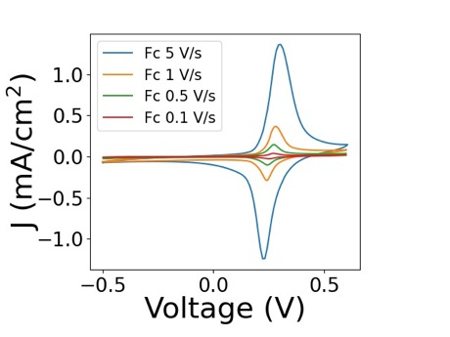
Figure S1. Chemical characterization of the Au/SC₁₁Fc. Au/SC₁₁Fc CV recorded at the 6 mm diameter gold working electrodes at 0.1, 0.5, 1 and 5 V/s versus Ag/AgCl reference electrode and 1 M NaClO₄ electrolyte.

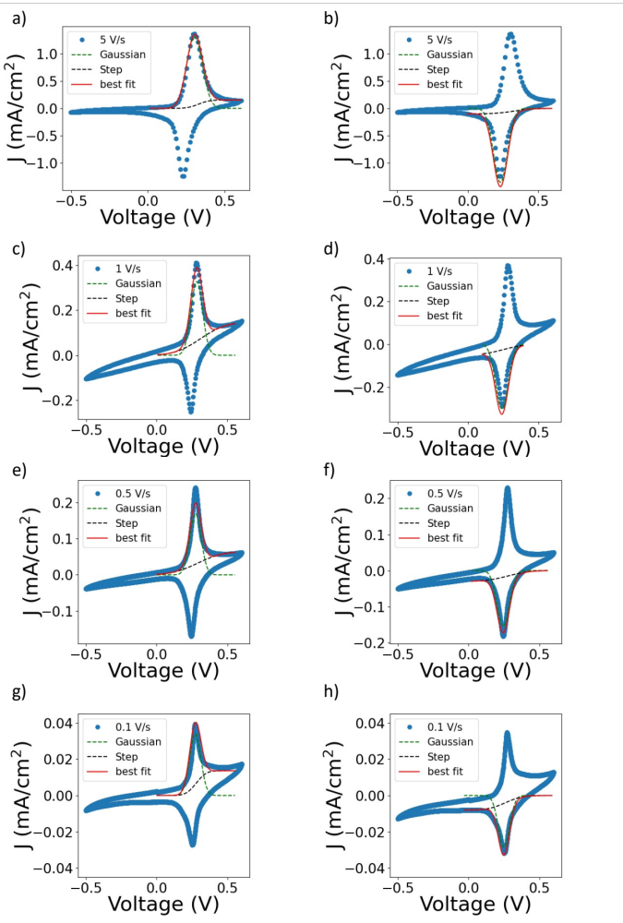
Figure S2. Fitting of the electrochemical waves for Au/SC₁₁Fc SAMs at different scan rates. (a,c,e,g) anodic peak at 5, 1, 0.5 and 0.1 V/s, (b, d, f, h) cathodic peak at 5, 1, 0.5, 0.1V/s versus Ag/AgCl reference electrode and 1 M NaClO₄ electrolyte.

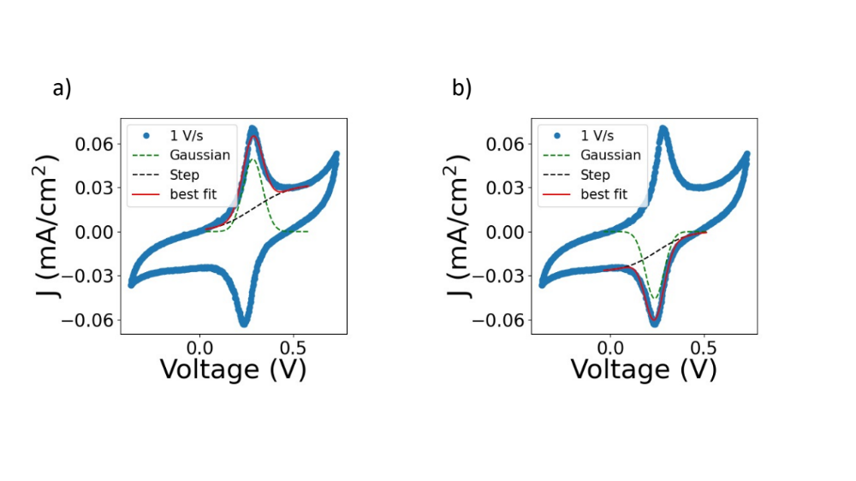
Figure S3. Fitting of the electrochemical waves for Au/SC₁₁Fc//Gr SAMs at 1 V/s. (a) anodic peak, (b) cathodic peak versus Ag/AgCl reference electrode and 1 M NaClO₄ electrolyte.

Table S1. Fitting parameters.

Anodic peak
 |  | Au/SC₁₁Fc |  |  |  |  | Au/SC₁₁Fc//Gr
Scan rate (V/s) |  | 5 | 1 | 0.5 | 0.1 |  | 1
Step | Amplitude (C) | 0.15 | 0.14 | 0.06 | 0.02 |  | 0.032
Step | Center (V) | 0.33 | 0.31 | 0.29 | 0.28 |  | 0.29
Step | Sigma | 0.08 | 0.20 | 0.20 | 0.08 |  | 0.22
Gaussian | Amplitude (C) | 0.17 | 0.034 | 0.017 | 0.004 |  | 0.006
Gaussian | Center (V) | 0.30 | 0.29 | 0.28 | 0.28 |  | 0.29
Gaussian | Sigma | 0.05 | 0.04 | 0.04 | 0.06 |  | 0.05
Cathodic peak
 |  |  | Au/SC₁₁Fc |  |  |  | Au/SC₁₁Fc//Gr
Scan rate (V/s) |  | 5 | 1 | 0.5 | 0.1 |  | 1
Step | Amplitude (C) | 0.10 | 0.05 | 0.03 | 0.01 |  | 0.026
Step | Center (V) | 0.33 | 0.25 | 0.28 | 0.26 |  | 0.25
Step | Sigma | 0.15 | 0.16 | 0.17 | 0.13 |  | 0.18
Gaussian | Amplitude (C) | 0.17 | 0.034 | 0.017 | 0.003 |  | 0.005
Gaussian | Center (V) | 0.23 | 0.25 | 0.26 | 0.27 |  | 0.23
Gaussian | Sigma | 0.15 | 0.16 | 0.03 | 0.03 |  | 0.05

Note 2. Raman spectroscopy and optical image

Optical images and Raman spectroscopy demonstrate the formation of high-quality single layer graphene.
a) b)
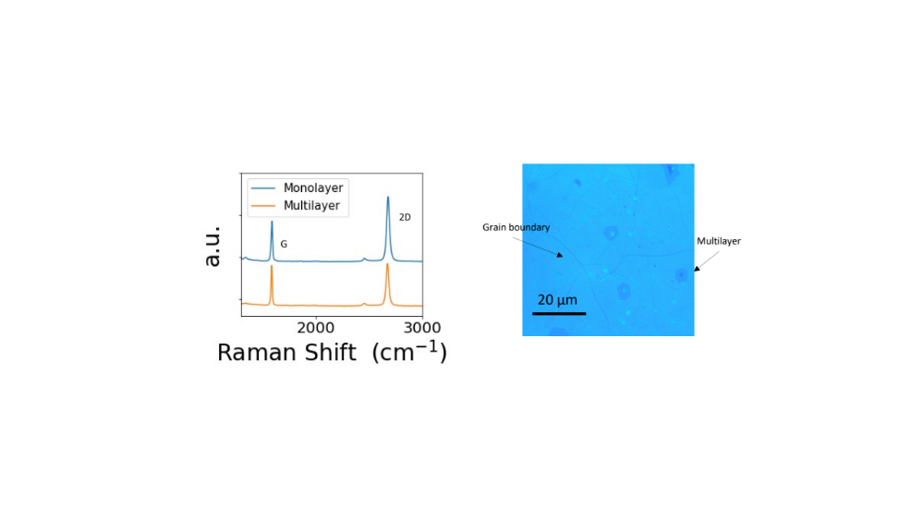

Figure S4. Optical and Raman spectroscopy characterization of a CVD graphene layer transferred on a silicon wafer. (a) Raman spectra from single and multilayer zones. (b) Optical image of the CVD grown graphene.

Note 3. X-ray photoelectron spectroscopy

In Figure S5a, two peaks can be seen, located at E_{b} = 163.0 eV and E_{b} = 161.8 eV which are assigned to S2p ½ and S 2p 3/2 core levels, respectively while in Figure S5b the values are almost the same, E_{b} = 163.0 eV and E_{b} = 161.7 eV. These peaks fall slightly below the value of a S thiol bonded to Au (162.5 eV for S 2p 3/2). The study that agrees with earlier reports^{11–14} includes fresh and aged (60 days at ambient conditions) samples to highlights the effect on the encapsulation over the time.

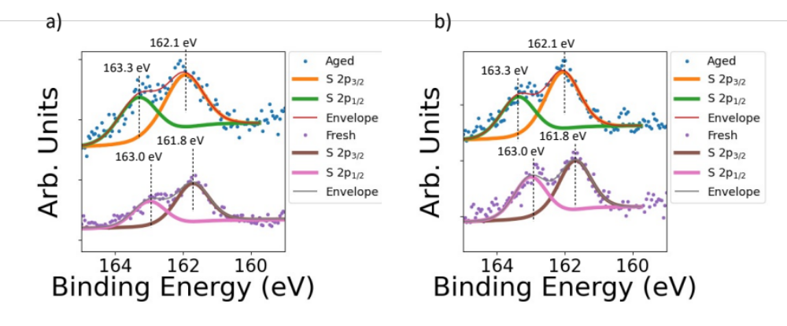
Figure S5 .XPS spectra of a ferrocenyl SAM samples, covered and uncovered by Gr. Core energy levels: (a) S2p on a sample without graphene, (b) S2p in a sample with graphene before and after aging.

The XPS C1s spectra of the unprotected and graphene protected sample and its evolution with time are shown in the Figure S6. For the unprotected ferrocene fresh sample (lower curve of S6a) the main peak is located at 284.6 eV, and we do not distinguish the different contributions of the carbon chain and the carbon in the ferrocene rings. There is some contamination, corresponding to C-OH or C-O components at 286 eV, probably coming from the ferrocene deposition method. For the fresh graphene protected sample (lower curve S6b) the main peak appears at a similar binding energy of 284.7 eV, and we cannot distinguish the graphene from the contribution of the underneath ferrocene. In this sample some other peaks appears at 286, 287.7 y 289 eV, that are compatible with contamination and remaining residues of the transfer process¹⁵For the aged samples (upper curves of S6a and S6b) we observe a clear increase of the carbon contamination peaks in the unprotected sample, but a similar amount of contamination/residues in the fresh and aged graphene sample.

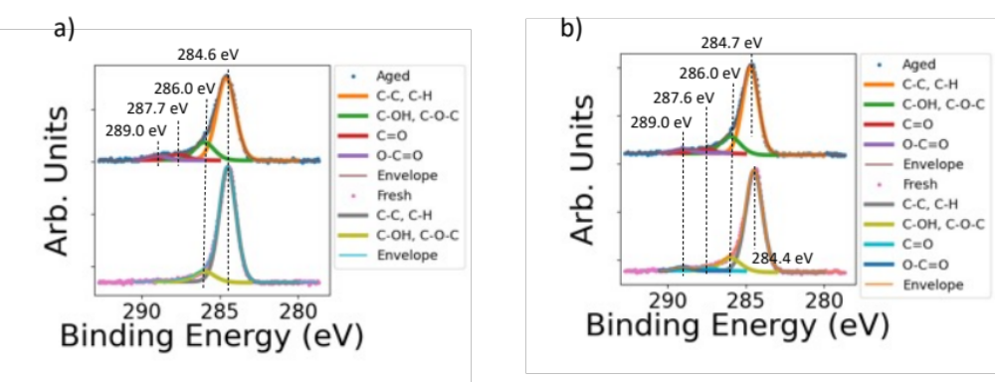

Figure S6. C1s core level spectrum obtained from the measurement of (a) Au/FcC₁₁ and (b) AuFcC₁₁//Gr before and after aging. The main peak of the spectrum, at 284.6 eV, encompasses both the peaks belonging to the ferrocene and the graphene, being both C-C bonds.

During operando measurements shifts in the spectra proportional to the applied voltages are obtained both in the Fc 2p and Au 4f core levels. Additionally, a reversible decrease in the intensity while applying a voltage is observed for the Fc 2p core level. This reduction is not observed in the Au 4f core level intensities that remains unvarying independently of the applied voltage.

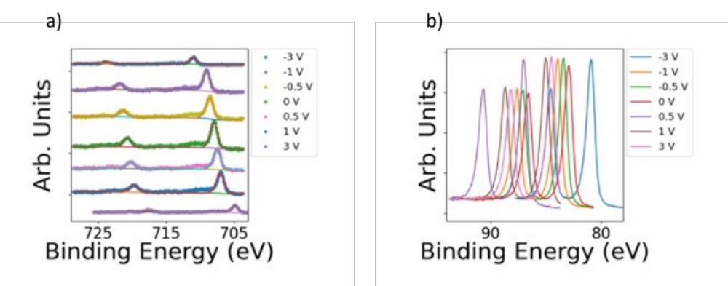
Figure S7. XPS operando spectra. (a) XPS spectra of Fe 2p core level of a Au/SC11Fc//Gr sample to which a range of voltages was applied. (b) Au 4f core level spectra of the same sample.

Note 4. Band diagram

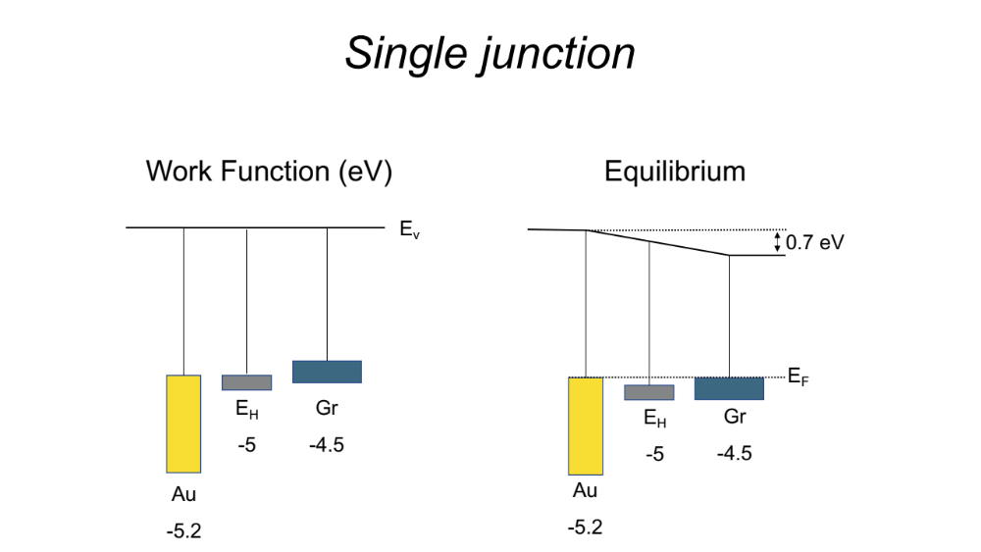

Figure S8. Band diagrams of a gold/molecule/graphene junction. (a) Before equilibrium, (b) in equilibrium. Work functions are expressed in eV.

Note 5. Density functional theory

The corresponding atomic configuration is represented in Figure S9. Within a Density Functional Theory (DFT) formalism, we determine the electronic structure and in particular the projected Density of States (PDOS) of the molecule between the gold and graphene electrodes (Figure S10b). As a result, we can notice a quasi-symmetric distribution of the electronic levels near the Fermi level (at around -0.5 and +0.35 eV). Such distribution let us anticipate a low rectification of the molecular junction, as well as a symmetric evolution of the electronic current when gating the system.

a) b)
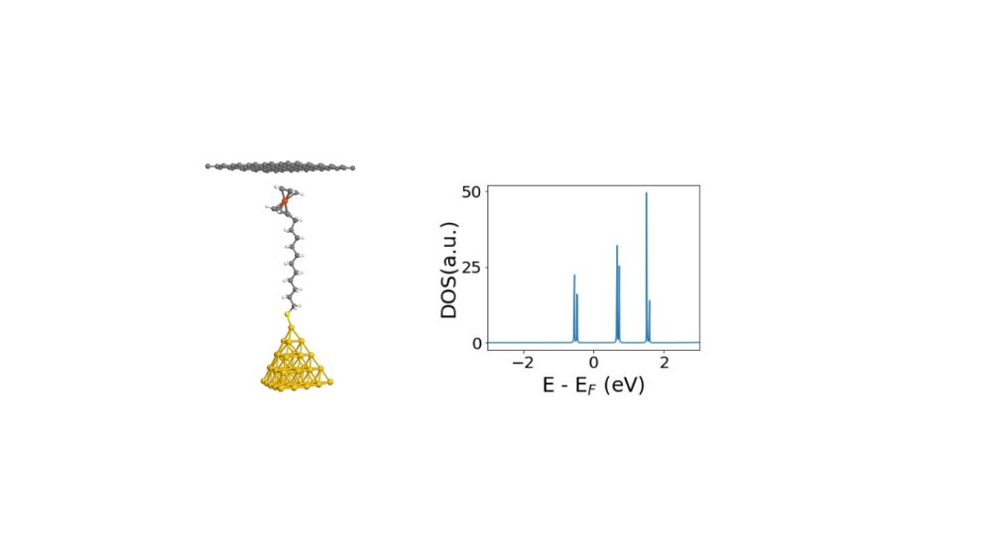
Figure S9. Density Functional Theory. (a) Calculated representation of a single molecule junction, (b) Calculated Density of states of the system of the molecules in the molecular junction.

The electronic transmission of the junction as a function of the energy is presented in Figure S10. The molecular junction with a graphene electrode presents a higher conductance than the junction with only gold electrodes. The introduction of graphene removes the rectification in the Fc junctions.

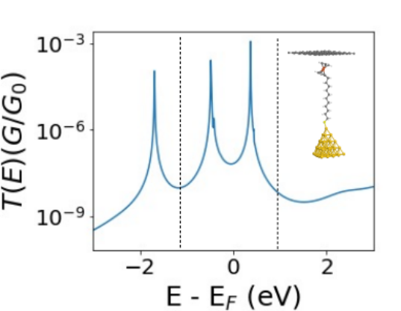
Figure S10. Density Functional Theory. DFT calculated electronic transmission T(E) for the represented source-drain voltages. In inset, the atomic configuration of the model molecular junction used for the calculations.
We can notice the Dirac point is close to the Fermi level. That indicates there is no doping of graphene by ferrocene. Additionally, the total charge of graphene on Fc SAMs is almost equivalent to that of isolated graphene. This can probably be explained by the strong interaction on the other side between gold and thiol, the latter removing the charge from the molecule and the ferrocene, so there is no transfer with graphene.
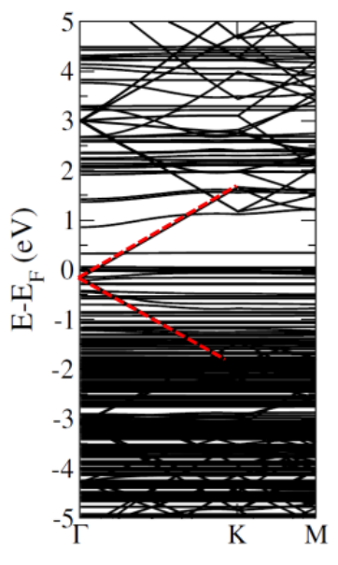

Figure S11. Density Functional Theory. Au/SC₁₁Fc//Gr single molecule system band structure. Highlighted the Graphene Dirac point at Γ.

Note 6. Platform fabrication: Optical, AFM and CAFM images of m-GFET device

Optical images are helpful to discern between single or multiple graphene monolayers as well as its quality. In Figure S12a we can appreciate zones with high quality monolayer, bilayer and multilayers. Once mounted the graphene is mounted in a m-GFET it is reshaped in the area highlighted by the dotted line graphene channel in Figure S12b. 2400 µm² of graphene is directly back gated between the silicon highly doped through the SiO₂. Note that 70% of the graphene is not screened by the electrodes.
a) b)
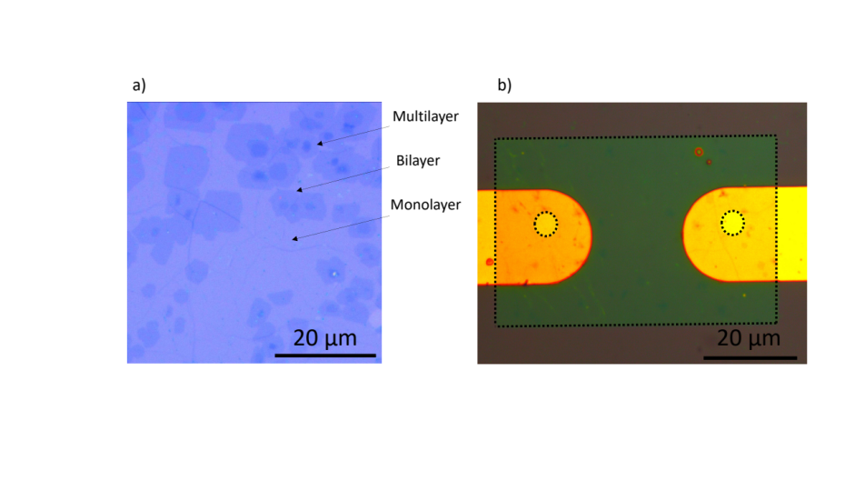
Figure S12 Graphene optical images. (a) 50 x 50 µm image shows areas with multilayer that may play a role especially during the electron transfer. (b) Optical image of a m-GFET.

The topography study of the electrodes prior of molecular functionalization demonstrate that the HfO₂ etching is roughly 8 nm depth and the CAFM current versus voltage demonstrates an ohmic contact with the metallic electrode (c).

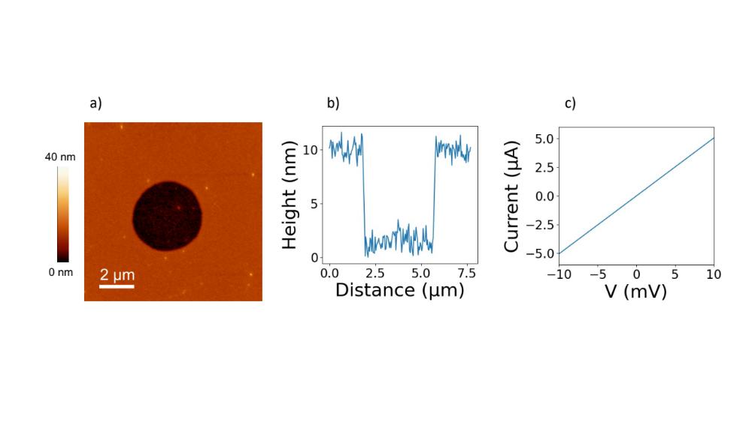

Figure S13. Structural characterization of the electrode. (a) AFM image of the electrode. (b) Topographical cross section. (c) IV curve between the AFM conductive tip and the gold substrate in the etched zone.

Note 7. Electrical transport characteristics

In our fabricated graphene field effect transistors (GFETs) the contact resistance is in order of KΩ while the graphene channel resistance is one order of magnitude lower.

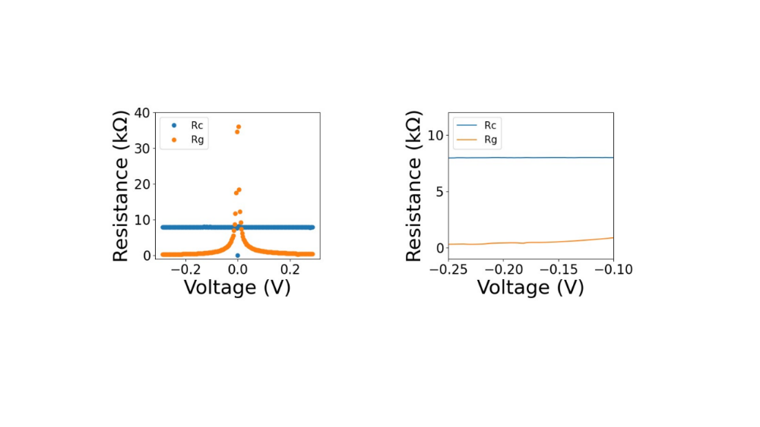
Figure S14. Electrical characerization of the G-FET. (a) Contact and graphene channel resistance between source and drain in the G-FET.

A key feature in the GFETs is the type (holes and electrons) and density of carriers in the channel that can be controlled by the potential difference between the channel and the gate (V_{BG}). The situation where the semimetal graphene behavior changes from “hole conductivity” regime at the negative electrostatic potential to “electron conductivity” at the positive electrostatic potential is called the Dirac point¹⁶.
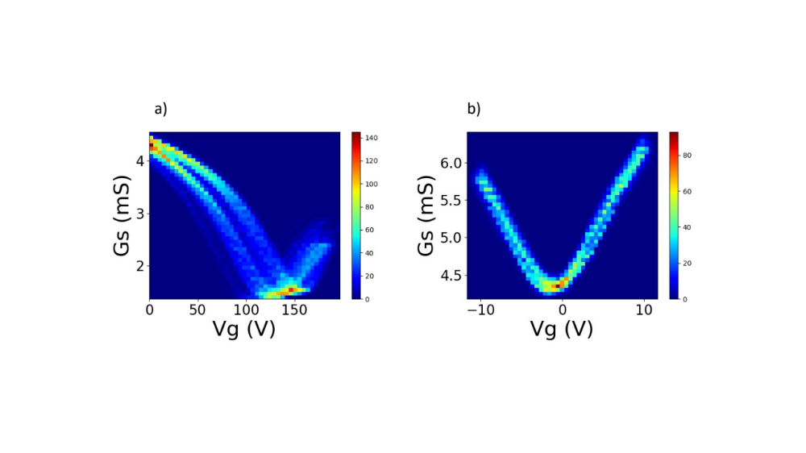
Figure S15. Electrical characerization of (a) GFET and (b) m-GFET.

We observe the tunning of Dirac point by up to 100-150 V. Different gate voltage ranges generate changes in the number of charge trapped at the SiOx // Graphene interface and subsequently false doped states shifting the Dirac point. Actually, this feature varies with the solvent (H₂O, EtOH or acetone) employed before the electrical measurements (Figure S16). It indicates that operating these m-GFETs in transient states may discern solvent effect for biosensing applications^{17,18}.
- b) c)
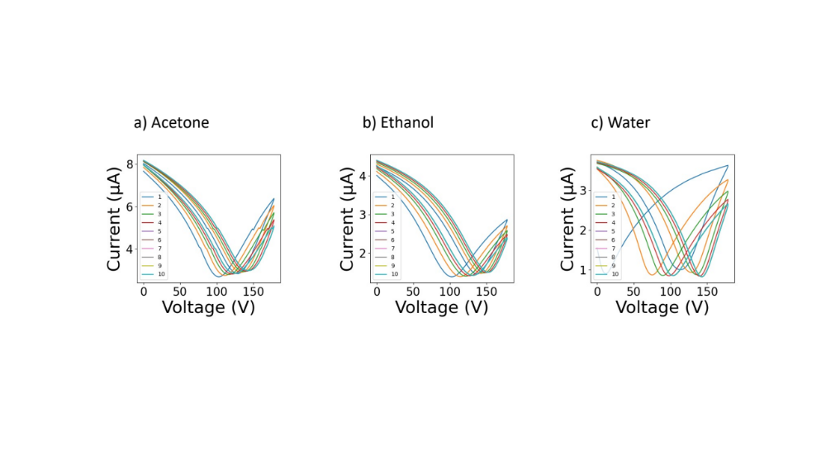
Figure S16. Transport characteristics of the m-GFETs. a) After rinsing with Acetone. b) IPA c) H₂O.

Although back-gated devices suffer from large parasitic capacitances due to the defects in the SiO₂ layer they are helpful for proof-of-concept purposes. These effects may be exploited for memristive and unconventional computing^{19–21} and were employed before for electrical measurements with potential application in biosensing^{17,18}. In fact the motion of molecular entities around topological defects is a key aspect for the rational design of molecular devices²². Figure S18 illustrates the dynamics of the transport characteristics for on gate voltage of V_{G} = 10V during 10s and consequent off gate voltage of V_{G} = 0V during 5s. Along the 7 cycles we found two different processes with τ =3 and 16 s. These memory effects are most probably associated with ions movements depends on the history in each device and can be deeply investigated and tuned. Static measurements are affected by the charge movement in the system. For instance, V_{BG} step voltages applied during some time can tune the Dirac Point as it is shown in Figure S17.
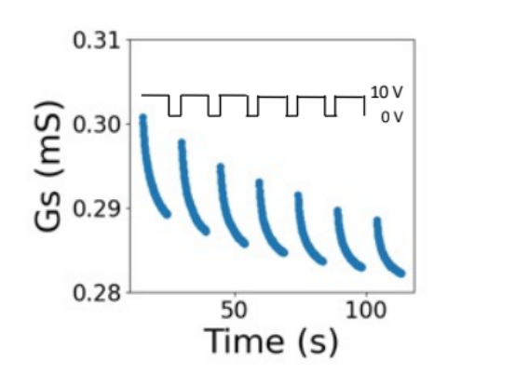
Figure S17. Source to drain conductance vs time for a V_{BG} square wave.

a) b)
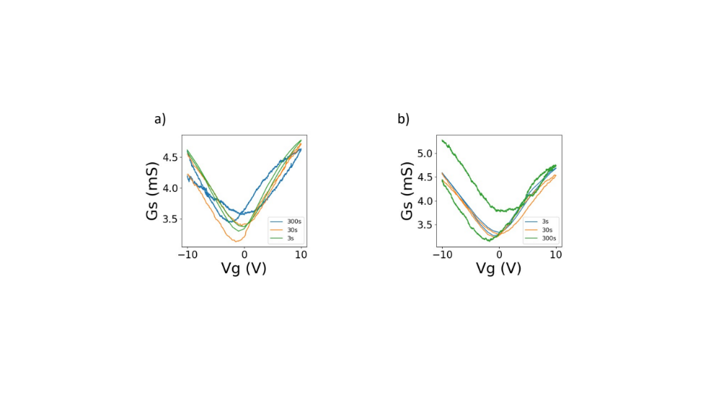
Figure S18. Transport characteristics of the m-GFETs as a function of scan rate and direction. The forward scan goes from V_{BG} = -10 V to V_{BG} = 10 V while the backwards foes from V_{BG} = 10 V to V_{BG} = -10 V. (a) Sequence going from a fast scan (3 s) to medium (30 s) and slow (300 s). (b) Sequence going from slow, medium and fast.

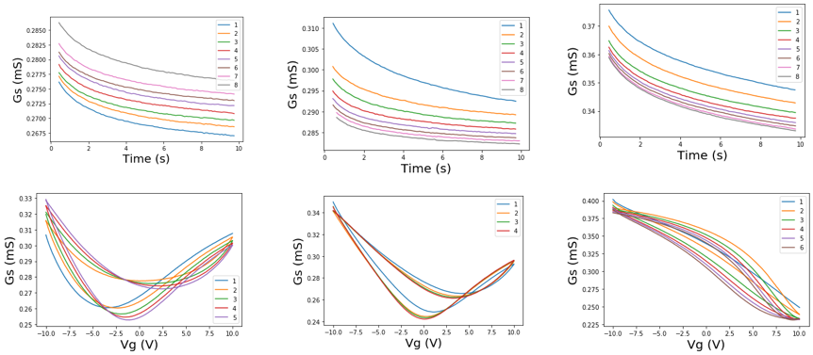
b) d) f)
a) c) e)
Figure S19. Transport characteristics of the m-GFETs, charging effect. (a) Sampling source conductance during 10 s, 8 times at V_{BG} = 0 V. (b) Subsequent V_{BG} sweeps from V_{BG} = -10 V to V_{BG} = 10 V. (c) Sampling source conductance during 10 s, 8 times at V_{BG} = 10 V (d) Subsequent V_{BG} sweeps from V_{BG} = -10 V to V_{BG} = 10 V. (e) Sampling source conductance during 10 s, 8 times at V_{BG} = 50 V (f) Subsequent V_{BG} sweeps from V_{BG} = -10 V to V_{BG} = 10 V.

Note 8. m-GFET electrical configuration

The total resistance is the sum of the resistance of one molecular diode in forward direction, the resistance of the graphene and the resistance of the other molecular diode at the reverse bias (R_{T} = R_{Fc,F} + R_{G} + R_{Fc,R}).

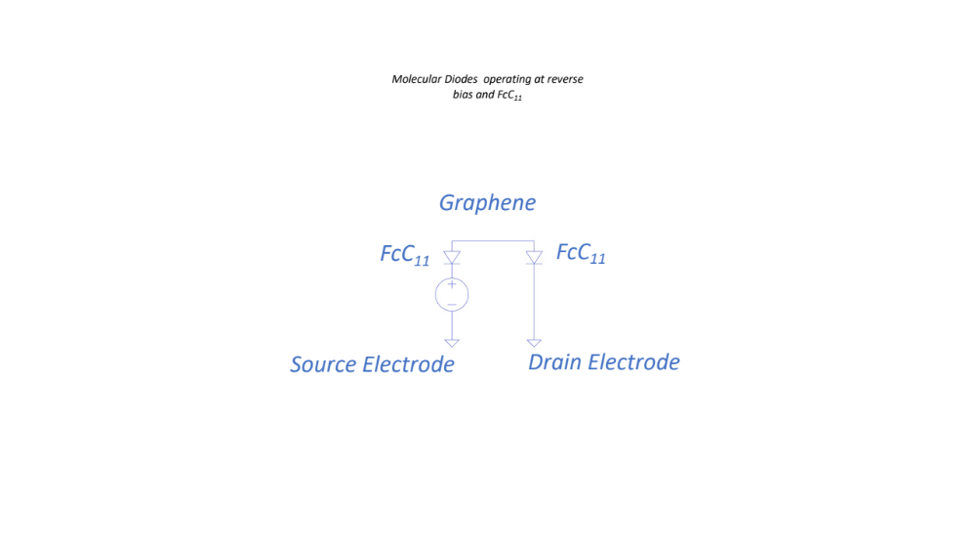

Figure S20. Face to face diode arrangement.

Taking into account the band diagram for the face-to-face diode arrangement there should be a window for source to drain bias higher than 3V (η ≈ 0.7) where both diodes operate at forward regime.

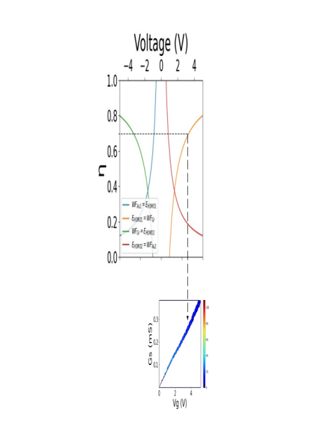

Figure S21. (a) Simulated voltage drop as a function of applied voltage. (b) 2D source to drain current histogram.

Note 9. X-ray absorption spectroscopy

Figure S22 shows a XAS image acquired at the Fe L3 edge. A clear bright signal corresponding to a higher number of emitted secondary electrons was observed during all the experiments in the region of the electrode marked with a circle. XAS spectra extracted from this region are showed in figure S19a. In each spectrum, two clear contributions can be distinguished coming from the two molecular states, at 708.8 eV for the Fe²⁺ and 710 eV for the Fe³⁺. In-operando XAS spectroscopy was performed by applying systematically the sequence of 0, 1, 2, 0, -1, -2 V between the source and drain electrodes.
a) b)
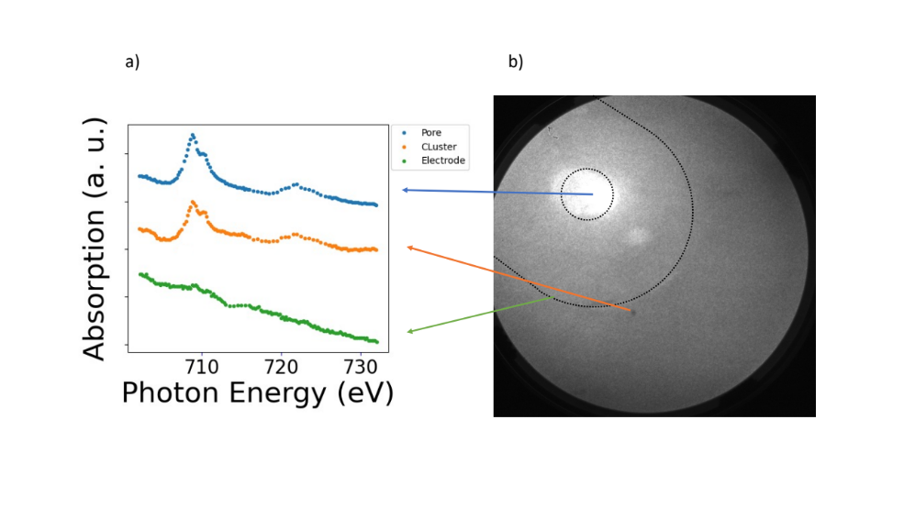
Figure S22. Evolution of the X-ray absorption spectra. (a) Local XAS spectra integrated in the circle where the FcC₁₁SH are placed (b) XAS-PEEM micrograph of the m-GFET electrode at the photon energy Fe L3 edge at room temperature. Field of view is 20 µm.

Note 10. Photo response

Note that the ferrocene redox couple has been used for high-efficiency dye-sensitized solar cells²³ due to differences between the electron and hole transfer times (ps and ns respectively)²⁴. In contrast to ionic liquid configuration²⁵, the backgated joint with the graphene transparency permits not only operando characterization but also to use light as an extra gateway for external stimuli for accessing to the molecular functionality of the device²⁶. This ambipolar conductivity based on the ferrocenium stability²⁷ can be understood in terms of ferrocene based redox switch²⁸.

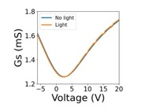
Figure S23. Photoresponse. Drain to source conductance at dark and light pulsing conditions. Light power: 8.8 mW, V_{DS} = 0.1V

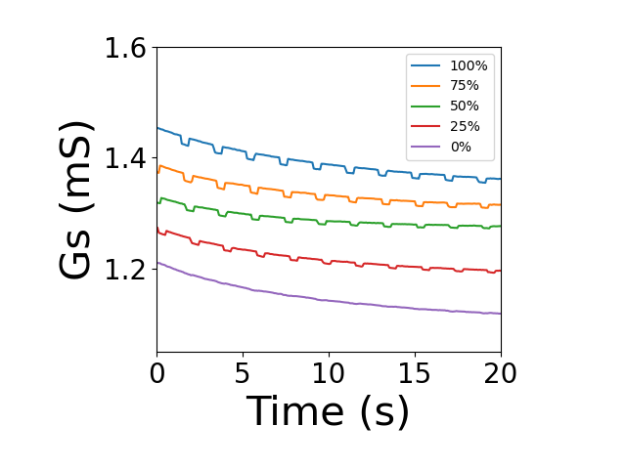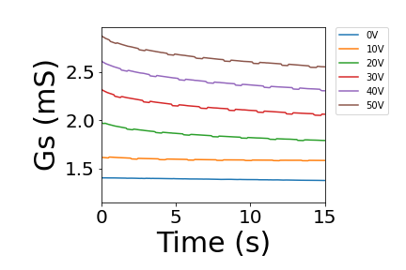
Figure S24. Photoresponse. (a) Drain to source conductance as a function of light power (max. 8.8 mW). V_{GB} = 20V, V_{DS} = 0.1V. (b) Drain to source conductance as a function of V_{GB}. Light power: 8.8 mW, V_{DS} = 0.1V.

References

1. Park, S., Park, J. H., Hwang, S. & Kwak, J. Programmable Electrochemical Rectifier Based on a Thin-Layer Cell. ACS Appl. Mater. Interfaces 9, 20955–20962 (2017).
2. Nerngchamnong, N. et al. The role of van der Waals forces in the performance of molecular diodes. Nat. Nanotechnol. 8, 113–118 (2013).
3. Tian, H., Dai, Y., Shao, H. & Yu, H. Modulated Intermolecular Interactions in Ferrocenylalkanethiolate Self-Assembled Monolayers on Gold. (2013) doi:10.1021/jp310012v.
4. Reuter, M. G., Hersam, M. C., Seideman, T. & Ratner, M. A. Signatures of cooperative effects and transport mechanisms in conductance histograms. Nano Lett. 12, 2243–2248 (2012).
5. Trasobares, J. et al. Estimation of π-π Electronic Couplings from Current Measurements. Nano Lett. 17, 3215–3224 (2017).
6. Nerngchamnong, N. et al. Nonideal Electrochemical Behavior of Ferrocenyl-Alkanethiolate SAMs Maps the Microenvironment of the Redox Unit. J. Phys. Chem. C 119, 21978–21991 (2015).
7. D’Andrade, B. W. et al. Relationship between the ionization and oxidation potentials of molecular organic semiconductors. Org. Electron. 6, 11–20 (2005).
8. Heimel, G., Romaner, L., Zojer, E. & Bredas, J. L. The interface energetics of self-assembled monolayers on metals. Acc. Chem. Res. 41, 721–729 (2008).
9. Alévêque, O. et al. Electroactive self-assembled monolayers: Laviron’s interaction model extended to non-random distribution of redox centers. Electrochem. commun. 12, 1462–1466 (2010).
10. Laviron, E. Surface linear potential sweep voltammetry. Equation of the peaks for a reversible reaction when interactions between the adsorbed molecules are taken into account. J. Electroanal. Chem. 52, 395–402 (1974).
11. Umaña, M., Rolison, D. R., Nowak, R., Daum, P. & Murray, R. W. X-ray photoelectron spectroscopy of metal, metal oxide, and carbon electrode surfaces chemically modified with ferrocene and ferricenium. Surf. Sci. 101, 295–309 (1980).
12. De Leo, L. P. M., De La Llave, E., Scherlis, D. & Williams, F. J. Molecular and electronic structure of electroactive self-assembled monolayers. J. Chem. Phys. 138, 114707 (2013).
13. Rabti, A., Mayorga-martinez, C. C., Baptista-pires, L., Raoua, N. & Merkoçi, A. Ferrocene-functionalized graphene electrode for biosensing applications. Anal. Chim. Acta J. 926, 28–35 (2016).
14. Watcharinyanon, S., Moons, E. & Johansson, L. S. O. Mixed self-assembled monolayers of ferrocene-terminated and unsubstituted alkanethiols on gold: Surface structure and work function. J. Phys. Chem. C 113, 1972–1979 (2009).
15. Pirkle, A. et al. The effect of chemical residues on the physical and electrical properties of chemical vapor deposited graphene transferred to SiO2. Appl. Phys. Lett. 99, 2009–2012 (2011).
16. Chaves, F. A., Jiménez, D., Cummings, A. W. & Roche, S. Physical model of the contact resistivity of metal-graphene junctions. J. Appl. Phys. 115, (2014).
17. Dai, X. et al. Modularized Field-Effect Transistor Biosensors. Nano Lett. 19, 6658–6664 (2019).
18. Ono, T. et al. Electrical Biosensing at Physiological Ionic Strength Using Graphene Field-Effect Transistor in Femtoliter Microdroplet. Nano Lett. 19, 4004–4009 (2019).
19. Schranghamer, T. F., Oberoi, A. & Das, S. Graphene memristive synapses for high precision neuromorphic computing. Nat. Commun. 11, 1–11 (2020).
20. Burzurí, E., Granados, D. & Pérez, E. M. Physically Unclonable Functions Based on Single-Walled Carbon Nanotubes: A Scalable and Inexpensive Method toward Unique Identifiers. ACS Appl. Nano Mater. 2, 1796–1801 (2019).
21. Viero, Y. et al. Light-Stimulatable Molecules/Nanoparticles Networks for Switchable Logical Functions and Reservoir Computing. Adv. Funct. Mater. 28, 1801506 (1–10) (2018).
22. Nirmalraj, P., Daly, R., Martin, N. & Thompson, D. Motion of Fullerenes around Topological Defects on Metals: Implications for the Progress of Molecular Scale Devices. ACS Appl. Mater. Interfaces 9, 7897–7902 (2017).
23. Daeneke, T. et al. High-efficiency dye-sensitized solar cells with ferrocene-based electrolytes. Nat. Chem. 3, 211–215 (2011).
24. Ponseca, C. S., Chábera, P., Uhlig, J., Persson, P. & Sundström, V. Ultrafast Electron Dynamics in Solar Energy Conversion. Chem. Rev. 117, 10940–11024 (2017).
25. Jia, C. et al. Quantum interference mediated vertical molecular tunneling transistors. Sci. Adv. 4, eaat8237 (2018).
26. Xin, N. et al. Concepts in the design and engineering of single-molecule electronic devices. Nat. Rev. Phys. 1, 211–230 (2019).
27. Tarafder, K., Surendranath, Y., Olshansky, J. H., Alivisatos, A. P. & Wang, L. W. Hole transfer dynamics from a CdSe/CdS quantum rod to a tethered ferrocene derivative. J. Am. Chem. Soc. 136, 5121–5131 (2014).
28. Fabbrizzi, L. The ferrocenium/ferrocene couple: a versatile redox switch. ChemTexts 6, 1–20 (2020).

