Comprehensive analysis of microsatellite polymorphisms in human populations

Leo Gochi¹, Yosuke Kawai², and Akihiro Fujimoto¹

1; Department of Human Genetics, The University of Tokyo, Graduate School of Medicine, Japan, 2; National Center for Global Health and Medicine

Corresponding author:

Akihiro Fujimoto
Department of Human Genetics, The University of Tokyo, Graduate School of Medicine, 113-0003, Japan;
E-mail: afujimoto@m.u-tokyo.ac.jp

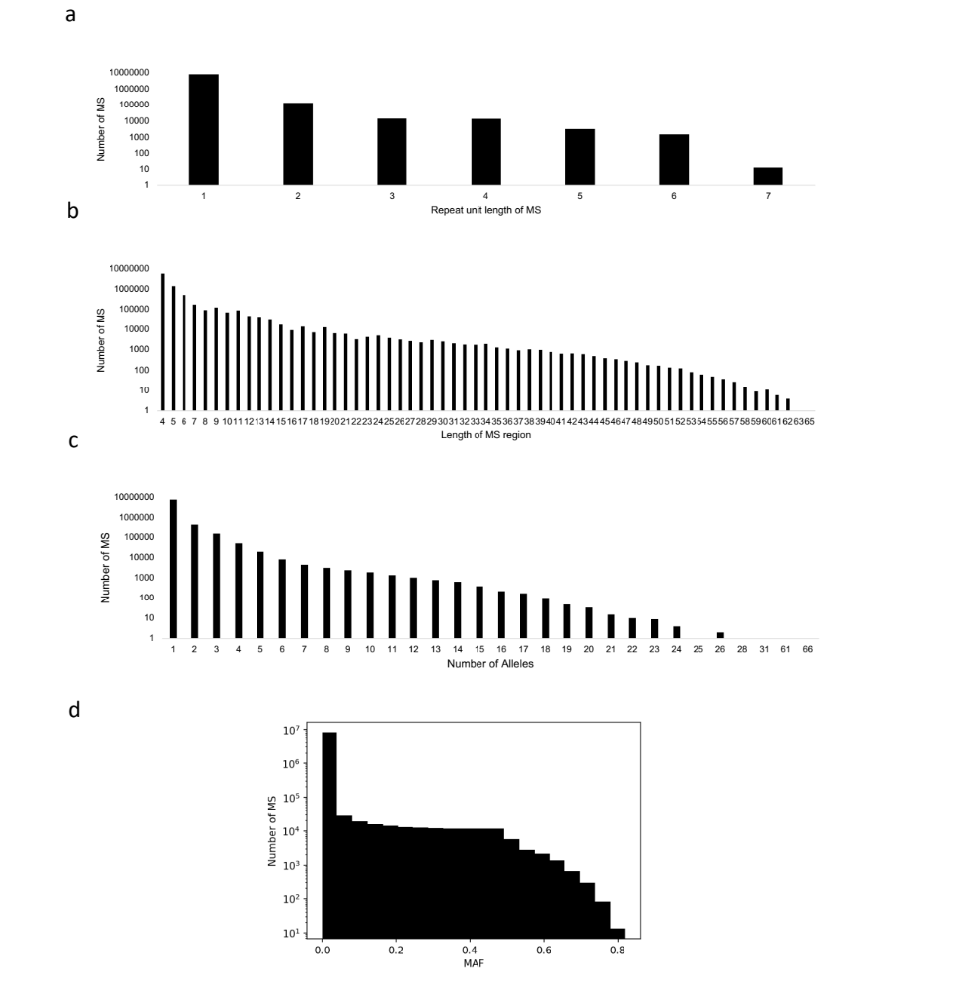
Figure S1
Distributions of MS. (a) Distribution of repeat unit lengths. (b): Distribution of lengths of MS regions in the reference genome. (c): Distribution of number of alleles. (d): Distribution of minor allele frequencies (MAF).

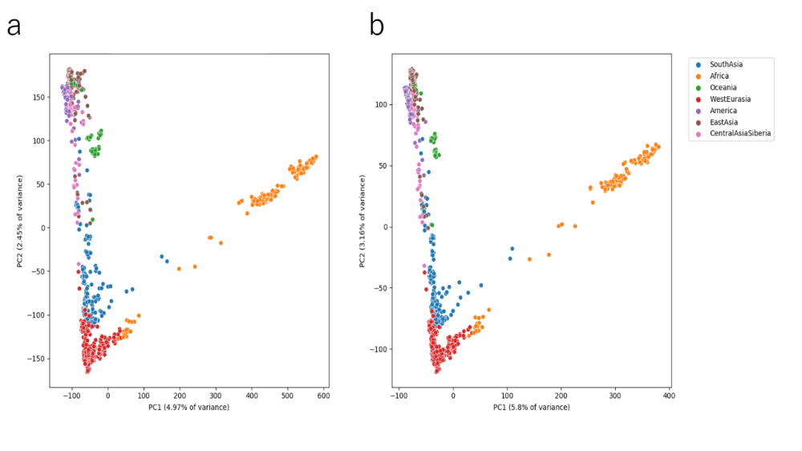
Figure S2
PCA with SGDP+HGDP samples using two methods. (a) Multiallelic method. (b) Average method.

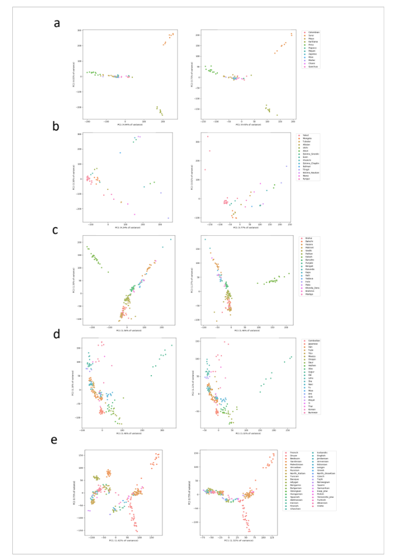
Figure S3
PCA of all SGDP and HGDP samples using SNP (left) and MS (right). (a) America. (b) Central Asia and Siberia. (c) South Asia. (d) East Asia. (e) Oceania. (f) West Eurasia.

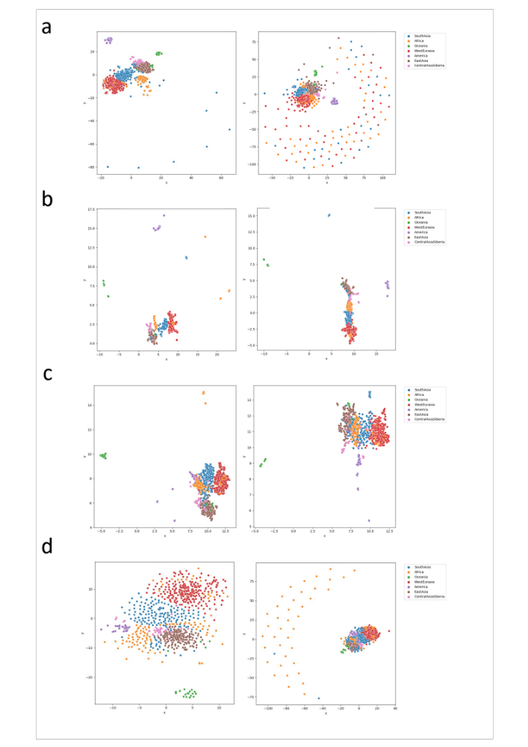
Figure S4
Dimensionality reduction of all SGPP and HGDP samples using SNP (left) and MS (right). (a) t-SNE. (b) UMAP. (c) PCA-t-SNE. (d) PCA-UMAP.

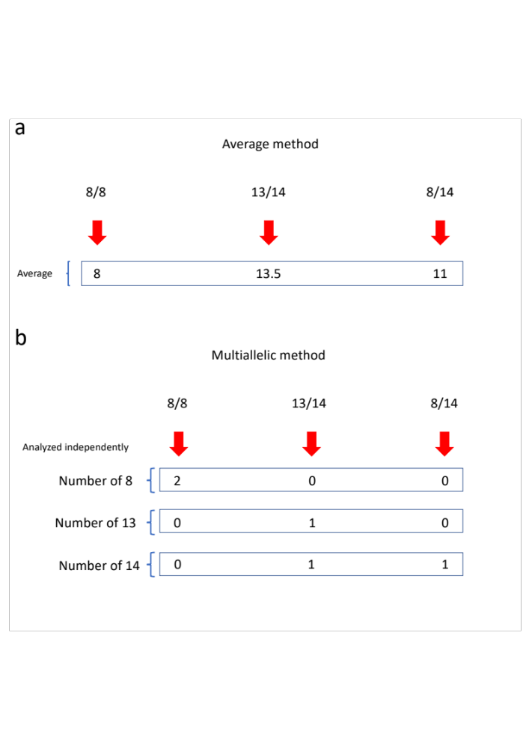
Figure S5
Methods to convert MS genotypes to numerical values.
(a) Average method. (b) Multiallelic method

