Supplementary Information
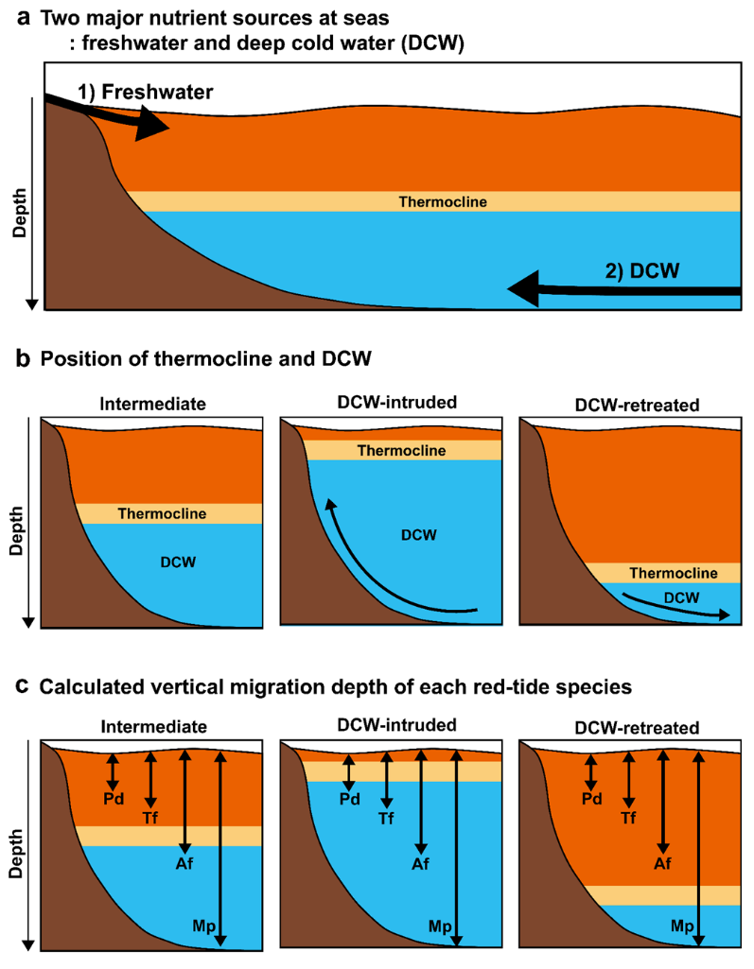
Fig. S1 (a) Diagram showing the two major nutrient sources: freshwater and deep cold water (DCW). (b) The position of the thermocline and DCW. Arrows indicate the direction in which the DCW moves. (c) Calculated vertical migration depth of the four red-tide species for 10-hour travel (up-down arrows; Jeong et al. 2015) when the DCW intrudes or retreats. Under the intermediate condition, only Alexandrium fraterculus (Af) and Margalefidinium polykrikoides (Mp) can reach the DCW passing through the thermocline. Under the DCW intrusion condition, Prorocentrum donghaiense (Pd), Tripos furca (Tf), Af, and Mp can reach the DCW. Under the DCW retreat condition, only Mp can reach the DCW

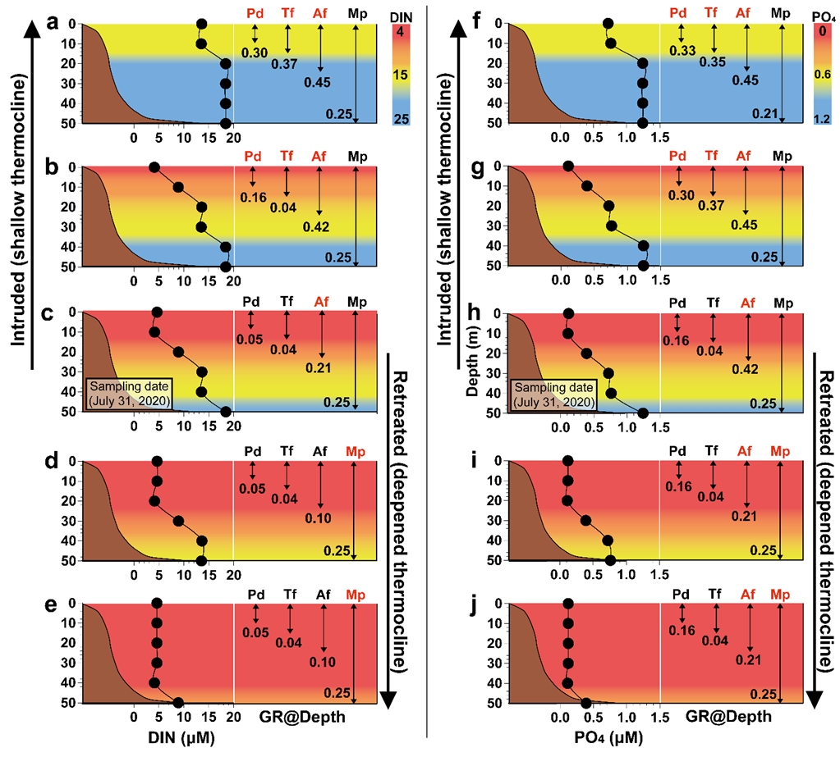
Fig. S2 Scenarios based on dissolved inorganic nitrogen (DIN; a–e) or PO₄ concentration (f–j) at each depth for red-tide formation of each dinoflagellate species during intrusion or retreat of deep cold waters. Measured or calculated growth rate (GR; d⁻¹) of each red-tide species for nitracline or phosphocline positions on July 31, 2020, at Station 111 (c, h); ascended by 10 m (b, g) and 30 m (a, f) by the deep cold water intrusion; and descended by 10 m (d, i) and 30 m (e, j) by the deep cold water retreat. Closed circles indicate the DIN or PO₄ concentration (µM) at each given depth. Upward and downward arrows in each box indicate range of vertical migration depth of each species for 10 h (Jeong et al. 2015). The species name in red indicates the dominant species under each given condition, which was determined by combining the relative growth rates of the four species at a given depth (GR@Depth), vertical migration depths (m), and position of deep cold waters (or nitracline or phosphocline). The species with the highest growth rate was selected as the dominant species as well as 1–2 additional species if their growth rates were >2/3 of the growth rate of the species with the highest growth rate at a given depth. Pd, Prorocentrum donghaiense; Tf, Tripos furca; Af, Alexandrium fraterculus; Mp, Margalefidinium polykrikoides

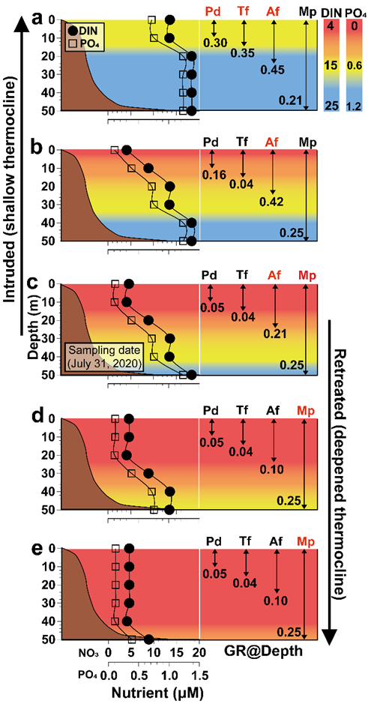
Fig. S3 Integrative scenarios based on combination of dissolved inorganic nitrogen (DIN) and PO₄ concentration at each depth from Fig. S2 for red-tide formation of each dinoflagellate species during intrusion or retreat of deep cold waters. Measured or calculated growth rate (GR; d⁻¹) of each red-tide species for nitracline or phosphocline positions on July 31, 2020, at Station 111 (c); ascended by 10 m (b) and 30 m (a) by the deep cold water intrusion; and descended by 10 m (d) and 30 m (e) by deep cold water retreat. The lower of two GRs of each species at each depth was selected in the scenarios based on DIN and PO₄ concentrations at each depth (Fig. S2a–e and Fig. S2f–j, respectively). Upward and downward arrows in each box indicate range of vertical migration depth of each species for 10 h (Jeong et al. 2015). The species name in red indicates the dominant species under each given condition, which was determined by combining the relative growth rates of the four species at a given depth (GR@Depth), vertical migration depths (m), and position of deep cold waters (or nitracline or phosphocline). The species with the highest growth rate was selected as the dominant species as well as 1–2 additional species if their growth rates were > 2/3 of the growth rate of the species with the highest growth rate at a given depth. Pd, Prorocentrum donghaiense; Tf, Tripos furca; Af, Alexandrium fraterculus; Mp, Margalefidinium polykrikoides

