Supplementary Materials for

Mediterranean viticulture in response to global climate change drivers - lessons from the past and projections for the future

Joel Guiot, Nicolas Bernigaud, Alberte Bondeau, Wolfgang Cramer, Laurent Bouby

Correspondence to: guiot@cerege.fr

S1. Past and future data used for calibration
S1.1. The past data

The past time periods retained are (1) the Last Glacial Maximum (21ka) characterized by very low greenhouse gases (GHG), large eccentricity (ecc), obliquity (obl) close to present value and very negative solar longitude at perihelion (omega); (2) the mid Holocene (6 ka) characterized by GHG close to pre-industrial period, relatively large eccentricity, large obliquity and slightly negative omega; (3) five periods of the last millennium (Fig. S1) representing various combinations of solar (S) and volcanic (V) forcings: V-S+ (1200-1220), V+S- (1255-1320), V-S+ (1380-1420), V-S++ (1720-1780), V+S+ (1810-1840); (4) the pre-industrial (PI) reference period with intermediate GHG concentrations, low eccentricity, large obliquity, large omega, large volcanic and solar activities.
The simulations were archived by the Paleoclimate Modelling Intercomparison Project (PMIP), which produced snapshot simulations of the mid-Holocene (6 ka BP) and Last Glacial Maximum (21 ka BP) time slices to study the effects of insolation, greenhouse gases and massive ice sheets on the climate, https://pmip3.lsce.ipsl.fr/overview/ (Braconnot et al 2012). The models used for intercomparisons were coupled atmosphere-ocean-vegetation models with various levels of complexity and resolution (Table S2).

Fig. S1. Natural (volcanic activity and solar activity) and anthropogenic forcing (CO2) for the last millennium. Upper panel: the effective aerosol radius which is directly related to the aerosol optical depth is calculated by (2013); middle panel: the proxy indicating the total solar irradiance (TSI), i.e. the solar modulation function in MeV based on ¹⁴C (Muscheler et al 2007); lower panel: atmospheric CO2 concentration (in ppm). The horizontal red lines represent the mean values of the five selected periods.

S1.2. The future data

The future periods are determined by increasingly high GHG concentrations (depending on the scenario, see below), and the other forcing variables were set to the PI value. The simulations were archived by the Coupled Model Intercomparison Project (CMIP). We used simulations of CMIP5 (Taylor et al 2012). These include both (i) century-scale integrations, which usually start from a preindustrial control, and climate predictions until the end of the 21st century, and (ii) near-term integrations for the next 10 to 30 years, which are initialized using observed ocean and sea-ice conditions. The CMIP5 climate change projections are driven by emission scenarios, divided into four classes referred to as “representative concentration pathways” (RCPs) (Moss et al 2010). The high-emissions scenario, named RCP8.5 or “business as usual”, refers to a high radiative forcing of emissions at the end of the 21st century (8.5 W m⁻²). The low-emission scenario, which roughly represents that of the Paris Agreement, reaches its maximum value near the middle of the century before decreasing to a level of 2.6 W m⁻² at the end of the century. We only used the intermediate scenario RCP4.5 which refers to a radiative forcing maintained at values of 4.5 W m⁻² at the end of the 21st century. We used 10 time slices interpolated at a 10-year steps (2010, 2020, …, 2100). The forcing variables for the future scenarios are provided from the website http://www.iiasa.ac.at/web-apps/tnt/RcpDb.
S2. Downwcaling
Earth System Model (ESM, see section 2.1) resolution is too coarse (>100 km depending on the model) to assess the impact and risk of climate changes on ecosystems or human systems. Different approaches can be used to derive higher-resolution information. We use a statistical downscaling (SD), based on statistical relationships that link large-scale atmospheric variables with local/regional climate variables and that are applied to coarser-resolution model simulations (Su et al 2016, Grouillet et al 2016, Levavasseur et al 2011), so providing higher-resolution estimates of climate variables. SD methods are not computably expensive.
The SD that we use assumes the hypothesis that the fields of climate anomalies do not depend on the grid resolution. So, they can be interpolated at a finer resolution than the initial resolution. We use a common 0.5° high-resolution (HR) grid for each climate simulation. It is provided by the high-resolution data set of surface climate over global land areas (New et al 2002) (which has a 10 minutes resolution and aggregated at a 30 minutes resolution). This climatology is based on the 1961-1990 period. Each low-resolution (LR) anomaly field provided by the ESM is downscaled to the HR grid by the bilinear interpolator of platform R (function interp.surface of package fields). This HR anomaly field is added to the 1961-1990 climatological HR field. As the simulations are corrected by the differences between control simulations and observations, the systematic biases of the model are removed. For the PMIP3 simulations (LGM, MidHol and historical), the control is the pre-industrial simulation (PI) so we use the 1900-1931 climatology very close to the PI (1861-1890) used by the recent IPCC reports (Allen et al 2018). Fig. S2 presents the global mean temperature for each period and scenario considered

Fig. S2. Global annual temperature simulated by the various models of PMIP3 and CMIP5. The left graphic represents the past simulations, the right graphic represents the present and future projections for three scenarios (RCP2.6 in green, RCP4.5 in orange, RCP8.5 in red). Each dot represents a model simulation. The vertical scales are shifted for a better readability. The reference is given by the (New et al 2002) 1961-1990 dataset; the global mean of this reference is approximately 9°C and is noted 1961-1990 GM. Note that this value underestimates the true earth surface temperature because our mean is based on the equirectangular projection which gives too much weight to the high latitudes.

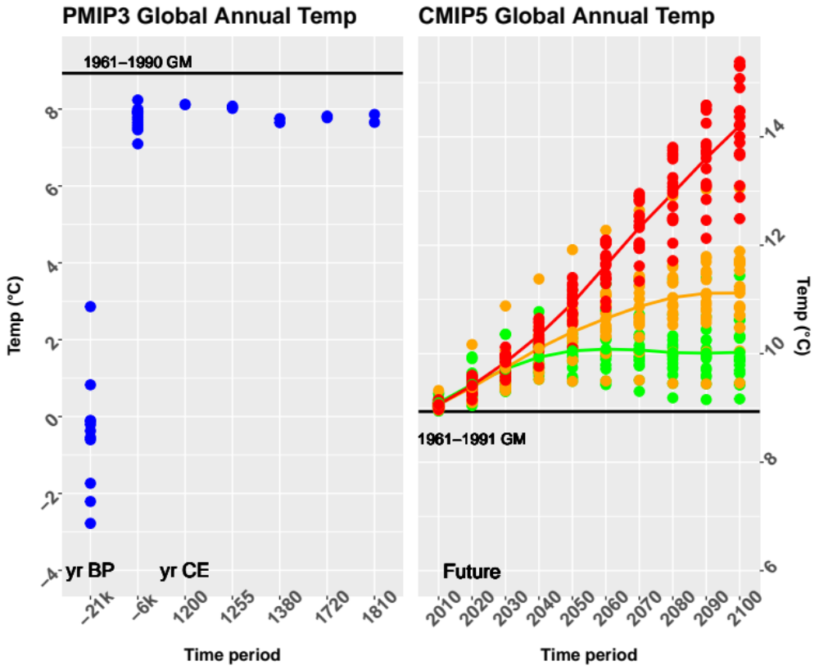

S3. Vegetation model (BIOME4)
The impact models that have been developed for ecosystems display considerable diversity. The Inter-Sectoral Impact Model Intercomparison Project (ISIMIP) report several tens of models covering different sectors such as water, vegetation, agriculture, and health, etc. (Warszawski et al 2014, Frieler et al 2017). Here, we use an equilibrium global vegetation model that simulates some of the most important processes related to vegetation at the scale of the ecosystem, specifically photosynthesis, respiration, evapotranspiration, BIOME4 (Kaplan et al 2003), which has been used in numerous regional to global scale studies at different time scales, including paleo scale (Harrison and Prentice 2003). This model predicts structure and productivity of broad-scale land ecosystems from monthly temperature and rainfall values and annual CO₂ concentration. It uses a photosynthesis scheme that simulates acclimation of plants to changed atmospheric CO₂ by optimization of nitrogen allocation to foliage and by accounting for the effects of CO₂ on net assimilation, stomatal conductance, leaf area index (LAI) and ecosystem water balance. BIOME4 is based on sufficiently simple description of ecophysiological processes to allow broad-scale application. It represents substantial advantages over niche-models because it has not been tuned to reproduce present-day potential vegetation, but rather to simulate correctly the main processes underlying the potential vegetation distribution which are assumed to have been similar throughout the Holocene. BIOME4 does not account for human land use.
The inputs of the model are monthly average values of temperature, precipitation and sunshine percentage, atmospheric CO₂ concentration, and soil texture. The temperature and precipitation variables are directly obtained from the simulations downscaled at the 0.5° grid (section S2). The sunshine percentages (S) are obtained by linear regression on temperature (T) and precipitation (P) (Guiot et al 2000):
$S_{ij}=a_{j}+b_{j}T_{ij}+c_{j}P_{ij} for j=1,…,12$ (S1)
where j is a subscript for the 12 months and i a subscript for the n pixels. The absolute minimum temperature is derived from the mean temperature of the coldest month according to the quadratic equation of Prentice et al 1992. The soil data are provided by the FAO (Zobler 1986). The CO₂ atmospheric concentration values are those considered by CMIP5 and PMIP3 as boundary conditions for their simulations.
The outputs include net primary production (NPP) of each of the potentially occurring 13 plant functional types (PFT), the total NPP and the corresponding ‘biome type’, from a set of 28 broad categories (Table S1). The model provides also several bioclimatic variables presented also in Table S1.

Table S1. The biome types simulated by BIOME4 and output variables used for the paper; note that there is no correspondence between the two columns.
N° | Biome names | Ouput variables
1 | Tropical evergreen forest | NPPtot : total net primary production
2 | Tropical semi-deciduous forest | Dominant PFT (plant function type)
3 | Tropical deciduous forest/woodland | AET actual evapotranspiration (mm)
4 | Temperate deciduous forest | MTCO mean temperature of the coldest month (°C)
5 | Temperate conifer forest | MTWA mean temperature of the warmest month (°C)
6 | Warm mixed forest | E/PE actual over potential evapotranspiration
7 | Cool mixed forest | GDD5 growing degree-days above 5°C (° days)
8 | Cool conifer forest | TANN annual mean temperature (°C)
9 | Cold mixed forest | PANN annual sum of precipitation (mm)
10 | Evegreen taiga/montane forest
11 | Deciduous taiga/montane forest
12 | Tropical savanna | NPP net primary production of following PFTs
13 | Tropical xerophytic shrubland | Tet: Tropical Evergreen Trees
14 | Temperate xerophytic shrubland | Trt: Tropical Drought-deciduous Trees (raingreens)
15 | Temperate sclerophyll woodland | Tbe: Temperate Broadleaved Evergreen Trees
16 | Temperate broadleaved savanna | Tst: Temperate Deciduous Trees
17 | Open conifer woodland | Ctc: Cool Conifer Trees
18 | Cool Desert | Bec: Boreal Evergreen Trees
19 | Tropical grassland | Bst: Boreal Deciduous Trees
20 | Temperate grassland | tg: C3/C4 temperate grass plant type
21 | Hot Desert | Trg4: C4 tropical grass plant type
22 | Steppe tundra | Wds: C3/C4 woody desert plant type
23 | Shrub tundra | Tsg: Tundra shrub type
24 | Dwarf shrub tundra | Ch: cold herbaceous type
25 | Prostrate shrub tundra | Lf: Lichen/forb type
26 | Cushion forb lichen moss tundra
27 | Barren
28 | Land ice

S4. The emulator technique
For any choice of input q-vector $x$ (forcings), the climate simulator $y(x,s)=(y_{1}\left(x,s\right), …,y_{m}\left(x,s\right))$, where m is the number of (bio)climatic variables whose response is to be analyzed and s is the location where the climate variables must be estimated. It is a deterministic and possibly non-linear function. The objective is to build a statistical model that estimates the ESM+BIOME4 output for any value of x based on a limited number of well-chosen experiments (O’Hagan 2004, Vernon et al 2010). This model, called also an “emulator”, is then treated as a statistical representation of the ESM+BIOME4 model, with the very interesting properties to run very fast and provide an uncertainty description for the whole plausible input space (i.e. conform to physics, internally consistent and reasonable (Amara 1991)).
$y_{j}\left(x,s\right)=X β_{j}(s)+e_{j}\left(s\right) j=1,⋯,m;s=1,…,n$ (S2)
where s indicates the grid point out of a total of n points, $y_{j}\left(x,s\right)$ is the anomaly of the climatic variable j (out of m) at location s, i.e. the climate variable at time t minus the climate variable at time 0 (present), X is a matrix with v specified columns of the input global forcings (they do not depend on the location s), and $e(s)$ is a stationary gaussian variable $N(0,σ_{j}^{2})$. This can be considered as a least-square problem where the coefficients $β_{j}(s)$ are estimated to minimize the sum of the squared errors. These coefficients can be written as
$\hat{β_{j}}\left(s\right)={\left(X^{T}W\left(s\right)X\right)}^{-1}X^{T}W\left(s\right)y_{j}$ (S3)
with W(s) is a matrix of weights specific to location s such that observations nearer to s are given greater weight than observations further away, T is the transpose symbol. The estimation of $β_{j}(s)$ in location s is provided by weighting all the observations according to their distance from s, $d_{is}$. The method is called “Geographically Weighted Regression” (GWR) (Brunsdon et al 1998). We use a bisquare weighting function, so that W(s) is the diagonal matrix with elements
$w_{is}={(1-{\left(\frac{d_{is}}{h}\right)}^{2})}^{2} if d_{is}<h and 0 if d_{is}>h$ (S4)
h is called the band width. We use here the function gwr.basic of package gw.model on R (Lu et al 2014). We have chosen h=8 (in longitude and latitude degree units).
The emulator is trained on an ensemble of simulations performed on data browsing sufficiently well the plausible input space. The more the input space is filled, the more robust the emulator will be. The fact that we have extended the range of forcing parameters to past, present and future scenarios, thanks to the CMIP5 and PMIP3 simulations (Table S2), is an excellent way to fill this input space. Even if they are not an exhaustive sampling, it is reasonable to assume that they represent a model population (Chandler 2013). The emulator is used to estimate the conditional probability distribution of the ecosystem variables (Table S1) in each location or biome, based on the forcing variables (Table S3).

Table S2. CMIP5 and PMIP3 simulations used in the paper. First column is the code of model, the second the institute which built the model; the other columns provide the availability of the scenarios or time slices. Hist. = historical period (last millennium), MidHol = Mid Holocene (6 kyr BP), LGM = Last Glacial Maximum (21kyr BP).
Model | Institute | RCP2.6 | RCP4.5 | RCP8.5 | Hist. | MidHol | LGM
bcc-csm1-1 | Beijing Climate Center, China Meteorological Administration | X | X | X |  | X
bcc-csm1-1-m | Beijing Climate Center, China Meteorological Administration | X | X | X
CCSM4 | Community Climate System Model Contributors, UCAR-NSF-DoE-NASA, USA |  |  |  |  | X | X
CCSM4b | Community Climate System Model Contributors, UCAR-NSF-DoE-NASA, USA |  |  |  |  | X | X
CanESM2 | Canadian Centre for Climate modelling, Canada | X | X | X
CESM1-BGC | Community Earth System Model Contributors, NSF-DoE-NCAR, USA |  | X
CSIRO-Mk3 | CSIRO Marine and Atmospheric Research, Victoria, Australia |  |  |  |  | X
CSIRO-Mk3L | CSIRO Marine and Atmospheric Research, Victoria, Australia |  |  |  | X | X
CMCC-CM | Centro Euro-Med per Cambiamenti Climatici, Italy |  | X | X
CNRM-CM5 | Centre National de Recherches Météorologiques / Centre Européen de Recherche et Formation Avancée en Calcul Scientifique, France | X | X | X |  | X | X
COSMOS-ASO |  |  |  |  |  |  | X
FGOALS-g2 | LASG, Institute of Atmospheric Physics, Chinese Academy of Sciences and CESS,Tsinghua University, China |  |  |  |  | X
FGOALS-s2 | LASG, Institute of Atmospheric Physics, Chinese Academy of Sciences and CESS,Tsinghua University, China |  |  |  |  | X | X
GFDL-CM3 | NOAA Geophysical Fluid Dynamics Laboratory, USA | X | X
GISS-E2-H | NASA Goddard Institute for Space Studies, USA | X | X | X
GISS-E2-H-CC | NASA Goddard Institute for Space Studies, USA
GISS-E2-R | NASA Goddard Institute for Space Studies, USA | X | X | X |  | X | X
GISS-E2-Rb | NASA Goddard Institute for Space Studies, USA |  |  |  |  |  | X
HadCM3 | Met-Office – Hadley Center, UK |  |  |  | X
HadGEM2-AO | Met-Office – Hadley Center, UK | X | X | X
HadGEM2-ES | Met-Office – Hadley Center, contributed by Instituto Nacional de Pesquisas Espaciais, Spain | X
inmcm4 | Inst. For Numerical Mathematics, Russia |  | X | X
IPSL-CM5A-LR | Institut Pierre-Simon Laplace, France | X | X | X |  | X | X
IPSL-CM5A-MR | Institut Pierre-Simon Laplace, France | X | X | X
IPSL-CM5B-LR | Institut Pierre-Simon Laplace, France
MIROC-ESM | University of Tokyo, National Institute for Environmental Studies, and Japan Agency for Marine-Earth Science and Technology |  |  |  |  | X | X
MPI-ESM-LR | Max-Planck Inst. für Meteorologie, Germany | X | X | X
MPI-ESM-P | Max-Planck Inst. für Meteorologie, Germany |  |  |  |  | X | X
MPI-ESM-MR | Max-Planck Inst. für Meteorologie, Germany | X | X | X
MRI-CGCM3 | Meteorological Research Institute, Japan | X | X | X |  | X | X
NorESM1-M | Norwegian Climate Centre | X | X | X
NorESM1-ME | Norwegian Climate Centre | X | X | X
Nb simulations |  | 16 | 18 | 16 | 2 | 13 | 11

Table S3. The nine global forcing variables and their values for the different periods considered. The global forcing variables are the predictors of the emulator; we give their values for the time slices used in the calibration: GHG atmospheric concentration (carbon dioxide, methane, nitrogen protoxide) in ppm, earth orbit parameters (eccentricity, obliquity, omega), population in million people (M), volcanic activity (Volc), solar activity (Sol, MeV). Every column is one out of the v forcings of eq. S2 (columns of X). For columns CO₂, CH₄, N₂O and Population, we use observations until 2010 (see section S1) and the values used by the three scenarios (RCP2.6, RCP4.5, RCP8.5) for projections (2020 to 2100).
Time period | CO₂ | CH₄ | N₂O | Ecc | Obl | Ω | Population | Volc | Sol
21k | 185 | 350 | 200 | 0.0196 | 23.4 | -213 | 2M | 0.3 | 270
6k | 280 | 650 | 270 | 0.0190 | 24.2 | -27 | 28M | 0.3 | 270
1200 | 280 | 650 | 270 | 0.0170 | 23.6 | 85 | 394M | 0.2 | 400
1255 | 280 | 650 | 270 | 0.0170 | 23.6 | 85 | 396M | 0.4 | 200
1380 | 280 | 650 | 270 | 0.0170 | 23.6 | 85 | 390M | 0.2 | 200
1720 | 280 | 650 | 270 | 0.0170 | 23.6 | 85 | 768M | 0.2 | 600
1810 | 280 | 650 | 270 | 0.0167 | 23.4 | 102 | 1082M | 0.5 | 400
2006 | 379 | 1754 | 319 | 0.0167 | 23.4 | 102 | 6542M | 0.3 | 270
2010 | 389 | 1773 | 323 | 0.0167 | 23.4 | 102 | 6958M | 0.3 | 270
2020 | 412,412,416 | 1731,1801,1824 | 329,330,332 | 0.0167 | 23.4 | 102 | 7510M, 7505M, 7530M | 0.3 | 270
2030 | 431,435,449 | 1600,1830,2132 | 334,337,342 | 0.0167 | 23.4 | 102 | 8200M, 8180M, 8800M | 0.3 | 270
2040 | 440,461,489 | 1527,1842,2399 | 339,344,354 | 0.0167 | 23.4 | 102 | 8800M, 8500M, 9400M | 0.3 | 270
2050 | 443,487,541 | 1452,1833,2740 | 342,351,367 | 0.0167 | 23.4 | 102 | 9000M, 8900M, 10400M | 0.3 | 270
2060 | 442,509,604 | 1365,1801,3076 | 343,356,381 | 0.0167 | 23.4 | 102 | 9100M, 9000M,10700M | 0.3 | 270
2070 | 437,524,677 | 1311,1745,3322 | 344,361,394 | 0.0167 | 23.4 | 102 | 9150M, 9050M, 11500M | 0.3 | 270
2080 | 432,531,758 | 1285,1672,3490 | 344,365,408 | 0.0167 | 23.4 | 102 | 9150M, 9050M, 11900M | 0.3 | 270
2090 | 426,534,845 | 1268,1614,3639 | 344,369,421 | 0.0167 | 23.4 | 102 | 9150M, 8950M, 12050M | 0.3 | 270
2100 | 421,538,936 | 1254,1576,3751 | 344,372,435 | 0.0167 | 23.4 | 102 | 9050M, 8800M, 12300M | 0.3 | 270

The total number of simulations available for 18 time slices and three scenarios (for the 2020 to 2100 time slices) from 2 to 18 models is 582. As each one simulates climate for 65,559 grid points of the globe (after downscaling), the total of available observations is ~4 10⁷. Because of the strong spatial correlation, it is not necessary to use all the grid points. To have a balance between the different biomes represented on the Earth, for each time slice and each model, we randomly draw a subset of grid points in each biome proportional to its representativity. So, the calibration is done on about 3 10⁵ observations (the number is slightly lower than expected because some biomes are absent in some simulations).
As the global forcing variables have the same value for all the grid points for a given time slice and scenario, this may produce problem for the computation of the emulator; we have then added to them a small noise value (a gaussian value with mean=0 and standard deviation equal to the initial standard deviation divided by 100).
Because of collinearity between the predictors (global forcing variables), their dimensionality is reduced using principal components (PC). The nine variables are reduced into five PC explaining together 89% of their total variance. The PC loadings are shown in Table S4. The first PC is mainly related to the greenhouse gases and the global population which is strongly correlated with them. PC3 shows the opposition between solar and volcanic activity. The other ones are difficult to interpretate.
The 13 PFTs are aggregated into 8 PFTs, representing the main types of vegetation across the world (Table S5). This enables to reduce the dimension of ecosystem variables vector. The number of variables to be estimated by the emulator is finally reduced to 17 (predictands in Table S6).
For comparison, we first apply a simple linear model to the data. Table S6 shows that most of the bioclimatic variables are not well fitted. Indeed, only 9 on 17 have a proportion of reconstructed variance higher than 10% (column R2(lm)), which shows well that a single linear model is not adapted to our objective. The gwr is much better as the half of the bioclimatic variables have a squared-R higher than 0.50, but at the cost of a much larger effective number of parameters (ENP) (ENP ~1311 vs 6 for the global linear model). As we have a very high number of observations (~3 10⁵), the gwr regressions remain very significant. This is illustrated in Fig. S3 by the maps of the regression coefficients spatial distribution (they are standardized by their standard error so giving the t-value). The degree of smoothing is defined by the bandwidth h here set to 8. With a low h, the patterns should be much patchier and the ENP should become much larger, so diminishing the prediction capability of the model.
The interpretation is not straightforward because the predictors are not the forcing parameters but their PCs, but it becomes possible if we know the correlation of the PCs with the forcings. For example, PC1 is correlated with the greenhouse gases (GHG) and the population size, Fig. S3 (Tann/PC1) shows that the maximum impact of the GHG on temperature is on Russia. Fig. S3 (Pann/PC1) shows that the GHG have a negative effect on the precipitation around Mediterranean and northern Africa and a positive effect on Russia. The decrease of precipitation according to the increase of GHG is a well-known feature in the Mediterranean (Giorgi and Lionello 2008). This confirms that the emulator correctly reproduces the model simulations. Fig. S3 shows also that the annual temperature (Tann / Pred vs Obs) is well emulated with a strong correlation with CO₂. It is also true, but in a less measure, for NPPtot. The annual precipitation estimates have a much lower variance than the observations.

Table S4. Principal components loadings of the forcing variable
Forcing | PC1 | PC2 | PC3 | PC4 | PC5
CO2 | 0.84 | -0.42 | 0.25 | -0.16 | 0.05
CH4 | 0.82 | -0.37 | 0.21 | -0.13 | 0.1
N2O | 0.95 | -0.2 | 0.13 | -0.06 | -0.11
Ecc | -0.83 | -0.5 | 0.16 | -0.06 | 0.14
Obl | -0.62 | -0.39 | 0.29 | -0.16 | -0.59
Omega | 0.78 | 0.44 | -0.09 | 0 | -0.43
POP | 0.96 | -0.07 | -0.01 | 0.08 | 0.08
Volc | 0.03 | -0.18 | -0.79 | -0.59 | -0.01
Solar | -0.16 | 0.54 | 0.54 | -0.6 | 0.14

Table S5. Aggregation of the plant functional types (PFT). The 13 original PFT are defined in Table S1.
aggregated PFT (aPFT) | original PFT (PFT)
Tropical trees (trt) | tet, trt
Temperate Broadleaved Evergreen Trees (tbe) | tbe
Temperate trees (tet) | tst, ctc
Boreal trees (bot) | bec, bst
C3/C4 temperate grass plant type (teg) | tg
C4 tropical grass plant type (trg4) | trg4
C3/C4 woody desert plant type (wds) | wds
Tundra grass/shrub (tug) | tsg, ch, lf

Table S6. The t-values of the linear regression between the PFT and bioclimatic variables and the five PCs of the forcing variables with the squared R of the linear model and the gwr-model. For the latter, the coefficients cannot be displayed in a table and are represented as maps in Fig. S3.
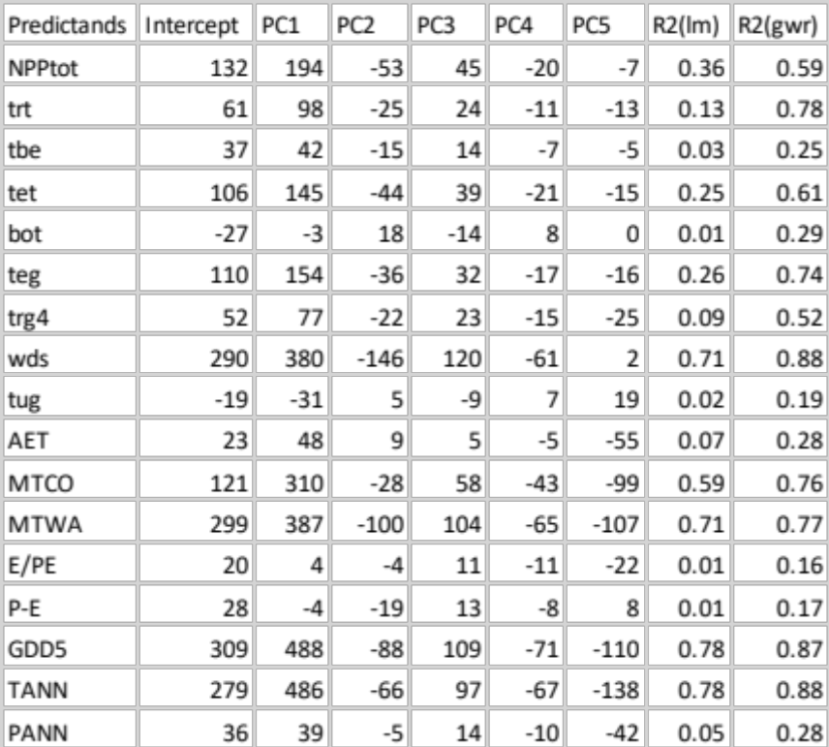

Fig. S3. Local (longitude x latitude) response of a few (bio)climatic variables to the PCs of forcing variables. The colors represent the t-values (t-val) of the response (= regression coefficient / standard error). Maps 1 to 5 represent the first five PCs; Map 6, the square-R of the regressions; Maps 7 and 8 represent the estimates for low CO₂ (<290 ppm, LGM and Mid-Holocene) and high CO2 (>600 ppm, second half of 21st century with scenario RCP8.5) respectively. The last graphic represents the estimates in function of the observations: blue dots are for observations with CO2<250 ppm, green dots for CO2 belonging to [250, 400] ppm, orange dots for [400, 600] ppm, red dots for CO2>600 ppm. The first series of maps are for the net primary production of the ecosystem (NPPtot), the second for annual temperature (Tann), the last one for annual precipitation (Pann).

S5. Paleodata assimilation
The parameters that may be optimized using temperature and precipitation data, are: (i) input volcanic activity, (ii) input solar activity, (iii) a possible bias for the temperature (δT) and (iv) for the precipitation (δP), (v) the standard error of temperature (σT) and (vi) precipitation (σP). Parameters (iii) and (iv) are related to a global ESM bias and are then independent of the geographical position. Parameters (v) and (vi) express the mean quadratic difference between observations and simulations.
The reconstructed annual temperature and precipitation values are expressed as anomalies relative to the present day for each time slice and each box given in Table S7. It shows that the first two time slices (4200 and 3200 yr BP) were characterized by dry conditions in the eastern Mediterranean Basin. All the other time slices are characterized by temperature changes. The 13 time slices or scenarios are characterized by the forcings shown in Table 2.
This process is known as a data-model assimilation (Goosse et al 2012). The model used is the emulator. Its statistical simplification makes it possible to run it thousands of times in a relatively short computational time as required by the assimilation methods (Widmann et al 2010). We use a Bayesian approach called the Markov Chain Monte Carlo method (MCMC), which makes it possible to converge towards the best parameters in the sense of probability distribution (Hargreaves and Annan 2002).
Starting from the prior probability distributions of the six parameters, available climate reconstructions and model outputs provide estimates of their posterior probability distributions. For each time period, these six parameters were optimized to provide the best a posteriori probability distribution of mean temperature and precipitation at the centers of the ten Mediterranean boxes. The a priori probability distributions are given by uniform distributions delimited by the + d (Table 2) for the volcanic and solar activity. The a priori distribution of the other parameters was assumed to be uniform within wide ranges so that they were considered as non-informative for the purpose of this study.
From Table 1, we consider that the 4200 and 3200 yr BP time slices provide robust paleoclimatic information for precipitation, and that the other periods provide robust information for temperature. Both the precipitation and temperature signals were robust for the present time slice. Even if we ultimately calculate both temperature and precipitation, only the robust variable(s) is (are) used to constrain the emulator.

Table S7. Proxy-based reconstruction of annual temperature (TANN, °C) and annual precipitation (PANN, mm). The values are expressed as anomalies from the pre-industrial period for the 10 spatial boxes and the 9 time slices, obtained from pollen (Guiot and Kaniewski 2015) and corrected/precised as indicated in Table 1 of the main text.

TANN | WMa | EMa | Lev | Ana | CMed | Ibe | Fra | Alp | Balk | Narb
4200 BP | 0.14 | 0.14 | 0.02 | -0.48 | -0.26 | 0.26 | 0.62 | 0.26 | -0.6 | 0.62
3200 BP | -0.08 | -0.08 | -0.15 | -0.04 | -0.08 | -0.02 | 0.16 | 0.05 | -0.2 | 0.16
2500 BP | 0.24 | 0.24 | 0.13 | -0.12 | -0.2 | -0.13 | -1.22 | -1 | -1 | -1.22
2000 BP | 0.04 | 0.04 | 0.18 | 0.18 | 0.5 | 0.5 | 0.8 | 0.5 | -0.02 | 0.5
1300 BP | 0.03 | 0.03 | -0.14 | 0.09 | -0.25 | -0.2 | -0.43 | -0.43 | -0.68 | -0.43
1000 BP | -0.07 | -0.07 | -0.17 | -0.07 | 0.07 | 0.09 | 0.54 | 0.41 | -0.25 | 0.54
700 BP | -0.07 | -0.07 | -0.25 | 0.27 | 0.09 | -0.5 | -0.8 | -0.8 | 0.25 | -0.8
200 BP | -0.3 | -0.3 | -0.33 | -0.15 | -0.3 | -0.3 | -0.5 | -0.5 | -0.5 | -0.5
Present | 1.4 | 1.3 | 1.2 | 1.4 | 1.4 | 1 | 1.2 | 1.5 | 1.5 | 1.2
PANN | WMa | EMa | Lev | Ana | CMed | Ibe | Fra | Alp | Balk | Narb
4200 BP | 48.4 | 48.4 | -80 | -88.7 | 29.94 | 40.83 | 18.11 | 51.92 | 42.84 | 18.11
3200 BP | -6.84 | -6.84 | -33 | -50.04 | 4.11 | 5.13 | 41.03 | 34.74 | 2.82 | 41.03
2500 BP | 61.33 | 61.33 | -34.03 | -14.8 | 25.58 | 43.78 | -8.9 | 35.35 | 3.02 | -8.9
2000 BP | -11.18 | -11.18 | 4.23 | 10.3 | 34.61 | -2.78 | 22.4 | 47.35 | 10.2 | 22.4
1300 BP | 20.41 | 20.41 | -11.98 | -5.78 | 67.64 | 27.34 | 48.13 | 94.55 | 36.31 | 48.13
1000 BP | -8.72 | -8.72 | -24.36 | -26.77 | 40.28 | -0.45 | 24.36 | 51 | 39.21 | 24.36
700 BP | 37.51 | 37.51 | -37.45 | -7.43 | 1.94 | 25.73 | -9.59 | 16.18 | -29.73 | -9.59
200 BP | 68.77 | 68.77 | -37.65 | -3.47 | -2.94 | 63.72 | 48.56 | 21.99 | -12.64 | 48.56
Present | -40 | -20 | -20 | 0 | -40 | -40 | -50 | 0 | 0 | -20

Figure S4. Temperature and precipitation anomalies for the 10 Mediterranean boxes estimated by data assimilation versus data reconstructed from proxies. Temperature dots correspond to the 10 boxes of the 11 periods between 2500 to present and precipitation data to the two oldest periods (4200 and 3200 yr BP) and the present. The vertical bars are the 90% confidence intervals. The blue line is the perfect estimate line, and the black line is the regression line between the simulations and proxy reconstructions.

References

Allen M R, Dube O P, Solecki W, Aragón-Durand F, Cramer W, Humphreys S, Kainuma M, Kala J, Mahowald N, Mulugetta Y, Perez R, Wairiu M and Zickfeld K 2018 Framing and Context Global Warming of 1.5°C. An IPCC Special Report on the impacts of global warming of 1.5°C above pre-industrial levels and related global greenhouse gas emission pathways, in the context of strengthening the global response to the threat of climate change, ed V Masson-Delmotte, P Zhai, H-O Pörtner, D Roberts, J Skea, P R Shukla, A Pirani, W Moufouma-Okia, C Péan, R Pidcock, S Connors, J B R Matthews, Y Chen, X Zhou, M I Gomis, E Lonnoy, T Maycock, M Tignor and T. Water (In press) pp 49–92
Amara R 1991 Views on futures research methodology Futures 23 645–9
Braconnot P, Harrison S P, Kageyama M, Bartlein P J, Masson-Delmotte V, Abe-Ouchi A, Otto-Bliesner B and Zhao Y 2012 Evaluation of climate models using palaeoclimatic data Nat. Clim. Chang. 2 417–24 Online: http://dx.doi.org/10.1038/nclimate1456
Brunsdon C, Fotheringham S and Charlton M 1998 Geographically weighted regression - Modelling spatial non-stationarity J. R. Stat. Soc. Ser. D Stat. 47 431–43
Chandler R E 2013 Exploiting strength, discounting weakness: Combining information from multiple climate simulators Philos. Trans. R. Soc. A Math. Phys. Eng. Sci. 371
Crowley T J and Unterman M B 2013 Technical details concerning development of a 1200 yr proxy index for global volcanism Earth Syst. Sci. Data 5 187–97 Online: http://dx.doi.org/10.5194/essd-5-187-2013
Frieler K, Lange S, Piontek F, Reyer C P O, Schewe J, Warszawski L, Zhao F, Chini L, Denvil S, Emanuel K, Geiger T, Halladay K, Hurtt G, Mengel M, Murakami D, Ostberg S, Popp A and Riva R 2017 Assessing the impacts of 1 . 5 ◦ C global warming – simulation protocol of the Inter-Sectoral Impact Model Intercomparison Project ( ISIMIP2b ) Geosci. Model Dev. 10 4321–45 Online: https://doi.org/10.5194/gmd-10-4321-2017
Giorgi F and Lionello P 2008 Climate change projections for the Mediterranean region Glob. Planet. Change 63 90–104
Goosse H, Guiot J, Mann M E M E, Dubinkina S, Sallaz-Damaz Y and ... 2012 The medieval climate anomaly in Europe: Comparison of the summer and annual mean signals in two reconstructions and in simulations with data assimilation Glob. Planet. Change 84–85 35–47 Online: http://www.meteo.psu.edu/holocene/public_html/shared/articles/GoosseEtAlGPC12.pdf
Grouillet B, Ruelland D, Ayar P V and Vrac M 2016 Sensitivity analysis of runoff modeling to statistical downscaling models in the western Mediterranean Hydrol. Earth Syst. Sci. 20 1031–47
Guiot J and Kaniewski D 2015 The Mediterranean Basin and Southern Europe in a warmer world: What can we learn from the past? vol 3
Guiot J, Torre F, Jolly D, Peyron O, Boreux J J J, Cheddadi R, Borreux J J and Cheddadi R 2000 Inverse vegetation modeling by Monte Carlo sampling to reconstruct paleoclimate under changed precipitation seasonality and CO2 conditions: application to glacial climate in Mediterranean region Ecol. Modell. 127 119–40
Hargreaves J and Annan J 2002 Assimilation of paleo-data in simple Earth system model Clim. Dyn. 19 371–81
Harrison S P and Prentice C I 2003 Climate and CO2 controls on global vegetation distribution at the Last Glacial Maximum: analysis based on paleovegetation data, biome modelling and paleoclimate simulations Glob. Chang. Biol. 9 983–1004
Kaplan J O, Bigelow N H, Prentice I C, Harrison S P, Bartlein P J, Christensen T R, Cramer W, Matveyeva N V, McGuire A D, Murray D F, Razzhivin V Y, Smith B, Walker D A, Anderson P M, Andreev A A, Brubaker L B, Edwards M E and Lozhkin A V 2003 Climate change and Arctic ecosystems: 2. Modeling, paleodata-model comparisons, and future projections J. Geophys. Res. 108 8171 Online: http://dx.doi.org/10.1029/2002JD002559
Levavasseur G, Vrac M, Roche D M, Paillard D, Martin A and Vandenberghe J 2011 Present and LGM permafrost from climate simulations: Contribution of statistical downscaling Clim. Past 7 1225–46
Lu B, Charlton M, Harris P and Fotheringham A S 2014 Geographically weighted regression with a non-Euclidean distance metric: A case study using hedonic house price data Int. J. Geogr. Inf. Sci. 28 660–81
Moss R H, Edmonds J a, Hibbard K a, Manning M R, Rose S K, van Vuuren D P, Carter T R, Emori S, Kainuma M, Kram T, Meehl G a, Mitchell J F B, Nakicenovic N, Riahi K, Smith S J, Stouffer R J, Thomson A M, Weyant J P and Wilbanks T J 2010 The next generation of scenarios for climate change research and assessment. Nature 463 747–56 Online: http://www.ncbi.nlm.nih.gov/pubmed/20148028
Muscheler R, Joos F, Beer J, Müller S A, Vonmoos M and Snowball I 2007 Solar activity during the last 1000yr inferred from radionuclide records Quat. Sci. Rev. 26 82–97 Online: http://www.sciencedirect.com/science/article/pii/S0277379106002460
New M, Lister D, Hulme M and Makin I 2002 A high-resolution data set of surface climate over global land areas Clim. Res. 21 1–25
O’Hagan A 2004 Bayesian analysis of computer code outputs Reliab. Eng. Syst. Saf. 91 1290--1300
Prentice I C, Cramer W, Harrison S P, Leemans R, Monserud R A and Solomon A M 1992 A global biome model based on plant physiology and dominance, soil properties and climate J. Biogeogr. 19 117–34
Su B, Huang J, Gemmer M, Jian D, Tao H, Jiang T and Zhao C 2016 Statistical downscaling of CMIP5 multi-model ensemble for projected changes of climate in the Indus River Basin Atmos. Res. 178 138–49
Taylor K E, Stouffer R J and Meehl G A 2012 An overview of CMIP5 and the experiment design Bull. Am. Meteorol. Soc. 93 485–98
Vernon I, Goldsteiny M and Bowerz R G 2010 Galaxy formation: A Bayesian uncertainty analysis Bayesian Anal. 5 619–70
Warszawski L, Frieler K, Huber V, Piontek F, Serdeczny O and Schewe J 2014 The Inter-Sectoral Impact Model Intercomparison Project (ISI-MIP): project framework. Proc. Natl. Acad. Sci. U. S. A. 111 3228–32
Widmann M, Goosse H, van der Schrier G, Schnur R and Barkmeijer J 2010 Using data assimilation to study extratropical Northern Hemisphere climate over the last millennium Clim. Past 6 627–44 Online: http://www.clim-past.net/6/627/2010/
Zobler L 1986 A world soil file grobal climate modeling NASA Tech. Memo 32 Online: http://ci.nii.ac.jp/naid/10004560598/en/

