Development of Na⁺ ion conducting solid biopolymer electrolyte based on Na-CMC-SPA hydrogel for energy storage devices
Dipendra Kumar Verma†, Rudramani Tiwari†, Devendra Kumar†, Shashikant Yadav†, Km Parwati†, Pubali Adhikary‡, S. Krishnamoorthi†*
†Department of Chemistry, Centre of Advanced Studies, Institute of Science, Banaras Hindu University, Varanasi 221005, India.
‡Central Discovery Centre, Institute of Science, Banaras Hindu University, Varanasi 221005, India.
* Corresponding Author: Prof. S. Krishnamoorthi, (E-mail: dr.skmoorthi@gmail.com), Tel: +91 9450200221

Supporting Information
1. Materials
SPA polymer (20% hydrolyzed) were used that is previously synthesized and characterized by ¹H NMR and GPC method that authors already reported in the previous article [Ref. ef-2022-003216.R2]. All the chemicals are purchased from commercially available sources as Carboxymethyl Cellulose Sodium Salt (SRL, India), Acrylic Acid (99%, SRL, India), Ethyl Acetate (SDFCL India), Polyethylene glycol 400 (SDFCL, India), Sodium hydroxide pellets (Merck, India) Sodium iodide (99%, SRL, India).
2. Methods of characterization:
Infrared spectroscopy of synthesized polymer was analyzed by FT-IR Spectrometer model FTIR 4700 (Make:JASCO,Tokyo). Thermal analysis was recorded by TGA-DTA (Perkin-Elmer STA 6000) within the temperature range of 30ºC to 700ºC under inert atmosphere and the heating rate was 10ºC per minute. XRD spectrum was recorded by bench-top XRD Rigaku Miniflex 600 Desktop X-Ray Diffraction System, Rigaku Corporation. XRD analysis was performed with 1.54059 wavelength, step size 0.02 and scan rate 5º/minute within 5º to 90º range. Polymer film was used to analysis in XRD by using power XRD diffraction (reflection) method. Data recorded by auto-subtracting the blank data from the instrument. SEM-EDS analysis was performed using Nova NanoSEM 450 instrument with Bruker laser assembly (Czech republic). All electrochemical analyses are performed using Ivium compact state model B10049 (Make: Ivium technologies, Holland) instrument. Linear sweep voltammetry (LSV) was performed in voltage range of 0V to 1.3V and scan rate of 10mVs⁻¹. In the case of solid state two electrode systems work first is the reference electrode joined at the anode and the second is the working electrode joined at the cathode. CV data is recorded in the voltage range of 0V to 1.3V and scan rate of 10mVs⁻¹. Chronoaperometry analysis was performed by applying potential of 1V for 2900 sec. EIS for conductivity study performed by Wayne Karr impedance analyzer model 6500B made by Wayne Karr instrument UK at 1V potential and frequency range 20 Hz to 10 MHz. Dielectric measurements are performed by Wayne Karr impedance analyzer model 6500B made by Wayne Karr instrument UK at 1V potential and frequency range 20 Hz to 10 MHz. Here we take data at a varying temperature from 20ºC to 80ºC for conductivity and dielectric analysis.

Table.S1. show value of σ_{ac}, A, n, R², C_{b} , ε_{b}, µ and V_{d} at different temperatures

T  (^{O}C) | σ_{dc} (m S/cm) | A x10⁻⁸ | n | R² | C_{b}(F)x 10⁻⁶ | $ε$_{b} (F/m) | µ (m²/Vs) x 10⁻⁶ | V_{d}(m/s)  x 10⁻⁴ | Dx10⁷ (m²/s)
20 | 0.020 | 0.70 | 0.65 | 0.99 | 9.45 | 1.07x10⁸ | 0.935 | 2.34 | 0.236
30 | 0.031 | 1.8 | 0.57 | 0.99 | 8.10 | 91592491 | 1.37 | 3.42 | 0.619
40 | 0.046 | 2.4 | 0.57 | 0.99 | 7.11 | 80372724 | 2.2 | 5.49 | 1.69
50 | 0.069 | 1.8 | 0.60 | 0.99 | 7.35 | 83098611 | 2.99 | 7.48 | 0.58
60 | 0.180 | 4.1 | 0.56 | 0.98 | 6.14 | 69453330 | 3.76 | 9.4 | 0.377
70 | 0.362 | 1.2 | 0.65 | 0.98 | 5.09 | 57561222 | 4.58 | 11.46 | 0.319
80 | 0.560 | 0.85 | 0.69 | 0.98 | 4.56 | 51517278 | 5.57 | 13.93 | 0.408

S2: SEM-EDS
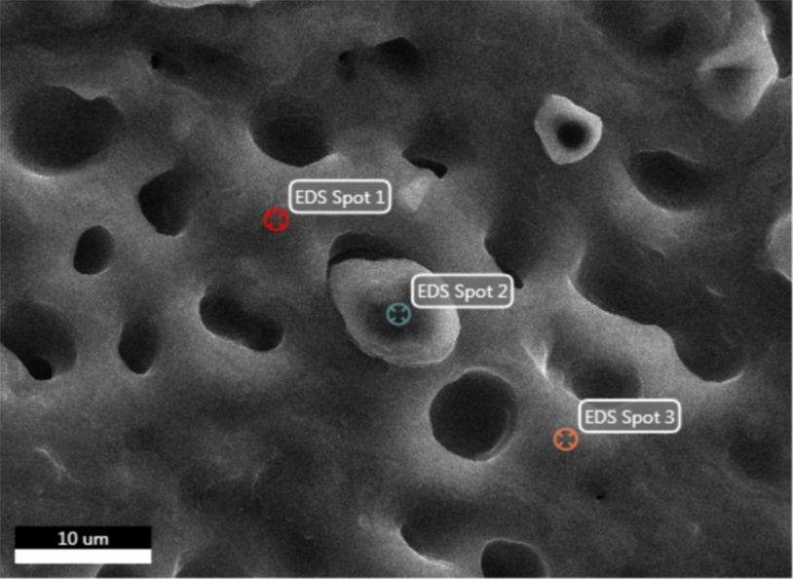

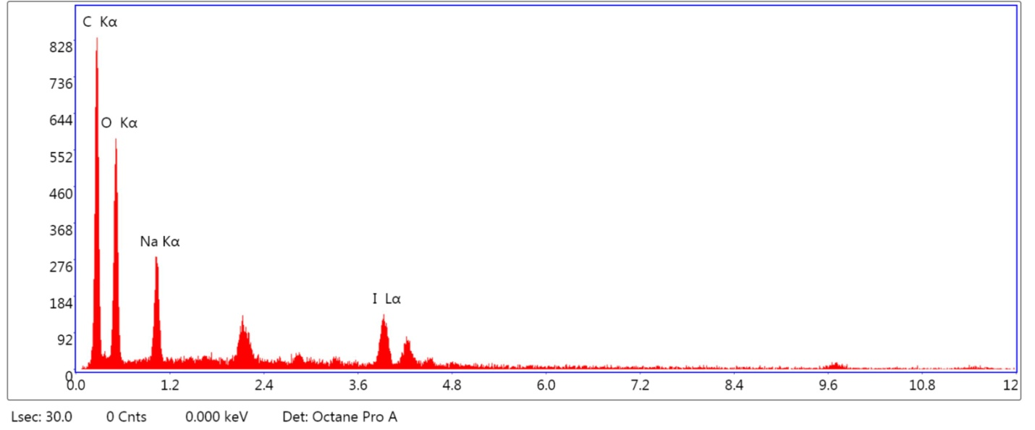
Element |  |  |  | Weight % |  |  |  | Atomic % |  | Net Int. |  |  |  | Error % |  |  |  | Kratio |  |  |  | Z |  |  |  | A |  |  |  |  |  | F
C K |  |  |  | 37.69 |  |  |  | 60.96 |  | 172.76 |  |  |  | 2.90 |  |  |  | 0.2965 |  |  |  | 0.7726 |  |  |  | 1.0182 |  |  |  |  |  | 1.0000
O K |  |  |  | 19.07 |  |  |  | 23.16 |  | 108.14 |  |  |  | 7.28 |  |  |  | 0.0902 |  |  |  | 0.7343 |  |  |  | 0.6440 |  |  |  |  |  | 1.0000
NaK |  |  |  | 13.38 |  |  |  | 11.31 |  | 70.19 |  |  |  | 7.82 |  |  |  | 0.0585 |  |  |  | 0.6691 |  |  |  | 0.6521 |  |  |  |  |  | 1.0013
I L |  |  |  | 29.86 |  |  |  | 4.57 |  | 52.28 |  |  |  | 9.91 |  |  |  | 0.1632 |  |  |  | 0.5006 |  |  |  | 1.0918 |  |  |  |  |  | 1.0001

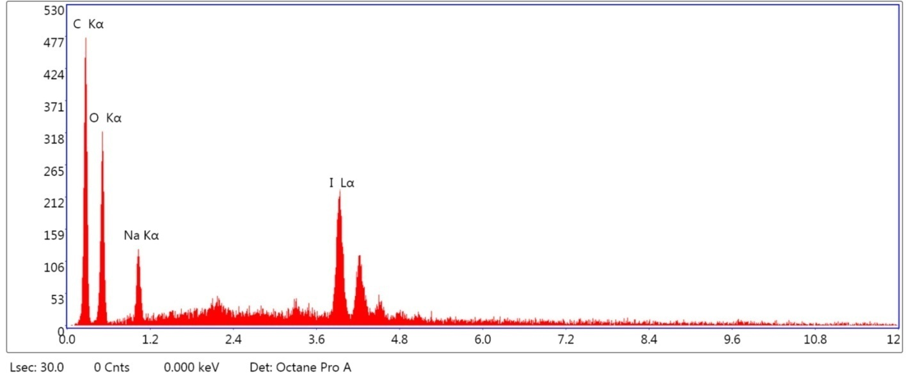
Element | Weight % | Atomic % | Net Int. | Error % | Kratio | Z | A | F
C K | 22.84 | 57.43 | 86.69 | 4.03 | 0.2016 | 0.8369 | 1.0543 | 1.0000
O K | 10.26 | 19.36 | 52.66 | 7.74 | 0.0595 | 0.7802 | 0.7435 | 1.0000
NaK | 6.79 | 8.91 | 22.57 | 12.30 | 0.0255 | 0.6989 | 0.5362 | 1.0015
I L | 60.11 | 14.30 | 78.98 | 8.23 | 0.3342 | 0.5163 | 1.0767 | 1.0000

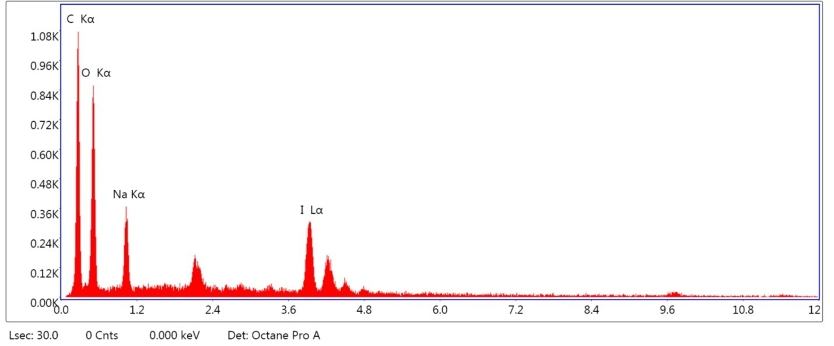
Element | Weight % | Atomic % | Net Int. | Error % | Kratio | Z | A | F
C K | 28.79 | 57.62 | 208.87 | 2.78 | 0.2366 | 0.8010 | 1.0261 | 1.0000
O K | 14.85 | 22.31 | 143.20 | 6.25 | 0.0788 | 0.7542 | 0.7038 | 1.0000
NaK | 10.97 | 11.47 | 80.13 | 8.24 | 0.0441 | 0.6817 | 0.5884 | 1.0014
I L | 45.38 | 8.60 | 121.04 | 6.68 | 0.2495 | 0.5073 | 1.0836 | 1.0000

