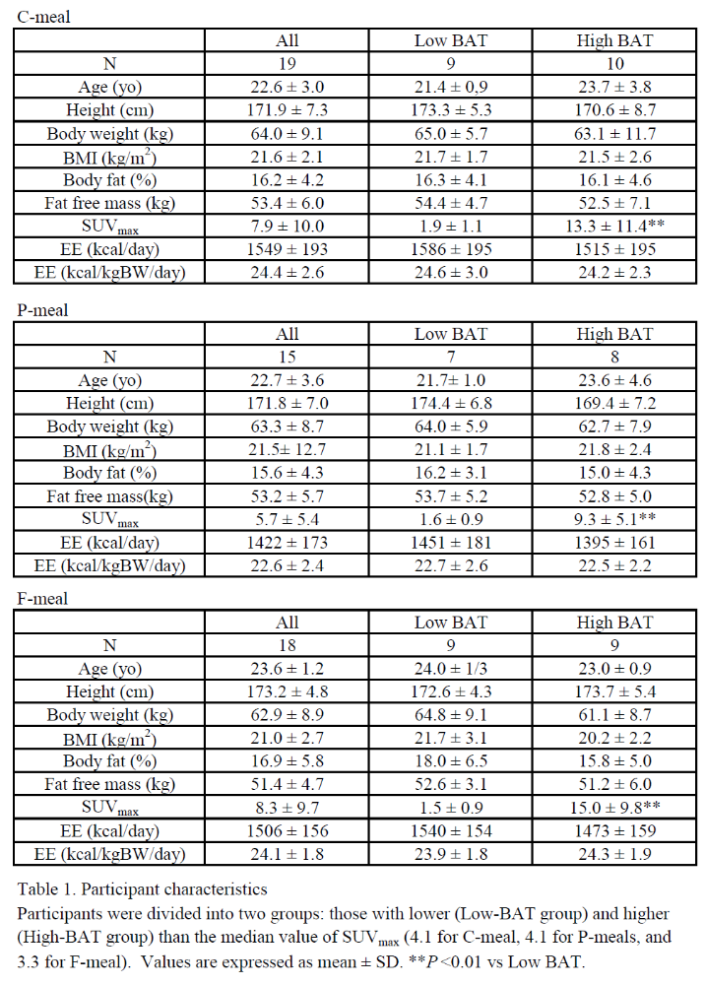Table 1. Participant characteristics.
Participants were divided into two groups: those with lower (Low-BAT group) and higher (High-BAT group) than the median value of SUVmax (4.1 for C-meal, 4.1 for P-meals, and 3.3 for F-meal). Values are expressed as mean ± SD. **P<0.01 vs Low BAT.

