Supplementary Tables:

Supplementary Table S1: Location information for P. lemhiensis samples utilized for genetic analysis.
POPULATION | LONGITUDE | LATITUDE
Population 1 - Sula | -113.9526937 | 45.88939723
Population 1 - Sula | -113.9527076 | 45.88941487
Population 1 - Sula | -113.9531266 | 45.88978207
Population 1 - Sula | -113.9531009 | 45.88978274
Population 1 - Sula | -113.9530212 | 45.88973979
Population 1 - Sula | -113.9530088 | 45.88974911
Population 1 - Sula | -113.9527033 | 45.889577
Population 1 - Sula | -113.9527047 | 45.88960397
Population 1 - Sula | -113.9527047 | 45.88960397
Population 2 – French Creek | -112.908503 | 45.331521
Population 2 – French Creek | -112.9000751 | 45.340141
Population 2 – French Creek | -112.9026505 | 45.338532
Population 2 – French Creek | -112.9094681 | 45.331757
Population 2 – French Creek | -112.9096834 | 45.331708
Population 2 – French Creek | -112.9041115 | 45.335663
Population 2 – French Creek | -112.9098185 | 45.325855
Population 2 – French Creek | -112.9088479 | 45.33039
Population 3 – Vipond Park | -112.8776534 | 45.68472709
Population 3 – Vipond Park | -112.8775645 | 45.68475555
Population 3 – Vipond Park | -112.8776528 | 45.68470909
Population 3 – Vipond Park | -112.8791301 | 45.68395572
Population 3 – Vipond Park | -112.8791933 | 45.68392768
Population 3 – Vipond Park | -112.8791933 | 45.68392768
Population 3 – Vipond Park | -112.8791933 | 45.68392768
Population 3 – Vipond Park | -112.8792838 | 45.68394419
Population 3 – Vipond Park | -112.8797342 | 45.68397278
Population 4 – Badger Pass | -113.2647913 | 45.917209
Population 4 – Badger Pass | -113.2647913 | 45.917209
Population 4 – Badger Pass | -112.9461195 | 45.244886
Population 4 – Badger Pass | -112.9459828 | 45.244987
Population 4 – Badger Pass | -112.9458443 | 45.245034
Population 4 – Badger Pass | -112.9461743 | 45.244624
Population 4 – Badger Pass | -112.9458101 | 45.245152
Population 4 – Badger Pass | -112.9458446 | 45.245043
Population 4 – Badger Pass | -112.9458676 | 45.244971
Population 5 - Highland | -112.5107728 | 45.78287785
Population 5 - Highland | -112.5100902 | 45.78332791
Population 5 - Highland | -112.5101036 | 45.78334574
Population 5 - Highland | -112.5101948 | 45.78338954
Population 5 - Highland | -112.5101058 | 45.78342672
Population 5 - Highland | -112.5103118 | 45.783433
Population 5 - Highland | -112.5103377 | 45.78344165
Population 5 - Highland | -112.5103132 | 45.78348698
Population 5 - Highland | -112.5104923 | 45.78344861
Population 6 – Sharkey Hot Springs | -113.5601331 | 45.03510649
Population 6 – Sharkey Hot Springs | -113.560103 | 45.03511617
Population 6 – Sharkey Hot Springs | -113.5600561 | 45.03511722
Population 6 – Sharkey Hot Springs | -113.5600692 | 45.03512593
Population 6 – Sharkey Hot Springs | -113.560125 | 45.03512468
Population 6 – Sharkey Hot Springs | -113.560146 | 45.03516921
Population 6 – Sharkey Hot Springs | -113.5603801 | 45.03506494
Population 6 – Sharkey Hot Springs | -113.5601309 | 45.03528658
Population 7 – William Creek | -113.9704524 | 45.098348
Population 7 – William Creek | -113.9704647 | 45.098339
Population 7 – William Creek | -113.9742103 | 45.098511
Population 7 – William Creek | -113.9743372 | 45.098508
Population 7 – William Creek | -113.9743123 | 45.098518
Population 7 – William Creek | -113.9743259 | 45.098535
Population 7 – William Creek | -113.9742267 | 45.098583
Population 7 – William Creek | -113.9704007 | 45.098331
Population 8 – Big Hole | -113.6488139 | 45.652331
Population 8 – Big Hole | -113.6493355 | 45.651689
Population 8 – Big Hole | -113.6490647 | 45.652478
Population 8 – Big Hole | -113.6466901 | 45.654108
Population 8 – Big Hole | -113.6472844 | 45.653374
Population 8 – Big Hole | -113.6531846 | 45.648404
Population 8 – Big Hole | -113.6525209 | 45.648752
Population 8 – Big Hole | -113.6491007 | 45.653242
Population 8 – Big Hole | -113.6497473 | 45.650626
Population 8 – Big Hole | -113.6505053 | 45.650914
Population 8 – Big Hole | -113.6554558 | 45.644867
Population 8 – Big Hole | 113.6592876 | 45.643671
Population 8 – Big Hole | -113.6567991 | 45.645592
Population 8 – Big Hole | -113.6567991 | 45.645592
Population 8 – Big Hole | -113.6583946 | 45.643242
Population 8 – Big Hole | -113.6559336 | 45.644388
Population 8 – Big Hole | -113.6573105 | 45.643654
Population 8 – Big Hole | -113.655901 | 45.645055
Population 8 – Big Hole | -113.6558304 | 45.645462
Population 8 – Big Hole | -113.6583946 | 45.643242
Population 8 – Big Hole | -113.645728 | 45.641862
Population 8 – Big Hole | -113.645728 | 45.641862
Population 8 – Big Hole | -113.645728 | 45.641862
Population 8 – Big Hole | -113.645728 | 45.641862
Population 8 – Big Hole | -113.645728 | 45.641862
Population 8 – Big Hole | -113.645728 | 45.641862
Population 8 – Big Hole | -113.645728 | 45.641862
Population 8 – Big Hole | -113.645728 | 45.641862
Population 8 – Big Hole | -113.645728 | 45.641862
Population 8 – Big Hole | -113.645728 | 45.641862
Population 8 – Big Hole | -113.645728 | 45.641862
Population 8 – Big Hole | -113.645728 | 45.641862
Population 8 – Big Hole | -113.645728 | 45.641862

Supplementary Table S2: Biogeophysical, disturbance, bioclimatic predictor variables, descriptions and statistics across the whole study area, and the Lemhi observation sites (n=380). Variables retained in the final model are in bold. ** were removed due to lack of data in historical and or future projections. **^variable replaced *^ variable in the final model due to data availability in WorldClim historic time periods.

Class | Variable | Details | Min | Mean | Max | Min-Obs | Mean-Obs | Max-Obs
BioGeophysical | Elevation | (m) | 297.7 | 1,838.6 | 3,839.1 | 973.1 | 1,882.7 | 2,491.1
 | Aspect | (Deg) | 0.0 | 179.8 | 360.0 | 5.1 | 184.3 | 355.5
 | Slope | (Deg) | 0.0 | 13.0 | 66.4 | 0.7 | 15.0 | 42.9
 | Topography Position Index | 1-Ridge, 2-Upper Slope, 3-Mid Slope, 4-Flat, 5-Lower Slope, 6-Valleys | 1.0 | 3.3 | 6.0 | 1.0 | 3.1 | 6.0
 | Soil moisture regime ** | 1-Ustic, 2 - Aquic, 3- Udic, 4-Aridic, 5-Xeric, 6-Null | 1.0 | 3.6 | 6.0 | 1.0 | 2.5 | 5.0
 | Soil temperature regime | 1- Frigid, 2-Cryic, 3-Mesic, 4- Null, 5-Pergelic | 1.0 | 1.9 | 5.0 | 1.0 | 1.8 | 2.0
 | Available Soil Water Storage** | Weighted average soil components 0-150 cm depth (mm) | 0.0 | 121.4 | 597.9 | 18.3 | 108.6 | 217.6
Disturbance | Distance to Fire** | Distance to fire disturbance (m) | 0.0 | 7,352.1 | 41,046.3 | 0.0 | 7,236.0 | 34,233.4
 | Annual Mean Temperature | Annual Mean Temperature (Deg C) | -3.5 | 4.4 | 12.9 | 1.5 | 4.2 | 8.1
 | Mean Diurnal Range | Annual Mean Diurnal Range (Deg C) | 7.8 | 13.2 | 18.2 | 10.4 | 13.3 | 16.7
BioClimatic | Isothermality | Isothermality (Percent) | 27.0 | 36.5 | 44.3 | 31.7 | 36.2 | 41.1
 | Temperature Seasonality**^ | Temperature Seasonality Std Dev (Deg C) | 6.5 | 7.9 | 10.1 | 7.2 | 8.0 | 8.8
 | Temperature Seasonality *^ | Temperature Seasonality CV (Percent) | 28.2 | 34.3 | 43.3 | 31.5 | 34.7 | 37.8
 | Max Temperature of Warmest Month | Max Temperature of Warmest Month (Deg C) | 14.3 | 25.2 | 35.0 | 20.1 | 25.4 | 31.6
 | Min Temperature of Coldest Month | Min Temperature of Coldest Month (Deg C) | -17.7 | -11.0 | -1.4 | -15.8 | -11.3 | -8.4
 | Annual Temperature Range | Annual Temperature Range (Deg C) | 28.2 | 36.2 | 45.9 | 31.5 | 36.7 | 41.2
 | Mean Temperature of Wettest Quarter | Mean Temperature of Wettest Quarter (Deg C) | -10.6 | 3.4 | 16.6 | -5.9 | 5.4 | 15.2
 | Mean Temperature of Driest Quarter | Mean Temperature of Driest Quarter (Deg C) | -9.7 | 8.8 | 23.2 | -8.4 | 8.9 | 18.8
 | Mean Temperature of Warmest Quarter | Mean Temperature of Warmest Quarter (Deg C) | 6.3 | 14.8 | 23.3 | 11.1 | 14.7 | 19.3
 | Mean Temperature of Coldest Quarter | Mean Temperature of Coldest Quarter (Deg C) | -11.4 | -5.5 | 3.2 | -8.5 | -5.9 | -3.2
 | Annual Precipitation | Annual Precipitation (mm) | 159.0 | 668.2 | 2,487.8 | 251.0 | 517.1 | 959.0
 | Precipitation of Wettest Month | Precipitation of Wettest Month (mm) | 20.3 | 90.2 | 357.4 | 39.6 | 65.8 | 115.2
 | Precipitation of Driest Month | Precipitation of Driest Month (mm) | 4.1 | 26.2 | 86.9 | 11.7 | 26.8 | 45.7
 | Precipitation Seasonality | Precipitation Seasonality CV (Percent) | 13.3 | 35.7 | 72.2 | 14.4 | 28.2 | 46.2
 | Precipitation of Wettest Quarter | Precipitation of Wettest Quarter (mm) | 55.0 | 246.0 | 1,044.6 | 97.4 | 178.5 | 332.2
 | Precipitation of Driest Quarter | Precipitation of Driest Quarter (mm) | 14.8 | 89.5 | 288.6 | 39.1 | 150.3 | 87.6
 | Precipitation of Warmest Quarter | Precipitation of Warmest Quarter (mm) | 25.6 | 123.8 | 357.2 | 65.5 | 117.1 | 194.9
 | Precipitation of Coldest Quarter | Precipitation of Coldest Quarter (mm) | 14.8 | 190.9 | 972.1 | 41.4 | 127.0 | 306.5

Supplementary Table S3: Species distribution model variable contributions across replicate maxent runs.

Variable | Percent contribution | Permutation importance
Precipitation Seasonality | 19.6 | 11.2
Temperature Seasonality | 17.3 | 12.2
Slope | 15.8 | 7.9
Precipitation of Warmest Quarter | 11.3 | 14.9
Aspect | 9.9 | 4.3
Mean Temperature of Wettest Quarter | 7.3 | 8.8
Min Temperature of Coldest Month | 6.3 | 6.8
Elevation | 5.1 | 5.5
Precipitation of Driest Quarter | 2.5 | 10.3
Isothermality | 2.4 | 1.6
Precipitation of Wettest Month | 1.5 | 6.3
Mean Temperature of Coldest Quarter | 0.9 | 10.3

Supplementary Figures:

Supplementary Figure S1: Discriminant Analysis of Principal Components (DAPC) based on SNP data of P. lemhiensis. Seven clusters were identified, each representing a single population, with the exception of cluster five, which includes both POP2 and POP4

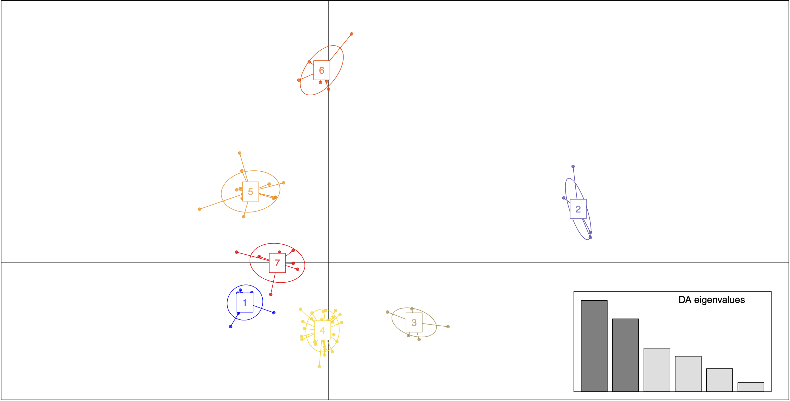

Supplementary Figure S2: Neighbor-Joining Tree based on the genetic distance of 93 individuals of P. lemhiensis. Populations are labeled accordingly.

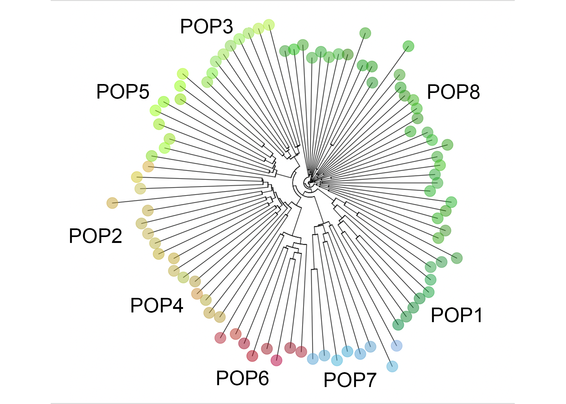

Supplementary Figure S3: Species distribution models showcasing range estimations for P. lemhiensis based on climatic suitability across four periods: (a) the Last Glacial Maximum (0.020 Ma); (b) mid Holocene (0.0117 – 0 Ma); (c) current range; (d) future projects (2070-2099) based on representative concentration pathways (RCP) of 8.5. F_{ST} (genetic differentiation) estimates between populations overlayed.

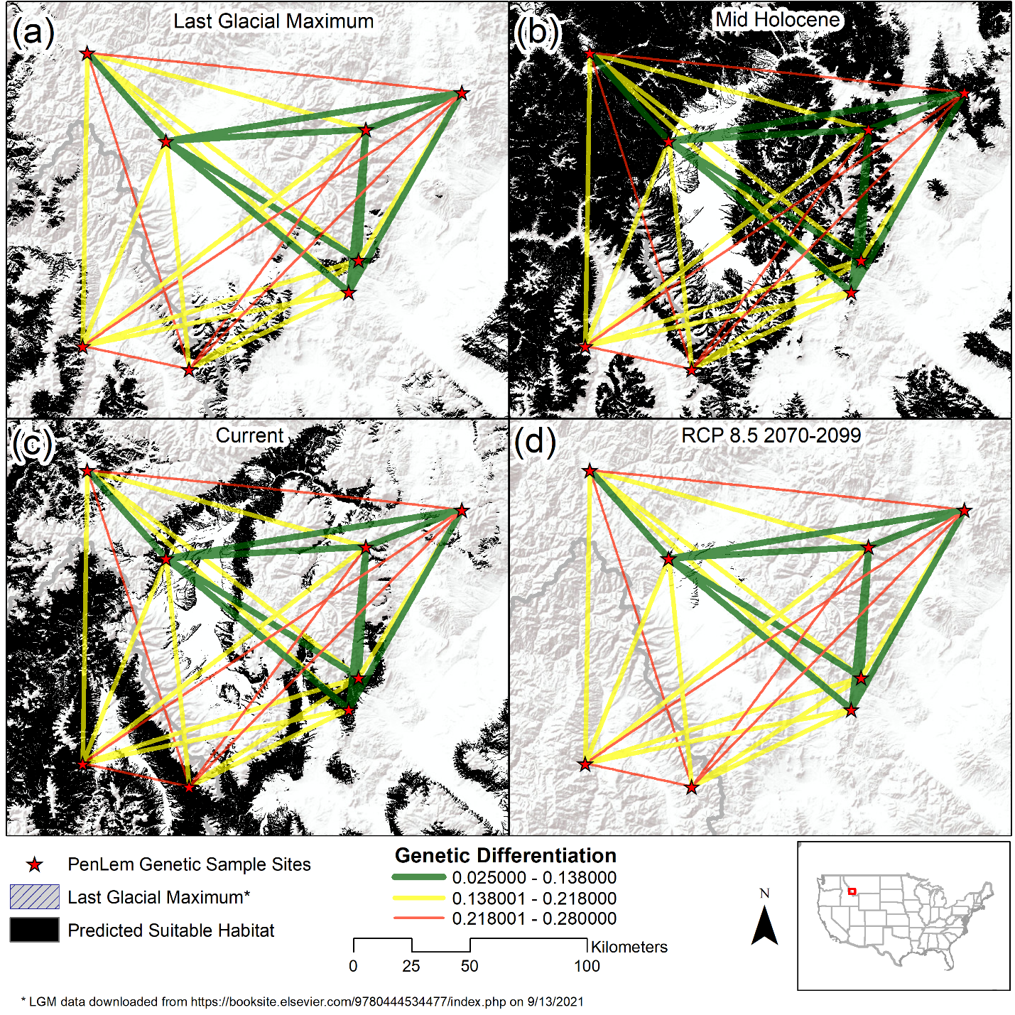

Supplementary Figure S4: Change in Penstemon lemhiensis suitable habitat over time from a) last glacial maximum, b) mid-Holocene, c) current, to b) potential future in the Upper Big Hole valley, Montana, US. Key players are shown, with Big Hole National Battlefield (NPS) as the potential central nexus for catalyzing collaborative conservation.

