Supplementary Figures

Modulation of mouse laryngeal inflammatory and immune cell responses by low and high doses of mainstream cigarette smoke

Meena Easwaran^{1,2}, Joshua D. Martinez¹, Juyong Brian Kim², Elizabeth Erickson-DiRenzo¹
¹Department of Otolaryngology-Head and Neck Surgery, Stanford University School of Medicine, Stanford, CA, USA.
²Department of Cardiovascular Medicine, Stanford University School of Medicine, Stanford, CA, USA.

*Correspondence:
Elizabeth Erickson-DiRenzo Ph.D., CCC-SLP
Assistant Professor, Division of Laryngology
Department of Otolaryngology-Head & Neck Surgery
Stanford University School of Medicine
801 Welch Road, Stanford, CA 94305-5739
Office: 650-498-9051
Email: edirenzo@stanford.edu

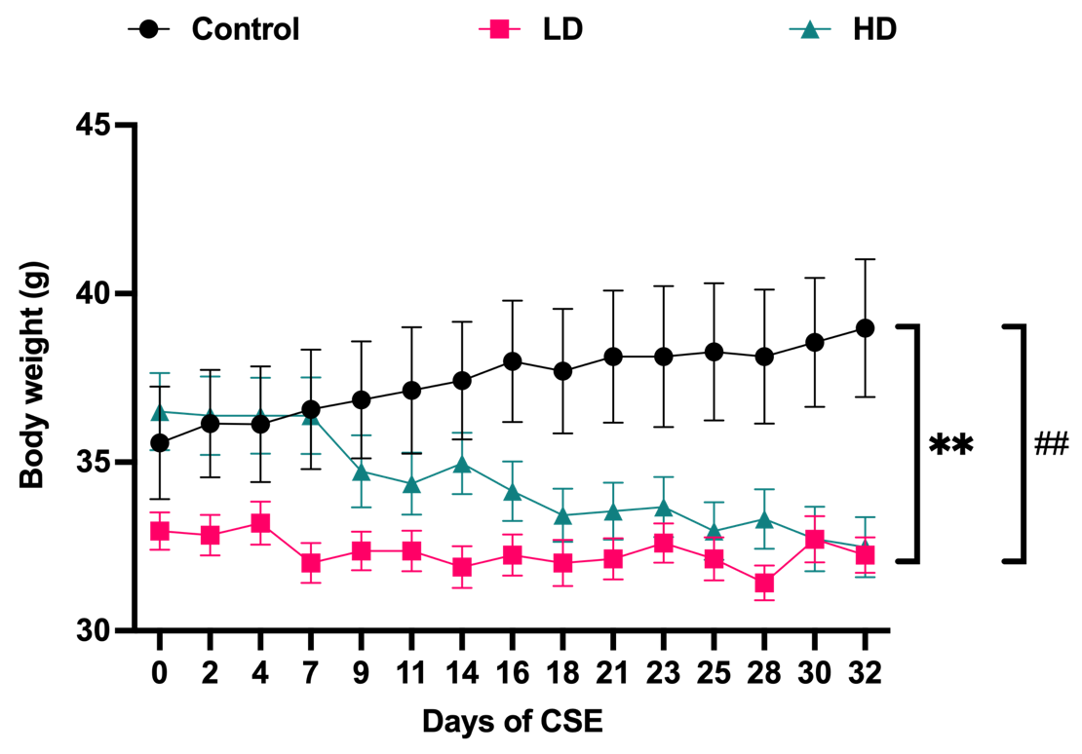
Supplementary Figure 1. Mice body weight. Control, LD, and HD experimental group mice did not significantly differ in body weights before the start of CS exposures (Day 0). Body weight of mice in HD group was significantly lower than body weight gained by control mice at the end of CS exposures (Day 32). Despite no evident changes to LD group mice body weight from exposure start to end, their body weight remained significantly lower to the body weight gained by control mice at exposure end. Mean with SEM are depicted in the line graphs. * significance between control and HD. # significance between control and LD. ** p -value ≤ 0.01 and ## p -value ≤ 0.01.

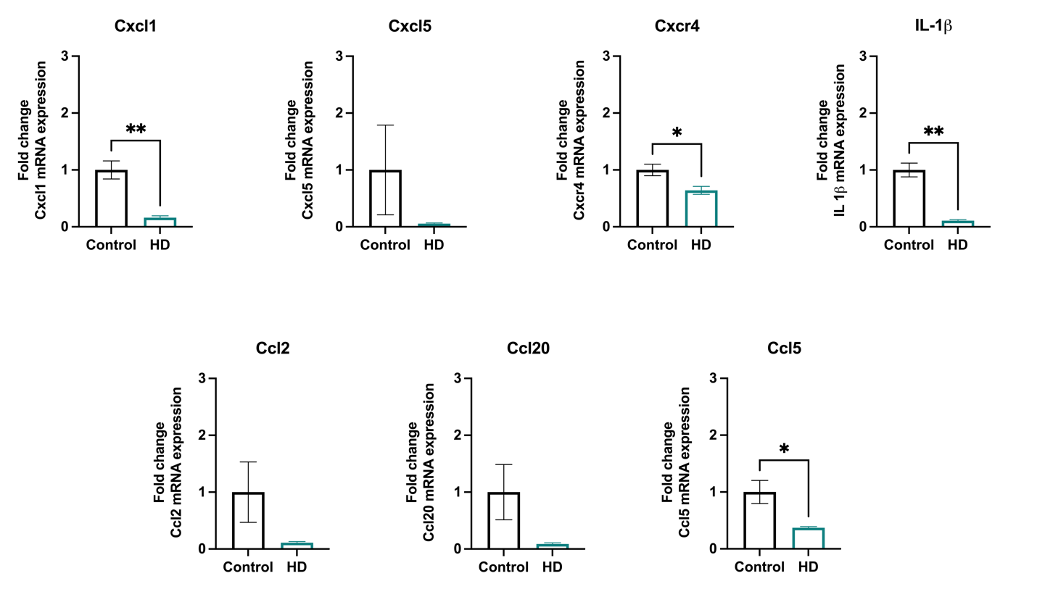

Supplementary Figure 2. Quantification of hub gene mRNA expression via qPCR. Key inflammatory cytokines and chemokines hub genes identified from StringDB PPI were validated for their gene expression via qPCR. Cxcl1, Cxcr4, IL-1β and Ccl5 gene expression was significantly lower in the HD group in comparison to the control. Ccl2, Ccl20, and Cxcl5 mRNA expression was non-significant between the groups, despite exhibiting a downward trend in HD group than the control. Gene expression was normalized to the reference gene, Gusb. Bar plots are represented as mean with SEM. * p ≤ 0.05 and ** p ≤ 0.01.
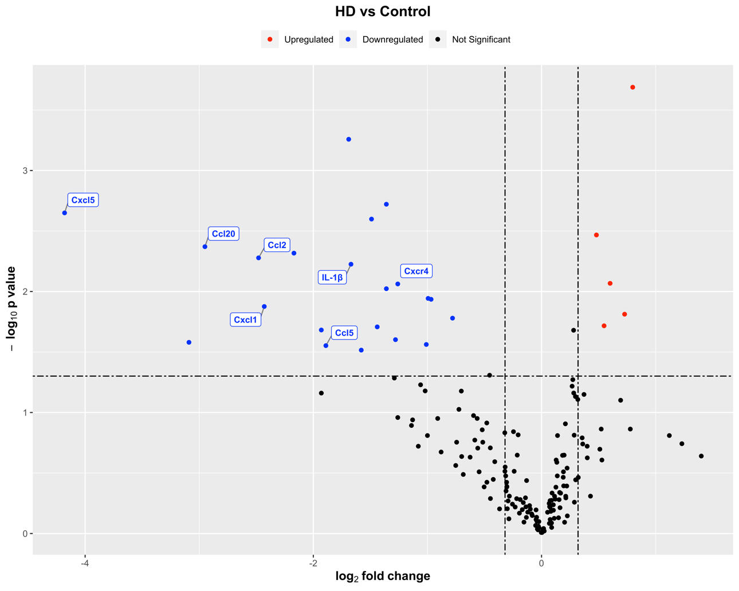
Supplementary Figure 3. Downregulation of inflammatory cytokine related hub genes. Seven out of 10 hub genes identified from the StringDB PPI on Cytoscape platform were inflammatory cytokines and chemokines. These hub genes (IL-1β, Cxcl1, Cxcl5, Cxcr4, Ccl2, Ccl20 and Ccl5) were significantly downregulated upon NanoString differential expression analysis.

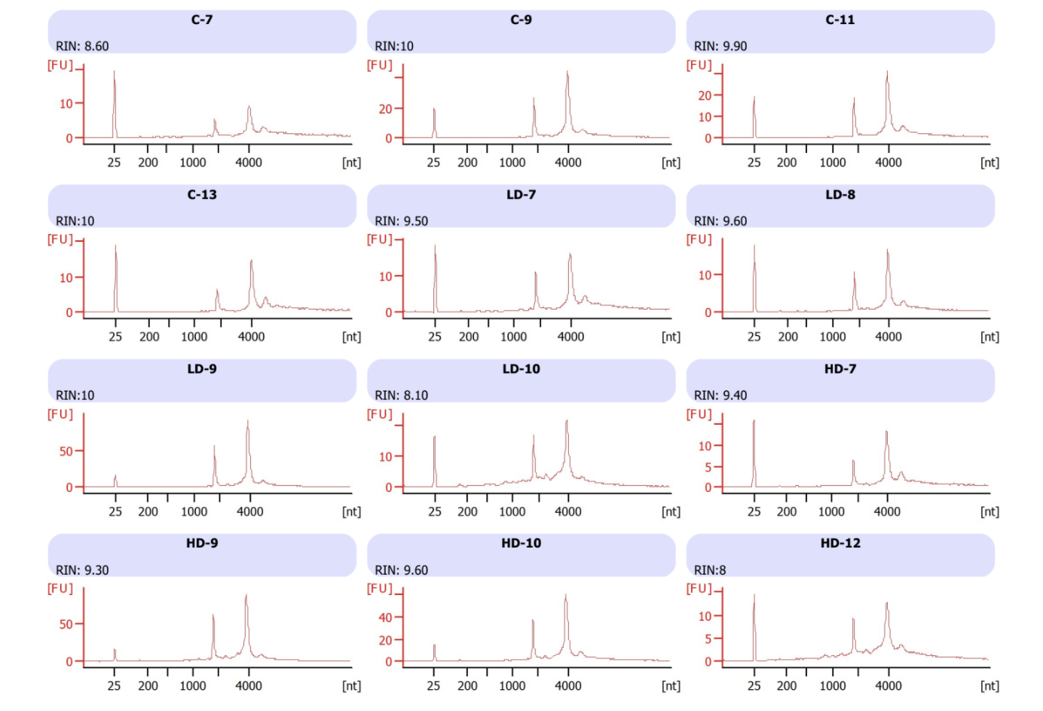
Supplementary Figure 4. Assessment of RNA integrity numbers (RIN) for experimental samples. Using Agilent Bioanalyzer 2100, RIN values were computed for the total murine laryngeal RNA samples isolated from all the experimental groups, control, LD, and HD (n = 4 each). All samples had RIN > 8 and were selected for subsequent NanoString analysis. Control sample names: C-7, C-9, C-11, and C-13; LD group sample names: LD-7, LD-8, LD-9, and LD-10; HD group sample names: HD-7, HD-9, HD-10, and HD-12. All analyses were executed by Stanford Protein and Nucleic acid core facility (PAN).

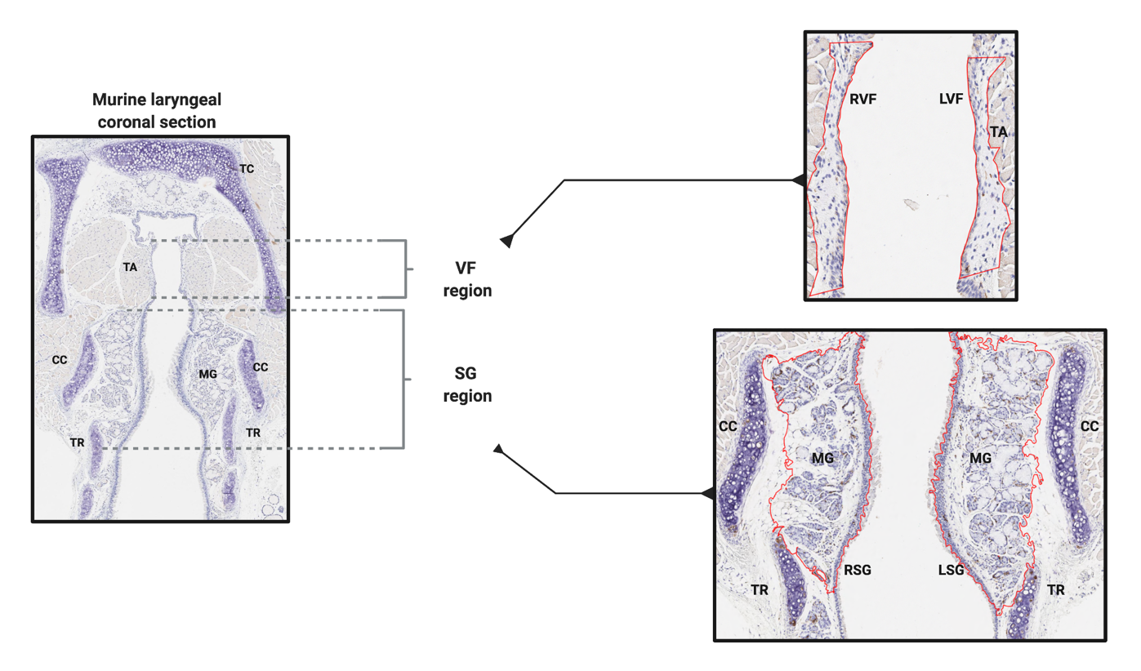
Supplementary Figure 5. Anatomical landmarks for vocal folds and subglottic regions in a murine laryngeal coronal section. Within a coronal section of mouse larynx, vocal fold (VF) and subglottic (SG) regions can be viewed simultaneously and are well distinguished. VF regions are lined by stratified squamous epithelium with underlying layers of lamina propria and thyroarytenoid (TA) vocalis muscle. SG regions are lined by pseudostratified ciliated columnar respiratory epithelium with underlying mucosal glands (MG) and flanked by cricoid cartilage (CC). For immunohistochemical assessment of immune cell infiltrates, the mid membranous regions on the right and left vocal fold (RVF/LVF) were traced. Regions starting from the lower end of VF regions until the first tracheal ring (TR) on right and left sides are the subglottic regions (RSG/LSG) and these were also traced to quantify various immune cells. All tracings were done in QuPath v 3.0 and are highlighted in red. TC: Thyroid cartilage

