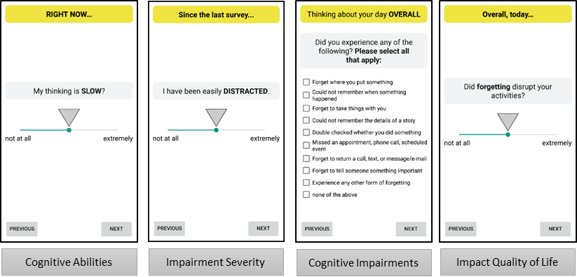
Figure S1. Example Perceived Cognition EMA Items. Momentary surveys of perceived cognitive ability and impairment severity were administered at every Beeped and Bedtime survey. Participants were asked to rate their perceived cognitive ability in the current moment and rate impairment severity since the previous survey. During Bedtime surveys participants were asked to catalog any specific impairments experienced during that day and rate the degree to which forgetting and distraction bothered or disrupted daily activities.

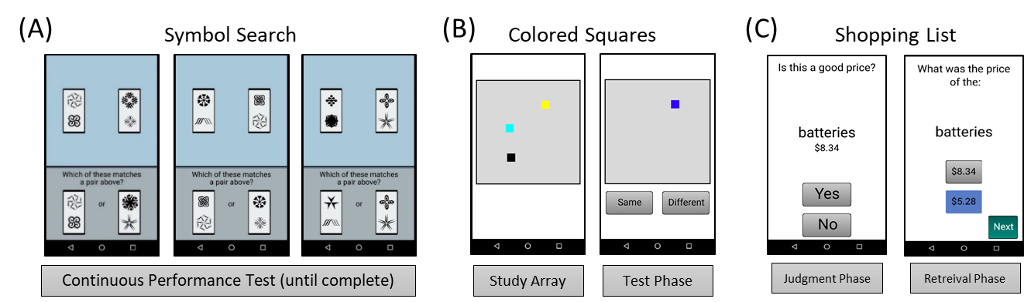
Figure S2. Ambulatory Cognitive Assessments. (A) Symbol Search task. (B) Colored Squares task. (C) Shopping List Task.

