Supplementary Materials
Integrated transcriptomic and metabolomic analyses reveal key genes controlling flavonoid biosynthesis in Citrus grandis ‘Tomentosa’ fruits
Ruiyi Fan¹, Congyi Zhu¹, Diyang Qiu¹, Genlin Mao¹, Bernd Mueller-Roeber^{2,3,4, *}, Jiwu Zeng^{1,*}
¹ Institute of Fruit Tree Research, Guangdong Academy of Agricultural Sciences; Key Laboratory of South Subtropical Fruit Biology and Genetic Resource Utilization, Ministry of Agriculture and Rural Affairs; Guangdong Provincial Key Laboratory of Tropical and Subtropical Fruit Tree Research, Guangzhou, 510640, China
² Institute of Biochemistry and Biology, University of Potsdam, 14476 Potsdam‐Golm, Germany
³ Max Planck Institute of Molecular Plant Physiology, 14476 Potsdam-Golm, Germany
⁴ Center of Plant Systems Biology and Biotechnology (CPSBB), 139 Ruski Blvd., 4000 Plovdiv, Bulgaria

Corresponding authors: Jiwu Zeng, e-mail address: zengjiwu@gdaas.cn, and Bernd Mueller-Roeber, e-mail address: bmr@uni-potsdam.de

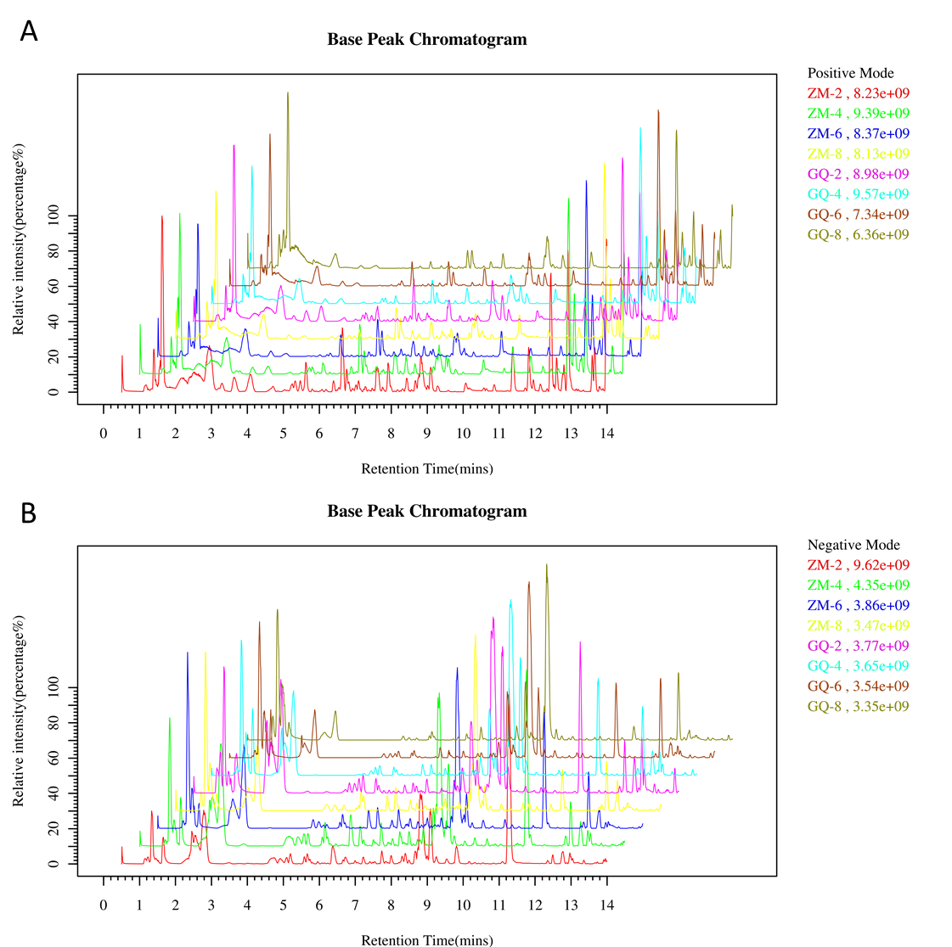
Fig. S1. Base peak ion (BPI) chromatograms of two Citrus grandis ‘Tomentosa’ varieties during fruit development stages in positive (A) and negative (B) modes. (ZM and GQ stands for the variety name and the number means the diameter in centimeter of the fruits).

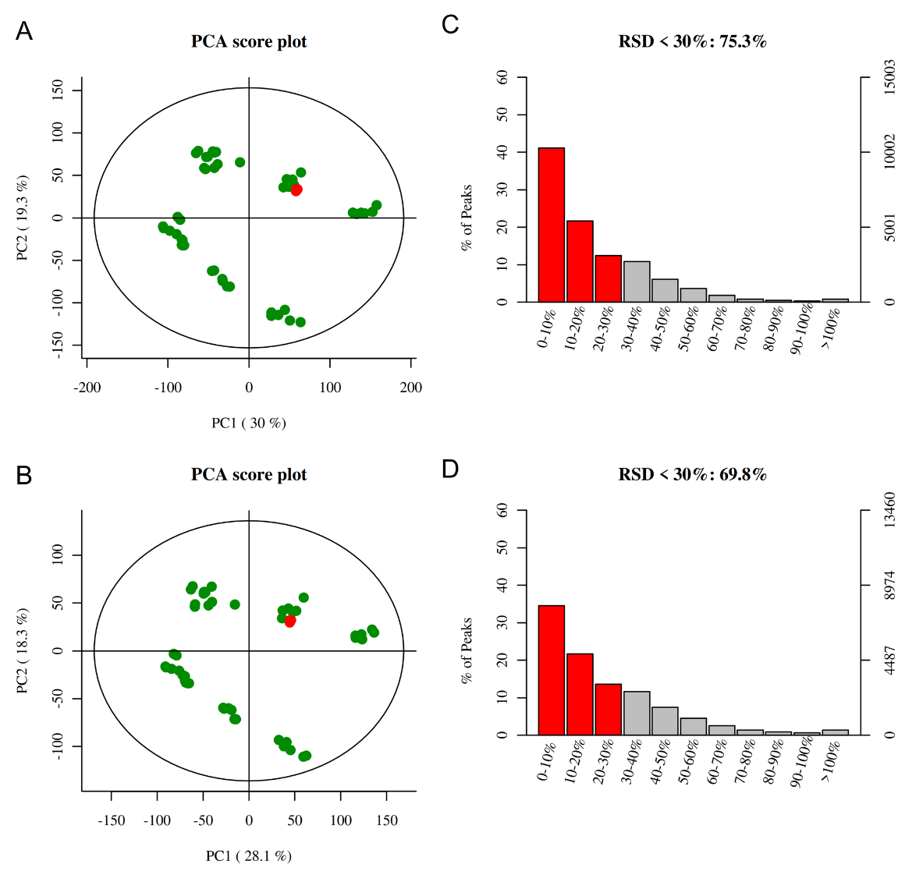
Fig. S2. Score scatter plots for principal component analysis (PCA) model with all the samples represent with green dots and the quality control (QC) represent with red dots in positive mode (A) and negative mode (B). Relative standard deviation (RSD) tests of the detected peaks in positive mode (C) and negative mode (D).

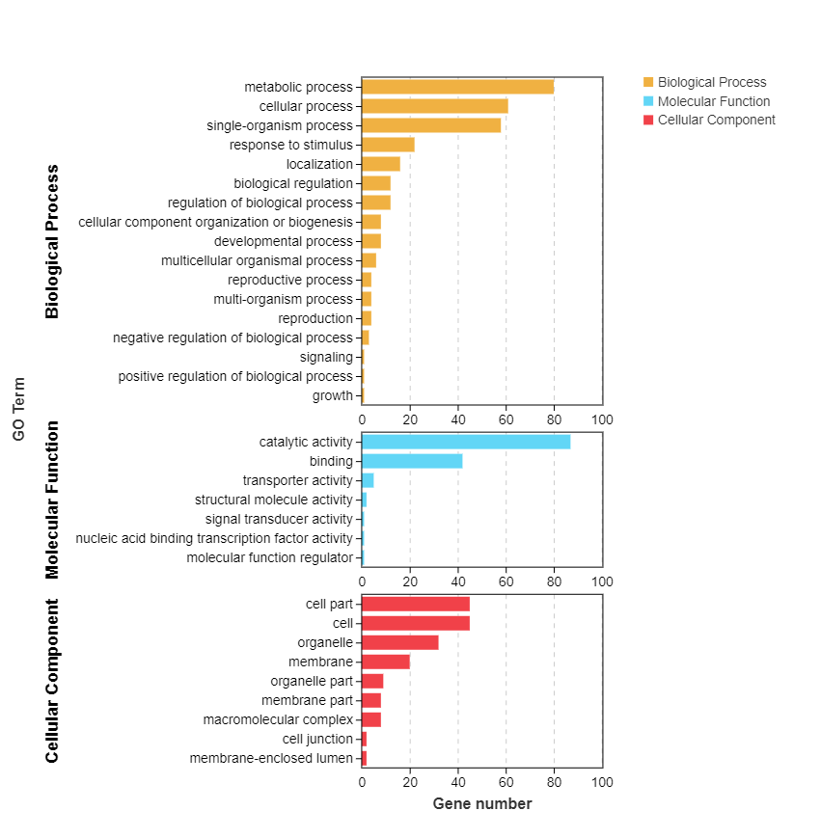
Fig. S3. Gene Ontology (GO) functional classification for the differently expressed 646 genes between ‘ZM’ and ‘GQ’ throughout all four developmental fruit stages.

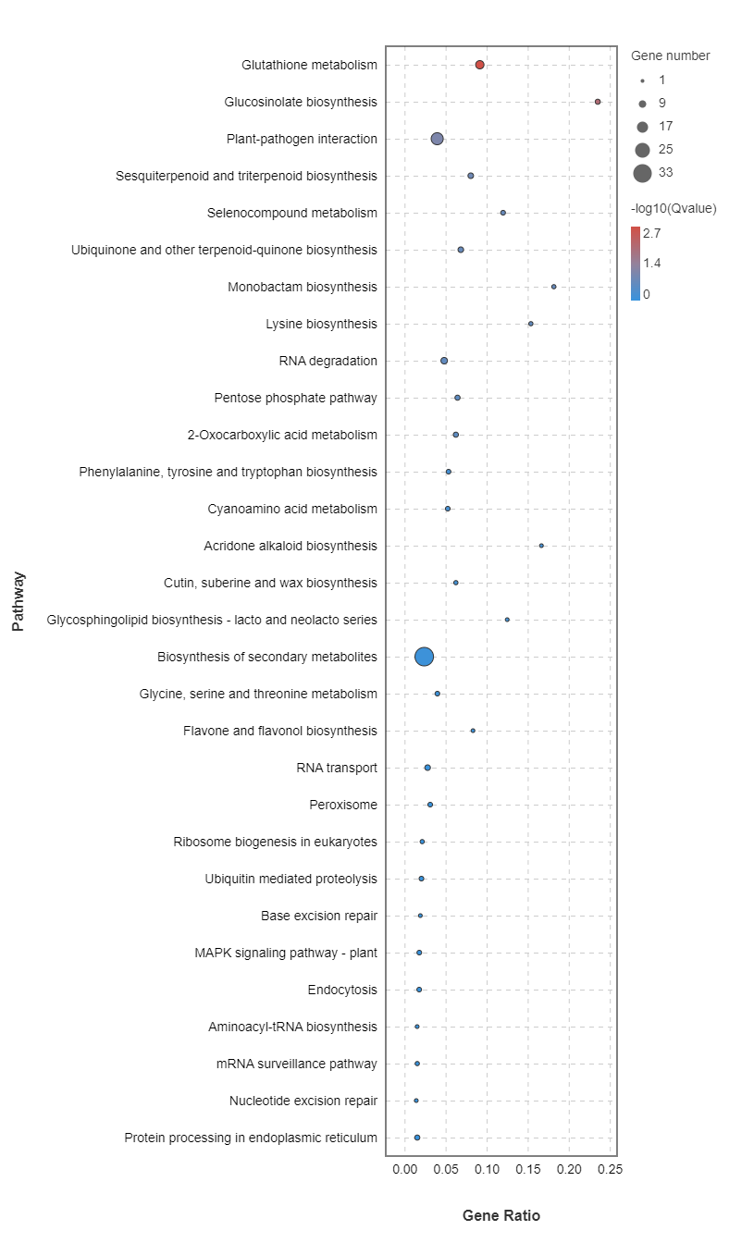
Fig. S4. Statistic of KEGG pathway enrichment for the differently expressed 646 genes between ‘ZM’ and ‘GQ’ throughout all four developmental fruit stages.

Fig. S5. Number of genes (A) and transcriptional factors (B) in various modules.

