Supplementary Note 1. Description of the procedure used for collecting and describing cost data in the InvaCost database (adapted from Diagne et al. 2020).
InvaCost provides the first comprehensive collation of standardized monetary cost data that can be used to thoroughly assess the distribution of costs of IAS at various spatial scales, from subnational to continental. InvaCost is the most up-to-date, comprehensive, and harmonized resource that records and describes monetary cost estimates associated with biological invasions worldwide. The current version (v4.1) is built upon 1,409 references in English and 15 other languages; 9,823 documented costs; 1,013 species or species complexes; and is supplemented with a set of descriptors (10.6084/m9.figshare.12668570).
Cost data were collated as they appeared in the original source (‘Raw cost estimate local currency’ column). When several cost estimates were provided in a study, we also collated the minimum and maximum estimates provided. We also retrieved temporal information under the ‘Period of estimation’, ‘Probable starting/ending years’ and the ‘Time range’ (year if the estimate is given yearly or for a period up to one year, period if the estimate is given for a period exceeding a year).
For each cost estimate recorded, we provided information on including (a) the reference from which the cost was extracted, (b) the taxonomy of the associated species, (c) the spatial and temporal coverage of the study, (d) the typology of each cost estimate and (e) the evaluation of the reliability of the estimation method(s). Using the World Bank Open Data and the Organization for Economic Cooperation and Development (OECD), we expressed all retrieved costs (raw costs and costs per year) in US dollars (US$) for the year 2017 using the following formula to convert and standardize each cost estimate:
C_{e} = (M_{V}/C_{F}) x I_{F}
with Ce = Converted cost estimate (to 2017 US dollars based on exchange rate or PPP)
M_{V} = Cost estimate (either the ‘Raw cost estimate local currency’ extracted from analysed paper or the ‘Cost per year local currency’ transformed by us)
C_{F} = Conversion factor (either the official market exchange rate or the purchasing power parity, in US dollars)
I_{F} = Inflation factor since the year of cost estimation, calculated as CPI₂₀₁₇/CPIy with CPI corresponding to the Consumer Price Index and y the year of the cost estimation (‘Applicable year’).
Below, we presented the categories used for each descriptive variable that corresponds to a specific column in the InvaCost database (Supplementary Table 1).
Supplementary Table 1. Description of InvaCost database columns.
Column title | Description
Acquisition method | The method used to provide the cost estimate as a report/estimation (gathered or derived from field-based information) or extrapolation (cost modelled beyond the original spatial and/or temporal observation range)
Applicable year | The year of the ‘Currency’ value (not the year of the cost occurrence) considered for the conversion/standardization of the cost estimate
Authors | The authors of the material analysed
Availability | The accessibility of the material as a searchable document (yes/no)
Benefit value(s) | The mention of if any benefit value was found in the analysed material; this might cover different types of benefits (such as real benefits provided by direct use or exploitation of invasive species or benefits that are actually avoided costs) — the figure was not recorded or described as being out of the scope of InvaCost
Common name | The non-scientific (or vernacular) name(s) provided by the authors, or by the International Union for Conservation of Nature (UICN) when not provided
Contributors | The name of collaborator(s) having recorded the cost estimate; currently, it is only the initials of the authors, but each future contributor will be consistently acknowledged here
Cost estimate per year local currency | The ‘Raw cost estimate local currency’ transformed to a cost estimate per year of the ‘Period of estimation’ (obtained by dividing the raw cost estimate by the number of years* of the ‘Period of estimation’)
Cost estimate per year 2017 USD exchange rate | The ‘Cost estimate per year local currency’ standardized from local ‘Currency’ and ‘Applicable year’ to 2017 USD based on ER** (See the formula in the ‘Standardization of cost data’ section)
Cost estimate per year 2017 USD PPP | The ‘Cost estimate per year local currency’ standardized from local ‘Currency’ and ‘Applicable year’ to 2017 USD based on PPP*** (See the formula in the ‘Standardization of cost data’ section)
Cost ID | A unique numerical identifier for the cost estimate
Currency | The currency of the ‘Raw cost estimate local currency’ as extracted from the material
Details | When necessary, narrative elements deemed important either to understand the cost estimate or to support choices made for completing the database; this column was left unchanged from the original entries in order to allow trace-back investigations
Environment | The type of habitat (aquatic, terrestrial, semi-aquatic) where the cost estimate occurred
Geographic region | The geographical region(s) where the cost estimate occurred (Africa, Asia, Central America, Europa, North America, Oceania-Pacific islands, South America)
Impacted sector | The sector impacted by the cost estimate in our socio-ecosystems (such as agriculture, health, public and social welfare; see Table 3 for details on each category)
Implementation | This states – at the time of the estimation – whether the reported cost was actually observed (cost actually incurred) or potential (not incurred but expected cost)
Location | When provided, the precise location (such as region, city, area) where the cost estimate occurred
Max raw cost estimate local currency | The higher boundary of the ‘Raw cost estimate local currency’ (if a range of estimates was provided by the authors)
Method reliability | The assessment of the methodological approach used for cost estimation as of (i) high reliability if either provided by officially pre-assessed materials (peer-reviewed articles and official reports) or the estimation method was documented, repeatable and/or traceable if provided by other grey materials, or (ii) low reliability if not (see Figure 5 for more details)
Min raw cost estimate local currency | The lower boundary of the ‘Raw cost estimate local currency’ (if a range of estimates was provided by the authors)
Occurrence | The status of the cost estimate as potentially ongoing (if the cost can be expected to continue over time) or one-time (if the cost was explicitly considered as over by the authors)
Official country | The country or official territory where the cost is incurred; sometimes, this is not congruent with the geographic regions as some territories (such as overseas areas) are situated on other continents than their country of attachment
Period of estimation | If provided, the exact period of time covered by the costs estimated, otherwise the raw formulation (such as the late 90’s, during 5 years)
Previous materials | If any, the list of successive materials checked before reaching the material originally providing the cost estimate
Probable starting year | The year range in which the cost is known or assumed to occur. When not explicitly provided by the authors, we mentioned 'unspecified' in both columns unless the authors provided a clear duration time. In this case, we considered the ‘Publication year’ as a reference for the probable starting/ending year from which we added/subtracted the number of years* of the ‘Period of estimation’. In the case of a cost estimate provided for a one-year period straddling two calendar years, we mentioned the latest year of the cost occurrence in both columns. When vague formulations were used (such as the early 90’s), we still translated them into probable ending/starting years (for example, 1990-1995). We will harmonize the way these specific cases are dealt with when reviewing and validating new lines proposed by new contributors.
Probable ending year
Publication year | The publication year of the material analysed
Raw cost estimate local currency | The cost estimate directly retrieved from the analysed materials
Raw cost estimate 2017 USD exchange rate | The ‘Raw cost estimate local currency’ standardized from local ‘Currency’ and ‘Applicable year’ to 2017 US$ based on exchange rate**
Raw cost estimate 2017 USD PPP | The ‘Raw cost estimate local currency’ standardized to 2017 US$ based on purchasing power parity***
Reference ID | The numerical identifier of the material analysed, which allows correspondence with Data citation 1 that provides bibliographic details
Reference title | The title of the material analysed
Repository | The original source of each material: 'Web of Science (WoS)', 'Google Scholar (GS)', 'Google search engine (Go)' or ‘Targeted collection (TC)'
Spatial scale | The spatial scale considered for estimating the cost: global (worldwide-scale), intercontinental (sites from two or more geographic regions) continental ('geographic region' level), regional (several countries within a single geographic region), country, site (for cost evaluated at intra-country level, including USA) and unit (for costs evaluated for a well-defined surface area or entity)
Taxonomy | For each species recorded, the taxonomic information from kingdom to species level using the Global Biodiversity Information Facility as a reference
Time range | The time range considered by the authors for providing the cost estimate: year (when costs were if the estimate is given yearly or for a period up to one year) or period (when costs were provided for a period exceeding a year)
Type of cost | The type of the cost includes: damages and losses incurred by an invasion (such as damage repair, medical care, value of crop losses), or means dedicated to understand or predict (such as research), prevent (such as education, biosecurity), early detect (such as monitoring, surveillance) and/or manage (such as control, eradication) the IAS
Type of applicable year | The assessment of the applicable year as effective if explicitly stated by the authors or publication year if no explicit information provided
Type of material | The type of material analysed (scientific peer-reviewed article or grey literature); for grey literature, the exact nature of the material was indicated (such as official report, press release)
* The number of years of the ‘Period of estimation’ is the difference between the ‘Probable ending year’ and the ‘Probable starting year”
** Market exchange rate (local currency unit per US$) provided by the World Bank Open Data (available at https://data.worldbank.org/indicator/PA.NUS.FCRF?end=2017&start=1960).
*** Purchase power parity (local currency unit per US$) provided by the World Bank Open Data (available at https://data.worldbank.org/indicator/PA.NUS.PPP?end=2017&start=1990) and the Organization for Economic Cooperation and Development (available at https://data.oecd.org/conversion/purchasing-power-parities-ppp.htm).

Supplementary Table 2. Top ten recent (2015-2019) and historical (1995-1999) trading partners by total import volume in metric tonnes. Data from the Centre d'Études Prospectives et d'Informations Internationales’ BACI database (CEPII 2022).

Recent trade | Origin | Recipient | Million tonnes
1 | Australia | China | 877
2 | Canada | United States | 337
3 | Brazil | China | 332
4 | Indonesia | China | 226
5 | Australia | Japan | 217
6 | United States | Mexico | 156
7 | Russia | China | 153
8 | United States | Canada | 143
9 | Indonesia | India | 132
10 | Mexico | United States | 116
Historical trade
1 | Canada | United States | 249
2 | Canada | Denmark | 249
3 | Australia | Netherlands | 205
4 | Australia | Japan | 177
5 | Mexico | United States | 111
6 | Mexico | Denmark | 111
7 | United States | Peru | 99
8 | United States | Great Britain | 91
9 | Brazil | Netherlands | 76
10 | Russia | Guatemala | 75
Centre d'Études Prospectives et d'Informations Internationales (CEPII) (2022) BACI: International Trade Database at the Product-Level. http://www.cepii.fr/CEPII/en/bdd_modele/presentation.asp?id=37

Supplementary Note 2. Description of temporal trends in sender and receiver dynamics as well as alien species lists.
We identified an increase over time in both costs and species sent and received, albeit showing considerable variability across regions. With regard to costs, those caused by species originating from Asia (and to a lesser degree, from Africa) increased most rapidly over time. For recipient regions, costs caused to North America increased particularly markedly (Supplementary Figure 1). In turn, the increase in numbers of costly species sent was strongest in Asia, Africa and North America, while the largest increase in the number of costly species received was in Europe (Supplementary Figure 2).

Supplementary Figure 1. Costs sent and received per decade.

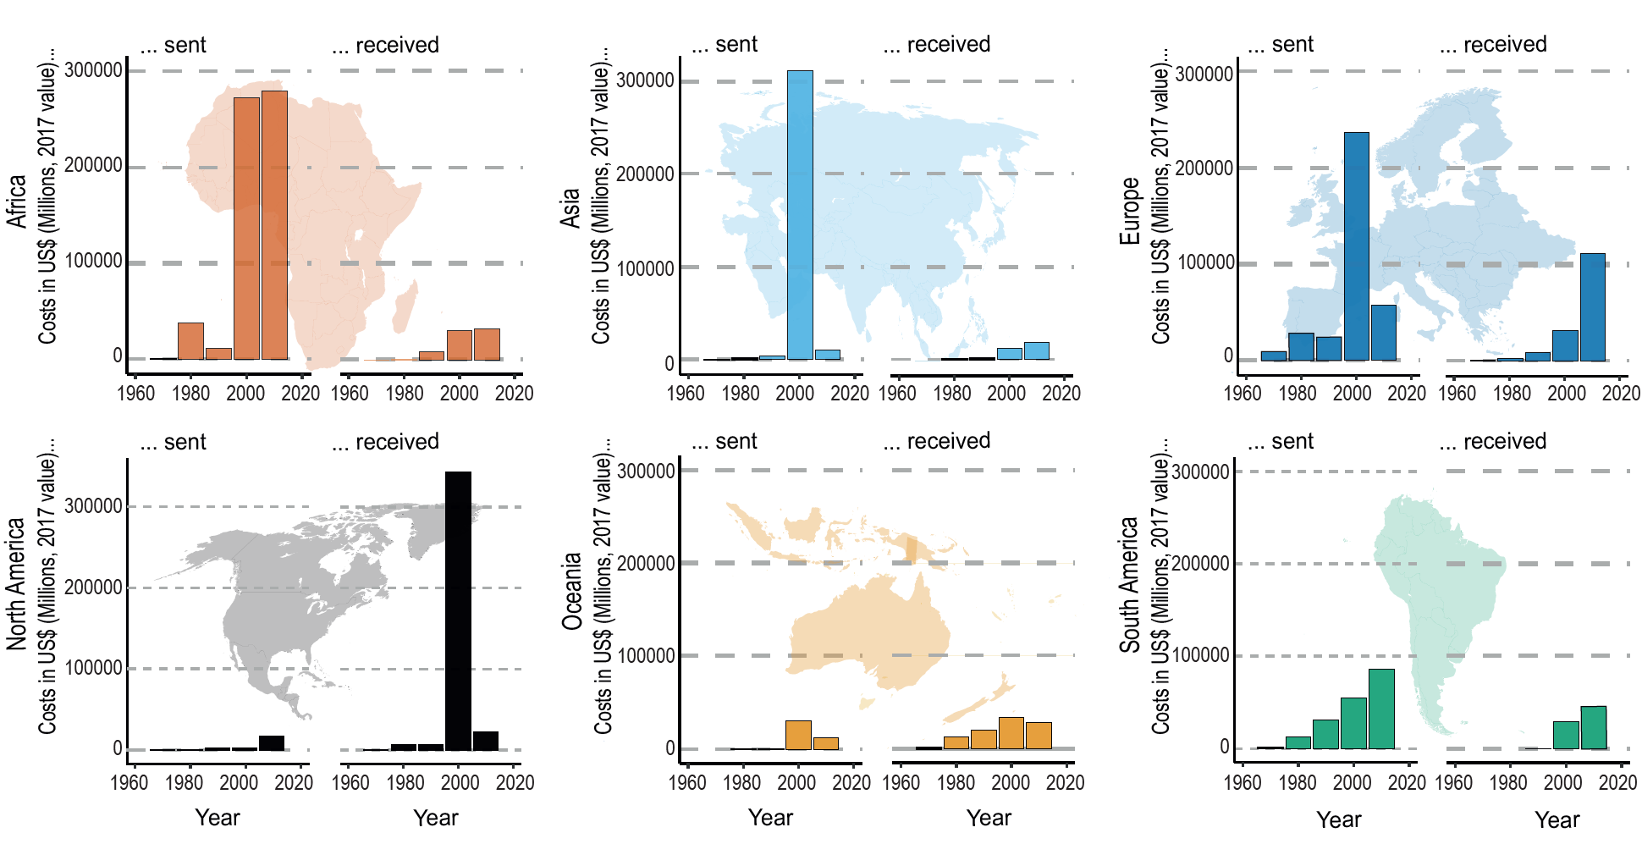

Supplementary Figure 2. Numbers of species sent and received per decade.
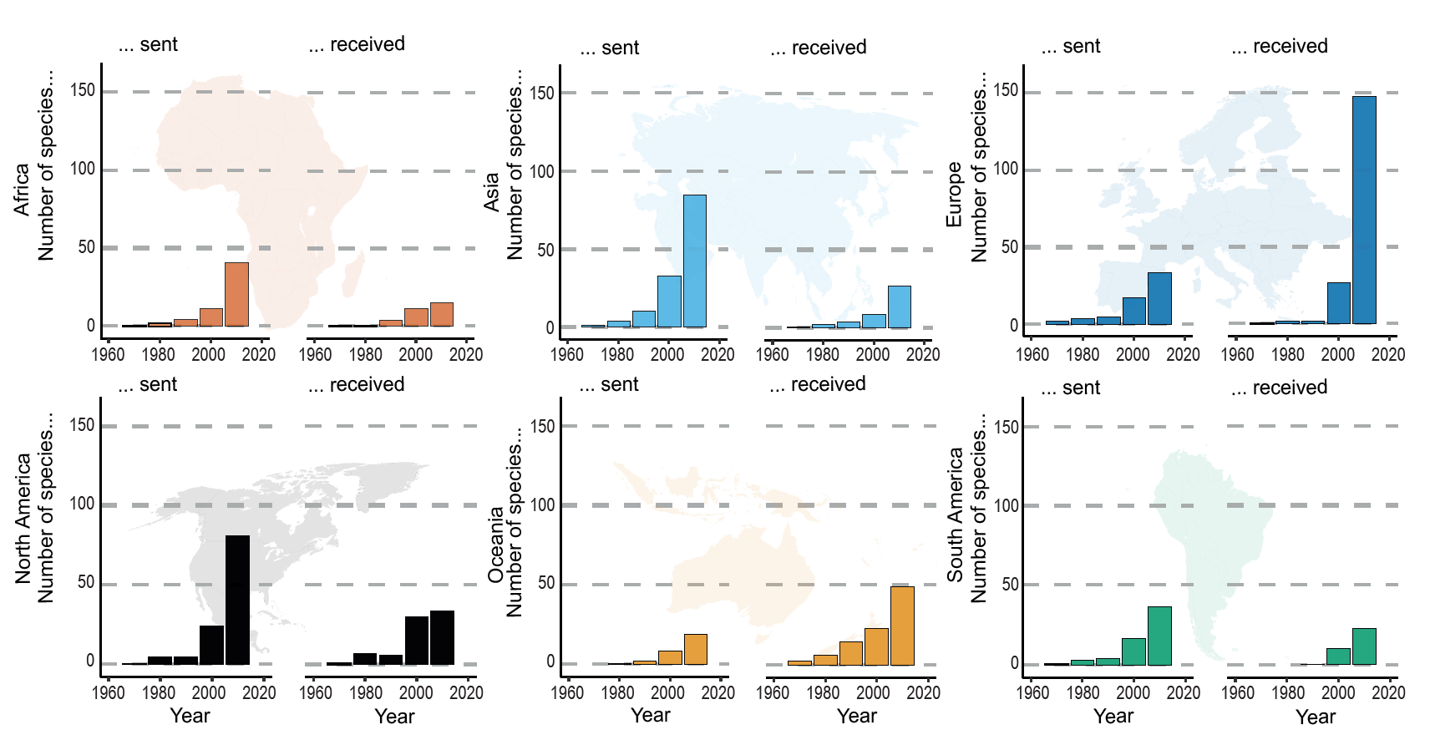

Supplementary Note 3: Further exploration of data gaps and caveats
Firstly, reporting of economic costs of biological invasions is distributed highly unevenly, both geographically and taxonomically (Diagne et al., 2021). This also reflects wider unevenness within invasion science as a field (Pyšek et al., 2008). Indeed costs in InvaCost are known to be skewed towards just a few well-studied taxa in certain places (Diagne et al., 2021), with several hyper-costly species (for example, the Formosan termite Coptotermes formosanus, yellow fever mosquito, Aedes aegypti and boll weevil, Anthonomus grandis) likely to disproportionately influence global trends. A lack of cost reporting resolution and specificity is also problematic. For example, the vast majority of India’s total IAS cost is attributed to diverse or unspecified species (Bang et al., 2022). Out of the small percentage of that cost attributable to particular species, the vast majority is caused by A. aegypti, which has no country-level origin information in our dataset (Supplementary Figure 4b). The duality of these costs — constituting a massive economic burden but containing widespread knowledge gaps — is an especially severe hurdle to sustainability in lower-middle-income countries.
Publication biases may also influence cost flows, whereby high levels of reporting of impacts in North America in particular could have emanated from relatively early efforts to report invasion costs in the United States, which prompted further research effort into effects on that economy in the last two decades (Pimentel et al., 2000; Crystal-Ornelas et al., 2021). Further, whereas InvaCost captures reported costs from IAS in over 21 languages other than English, impacts in several languages in Asia and Africa, in particular, are missing (Angulo et al., 2021).
Moreover, differences in purchasing power are pervasive across geographic regions. Costs associated with IAS management will be inherently greater in countries with higher salary costs for human labour and those with more economic assets to be impacted. Any given impact (e.g. destruction of 1 ha of forest, or a 1% reduction in property values) will also have a greater cost in US dollars in countries with greater purchasing power. These factors would each act to reduce the received impacts of biological invasion in countries with lesser economic output. Last, economic impacts are not the sole rationale for invasion management, with impacts on ecosystems and health, which are difficult to monetize, also a key motivator for management action (Pyšek et al., 2020).
Notably, large shares of economic costs in InvaCost are attributed to diverse or unspecified species, without the possibility of distinguishing species-specific contributions, and thus costs to a particular geographic origin. These gaps urge for the precision of cost reporting to be improved and standardized in the future.
Further, our analysis was not explicitly linked to invasion routes, which are often complex or unknown, meaning there may be some inaccuracies in attributing sender regions. For example, at the country-level, substantial flows from China sensu lato arose from native ranges spanning China, Hong Kong, Macau, and Taiwan, without an ability to decipher one specific origin country. Such an approach would require molecular techniques to identify source locations and reconstruct invasion routes, but these have only been applied for a few IAS (North et al., 2021). It is also possible that IAS with costs in a receiver region did not originate directly from the species native region, but rather from ‘stepping stone’ regions that had been already invaded (Seebens et al., 2021). This phenomenon challenges the precise attribution of economic cost sources, with invasions potentially caused by trade patterns spatio-temporally independent of the initial origin region.
In addition to biases in cost data of InvaCost, there are also biases in species origin data. For certain taxa and geographic regions, biogeographies are less well-resolved or are highly debated (Wyatt and Carlton, 2002) — hampering reliable assignments of invasion history. There are also biases in the large databases such as the Centre for Agriculture and Bioscience International (CABI), Global Biodiversity Information Facility (GBIF) and global invasive species database (GISD) that we used to collect native range data. This is evidenced by the handful of species listed as native in more continents than countries in our dataset (seven total), indicating a lack of fine-scale resolution origin country data within continents. One of the species, the European starling (Sturnus vulgaris) is responsible for the high cost flow emanating from Ghana, as this is the only country-level native range datapoint we have for this species, whereas continent-level records indicate it is native to three continents (Africa, Asia, and Europe).
Angulo, E., Diagne, C., Ballesteros-Mejía, L., Ahmed, D. A., Akulov, E., Banerjee, A. K., … & Courchamp, F. (2021). Non-English languages enrich scientific knowledge: the example of economic costs of biological invasions. Science of the Total Environment 775: 144441.
Bang, A., Cuthbert, R.N., Haubrock, P.J., Fernandez, R.D., Moodley, D., Diagne, C., Turbelin, A.J., Renault, D., Dalu, T., Courchamp, F. Massive economic costs of biological invasions despite widespread knowledge gaps: a dual setback for India. Biological Invasions, in press. doi: 10.1007/s10530-022-02780-z
Crystal-Ornelas, R. Hudgins, E.J., Cuthbert, R.N., Haubrock, P. J., Fantle-Lepczyk, J., Angulo, E., … & Courchamp, F. (2021). Economic costs of biological invasions within North America. NeoBiota 67: 485–510. Special Issue “Economic costs of invasive alien species worldwide”.
Diagne, C., Leroy B., Vaissière A-C., Gozlan, R.E., Roiz, D., Jarić, I., ... & Courchamp, F. (2021). High and rising economic costs of biological invasions worldwide. Nature 592: 571–576.
North, H.L., McGaughran, A., Jiggins, C.D. (2021). Insights into invasive species from whole-genome resequencing. Molecular Ecology 30: 6289-6308.
Pimentel, D., Lach, L., Zuniga, R., & Morrison, D. (2000). Environmental and economic costs of nonindigenous species in the United States. BioScience 50: 53–65.
Pyšek, P., Richardson, D.M., Pergl, J., Jarošík, V., Sixtová, Z., & Weber, E. (2008). Geographical and taxonomic biases in invasion ecology. Trends in Ecology and Evolution 23: 237-244.
Pyšek P. et al. (2020) South Africa as a Donor of Naturalised and Invasive Plants to Other Parts of the World. In: van Wilgen B., Measey J., Richardson D., Wilson J., Zengeya T. (eds) Biological Invasions in South Africa. Invading Nature - Springer Series in Invasion Ecology, vol 14. Springer, Cham.
Seebens, H., Bacher, S., Blackburn, T. M., Capinha, C., Dawson, W., Dullinger, S., … & Essl, F. (2021). Projecting the continental accumulation of alien species through to 2050. Global Change Biology 27: 970–982.
Wyatt, T., & Carlton, J.T. (2002). Phytoplankton introductions in European coastal
waters: why are so few invasions reported? CIESM 41-46.

Supplementary Figure 3. Decadal smoother function fit for the country-level cost flow model.
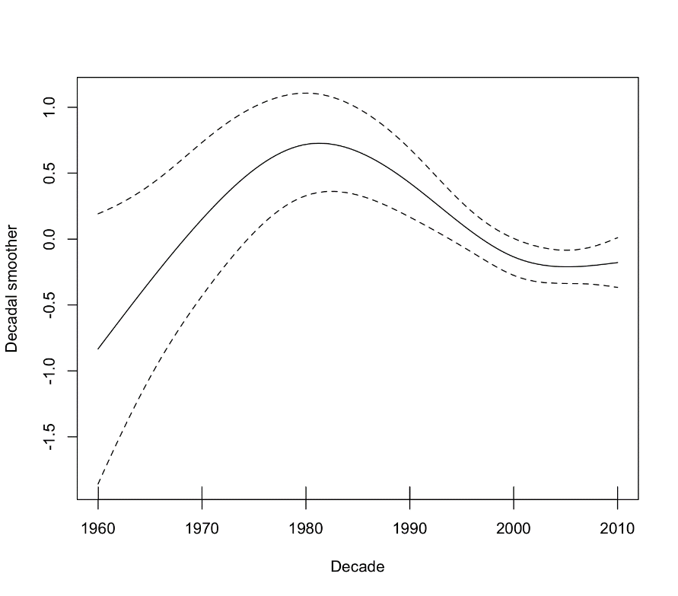

Supplementary Figure 4. The extent of missing cost information, including a. The proportion of unspecified monetary costs across geographic regions reported in InvaCost, with the total cost reported in the legend in 2017 US$ millions, as well as the total number of cost records in InvaCost associated with these unknown cost flows in parentheses. b. The top ten receiver countries when accounting for species that lack country-level origin information (such as A. aegyptii). Overall, there were 1,294 InvaCost entries corresponding to Diverse/Unspecified species, and 263 entries corresponding to genus-level identifications that could not be associated with a single native range (1,557 entries in total). In addition, 905 entries were filtered out as they corresponded to species with unknown native ranges (resulting in a total of 2,462 entries and 321 unique combinations of species or higher taxonomic levels). Including species without country-level origin information substantially changed the top ten receiver countries, resulting in several more entries from Asia.

a.
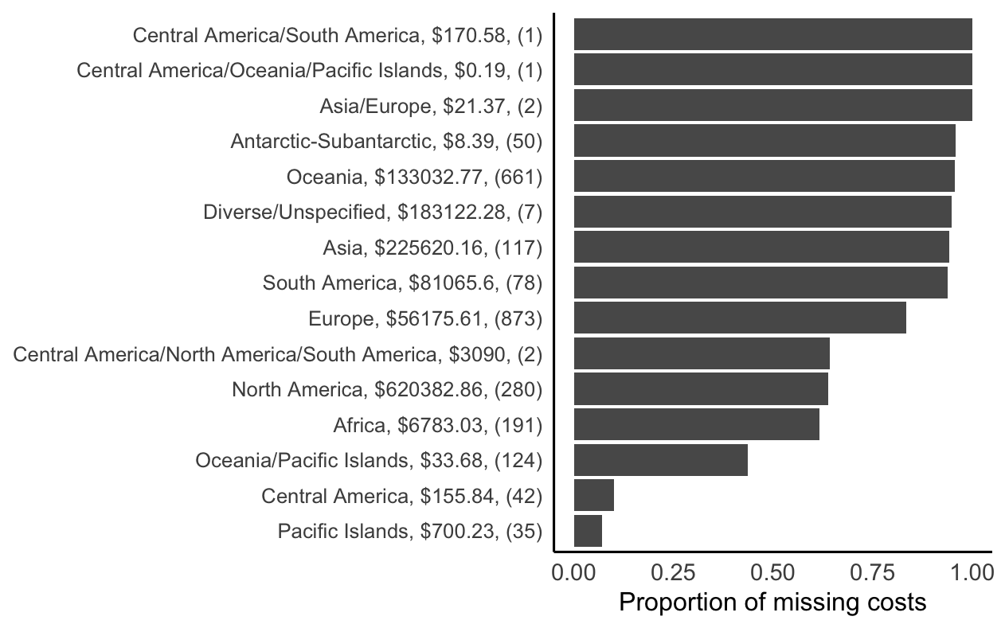
b.
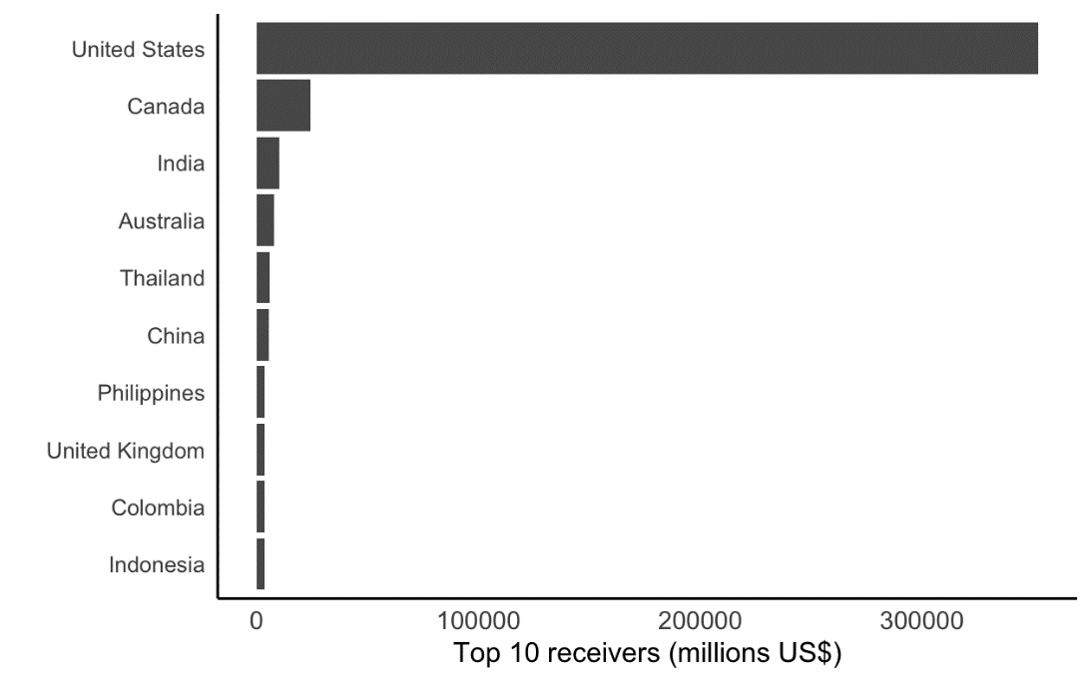

Supplementary Table 3. Results of GAM for log-scaled country-level cost flows with log-scaled predictors. The smoother for decade had an empirical degrees of freedom of 3.38, and a p-value of <0.0001 (Supplementary Figure 4). The overall model had 24.9% deviance explained (n = 5362). Italics indicate non-significant model terms, and significant terms are in bold. The model intercept was significant (Estimate =-10.11, p<0.0001).

Predictor | Estimate | p-value
Distance between  countries (km) | -0.29 | <0.0001
GDP in origin (at decade,  in 2022 US$) | 0.29 | <0.0001
Human population in  destination (at decade) | -0.5 | <0.0001
Land area of recipient  country (square kilometers) | 0.52 | <0.0001
Number of cost references  in InvaCost for species native to this origin country (within decade) | -0.71 | <0.0001
Number of species with costs | 0.27 | <0.0001
Presence of common  language | 1.06 | <0.0001
Presence of current free  trade agreement between countries | -0.62 | <0.0001
Presence of shared border | -2.23 | <0.0001
Presence of a common  biome in both countries | 0.83 | <0.0001
Total IAS impacts by  origin across all destinations (at decade, 2017 US$) | 0.61 | <0.0001
Total imports 1995-1999  (metric tonnes) | -0.11 | <0.0001
GDP in destination (at  decade, in 2022 US$) | 0.28 | <0.0001
Number of cost references  in InvaCost from this destination country (within decade) | -0.14 | 0.051
Human population in  origin (at decade) | -0.1 | 0.059
Total imports 2015-2019  (metric tonnes) | -0.03 | 0.068
Species richness in  origin | 0.1 | 0.078
Land area of origin  country (square km) | 0.06 | 0.09
Species richness in  destination | -0.09 | 0.21
Presence of shared  colonial history | 0.26 | 0.59

Supplementary Table 4. Species impacted by the continent designation exceptions for Turkey and Russia. Since most of Turkey’s human population is in Asia and the majority of Russia’s human population is in Europe, we assigned them these continents. In the case of origin regions, we chose the continent(s) for which there was likely to be substantial overlap in landmass based on database descriptions and other listed countries within the native range

- Species with ambiguous continental ranges with country ranges in Turkey:

Species | Designation
Heracleum sosnowskyi | Asia
Prosopis spp. | Asia
Adelges piceae | Europe
Clematis vitalba | Europe
Centaurea affinis | Europe
Helix lucorum | Europe
Echium plantagineum | Europe
Clarias gariepinus | Asia
Marchalina hellenica | Europe
Rousettus aegyptiacus | Asia

- Species with ambiguous continental ranges with country ranges in Russia

Species | Designation
Styela clava | Asia
Channa argus | Asia
Nyctereutes procyonoides | Asia
Rosa rugosa | Asia
Sargassum muticum | Asia
Corbicula fluminea | Asia
Cytisus scoparius | Europe
Echium plantagineum | Europe
Petromyzon marinus | Europe
Paralithodes camtschaticus | Asia
Dicentra peregrina | Asia

Supplementary Note 4. Additional References used to construct the native range database when information from Centre for Agriculture and Bioscience International, Global Biodiversity Information Facility and/or Global Invasive Species Database was inconclusive.

Specific publications used

Agounké, D., & Bokonon-Ganta, H. A. (1988). Rastrococcus invadens Williams (Hemiptera: Pseudococcidae), a serious exotic pest of fruit trees and other plants in West Africa. Bulletin of Entomological Research, 78(4), 695–702.

Aldridge, D. C., Salazar, M., Serna, A., & Cock, J. (2008). Density-dependent effects of a new invasive false mussel, Mytilopsis trautwineana (Tryon 1866), on shrimp, Litopenaeus vannamei (Boone 1931), aquaculture in Colombia. Aquaculture, 281(1–4), 34–42.

Alaux, C., Le Conte, Y., & Decourtye, A. (2019). Pitting wild bees against managed honey bees in their native range, a losing strategy for the conservation of honey bee biodiversity. Frontiers in Ecology and Evolution, 7, 60.

Amsellem, L., Noyer, J. L., & Hossaert‐McKey, M. (2001). Evidence for a switch in the reproductive biology of Rubus alceifolius (Rosaceae) towards apomixis, between its native range and its area of introduction. American Journal of Botany, 88, 2243–2251.

Arun, P. R., & Mahajan, M. V. (2012). Ecological costs and benefits of Teak Defoliator (Hyblaea puera Cramer) outbreaks in a mangrove ecosystem. Marine Science, 2, 48–51.

Asante, S. K. (1997). Natural enemies of the woolly apple aphid, Eriosoma lanigerum (Hausmann) (Hemiptera: Aphididae): a review of the world literature. Plant Protection Quarterly, 12, 166–172.

Avtzis, D. N., Melika, G., Matošević, D., & Coyle, D. R. (2019). The Asian chestnut gall wasp Dryocosmus kuriphilus: a global invader and a successful case of classical biological control. Journal of Pest Science, 92(1), 107–115.

Basoalto, A., Ramírez, C. C., Lavandero, B., Devotto, L., Curkovic, T., Franck, P., & Fuentes-Contreras, E. (2020). Population genetic structure of codling moth, Cydia pomonella (L.) (Lepidoptera: Tortricidae), in different localities and host plants in Chile. Insects, 11, 285.

Blanco, S., & Ector, L. (2009). Distribution, ecology and nuisance effects of the freshwater invasive diatom Didymosphenia geminata (Lyngbye) M. Schmidt: a literature review. Nova Hedwigia, 88(3), 347.

Bonizzoni, M., Gasperi, G., Chen, X., & James, A. A. (2013). The invasive mosquito species Aedes albopictus: current knowledge and future perspectives. Trends in Parasitology, 29(9), 460–468.

Broadfield, N., & McHenry, M. T. (2019). A world of gorse: persistence of Ulex europaeus in managed landscapes. Plants, 8(11), 523.

Bulgarella, M., Quiroga, M. A., Brito Vera, G. A., Dregni, J. S., Cunninghame, F., Mosquera Muñoz, D. A., ... & Heimpel, G. E. (2015). Philornis downsi (Diptera: Muscidae), an avian nest parasite invasive to the Galápagos Islands, in mainland Ecuador. Annals of the Entomological Society of America, 108(3), 242–250.

Bruner, E., Costantini, D., Fanfani, A., & Dell’Omo, G. (2005). Morphological variation and sexual dimorphism of the cephalic scales in Lacerta bilineata. Acta Zoologica, 86, 245–254.

Bungard, R. A., Wingler, A., Morton, J. D., Andrews, M., Press, M. C., & Scholes, J. D. (1999). Ammonium can stimulate nitrate and nitrite reductase in the absence of nitrate in Clematis vitalba. Plant, Cell & Environment, 22, 859–866

Byers, J. E., McDowell, W. G., Dodd, S. R., Haynie, R. S., Pintor, L. M., & Wilde, S. B. (2013). Climate and pH predict the potential range of the invasive apple snail (Pomacea insularum) in the southeastern United States. PLoS ONE, 8(2), e56812.

Clement, S. L., McPhee, K. E., Elberson, L. R., & Evans, M. A. (2009). Pea weevil, Bruchus pisorum L.(Coleoptera: Bruchidae), resistance in Pisum sativum× Pisum fulvum interspecific crosses. Plant Breeding, 128, 478–485.

Coleman, T. W., Jones, M. I., Courtial, B., Graves, A. D., Woods, M., Roques, A., & Seybold, S. J. (2014). Impact of the first recorded outbreak of the Douglas-fir tussock moth, Orgyia pseudotsugata, in southern California and the extent of its distribution in the Pacific Southwest region. Forest Ecology and Management, 329, 295–305.

Coombs, G., & Peter, C. I. (2010). The invasive ‘mothcatcher’ (Araujia sericifera Brot.; Asclepiadoideae) co-opts native honeybees as its primary pollinator in South Africa. AoB Plants, 2010, plq021.

Cope, T., & Gray, A. (2009). Grasses of the British Isles. BSBI Handbook 13. Kew: Royal Botanic Gardens.

Cowan, P. (2014). Variability in the seasonality of breeding by the common brushtail possum, Trichosurus vulpecula: its possible causes and management implications. Australian Mammalogy, 36(2), 131–136.

Cucchi, T., Vigne, J. D., & Auffray, J. C. (2005). First occurrence of the house mouse (Mus musculus domesticus Schwarz & Schwarz, 1943) in the Western Mediterranean: a zooarchaeological revision of subfossil occurrences. Biological Journal of the Linnean Society, 84(3), 429–445.

Dickens, R. K. (1975). The koala (Phascolarctos cinereus): past, present and future. Australian Veterinary Journal, 51, 459–463.

Dupuis, J. R., Guerrero, F. D., Skoda, S. R., Phillips, P. L., Welch, J. B., Schlater, J. L., ... & Geib, S. M. (2018). Molecular characterization of the 2016 New World screwworm (Diptera: Calliphoridae) outbreak in the Florida keys. Journal of Medical Entomology, 55(4), 938–946.

Egorov, R. (2017). Helix lucorum lucorum Linnaeus, 1758 (Pulmonata, Helicidae) in the city of Moscow. Malacologica Bohemoslovaca, 16, 28–32.

Featured Creatures. (nd). Vegetable Leafminer, Liriomyza sativae. Accessed 25th March 2021 http://entnemdept.ufl.edu/creatures/VEG/LEAF/vegetable_leafminer.htm

Foster, J. T., Allan, G. J., Chan, A. P., Rabinowicz, P. D., Ravel, J., Jackson, P. J., & Keim, P. (2010). Single nucleotide polymorphisms for assessing genetic diversity in castor bean (Ricinus communis). BMC Plant Biology, 10(1), 1–11.

Goyal, N., Pardha-Saradhi, P., & Sharma, G. P. (2014). Can adaptive modulation of traits to urban environments facilitate Ricinus communis L. invasiveness? Environmental Monitoring and Assessment, 186(11), 7941–7948.

Hailer, F., & Leonard, J. A. (2008). Hybridization among three native North American Canis species in a region of natural sympatry. PLoS ONE, 3(10), e3333.

Hammel, B. E. (2005). Plantas ornamentales nativas de Costa Rica [Native ornamental plants of Costa Rica], 3rd Edition. INBio, the Costa Rican Biodiversity Institute.

Han, F., Wallberg, A., & Webster, M. T. (2012). From where did the Western honeybee (Apis mellifera) originate? Ecology and Evolution, 2(8), 1949–1957.

Hill, M. P., Hoffmann, A. A., Macfadyen, S., Umina, P. A., & Elith, J. (2012). Understanding niche shifts: using current and historical data to model the invasive redlegged earth mite, Halotydeus destructor. Diversity and Distributions, 18, 191–203.

Hirose, Y., Kajita, H., Takagi, M., Okajima, S., Napompeth, B., & Buranapanichpan, S. (1993). Natural enemies of Thrips palmi and their effectiveness in the native habitat, Thailand. Biological Control, 3(1), 1–5.

Hiwat, H., & Bretas, G. (2011). Ecology of Anopheles darlingi Root with respect to vector importance: a review. Parasites & Vectors, 4(1), 1–13.

Hura, T., Szewczyk-Taranek, B., Hura, K., Nowak, K., & Pawłowska, B. (2017). Physiological responses of Rosa rubiginosa to saline environment. Water, Air, & Soil Pollution, 228, 81.

Gherardi F. (2006). Crayfish invading Europe: the case study of Procambarus clarkii. Marine and Freshwater Behaviour and Physiology. 39, 175–191

Ghesini, S., Mueller, G., & Marini, M. (2020). First record of the subterranean termite Reticulitermes grassei in Switzerland. Bulletin of Insectology, 73(1), 149–151.

Gomes, V. G. N., Quirino, Z. G. M., & Araujo, H. F. P. (2014). Frugivory and seed dispersal by birds in Cereus jamacaru DC. ssp. jamacaru (Cactaceae) in the Caatinga of Northeastern Brazil. Brazilian Journal of Biology, 74, 32–40.

Goss, E. M., Tabima, J. F., Cooke, D. E., Restrepo, S., Fry, W. E., Forbes, G. A., ... & Grünwald, N. J. (2014). The Irish potato famine pathogen Phytophthora infestans originated in central Mexico rather than the Andes. Proceedings of the National Academy of Sciences, 111(24), 8791–8796.

Gozlan, R. E., Pinder, A. C., & Shelley, J. (2002). Occurrence of the Asiatic cyprinid Pseudorasbora parva in England. Journal of Fish Biology, 61(1), 298–300.

Imatake, S., Imaizumi, N., Ohashi, Y., Matsumura, H., Urakawa, M., Konaka, Y., ... & Yasuda, M. (2020). Reproductive cycle and maturation of Swinhoe’s tree lizard (Diploderma swinhonis (Günther, 1864)) in Hyuga City, Miyazaki Prefecture, Japan. Journal of Veterinary Medical Science, 82(10), 1551–1557.

Kalníková, V., & Palpurina, S. (2015). Epilobium adenocaulon and Oenothera glazioviana (Onagraceae): new alien species for the Bulgarian flora. Phytologia Balcanica, 21, 21–27

Kaplan, H., Van Zyl, H. W. F., Le Roux, J. J., Richardson, D. M., & Wilson, J. R. U. (2012). Distribution and management of Acacia implexa (Benth.) in South Africa: A suitable target for eradication? South African Journal of Botany, 83, 23–35.

Kim, K. S., Jones, G. D., Westbrook, J. K., & Sappington, T. W. (2010). Multidisciplinary fingerprints: forensic reconstruction of an insect reinvasion. Journal of the Royal Society Interface, 7(45), 677–686.

Koutika, L. S., & Richardson, D. M. (2019). Acacia mangium Willd: benefits and threats associated with its increasing use around the world. Forest Ecosystems, 6, 1–13.

Kfir, R. (1997). The diamondback moth with special reference to its parasitoids in South Africa. The Management of Diamondback Moth and Other Crucifer Pests, 54–60.

Krishna K., Grimaldi D.A., Krishna V., Engel M.S. (2013) Treatise on the Isoptera of the world. Bulletin of the American Museum of Natural History, 377.

Kumar, V., McKenzie, C. L., Mannion, C., Stocks, I., Smith, T., & Osborne, L. S. (2013). Rugose spiraling whitefly Aleurodicus rugioperculatus Martin (Hemiptera: Aleyrodidae). EENY578. University of Florida, IFAS Extension.

Lange, C., Goeke, D. F., Hickman, D. T., Podolyan, A., & Houliston, G. J. (2018). Chloroplast diversity of giant buttercup (Ranunculus acris L., Ranunculaceae) in New Zealand and in its native range. New Zealand Journal of Botany, 56(4), 385–395.

Lazzaro, L., Sarracco, E., Benesperi, R., & Coppi, A. (2018). A probable anthropic origin of Nerium oleander L.(Apocynaceae) population in Montecristo island (Italy, Tuscany): evidence from loci polymorphism and ISSR analysis. Caryologia, 71(1), 50–57.

Lees, A. C., & Bell, D. J. (2008). A conservation paradox for the 21st century: the European wild rabbit Oryctolagus cuniculus, an invasive alien and an endangered native species. Mammal Review, 38(4), 304–320.

LepIntercept. (nd). NOCTUIDAE - Helicoverpa armigera (Hübner). Accessed 19th March 2021 https://idtools.org/id/leps/lepintercept/armigera.html

Leppäkoski E., & Olenin S. (2000). Non-native species and rates of spread: lessons from the brackish Baltic Sea. Biological Invasions, 2, 151–163.

Leung, H., Hung, A., Hui, A. C. F., & Chan, T. Y. K. (2008). Warfarin overdose due to the possible effects of Lycium barbarum L. Food and Chemical Toxicology, 46, 1860–1862

Li, J., Jin, D. C., & Yi, T. C. (2017). Ontogenetic development and redescription of Oligonychus metasequoiae (Acari: Tetranychidae). Systematic and Applied Acarology, 22, 1495–1520.

Li, E., Sun, F., Zhang, R., Chen, J., & Wu, X. (2016). The complete mitochondrial genome of the striped-tailed rat-snake, Orthriophis taeniurus (Reptilia, Serpentes, Colubridae). Mitochondrial DNA Part A, 27, 599–600.

Lorenzo, P., Palomera-Pérez, A., Reigosa, M. J., & González, L. (2011). Allelopathic interference of invasive Acacia dealbata Link on the physiological parameters of native understory species. Plant Ecology, 212, 403–412.

Loss, S. R., & Marra, P. P. (2017). Population impacts of free‐ranging domestic cats on mainland vertebrates. Frontiers in Ecology and the Environment, 15(9), 502–509.

Lv, C., Zhong, B., Zhong, G., Weng, Q., Chen, S., Hu, M., ... & Qin, W. (2012). Four botanical extracts are toxic to the hispine beetle, Brontispa longissima, in laboratory and semi–field trials. Journal of Insect Science, 12(1), 58.

Lynch, A. M. (2014). Spruce aphid (Elatobium abietinum Walker) (Hemiptera: Aphididae). Pages 259–270 in: van den Driesche R., Reardon R. (eds) The Use of Classical Biological Control to Preserve Forest in North America. U.S. Department of Agriculture, Forest Service, Forest Health Technology Enterprise Team, Morgantown, WV.

Morton, J. (1987). Japanese Persimmon. Pages 411–416 in: Morton J.F. Fruits of Warm Climates. Miami, FL.

Muzashvili, T., Masullo, M., Kemertelidze, E., Pizza, C., & Piacente, S (2015). Chemical composition of Periploca graeca L. The international research and practice conference “achievements and prospects for the development of phytochemistry”. Karaganda, Kazakhstan. 51 pp.

Native Plants Hawaii. (nd). Plectranthus parviflorus Accessed 25th March 2021. http://nativeplants.hawaii.edu/plant/view/Plectranthus_parviflorus

Nebel, C., Harl, J., Pajot, A., Weissenböck, H., Amar, A., & Sumasgutner, P. (2020). High prevalence and genetic diversity of Haemoproteus columbae (Haemosporida: Haemoproteidae) in feral pigeons Columba livia in Cape Town, South Africa. Parasitology Research, 119(2), 447–463.

Nordsieck, R. (nd). The Turkish Snail. Accessed 2nd April 2021. http://www.molluscs.at/gastropoda/terrestrial/helix.html?/gastropoda/terrestrial/helix/lucorum.html

NSW WeedWise. (nd). Hoary cress (Lepidium draba). NSW Department of Primary Industries. Accessed 2nd April 2021. https://weeds.dpi.nsw.gov.au/Weeds/HoaryCress

Peddu, H., Fand, B. B., Sawai, H. R., & Lavhe, N. V. (2020). Estimation and validation of developmental thresholds and thermal requirements for cotton pink bollworm Pectinophora gossypiella. Crop Protection, 127, 104984.

Pacific Island Ecosystems at Risk (PIER). (nd). Rubus adenotrichos. Accessed 2nd April 2021. http://www.hear.org/pier/species/rubus_adenotrichos.htm#:~:text=Native%20range%3A%20Mexico%2C%20Costa%20Rica,Honduras%2C%20Venezuela%20(GRIN)

Paini, D.R., Sheppard, A.W., Cook, D.C., De Barro, P.J., Worner, S.P. & Thomas, M.B. (2016).
Global threat to agriculture from invasive species. Proceedings of the National Academy of
Sciences, 113(27), 7575–7579.

Pyšek P. et al. (2020) South Africa as a donor of naturalised and invasive plants to other parts of the world. Pages 759–785 in: van Wilgen B., Measey J., Richardson D., Wilson J., Zengeya T. (eds) Biological Invasions in South Africa. Invading Nature - Springer Series in Invasion Ecology, vol 14. Springer, Cham.

Ramalhosa, P., Camacho-Cruz, K., Bastida-Zavala, R., & Canning-Clode, J. (2014). First record of Branchiomma bairdi McIntosh, 1885 (Annelida: Sabellidae) from Madeira Island, Portugal (northeastern Atlantic Ocean). BioInvasions Records, 3(4), 235–239.

Redmond, C. M., & Stout, J. C. (2018). Breeding system and pollination ecology of a potentially invasive alien Clematis vitalba L. in Ireland. Journal of Plant Ecology, 11, 56–63.

Rodríguez-Castañeda, G., MacVean, C., Cardona, C., & Hof, A. R. (2017). What limits the distribution of Liriomyza huidobrensis and its congener Liriomyza sativae in their native niche: when temperature and competition affect species’ distribution range in Guatemala. Journal of Insect Science, 17(4), 88.

Roy, H. E., Peyton, J., Aldridge, D. C., Bantock, T., Blackburn, T. M., Britton, R., ... & Walker, K. J. (2014). Horizon scanning for invasive alien species with the potential to threaten biodiversity in Great Britain. Global Change Biology, 20(12), 3859–3871.

Saarela, J. M. (2012). Taxonomic synopsis of invasive and native Spartina (Poaceae, Chloridoideae) in the Pacific Northwest (British Colombia, Washington and Oregon), including the first report of Spartina × townsendii for British Colombia, Canada. PhytoKeys, 10, 25.

Scheffrahn, R.H., Křeček, J., Ripa, R., & Luppichini, P. (2009). Endemic origin and vast anthropogenic dispersal of the West Indian drywood termite. Biological Invasions, 11(4), 787–799.

Shapiro, M. D., & Domyan, E. T. (2013). Domestic pigeons. Current Biology, 23(8), R302–R303.

Sharma, G. P., & Esler, K. J. (2008). Phenotypic plasticity among Echium plantagineum populations in different habitats of Western Cape, South Africa. South African Journal of Botany, 74, 746–749

Shiels, A. B., Pitt, W. C., Sugihara, R. T., & Witmer, G. W. (2014). Biology and impacts of Pacific island invasive species. 11. Rattus rattus, the black rat (Rodentia: Muridae). Pacific Science, 68(2), 145–184.

Society of Nematologists. (2003). A list of exotic nematode plant pests of agricultural and environmental significance to the United States: pine wood nematode. Accessed 19th March 2021. https://nematode.unl.edu/projectpest.htm

Sousa R., Antunes S., & Guilhermino L. (2008) Ecology of the invasive Asian clam Corbicula fluminea (Müller, 1774) in aquatic ecosystems: an overview. Annales de Limnologie - International Journal of Limnology, 44, 85–94

South African National Biodiversity Institute. (nd). Freesia leichtlinii Klatt subsp. alba (G.L.Mey.) J.C.Manning & Goldblatt (=Freesia alba (G.L.Mey.) Gumbl.). http://pza.sanbi.org/freesia-leichtlinii-subsp-alba#:~:text=Freesia%20is%20endemic%20to%20southern,caryophyllacea%2C%20F Accessed 2nd April 2021. http://pza.sanbi.org/freesia-leichtlinii-subsp-alba#:~:text=Freesia%20is%20endemic%20to%20southern,caryophyllacea%2C%20F

Strubbe, D., & Matthysen, E. (2009). Experimental evidence for nest-site competition between invasive ring-necked parakeets (Psittacula krameri) and native nuthatches (Sitta europaea). Biological Conservation, 142(8), 1588–1594.

Stuart, Y. E., Campbell, T. S., Hohenlohe, P. A., Reynolds, R. G., Revell, L. J., & Losos, J. B. (2014). Rapid evolution of a native species following invasion by a congener. Science, 346(6208), 463–466.

Sweetman, H. L., & Wedemeyer, J. (1933). Further studies of the physical ecology of the alfalfa weevil, Hypera postica (Gyllenhal). Ecology, 14(1), 46–60.

The living world of snails. nd. The homepage on gastropods, bivalves and other molluscs by Robert Nordsieck.The Turkish Snail. http://www.molluscs.at/gastropoda/terrestrial/helix.html?/gastropoda/terrestrial/helix/lucorum.html Accessed 2nd April 2021

Thorne, B. L., Vargo, E. L., Adams, E. S., & Johnson, L. N. (2019). Genetic analysis of invasive conehead termites (Blattodea: Termitidae) reveals a single origin for two populations in Florida. Journal of Economic Entomology, 112(6), 2545–2557.

Towns, D. R. (2009). Eradications as reverse invasions: lessons from Pacific rat (Rattus exulans) removals on New Zealand islands. Biological Invasions, 11, 1719–1733.

van Kleunen, M. et al. (2015). Global exchange and accumulation of non-native plants. Nature, 525, 100–103.

van Kleunen, M., Xu, X., Yang, Q. et al. (2020). Economic use of plants is key to their naturalization success. Nature Communications, 11, 3201

Vaughan, J. G. (1977). A multidisciplinary study of the taxonomy and origin of Brassica crops. BioScience, 27(1), 35–40.

Wei, J., Zhang, H., Zhao, W., & Zhao, Q. (2017). Niche shifts and the potential distribution of Phenacoccus solenopsis (Hemiptera: Pseudococcidae) under climate change. PloS ONE, 12(7), e0180913.

Wills, B. D., Moreau, C. S., Wray, B. D., Hoffmann, B. D., & Suarez, A. V. (2014). Body size variation and caste ratios in geographically distinct populations of the invasive big-headed ant, Pheidole megacephala (Hymenoptera: Formicidae). Biological Journal of the Linnean Society, 113(2), 423–438.

Wojcik, V. A. (2011). Bees (Hymenoptera: Apoidea) utilizing Tecoma stans (L.) Juss. ex Kunth (Bignoniaceae) in urban landscapes: a comparison of occurrence patterns and community composition in three cities in northwestern Costa Rica. Journal of the Kansas Entomological Society, 84(3), 197–208.

Yang, Q. Q., Liu, S. W., He, C., & Yu, X. P. (2018). Distribution and the origin of invasive apple snails, Pomacea canaliculata and P. maculata (Gastropoda: Ampullariidae) in China. Scientific Reports, 8(1), 1–8.

Yonow, T., Kriticos, D. J., Ota, N., Van Den Berg, J., & Hutchison, W. D. (2017). The potential global distribution of Chilo partellus, including consideration of irrigation and cropping patterns. Journal of Pest Science, 90(2), 459–477.

Zhang, Q., Chen, W., Zhao, J., & Xi, W. (2016). Functional constituents and antioxidant activities of eight Chinese native goji genotypes. Food Chemistry, 200, 230–236.

Zuchowski, W., & Forsyth, T. (2007). Tropical Plants of Costa Rica. Comstock Pub. Associates.

Other Generic Databases used

https://www.cabi.org/ISC

http://www.iucngisd.org/gisd/

https://animaldiversity.org/

www.plantsoftheworldonline.org

www.fishbase.org

www.gbif.org

https://nas.er.usgs.gov/default.aspx

https://www.invasivespeciesinfo.gov/

https://www.antwiki.org/wiki/

https://invasions.si.edu/nemesis/chesreport/

https://www.missouribotanicalgarden.org/

https://www.usda.gov/

https://parasitipedia.net/

https://bugguide.net/node/view/15740

http://www.invadingspecies.com/

https://www.naro.affrc.go.jp/archive/niaes/techdoc/apasd/menu.html

http://www.columbia.edu/itc/cerc/danoff-burg/invasion_bio/inv_spp_summ/invbio_plan_report_home.html

http://www.guaminsects.net/gisac2015/index.php?title=Main_Page

https://www.invasiveplantatlas.org/index.cfm

https://inaturalist.org/

https://en.hortipedia.com/

https://www.ceson.org/

https://www.smsl.co.nz

https://entnemdept.ufl.edu

https://www.butterfliesandmoths.org

https://websites.rbge.org.uk/

https://plants.sc.egov.usda.gov

https://www.biodiversitylibrary.org/

http://msue.anr.msu.edu/

http://www.hear.org/

https://florabase.dpaw.wa.gov.au

https://www.agric.wa.gov.au/biosecurity

http://cookislands.bishopmuseum.org

https://www.nobanis.org/

https://www.fishbase.de/

https://www.iucnredlist.org/

https://bie.ala.org.au

