Appendix

Corrected ejection fraction
The EFc was calculated using the following regression equation¹⁷:
EF_{c} (%) = 38.9-0.423D+2.07W-0.648${}_{z}$ -2.07${}_{θ}$ -0.174L (R² = 0.856, P<0.0001).
(Eq 1)
Where D = LVIDd (mm), W=EDWT (mm), ${}_{z}$ = longitudinal shortening, ${}_{θ}$ = midwall circumferential shortening. To calculate the EF_{c}, we inputted D and W using the mean of the normal control cohort i.e. D = 52 mm, W = 7.6 mm and the longitudinal shortening (${}_{z})$, midwall circumferential shortening (${}_{θ})$ and length (L) were inputted as the measured values in each individual.

Midwall circumferential shortening
Midwall circumferential shortening (${}_{θ}$) was estimated using the following equation:
${}_{θ} \left(\%\right)= \frac{\left(\left(LVIDd + EDWT\right)– \left(LVIDs + H\right)\right)}{\left(LVIDd + EDWT\right)× 100}$ (Eq 2)
where H = ((LVIDd + EDWT)³ – (LVIDd)³ + (LVIDs)³)^{1/3} - LVIDs

Stresses

Longitudinal Lamé stress
$σ_{z}=\frac{P_{i}{r_{i}}^{2} - P_{o}{r_{o}}^{2}}{\left({r_{o}}^{2}-{r_{i}}^{2}\right)}$ and since pericardial pressure is small the $P_{o}{r_{o}}^{2}$ term can be ignored, and the equation simplified to:
$σ_{z}=\frac{P_{i}{r_{i}}^{2}}{\left({r_{o}}^{2}-{r_{i}}^{2}\right)}$ (Eq 3)

Midwall circumferential (hoop) Lamé stress
$σ_{θ} = \frac{P_{i}{r_{i}}^{2} - P_{o}{r_{o}}^{2}}{\left({r_{o}}^{2}-{r_{i}}^{2}\right)} - \frac{{r_{i}}^{2}{r_{o}}^{2}\left(P_{o}-P_{i}\right)}{{r_{m}}^{2}\left({r_{o}}^{2}-{r_{i}}^{2}\right)}$ (Eq 4)
where P_{i} is inner (ventricular cavity) pressure (in Pa), P_{o} is outer (pericardial) pressure and r_{m} is midwall, r_{o} is outer (epicardial), and r_{i} is inner (luminal) LV radii. We assumed P_{o} to be atmospheric, i.e., P_{o} = 0 - gauge pressure).

Laplace longitudinal stress
$Laplace longitudianal stress=P×\frac{D}{4t}$, (Eq 5)
where P is systolic pressure, D is internal diameter, t is mean wall thickness.

Cardiomyocyte stress
Longitudinal force per shell=cos(θ) × cardiomyocyte stress × π(S²+2rS) (Eq 6)
where r=inner edge of shell radius, S = shell thickness, θ = helical angle in radians.
Assuming a 10-shell model S=t/10 where t=end-diastolic wall thickness. Cardiomyocyte stress is then calculated so that total accumulative force for all the shells, calculated using numerical integration, is the same as that determined from longitudinal stress using the Lamé equation (Eq 3).

Stroke work
SW = MAP $×$ SV (Eq 7a)
where MAP = (SBP + 2 $×$ DBP)/3. SBP is peak systolic blood pressure and DBP is diastolic blood pressure measure in Pa.

LV pressure-strain loop (LV PSL) index
$LV PSL=SBP× ε_{z}\left(\%\right)$ in mmHg% (Eq 7b)
converted from mmHg% to mHg% by dividing by 1,000.

Strain energy density and strain energy
GLASED was calculated using the longitudinal Lamé derived stress ($σ_{z})$ and longitudinal shortening ${(ε}_{z})$, such that:
GLASED = ${½ × σ}_{z }× ε_{z}$. (Eq 8)
CASED was calculated using the midwall circumferential (hoop) Lamé derived stress ($σ_{θ})$ and midwall circumferential shortening $\left({}_{θ}\right)$, such that:
CASED = ${½ × σ_{θ}}_{ }× {}_{θ}$ (Eq 9)
GLASE and CASE were calculated from $M× GLASED$ and $M× CASED$ respectively, where M= left ventricular muscle volume derived by MRI.

The Laplace stress-strain product (SSP)
Laplace longitudinal stress strain product was calculated as follows:
SSP=$½*ε_{z} ×Laplace stress$
$=ε_{z} × P×\frac{D}{8t}$, (Eq 10)
where $ε_{z}$ is longitudinal shortening, P is systolic pressure, D is internal diameter, t is mean wall thickness.

Worked example showing the calculation of GLASED
GLASED = ${½ × σ}_{z }× ε_{z}$
= ${½ × \frac{P_{i}{r_{i}}^{2}}{\left({r_{o}}^{2}-{r_{i}}^{2}\right)}}_{ }× ε_{z}$
Let $P_{i}=16,665.3$ Pa (SBP 125 mmHg), $r_{i}= 0.26$ m (half of LVIDD = 52 mm), $r_{o=} 0.336 m$ ($r_{i}+EDWT= 26+7.6 mm)$ and $ε_{z}= 15.2\%$
${=½× \frac{16,665 × {26.0}^{2}}{\left({33.6}^{2 }- {26.0}^{2}\right)}}_{ }× 15.2\%$
${=½ × \frac{16,665 × 676}{\left(11,29 - 676\right)}}_{ }× 15.2\%$
$={½ × \frac{11,265,540}{453}}_{ }× 15.2\%$
${=½ × 24,871}_{ }× 15.2\%$
GLASED = 1.93 KJ/m³

Active strain energy density: comparison of non-linear and linear methods
A typical pressure-strain curve was derived from a study by Loncaric and colleagues (Figure A1).⁴⁴ The curve was divided into 13 points adjusting mural thickness and ventricular diameter between mitral valve closure (MVC) and aortic valve closure (AVC) and a stress-strain curve plotted (Figure A2). The individual longitudinal stress for each of the 12 periods were calculated using the Lamé equation and the longitudinal ASED (GLASED) was calculated from the sum of the ASED for each period and giving the area under the curve between MVC and AVC (Figure A3).
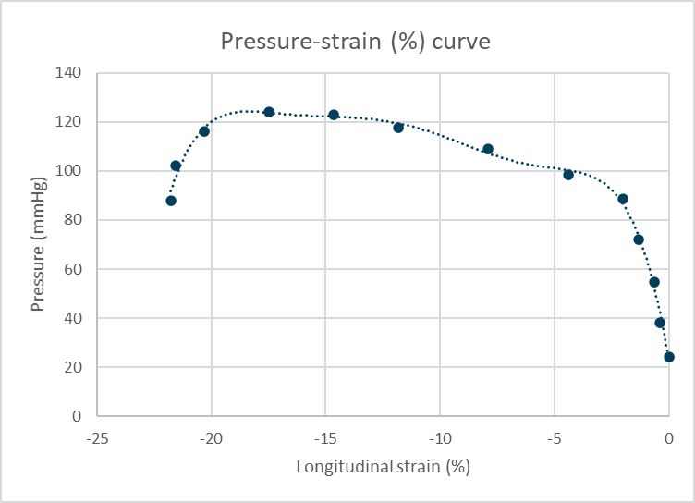
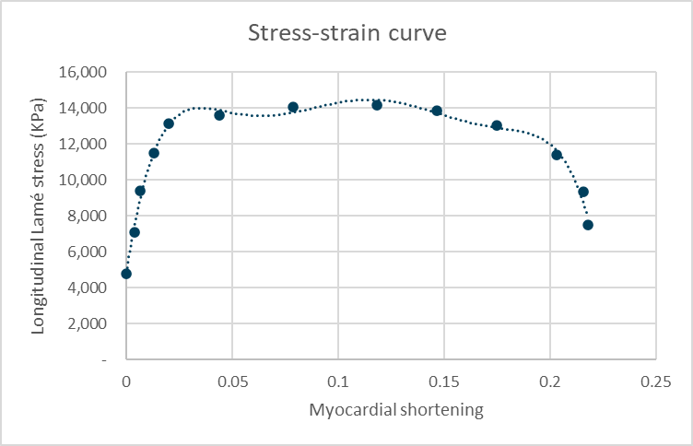
MVC
MVC
AVC
A2
AVC
A1
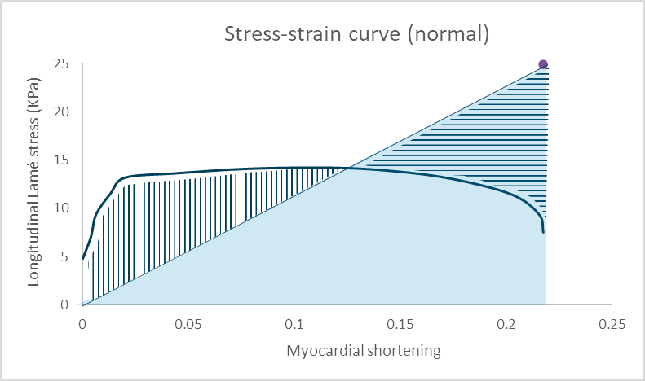
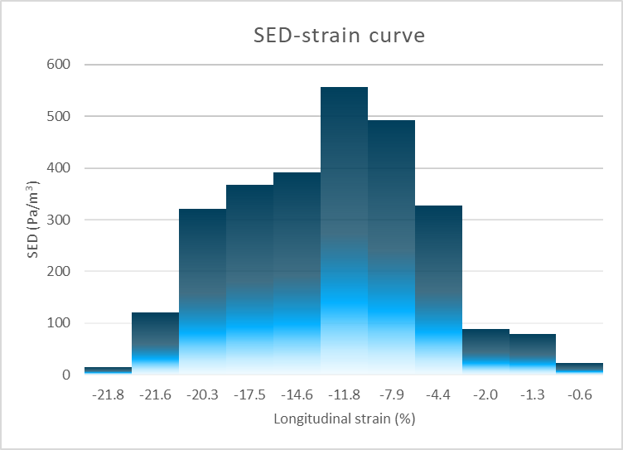
$$σ_{z }$$
$$ε_{z }$$
A3
A4
In this example, the GLASED was 2.80 KPa/m³ (non-linear method) and using Eq 8 was 2.71 KPa/m³ (linear method - blue triangle A4) suggesting that using the $½$ factor is a reasonable compromise for routine use in clinical practice. Geometrically, the $½$ factor is half the area of the rectangle with height ($σ_{z }$, peak stress based on SBP) and width ($ε_{z}$, peak strain) with area of ($σ_{z }× ε_{z}$, dashed box). Note that this compromise is achieved because the vertical hatched area is similar to the horizontal hatched area in Figure A4.

Strain energy density proof
SED can be derived from the definition of Work i.e. F × l
where F = force, l = displacement/distance, V=volume, A = cross sectional area, L, original length.
$Energy \left(work\right)=½×F×l$, where F is the peak force (see Figure A4).
$=½×\frac{F×l}{V}×V$, where V is volume.
$=½×\frac{F×l}{A×L}×V$, where A is cross sectional area, L is original length.
$$=½×\frac{F}{A}×\frac{l}{L}×V$$
Substituting $σ= \frac{F}{A}$ and $ϵ=$ $\frac{l}{L}$, gives
Strain energy (SE) $=½×σ×ϵ×$V, and
Strain energy density (SED) =SE/V
$=½×σ×ϵ$

Reproducibility: Interclass correlation Class 2, Type 1 and Alpha 0.05 in 20 individuals from control group
Measurement | ICC | Lower | Upper
LV ED length 4C | 0.984 | 0.960 | 0.990
LV ED length 3C | 0.983 | 0.959 | 0.993
LV ED length 2C | 0.990 | 0.974 | 1.000
LV ES length 4C | 0.991 | 0.978 | 0.996
LV ES length 3C | 0.990 | 0.975 | 0.996
LV ES length 2C | 0.984 | 0.960 | 0.994
EDWT | 0.981 | 0.952 | 0.992
ED, end-diastolic; ES, end-systolic; 4C, 4 chamber view; 3C, 3 chamber view; 2C, 2 chamber view; EDWT, end-diastolic wall thickness.

