APPENDIX I
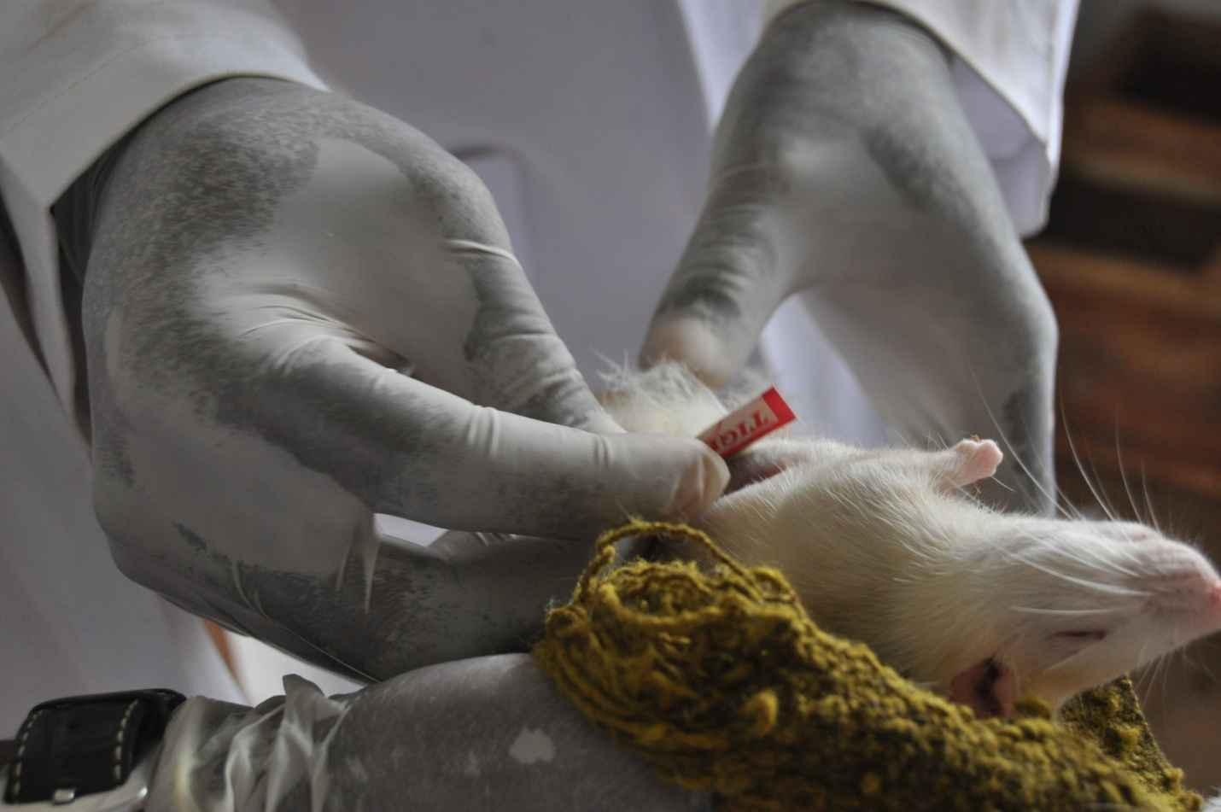
Figure 3: Rat under anesthesia, being prepared for cotton pellet implantation.

APPENDIX II
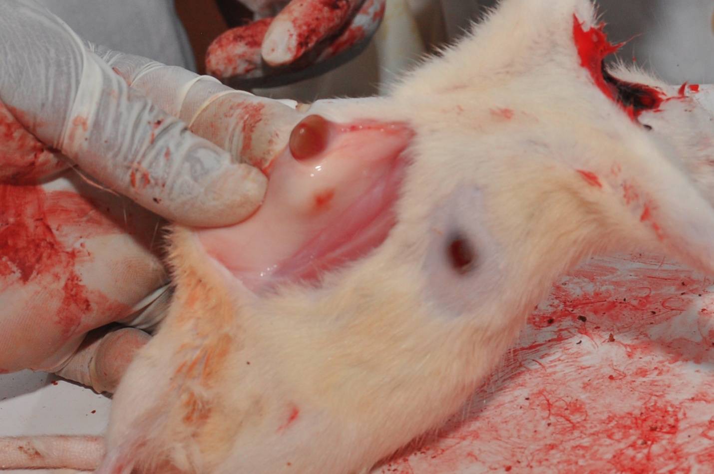
Figure 4: Granuloma tissue formed around implanted cotton pellets.

APPENDIX III
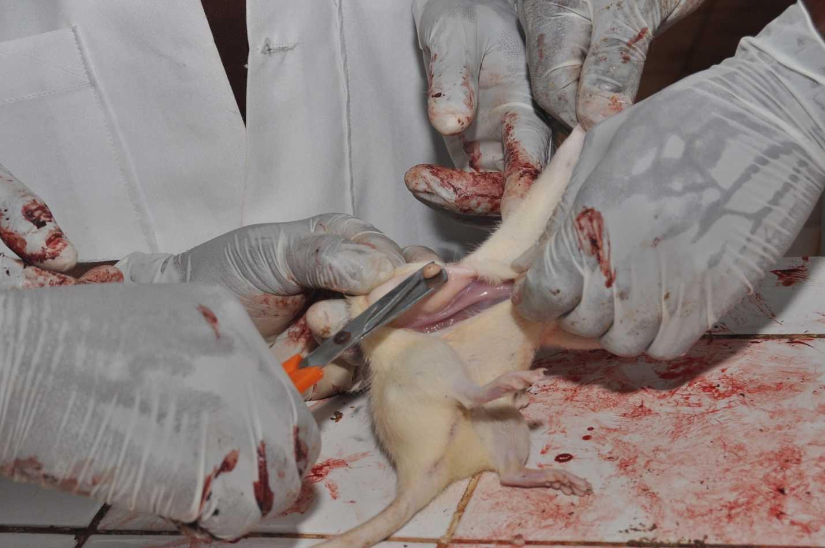

Figure 5: Removal of the cotton pellet from the formed the granuloma tissues

