Extended Data
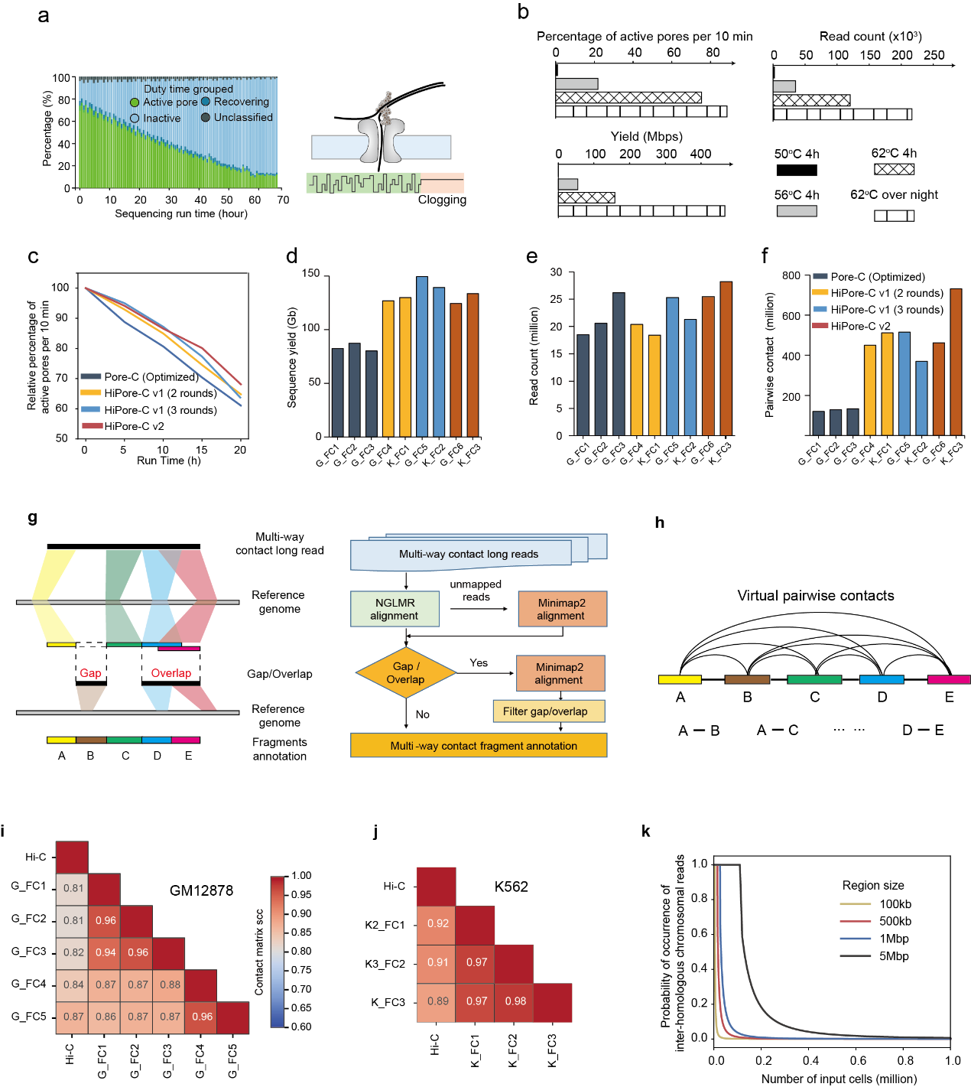
Extended Data Fig. 1|Solving nanopore clogging dramatically increases the output of multiway contact sequencing.
a, Statistical report of the ONT nanopore channel states (active, inactive, recovering, and unclassified) during Pore-C (optimized) DNA library sequencing. The diagram on the right shows the multiway contact DNA with peptide-DNA adducts clogging the flow cell channels during sequencing.
b, Evaluation of optimized Pore-C library sequencing on an ONT MinION flow cell. The percentage of active pores after 60 minus sequencing, number of generated reads, and total sequence yields were compared.
c-f, Comparison of the relative percentage of active pores per 10 minutes against sequencing run time, sequence yields, total reads per run, and virtual pairwise contact number for Pore-C (optimized, blue line), HiPore-C v1 (orange line for 2 rounds and cyan line for 3 rounds of reverse crosslinking and proteinase K digestion) and HiPore-C v2 (brown line).
g, Schematic workflow of MapPoreC.
h, Diagram showing the generation of virtual pairwise contacts from multiway contact reads.
i, Stratum-adjusted correlation coefficient diagram between Hi-C datasets (4DN Data Portal, 4DNFIXVAKX9Q) and five replicates of HiPore-C on GM12878 cells.
j, Stratum-adjusted correlation coefficient heatmap between Hi-C datasets (4DN Data Portal, 4DNFIYW415LY) and three replicates of HiPore-C on K562 cells.
k, Occurrence probability of interhomologous chromosome reads. x-axis, input cell numbers in millions; y-axis, probability of at least 2 fragments in a read being from homologous chromosomes. Yellow, red, blue, and black lines correspond to the region sizes of 100 kb, 500 kb, 1 Mb, and 5 Mb, respectively, used for this analysis.

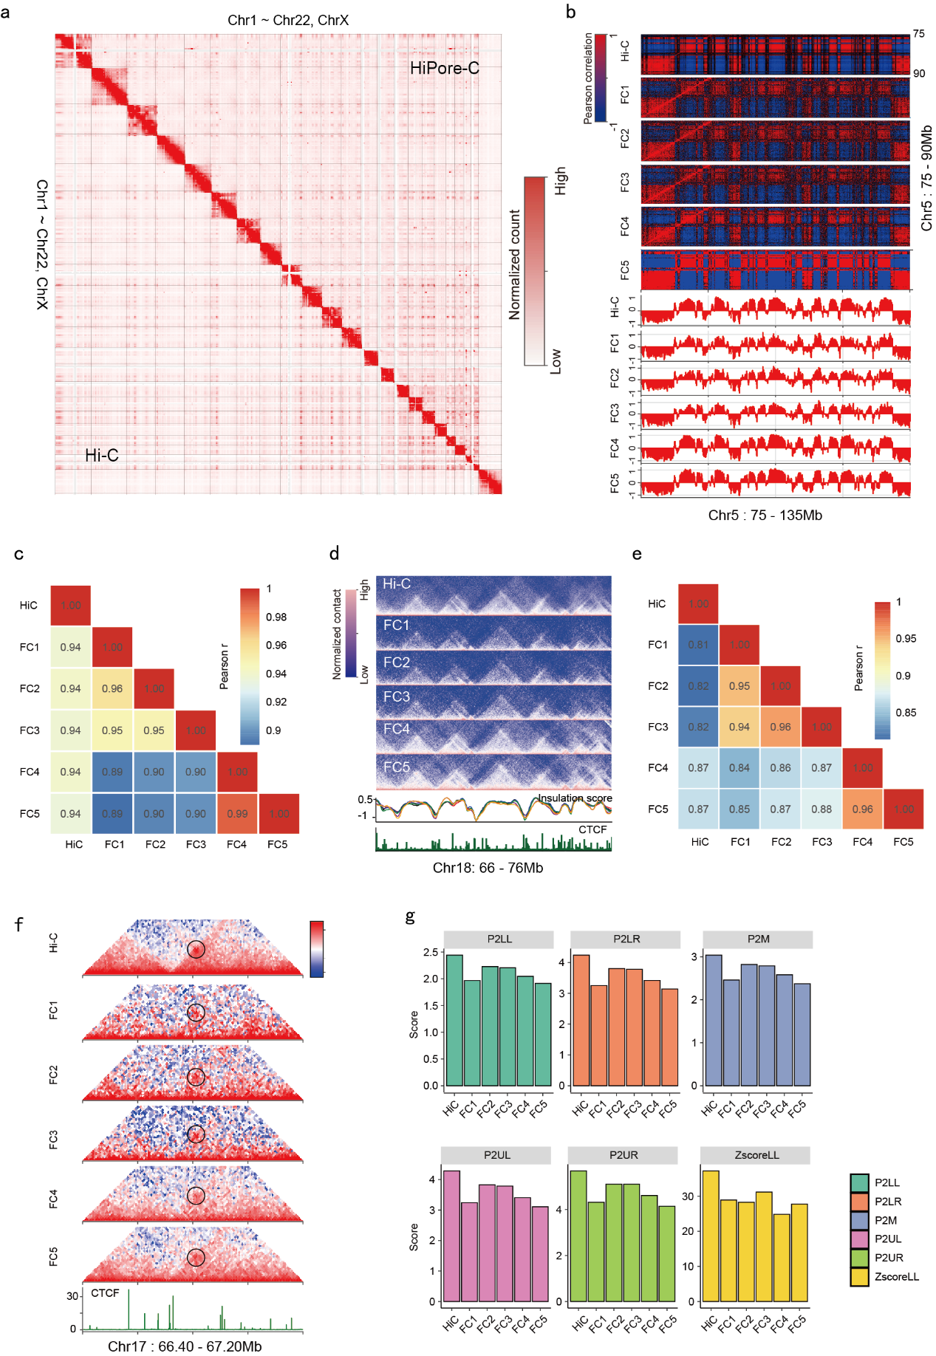
Extended Data Fig. 2|HiPore-C faithfully reproduces canonical 3D genome structures.
a, Comparison of global pairwise contact heatmaps between merged HiPore-C and Hi-C datasets (upper right, HiPore-C; bottom left, Hi-C).
b, An exemplary genomic region showing the reproducibility of compartments (100 kb resolution) with Hi-C as a control. Eigenvector score tracks are shown.
c, Histogram showing Pearson’s correlation coefficients between pairs of compartment eigenvector scores of HiPore-C replicates and Hi-C data.
d, An exemplary genomic region showing the reproducibility of TADs (10 kb resolution) with Hi-C data as a control. Insulation scores and CTCF tracks are shown.
e, Histogram showing Pearson’s correlation coefficients between pairs of insulation values of HiPore-C replicates and Hi-C data.
f, An exemplary genomic region showing the reproducibility of chromatin loops (10 kb resolution) with Hi-C as a control. The CTCF track is shown.
g, The reproducibility of APA results with Hi-C data as a control. P2LL, the ratio of the central pixel to the mean of the pixels in the lower left corner; P2LR, the ratio of the central pixel to the mean of the pixels in the lower right corner; P2M, the ratio of the central pixel to the mean of the remaining pixels; P2UL, the ratio of the central pixel to the mean of the pixels in the upper left corner; ZscoreL, the Z score of the central pixel relative to all of the pixels in the lower left corner.

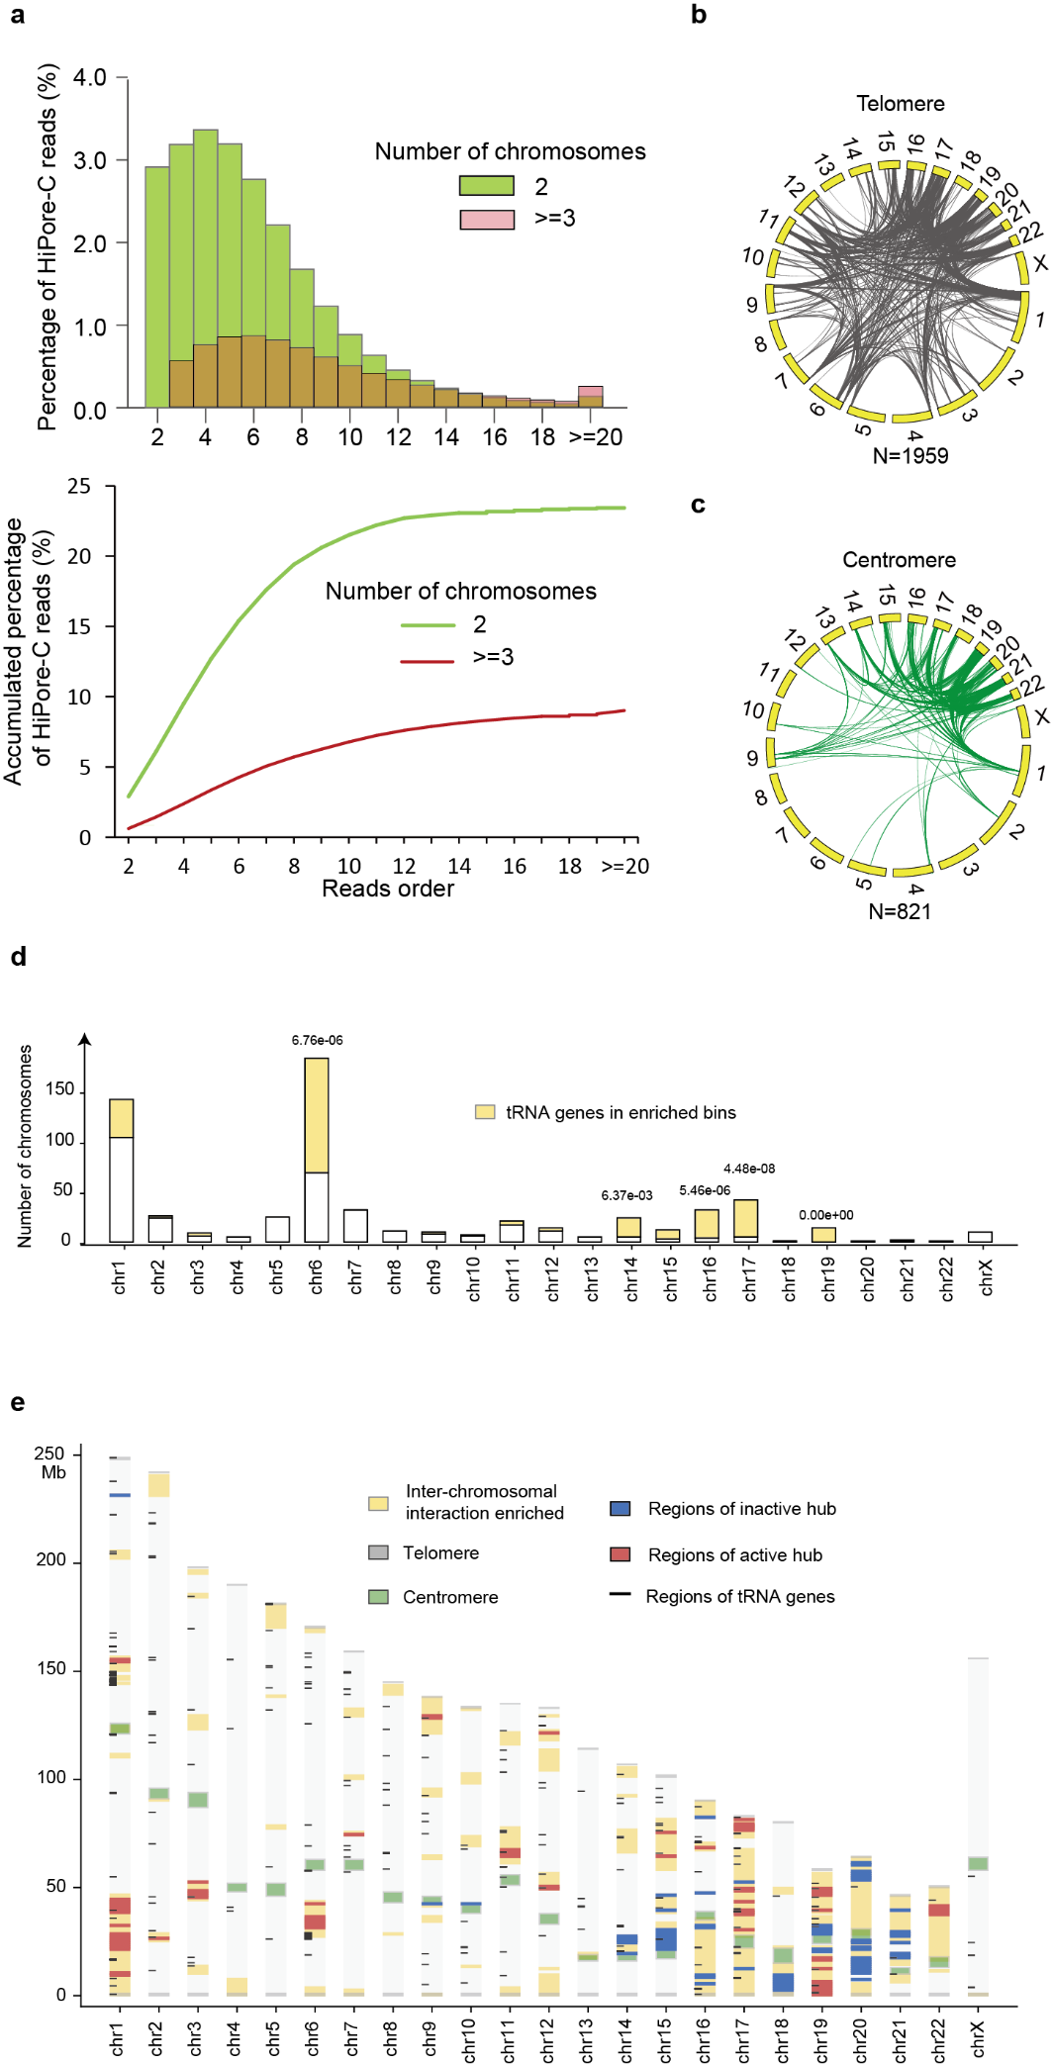
Extended Data Fig. 3|HiPore-C reveals interchromosomal chromatin clustering.
a, Percentage (top) and accumulation ratio (bottom) of the multiway contact reads spanning two or more chromosomes. x-axis, the number of fragments in reads; y-axis, percentage or accumulated ratio of reads.
b and c, Circos diagrams of statistically significant (enrichment score >=2 and p < 0.01, binomial test followed by Bonferroni's multiple correction) interchromosome contacts with telomeres or centromeres at one end.
d, Number of tRNA genes that are enriched in interchromosome interactions. Yellow bars correspond to numbers of significantly enriched tRNA genes. Significance was calculated using a binomial distribution, and p values were adjusted with Bonferroni's multiple correction. p < 0.01 was defined as significant.
e, Diagram of regions significantly enriched in interchromosome interactions. The colors gray, green, yellow, blue, red, and black indicate telomeres, centromeres, enriched genomic regions, regions in inactive hubs, regions in active hubs, and tRNA genes, respectively.

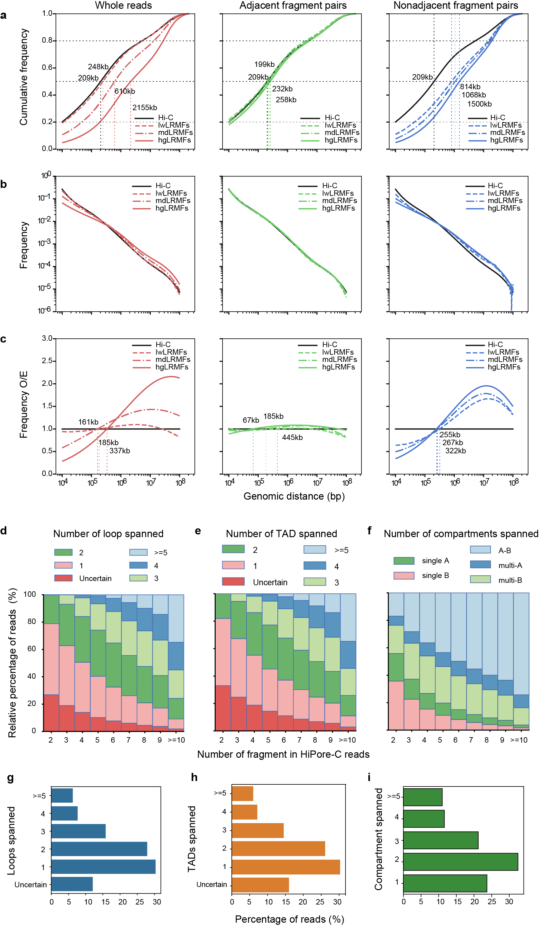
Extended Data Fig. 4|Multiway contacts span multiple compartments, TADs, and loops.
a, Cumulative ratio of Hi-C and HiPore-C reads and virtual pairwise contacts between adjacent fragments or between nonadjacent fragments in different groups of HiPore-C reads. HiPore-C reads are separated into three groups of lwLRMFs (red), mdLRMFs (green), and hgLRMFs (blue) containing 2-3, 4-9, and >=10 fragments, respectively.
b, Decaying curves of different types of paired fragments in different groups of HiPore-C reads. HiPore-C reads are separated as in a.
c, Frequencies of different types of paired fragments in different groups of HiPore-C reads normalized against those of Hi-C data over continuous genomic distance. HiPore-C reads are separated as in a.
d-f, Number of chromatin loops (d), TADs (e), and compartments (f) spanned by multiway contact reads containing different numbers of fragments.
g-i, Percentage of multiway contact reads spanning different numbers of chromatin loops (g), TADs (h), and compartments (i).

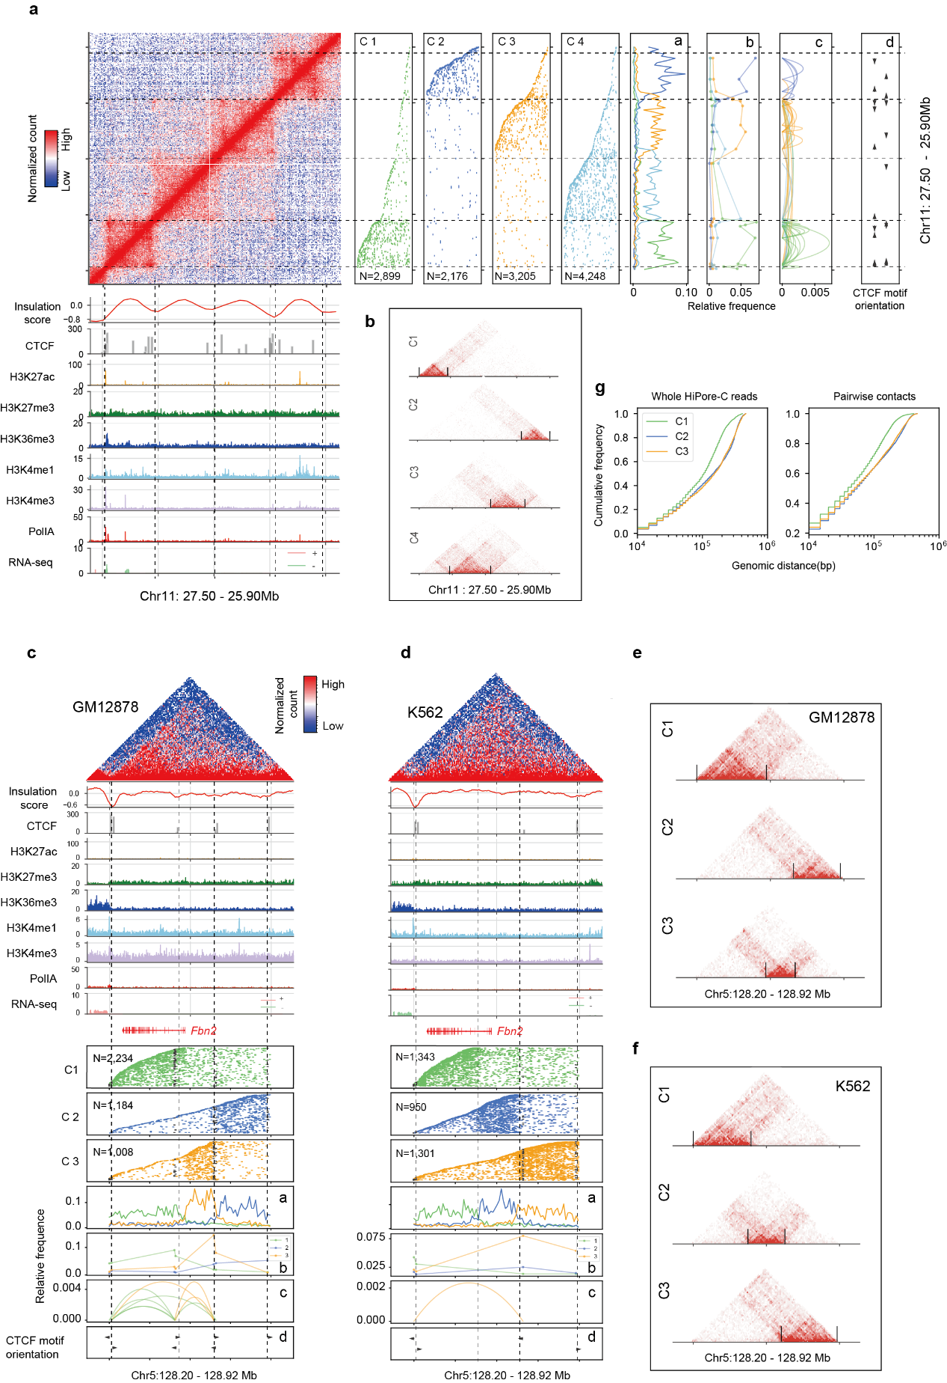
Extended Data Fig. 5|Polymorphism and cell type-specificity of single-allele topology clusters underlie the formation of TADs.
a, HiPore-C reads are clustered into four discrete genomic regions corresponding to four neighboring TADs in GM12878 cells. Five percent reads of each cluster were randomly selected and plotted for visualization in panels C1-C4.
b, Heatmaps generated from the four clusters of HiPore-C reads (a).
c and d, HiPore-C reads are clustered for the typical TAD containing the fbn2 gene in GM12878 (c) and K562 (d) cell lines.
e and f, Heatmaps generated from the clusters of HiPore-C reads (c and d).
g, Accumulation of the three clusters of HiPore-C reads (c and d) against genomic distance.

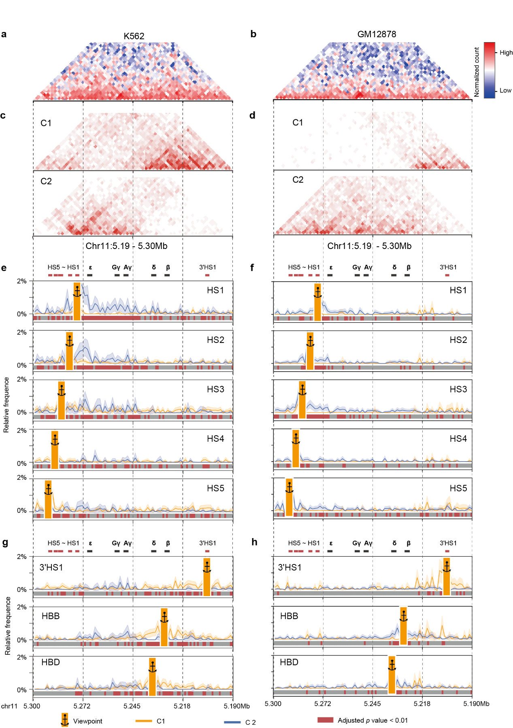
Extended Data Fig. 6|HiPore-C reveals a cell type-specific enhancer hub at the β-globin locus.
a and b, Virtual pairwise contact heatmaps of the human β-globin gene locus in K562 (a) and GM12878 (b) cell lines.
c and d, Heatmaps generated from clustered HiPore-C reads covering the human β-globin gene locus in K562 (c) and GM12878 (d) cell lines.
e and f, Multiway contacts anchored at different sites in the human β-globin gene locus (HS1, HS2, HS3, HS4, and HS5) in the two HiPore-C clusters in K562 (e) and GM12878 (f) cell lines.
g and h, Multiway contacts anchored at different sites in the human β-globin gene locus (3’HS1 and β- and δ-globin genes) in the two HiPore-C clusters in K562 (g) and GM12878 (h) cell lines.

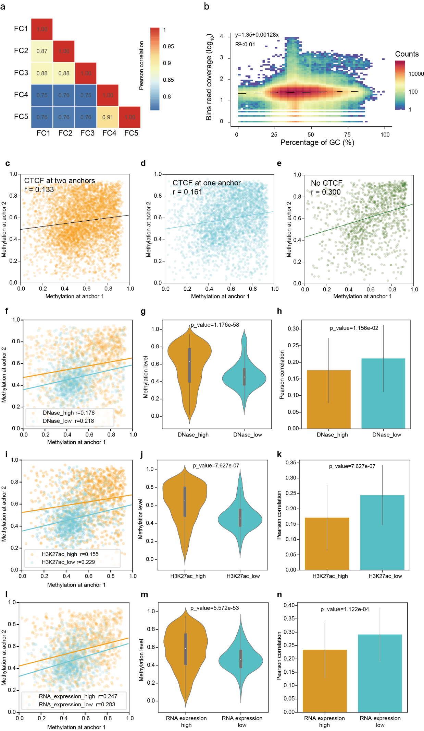
Extended Data Fig. 7|HiPore-C captures DNA methylation and chromatin topology simultaneously.
a, Histogram showing Pearson’s correlation coefficients of CpG methylation with WGBS as a control.
b, Evaluation of HiPore-C coverage bias for sequences with different GC contents. The dependence degree of coverage on the GC content is represented by the slope of the regression model. The slopes of WGBS and WGS data obtained by ONT nanopore sequencing were reported to be -1.51 and -0.1⁶⁵, respectively.
c, Correlation between CpG methylation levels at anchors with CTCF binding at both ends.
d, Correlation between CpG methylation levels at anchors with CTCF binding at one end.
e, Correlation between CpG methylation levels at anchors without CTCF binding.
f, Correlation between CpG methylation levels at anchors of chromatin loops of high- and low-density DNaseI-sensitive sites.
g, Violin plot showing the CpG methylation levels of chromatin loops of high- and low-density DNaseI-sensitive sites.
h, Pearson’s correlation between CpG methylation levels of chromatin loops of high- and low-density DNaseI-sensitive sites.
i-k, Analysis of chromatin loops of high- and low-H3K27ac density as in (f-h).
l-n, Analysis of chromatin loops of high- and low-RNA expression as in (f-h).

