Electronic Supplementary Information

Anchoring carboxylated pineapple peel cellulose and EDTA onto magnetic (3-aminopropyl)triethoxysilane to effective diminish copper(II) and zinc(II) from polluted water

Cellulose

Hanan Sayahi, Simin Asadabadi*
Department of Applied Chemistry, Faculty of Chemistry, Bu–Ali Sina University, Hamedan 6517838695, Iran

*Corresponding author: (Dr. Simin Asadabadi), E-mail address: s.asadabadi@basu.ac.ir
Corresponding author’s ORCID ID: 0000-0001-8992-6894

Supplementary Figures and Tables

(a)  λ_{max} = 600 nm | λ_{max} = 620 nm  (b)
Fig. S1 UV-Vis absorption spectra of cation-bound Zincon (a) Cu²⁺-Zincon at concentration of 12.0 mg·L⁻¹ in 10.0 ml phosphate buffer and (b) Zn²⁺-Zincon at concentration of 20.0 mg·L⁻¹ in 10.0 ml phosphate buffer

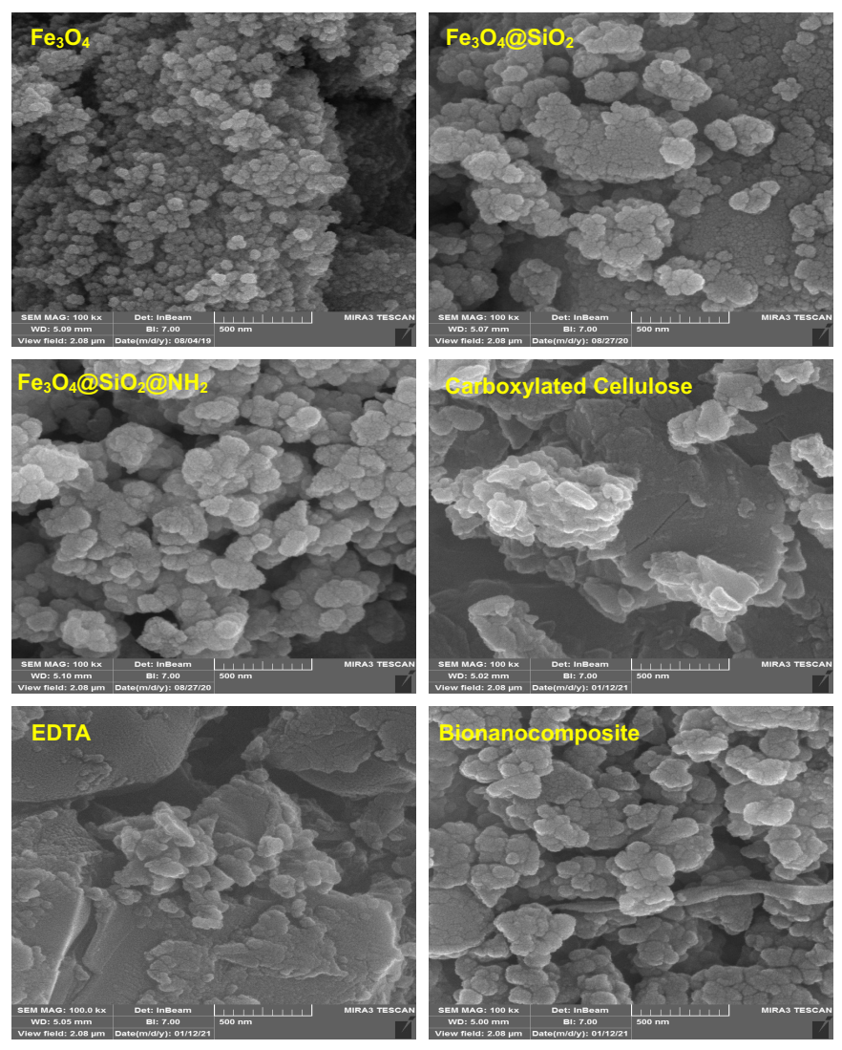
Fig. S2 FE-SEM image of Fe₃O₄, Fe₃O₄@SiO₂, Fe₃O₄@SiO₂@NH₂, EDTA, carboxylated cellulose, and bionanocomposite

Fig. S3 Graph of ΔpH versus pH_{initial}

(a)
Table S1 Levels of factors used for design of experiments
Factor | Level
Factor | -α | -1 | 0 | +1 | +α
 | Cu²⁺
pH | 3.15 | 4.00 | 5.25 | 6.50 | 7.35
T (°C) | 20.0 | 25.0 | 32.5 | 40.0 | 45.1
C_{BNC} (g·L⁻¹) | 0.06 | 0.12 | 1.30 | 2.00 | 2.48
 | Zn²⁺
pH | 3.97 | 5.25 | 7.12 | 9.00 | 10.28
T (°C) | 20.0 | 25.0 | 32.5 | 40.0 | 45.1
C_{BNC} (g·L⁻¹) | 0.06 | 0.12 | 1.30 | 2.00 | 2.48

Table S2 Statistic used for testing the adequacy of model
Formula
$$residual=R_{exp\text{,i}}-R_{cal\text{,i}}$$ | $R_{exp\text{,i}}:$ experimental response  $R_{cal\text{,i}}$: calculated response
$${SS}_{residual}=\sum_{i=1}^{n}{(R_{exp\text{,}i}-R_{cal\text{,}i})^{2}}$$ | ${SS}_{residual}$: sum of squares of residual
$${{SS}_{model}=SS}_{total}-{SS}_{residual}$$ | ${SS}_{model}:$sum of squares of model
$${SS}_{total}=\sum_{i=1}^{n}{(R_{exp\text{,}i}-\overline{R})^{2}}$$ | ${SS}_{total}$: sum of squares of total
$$PRESS=\sum_{i=1}^{n}{(R_{exp\text{,}i}-R_{cal\text{,}i})^{2}}$$ | $PRESS$: prediction error sum of squares
$$R^{2}=1-\frac{{SS}_{residual}}{({SS}_{model}+{SS}_{residual})}$$ | $R^{2}$: coefficient of determination
$$R_{Adj\text{.}}^{2}=1-\frac{{{SS}_{residual}}/{(n-p)}}{{({SS}_{model}+{SS}_{residual})}/{(n-1)}}$$ | $R_{Adj\text{.}}^{2}$: adjusted coefficient of determination
$$R_{Pred\text{.}}^{2}=1-\frac{PRESS}{{({SS}_{model}+{SS}_{residual})}/{(n-1)}}$$ | $R_{Pred\text{.}}^{2}$: predicted coefficient of determination
$$SD=\sqrt{\frac{\sum_{i=1}^{n}{(R_{exp\text{,}i}-\overline{R})^{2}}}{n-1}}$$ | $SD$: standard deviation
$$C\text{.}V\text{.}\%=\frac{s}{\overline{R}}×100\%$$ | $C\text{.}V\text{.}\%$: coefficient of variation
$$A\text{.}P\text{.}=\frac{Signal}{Noise}$$ | $A\text{.}P\text{.}$: adequate precision

Table S3 Kinetics model parameters, $R_{Adj\text{.}}^{2}$, AIC_{c}, $χ^{2}$ and RMSE at optimum conditions and concentration of 30.0 mg·g⁻¹
Model | Cation | Parameter |  |  | Goodness of Fit
PFO |  | $$q_{e} (mg·g^{-1})$$ | $$k_{1}$$ | - | $$R_{Adj\text{.}}^{2}$$ | $${AIC}_{c}$$ | $$χ^{2}$$ | RMSE
PFO | Cu²⁺ | 13.47 | 2.86 |  | 0.9732 | 0.677 | 0.3232 | 0.6405
PFO | Zn²⁺ | 13.52 | 0.08 |  | 0.9632 | 1.240 | 0.7403 | 0.8118
PSO |  | $$q_{e} (mg·g^{-1})$$ | $$k_{2}$$ | - | $$R_{Adj\text{.}}^{2}$$ | $${AIC}_{c}$$ | $$χ^{2}$$ | RMSE
PSO | Cu²⁺ | 14.00 | 0.43 |  | 0.9966 | -1.377 | 0.0449 | 0.2294
PSO | Zn²⁺ | 16.77 | 0.004 |  | 0.9306 | 1.874 | 1.2672 | 1.1149
Elovich |  | $$a_{E}$$ | $$b_{E}$$ | - | $$R_{Adj\text{.}}^{2}$$ | $${AIC}_{c}$$ | $$χ^{2}$$ | RMSE
 | Cu²⁺ | 5356234.77 | 1.32 |  | 0.9927 | -0.621 | 0.0878 | 0.3348
 | Zn²⁺ | 1.70 | 0.25 |  | 0.8932 | 2.305 | 1.8445 | 1.3833
MOE |  | $$q_{e} (mg·g^{-1})$$ | $$k_{1}$$ | $$F_{2}$$ | $$R_{Adj\text{.}}^{2}$$ | $${AIC}_{c}$$ | $$χ^{2}$$ | RMSE
 | Cu²⁺ | -0.05 | -14.38 | 0.00 | 0.9560 | 1.458 | 0.4555 | 0.8200
 | Zn²⁺ | 12.72 | 0.16 | -6.63 | 0.9995 | -2.620 | 0.0108 | 0.0985
PnO |  | $$q_{e} (mg·g^{-1})$$ | $$k_{1}$$ | $$n$$ | $$R_{Adj\text{.}}^{2}$$ | $${AIC}_{c}$$ | $$χ^{2}$$ | RMSE
 | Cu²⁺ | 14.61 | 0.08 | 2.88 | 0.9986 | -1.964 | 0.0163 | 0.1481
 | Zn²⁺ | 13.34 | 0.09 | 0.80 | 0.9624 | 1.620 | 0.7252 | 0.8210
MPnO |  | $$q_{e} (mg·g^{-1})$$ | $$k^{'}$$ | $$n$$ | $$R_{Adj\text{.}}^{2}$$ | $${AIC}_{c}$$ | $$χ^{2}$$ | RMSE
 | Cu²⁺ | 13.98 | 7.75 | 0.04 | 0.9990 | -2.314 | 0.0110 | 0.1244
 | Zn²⁺ | 12.81 | 0.39 | 0.31 | 0.9977 | -1.188 | 0.0446 | 0.2017
FL-PFO |  | $$q_{e} (mg·g^{-1})$$ | $$k_{1}^{'}$$ | $$a$$ | $$R_{Adj\text{.}}^{2}$$ | $${AIC}_{c}$$ | $$χ^{2}$$ | RMSE
 | Cu²⁺ | 13.31 | 24.57 | 36.93 | 0.0823 | 4.496 | 48029879338 | 3.7456
 | Zn²⁺ | 12.69 | 0.01 | 1.76 | 0.9993 | -2.373 | 0.0146 | 0.1115
FL-PSO |  | $$q_{e} (mg·g^{-1})$$ | $$k_{2}^{'}$$ | $$a$$ | $$R_{Adj\text{.}}^{2}$$ | $${AIC}_{c}$$ | $$χ^{2}$$ | RMSE
 | Cu²⁺ | 14.49 | 0.32 | 0.65 | 0.9947 | -0.337 | 0.0148 | 0.3085
 | Zn²⁺ | 13.07 | 0.00 | 2.68 | 0.9987 | -2.061 | 0.1018 | 0.1411

Table S4 Isotherm parameters, $R_{Adj\text{.}}^{2}$, AIC_{c}, $χ^{2}$ and RMSE at optimum conditions
Isotherm | Cation | Parameter |  |  | Goodness of Fit
Langmuir |  | $$q_{m} (mg·g^{-1})$$ | $$K_{L}$$ | - | $$R_{Adj\text{.}}^{2}$$ | $${AIC}_{c}$$ | $$χ^{2}$$ | RMSE
Langmuir | Cu²⁺ | 151.0 | 0.738 |  | 0.9868 | 5.3078 | 66.6955 | 6.2071
Langmuir | Zn²⁺ | 179.5 | 0.126 |  | 0.9508 | 6.6744 | 17.3114 | 12.2920
Freundlich |  | $$K_{F}$$ | $$c$$ | - | $$R_{Adj\text{.}}^{2}$$ | $${AIC}_{c}$$ | $$χ^{2}$$ | RMSE
Freundlich | Cu²⁺ | 73.4 | 0.181 |  | 0.8974 | 7.3581 | 34.1722 | 17.3020
Freundlich | Zn²⁺ | 45.4 | 0.301 |  | 0.8106 | 8.0218 | 63.7484 | 24.1115
Temkin |  | $$b_{T}$$ | $$K_{T}$$ | - | $$R_{Adj\text{.}}^{2}$$ | $${AIC}_{c}$$ | $$χ^{2}$$ | RMSE
Temkin | Cu²⁺ | 131.9 | 54.49 |  | 0.9501 | 6.6371 | 18.8014 | 12.7969
Temkin | Zn²⁺ | 66.9 | 1.30 |  | 0.9075 | 7.3054 | 25.9123 | 17.8741
Modified Langmuir |  | $$q_{m} (mg·g^{-1})$$ | $$K_{ML}$$ | - | $$R_{Adj\text{.}}^{2}$$ | $${AIC}_{c}$$ | $$χ^{2}$$ | RMSE
Modified Langmuir | Cu²⁺ | 151.0 | 2952213 |  | 0.9856 | 5.7549 | 66.6956 | 6.4883
Modified Langmuir | Zn²⁺ | 179.4 | 3803 |  | 0.9508 | 6.6744 | 17.3114 | 12.2920
Redlich-Peterson |  | $$K_{RP}$$ | $$a_{RP}$$ | $$β$$ | $$R_{Adj\text{.}}^{2}$$ | $${AIC}_{c}$$ | $$χ^{2}$$ | RMSE
Redlich-Peterson | Cu²⁺ | 11390440.3 | 155116.5 | 0.82 | 0.8846 | 7.8342 | 34.1697 | 18.3509
Redlich-Peterson | Zn²⁺ | 11390440.3 | 250829.9 | 0.70 | 0.7870 | 8.4980 | 63.7483 | 25.5740
Toth |  | $$q_{m} (mg·g^{-1})$$ | $$a_{T}$$ | $$c$$ | $$R_{Adj\text{.}}^{2}$$ | $${AIC}_{c}$$ | $$χ^{2}$$ | RMSE
Toth | Cu²⁺ | 153.8 | 0.885 | 0.88 | 0.9857 | 5.7430 | 51.2939 | 6.4497
Toth | Zn²⁺ | 152.2 | 0.077 | 3.94 | 0.9986 | 3.5069 | 0.3636 | 2.1086
Extended Langmuir |  | $$q_{m} (mg·g^{-1})$$ | $$K_{EL}$$ | $$a$$ | $$R_{Adj\text{.}}^{2}$$ | $${AIC}_{c}$$ | $$χ^{2}$$ | RMSE
Extended Langmuir | Cu²⁺ | 155.1 | 0.840 | 0.17 | 0.9856 | 5.7549 | 55.1085 | 6.4883
Extended Langmuir | Zn²⁺ | 105.8 | 0.077 | -1.15 | 0.9954 | 4.6692 | 1.0832 | 3.7703
Langmuir-Freundlich |  | $$q_{m} (mg·g^{-1})$$ | $$K_{LF}$$ | $$c$$ | $$R_{Adj\text{.}}^{2}$$ | $${AIC}_{c}$$ | $$χ^{2}$$ | RMSE
Langmuir-Freundlich | Cu²⁺ | 155.4 | 0.707 | 0.85 | 0.9872 | 5.6392 | 27.7330 | 6.1238
Langmuir-Freundlich | Zn²⁺ | 157.3 | 0.155 | 1.83 | 0.9915 | 5.2806 | 6.7317 | 5.1184
Modified Langmuir-Freundlich |  | $$q_{m} (mg·g^{-1})$$ | $$K_{MLF}$$ | $$c$$ | $$R_{Adj\text{.}}^{2}$$ | $${AIC}_{c}$$ | $$χ^{2}$$ | RMSE
Modified Langmuir-Freundlich | Cu²⁺ | 155.4 | 2830297 | 0.85 | 0.9872 | 5.6392 | 27.7332 | 6.1238
Modified Langmuir-Freundlich | Zn²⁺ | 157.3 | 4675 | 1.83 | 0.9915 | 5.2801 | 6.7283 | 5.1173

