SUPPLEMENTARY INFORMATION

Tetrahydroquinolinone derivatives exert antiproliferative effect on colorectal and lung cancer cells through apoptosis induction

Małgorzata Ryczkowska¹, Natalia Maciejewska², Mateusz Olszewski², Milena Witkowska¹, and Sławomir Makowiec¹*

¹ Department of Organic Chemistry, Faculty of Chemistry, Gdansk University of Technology, Narutowicza 11/12, 80-233, Gdansk, Poland.
² Department of Pharmaceutical Technology and Biochemistry, Faculty of Chemistry, Gdansk University of Technology, Narutowicza 11/12, 80-233, Gdansk, Poland.*mak@pg.edu.pl

EXPERIMENTAL DATA

A. General procedure for benzyl-type derivatives of ethyl benzoylacetate
A solution of ethyl benzoylacetate (0.63 mmol) and K₂CO₃ (0.95 mmol) in 3 ml of DMF was placed in round-bottomed flask with stir bar. Corresponding benzyl halide (0.82 mmol) was added in one portion. The reaction mixture was heated to 60ºC and left for 4h. DMF was evaporated. The residue was dissolved with ethyl acetate and washed with water and brine. Organic layer was dried with anhydrous MgSO₄. Crude products were isolated by flash column chromatography (ethyl acetate : hexane 1:40 + 2% toluene). Yields and characteristic of title compounds are collected below.

1. ethyl 2-(1-naphthylmethyl)-3-oxo-3-phenyl-propanoate (2a)
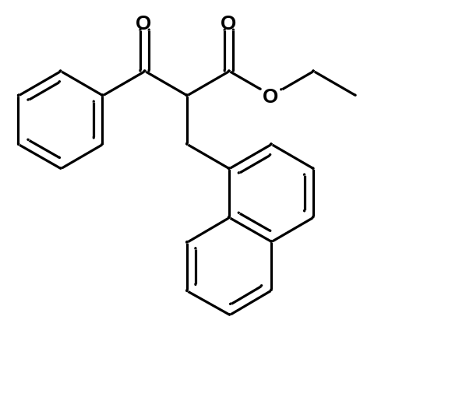
Colorless oil, yield: 67%,
¹H NMR (CDCl₃, 400 MHz): δ= 8.07 (d, J = 8.4 Hz, 1 H), 7.90 – 7.85 (m, 3 H), 7.71 (d, J = 8 Hz, 1 H), 7.57 – 7.48 (m, 3 H), 7.41 – 7.32 (m, 4 H), 4.82 (t, J = 7.2 Hz , 1 H), 4.14 – 4.05 (m, 2 H), 3.84 (d, J = 7.2 Hz, 2 H), 1.09 (t, J = 7.1 Hz, 3 H)

¹³C NMR (CDCl₃, 100 MHz): δ= 194.75, 169.60, 136.40, 134.35, 134.03, 133.60, 131.77, 129.13, 128.73, 128.69, 127.63, 127.47, 126.38, 125.72, 125.55, 123.36, 61.69, 55.02, 31.82, 14.02

HRMS (ESI+): m/z
[M + H]+ calcd for C₂₂H₂₁O₃: 333.1491; found: 333.1498
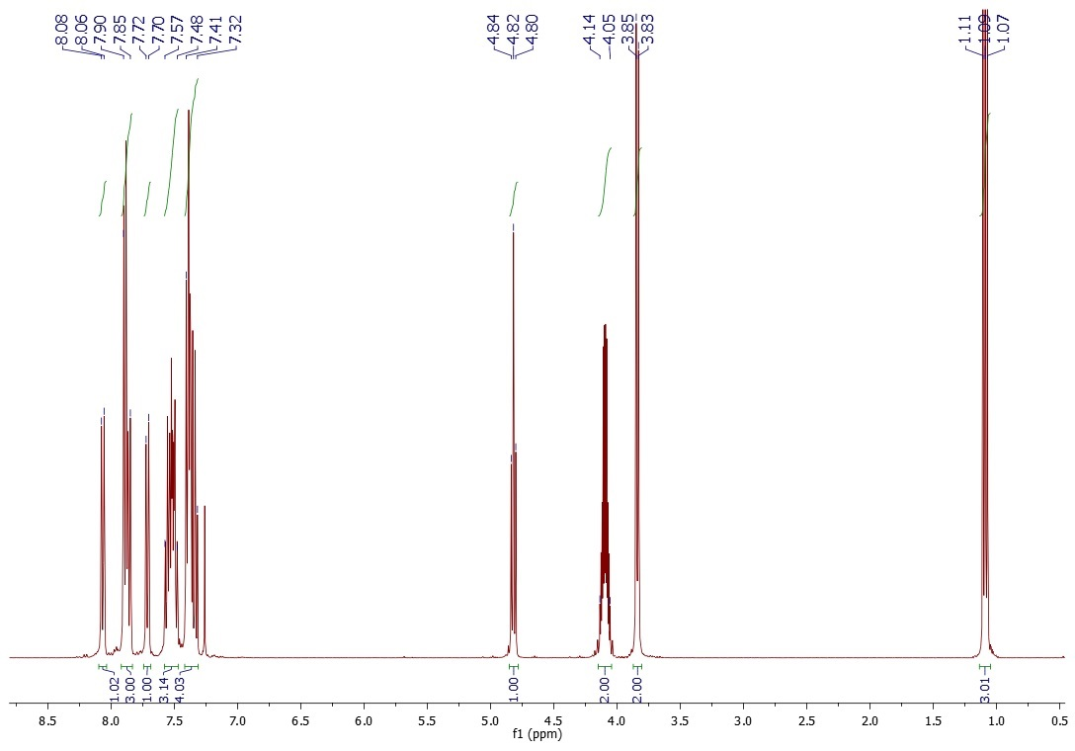
Figure S1. ¹H NMR of ethyl 2-(1-naphthylmethyl)-3-oxo-3-phenyl-propanoate
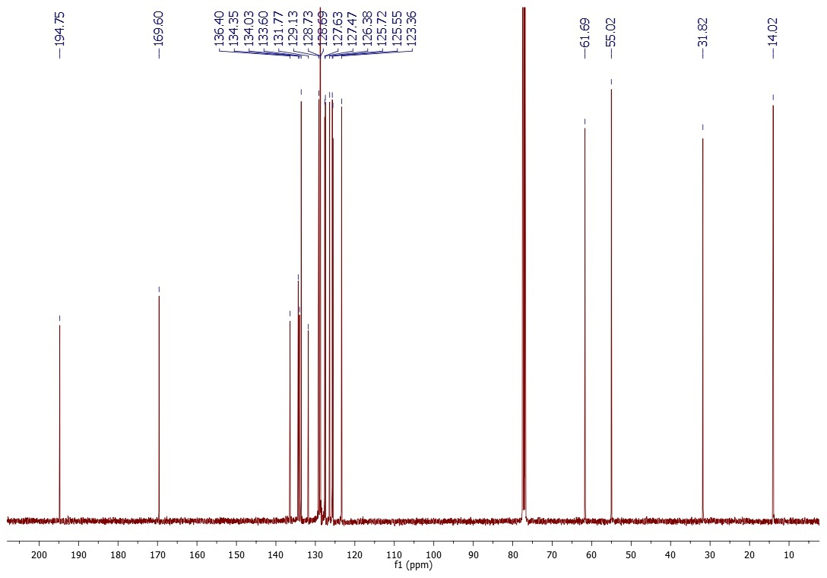
Figure S2. ¹³C NMR of ethyl 2-(1-naphthylmethyl)-3-oxo-3-phenyl-propanoate

2. ethyl 2-(2-naphthylmethyl)-3-oxo-3-phenyl-propanoate (2b)

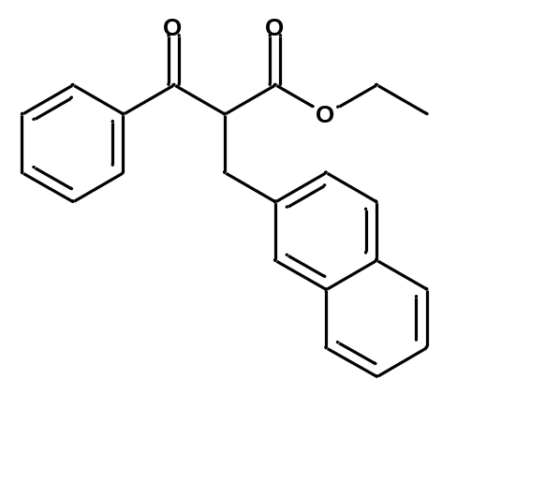Colorless oil, yield: 75%,
Mixture of tautomers 7:3
¹H NMR (CDCl₃, 400 MHz): δ= 7.99 – 7.97 (m, 1.86 H), 7.87 – 7.68 (m, 4 H), 7.62 – 7.36 (m, 6 H), 7.23 – 7.20 (m, 0.14 H), 4.73 (t, J = 7.3 Hz, 0.78 H), 4.30 – 4.19 (m, 0.36 H), 4.16 – 4.04 (m, 1.63 H), 3.99 (s, OH), 3.67 (d, J =14.1 Hz, 0.14 H), 3.58 (d, J = 14.1 Hz, 0.14 H) 3.69 – 3.42 (dd, J³ = 7.3 Hz, J² = 2 Hz, 1.63 H), 1.26 (t, J = 7.1 Hz , 0.87 H), 1.10 (t, J = 7.1 Hz, 2.13 H)

¹³C NMR (CDCl₃, 100 MHz): δ= 194.54, 169.40, 136.30, 136.09, 133.69, 133.61, 132.41, 128.84, 128.82, 128.33, 127.72, 127.64, 127.37, 126.17, 125.68, 61.70, 56.31, 35.02, 14.08

HRMS (ESI+): m/z
[M + H]+ calcd for C₂₂H₂₁O₃: 333.1491; found: 333.1492

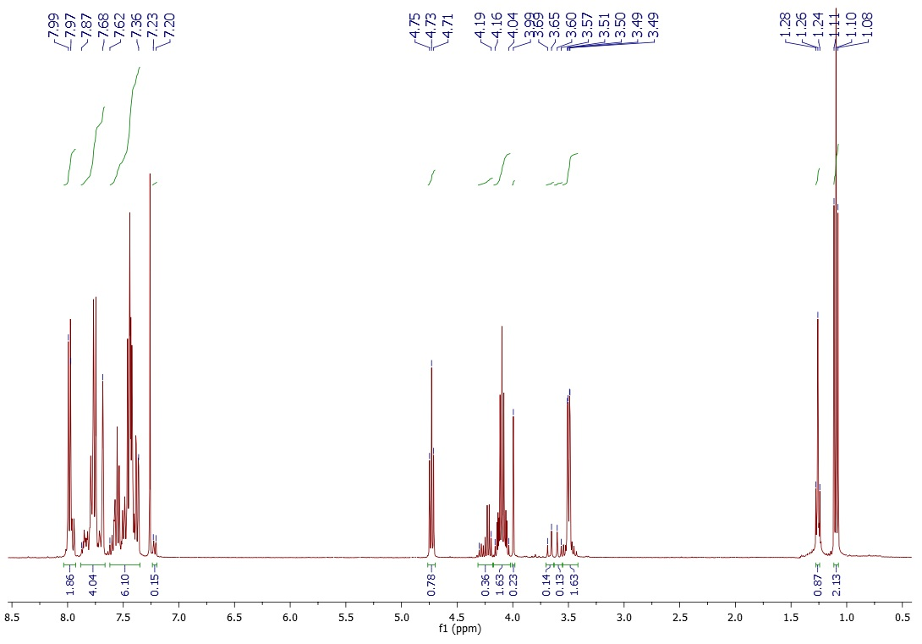
Figure S3. ¹H NMR of ethyl 2-(2-naphthylmethyl)-3-oxo-3-phenyl-propanoate
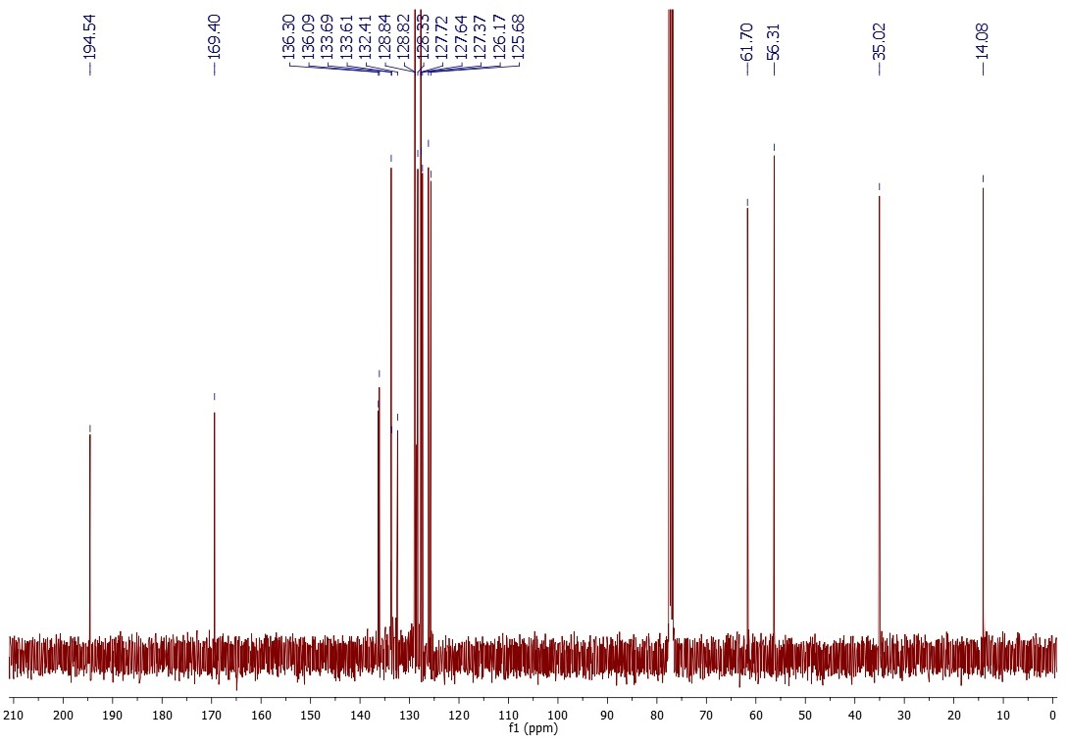
Figure S4. ¹³C NMR of ethyl 2-(2-naphthylmethyl)-3-oxo-3-phenyl-propanoate
3. ethyl 3-oxo-3-phenyl-2-[(4-phenylphenyl)methyl]propanoate (2c)

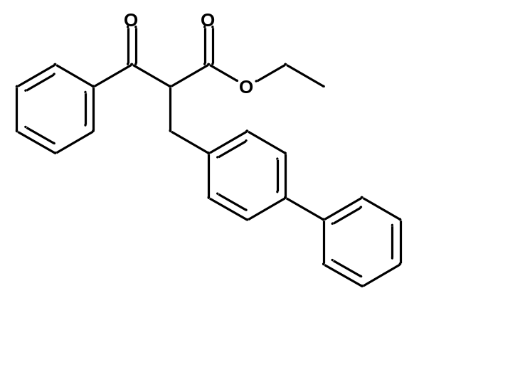Colorless oil, yield: 85%,
¹H NMR (CDCl₃, 400 MHz): δ= 8.00 – 7.98 (m, 2 H), 7.59 – 7.54 (m, 3 H), 7.51 – 7.40 (m, 6 H), 7.34 – 7.30 (m, 3 H), 4.66 (t, J = 7.3, 1 H), 4.18 – 4.07 (m, 2 H), 3.38 (dd, J³ = 7.3 Hz, J² = 1.7 Hz, 2 H), 2 H), 1.13 ( t, J = 7.1 Hz, 3 H)

¹³C NMR (CDCl₃, 100 MHz): δ= 194.57, 169.41, 140.95, 139.68, 137.67, 136.31, 133.70, 129.50, 128.87, 128.85, 128.85, 127.37, 127.31, 127.11, 61.70, 56.28, 34.52, 14.09

HRMS (ESI+): m/z
[M + H]+ calcd for C₂₄H₂₃O₃: 359.1647; found: 359.1651.
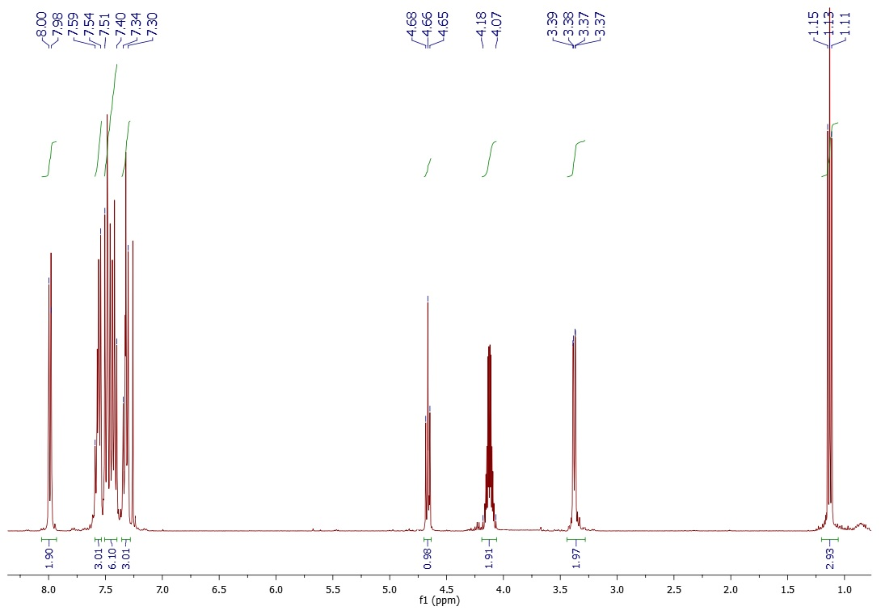
Figure S5. ¹H NMR of ethyl 3-oxo-3-phenyl-2-[(4-phenylphenyl)methyl]propanoate
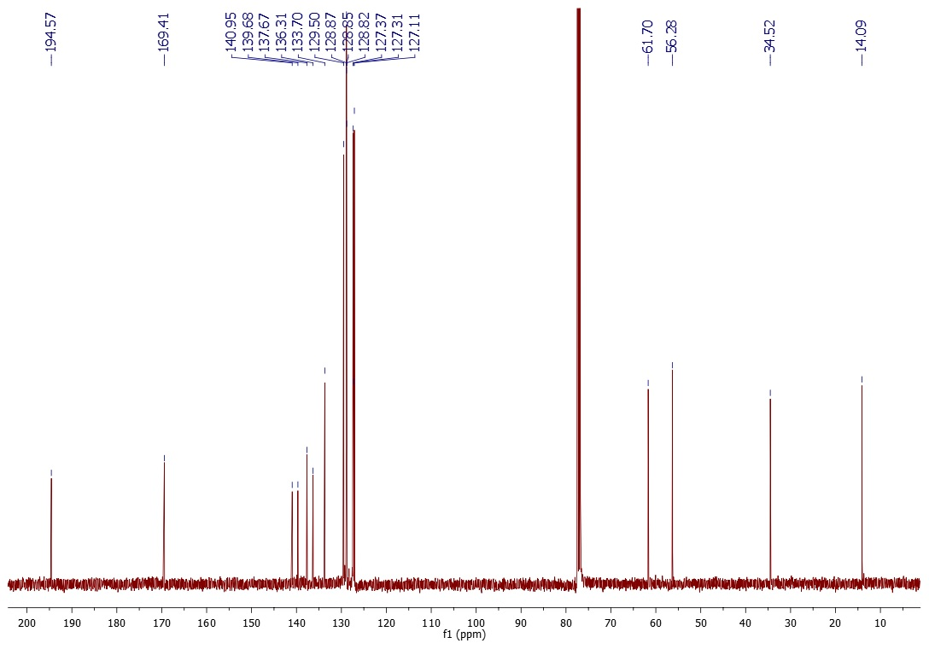
Figure S6. ¹³C NMR of ethyl 3-oxo-3-phenyl-2-[(4-phenylphenyl)methyl]propanoate

4. ethyl 3-oxo-3-phenyl-2-[(3-phenylphenyl)methyl]propanoate (2d)

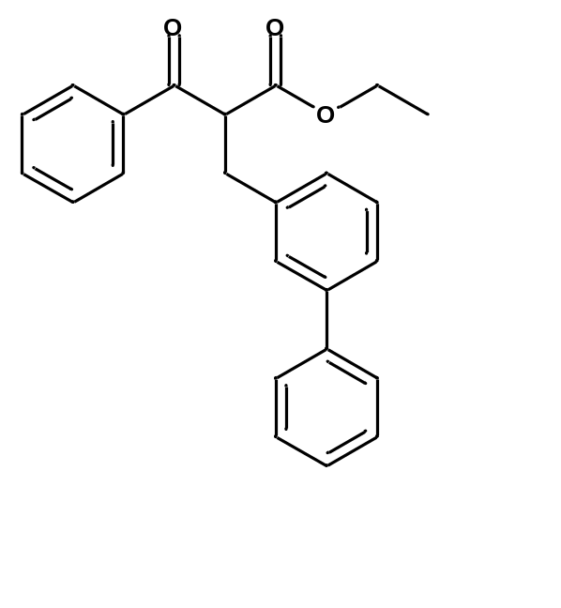Bright yellow oil, yield: 91%,
¹H NMR (CDCl₃, 400 MHz): δ= 7.99 – 7.96 (m, 2 H), 7.58 – 7.52 (m, 3 H), 7.47 – 7.41 (m, 6 H), 7.36 – 7.31 (m, 2 H), 7.23 – 7.21 (d, J = 7.6 Hz, 1 H), 4.68 (t, J = 7.3 Hz, 1 H), 4.15 – 4.07 (m, 2 H), 3.40 (dd, J² = 2.2 Hz, J³ = 7.3 Hz, 2 H), 1.11 (t, J = 7.1 Hz, 3 H)

¹³C NMR (CDCl₃, 100 MHz): δ= 194.61, 169.41, 141.59, 141.15, 139.06, 136.35, 133.68, 129.08, 128.84, 128.82, 128.01, 127.96, 127.43, 127.27, 125.65, 61.69, 56.26, 34.99, 14.08

HRMS (ESI+): m/z
[M + H]+ calcd for C₂₄H₂₃O₃: 359.1647; found: 359.1646.

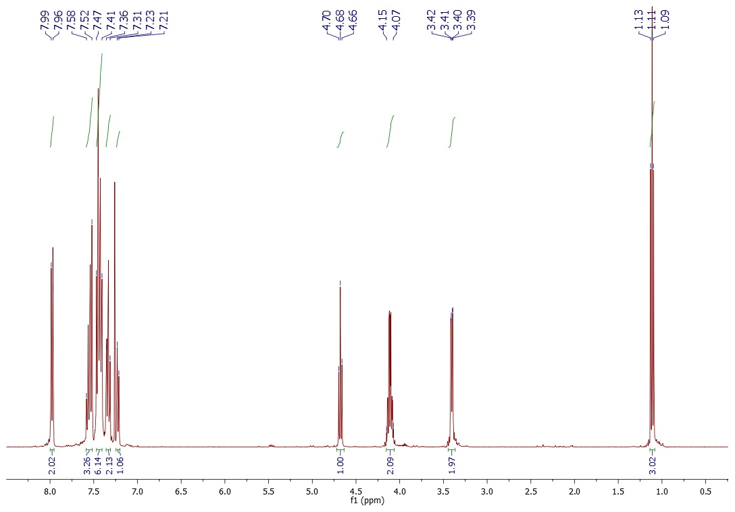
Figure S7. ¹H NMR of ethyl 3-oxo-3-phenyl-2-[(3-phenylphenyl)methyl]propanoate

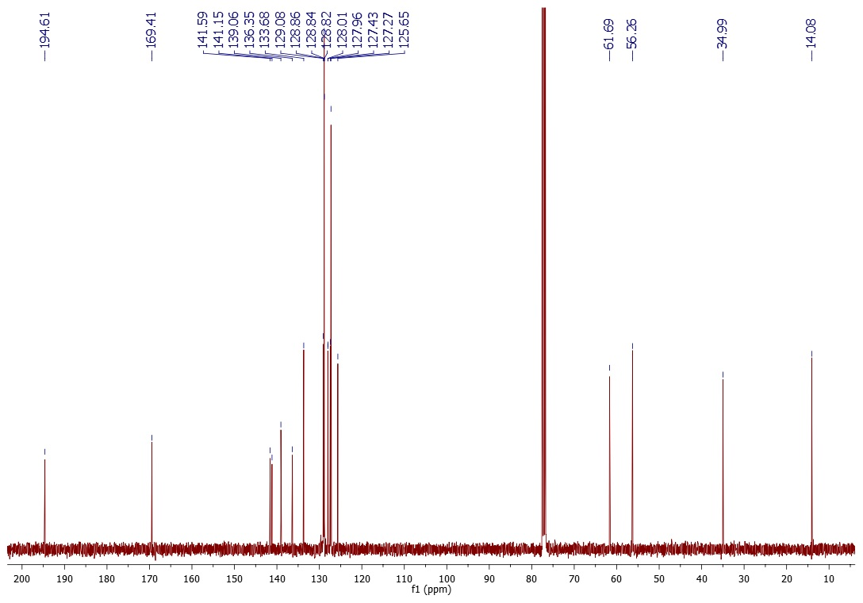
Figure S8. ¹³C NMR of ethyl 3-oxo-3-phenyl-2-[(3-phenylphenyl)methyl]propanoate
7. ethyl 3-oxo-3-phenyl-2-[[4-(trifluoromethyl)phenyl]methyl]propanoate (2e)

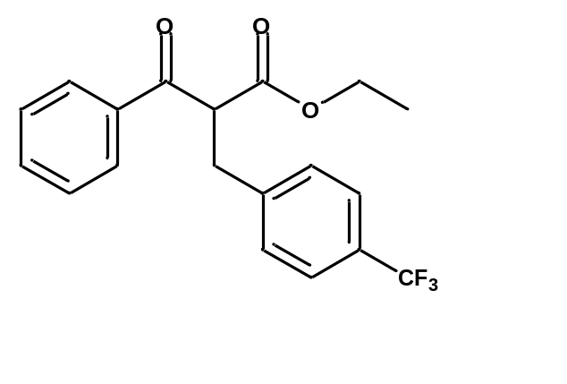Colorless oil, yield: 65%,
Mixture of tautomeres 1:9
¹H NMR (CDCl₃, 400 MHz): δ= 7.97 – 7.95 (m, 2 H), 7.60 – 7.56 (m, 1 H), 7.53 – 7. 44 (m, 4 H), 7.36 (d, J = 8.0 Hz, 2 H), 4.62 (t, J = 7.4 Hz, 1 H), 4.14 – 4.06 (m, 2 H), 3.38 (d, J =7.4 Hz, 2 H), 1.11 (t, J = 7.1 Hz, 3 H)

¹³C NMR (CDCl₃, 100 MHz): δ= 194.00, 169.06, 142.69 (q, J⁵ = 1,1Hz), 136.07, 133.88, 129.47, 129.16 (q, J² = 23.9 Hz), 128.91,128.78, 128.63, 125.57 (q, J³= 3.7 Hz), 124.27 (q, J¹ = 279, 4 Hz), 61.85, 55.84, 34.51, 14.02

HRMS (ESI+): m/z
[M + H]+ calcd for C₁₉H₁₈F₃O₃: 351.1208; found: 351.1204.

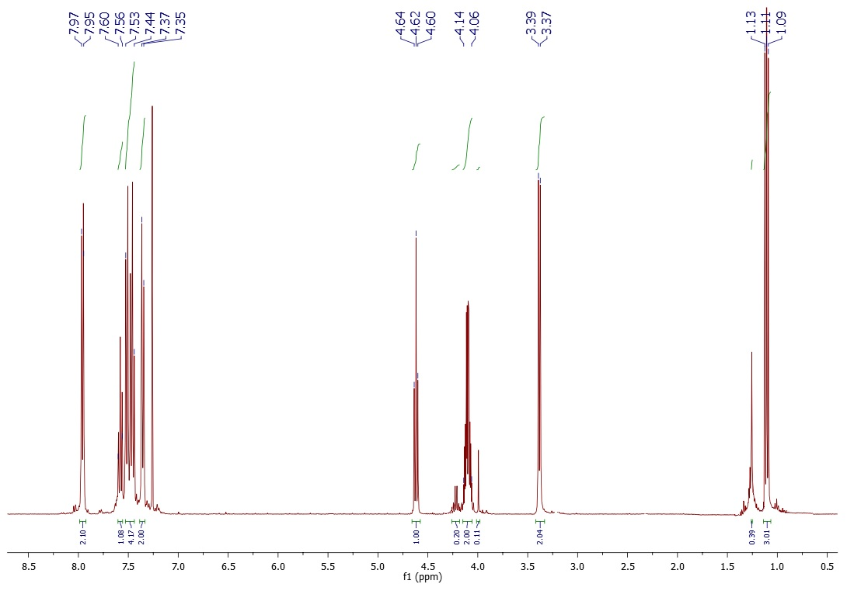
Figure S9. ¹H NMR of ethyl 3-oxo-3-phenyl-2-[[4-(trifluoromethyl)phenyl]methyl]propanoate
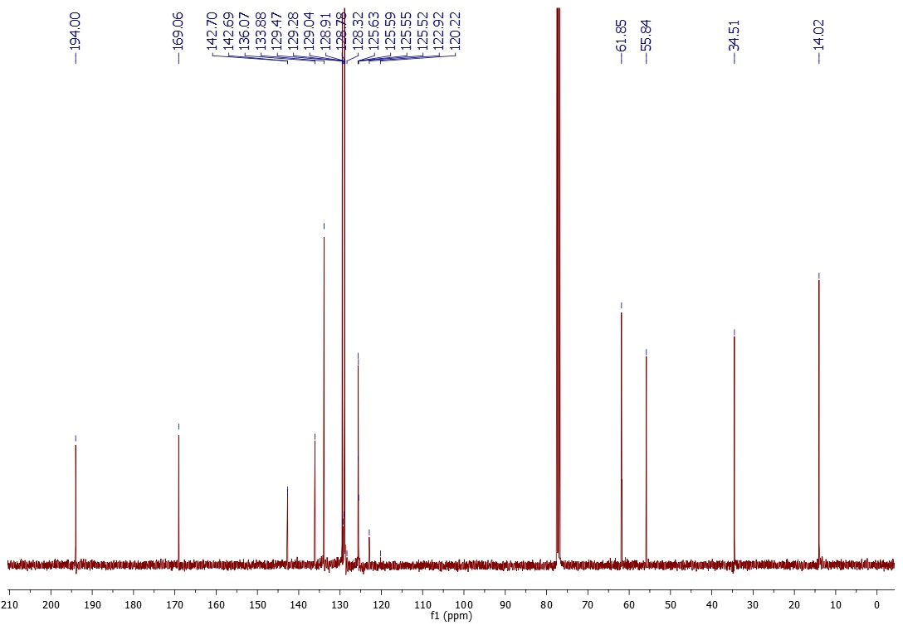Figure S10. ¹³C NMR of ethyl 3-oxo-3-phenyl-2-[[4-(trifluoromethyl)phenyl]methyl]propanoate

B. General procedure for aromatic derivatives of 3-oxo-3-phenyl-propanamide [1]
Benzyl-type derivatives of ethyl benzoylacetate 2a-e (0.63 mmol) and 50 ml of 24% amonnia water were placed in round-bottomed flask with stir bar. The reaction temperature was raised to 45ºC for 16h to 3 days depending on corresponding substrate and monitored by thin layer chromatography. After cooling to RT solvent was evaporated. Title products were purified by flash column chromatography (ethyl acetate : hexane 1:1). Yields and characteristic of title compounds are collected below.

1. 2-(1-naphthylmethyl)-3-oxo-3-phenyl-propanamide (3a)

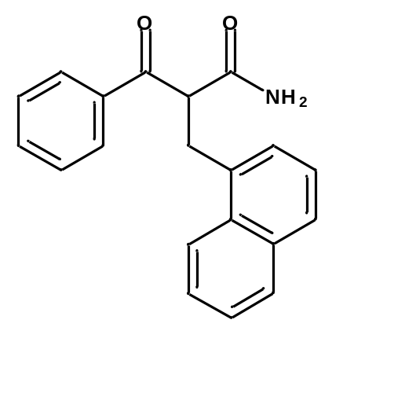White amorphous powder, yield: 33%,
¹H NMR (CDCl₃, 400 MHz): δ= 8.12 (d, J = 8.1 Hz, 1 H), 7.82 (d, J = 8.0 Hz, 1 H), 7.73 (d, J = 7.4 Hz, 1 H), 7.57 (t, J = 7.2 Hz, 1 H), 7.51 – 7.45 (m, 2 H), 7.31 – 7.24 (m, 4 H), 6.47 (s, NH), 5.62 (s, NH), 4.81 (t, J = 6.1 Hz, 1 H), 3.88 – 3.76 (m, 2 H)

¹³C NMR (CDCl₃, 100 MHz): δ= 199.01, 171.02, 136.54, 134.01, 133.97, 133.67, 131.53, 129.13, 128.76, 128.65, 128.60, 127.90, 127.51, 126.68, 125.87, 125.49, 123.35, 56.27, 35.41

HRMS (ESI+): m/z
[M + H]+ calcd for C₂₀H₁₈NO₂: 304.1338; found: 304.1338
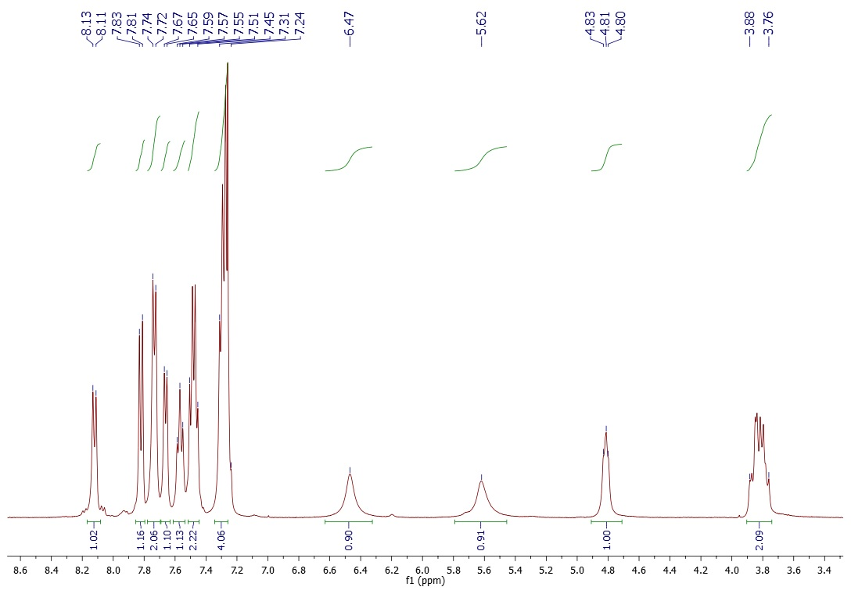
Figure S11. ¹H NMR of 2-(1-naphthylmethyl)-3-oxo-3-phenyl-propanamide
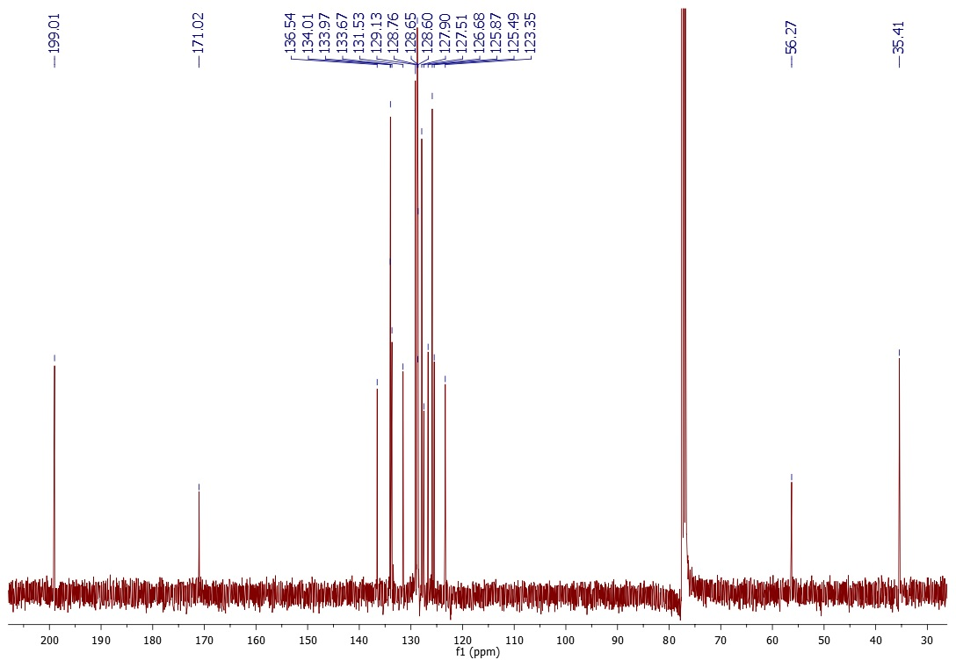
Figure S12. ¹³C NMR of 2-(1-naphthylmethyl)-3-oxo-3-phenyl-propanamide
2. 2-(2-naphthylmethyl)-3-oxo-3-phenyl-propanamide (3b)

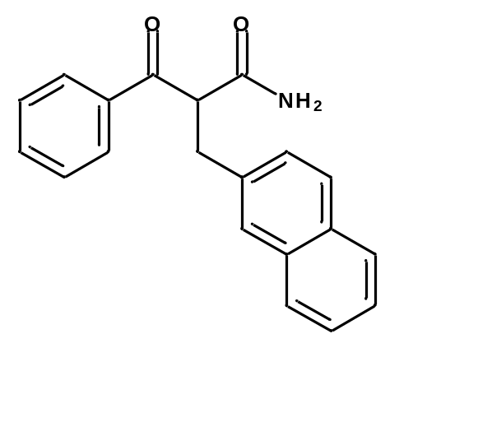White amorphous powder, yield: 31%,
¹H NMR (CDCl₃, 400 MHz): δ= 7.93 – 7.91 (m, 1 H), 7.77 – 7.71 (m, 3 H), 7.66 – 7.62 (m, 1 H), 7.46 – 7.38 (m, 6 H), 6.40 (s, NH), 5.74 (s, NH), 4.73 (t, J = 7.3 Hz, 1 H), 3.57 (dd, J² = 13.7 Hz, J³ = 7.3 Hz, 1 H), 3.46 (dd, J² = 13.7 Hz, J³ = 7.3 Hz, 1 H)

¹³C NMR (CDCl₃, 100 MHz): δ= 198.61, 171.00, 136.47, 135.27, 134.13, 133.62, 132.48, 130.24, 128.96, 128.78, 128.48, 127.77, 127.73, 127.11, 126.25, 125.83, 57.57, 38.16

HRMS (ESI+): m/z
[M + H]+ calcd for C₂₀H₁₈NO₂: 304.1338; found: 304.1335

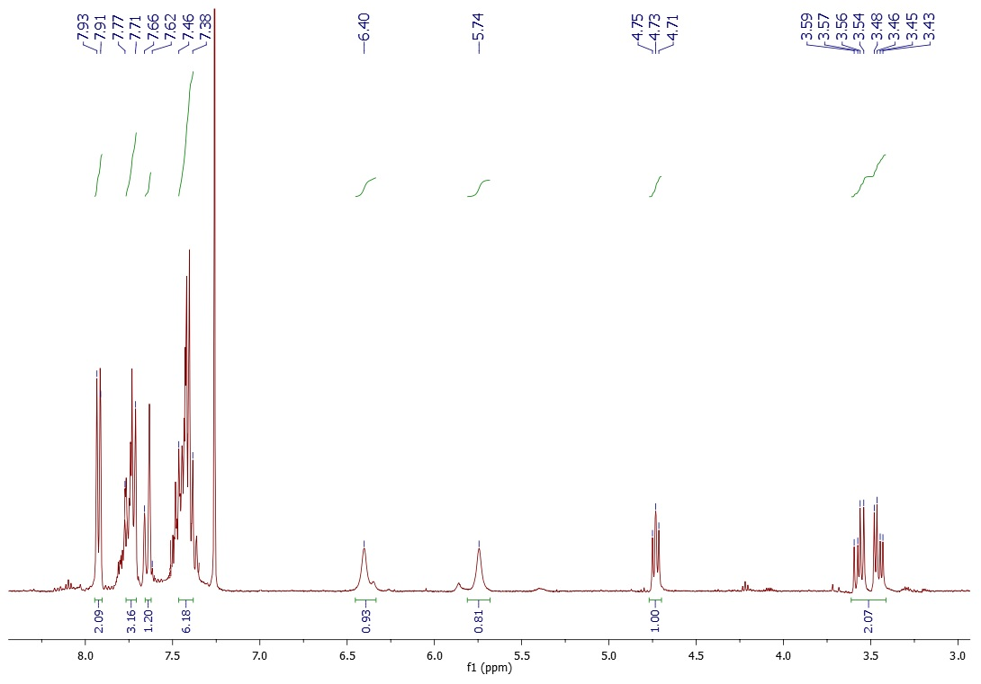

Figure S13. ¹H NMR of 2-(2-naphthylmethyl)-3-oxo-3-phenyl-propanamide
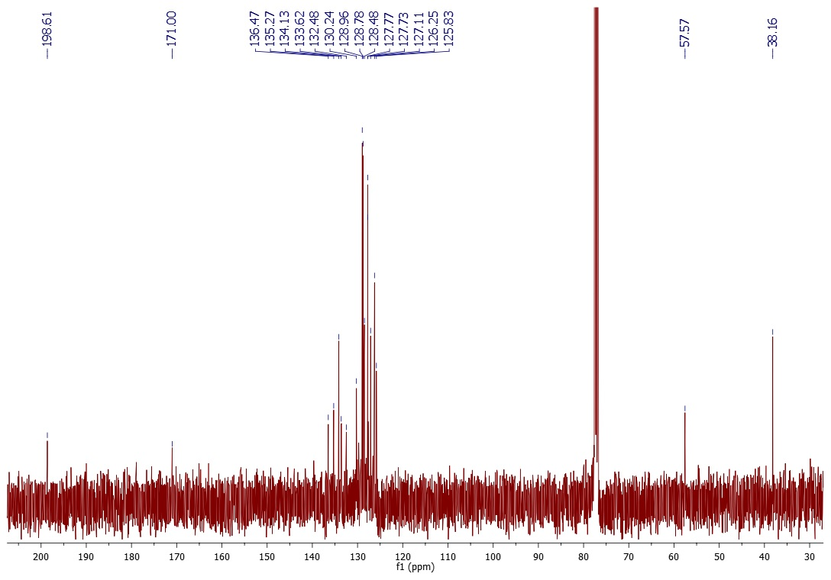Figure S14. ¹³C NMR of 2-(2-naphthylmethyl)-3-oxo-3-phenyl-propanamide

3. 3-oxo-3-phenyl-2-[(4-phenylphenyl)methyl]propanamide (3c)

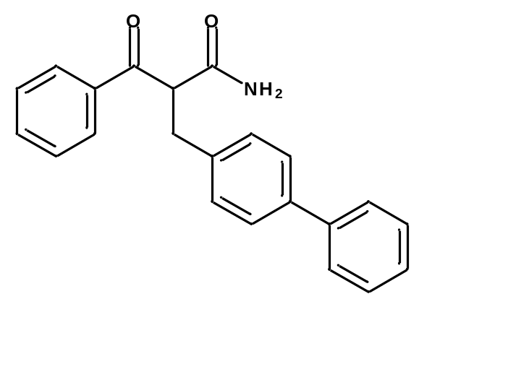White amorphous powder, yield: 51%,
¹H NMR (DMSO, 500 MHz): δ = 8.05 – 8.03 (m, 2 H), 7.74 (s, NH), 7.65 – 7.62 (m, 3 H), 7.57 – 7.56 (m, 2 H), 7.54 – 7.51 (m, 2 H), 7.46 – 7.42 (m, 3 H), 7.37 – 7.35 (m, 2 H), 7.14 (s, NH), 4.74 (t, J = 7.2 Hz, 1 H), 3.23 (dd, J² = 13.9 Hz, J³ = 6.9 Hz, 1 H ), 3.12 (dd, J² = 13.9 Hz, J³ = 6.9Hz, 1 H)

¹³C NMR (DMSO, 125 MHz): δ= 194.96, 169.87, 139.97, 138.67, 138.01, 136.12, 133.35, 129.52, 128.88, 128.70, 128.31, 128.18, 126.48, 126.42, 56.11, 34.00

HRMS (ESI+): m/z
[M + H]+ calcd for C₂₂H₂₀NO_{2:} 330.1494; found: 330.1475
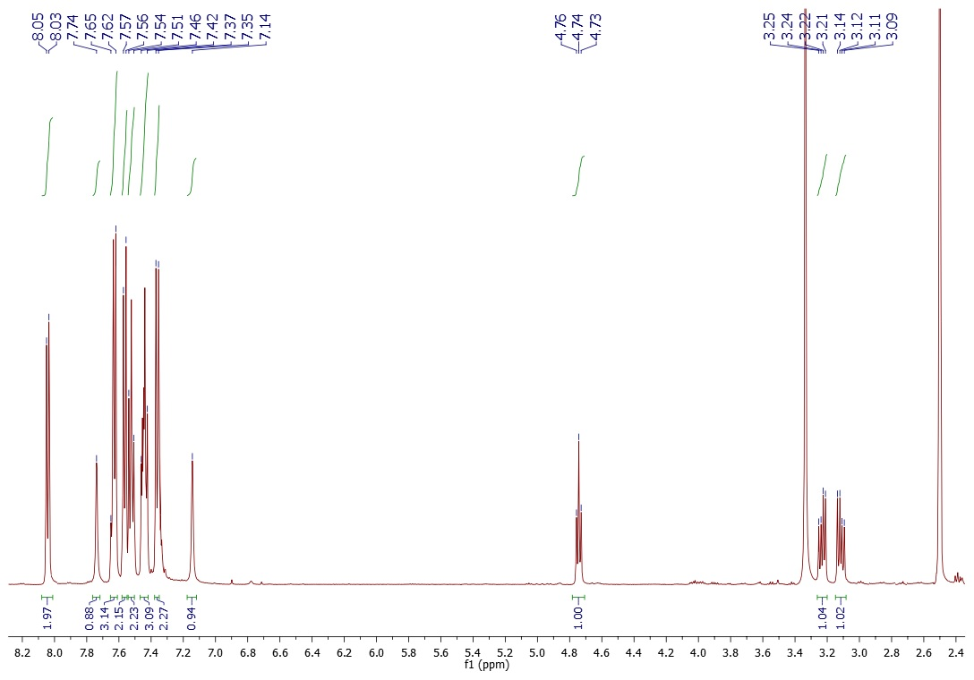
Figure S15. ¹H NMR of 3-oxo-3-phenyl-2-[(4-phenylphenyl)methyl]propanamide
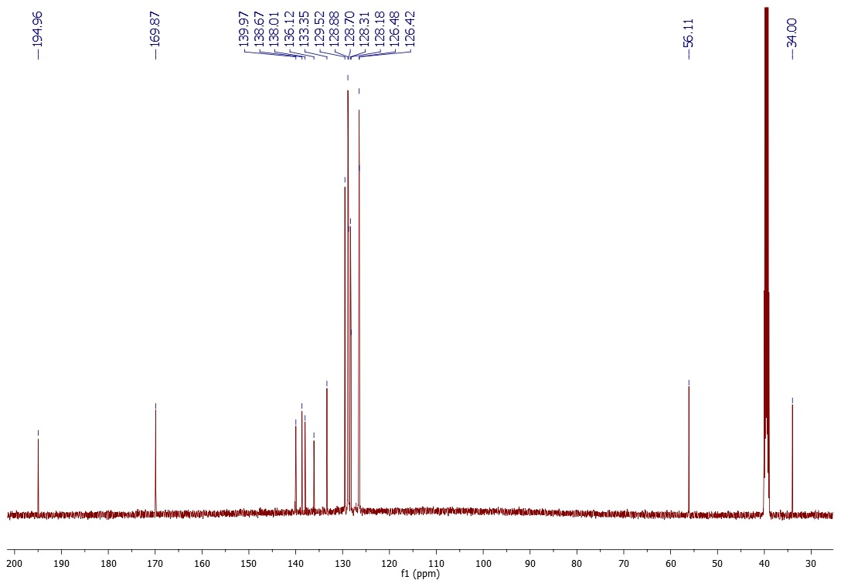
Figure S16. ¹³C NMR of 3-oxo-3-phenyl-2-[(4-phenylphenyl)methyl]propanamide
4. 3-oxo-3-phenyl-2-[(3-phenylphenyl)methyl]propanamide (3d)

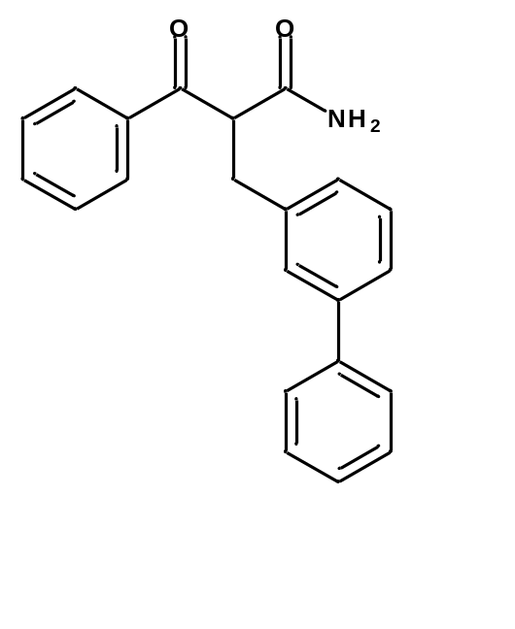White amorphous powder, yield: 50%,
¹H NMR (CDCl₃, 400 MHz): δ= 7.93 – 7.91 (m, 2 H), 7.59 – 7.53 (m, 2 H), 7.49 – 7.46 (m, 2 H), 7.43 – 7.38 (m, 5 H), 7.34 – 7.27 (m, 2 H), 7.17 – 7.15 (d, J = 7.6, 1 H), 6.59 (s, NH), 6.11 (s, NH), 4.69 (dd, J³_{a} = 6.4 Hz, J³_{b}= 8.3 Hz, 1 H), 3.45 (dd, J² = 13.7 Hz, J³ = 8.3 Hz, 1 H), 3.37 (dd, J² = 13.7 Hz, J³ = 6.4 Hz, 1 H)

¹³C NMR (CDCl₃, 100 MHz): δ= 198.58, 171.45, 141.62, 140.95, 138.18, 136.46, 134.12, 129.15, 128.94, 128.84, 128.78, 127.87, 127.86, 127.46, 127.22, 125.89, 57.30, 38.18

HRMS (ESI+): m/z
[M + H]+ calcd for C₂₂H₂₀NO₂: 330.1494; found: 330.1492
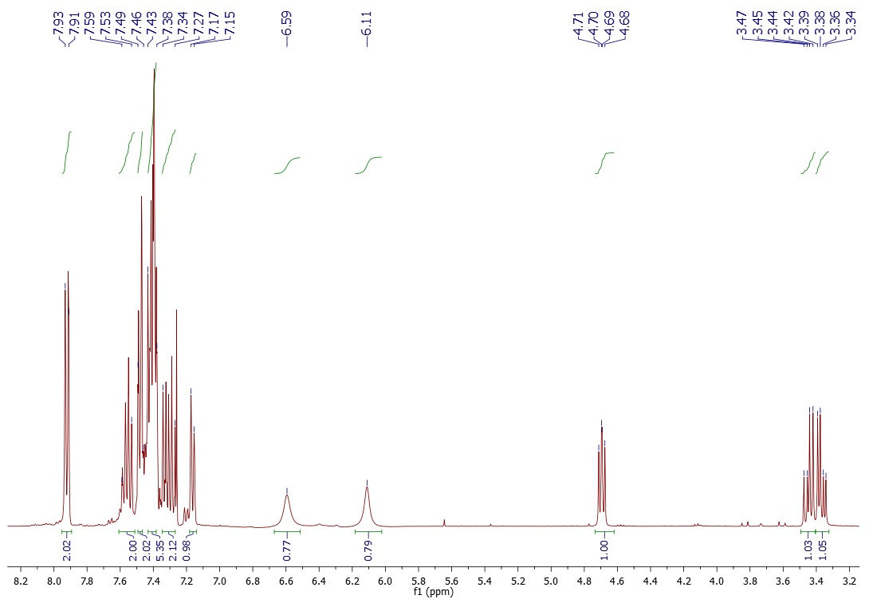
Figure S17. ¹H NMR of ethyl 3-oxo-3-phenyl-2-[(3-phenylphenyl)methyl]propanamide
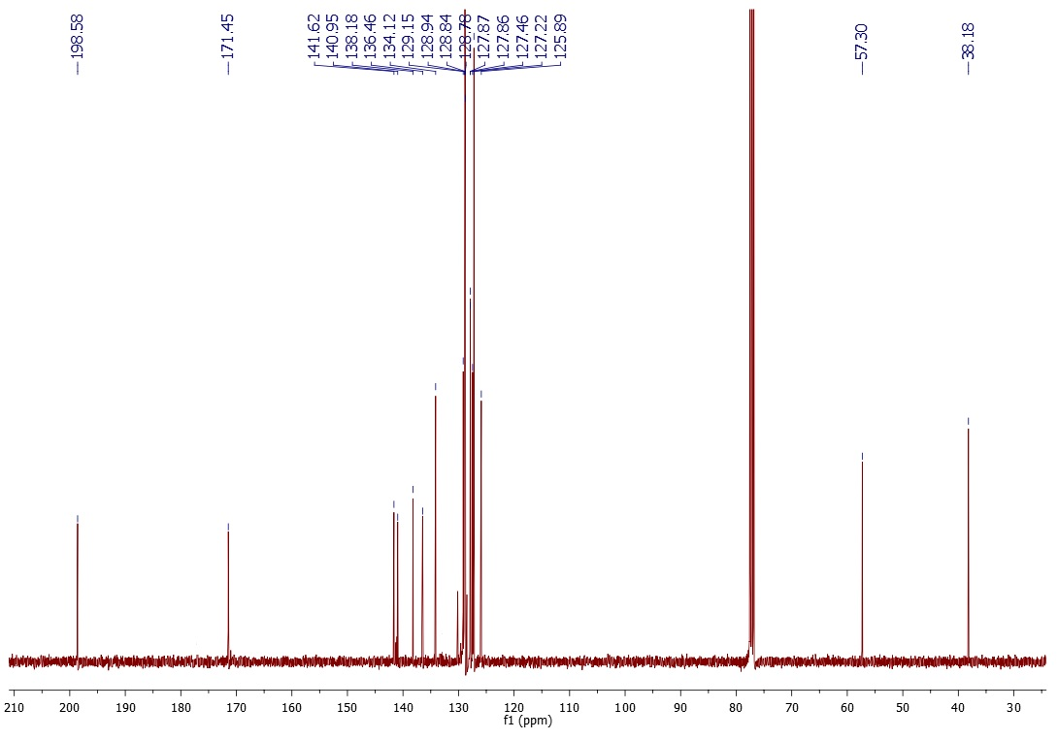
Figure S18. ¹³C NMR of ethyl 3-oxo-3-phenyl-2-[(3-phenylphenyl)methyl]propanamide

5. 3-oxo-3-phenyl-2-[[4-(trifluoromethyl)phenyl]methyl]propanamide (3e)

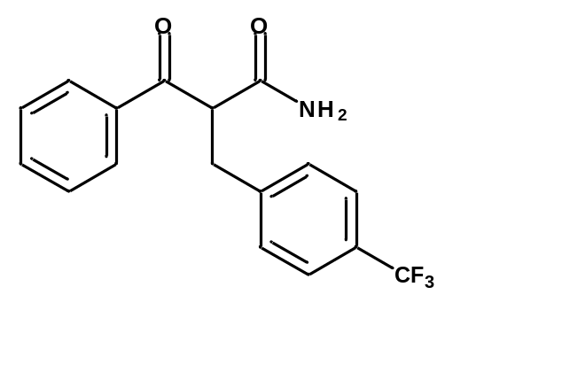White amorphous powder, yield: 80%,
¹H NMR (CDCl₃, 400 MHz): δ= 7.93 – 7.90 (m, 1 H), 7.61 – 7.54 (m, 2 H), 7.50-7.43 (m, 3 H), 7.34 – 7.29 (m, 3 H), 6.36 (s, NH), 5.78 (s, NH), 4.62 (dd, J³_{a} = 8.2 Hz, J³_{b} = 6.6 Hz, 1 H), 3.44 (dd, J² = 13.7 Hz, J³ = 8.2 Hz, 1 H), 3.44 (dd, J² = 13.7 Hz, J³ = 6.6 Hz, 1 H),

¹³C NMR (CDCl₃, 100 MHz): δ= 198.17, 176.25, 144.40, 136.21, 134.41, 129.40, 129.10, 129.00 (q, J² = 24.8 Hz), 128.80, 125.67 (q, J³ = 3.3 Hz), 57.18, 30.51

HRMS (ESI+): m/z
[M + H]+ calcd for C₁₇H₁₅F₃NO₂: 322.1055; found: 322.1061

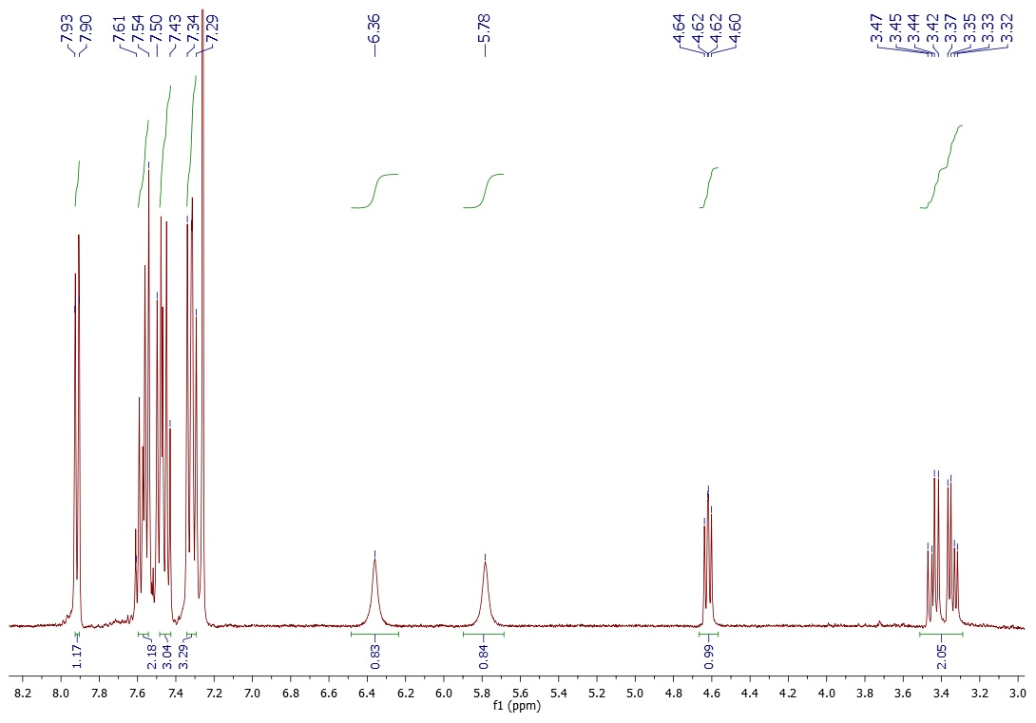
Figure S19. ¹H NMR of 3-oxo-3-phenyl-2-[[4-(trifluoromethyl)phenyl]methyl]propanamide
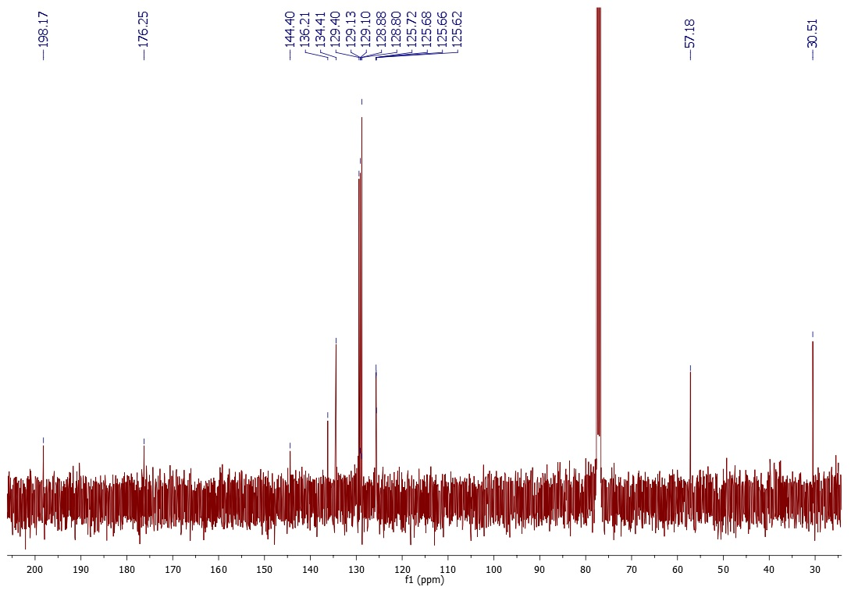
Figure S20. ¹³C NMR of 3-oxo-3-phenyl-2-[[4-(trifluoromethyl)phenyl]methyl]propanamide
C. General procedure for benzyl-type derivatives of 4-phenyl-5,6,7,8-tetrahydro-1H-quinolin-2-one [1]
A mixture of 3-oxo-3-phenyl-propanamide derivatives 3a-e (0.19 mmol), cyklohexanone (0.28 mmol), TsOH (0.38 mmol), and 2.5 ml of toluene was added to round-bottomed flask fitted with Soxhlet apparatus with MgSO₄ and stir bar. Reaction mixture was heated to reflux and left overnight. The solvent was evaporated. Residue was dissolved in AcOEt and washed with water, 2M NaOH and brine. Organic layer was dried with anhydrous MgSO_{4.} The titled products were isolated by flash column chromatography (dichloromethane/methanol 200:1). Yields and characteristics of title compounds are collected below.

1. 3-(1-naphthylmethyl)-4-phenyl-5,6,7,8-tetrahydro-1H-quinolin-2-one (4a)

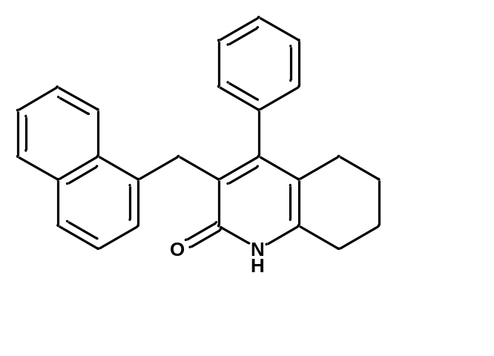White amorphous powder, yield: 75%
Mixture of tautomers 9:1
¹H NMR (CDCl₃, 400 MHz): δ= 7.86 (d, J = 8.2 Hz, 1 H), 7.79 – 7.76 (m, 1 H), 7.62 (d, J = 8.12 Hz, 1 H), 7.42 – 7.35 (m, 2 H), 7.23 – 7.09 (m, 4 H + 0.8 NH), 6.92 – 6.87 (m, 3 H), 5.30 (s, 0.2 OH), 4.13 (s, 1.8 H), 3.93 (s, 0.2 H), 2.84 (t, J = 6.5 Hz, 0.2 H), 2.67 (t, J = 5.9 Hz, 1.74 H), 2.21 (t, J = 6.5 Hz, 0.26 H), 2.05 (t, J = 5.9 Hz, 1.8 H), 1.75 – 1.69 (m, 2 H), 1.64 – 1.59 (m, 2 H)

¹³C NMR (CDCl₃, 100 MHz): δ= 162..17, 157.23, 136.04, 133.69, 132.02, 128.63, 128.56, 127.95, 127.27, 126.51, 125.71, 125.43, 125.39, 124.91, 123.80, 117.68, 29.62, 27.32, 26.03, 22.63, 21.47

HRMS (ESI+): m/z
[M + H]+ calcd for C₂₆H₂₄NO: 366.1857; found: 366.1862.
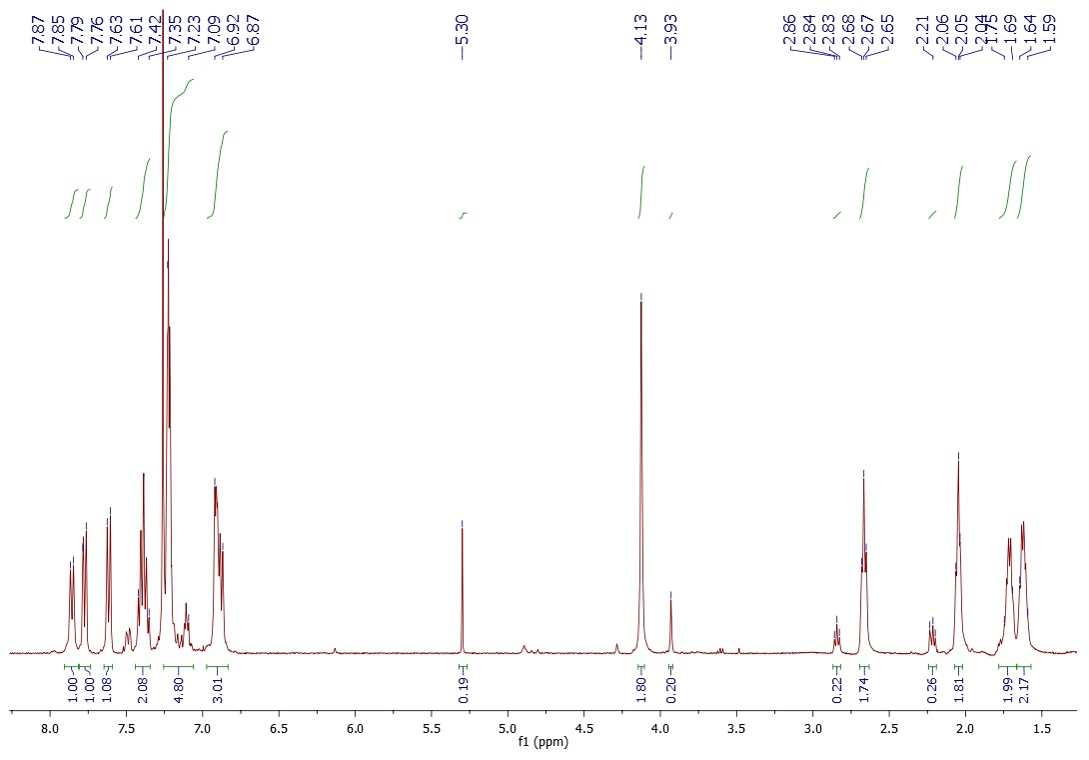
Figure S21. ¹H NMR of 3-(1-naphthylmethyl)-4-phenyl-5,6,7,8-tetrahydro-1H-quinolin-2-one
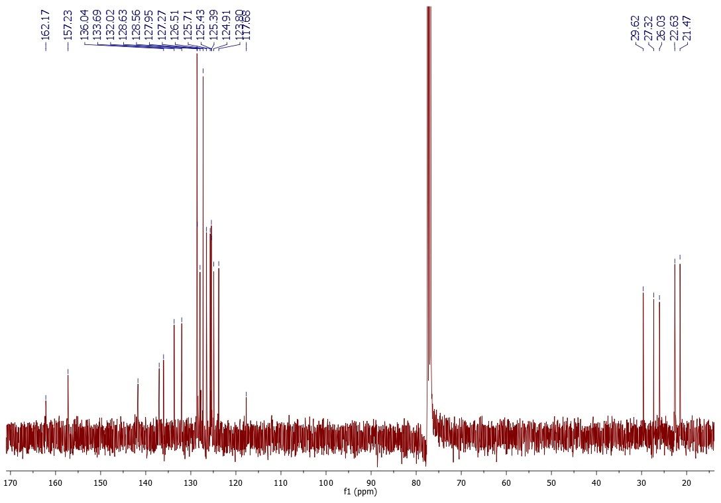
Figure S22. ¹³C NMR of of 3-(1-naphthylmethyl)-4-phenyl-5,6,7,8-tetrahydro-1H-quinolin-2-one

2. 3-(2-naphthylmethyl)-4-phenyl-5,6,7,8-tetrahydro-1H-quinolin-2-one (4b)

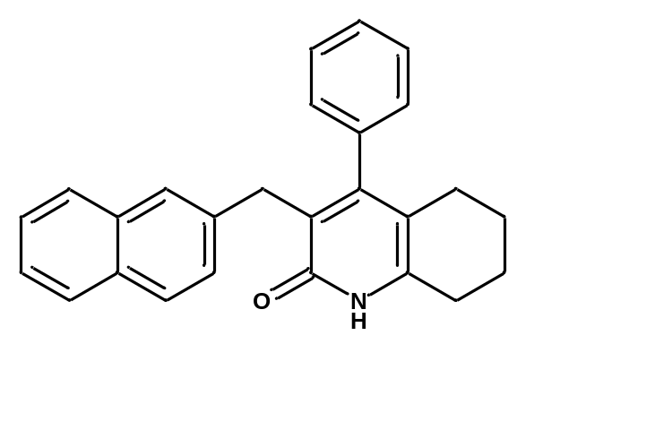Bright yellow amorphous powder, yield: 85%
Mixture of tautomers 4:1
¹H NMR (CDCl₃, 400 MHz): δ= 7.83 – 7.66 (m, 3 H), 7.66 – 7.60 (m, 1.6 H), 7.47 – 7.42 (m, 1.64 H), 7.39 – 7.34 (m, 4.36 H), 7.22 (s, 0.9 NH), 6.97 – 6.95 (m, 1.4 H), 5.29 (s, 0.1 OH), 3.86 (s, 1.78 H), 3.73 (s, 0.22 H), 3.14 (t, J = 7.7 Hz, 0.44 H), 2.73 (t, J = 6.1 Hz, 1.56 H), 2.62 (t, J = 7.7 Hz, 0.43 H), 2.05 (t, J = 6.1 Hz, 1.57), 1.71 – 1.65 (m, 2 H), 1.62 – 1.57 (m, 2 H)

¹³C NMR (CDCl₃, 100 MHz): δ= 161.93, 157.19, 133.46, 132.09, 128.74, 128.20, 127.77, 127.68, 127.66, 127.58, 127.47, 127.44, 126.80, 125.79, 125.22, 118.62, 29.49, 27.29, 26.01, 22.50, 21.33

HRMS (ESI+): m/z
[M + H]+ calcd for C₂₆H₂₄NO: 366.1857; found: 366.1856
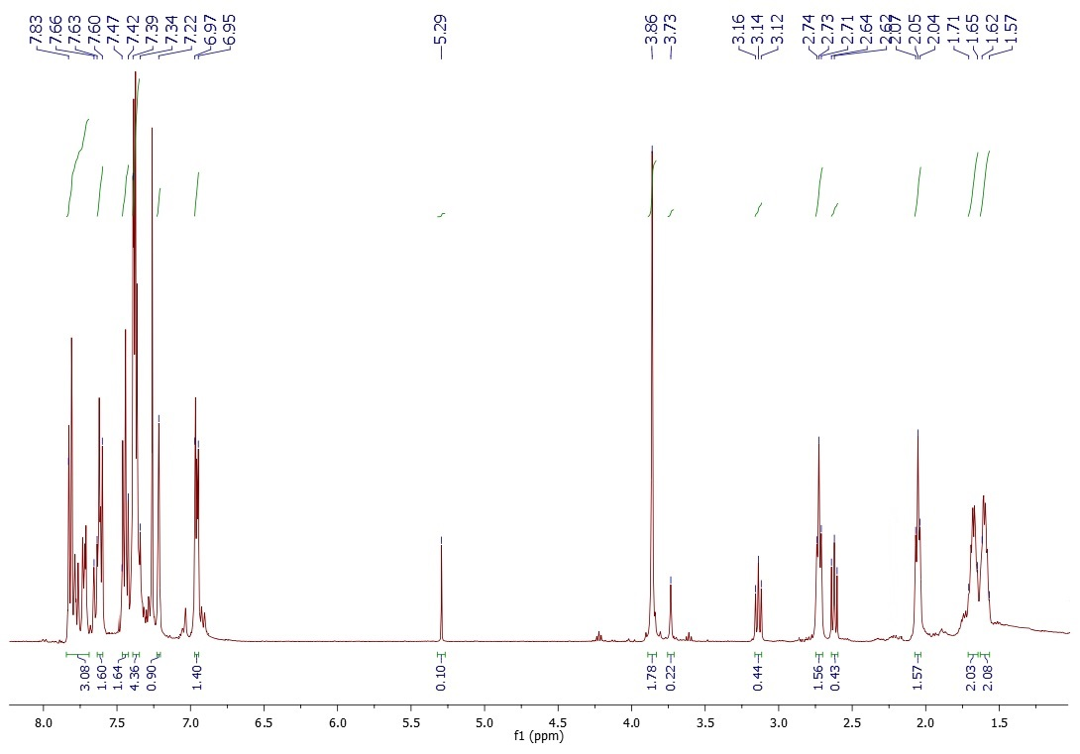
Figure S23. ¹H NMR of 3-(2-naphthylmethyl)-4-phenyl-5,6,7,8-tetrahydro-1H-quinolin-2-one
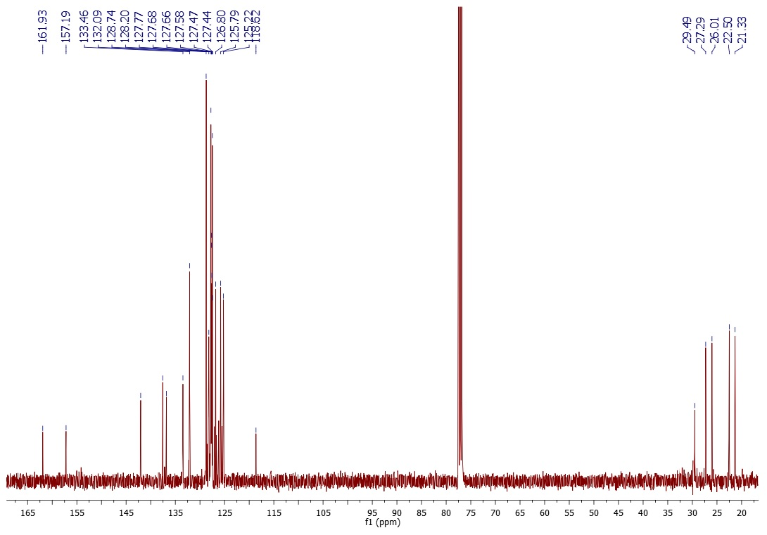
Figure S24. ¹³C NMR of 3-(2-naphthylmethyl)-4-phenyl-5,6,7,8-tetrahydro-1H-quinolin-2-one
3. 4-phenyl-3-[(4-phenylphenyl)methyl]-5,6,7,8-tetrahydro-1H-quinolin-2-one (4c)

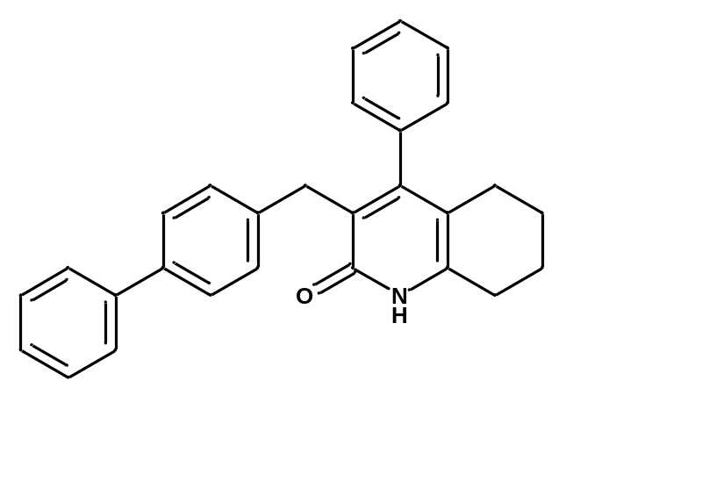White amorphous powder, yield: 33%
Mixture of rotamers 9:1
¹H NMR (CDCl₃, 400 MHz): δ= 7.83 – 7.81 (m, 1 H), 7.54 – 7.51 (m, 3 H), 7.49 – 7.46 (m, 4 H), 7.43 – 7.36 (m, 5 H), 7.34 – 7.32 (m, 1 H), 7.01 – 6.99 (m, 1 H), 3.82 (s, 0.26 H), 3.79 (s, 1.74 H), 3.00 (t, J = 7.7 Hz, 0.23 H), 2.97 (t, J = 6.2 Hz, 1.75 H), 2.59 (t, J = 7.7 Hz, 0.25 H), 2.22 (t, J = 6..2 Hz, 1.77 H), 1.89 – 1.83 (m, 2 H), 1.74 – 1.68 (m, 2 H)

¹³C NMR (CDCl₃, 100 MHz): δ= 160.71, 159.14, 140.83, 139.60, 137.18, 135.17, 132.24, 129.21, 129.01, 128.88, 128.79, 127.51, 127.38, 127.18, 127.10, 115.45, 31.61, 27.67, 26.24, 22.07, 21.00

HRMS (ESI+): m/z
[M + H]+ calcd for C₂₈H₂₆NO: 392.2014; found: 392.2018

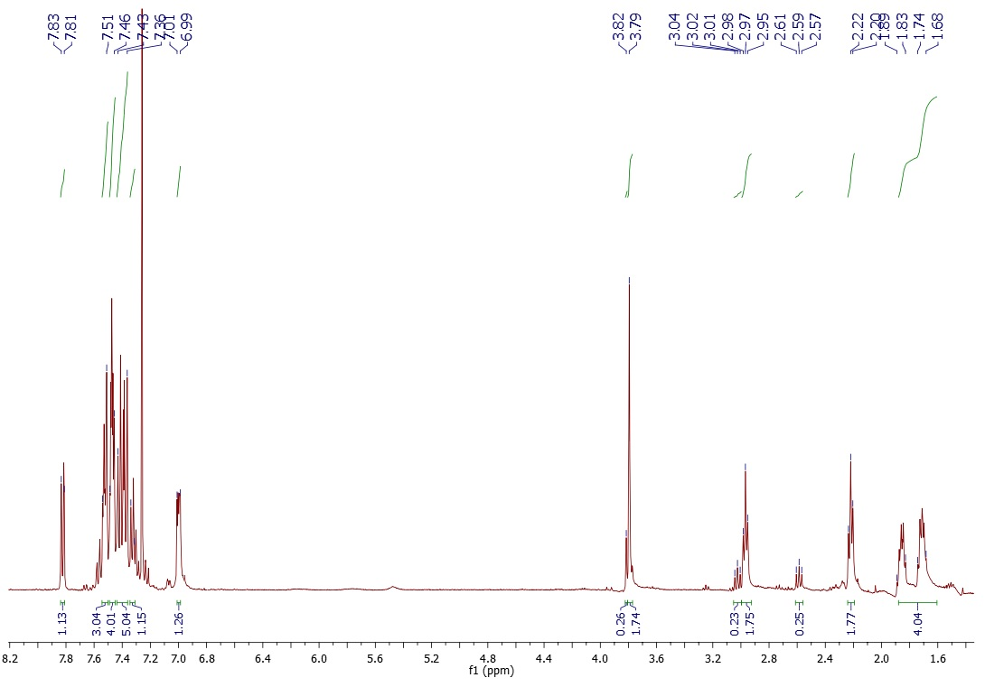
Figure S25. ¹H NMR of 4-phenyl-3-[(4-phenylphenyl)methyl]-5,6,7,8-tetrahydro-1H-quinolin-2-one
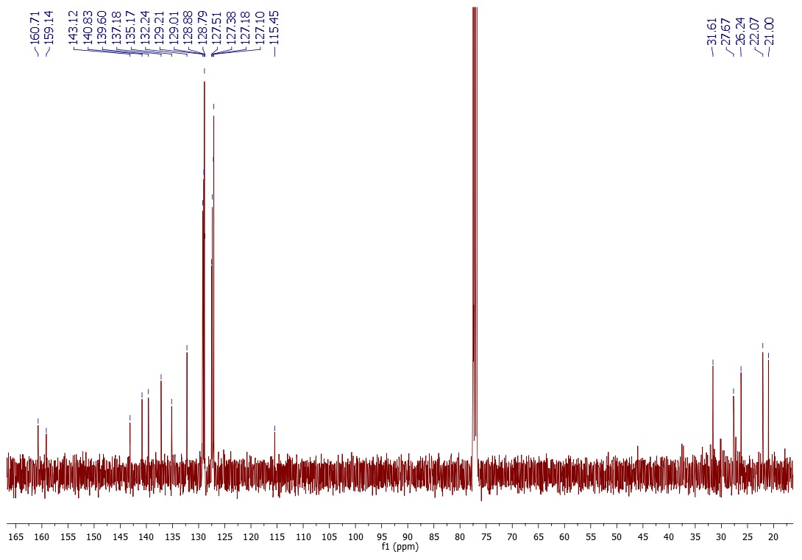
Figure S26. ¹³C NMR of 4-phenyl-3-[(4-phenylphenyl)methyl]-5,6,7,8-tetrahydro-1H-quinolin-2-one

4. 4-phenyl-3-[(3-phenylphenyl)methyl]-5,6,7,8-tetrahydro-1H-quinolin-2-one (4d)

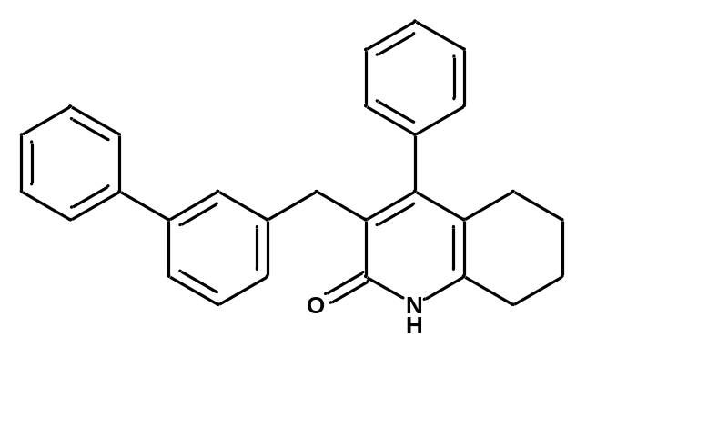White powder, yield: 40%
Mixture of rotamers 9:1
¹H NMR (CDCl₃, 400 MHz): δ= 7.484 – 7.81 (m, 0.26 H), 7.51 – 7.47 (m, 2 H), 7.45 – 7.33 (m, 5 H + 0.95 NH), 7.32 – 7.28 (m, 2 H), 7.22 – 7.16 (m, 2 H), 7.02 – 6.99 (m, 2.74 H), 5.29 (s, 0.05 OH), 3.77 (s, 1.89 H), 3.71 (s, 0.11 H), 3.05 (t, J = 7.8 Hz, 0.14 H), 2.69 (t, J = 6.1 Hz, 1.8 H), 2.59 (t, J = 7.8 Hz, 0.2 H), 2.03 (t, J = 6.1 Hz, 1.76 H), 1.71 – 1.66 (m, 2 H), 1.62 – 1.58 (m, 2 H)

¹³C NMR (CDCl₃, 100 MHz): δ= 162.57, 156.21, 141.71, 141.41, 140.94, 140.82, 137.26, 128.73, 128.70, 127.91, 127.18, 127.15, 117.26, 32.86, 27.19, 26.01, 22.63, 21.48

HRMS (ESI+): m/z
[M + H]+ calcd for C₂₈H₂₆NO: 392.2014; found: 392.2030.
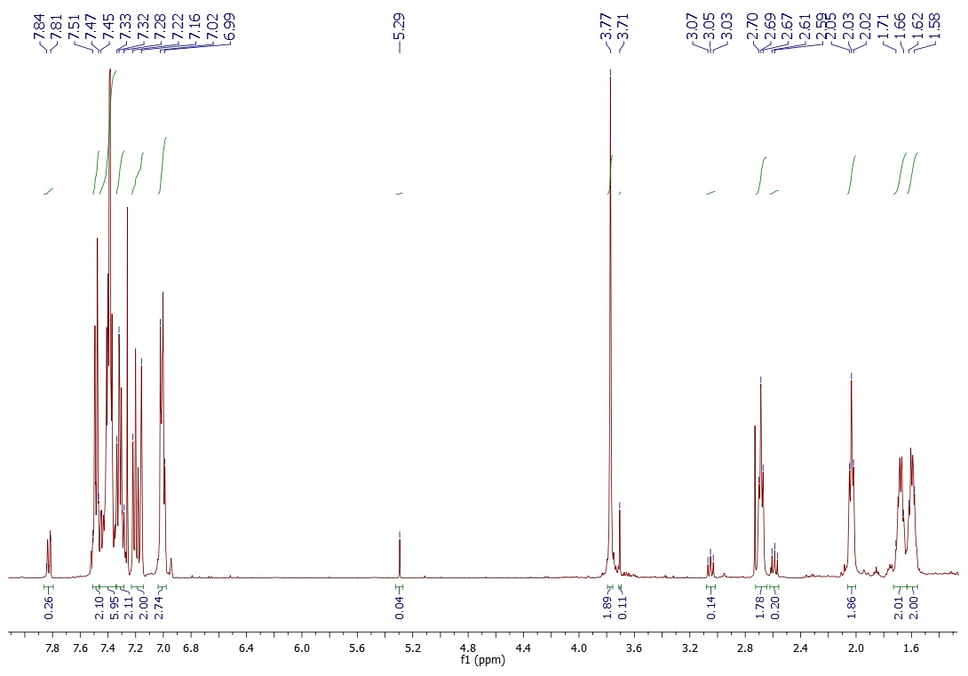
Figure S27. ¹H NMR of 4-phenyl-3-[(3-phenylphenyl)methyl]-5,6,7,8-tetrahydro-1H-quinolin-2-one

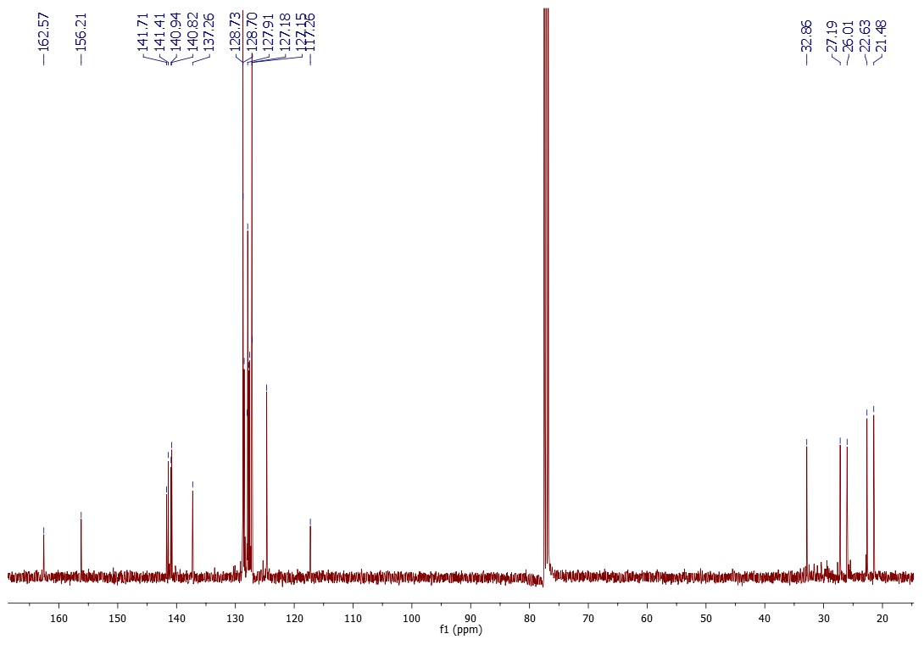
Figure S28. ¹³C NMR of 4-phenyl-3-[(3-phenylphenyl)methyl]-5,6,7,8-tetrahydro-1H-quinolin-2-one
5. 4-phenyl-3-[[4-(trifluoromethyl)phenyl]methyl]-5,6,7,8-tetrahydro-1H-quinolin-2-one (4e)

White powder, yield: 39%,
Mixture of rotamers 9:1
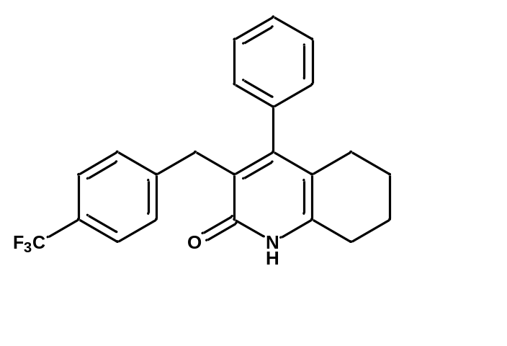¹H NMR (CDCl₃, 400 MHz): δ= 7.83 – 7.81 (m, 0.5 H), 7.47 – 7.34 (m, 6 H), 7.06 – 7.04 (d, J = 8 Hz, 2 H), 6.98 – 6.95 (m, 1.5 H), 3.74 (s, 2 H), 3.03 (t, J = 7.6 Hz, 0.18 H), 2.72 (t, J = 6.2 Hz, 1.8 H), 2.55 (t, J = 7.6 Hz, 0.2 H), 2.06 (t, J = 6.2 Hz, 1.82 H), 1.77 – 1.71 (m, 2 H), 1.65 – 1.60 (m, 2 H)

¹³C NMR (CDCl₃, 100 MHz): δ= 162.18, 156.84, 144.42 (q, J⁵ = 1.3 Hz), 142.26, 136.87, 132.12, 128.93, 128.87, 128.75, 128.26 (q, J² = 25.7 Hz), 127.66, 124.99 (q, J³ = 3.7 Hz), 124.44 (q, J¹ = 270 Hz), 117.90, 32.71, 27.27, 25.99, 22.55, 21.39

HRMS (ESI+): m/z
[M + H]+ calcd for C₂₃H₂₁F₃NO: 384.1575; found: 384.1603.
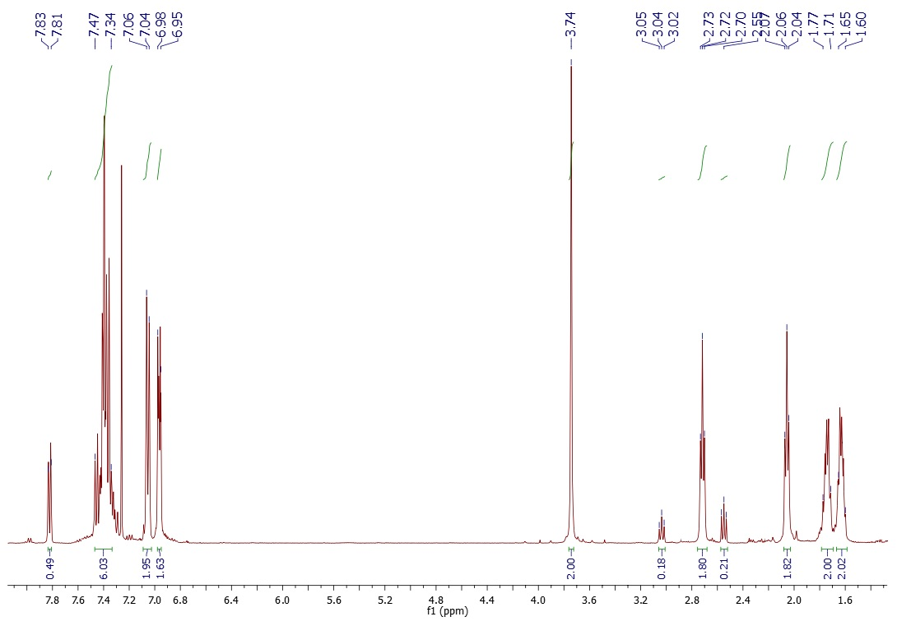
Figure S29. ¹H NMR of 4-phenyl-3-[[4-(trifluoromethyl)phenyl]methyl]-5,6,7,8-tetrahydro-1H-quinolin-2-one

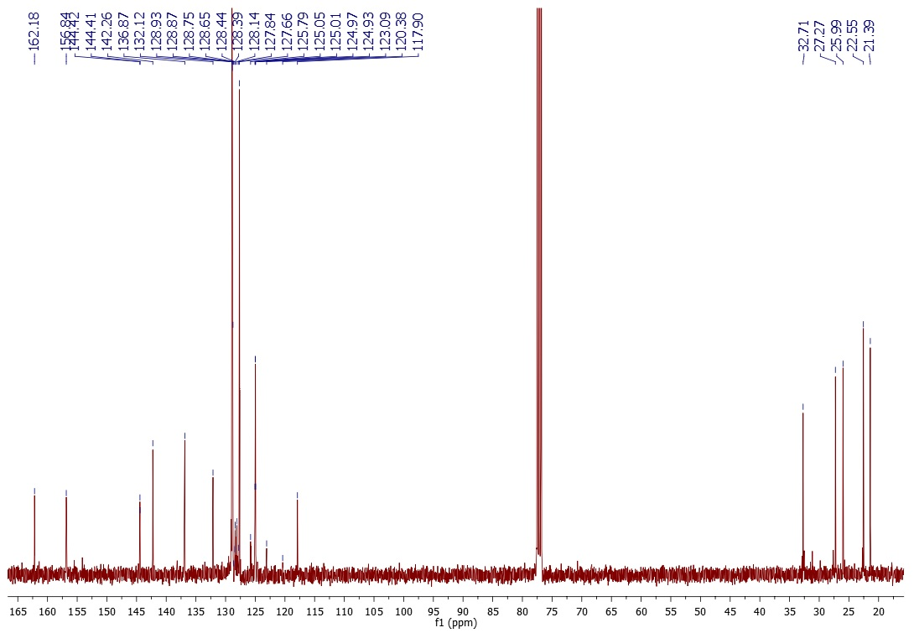
Figure S30. ¹³C NMR of 4-phenyl-3-[[4-(trifluoromethyl)phenyl]methyl]-5,6,7,8-tetrahydro-1H-quinolin-2-one

6. 2-chloro-3-(1-naphthylmethyl)-4-phenyl-5,6,7,8-tetrahydroquinoline (5) [2]
4a (0.13 g, 0.36 mmol) and 2 ml of PhPOCl₂ were placed round-bottomed flask with stir bar. The reaction temperature was raised to 160^{O}C and left overnight. Post-reaction mixture was gently diluted with water and washed with DCM. Organic layer was dried with anhydrous MgSO₄. After solvent evaporation the crude product was isolated by flash column chromatography (ethyl acetate : hexane 1:25). The title compound (0.074 g, 0.19 mmol, 53%) was obtained as bright yellow powder

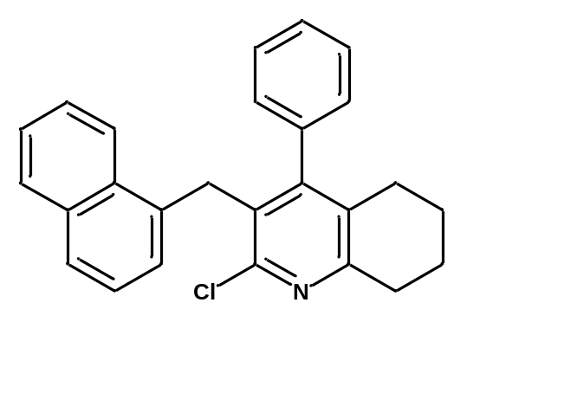Bright yellow amorphous powder, yield: 53%
¹H NMR (CDCl₃, 400 MHz): δ= 7.83 – 7.81 (m, 2 H), 7.68 (d, J = 8.24 Hz, 1 H), 7.47 – 7.40 (m, 2 H), 7.31 (t, J = 7.68 Hz, 1 H), 7.22 – 7.18 (m, 3 H), 6.97 – 6.93 (m, 2 H), 6.81 (d, J = 7.12 Hz, 1 H), 4.25 (s, 2 H), 3.04 (t, J = 6.46, 2 H), 2.31 (t, J = 6.36 Hz, 2 H), 1.92 – 1.86 (m, 2 H), 1.75 – 1.69 (m, 2 H)

¹³C NMR (CDCl₃, 100 MHz): δ= 156.49, 149.49, 137.32, 135.13, 133.64, 131.82, 130.47, 129.31 128.77, 128.69, 127.94, 127.55, 126.81, 125.96, 125.62, 125.49, 124.60, 123.12, 33.12, 29.85, 27.77, 22.77, 22.65

HRMS (ESI+): m/z
[M + H]+ calcd for C₂₆H₂₃ClN: 384.1519; found: 384.1555.

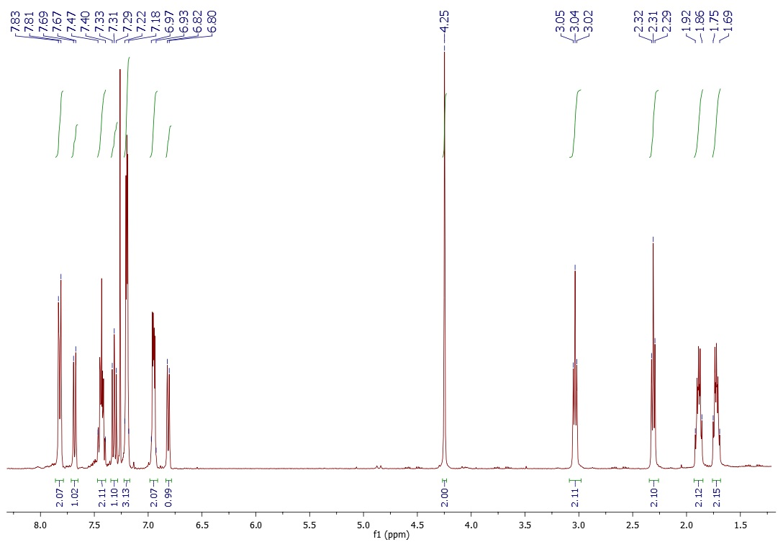
Figure S31. ¹H NMR of 2-chloro-3-(1-naphthylmethyl)-4-phenyl-5,6,7,8-tetrahydroquinoline
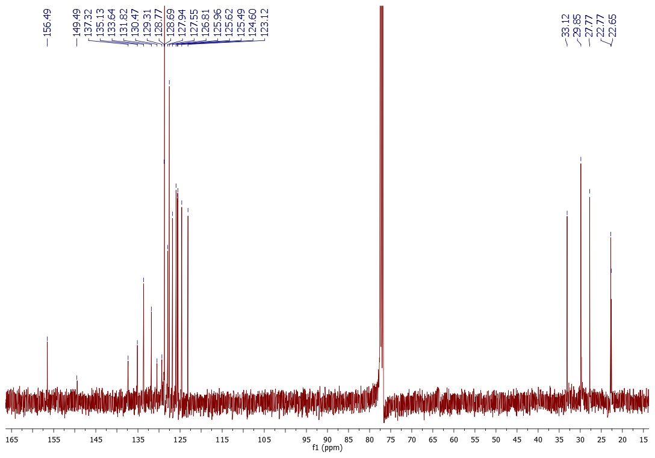
Figure S32. ¹³C NMR of 2-chloro-3-(1-naphthylmethyl)-4-phenyl-5,6,7,8-tetrahydroquinoline
7. 2-methoxy-3-(1-naphthylmethyl)-4-phenyl-5,6,7,8-tetrahydroquinoline (6) [3]
A solution of 4a (0.105 g, 0.28 mmol) in 0.35 ml of EtOH and 9.3 ml of ACN was placed in round bottomed flask with stir bar. Ag₂CO₃ (0.772 g, 2.8 mmol) and MeI (0.53 ml, 8.4 mmol) were added. The mixture was left overnight in RT. Ag₂CO₃ was filltred on celite and solvents were evaporated. Crude product was purified by flash column chromatography (ethyl acetate : hexane 1:50). Compound 6 (0.070 g, 0.18 mmol, 66%) was obtained as white amorphous powder.

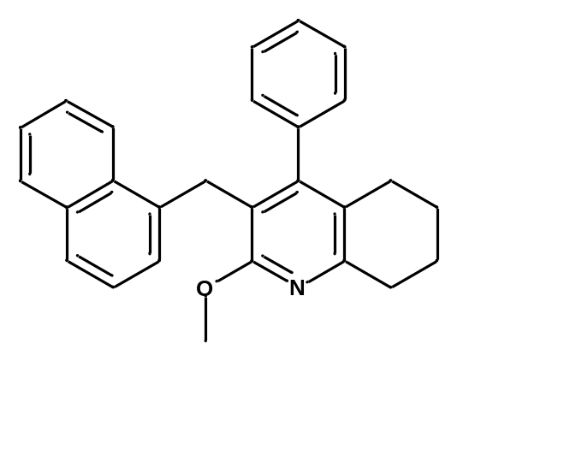White amorphous powder, yield: 66 %,
Mixture of rotamers 9:1
¹H NMR (CDCl₃, 400 MHz): δ= 8.27 (dd, J₁ = 8.44 Hz, J₂ = 0.66 Hz, 0.12 H), 7.92 – 7.87 (m, 1 H), 7.82 – 7.80 (m, 0.82 H), 7.66 (d, J = 8.2 Hz, 0.87 H), 7.57 – 7.52 (m, 0.18 H), 7.49 – 7.36 (m, 2H), 7.32 – 7.27 (m, 1 H), 7.22 – 7.19 (m, 3 H), 7.00 – 6.95 (m, 2 H), 6.84 (dd, J₁ = 7.12 Hz, J₂ = 0.8 Hz, 0.88 H), 6.74 (d, J = 7.76 Hz, 0.13 H), 4.12 (s, 1.69 H), 4.09 (s, 0.25 H), 3.87 (s, 3 H), 2.94 (t, J = 6.23 Hz, 2 H), 2.26 (t, J = 6.23 Hz, 2 H), 1.91 – 1.85 (m, 2 H), 1.74 – 1.68 (m, 2 H)

¹³C NMR (CDCl₃, 100 MHz): δ= 160.35, 153.15, 152.28, 133.57, 128.60, 128.38, 128.02, 127.35, 126.23, 125.60, 125.52, 125.32, 124.54, 123.59, 117.57, 53.72, 32.80, 29.53, 27.39, 23.32, 23.10

HRMS (ESI+): m/z
[M + H]+ calcd for C₂₇H₂₆NO: 380.2014; found: 380.2054.
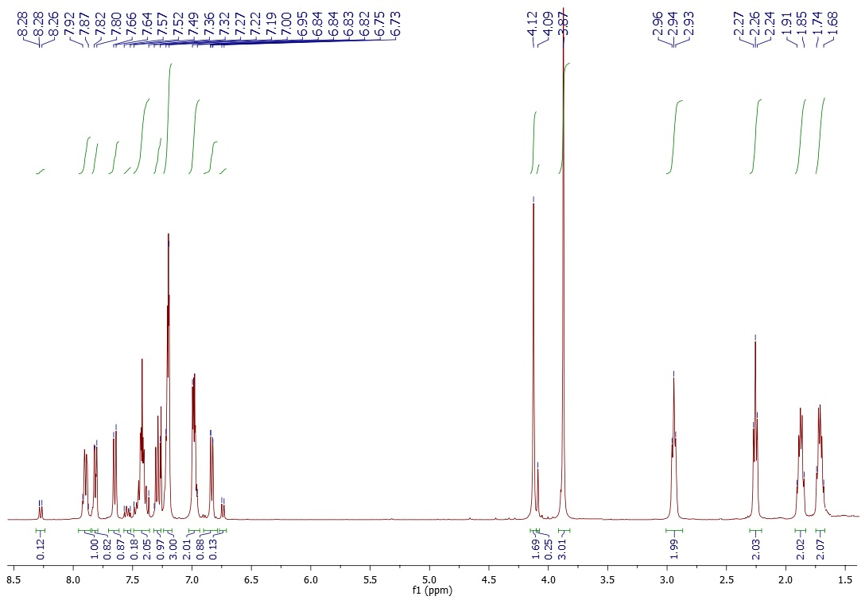
Figure S33. ¹H NMR of 2-methoxy-3-(1-naphthylmethyl)-4-phenyl-5,6,7,8-tetrahydroquinoline
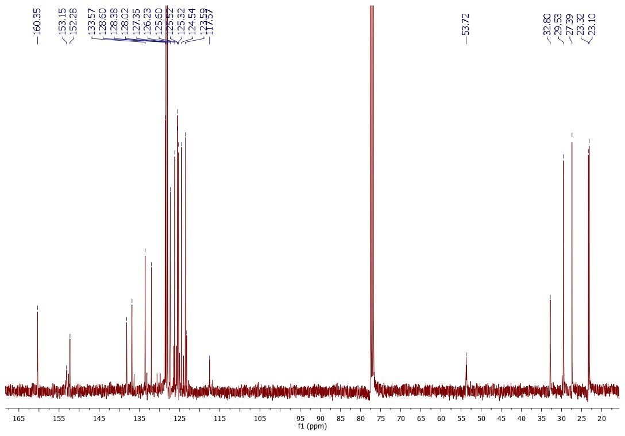
Figure S34. ¹³C NMR of 2-methoxy-3-(1-naphthylmethyl)-4-phenyl-5,6,7,8-tetrahydroquinoline

BIOLOGICAL EVALUATION
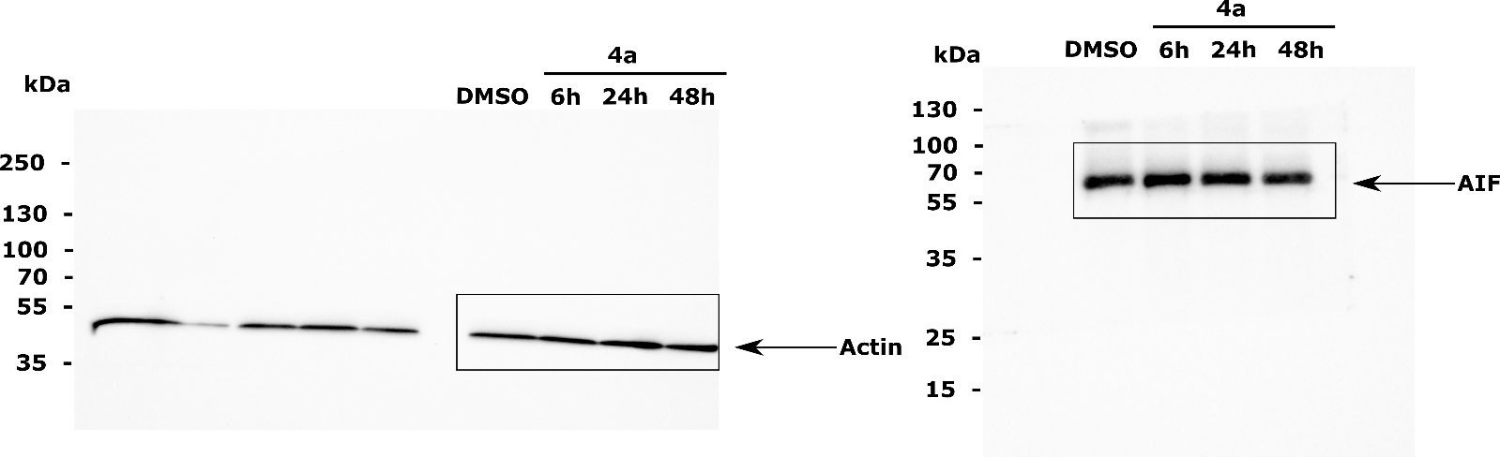
Figure S35. A full-length Western blot presented in Figure 5 of the main article. Boxes denote the cropped regions of the blots.
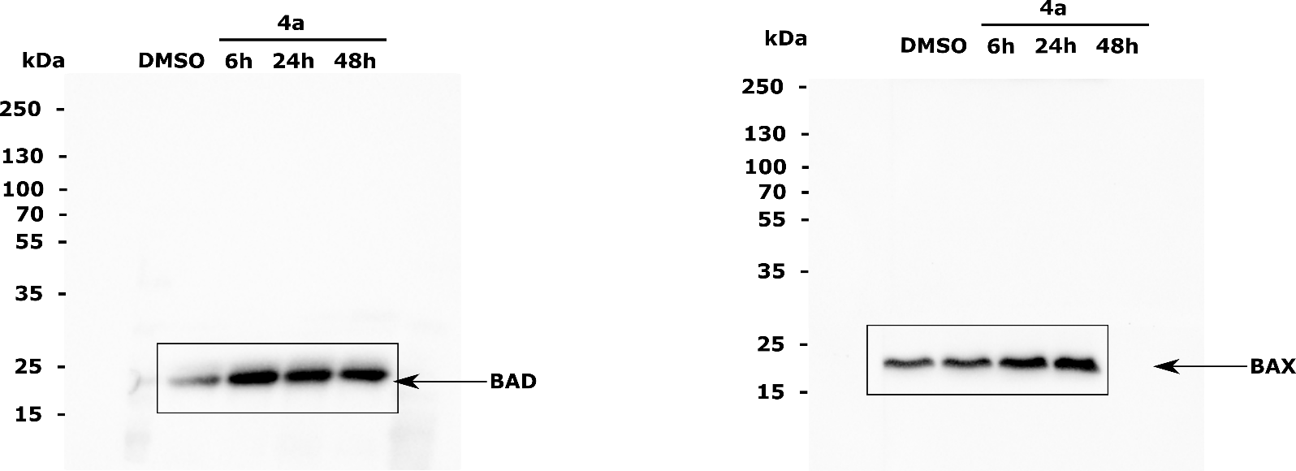
Figure S36. A full-length Western blot presented in Figure 5 of the main article. Boxes denote the cropped regions of the blots.

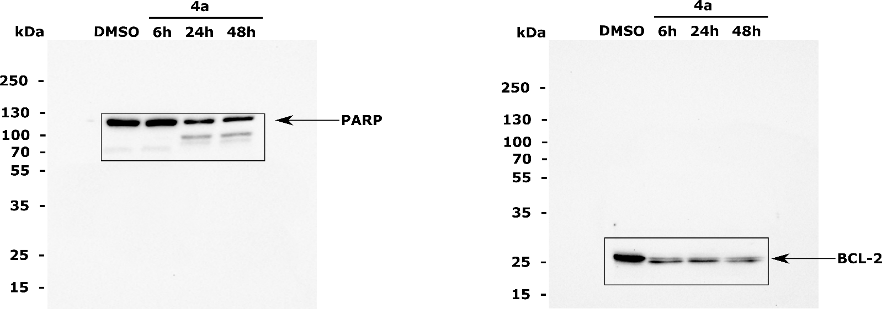

Figure S37. A full-length Western blot presented in Figure 5 of the main article. Boxes denote the cropped regions of the blots.

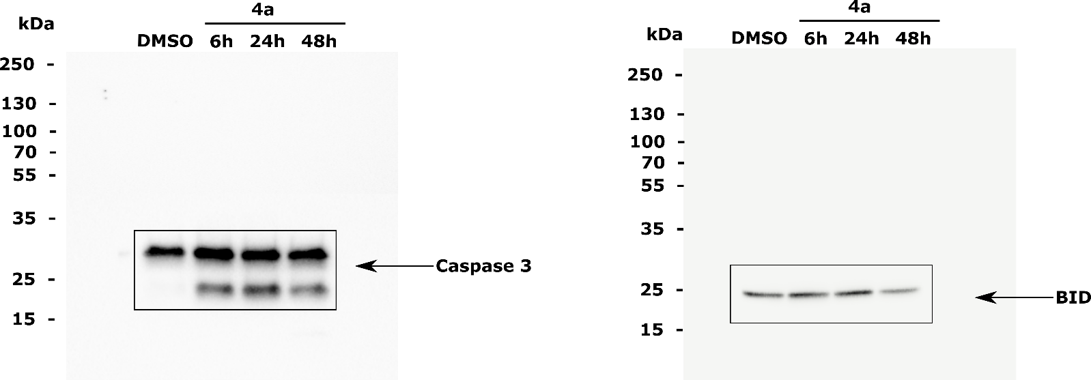

Figure S38. A full-length Western blot presented in Figure 5 of the main article. Boxes denote the cropped regions of the blots.
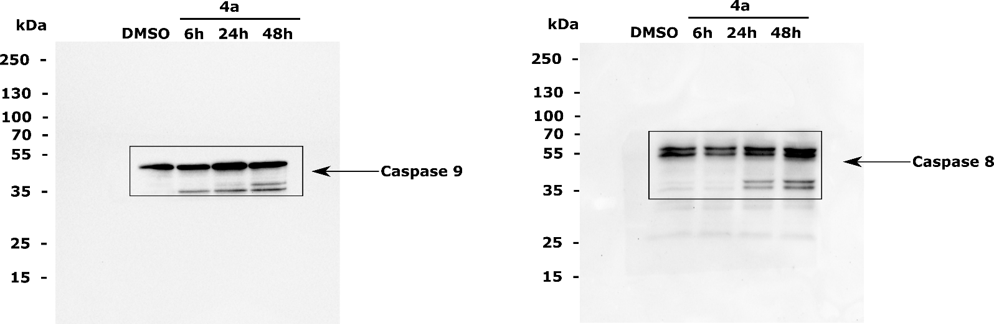

Figure S39. A full-length Western blot presented in Figure 5 of the main article. Boxes denote the cropped regions of the blots.

Table S1. List of antibodies used in Western blotting
Antibody name | Company | Dilution
Anti-Caspase-3 (#9662) | Cell Signaling | 1:1000
Anti-Caspase-9 (#9502) | Cell Signaling | 1:1000
Anti-Caspase-8 (1C12) (#9746) | Cell Signaling | 1:1000
Anti-PARP (#9542) | Cell Signaling | 1:1000
Anti-BCL-2 (#4223) | Cell Signaling | 1:1000
Anti-BID (#2002) | Cell Signaling | 1:1000
Anti-BAD (ab32445) | Abcam | 1:1000
Anti-AIF (#4642) | Cell Signaling | 1:1000
Anti-BAX (#2772) | Cell Signaling | 1:1000
Anti-actin (sc-1616) | Santa Cruz | 1:100
Anti-mouse-HRP (715-035-150) | Jacson ImmunoResearch Labs | 1:10000
Anti-rabbit-HRP (711-035-152) | Jacson ImmunoResearch Labs | 1:10000
Anti-goat-HRP (705-036-147) | Jacson ImmunoResearch Labs | 1:10000
Anti-mouse-HRP (715-035-150) | Jacson ImmunoResearch Labs | 1:10000
Anti-rabbit-HRP (711-035-152) | Jacson ImmunoResearch Labs | 1:10000
Anti-goat-HRP (705-036-147) | Jacson ImmunoResearch Labs | 1:10000

REFERENCES

1. Huilai Y., Jie M., Xuexi S., A method of preparing of blonanserin, CN 104447551 (2015).
2. Lyle M. P. A., Wilson P. T., Synthesis of a new chiral nonracemic C2-symmetric 2,2‘-bipyridyl ligand and its application in copper(I)-catalyzed enantioselective cyclopropanation reactions Org. Lett, 6, 855-857 (2004).
3. Morel A. F., Larghi L. E., Selvero M. M., Mild, efficient and selective silver carbonate mediated O-alkylation of 4-hydroxy-2-quinolones: Synthesis of 2,4-dialkoxyquinolines, Synlett, 18, 2755-2758 (2005).

