Supplementary information
Successful creation of CsPb(Br_{1-x}Cl_{x})₃/ZnS core/shell perovskite nanocrystals pure deep-blue light-emitting diodes with high luminance and efficiency

Yongju Hong^{1,#}, Chungman Yu^{1,#}, Hyeondoo Je^{1,#}, Taekyung Kim², Hionsuck Baik², Gracita M. Tomboc^{1,3}, Youngseo Kim¹, Jung Min Ha¹, Jinwhan Joo¹, Chai Won Kim¹, Han Young Woo¹, Sungnam Park¹, Dong Hoon Choi^{1,*}, and Kwangyeol Lee^{1,*}
¹Department of Chemistry and Research Institute for Natural Sciences, Korea University, Seoul 02841, Republic of Korea
²Korea Basic Science Institute (KBSI), Seoul 02841, Republic of Korea
³Green Hydrogen Lab (GH2Lab), Institute for Hydrogen Research (IHR), Université du Québec à Trois-Rivières (UQTR), 3351 Boulevard des Forges, Trois-Rivières, Québec G9A 5H7, Canada
#These authors contributed equally to the manuscript.
*e-mail: Dong Hoon Choi (dhchoi8803@korea.ac.kr); Kwangyeol Lee (kylee1@korea.ac.kr)

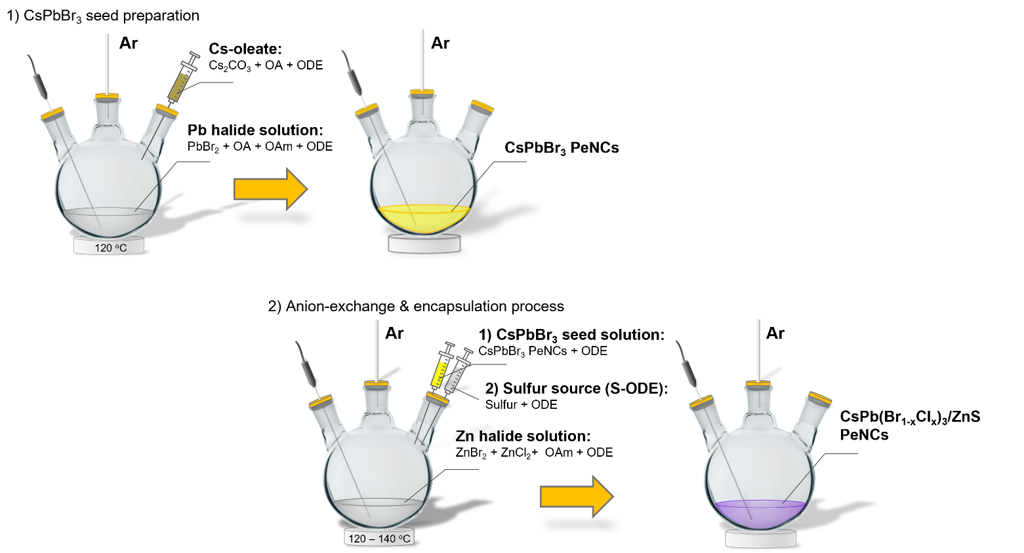
Supplementary Fig. 1│ Schematic of synthesis protocol. Steps included are as follows:
1) Synthesis of pristine CsPbBr₃ (CPB) seed perovskite nanocrystals (PeNCs). 2) Anion-exchange and encapsulation for core/shell CsPb(Br_{1-x}Cl_{x})₃/ZnS (CPBC/ZnS) PeNCs: anion-exchange and encapsulation using a modified hot-injection and seed-mediated method
Supplementary Note 1│ Steps involved in synthesis.
The synthesis consists of three steps:
- the formation of the CPBC core via anion-exchange,
- surface treatment via halide passivation, and
- the epitaxial growth of the ZnS shell.
The mixed-halide ZnX₂ (X = Cl, Br) additives functioned as both anion-exchange/surface passivation agents and Zn ion sources for the ZnS shell. Initially, the CPB PeNCs solution (in ODE) was injected into the pre-heated ZnCl₂/ZnBr₂ halide solution (in ODE) to minimise the heat exposure of CPB seeds and to avoid potential structural damage to the PeNCs. Thereafter, a rapid anion-exchange between Br⁻ and Cl⁻ occurred, forming a mixed-halide CPBC core. Simultaneously, the mixed-halide ZnX₂ served as a passivation agent for the as-treated CPBC surface that:
- eliminated the surface defects, which often lead to the formation of "black dots" on the perovskite surface, indicating a severe structural degradation, and
- served as a stable platform for the epitaxial growth of a thin ZnS shell, which is anticipated to hermetically seal the deep-blue-emitting CPBC PeNCs to ensure protection from the environment and to disable interparticle ion migration under an electric field. Finally, the reaction of Zn ions with S-ODE allowed for the epitaxial growth of a thin ZnS shell to enclose the mixed-halide CPBC core.
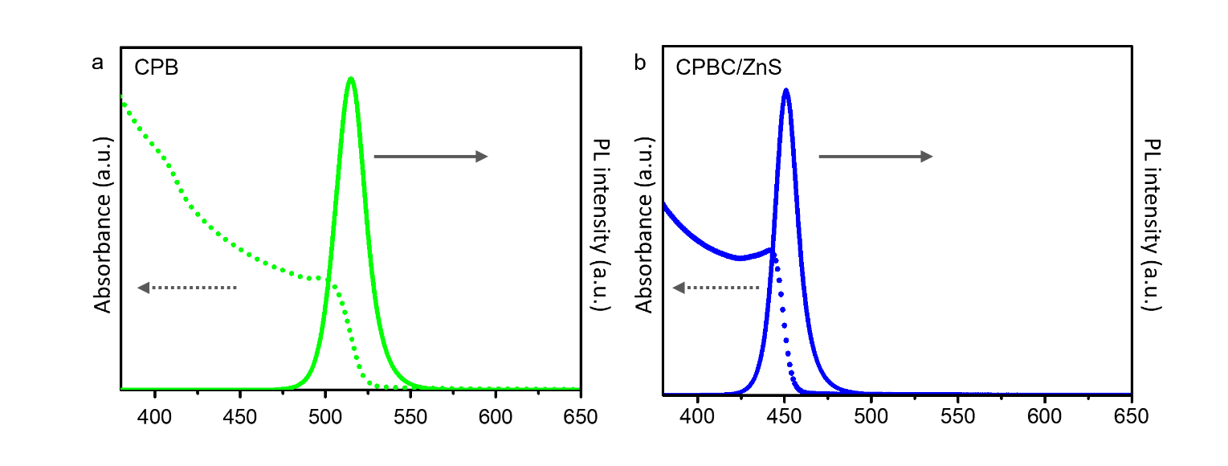
Supplementary Fig. 2│Photoluminescence and UV-vis absorption spectra. a, Pristine green-emitting CPB (λ_{em}^{max}=515 nm) and b, deep-blue emitting ZnS encapsulated CPBC/ZnS PeNCs (λ_{em}^{max}=451 nm).

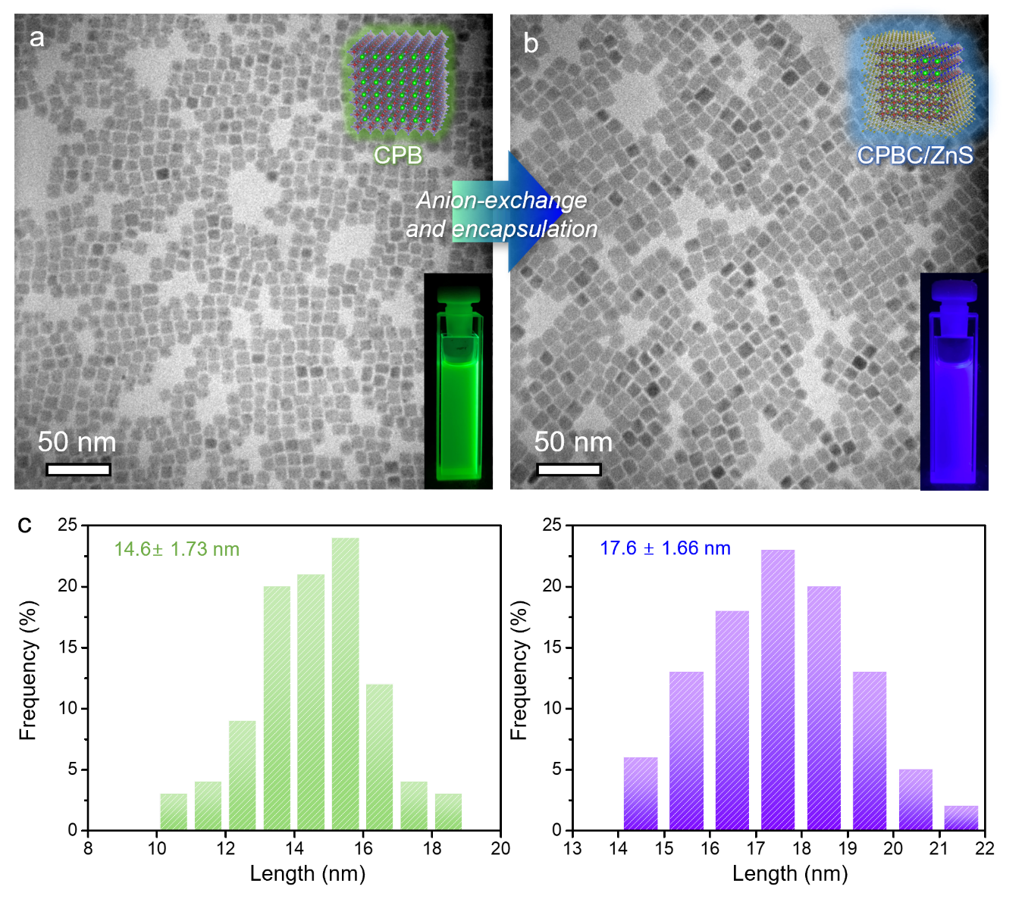
Supplementary Fig. 3│Representative TEM images and corresponding histogram of size distribution. a, CsPbBr₃ (CPB) PeNCs and b, core/shell CPBC/ZnS PeNCs, respectively; c, size distribution diagrams of CPB and core/shell CPBC/ZnS PeNCs, respectively.

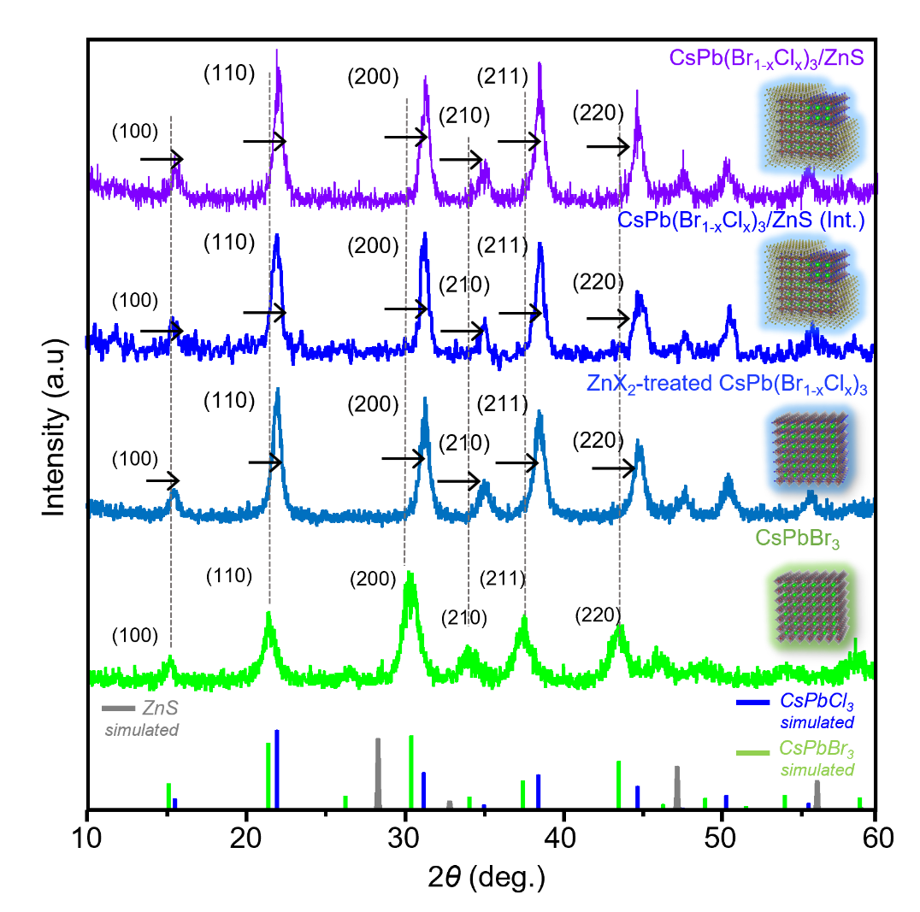
Supplementary Fig. 4│PXRD spectra of pristine CPB, ZnX₂-treated CPBC, CsPb(Br_{1-x}Cl_{x})₃/ZnS intermediates (CPBC/ZnS int.), and CPBC/ZnS PeNCs, respectively. PXRD spectra of ZnX₂-treated CPBC, CPBC/ZnS intermediates, and CPBC/ZnS PeNCs indicate a slight right-shift of peaks upon facilitation of anion-exchange (incorporation of Cl⁻) as compared with spectra of pristine CPBs.

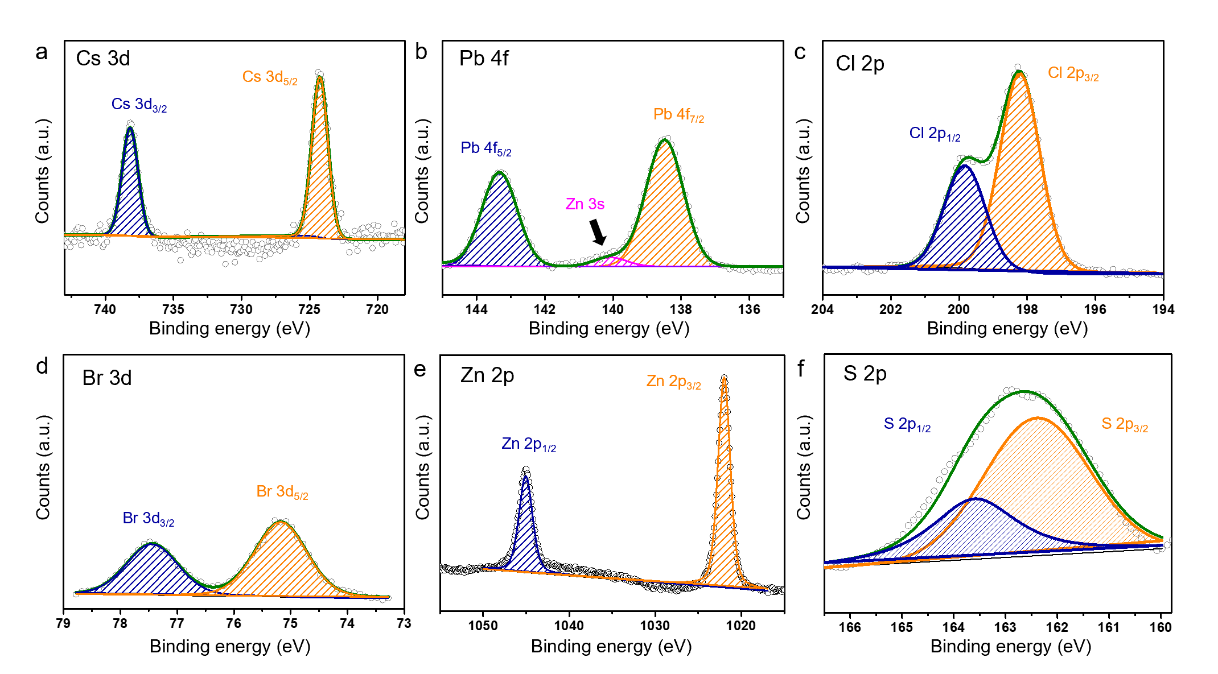

Supplementary Fig. 5│XPS analysis spectra. a, Cs 3d; b, Pb 4f; c, Cl 2p; d, Br 3d; e, Zn 2p; and f, S 2p regions of CPBC/ZnS PeNCs.
Supplementary Note 2│Comparison of XPS spectra.
The XPS spectra of Cs 3d, Pb 4f, Cl 2p, Br 3d indicate the formation of the mixed-halide PeNCs of CPBC. Moreover, the Zn 2p and S 2p spectra of CPBC/ZnS were similar to those of Zn²⁺ and S²⁻ of ZnS, respectively. The similarity further indicates the formation of nano-thin ZnS shells on the CPBC PeNCs. Furthermore, in the Pb 4f region, the additional peak located at 139.87 eV corresponds to the Zn 3s that results from the ZnS shell.
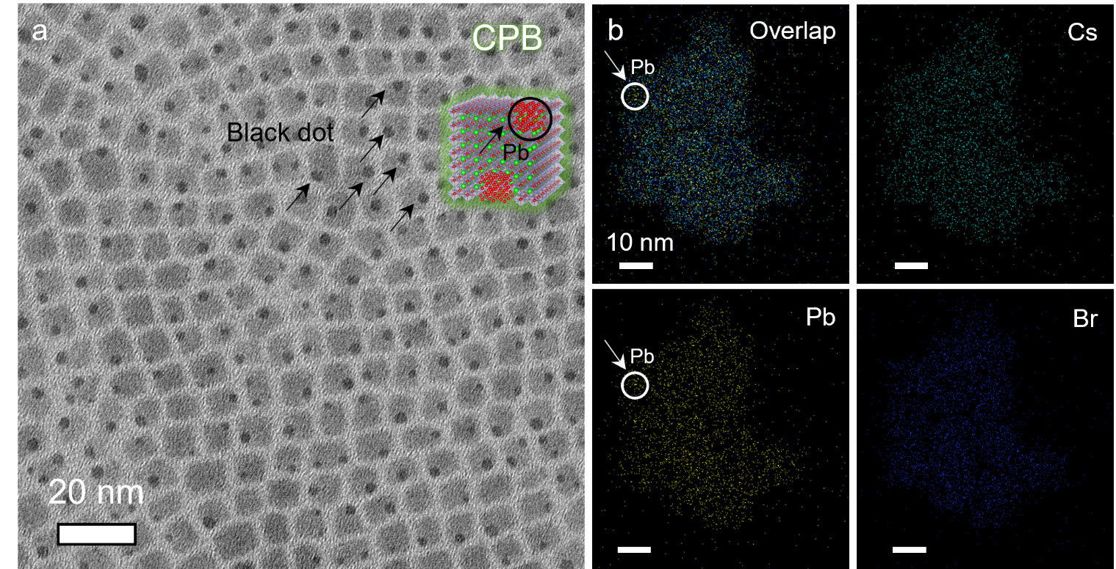
Supplementary Fig. 6│TEM characterisation and EDS elemental analysis of CPB with black dots. a, TEM image of pristine CPB PeNCs with black dots; b, EDS elemental mapping images demonstrating chemical compositions of CPB PeNCs and black dots, respectively.

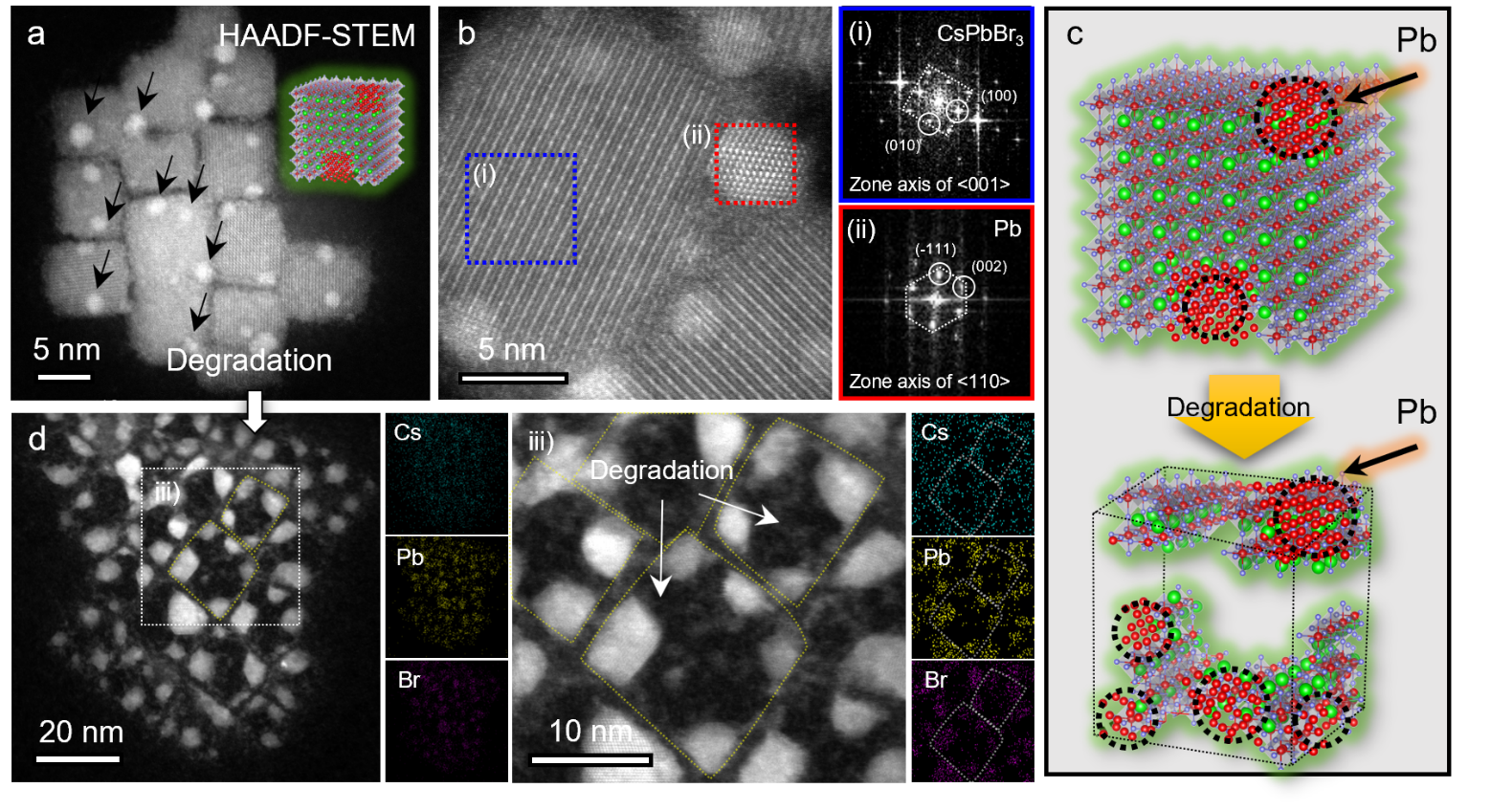
Supplementary Fig. 7│Morphology and crystal structure of CPB PeNCs and degradation process. a, Representative HAADF-STEM image of CPB PeNCs. b, Atomic-resolution HRSTEM image and corresponding FFT patterns of regions (i) and (ii), which are CsPbBr₃ and metallic Pb, respectively. c, Schematic of degradation process of CPB PeNCs induced by irradiation of electron beam. d, HAADF-STEM image, high-magnification image (iii), and corresponding EDS mapping images of degraded CPB PeNCs by electron beam.

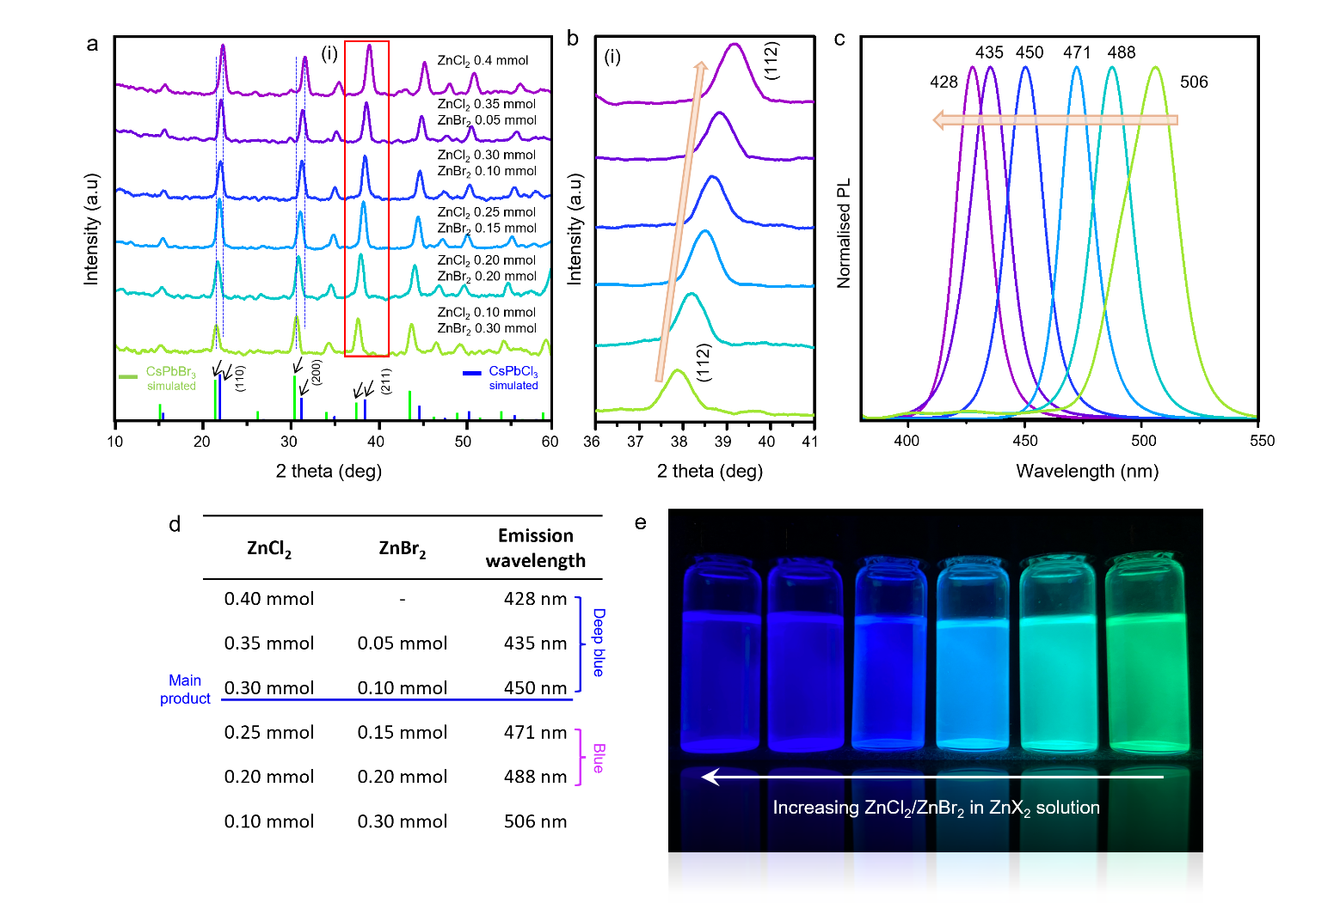
Supplementary Fig. 8│ Modulation of CPBC core halide compositions and bandgap. a, PXRD patterns of anion-exchanged CPBC/ZnS samples comprising different halide compositions; b, enlarged XRD patterns between 36 and 41°; c, corresponding photoluminescence spectrum (λ_{ex} = 365 nm for all samples); d, typical quantities of ZnCl₂ and ZnBr₂ for six perovskite nanocrystal samples; e, digital photographs of perovskite colloidal solutions in hexane upon irradiation with UV lamp (λ_{ex} = 365 nm).

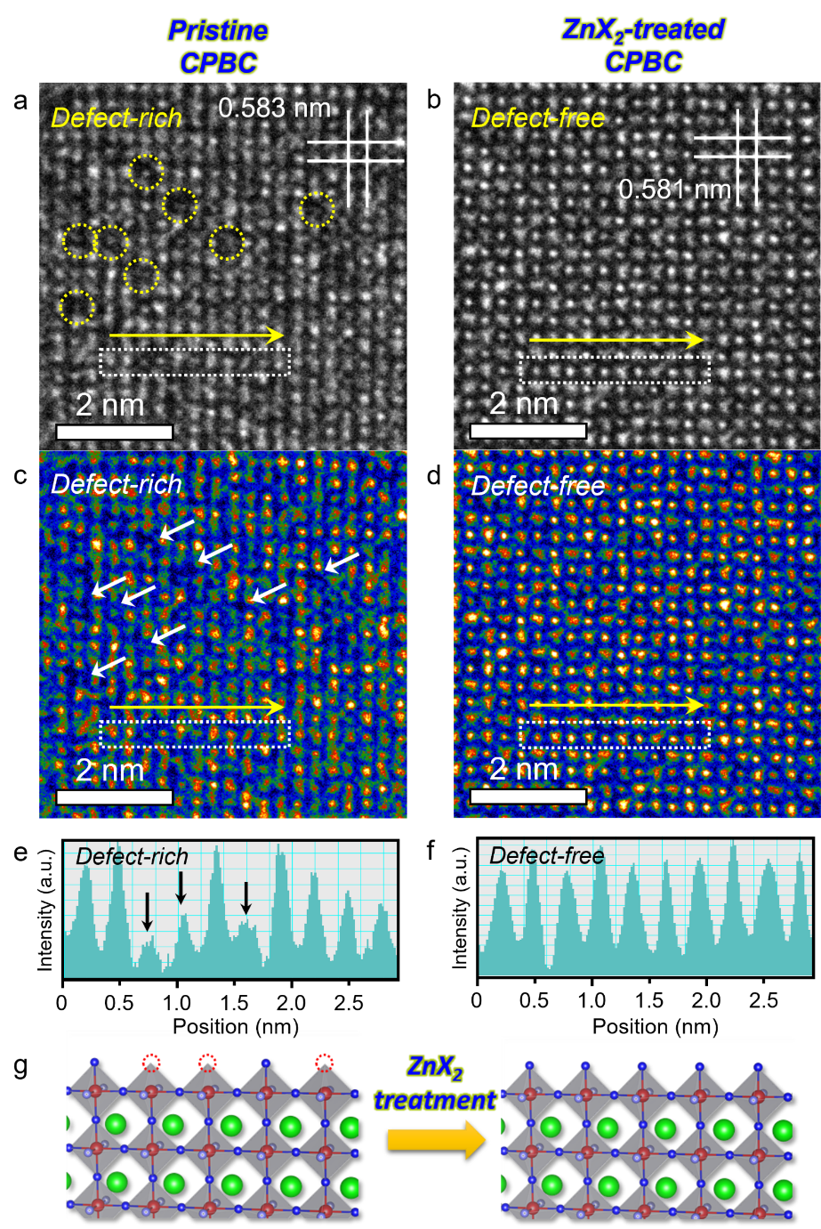
Supplementary Fig. 9│ Characteristics of defect densities of directly synthesised pristine CPBC and CPBC synthesised from CPB after ZnX₂ treatment. Atomic-resolution HRTEM images of a, directly synthesised pristine CPBC; and b, ZnX₂-treated CPBC PeNCs, respectively. Yellow dotted circles in (a) indicate defect sites on pristine CPBC PeNCs; c, d, corresponding false-colour images of HRTEM image of pristine CPBC and ZnX₂-treated CPBC, respectively. White arrows in (c) and (d) indicate defect sites. e, f, Comparison of intensity profile analysis (white dotted boxes) in respective HRTEM image of pristine CPBC and ZnX₂-treated CPBC further supports formation of defect sites in pristine CPBC PeNCs; g, schematic of halide defective surface of pristine CPBC PeNCs and defect passivated ZnX₂-treated CPBC PeNCs.
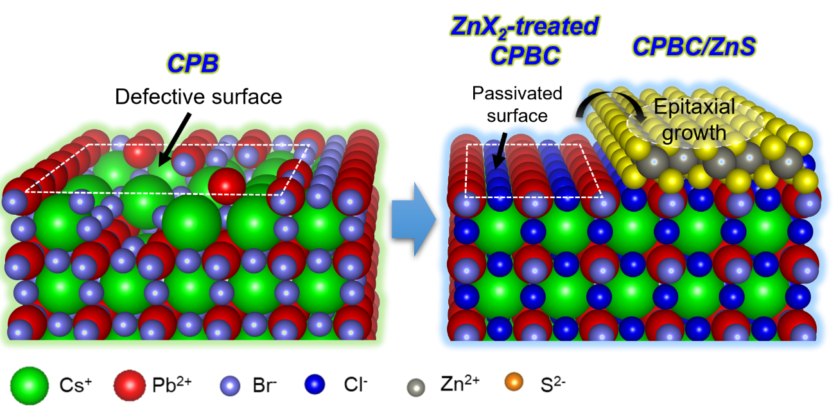
Supplementary Fig. 10│ Schematic demonstrating surface evolution mechanism from CPB to ZnX₂-treated-CPBC to CPBC/ZnS core/shell PeNCs.

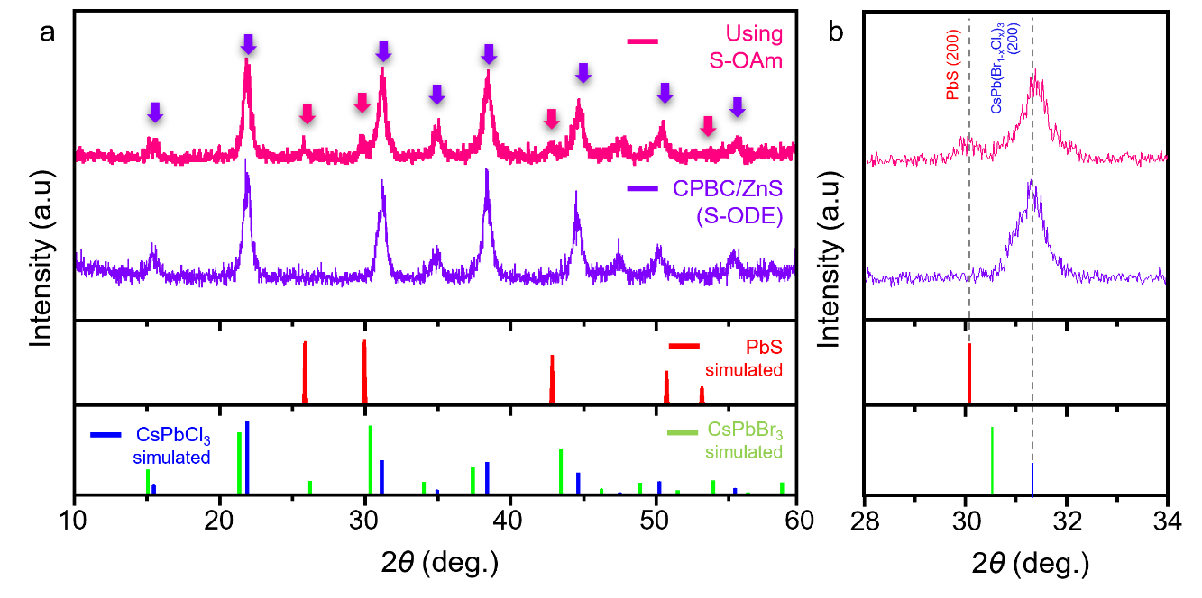
Supplementary Fig. 11│ PXRD characterisation of CPBC/ZnS and CPBC PeNCs synthesised using sulfur-oleylamine (S-OAm), demonstrating formation of by-product PbS.

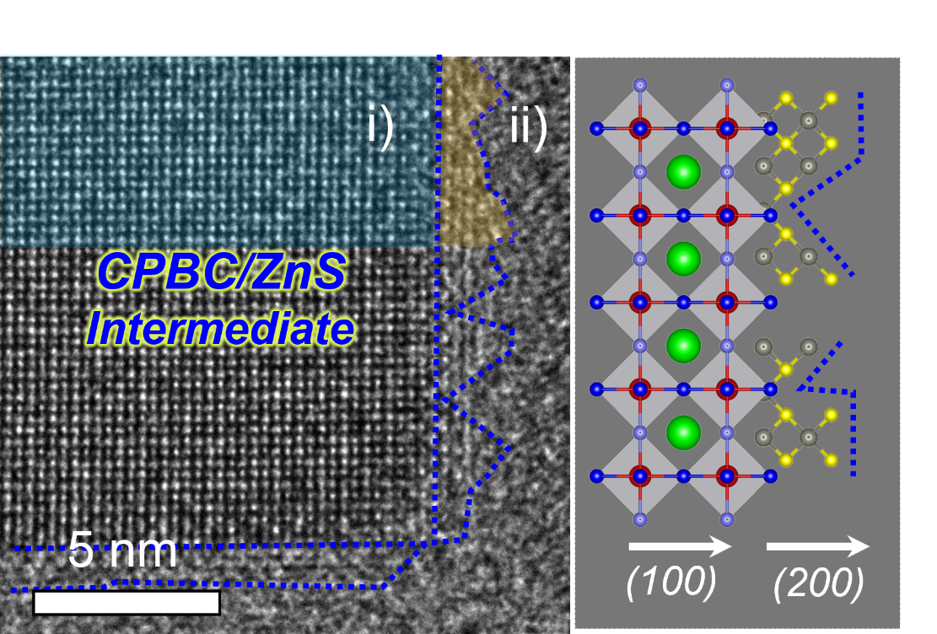
Supplementary Fig. 12│ HRTEM characterisation of CBPC/ZnS intermediate PeNC. a, HRTEM image and corresponding atomic model of CPBC/ZnS intermediate PeNC, showing rough surface of partially grown ZnS shell (ii) on CPBC core (i) without temperature increasing step to 140 ºC.

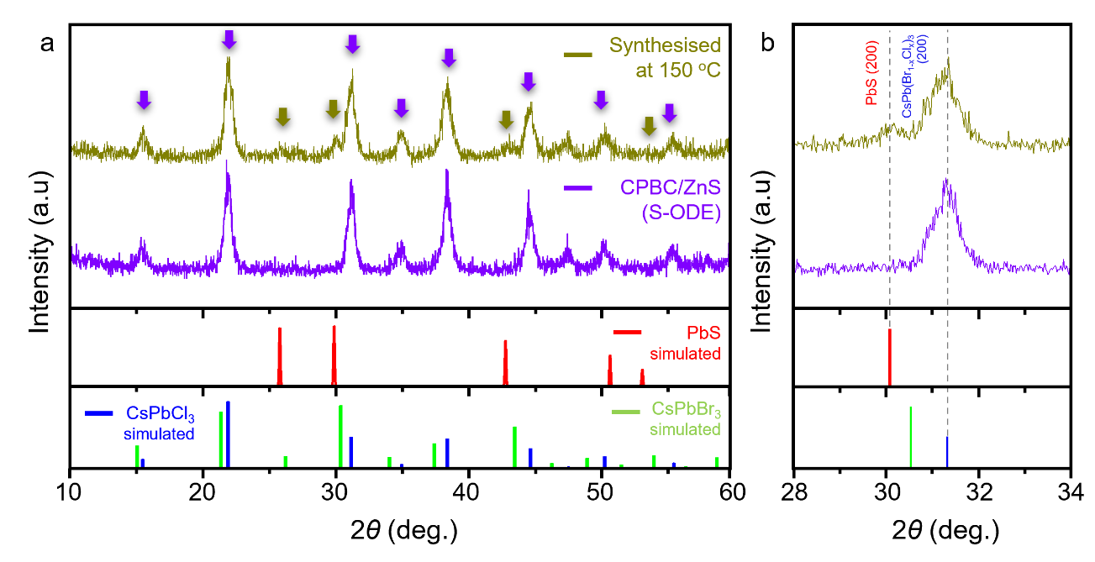

Supplementary Fig. 13│ PXRD characterisation of CPBC/ZnS and CPBC PeNCs directly synthesised at 150 °C, demonstrating formation of by-product PbS.

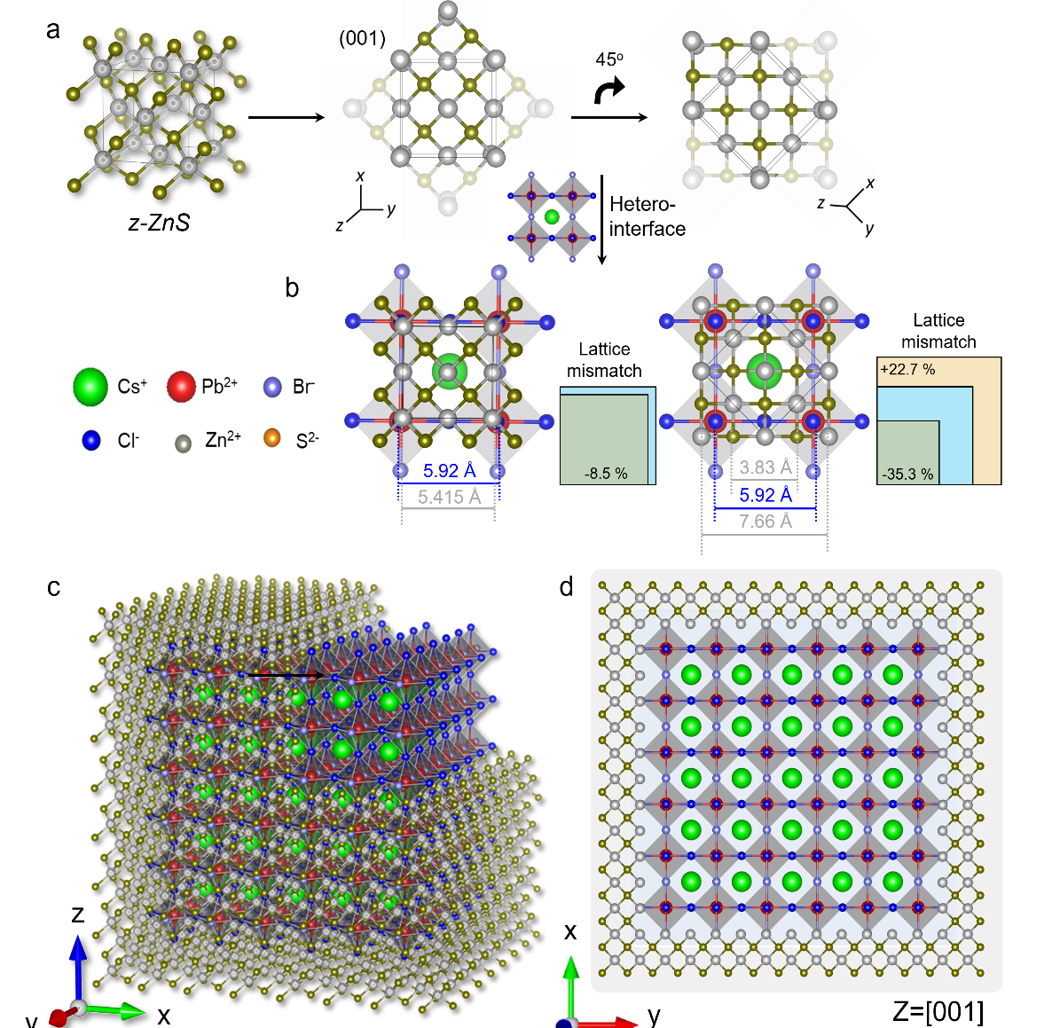

Supplementary Fig. 14│ Calculation of interfacial lattice mismatch between CPBC and ZnS, and optimal core/shell crystal structure with epitaxial relation. a, Crystallographic projections highlighting cubic-like zinc blende subunits within ZnS. The lattice parameters for CPBC core (5.920 Å) and z-ZnS shell (5.415 Å) for calculation were obtained by FFT analysis and theoretical value, respectively. b, Crystallographic projections of heterostructures of ZnS and CPBC with corresponding lattice mismatch calculations. c, d, 3D and 2D-simulated atomic models of CPBC/ZnS core/shell PeNCs.

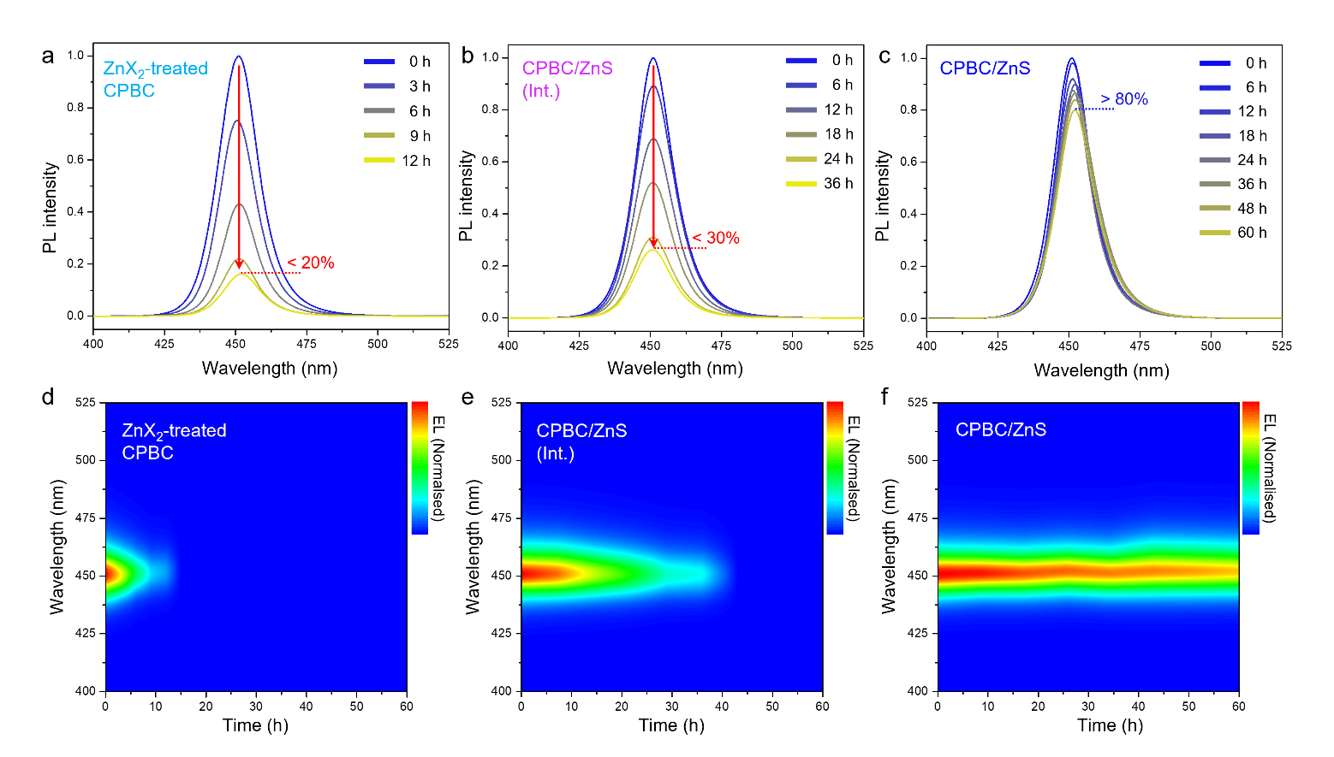
Supplementary Fig. 15│ Time-dependent photoluminescence spectra. a, d, ZnX₂-treated CPBC; b, e, CPBC/ZnS intermediates PeNCs; and c, f, CPBC/ZnS PeNCs, respectively.

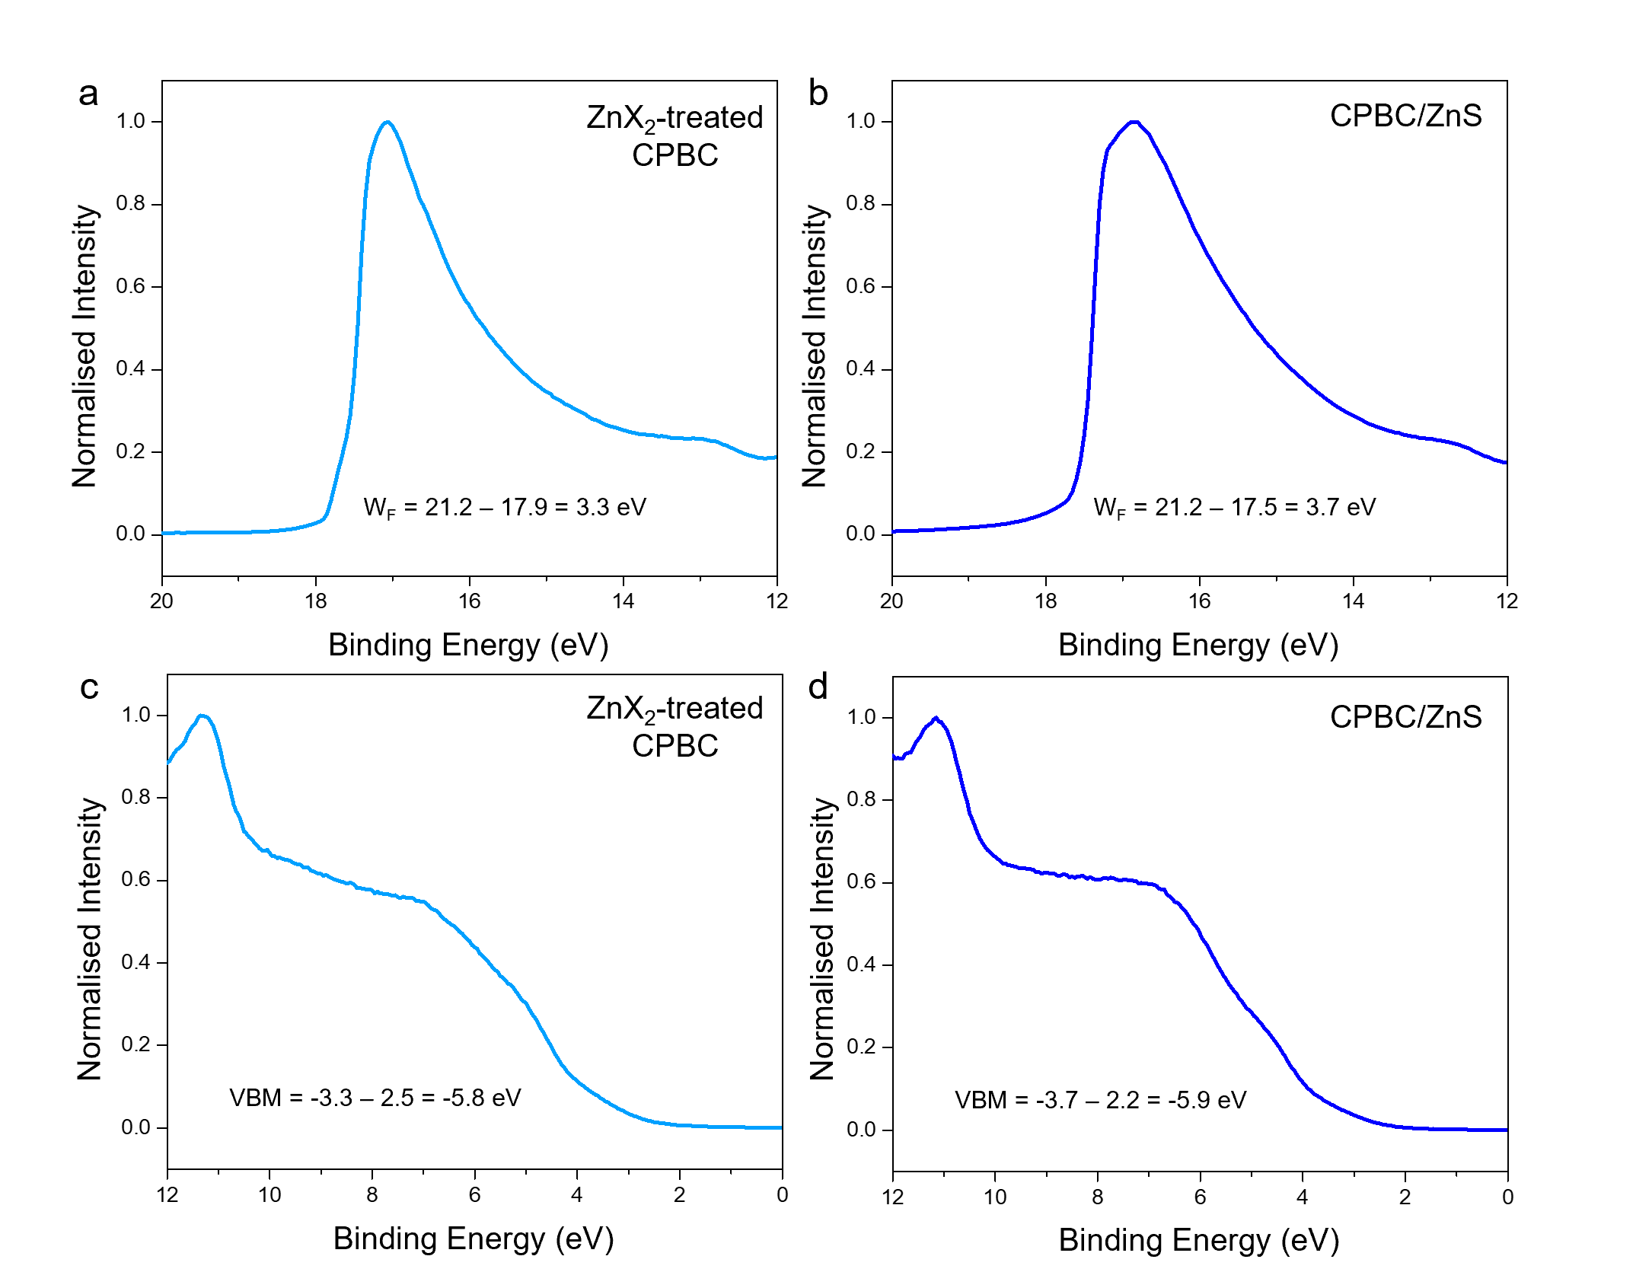
Supplementary Fig. 16│ Ultraviolet photoelectron spectroscopy characteristics. Second electron cut-off and valence band spectra of control of (a, c) CPBC; and (b, d) CPBC/ZnS, respectively.

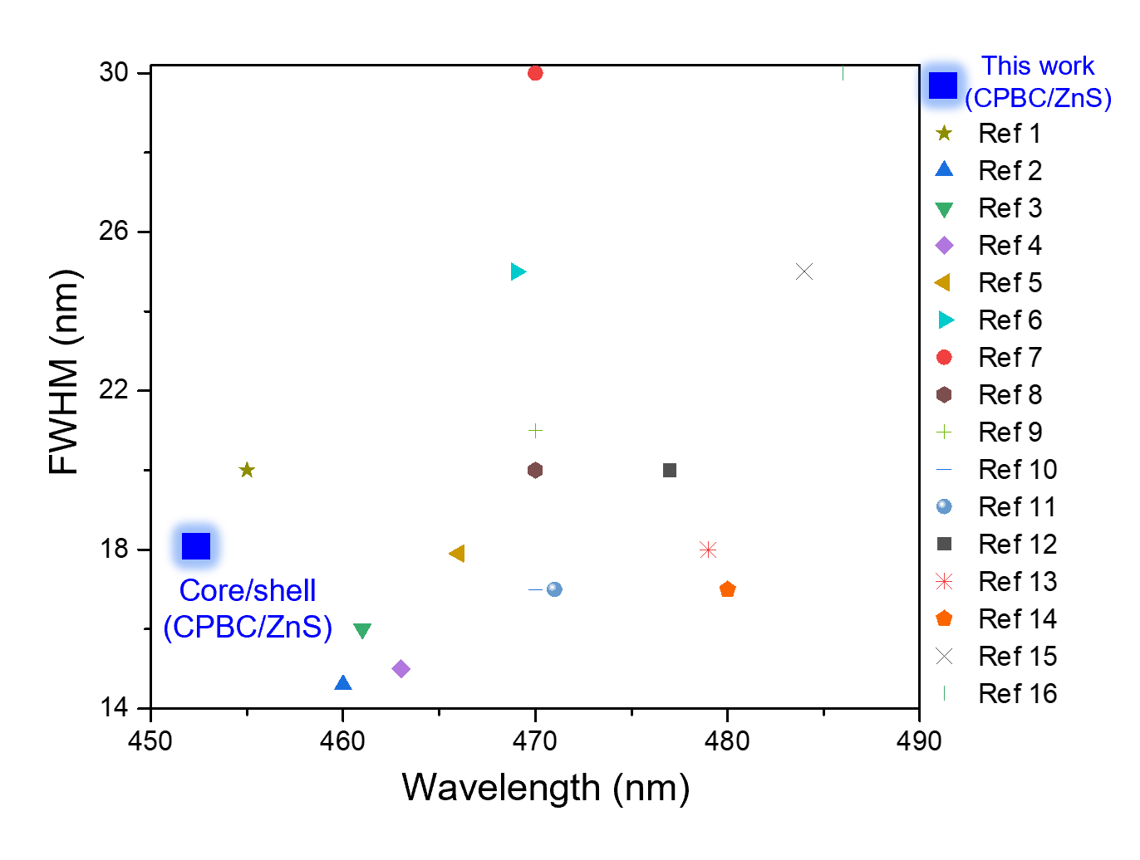
Supplementary Fig. 17│ Comparison of full width at half maximum, FWHM, of perovskite-based blue LEDs of this study with those of other mixed-halide perovskite nanocrystal-based PeLEDs.
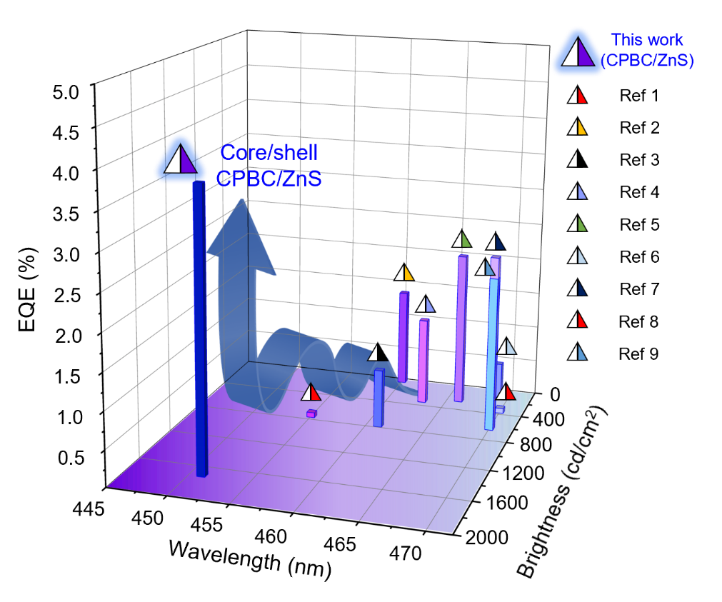
Supplementary Fig. 18│ Comparison of maximum EQE, luminance, and emission wavelength of perovskite-based deep-blue LEDs of this study with those of other mixed-halide perovskite nanocrystal-based PeLEDs.

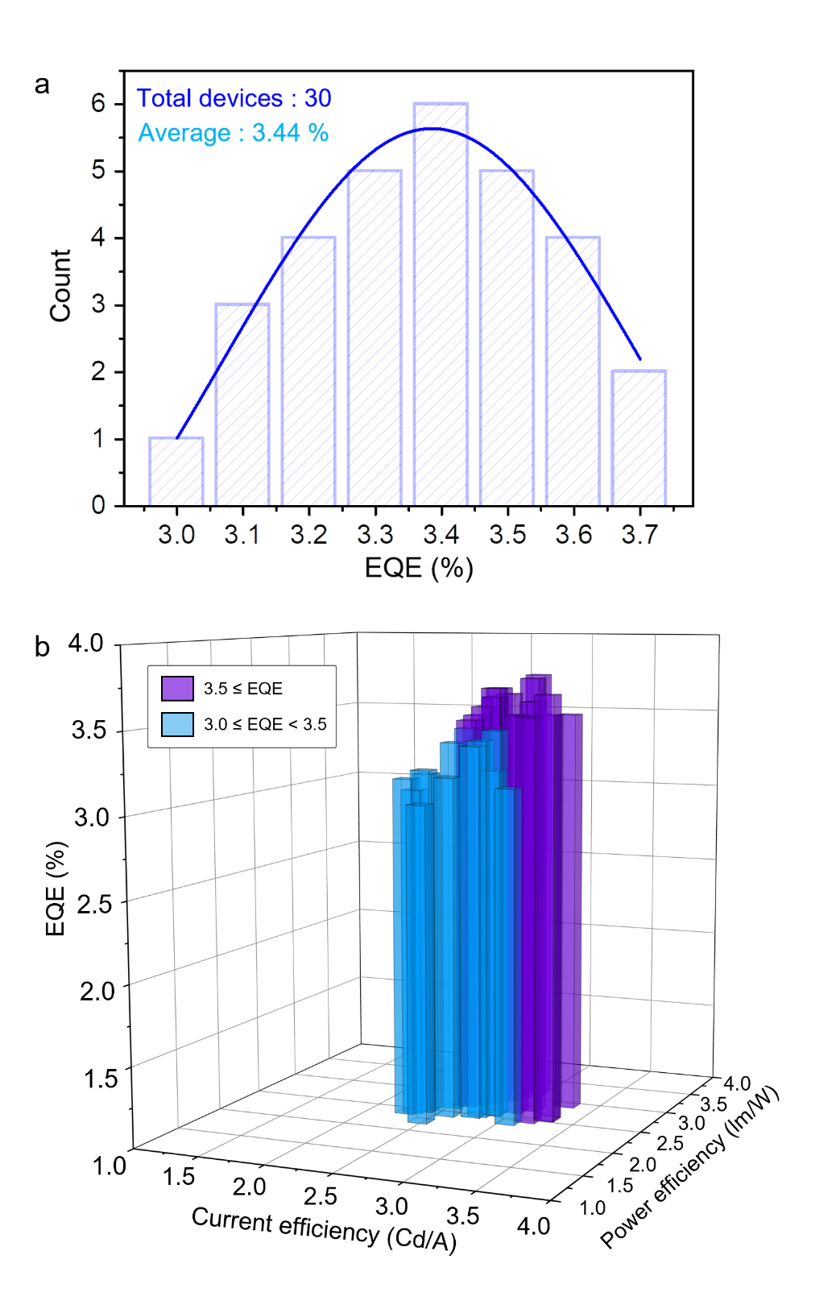
Supplementary Fig. 19│ Reproducibility of CPBC/ZnS-based PeLEDs. a, Histogram of maximum EQE of CPBC/ZnS PeLEDs, measured on 30 devices, with average EQE of 3.44%. b, Corresponding histogram of peak EQEs, current efficiency, and power efficiency of CPBC/ZnS PeLEDs.

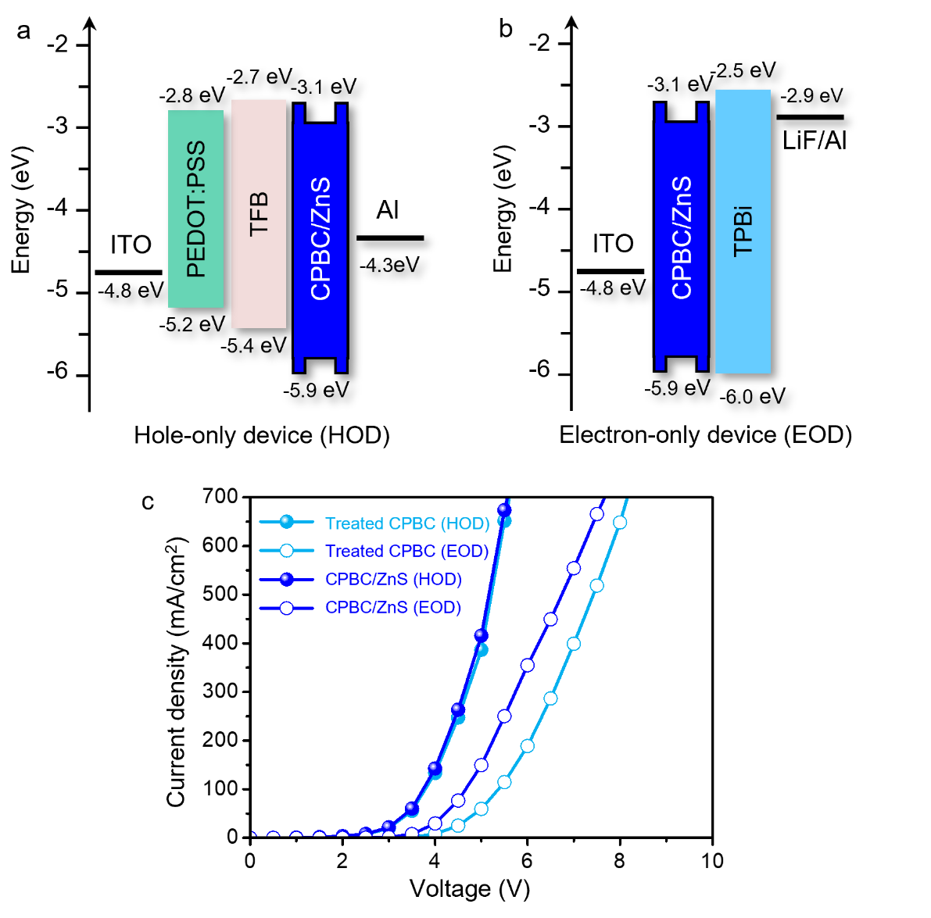
Supplementary Fig. 20│ Schematic and energy band diagrams. a, Hole-only device (HOD) and b, electron-only device (EOD); c, current density-voltage (J-V) characteristics of HODs and EODs using ZnX₂-treated CPBC and CPBC/ZnS, respectively.

Supplementary Note 3│ Effect of ZnS shell of CPBC PeNCs on performance of LED.

We determined the effect of the ZnS shell of the CPBC PeNCs on the LED performance. We prepared single-carrier devices (Supplementary Fig. 20a, b) using ZnX₂-treated CPBC and CPBC/ZnS; the carrier devices indicated that the electron currents increased substantially after the encapsulation of ZnS (Supplementary Fig. 20c). The differences in the electron and hole mobilities could be resolved by the ZnS shell, improving its charge balance by facilitating electron mobility.
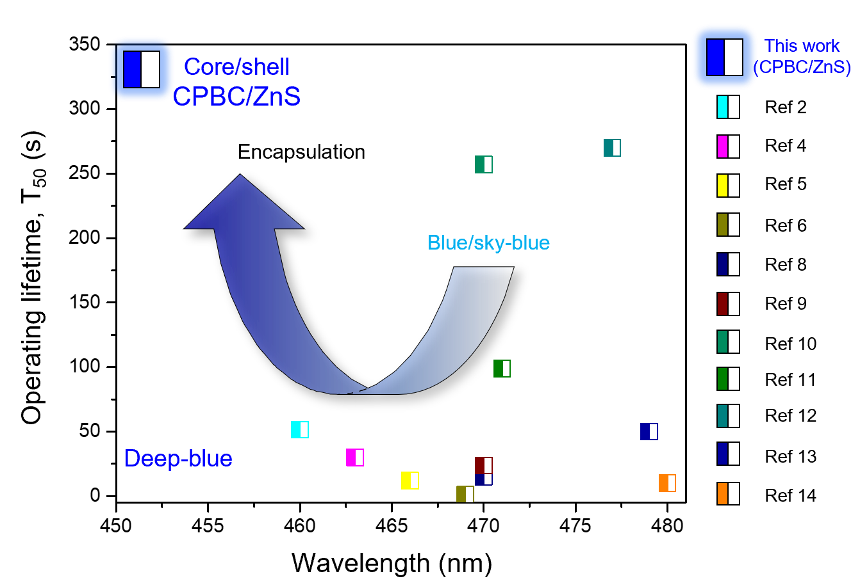
Supplementary Fig. 21│ Comparison of operating lifetimes (T₅₀) and emission wavelength of perovskite-based blue LEDs of this study with those of other mixed-halide perovskite nanocrystal-based PeLEDs.

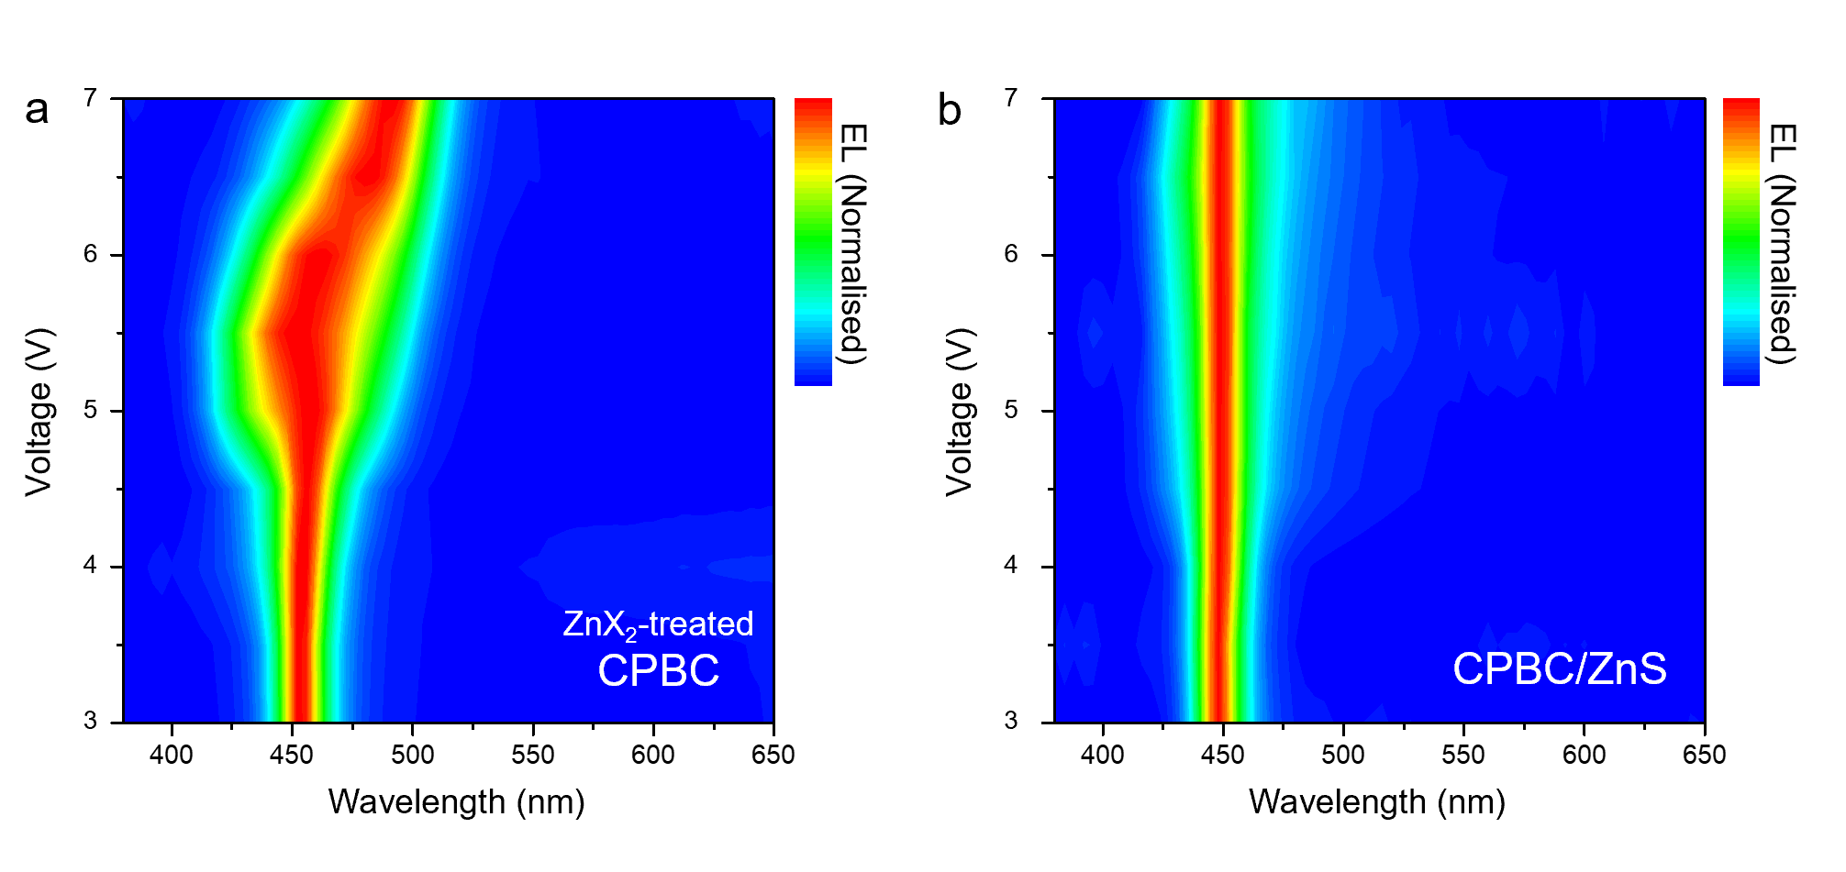
Supplementary Fig. 22│ Driven voltage dependent EL spectra for deep-blue PeLEDs. a, with and b, without ZnS encapsulation (ZnX₂-treated CPBC and CPBC/ZnS, respectively).

Supplementary Table. 1│ Electrical Performance of CPBC, and CPBC/ZnS-based deep-blue PeLEDs.

Sample | V_{on} ª  (V) | CEmax^{b}  (cd/A) | PEmax ^{c}  (lm/W) | Luminance ^{d}  (cd/m²) | EQEmax ^{e}  (%) | λ_{EL} ^{f}  (nm) | CIE ^{g}  (x, y)
ZnX₂-treated CPBC | 3.17 | 1.24 | 1.11 | 132 | 1.09 | 451 | (0.15, 0.03)
CPBC/ZnS | 2.84 | 2.74 | 2.86 | 1687 | 3.63 | 451 | (0.17, 0.06)
^{a)} Turn-on voltage at 1 cd/m². ^{b)} Maximum CE. ^{c)} Maximum PE. ^{d)} Maximum luminance. ^{e)} Maximum EQE. ^{h)} EL peak wavelength.
^{g)} CIE 1931 colour coordinates.

Supplementary Table. 2│ Comparison of state-of-the-art mixed-halide blue PeLEDs in previous literature with deep-blue PeLED of this study.

 | PeLED (EL) |  |  |  |  |  |  |  |  |  |  | Literature |  | Ref.
Structure | Wavelength  (nm) |  | EQE_{max}  (%) |  |  | Luminance  (cd/m²) |  | Operational lifetime |  |  | Device structure
CsPb(Br_{1-x}Cl_{x})₃/ZnS | 451 |  | 3.63 |  |  | 1687 |  | T50 = 335 s @ 100 cd m⁻² | ITO/PEDOT:PSS/TFB/perovskite/TPBi/LiF/Al |  |  |  | This work
CsPb(Br_{1-x}Cl_{x})₃ | 455 |  | 0.07 |  |  | 742 |  | - | ITO/PEDOT:PSS/PVK/perovskite/TPBi/LiF/Al |  |  |  | Adv. Mater. 27, 7162-7167 (2015) |  | 1
CsPb(Br_{1-x}Cl_{x})₃ | 460 |  | 1.35 |  |  | 33 |  | T50 = 51.5 s @ 3.7 V | ITO/PEDOT:PSS/poly-TPD/perovskite/TPBi/LiF/Al |  |  |  | J. Am. Chem. Soc. 141, 15423-15432 (2019) |  | 2
CsPb(Br_{1-x}Cl_{x})₃ | 461 |  | 0.8 |  |  | 763 |  | - | ITO/PEDOT:PSS/poly-TPD/perovskite/TPBi/LiF/Al |  |  |  | Adv. Opt. Mater. 7, 1900276 (2019) |  | 3
CsPb(Br_{1-x}Cl_{x})₃ | 463 |  | 1.2 |  |  | 318 |  | T50 = ~30 s @ 5.0 V | ITO/PEDOT:PSS/poly-TPD/CBP/perovskite/B3PYMPM/LiF/Al |  |  |  | ACS Appl. Mater. Interfaces 11, 21655-21660 (2019) |  | 4
CsPb(Br_{1-x}Cl_{x})₃ | 466 |  | 2.12 |  |  | 245 |  | T50 = 12 s @ 1 mA cm⁻² | ITO/PEDOT:PSS/TFB/PFI/perovskite/TPBi/LiF/Al |  |  |  | Joule 2, 2421-2433 (2018) |  | 5
CsPb(Br_{1-x}Cl_{x})₃ | 469 |  | 0.5 |  |  | 111 |  | T50 = 1 s @ 10 mA cm⁻² | ITO/PEDOT:PSS/TFB/PFI/perovskite/TPBi/LiF/Al |  |  |  | Adv. Mater. 30, 1706226 (2018) |  | 6
CsPb(Br_{1-x}Cl_{x})₃ | 470 |  | 2.4 |  |  | 612 |  | - | ITO/PEDOT:PSS/TFB/PFI/perovskite/TPBi/LiF/Al |  |  |  | ACS Appl. Mater. Interfaces 12, 14195-14202 (2020) |  | 7
CsPb(Br_{1-x}Cl_{x})₃ | 470 |  | 0.07 |  |  | 350 |  | Spectra shifted at ~15  s | ITO/NiOx/perovskite/TPBi/LiF/Al |  |  |  | Adv. Mater. 29, 1606859 (2017) |  | 8
CsPb(Br_{1-x}Cl_{x})₃ | 470 |  | 2.12 |  |  | 620 |  | T50 = 23.6 s @ 7 V | ITO/PEDOT:PSS/Poly-TPD/PVK/perovskite/TmPyPB/LiF/Al |  |  |  | Nanoscale 12, 11728-11734 (2020) |  | 9
CsPb(Br_{1-x}Cl_{x})₃ | 470 |  | 1.34 |  |  | 46.7 |  | T50 = 257 s @ 3.5 V | ITO/PEDOT:PSS/Poly-TPD/PFN-Cl/perovskite/TPBi/LiF/Al |  |  |  | ACS Appl. Mater. Interfaces 12, 35740-35747 (2020) |  | 10
CsPb(Br_{1-x}Cl_{x})₃ | 471 |  | 6.3 |  |  | 465 |  | T50 = 99 s @ 4.5 V | ITO/TFB/PFI/perovskites/3TPYMB/Liq/Al |  |  |  | ACS Energy Lett. 5, 793-798 (2020) |  | 11
CsPb(Br_{1-x}Cl_{x})₃ | 477 |  | 1.96 |  |  | 86.95 |  | T50 = 4.5 min @ 4.0 V | ITO/PEDOT:PSS/poly-TPD/PVK/perovskite/POT2T/LiF/Al |  |  |  | Adv. Funct. Mater. 30, 1908760 (2020) |  | 12
CsPb(Br_{1-x}Cl_{x})₃ | 479 |  | 0.86 |  |  | 29.9 |  | T50 = 50 s @ 4.0 V | ITO/PEDOT:PSS/Poly-TPD/perovskite/TPBi/LiF/Al |  |  |  | ACS Appl. Mater. Interfaces 11, 23401-23409 (2019) |  | 13
CsPb(Br_{1-x}Cl_{x})₃ | 480 |  | 0.0074 |  |  | 8.7 |  | spectra shift @ ~10 s | ITO/ZnO/perovskites/TFB/MoO₃/Al |  |  |  | Adv. Mater. 28, 3528-3534 (2016) |  | 14
CsPb(Br_{1-x}Cl_{x})₃ | 484 |  | 2.01 |  |  | 4015 |  | T50 = 300 min @ 25 mA cm⁻² | ITO/LiF/perovskite/LiF/Bphen/LiF/Al |  |  |  | ACS Energy Lett. 5, 1062-1069 (2020) |  | 15
CsPb(Br_{1-x}Cl_{x})₃ | 486 |  | 12.8 |  |  | 1390 |  | T50 = 16.2 min @ 150 cd m⁻² | ITO/ETA-PEDOT:PSS/perovskite/TPBi/LiF/Al |  |  |  | Adv. Funct. Mater. 31, 2103870 (2021) |  | 16

Supplementary Table. 3│ Comparison of state-of-the-art quantum-confined nanoplatelets CsPbBr₃-based blue PeLEDs in previous literature.

 | PeLED (EL) |  |  |  |  |  |  |  | Literature |  | Ref.
Structure | Wavelength  (nm) | EQE_{max}  (%) |  | Luminance  (cd/m²) |  | Operational lifetime | Device structure
CsPbBr₃ | 470 | 12.3 |  |  | ~500 | T₅₀ = 20 min @ 90 cd/m² | ITO/PEDOT:PSS/PTAA/perovskite/TPBi/LiF/Al |  |  | Nat. Nanotechnol. 15, 668- 674 (2020) |  | 17
CsPbBr₃ | 469 | 1.42 |  |  | 41.8 | T₅₀ = 24 s @ 1 mA/cm² | ITO/PEDOT:PSS/Poly-TPD/perovskite/TPBi/LiF/Al |  |  | J. Phys. Chem. C 123, 26161-26169 (2019) |  | 18
CsPbBr₃ | 464 | 0.3 |  |  | 40 | - | ITO/PEDOT:PSS/PD/TFB /perovskite/TPBi/Ca/Ag |  |  | ACS Energy Lett. 4, 1181-1188 (2019) |  | 19
CsPbBr₃ | 463 | 0.12 |  |  | 62 | - | ITO/PEDOT:PSS/Poly-TPD/perovskite/TPBi/LiF/Al |  |  | ACS Energy Lett. 3, 2030-2037 (2018) |  | 20
CsPbBr₃ | 463 | 2.0 |  |  | 141 | - | ITO/PEDOT:PSS/PTAA/PEABr/ /perovskite/TPBi/LiF/Al |  |  | ACS Energy Lett. 7, 1137-1145 (2022) |  | 21
CsPbBr₃ | 470 | 4.7 |  |  | 3850 | T₅₀ = 12 h @ 102 cd/m² | ITO/PEDOT:PSS//PVK/perovskite/ZnO/Ag |  |  | Adv. Mater. 33, 2006722 (2021) |  | 22

References

- Song, J. et al. Quantum dot light-emitting diodes based on inorganic perovskite cesium lead halides (CsPbX₃). Adv. Mater. 27, 7162-7167 (2015).
- Zhang, B.-B. et al. General mild reaction creates highly luminescent organic-ligand-lacking halide perovskite nanocrystals for efficient light-emitting diodes. J. Am. Chem. Soc. 141, 15423-15432 (2019).
- Yang, D. et al. Surface halogen compensation for robust performance enhancements of CsPbX₃ perovskite quantum dots. Adv. Opt. Mater. 7, 1900276 (2019).
- Ochesenbein, S. T., Krieg, F., Shynkarenko, Y., Raino, G. & Kovalenko, M. V. Engineering color-stable blue light-emitting diodes with lead halide perovskite nanocrystals. ACS Appl. Mater. Interfaces 11, 21655-21660 (2019).
- Hou, S., Gangishetty, M. K., Quan, Q. & Congreve, D. N. Efficient blue and white perovskite light-emitting diodes via manganese doping. Joule 2, 2421-2433 (2018).
- Gangishetty, M. K., Hou, S., Quan, Q. & Congreve, D. N. Reducing architecture limitations for efficient blue perovskite light-emitting diodes. Adv. Mater. 30, 1706226 (2018).
- Pan, G. et al. Bright blue light emission of Ni²⁺ ion-doped CsPbCl_{x}Br_{3–x} perovskite quantum dots enabling efficient light-emitting devices. ACS Appl. Mater. Interfaces 12, 14195-14202 (2020).
- Yao, E,-P. et al. High-brightness blue and white LEDs based on inorganic perovskite nanocrystals and their composites. Adv. Mater. 29, 1606859 (2017).
- Shao, H. et al. High brightness blue light-emitting diodes based on CsPb(Cl/Br)₃ perovskite QDs with phenethylammonium chloride passivation. Nanoscale 12, 11728-11734 (2020).
- Shin, Y. S. et al. Functionalized PFN-X (X = Cl, Br, or I) for balanced charge carriers of highly efficient blue light-emitting diodes. ACS Appl. Mater. Interfaces 12, 35740-35747 (2020).
- Zheng, X. et al. Chlorine vacancy passivation in mixed halide perovskite quantum dots by organic pseudohalides enables efficient Rec. 2020 blue light-emitting diodes. ACS Energy Lett. 5, 793-798 (2020).
- Yang, F. et al. Efficient and spectrally stable blue perovskite light-emitting diodes based on potassium passivated nanocrystals. Adv. Funct. Mater. 30, 1908760 (2020).
- Shin, Y. S. et al. Vivid and fully saturated blue light-emitting diodes based on ligand-modified halide perovskite nanocrystals. ACS Appl. Mater. Interfaces 11, 23401-23409 (2019).
- Li, G. et al. Highly efficient perovskite nanocrystal light-emitting diodes enabled by a universal crosslinking method. Adv. Mater. 28, 3528-3534 (2016).
- Yuan, F. et al. A cocktail of multiple cations in inorganic halide perovskite toward efficient and highly stable blue light-emitting diodes. ACS Energy Lett. 5, 1062-1069 (2020).
- Shen, Y. et al. Interfacial nucleation seeding for electroluminescent manipulation in blue perovskite light-emitting diodes. Adv. Funct. Mater. 31, 2103870 (2021).
- Dong, Y. et al. Bipolar-shell resurfacing for blue LEDs based on strongly confined perovskite quantum dots. Nat. Nanotechnol. 15, 668-674 (2020).
- Zhang, C. et al. Surface ligand engineering toward brightly luminescent and stable cesium lead halide perovskite nanoplatelets for efficient blue-light-emitting diodes. J. Phys. Chem. C 123, 26161–26169 (2019).
- Hoye, R. L. Z. et al. Identifying and reducing interfacial losses to enhance color-pure electroluminescence in blue-emitting perovskite nanoplatelet light-emitting diodes. ACS Energy Lett. 4, 1181-1188 (2019).
- Wu, Y. et al. In Situ passivation of PbBr₆^{4–} octahedra toward blue luminescent CsPbBr₃ nanoplatelets with near 100% absolute quantum yield. ACS Energy Lett. 3, 2030-2037 (2018).
- Wang, H. et al. Efficient CsPbBr₃ nanoplatelet-based blue light-emitting diodes enabled by engineered surface ligands. ACS Energy Lett. 7, 1137-1145 (2022).
- Bi, C. et al. Perovskite quantum dots with ultralow trap density by acid etching-driven ligand exchange for high luminance and stable pure-blue light-emitting diodes. Adv. Mater. 33, 2006722 (2021).

