Supplementary Table 1. Concentration of different elicitors and precursor added to MS medium and the time of sampling of cell suspension for quantification of cell biomass and anthocyanin content.
Elicitors and precursor | Final concentration | Harvesting time
ABA | 0, 10, 25, 50 and 100 µM | 3, 6, 9, 12, 15 and 18 days after addition of elicitors and precursor
SNP | 0, 10, 25, 50 and 100 µM
SA | 0, 10, 25, 50 and 100 µM
MJ | 0, 10, 25, 50 and 100 µM
PHE | 0.5, 1.0 and 5.0 mM

Supplementary Table 2. Ranking of reference genes by geNorm analysis, and overall rank under different elicitor treatment in D. carota in vitro cultures
 | Control | ABA | MJ | PHE | SA | SNP
1gene | ACT | ACT | GAP | TUB | GAP | GAP
1gene | GAP | TUB | ACT | GAP | ACT | TUB
2gene | TUB | GAP | TUB | ACT | TUB | ACT
M-value | 0.001245 | 0.00109 | 0.00444 | 0.0034 | 0.00294 | 0.00734

Supplementary Table 3. Complete list of DcMATE genes present in the D. carota
Gene Name | Gene  ID | Number of predicted TMHs | Protein length in aa | Molecular Weight (kDa) | Theoretical Isoelectric Point
MATE-1 | DCAR_025894 | 12 | 568 | 62159.22 | 6.28
MATE-2 | DCAR_010718 | 8 | 893 | 100087.24 | 6.48
MATE-3 | DCAR_025895 | 12 | 461 | 50414.79 | 6.70
MATE-4 | DCAR_025896 | 12 | 491 | 54070.91 | 6.20
MATE-5 | DCAR_025898 | 10 | 487 | 53446.39 | 5.00
MATE-6 | DCAR_025893 | 10 | 464 | 50486.59 | 8.55
MATE-7 | DCAR_018788 | 11 | 438 | 48058.93 | 8.98
MATE-8 | DCAR_023621 | 12 | 483 | 52912.98 | 6.52
MATE-9 | DCAR_019658 | 11 | 490 | 53679.92 | 9.32
MATE-10 | DCAR_015165 | 12 | 491 | 53409.27 | 7.90
MATE-11 | DCAR_011378 | 12 | 476 | 51846.39 | 6.59
MATE-12 | DCAR_016029 | 10 | 509 | 55412.25 | 6.39
MATE-13 | DCAR_015166 | 10 | 491 | 53389.00 | 7.10
MATE-14 | DCAR_019656 | 11 | 511 | 56177.77 | 8.96
MATE-15 | DCAR_021078 | 8 | 453 | 50291.62 | 9.14
MATE-16 | DCAR_021077 | 11 | 431 | 47799.63 | 9.24
MATE-17 | DCAR_011666 | 16 | 778 | 85024.90 | 5.90
MATE-18 | DCAR_025899 | 8 | 374 | 41073.41 | 6.60
MATE-19 | DCAR_026847 | 12 | 512 | 55673.34 | 5.60
MATE-20 | DCAR_021173 | 15 | 777 | 85479.12 | 8.37
MATE-21 | DCAR_031151 | 12 | 511 | 56144.00 | 7.52
MATE-22 | DCAR_031150 | 12 | 529 | 57721.86 | 5.91
MATE-23 | DCAR_008150 | 12 | 508 | 54870.80 | 6.98
MATE-24 | DCAR_011667 | 10 | 490 | 53685.77 | 6.24
MATE-25 | DCAR_015163 | 5 | 507 | 55032.37 | 5.47
MATE-26 | DCAR_018165 | 11 | 532 | 57857.68 | 8.33
MATE-27 | DCAR_016951 | 12 | 958 | 105476.86 | 6.98
MATE-28 | DCAR_009382 | 12 | 497 | 54665.47 | 6.79
MATE-29 | DCAR_008423 | 11 | 517 | 56282.69 | 7.49
MATE-30 | DCAR_004679 | 10 | 470 | 51330.04 | 8.33
MATE-31 | DCAR_011665 | 9 | 458 | 49901.07 | 6.44
MATE-32 | DCAR_014600 | 11 | 517 | 55814.38 | 8.58
MATE-33 | DCAR_012838 | 12 | 536 | 58351.33 | 8.07
MATE-34 | DCAR_020637 | 10 | 463 | 51046.35 | 6.22
MATE-35 | DCAR_023105 | 9 | 489 | 52977.81 | 7.40
MATE-36 | DCAR_028655 | 12 | 506 | 54508.52 | 8.12
MATE-37 | DCAR_018648 | 9 | 447 | 48564.87 | 9.28
MATE-38 | DCAR_020636 | 10 | 480 | 53294.85 | 6.66
MATE-39 | DCAR_016028 | 6 | 277 | 30473.89 | 6.57
MATE-40 | DCAR_023294 | 10 | 455 | 49581.65 | 8.49
MATE-41 | DCAR_032287 | 10 | 472 | 51081.60 | 8.73
MATE-42 | DCAR_006938 | 7 | 318 | 35081.08 | 5.38
MATE-43 | DCAR_019300 | 7 | 300 | 33069.34 | 6.94
MATE-44 | DCAR_020009 | 8 | 350 | 38748.39 | 5.48
MATE-45 | DCAR_026514 | 6 | 247 | 27638.73 | 8.63

Supplementary Table 4. Estimation of synonymous (Ks) and non-synonymous (Ka) substitution of duplicated DcMATE in D. carota
Sequences | Ka | Ks | Ka_Ks | T (MYA) | Duplication type
MATE-8–MATE-3 | 0.333 | 1.548 | 0.215 | 119.140 | Segmental
MATE-21–MATE-22 | 0.096 | 0.659 | 0.146 | 50.763 | Segmental
MATE-34–MATE-27 | 0.380 | 2.211 | 0.172 | 170.120 | Segmental
MATE-20–MATE-23 | 0.279 | 1.454 | 0.192 | 111.863 | Segmental
MATE-11–MATE-13 | 0.105 | 0.690 | 0.152 | 53.129 | Segmental
MATE-31–MATE-17 | 0.005 | 0.027 | 0.208 | 2.129 | Tandem
MATE-38–MATE-34 | 0.068 | 0.368 | 0.187 | 28.319 | Tandem
MATE-39–MATE-12 | 0.105 | 0.477 | 0.219 | 36.758 | Tandem
MATE-13–MATE-10 | 0.023 | 0.121 | 0.195 | 9.327 | Tandem
MATE-5–MATE-1 | 0.116 | 0.537 | 0.216 | 41.358 | Tandem
MATE-4–MATE-3 | 0.062 | 0.230 | 0.272 | 17.734 | Tandem

Supplementary Table 5. Summary of optimized concentration, maximum biomass, anthocyanin content and highly expressed biosynthesis and transporter genes achieved in response to abiotic stress in cell suspension culture of D. carota
Abiotic stress | Optimum conc. obtained for maximum biomass | Maximum biomass (g L⁻¹) | Optimum Conc. Obtained for TAC | Maximum anthocyanin content (mg L⁻¹) | Most expressed Biosynthesis genes | MATE Expression (Fold change)
ABA | 100 μM | 15.13 ± 1.17  (15 day) | 50 μM | 8.03 ± 0.16  (9 day) | F3H, LDOX, UFGT | 5.9
SNP | 100 µM | 15.12 ± 1.17  (15 day) | 10 µM | 6.22 ± 0.16  (9 day) | CHS, F3H, LDOX, UFGT | 2.5
SA | 25 µM | 21.73 ± 0.39  (12 day) | 25 µM | 6.21± 0.36  (12 day) | CHS, F3H, LDOX, UFGT | 3.0
MJ | 10 µM | 15.60 ± 0.28  (12 day) | 10 µM | 5.60 ± 0.10  (12 day) | F3H, LDOX, UFGT | 1.6
PHE | 0.5 mM | 22.90± 1.305  (12 day) | 0.5 mM | 14.59 ± 1.41  (12 day) | PAL, LDOX, UFGT | 4.1

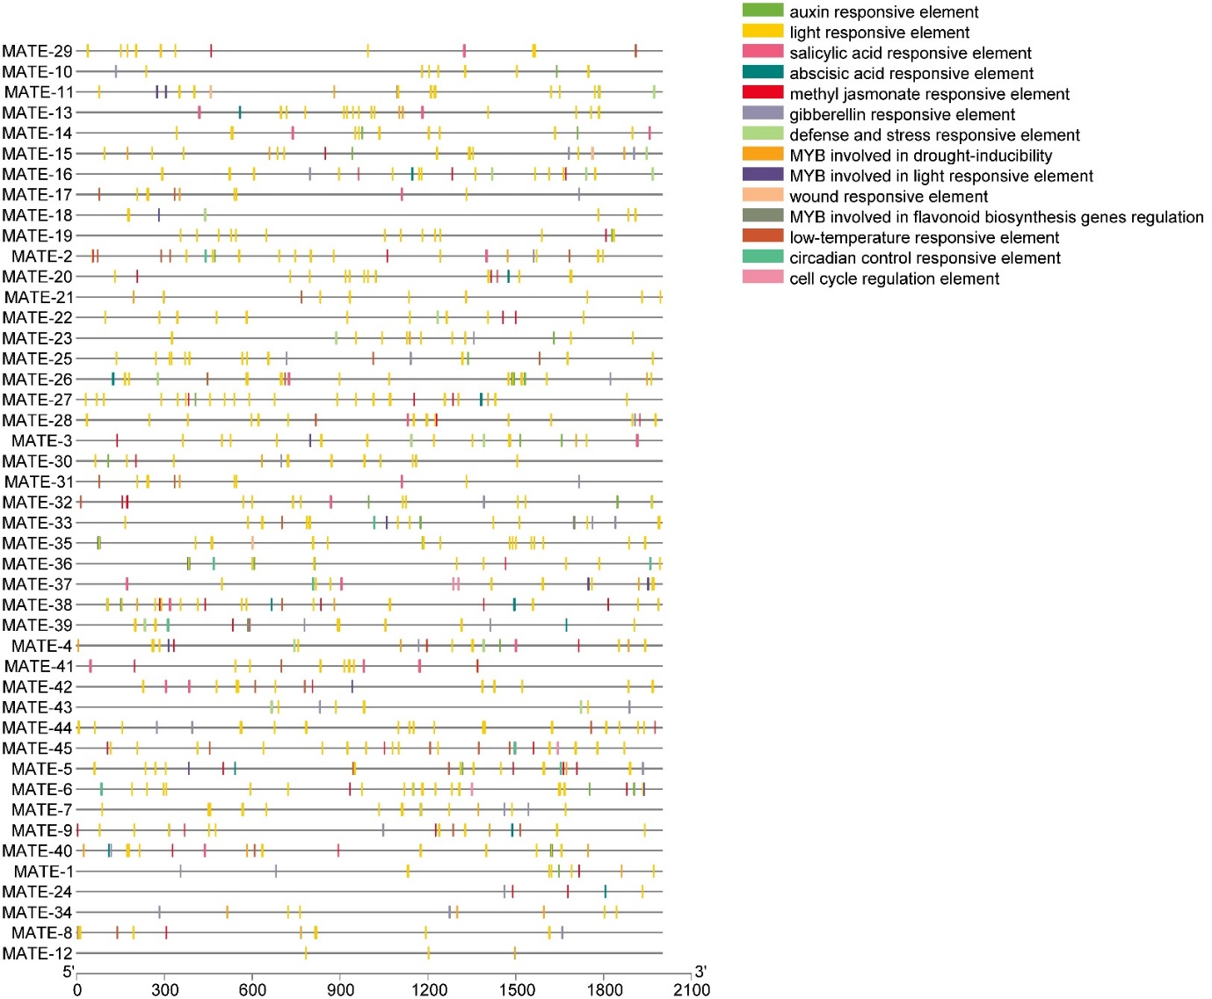

Supplementary Figure 1 Distribution of plant cis-elements in the promoter sequences of putative DcMATE

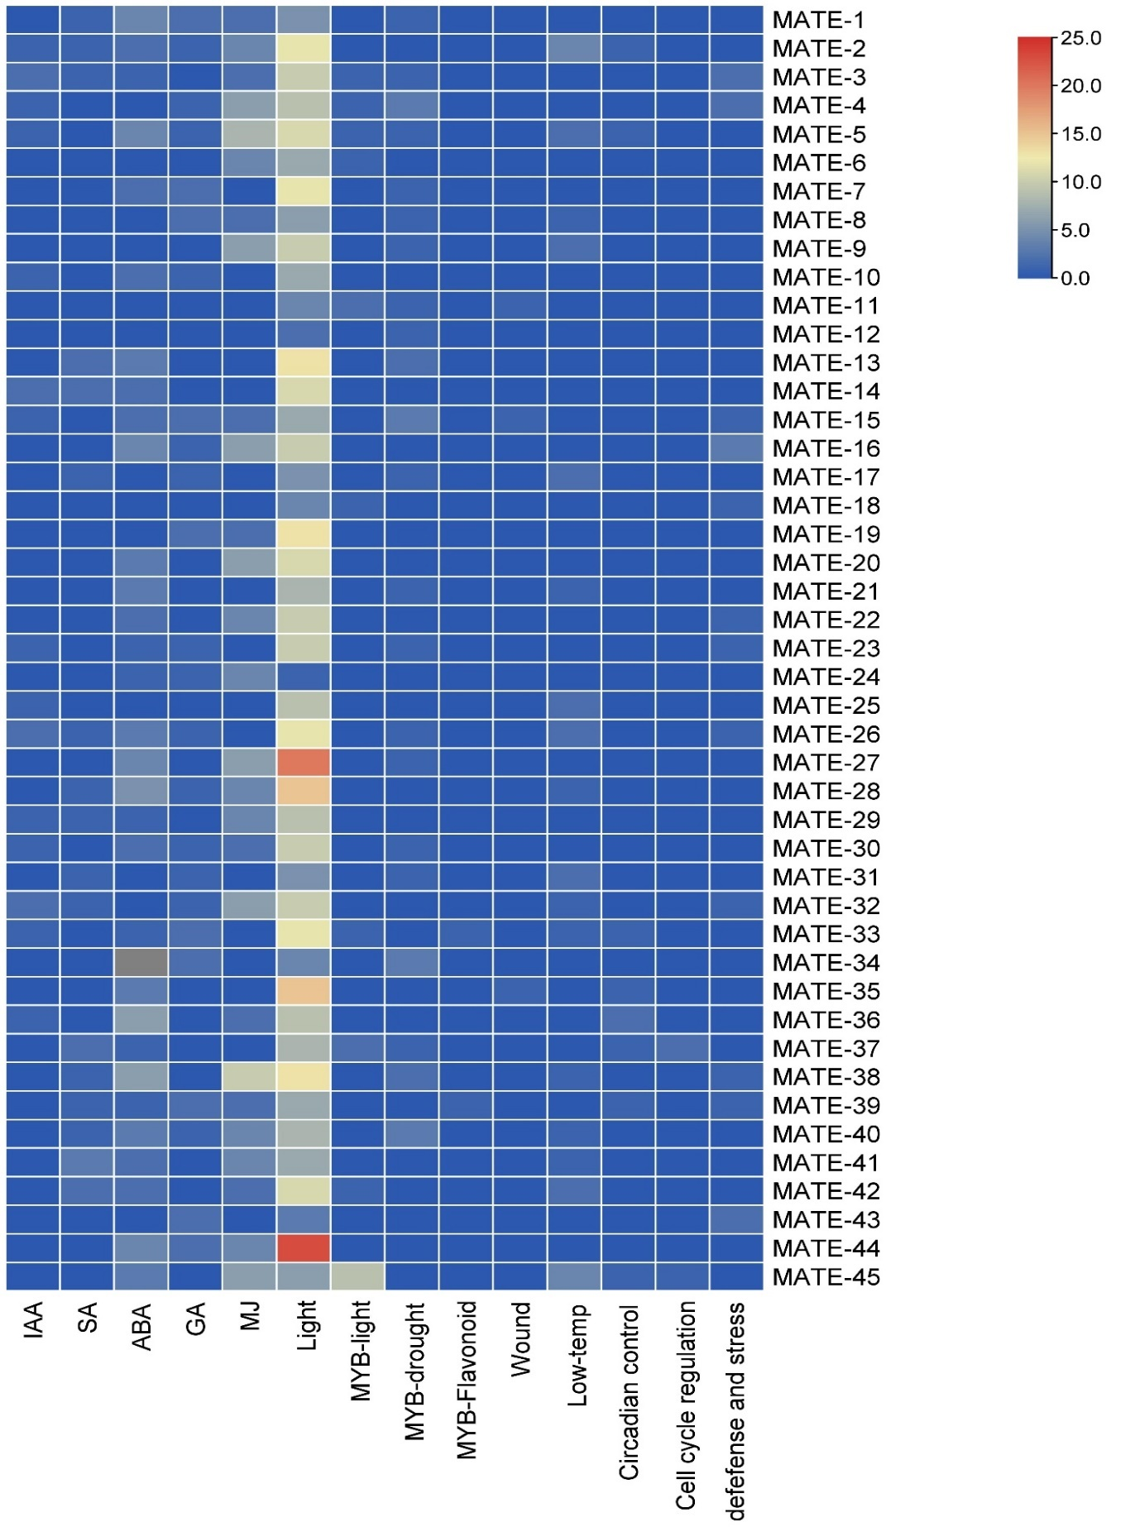

Supplementary Figure 2. The number of different cis-elements present in the promoter sequences of putative DcMATE.
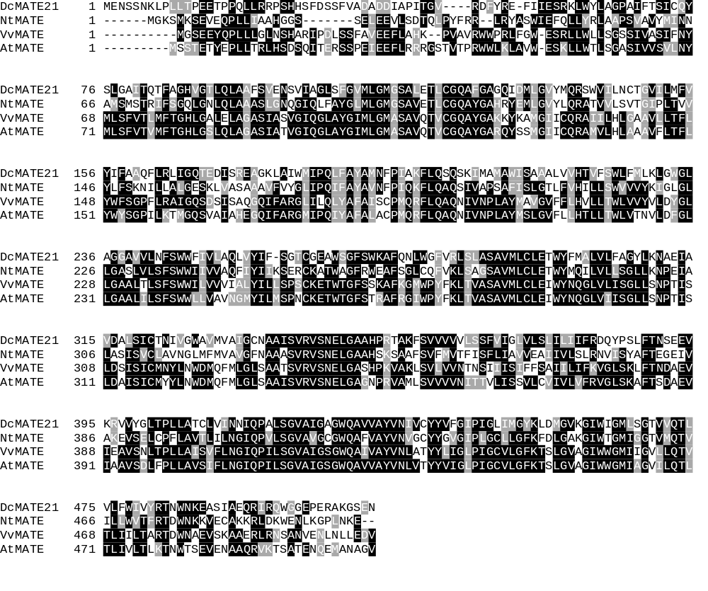
D1
D2
D3
D4
D5
Supplementary Figure 3. Multiple sequence alignment of amino acid sequences of DcMATE21 with selected MATE transporter orthologs from Vitis vinifera, Arabidopsis thaliana, and Nicotiana tabacum. Different conserved are marked with the re arrows

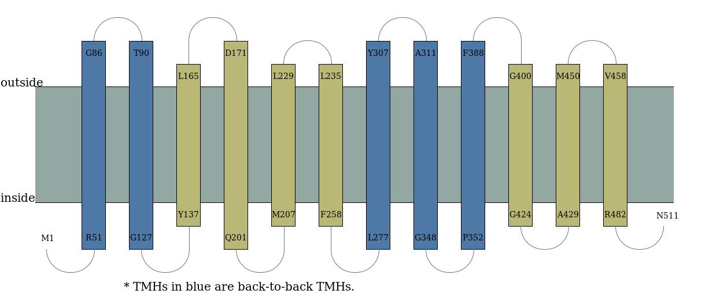
Supplementary figure 4. Predication of DcMATE membrane topology using MemBrain 3.1

