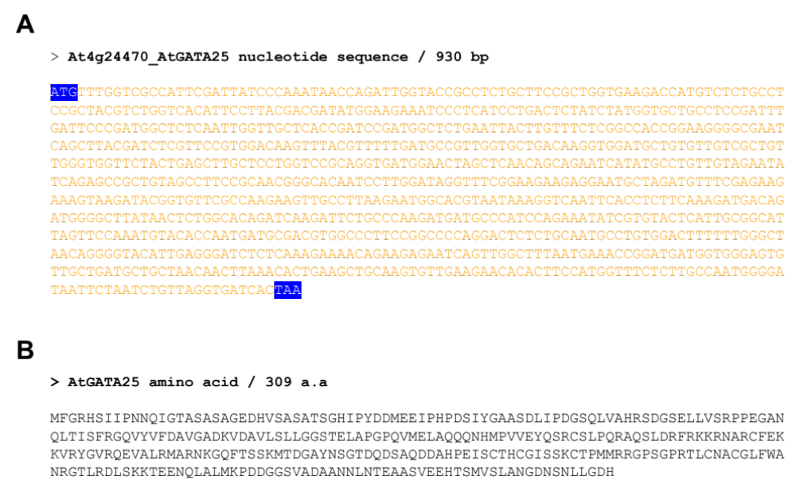
Supplementary Fig. S1 Sequence analysis of AtGATA25 gene. A AtGATA25 cDNA sequence obtained from Arabidopsis thaliana Col-0. B Protein sequence deduced from the AtGATA25 cDNA sequences

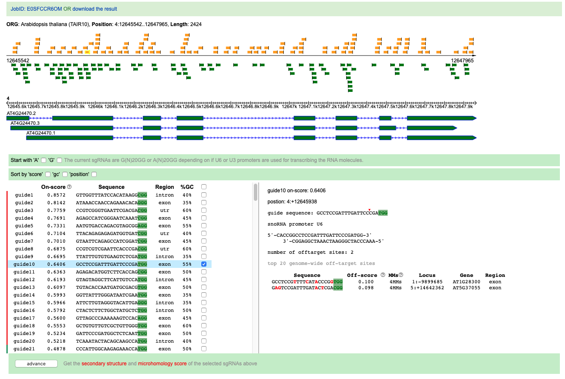
Supplementary Fig. S2 gRNA design result of AtGATA25 from Arabidopsis thaliana using CRISPR-P 2.0

Supplementary Table. S1 List of primers used in this study
