Table S1. Evolutionary lineages; sampling localities; number of sampled and analysed individuals per population in parenthesis; sample names (vouchers), in bold samples used to build the catalogue in stacks (M1m4n2, 1 individual/sub-basin); GenBank Accession numbers; % missing data per sample before SNP-filtering; Mean depth coverage per sample. (**GenBank Accession numbers will be provided before publication; data files can be temporarily accessed at https://figshare.com/s/c3ccb964fd75baedcd7f and https://figshare.com/s/ba04242816afcde74cd1)

Lineage | Basin | Sub-basin | River/Sampling location (number of sampled/analyzed individuals after SNP-filtering) | Locality | Sample | GenBank Accession Number | % missing data | Mean depth coverage
Cantabrian | Narcea |  | Narcea 1 (5/5) | Repolles | MNR_2 | xxxxxx | 19.23 | 16.91
 |  |  |  |  | MNR_3 | xxxxxx | 42.89 | 8.89
 |  |  |  |  | MNR_4 | xxxxxx | 27.27 | 8.08
 |  |  |  |  | MNR_5 | xxxxxx | 32.53 | 9.06
 |  |  |  |  | MNR_6 | xxxxxx | 38.10 | 8.41
Cantabrian |  |  | Narcea 2 (5/4) | Longoria | MNL_2 | xxxxxx | 41.13 | 8.01
 |  |  |  |  | MNL_4 | xxxxxx | 53.52 | 6.48
 |  |  |  |  | MNL_5 | xxxxxx | 75.36 | 7.98
 |  |  |  |  | MNL_6 | xxxxxx | 47.40 | 5.42
 |  |  |  |  | MNL_7 | xxxxxx | 26.50 | 11.58
Cantabrian |  |  | Narcea 3 (5/4) | Villanueva de Sorriba | MNS_1 | xxxxxx | 85.38 | 4.50
 |  |  |  |  | MNS_2 | xxxxxx | 45.38 | 6.15
 |  |  |  |  | MNS_3 | xxxxxx | 35.80 | 12.80
 |  |  |  |  | MNS_4 | xxxxxx | 29.24 | 10.28
 |  |  |  |  | MNS_6 | xxxxxx | 25.25 | 9.88
Cantabrian |  |  | Narcea 4 (5/4) | Villar de Lantero | MNV_1 | xxxxxx | 60.44 | 7.97
 |  |  |  |  | MNV_2 | xxxxxx | 53.32 | 10.67
 |  |  |  |  | MNV_4 | xxxxxx | 27.30 | 9.22
 |  |  |  |  | MNV_5 | xxxxxx | 51.96 | 8.14
 |  |  |  |  | MNV_6 | xxxxxx | 41.19 | 7.53
Cantabrian | Esqueiro |  | Esqueiro (5/5) | San Pedro de la Ribera | MEPR_1 | xxxxxx | 37.62 | 7.82
 |  |  |  |  | MEPR_2 | xxxxxx | 35.91 | 10.99
 |  |  |  |  | MEPR_3 | xxxxxx | 21.49 | 12.07
 |  |  |  |  | MEPR_4 | xxxxxx | 25.58 | 10.45
 |  |  |  |  | MEPR_5 | xxxxxx | 37.62 | 8.12
Cantabrian | Esva |  | Esva (5/5) | Meres | MEM_1 | xxxxxx | 47.78 | 11.60
 |  |  |  |  | MEM_4 | xxxxxx | 28.15 | 10.15
 |  |  |  |  | MEM_5 | xxxxxx | 30.81 | 10.38
 |  |  |  |  | MEM_6 | xxxxxx | 25.39 | 7.38
 |  |  |  |  | MEM_7 | xxxxxx | 27.40 | 8.73
Cantabrian | Porcia |  | Porcia (5/2) | Ermita de los Remedios | MPR_1 | xxxxxx | 27.80 | 6.21
 |  |  |  |  | MPR_4 | xxxxxx | 66.69 | 4.16
 |  |  |  |  | MPR_5 | xxxxxx | 32.61 | 11.90
 |  |  |  |  | MPR_6 | xxxxxx | 88.21 | 9.57
 |  |  |  |  | MPR_7 | xxxxxx | 67.68 | 6.21
Cantabrian | Navia |  | Navia (5/4) | Evernalla | MNE_1 | xxxxxx | 25.30 | 11.11
 |  |  |  |  | MNE_2 | xxxxxx | 42.87 | 6.77
 |  |  |  |  | MNE_3 | xxxxxx | 22.40 | 11.32
 |  |  |  |  | MNE_4 | xxxxxx | 24.42 | 5.99
 |  |  |  |  | MNE_6 | xxxxxx | 65.52 | 12.50
Cantabrian | Eo |  | Eo (5/5) | Trasdacorda | MET_1 | xxxxxx | 27.54 | 10.17
 |  |  |  |  | MET_2 | xxxxxx | 22.35 | 9.48
 |  |  |  |  | MET_3 | xxxxxx | 38.20 | 7.95
 |  |  |  |  | MET_4 | xxxxxx | 25.59 | 13.10
 |  |  |  |  | MET_6 | xxxxxx | 31.06 | 6.48
Cantabrian | Ouro |  | Ouro (5/4) | Castro de Ouro | MOU_1 | xxxxxx | 26.31 | 9.28
 |  |  |  |  | MOU_1 | xxxxxx | 67.71 | 12.08
 |  |  |  |  | MOU_1 | xxxxxx | 37.92 | 7.95
 |  |  |  |  | MOU_1 | xxxxxx | 26.59 | 13.10
 |  |  |  |  | MOU_1 | xxxxxx | 31.06 | 6.48
Cantabrian | Tagus | Alberche | Alberche (5/4) | Burgohondo | MAL_1 | xxxxxx | 50.95 | 3.89
 |  |  |  |  | MAL_2 | xxxxxx | 81.77 | 7.87
 |  |  |  |  | MAL_3 | xxxxxx | 56.59 | 7.70
 |  |  |  |  | MAL_5 | xxxxxx | 54.17 | 7.38
 |  |  |  |  | MAL_6 | xxxxxx | 52.62 | 6.61
Atlantic | Mandeo |  | Mandeo (5/5) | O Sisto | MMdeo_1 | xxxxxx | 30.68 | 14.32
 |  |  |  |  | MMdeo_1 | xxxxxx | 33.64 | 10.38
 |  |  |  |  | MMdeo_1 | xxxxxx | 34.63 | 12.10
 |  |  |  |  | MMdeo_1 | xxxxxx | 26.75 | 9.67
 |  |  |  |  | MMdeo_1 | xxxxxx | 24.48 | 16.30
Atlantic | Tambre |  | Tambre (5/5) | Ponte Carreira | MTamb_1 | xxxxxx | 37.04 | 14.90
 |  |  |  |  | MTamb_2 | xxxxxx | 24.96 | 11.22
 |  |  |  |  | MTamb_3 | xxxxxx | 20.62 | 12.69
 |  |  |  |  | MTamb_4 | xxxxxx | 36.50 | 8.19
 |  |  |  |  | MTamb_5 | xxxxxx | 29.32 | 9.89
Atlantic | Ulla | Ulla | Ulla (5/5) | Antas de Ulla | A_720 | xxxxxx | 18.81 | 13.04
 |  |  |  |  | A_721 | xxxxxx | 15.20 | 10.25
 |  |  |  |  | A_727 | xxxxxx | 26.60 | 20.42
 |  |  |  |  | A_730 | xxxxxx | 21.19 | 9.56
 |  |  |  |  | A_734 | xxxxxx | 18.08 | 12.52
Atlantic | Ulla | Arnego | Arnego (5/5) | Vila de Cruces | A_518 | xxxxxx | 21.32 | 9.94
 |  |  |  |  | A_522 | xxxxxx | 22.52 | 10.18
 |  |  |  |  | C_018 | xxxxxx | 25.68 | 10.41
 |  |  |  |  | C_019 | xxxxxx | 31.91 | 9.96
 |  |  |  |  | C_021 | xxxxxx | 32.92 | 9.48
Atlantic | Miño | Bibey | Bibey (5/5) | San Sebastián | MBib_1 | xxxxxx | 52.42 | 8.58
 |  |  |  |  | MBib_2 | xxxxxx | 39.60 | 8.40
 |  |  |  |  | MBib_3 | xxxxxx | 24.67 | 11.14
 |  |  |  |  | MBib_4 | xxxxxx | 22.75 | 6.93
 |  |  |  |  | MBib_5 | xxxxxx | 50.78 | 6.91
Atlantic | Neiva |  | Neiva (5/5) | Balugães | MNe_2 | xxxxxx | 34.34 | 10.05
 |  |  |  |  | MNe_2 | xxxxxx | 32.22 | 9.53
 |  |  |  |  | MNe_2 | xxxxxx | 32.10 | 10.59
 |  |  |  |  | MNe_2 | xxxxxx | 41.39 | 10.67
 |  |  |  |  | MNe_2 | xxxxxx | 34.49 | 11.42
Douro | Douro | Tâmega | Tâmega (5/5) | Cavês | MTa_1 | xxxxxx | 36.38 | 10.49
 |  |  |  |  | MTa_2 | xxxxxx | 43.77 | 10.78
 |  |  |  |  | MTa_3 | xxxxxx | 32.21 | 10.59
 |  |  |  |  | MTa_4 | xxxxxx | 41.39 | 10.67
 |  |  |  |  | MTa_5 | xxxxxx | 34.49 | 11.42
Douro | Douro | Tâmega | Beça G (5/5) | Gondiães | MBG_1 | xxxxxx | 38.12 | 9.87
 |  |  |  |  | MBG_2 | xxxxxx | 35.81 | 9.35
 |  |  |  |  | MBG_3 | xxxxxx | 32.88 | 10.42
 |  |  |  |  | MBG_4 | xxxxxx | 39.81 | 10.27
 |  |  |  |  | MBG_5 | xxxxxx | 33.45 | 9.12
Douro | Douro | Tâmega | Beça C (5/5) | Canedo | MBC_1 | xxxxxx | 42.66 | 9.87
 |  |  |  |  | MBC_2 | xxxxxx | 42.22 | 8.10
 |  |  |  |  | MBC_3 | xxxxxx | 42.12 | 7.85
 |  |  |  |  | MBC_4 | xxxxxx | 69.22 | 5.98
 |  |  |  |  | MBC_5 | xxxxxx | 48.39 | 10.07
Douro | Douro | Tâmega | Terva (5/5) | Boticas | MTr_1 | xxxxxx | 41.05 | 10.48
 |  |  |  |  | MTr_2 | xxxxxx | 43.72 | 9.84
 |  |  |  |  | MTr_3 | xxxxxx | 37.51 | 10.86
 |  |  |  |  | MTr_4 | xxxxxx | 53.78 | 8.77
 |  |  |  |  | MTr_5 | xxxxxx | 46.49 | 6.96
Douro | Douro | Tua | Mente (5/5) | São Jomil | MMJ_2 | xxxxxx | 36.87 | 9.72
 |  |  |  |  | MMJ_3 | xxxxxx | 41.20 | 10.96
 |  |  |  |  | MMJ_4 | xxxxxx | 38.93 | 10.41
 |  |  |  |  | MMJ_5 | xxxxxx | 35.73 | 9.96
 |  |  |  |  | MMJ_7 | xxxxxx | 26.50 | 11.43
Douro | Douro | Tua | Rabaçal | Revelhe | MRR_1 | xxxxxx | 46.05 | 10.55
 |  |  |  |  | MRR_2 | xxxxxx | 42.62 | 10.08
 |  |  |  |  | MRR_3 | xxxxxx | 34.22 | 9.02
 |  |  |  |  | MRR_4 | xxxxxx | 39.25 | 10.60
 |  |  |  |  | MRR_5 | xxxxxx | 39.53 | 9.60
Douro | Douro | Tua | Tuela | Fresulfe | MTF_1 | xxxxxx | 29.39 | 10.72
 |  |  |  |  | MTF_2 | xxxxxx | 32.70 | 9.32
 |  |  |  |  | MTF_3 | xxxxxx | 36.41 | 11.27
 |  |  |  |  | MTF_4 | xxxxxx | 34.70 | 9.76
 |  |  |  |  | MTF_5 | xxxxxx | 38.71 | 10.35
Douro | Douro | Paiva | Paiva V (5/5) | Várzea | MPV_1 | xxxxxx | 29.39 | 10.72
 |  |  |  |  | MPV_3 | xxxxxx | 32.70 | 9.32
 |  |  |  |  | MPV_4 | xxxxxx | 36.41 | 11.27
 |  |  |  |  | MPV_5 | xxxxxx | 39.19 | 10.78
 |  |  |  |  | MPV_6 | xxxxxx | 33.95 | 8038
Douro | Douro | Paiva | Paiva C (5/4) | Castro Daire | MPCD_1 | xxxxxx | 25.66 | 6.93
 |  |  |  |  | MPCD_2 | xxxxxx | 70.60 | 10.38
 |  |  |  |  | MPCD_3 | xxxxxx | 49.48 | 11.05
 |  |  |  |  | MPCD_5 | xxxxxx | 23.40 | 8.24
 |  |  |  |  | MPCD_6 | xxxxxx | 25.58 | 10.10

Table S2. Basic genetic diversity statistics estimated by the populations program of STACKS. Sites is the number of sites that have data for a particular population; Variant sites is the number of those sites that are polymorphic in at least one population; Private sites are alleles that are found only in a single populations; Polymorphic sites is the number of sites that are polymorphic within a particular population; % polymorphic sites is the percentage of sites that are polymorphic considering the total number of sites that have data for a particular population; and FIS is the inbreeding coefficient.
Population | Sites | Variant sites | Private sites | Polymorphic sites | % polymorphic sites | FIS | StdErr  FIS
Narcea 4 | 30831 | 30807 | 77 | 3435 | 11.14 | 0.0020 | 0.0053
Narcea 3 | 31374 | 31348 | 81 | 3630 | 11.57 | -0.0002 | 0.0051
Narcea 2 | 30958 | 30932 | 76 | 3800 | 12.28 | 0.0013 | 0.0053
Narcea 1 | 31603 | 31577 | 104 | 4751 | 15.03 | 0.0019 | 0.0057
Esqueiro | 31609 | 31583 | 105 | 501 | 15.87 | -0.0067 | 0.0055
Esva | 31591 | 31565 | 122 | 4729 | 14.97 | -0.0054 | 0.0057
Porcia | 29598 | 29579 | 35 | 2337 | 7.89 | 0.0038 | 0.0029
Navia | 31499 | 31473 | 91 | 4451 | 14.13 | -0.0076 | 0.0049
Eo | 31639 | 31614 | 133 | 5679 | 17.95 | -0.0037 | 0.0056
Ouro | 31473 | 31447 | 114 | 4737 | 15.05 | 0 | 0.0049
Mandeo | 31544 | 31520 | 114 | 4722 | 14.97 | -0.0025 | 0.006
Tambre | 31583 | 31558 | 162 | 5577 | 17.66 | -0.0026 | 0.0058
Ulla | 31562 | 31536 | 225 | 5465 | 17.31 | -0.0015 | 0.0052
Arnego | 31560 | 31534 | 144 | 5490 | 17.39 | -0.0095 | 0.0057
Bibey | 31354 | 31328 | 114 | 3924 | 12.51 | -0.0049 | 0.006
Neiva | 31597 | 31572 | 97 | 5273 | 16.69 | -0.0119 | 0.0058
Tâmega | 31357 | 31332 | 40 | 4526 | 14.43 | -0.0131 | 0.0064
Beça (19) | 31481 | 31456 | 52 | 4534 | 14.40 | -0.0107 | 0.0062
Beça (18) | 30631 | 30607 | 25 | 3508 | 11.45 | -0.0096 | 0.0055
Terva | 31126 | 31102 | 52 | 4284 | 13.76 | -0.0132 | 0.0065
Mente | 31546 | 31520 | 58 | 5163 | 16.37 | -0.0122 | 0.0061
Rabaçal | 31151 | 31125 | 50 | 4435 | 14.24 | -0.0145 | 0.0064
Tuela | 31439 | 31413 | 75 | 5040 | 16.03 | -0.0137 | 0.0062
Paiva (25) | 31465 | 31439 | 79 | 4107 | 13.05 | -0.0052 | 0.0049
Paiva (24) | 31525 | 31500 | 56 | 4290 | 13.61 | -0.0101 | 0.006
Alberche | 29406 | 29380 | 167 | 3025 | 10.29 | -0.0018 | 0.0053

Table S3. F_{ST} pairwise comparisons based on the Weir and Cockherhams’ estimator for all localities (above diagonal) and their p-values (below diagonal). In bold, significant p-values at 0.05 level

 | Alberche | Arnego | Beça Canedo | Beça Gondiaes | Bibey | Eo | Esqueiro | Esva | Mandeo | Mente | Narcea 1 | Narcea 2 | Narcea 3 | Narcea 4 | Navia | Neiva | Ouro | Paiva Castro Daire | Paiva Várzea | Porcia | Rabaçal | Tâmega | Tambre | Terva | Tuela | Ulla
Alberche | - | -0.04 | 0.06 | 0.04 | 0.04 | -0.04 | 0.02 | 0.03 | 0.0008 | -0.0008 | -0.001 | 0.006 | 0.01 | 0.03 | -0.002 | 0.001 | -0.05 | 0.007 | 0.03 | 0.004 | 0.04 | 0.05 | -0.04 | 0.06 | 0.007 | 0.001
Arnego | 0.06 | - | 0.01 | 0.04 | 0.04 | 0.05 | 0.07 | 0.08 | 0.04 | 0.05 | 0.07 | 0.001 | 0.08 | 0.02 | 0.06 | 0.06 | 0.03 | 0.07 | 0.07 | 0.03 | 0.04 | 0.06 | 0.02 | 0.04 | 0.04 | 0.07
Beça Canedo | 0.03 | 0.007 | - | -0.1 | 0.07 | 0.04 | 0.08 | 0.08 | 0.05 | -0.007 | 0.07 | 0.03 | 0.09 | 0.06 | 0.06 | 0.002 | 0.02 | 0.05 | 0.03 | 0.06 | -0.0007 | -0.12 | 0.02 | -0.06 | -0.02 | 0.05
Beça Gondiaes | 0.008 | 0.007 | 0.89 | - | 0.06 | 0.06 | 0.1 | 0.1 | 0.07 | 0.03 | 0.08 | 0.03 | 0.1 | 0.04 | 0.08 | 0.04 | 0.04 | 0.07 | 0.06 | 0.06 | 0.03 | -0.06 | 0.04 | -0.04 | 0.01 | 0.09
Bibey | 0.008 | 0.007 | 0.007 | 0.008 | - | 0.05 | 0.08 | 0.07 | 0.06 | 0.06 | 0.05 | 0.05 | 0.06 | 0.04 | 0.08 | 0.07 | 0.02 | 0.08 | 0.09 | 0.07 | 0.08 | 0.08 | 0.03 | 0.09 | 0.07 | 0.07
Eo | 0.04 | 0.006 | 0.009 | 0.007 | 0.008 | - | 0.08 | 0.05 | 0.05 | 0.05 | 0.04 | -0.03 | 0.06 | -0.001 | 0.07 | 0.07 | -0.005 | 0.07 | 0.1 | -0.04 | 0.06 | 0.09 | 0.006 | 0.05 | 0.06 | 0.08
Esqueiro | 0.008 | 0.008 | 0.008 | 0.008 | 0.007 | 0.008 | - | 0.09 | 0.05 | 0.09 | 0.08 | 0.03 | 0.08 | 0.04 | -0.06 | 0.1 | 0.06 | 0.1 | 0.12 | 0.07 | 0.11 | 0.12 | 0.04 | 0.1 | 0.1 | 0.12
Esva | 0.007 | 0.007 | 0.007 | 0.008 | 0.008 | 0.008 | 0.007 | - | 0.07 | 0.09 | 0.04 | 0.002 | 0.05 | 0.02 | 0.09 | 0.11 | 0.03 | 0.12 | 0.13 | -0.03 | 0.12 | 0.11 | 0.04 | 0.1 | 0.09 | 0.1
Mandeo | 0.01 | 0.009 | 0.007 | 0.008 | 0.007 | 0.008 | 0.007 | 0.008 | - | 0.08 | 0.07 | 0.03 | 0.06 | 0.04 | 0.04 | 0.08 | 0.03 | 0.08 | 0.09 | 0.04 | 0.08 | 0.1 | 0.02 | 0.09 | 0.08 | 0.1
Mente | 0.009 | 0.007 | 0.008 | 0.009 | 0.007 | 0.007 | 0.006 | 0.007 | 0.009 | - | 0.09 | 0.03 | 0.1 | 0.04 | 0.07 | 0.04 | 0.04 | 0.07 | 0.08 | 0.07 | -0.07 | 0.03 | 0.04 | 0.003 | 0.008 | 0.11
Narcea 1 | 0.01 | 0.008 | 0.006 | 0.008 | 0.008 | 0.007 | 0.006 | 0.009 | 0.008 | 0.007 | - | 0.35 | -0.02 | -0.06 | 0.07 | 0.08 | 0.03 | 0.07 | 0.09 | 0.01 | 0.11 | 0.1 | 0.04 | 0.09 | 0.1 | 0.1
Narcea 2 | 0.03 | 0.009 | 0.03 | 0.007 | 0.007 | 0.049 | 0.009 | 0.008 | 0.008 | 0.008 | -0.5 | - | 0.002 | -0.02 | 0.02 | 0.03 | -0.03 | 0.05 | 0.06 | -0.03 | 0.06 | 0.06 | -0.02 | 0.04 | 0.04 | 0.03
Narcea 3 | 0.03 | 0.006 | 0.03 | 0.007 | 0.007 | 0.006 | 0.008 | 0.007 | 0.009 | 0.008 | 0.05 | 0.03 | - | 0.26 | 0.03 | 0.08 | 0.02 | 0.07 | 0.09 | 0.04 | 0.11 | 0.12 | 0.04 | 0.1 | 0.1 | 0.09
Narcea 4 | 0.03a | 0.007 | 0.03 | 0.007 | 0.008 | 0.01 | 0.008 | 0.008 | 0.008 | 0.007 | 0.61 | 0.03 | -0.05 | - | 0.03 | 0.03 | -0.03 | 0.04 | 0.06 | 0.01 | 0.06 | 0.06 | -0.01 | 0.06 | 0.04 | 0.05
Navia | 0.02 | 0.008 | 0.03 | 0.009 | 0.008 | 0.01 | 0.31 | 0.007 | 0.007 | 0.009 | 0.007 | 0.03 | 0.08 | 0.04 | - | 0.1 | 0.04 | 0.09 | 0.11 | 0.05 | 0.09 | 0.1 | 0.03 | 0.09 | 0.09 | 0.11
Neiva | 0.02 | 0.008 | 0.01 | 0.008 | 0.007 | 0.007 | 0.008 | 0.009 | 0.007 | 0.007 | 0.009 | 0.008 | 0.007 | 0.009 | 0.007 | - | 0.05 | 0.08 | 0.06 | 0.07 | 0.03 | 0.05 | 0.06 | 0.03 | 0.03 | 0.12
Ouro | 0.05 | 0.008 | 0.03 | 0.008 | 0.01 | 0.02 | 0.008 | 0.008 | 0.007 | 0.007 | 0.008 | 0.08 | 0.03 | 0.15 | 0.03 | 0.009 | - | 0.05 | 0.07 | -0.02 | 0.05 | 0.07 | -0.03 | 0.04 | 0.05 | 0.07
Paiva Castro Daire | 0.03 | 0.009 | 0.03 | 0.007 | 0.007 | 0.008 | 0.01 | 0.007 | 0.007 | 0.008 | 0.007 | 0.03 | 0.03 | 0.03 | 0.02 | 0.008 | 0.03 | - | -0.04 | 0.08 | 0.09 | 0.1 | 0.05 | 0.07 | 0.09 | 0.12
Paiva Várzea | 0.008 | 0.006 | 0.008 | 0.009 | 0.008 | 0.006 | 0.007 | 0.008 | 0.007 | 0.008 | 0.007 | 0.009 | 0.007 | 0.007 | 0.008 | 0.008 | 0.008 | 0.008 | - | 0.1 | 0.07 | 0.07 | 0.07 | 0.06 | 0.06 | 0.13
Porcia | 0.07 | 0.04 | 0.06 | 0.046 | 0.05 | 0.09 | 0.05 | 0.04 | 0.05 | 0.04 | 0.05 | 0.07 | 0.06 | 0.07 | 0.07 | 0.04 | 0.14 | 0.06 | 0.04 | - | 0.09 | 0.09 | -0.02 | 0.08 | 0.06 | 0.03
Rabaçal | 0.01 | 0.007 | 0.006 | 0.009 | 0.008 | 0.008 | 0.01 | 0.009 | 0.007 | 0.49 | 0.008 | 0.008 | 0.008 | 0.007 | 0.007 | 0.007 | 0.007 | 0.007 | 0.008 | 0.05 | - | 0.02 | 0.04 | 0.002 | -0.0003 | 0.1
Tâmega | 0.008 | 0.007 | 0.99 | 0.18 | 0.008 | 0.006 | 0.007 | 0.01 | 0.009 | 0.008 | 0.008 | 0.008 | 0.008 | 0.009 | 0.008 | 0.007 | 0.009 | 0.008 | 0.008 | 0.05 | 0.006 | - | 0.06 | -0.04 | 0.01 | 0.11
Tambre | 0.12 | 0.01 | 0.007 | 0.008 | 0.007 | 0.008 | 0.007 | 0.009 | 0.009 | 0.01 | 0.008 | 0.06 | 0.008 | 0.04 | 0.007 | 0.009 | 0.007 | 0.008 | 0.006 | 0.05 | 0.008 | 0.008 | - | 0.04 | 0.06 | 0.06
Terva | 0.009 | 0.007 | 0.01 | 0.008 | 0.007 | 0.008 | 0.009 | 0.007 | 0.007 | 0.007 | 0.008 | 0.008 | 0.009 | 0.007 | 0.008 | 0.009 | 0.007 | 0.009 | 0.007 | 0.05 | 0.01 | 0.008 | 0.008 | - | -0.01 | 0.09
Tuela | 0.007 | 0.008 | 0.007 | 0.007 | 0.008 | 0.007 | 0.008 | 0.009 | 0.008 | 0.01 | 0.007 | 0.008 | 0.009 | 0.009 | 0.009 | 0.007 | 0.007 | 0.008 | 0.007 | 0.05 | 0.007 | 0.008 | 0.006 | 0.008 | - | 0.11
Ulla | 0.04 | 0.007 | 0.006 | 0.007 | 0.007 | 0.007 | 0.009 | 0.007 | 0.008 | 0.009 | 0.009 | 0.008 | 0.009 | 0.008 | 0.008 | 0.007 | 0.008 | 0.007 | 0.008 | 0.05 | 0.007 | 0.008 | 0.008 | 0.008 | 0.009 | -

Table S4. AMOVA analysis. * significant at 0.05 p-level

Source of variation | df | sum of squares | Variance components | Percentage of variation
Among hydrological sub-basins | 15 | 13319.602 | 38.78970 | 8.54*
Among locations within hydrological sub-basins | 10 | 3258.804 | -11.33090 | -2.47*
among locations | 212 | 91359.800 | 430.94245 | 94.01*
Total | 237 | 107938.206 | 458.40126

Supplementary Figures
Figure S1- sNMF (A1: K=2, A2: K=3) and Admixture (B1: K=2, B2: K=3) analyses for 26 hydrological locations

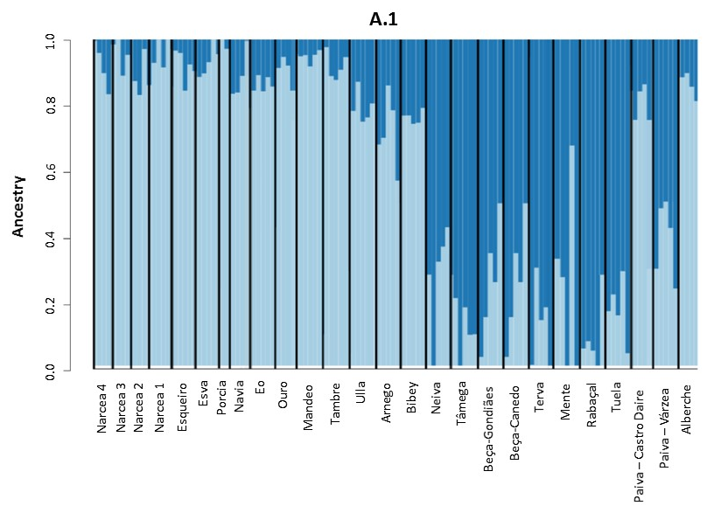
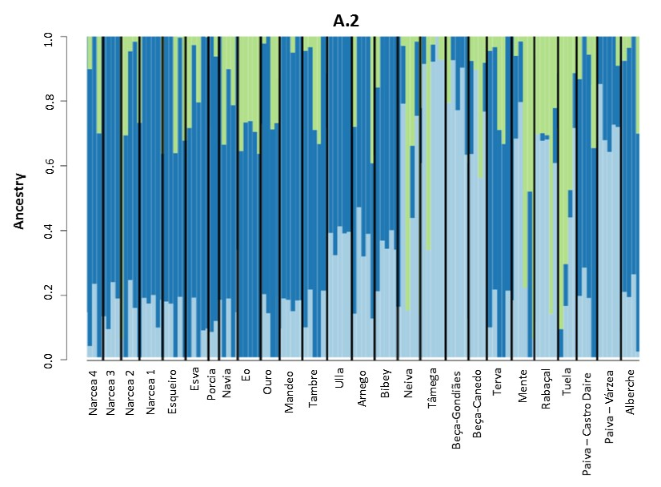

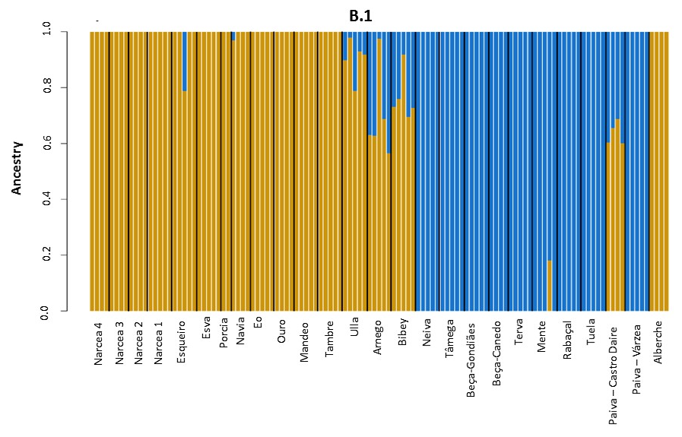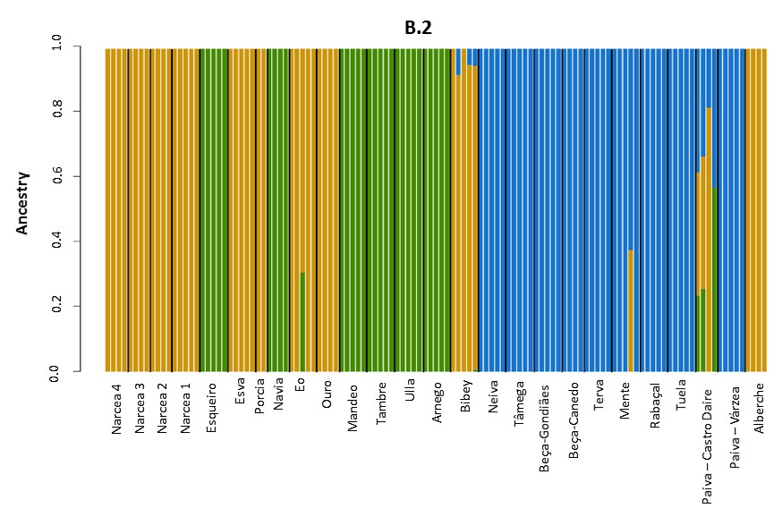

Figure S2 – (A) Cross-entropy for each number of K ancestral populations inferred with sNMF. (B) Mean cross-validation error across 100 ADMIXTURE runs. For each value of K (1 to 16), the point represents the mean cross-validation error of the 100 ADMIXTURE runs performed.

