Thematic Areas: Host Pathogen interaction at molecular level
QTL mapping “for bacterial leaf blight resistance in” RIL’s derived from Danteshwari x Dagad Deshi

Indra Kumar¹, Dr. Ashok Koshariya², Dr. A.S. Kotasthane¹
“Department of Plant Pathology, College of Agriculture, Indira Gandhi Krishi Vishwavidyalaya, Raipur – 492012 (Chhattisgarh”)
Depaetment of Plant Pathology, School of Agriculture, Lovely Professional University, Phagwara, Punjab. Email: indrakemro@gmail.com,
Corresponding author: ashok.koshariya@gmail.com

Abstract
In ”present study, quantitative trait loci (QTL) analysis was carried out using SSR HvSSR markers in F₇ recombinant inbred lines derived from a cross between two potential indica genotypes, Danteshwari and Dagad Deshi”. “A recombinant inbred line (RIL) population consisting of 122 lines was constructed from a cross between Danteshwari a high yielding popular rice cultivar and Dagad Deshi a tall deep rooted poor yielder”. “Six QTL’s were identified on chromosome1, 5, & 9 for bacterial blight tolerance” and explained 0.17% - 8.24% phenotypic variation at LOD value of > 2.5. “Three QTL’s were on CH# 1 (marker interval RM259 to RM243, RM572 to 58.61 cM and RM3825 to 147.21 cM), one on CH#5 (marker interval RM188 to 101.01cM) and two on CH#9 (marker interval HvSSR937 to 67.61 cM, and RM242 to RM278) which influenced lesion length”. “QTL influencing lesion length with positive additive effect” (one) “and negative additive effects” (05) were “identified indicating” that “alleles at these loci are being contributed by either of the parents respectively”.
Key words: QTL, rice, bacterial leaf blight, markers.
Introduction
“The rice crop is susceptible to a number of diseases among which bacterial leaf blight (BLB) caused by Xanthomonas oryzae pv. oryzae (Ishiyama) is one of the oldest known diseases and was first noticed by the farmers of Japan as early as in 1884-85 and now, it occurs globally from Asia to Africa to the Americas with varying degrees of virulence and endemic in many parts of Asia. It is a widespread and destructive disease in irrigated and rainfed environments and it causes 30 to 50% yield loss Ou” [12]. “The first report of bacterial leaf blight of rice from India was made from Bombay region in 1951 Srinivasan et al” [16].”In India, bacterial leaf blight emerged as a serious disease of rice after the introduction of semi dwarf, high yield and susceptible rice cultivars and it occurs in many states of India with yield loss up to 60-80% in severe infections””. “Molecular marker technology that widely used nowadays has been applied for the identification and mapping of genes conferring both complete and partial resistance, Quantitative resistance is controlled by multiple genes or quantitative trait loci (QTL), with each gene or QTL providing a partial increase in resistance. Genetic and molecular evidence have suggested that quantitative resistance can be pathogen race-nonspecific and even pathogen species-nonspecific, that is, broad-spectrum resistance.This type of resistance can also remain effective in cultivars grown for pro-longer periods in environments favorable to the spread of disease. Because no R genes against rice sheath blight, false smut, and bacterial streak have been reported, quantitative resistance may be the only form of resistance against these rice diseases. Resistance QTL against sheath blight, false smut, and bacterial streak has been identified. The resistance QTL and genes contributing to resistance QTL were incorporated into a physical map based on the physical positions of closely linked molecular markers of these QTL and rice genome sequences this approach has been used to display rice QTL for different agronomic traits. These QTL are distributed on all 12 chromosomes, and some of them are quite often clustered in corresponding chromosomal segments. Evidently, resistance QTL against different pathogen species are frequently co localized throughout the 12 chromosomes”. In this study an attempt was made to map QTLs for Bacterial leaf blight resistant using 122 RILs in rice.

Material and methods
Mapping population and Phenotyping
One hundred twenty two F_{7 “}recombinant inbred lines (RILs), derived by single seed descent method from” the cross Danteshwari D₁ (“high yielding popular rice cultivar but moderately susceptible to water stress, susceptible to” sheath blight) and Dagad Deshi D₂ (a “tall deep rooted poor yielder and tolerant to water stress and sheath blight were tested”, “respectively, to detect QTLs of resistance against Bacterial Blight. The 25-day-old seedlings of both RILs and parental lines were transplanted into an experimental field of Indira Gandhi Agricultural University Raipur” (C.G.),. Raipur is located at 21º 16’ N and 81º “36’ E at an altitude of 289.6 m above sea level. “Each line being planted as a single 10- row plot with 10 plants in each row”” Standard agronomic “practices were followed to raise the crop in” nursery and field conditions.
“Isolation and purification of the pathogen (Xanthomonas oryzae pv. Oryzae”)
“Bacterial blight diseased samples were frequently collected from the three geographical area of Chhattisgarh (Raipur, Dhamtari, and Kanker) and carried to the laboratory for isolation of the pathogen. The entire work of isolation was done under isolation chamber and laminar flow, which were sterilized by ethyl alcohol or formaldehyde and UV radiation, prior to use. The bacterial causal organism was isolated from naturally infected rice plant following procedure described by Kotasthane” [5]. “The technique takes the advantage of the natural phenomenon of oozing from the hydathodes/ cut end of the rice leaves. The procedure involves the use of moist chamber prepared by lining the petri-plates with moderately thick layer of wet blotter paper discs (lid and bottom). Rice plant showing natural bacterial blight infection (with advancing lesion) was collected. Small pieces (3-4 cm.) from the infected region were cut using a sharp scalpel blade and were placed in the moist chamber and incubated at 22 ± 1 ºC for 5-6 hours. The cut ends oozed out mass of bacterial cell, which were obseverd as viscous yellow and opaque against transmitted light under a dissecting stereo binocular microscope in the laminar flow. Using a fine point sterilized inoculation needle the bacterial mass from the cut end was then lifted, and streaked on to the medium (wakimoto’s) slants and were incubated at 27± 1 ºC. Bacterial colonies were observed the next day or the day after as smooth, convex, butyrous, whitish yellow to straw yellow colour, and opaque against transmitted light. The organism was then confirmed by challenge inoculation on susceptible rice cultivar TN” (1).
“Culture of Xanthomonas oryzae pv. oryzae isolate thus obtained was purified by repeated isolations on the medium and maintained on the PSA slants and incubated at 27 ± 2ºc till further use. The isolate was identified on the basis of the colony colour and colony characters of the bacterium by confirming with standard reports Ishiyama” [2]; Wakimoto [19]; Isaka [4].
Production of Inoculums and inoculation procedure
Xanthomonas oryzae p.v. oryzae “strain was cultured on a standard semi synthetic potato” sucrose “agar medium for 72 h and then prepared as a suspension (in sterile water) of approximately” 10⁸ “bacteria/ml. Five newly expanded leaves on different tillers of plants in each row plot were simultaneously inoculated with the Xoo strain 60 days after transplanting, using the standard leaf clipping method Kauffman et al” [6]. “Lesion length on each inoculated leaf was measured 21 days after inoculation. At random 5 plants were assessed for disease incidence (by visual observation) and severity (measuring the total leaf length and lesion length). Disease severity was calculated as”:
Total lesion length
“Percent Disease severity (% DS) = -------------------------- x 100
Total leaf length”
Construction of linkage map and QTL analysis
“Genotypic data generated from SSR HvSSR markers were used for linkage map construction using computer software MAPMAKER/EXP, version 3.0. Kosambi function was used to calculate the genetic distances between the markers Kosambi” [8]. “QTL mapping was carried out by Wang et al” [20] (“Composite Interval Mapping) with a threshold value of 2.5 to 3.0 LOD, was used for declaring the presence of a suggestive QTL. Contribution rate” (R² ) “was estimated as the percentage of the total phenotypic variation explained by each locus. Graphical presentation of the linkage map was carried out by using Map Chart 2.2 (http://www.biometris.wur.nl”).
“The genotypic data and field based phenotypic data of bacterial blight lesion size (total leaf length, total lesion length,) was analyzed using QTL cartographer 2.5”.
Result and discussion
“QTL analysis”
“The parents along with RILs exhibited marked variation for the reaction to bacterial blight. Differences were observed for the lesion size between the two parents (Danteshwari and Dagaddeshi). The RILs exhibited transgressive segregation in both directions, which indicated that neither parent contained all the alleles for resistance or susceptibility. Reaction of RILs, for bacterial blight, could not be classified into discrete classes of resistance and susceptibility as they showed continuous variation and skewed distribution that suggested the inheritance is quantitative. Transgressive segregations among the RILs were observed for the Lesion length”.
“The genotypic data and field based phenotypic data of bacterial blight (Lesion Length) was analyzed using QTL cartographer” 2.5. Six QTL‘s “were identified on chromosome1, 5, & 9 for bacterial blight tolerance (Lesion Length) under artificial inoculated conditions” (Table 1).
Table 1. “Identified QTL on D × D derived genotyped RIL population”
“S. No. | CH # | No. of QTLs”
1 | 1 | 3
2 | 5 | 1
3 | 9 | 2
 | Total | 6
QTL mapping was carried out by Wang et al [20] (“Composite Interval Mapping) with a threshold value of 2.5 to 3.0 LOD, was used for declaring the presence of a suggestive QTL. Contribution rate” (R²⁾ “was estimated as the percentage of the total phenotypic variation explained by each locus. The LOD score and phenotypic variance for QTL (LOD 2.5 to 3) ranged from 2.569565217 to 4.434782609 (Table” 3). “One QTL influencing lesion length was with positive additive effect and five QTLs with negative additive effects influencing lesion length was identified indicating that alleles at these loci are being contributed by either of the parents respectively (table” 2)

Table 2:-“Identified QTL influencing bacterial blight lesion size on D × D derived genotyped RIL population under artificial inoculated conditions expressing positive and negative additive effects”

S # | Trait | Ch# | Position | cM interval | Marker interval | Additive effect | R²
QTL with Positive additive effect
1 | 2 | 1 | 146.21 | 145.21 to 147.21 | RM3825 to 147.21 cM | 1.808927 | 1.1285
QTL’s with negative additive effect
1 | 2 | 1 | 42.81 | 40.81 to 42.81 | RM259 to RM243 | -0.676953 | 0.1789
2 | 2 | 1 | 54.61 | 53.11 to 58.61 | RM572 to  58.61 cM | -1.339674 | 0.702
3 | 2 | 5 | 101.01 | 100.01 to 101.01 | RM188 to 101.01cM | -3.831277 | 4.4068
4 | 2 | 9 | 63.91 | 62.91 to 67.61 | HvSSR937 to 67.61 cM | -4.919874 | 8.242
5 | 2 | 9 | 72.11 | 69.21 to 74.11 | RM242 to RM278 | -4.527706 | 7.0316

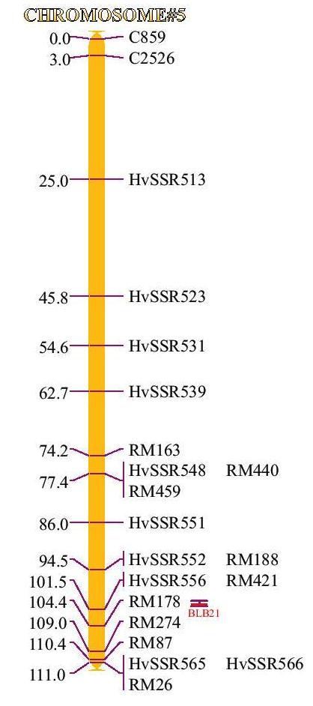
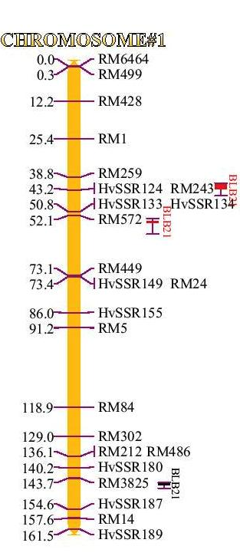

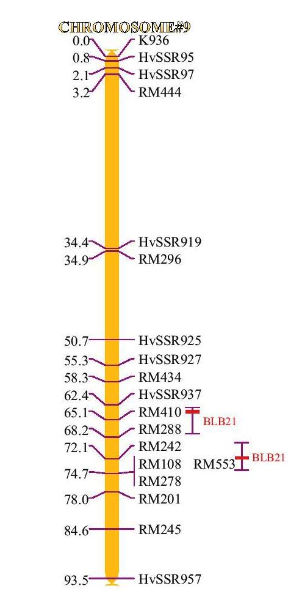
Fig 1: “Identified QTL influencing Bacterial Blight tolerance on D×D derived genotyped RIL population under artificial inoculated” condition CH#1, CH# 5 and CH#9

“QTL's associated with bacterial leaf blight tolerance”
“Six QTL’s on D × D derived genotyped RIL population under artificial inoculated condition was identified. Three QTL’s were on CH# 1 (marker interval RM259 to RM243, RM572 to 58.61 cM and RM3825” o “147.21 cM), one on CH#5 (marker interval RM188 to 101.01cM) and two on CH#9 (marker interval HvSSR937 to 67.61 cM, and RM242 to RM278) which influenced lesion length with LOD values 3.565217391, 2.845652174, 2.569565217, 2.919565217, 4.434782609, 3.52826087 which explained 0.1789, 0.702, 1.1285, 4.4068, 8.242, 7.0316 % phenotypic variation respectively” (Table 3).
“Plants or plant populations exposed to a certain pathogen or pest organism often differ in degree of infestation or infection in quantitative ways. Such differences may be due to environmental or plant development stage differences between plots or to differences in inherited levels of plant defense. Several cultural measures may be applied to reduce the development of foliar diseases, but they have their limitations Jorgensen et al” [3] “The most reliable and environmentally friendly way to protect crops is the growth of cultivars with genetic resistance against their attackers. Breeding for adequate levels of resistance is indeed one of the most important goals in crop breeding. More and more breeders are recognizing the use of quantitative resistance (QR) as a valuable approach to protect crops. In case the level of resistance achieved in a particular plant-pathosystem is not sufficient in some seasons or regions to protect the crop sufficiently, QR is still useful because of the reduction in required pesticide applications Naerstad” et al, [10]. “Screening a panel of accessions of a crop species against propagules of a pathogenic organism (inoculum) nearly always reveals diversity in quality and quantity of infection. Some plants may seem to be not infected at all (immune), others show at most some flecks but no reproduction of pathogens (full resistance), and again others show various levels of infections and pathogen reproduction. Two recent reviews, by Zhang” et al. [22] and by Poland et al. [13], “discuss the genetic and molecular basis of qualitative and quantitative resistances to biotrophic and necrotrophic pathogens, and a review by St. Clair” [15] “discusses particularly the quantitative aspect of resistance”.
“The presence of two major types of disease resistance to plant pathogens ± vertical resistance and horizontal resistance ± has long been recognized in interactions between plant hosts and their pathogens” Vander Plank [18]; Nelson [11]; Simmonds [14]. “Vertical resistance in many plant host-pathogen relationships is hypersensitive, race- specific, and governed by interactions between avirulence genes in pathogens and resistance genes in plant hosts Van der Plank” [18]. “In contrast, horizontal resistance is quantitative, presumably non-race specific, and controlled by polygenes Van der Plank” [18]; Nelson [11], “though these assumptions have not been actively tested. In the genetics of host-pathogen interactions, a long-standing controversial issue is the nature of the genetic basis of `stabilizing selection'' which largely determines the co- evolution of many plant host-pathogen relationships, Van der Plank” [17], [18]; Leonard and Czochor [9]. “This theory states that new pathogenic race(s) will suffer a loss in general fitness when they acquire new virulence genes by mutation. Genetically, this implies that conversion of avirulence genes into corresponding virulence genes by mutation is expected to result in lower fitness of the pathogen. Unfortunately, direct evidence to support this theory has been difficult to obtain. Rice (Oryza sativa L.) bacterial blight caused by Xanthomonas oryzae pv. oryzae (Xoo) is a devastating disease in Asia. Two types of resistance to Xoo, vertical (VR, complete whole-life resistance) and horizontal (HR, quantitative resistance), have been recognized in rice Zhang and Mew” [23]. “VR to Xoo is controlled by at least 20 major genes that are usually race specific Causse et al”. [1]; Q. “Zhang et al. [21]. However, resistance of a segregating rice population to specific Xoo strains often shows both qualitative and quantitative components Koch and Parlevliet” [7]. “These characteristics of the relationship between O. sativa and Xoo offer a unique opportunity to study the genetics of the interaction between host plants and their pathogens”.
“The rapid progress in the development of molecular marker technique has led to the intensive use of quantitative trait loci (QTL) mapping for quantitative resistance against pathogen. Identification and mapping of QTLs is a valuable starting point for positional cloning of genes present in the QTL region of the genomes. It can also help in the interpretation of the molecular and biochemical mechanisms involved in host-pathogen interaction. The QTL studies that are conducted over several years and locations, provided information about which regions of the genome are consistently associated with the target traits. In rice about 8646 QTLs have been reported. Of these 38 QTLs have been identified for sheath blight resistance by using various types of mapping populations (www.gramene.org”

Table 3:-“Identified QTL influencing bacterial leaf blight lesion size on D×D derived genotyped RIL population under artificial inoculated conditions”

S # | Trait | Ch# | Position | cM interval | Marker # | Marker interval | LOD | Additive effect | R²
1 | 2 | 1 | 42.81 | 40.81 to 42.81 | 5 | RM259 to RM243 | 3.565217391 | -0.676953 | 0.1789
2 | 2 | 1 | 54.61 | 53.11 to 58.61 | 10 | RM572 to 58.61 cM | 2.845652174 | -1.339674 | 0.702
3 | 2 | 1 | 146.21 | 145.21 to 147.21 | 21 | RM3825 o 147.21 cM | 2.569565217 | 1.808927 | 1.1285
4 | 2 | 5 | 101.01 | 100.01 to 101.01 | 13 | RM188 to 101.01cM | 2.919565217 | -3.831277 | 4.4068
5 | 2 | 9 | 63.91 | 62.91 to 67.61 | 10 | HvSSR937 to 67.61 cM | 4.434782609 | -4.919874 | 8.242
6 | 2 | 9 | 72.11 | 69.21 to 74.11 | 13 | RM242 to RM278 | 3.52826087 | -4.527706 | 7.0316

Tying genetic linkage map to physical map
“Identification of map position was accomplished by identifying BAC or PAC clones that simultaneously contained a hit from the microsatellite marker. Forward primer sequences of genotyped polymorphic marker(s) were used for blast analysis to detect the physical position of the molecular markers and the BAC / PAC clones to which they were anchored. By way of these co-mapped markers, the map in this study is tied to the physical and sequence map developed by the International Rice Genome Sequencing Project (http://rgp.dna.affrc.go.jp/; http://www.usricegenome.org/; http://genome.arizona.edu/fpc/rice/; http://www .gramene. org/) and the principal mapping populations used by the rice scientific community. The BAC / PAC clone to which the molecular marker was anchored also contained an anchored RFLP marker along with its cM distance on the IRGSP Build 5 BAC / PAC map. The cM distance of the RFLP marker was extrapolated / assumed for the genotyped polymorphic marker(s) anchored to the clone. In the order of their occurrence on the BAC /PAC map the cM distance generated for each genotyped polymorphic marker(s) was used for developing linkage map and for QTL analysis in QTL cartographer”.
References

      - Causse, M., Fulton, T.M., Cho, Y.G., Ahn, S.N., Wu, K., Xiao, J., Chunwongse, J., Yu, Z., Ronald, P.C., Harrington, S.B., Second, G.A., McCouch, S.R. and Tanksley, S.D.1994. Saturated molecular map of the rice genome based on an interspecific back cross population. Genetics.138: 1251-1274.
- Ishiyama, S. 1922. Studies on bacterial blight. Rep. Agric.Exp.Sta.Tokyo, 45:231-261.
- Jorgensen, J.H., Moseman, J.G. 1972. Recombination at the Ml-a locus in barley conditioning resistance to Erysiphe graminis f. sp. hordei. Can. J. Genet. Cytol. 14:43–48.
- Isaka , M. 1970. A new detection method for the pathogen of bacterial blight of rice (Xanthomonas oryzae p.v. oryzae)by means of bacterial exudation. Ann. Phytopathol. Sci.Japan., 36:313-318
- Kotasthane, A.S. 2003. A simple technique for isolation of Xanthomonas oryzae p.v. oryzae. J. Mycol.and Plant Pathol.;33 (2) :277-278.
- Kauffman, H. E., Reddy, A.P.K., Hsien, S.P.Y., Merca, S. D. 1973. An improved technique for evaluating resistance of rice varieties to Xanthomonas oryzae. Plant Dis Rep 57:537–541.
- Koch, M. and Prlevliet, J.E. 1991. Residual effects of the Xa-4 resistance gave in three rice cultivares when exposed to a virulent isolate of Xanthomonas campestris pv. Oryzae. Euphytica. 53:187-193.
- Kosambi, D.1944. The estimation of map distance from recombination values. Ann. Eugen.12:172-175.
- Leonard, K.J. and Czochor, R.J. 1980. Theory of genetic interactions among populations of plants and their pathogens. Annu. Rev. Phytopathol.18:237-258.
- Naerstad, R., Hermansen A, Bjor, T. 2007. Exploiting host resistance to reduce the use of fungicides to control potato late blight. Plant Pathol. 56:156–66
- Nelson, R. R., 1972. Stabilizing racial populations of plant pathogens by use of resistance genes. J. Environ. Qual. 1(3): 220–227.
- Ou, S.H. 1985. Rice Disease. (Commonwealth) Mycological Institute New Surrey, 2nd ed. England. 61-96.
- Poland J. A., Balint-Kurti P. J., Wisser R. J., Pratt R.C., Nelson R.J. 2009. Shades of gray: the world of quantitative disease resistance. Trends Plant Sci. 14:21–29.
- Simmonds, N. W. 1979. Principles of crop improvement. Longman, London-New York.
- St. Clair DA. 2010. Quantitative disease resistance and quantitative resistance loci in breeding. Annu. Rev. Phytopathol. 48:247–68.
- Srinivasan, M.C., Thirumalachor, M.J., Patel, M.K.1959. Bacterial blight disease of rice. Curr. Sci. 28:469-470.
- Van der Plank J. E. 1963. Plant diseases: epidemics and control. Academic Press, London-New York.
- Van der Plank, J.E.1968. Disease resistance in plants. Academic Press. New York London.
- Wakimoto, S. 1967. Strain of Xanthomonas oryzae p.v.oryzae in asia and their virulence against rice variety. Proc. Symposium on rice disease and control by growing resistant variety and other measures. Agriculture, Forestry and Fisheries Research Council, ministry of Agriculture and Forestry.Tokoyo,japan PP.19-24
- Wang,S.,Basten, C. J. and Zeng, Z.B. 2005. Window QTL cartographer version 2.5. Statistical genetics. North Carolina State Uni., Raleigh. 27695-7566.
- Zhang, Q., Angeles, E. R., Abenes, M.L.P., Khush, G.S. and Huang, N. 1996. RAPD and RFLP mapping for the bacterial blight resistance gene xa-13 in rice. Theor. Appl. Genet. 93:65-70.
- Zhang Y, Lubberstedt T, Xu ML. 2013. The genetic and molecular basis of plant resistance to pathogens. J. Genet. Genomics 40:23–35 136.
- Zhang, Qi and Mew, T.W. 1985. Adult plant resistance of rice cultivars to bacterial blight. Plant Dis. 69:896-898.

