Supplementary data

Supplementary Table 1: Clinical symptoms of Cases recruited at baseline and 2 months follow-up

Cohort | N | Night Sweat | Chest  Pain | Weight  Loss | Extreme Cough | Mild  cough
Baseline  TB – Only  TB – DM  TB - HIV | 60  23  7 | 53  5  5 | 50  6  7 | 60  8  7 | 46  7  6 | 14  3  1
Follow-up  TB – Only  TB – DM  TB - HIV | 35  10  5 | 8  3  1 | 14  1  3 | 12  1  1 | 2  1  2 | 30  3  3

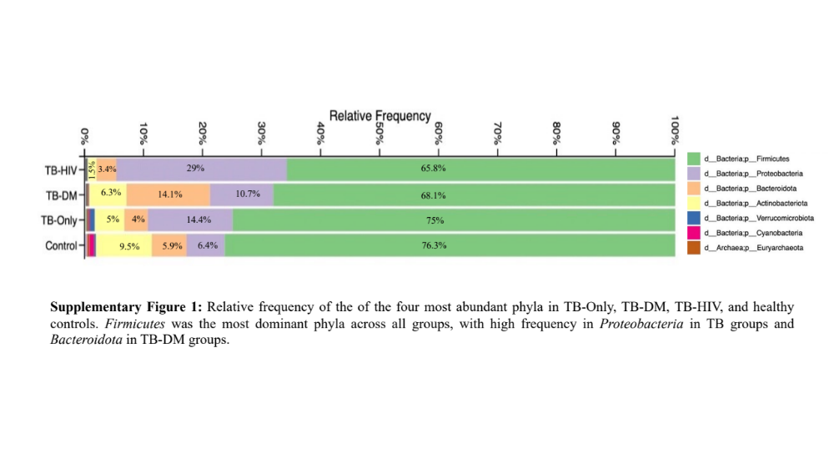

At the phylum level, healthy controls had the highest relative frequency of Firmicutes and Actinobacteriota compared to all the TB cohorts. However, in the TB-cohorts (TB-only, TB-HIV and TB-DM), Proteobacteria was highly abundant in all the chorts with the highest in TB-HIV while in the TB-DM cohorts, Bacteroidota was higly abaundant.

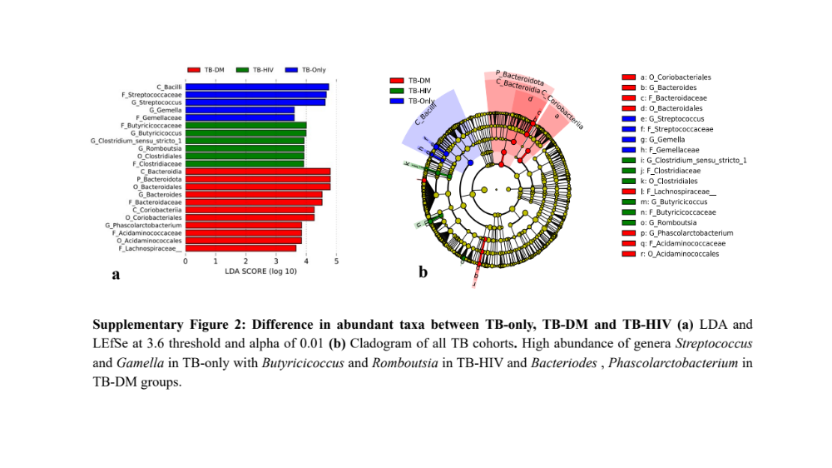

Amongst the three different TB cohorts, the genus Streptococcus of the class Bacilli was significantly dominant in the TB-only cohorts followed by the genus Gamella. Between the TB-DM cohort, the genus Bacteriodes of the phylum Bacteroidota, class Bacteroidia was significantly abundant. In addition, the genus Phascolarctobacterium was also abundant of the family Acidaminococcaceae. Within the TB-HIV cohort, the genera Butyriccoccus, Clostridium sensu stricto and Romboutsia were highy abundant.
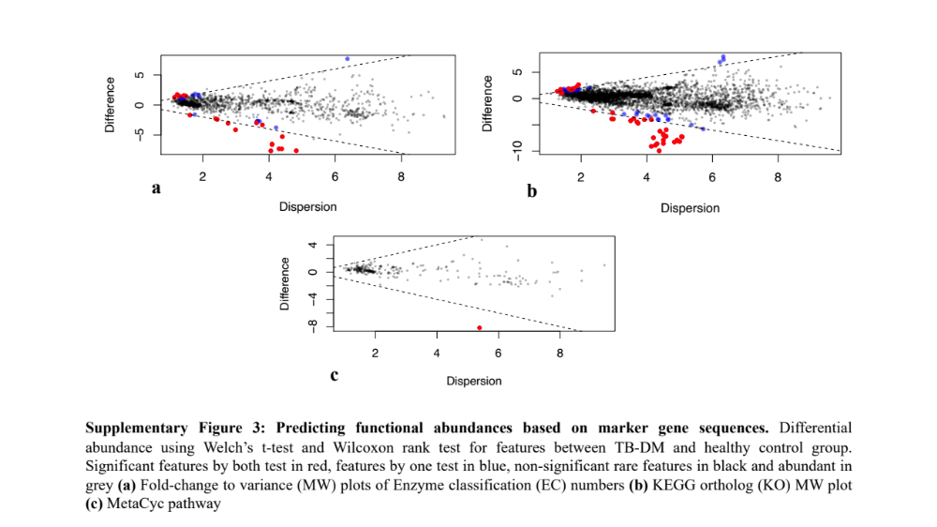
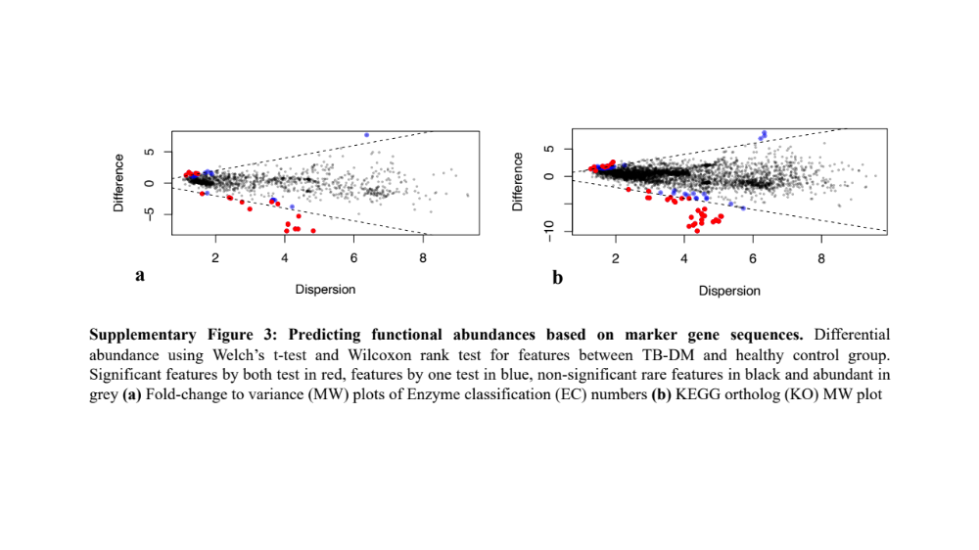

Alignment with PICRUSt2 identified a total of 4479 genes and genomes with 1350 enzyme classification numbers predicted and mapped into 252 metabolic pathways. A total of 37 pathways and 19 enzyme classification were significantly different between the TB diabetic comorbid groups and the healthy controls, of which 28 genes and 14 enzymes were decreased in TB-DM groups.

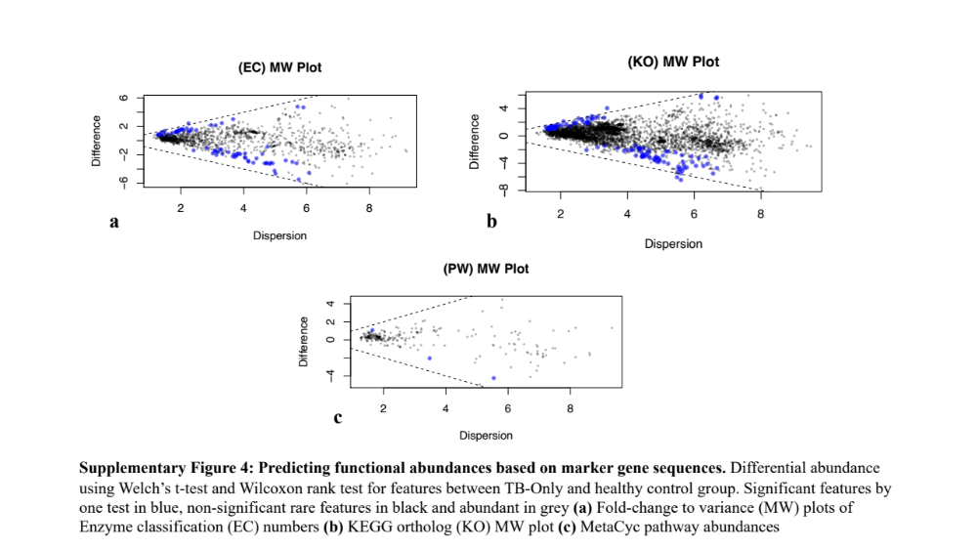

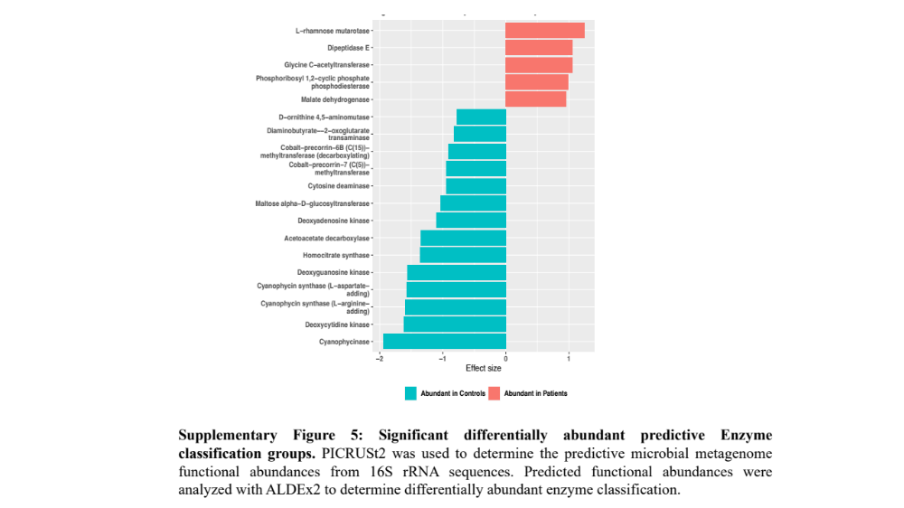

The enzymes groups L-rhamnose mutarotase, Dipeptidase E, Glycine C- acetyl tranferase and Malate dehydrogenase was abundant in TB-cohorts with depletion in other enxymes Cyanophycinase, Deoxycytidine kinase, Cyanophycin synthase , Deoxyguanosine kinase and Homocitrate synthase depleted in the TB-DM cohorts but abundant in healthy controls

Phylum | Class | Order | Family | Genus | Mean relative abundance (%)
 |  |  |  |  | TB-Only | TB-TDM | TB-HIV | Control
Firmicutes | Bacilli | Lactobacillales | Streptococcaceae | Streptococcus | 9.5 | 2 | 6.1 | 1.6
Firmicutes | Bacilli | Lactobacillales | Enterococcaceae | Enterococcus | 5.1 | 5.7 | 12.3 | 0.3
Firmicutes | Bacilli | Erysipelotrichales | Erysipelotrichaceae | Holdermanella | 1 | 1.8 | 0.9 | 2.8
Firmicutes | Bacilli | Erysipelotrichales | Erysipelatoclostridiaceae | Erysipelatoclostridium | 3.6 | 3.3 | 1 | 0
Firmicutes | Clostridia | Lachnospirales | Lachnospiraceae | Blautia | 6.5 | 8.6 | 3.3 | 4.8
 |  |  |  | gnavus_group | 4.3 | 1.4 | 1.6 | 0
 |  |  |  | Agathobacter | 0.7 | 0.6 | 1.6 | 4
 |  |  |  | Dorea | 2 | 1 | 1 | 2.7
Firmicutes | Clostridia | Oscillospirales | Ruminococcaceae | Faecalibacterium | 4.6 | 5.8 | 4.9 | 5.7
 |  |  |  | Subdoligranulum | 4.7 | 3.5 | 0.8 | 3.6
 |  |  |  | CAG.352 | 2.9 | 1.3 | 0.9 | 3.9
Proteobacteria | Gammaproteobacteria | Enterobacteriales | Enterobacteriaceae | Escherichia-Shigella | 11 | 9.2 | 8.7 | 0.9
 |  |  |  | Klebsiella | 2.4 | 0.4 | 19.7 | 2.16
Bacteriodetes | Bacteriodia | Bacteriodales | Prevotellaceae | Prevotella | 1.2 | 3.4 | 2.4 | 2.7
Bacteriodetes | Bacteriodia | Bacteriodales | Bacteriodaceae | Bacteriodes | 1.8 | 7.5 | 2.4 | 0.9
Actinobacteriota | Actinobacteria | Bifidobacteriales | Bifidobacteriaceae | Bifidobacterium | 1.3 | 1.8 | 0.8 | 4.4
Actinobacteriota | Coriobacteriia | Coriobacteriales | Coriobacteriaceae | Collinsella | 0.7 | 0.6 | 1.6 | 2.5

Table 2: Top abundant genera in gut microbiome of the three TB cohorts (TB-only, TB-DM, TB-HIV) and healthy controls

