Supplementary Information (SI)

Catalytic degradation of Methylene blue by Biosynthesized Au Nanoparticles on titanium dioxide (Au@TiO₂)

Yanan Wang,^{a, b#} Tieliang Zhang,^{a#} Yujie Zhao,ª Tong Lv,ª Wenjing Liu,^{a,}* and Xiaowei Liu ª

ªKey Laboratory for Environmental Factors Control of Agro-product Quality Safety, Agro-Environmental Protection Institute, Ministry of Agriculture and Rural Affairs, Tianjin 300191, China.

^{b}Nanjing Municipal Design and Research Institute Co., Ltd, Nanjing 210008, China.

#The first two authors contributed equally to this work.

E-mail: liuwenjing@caas.cn

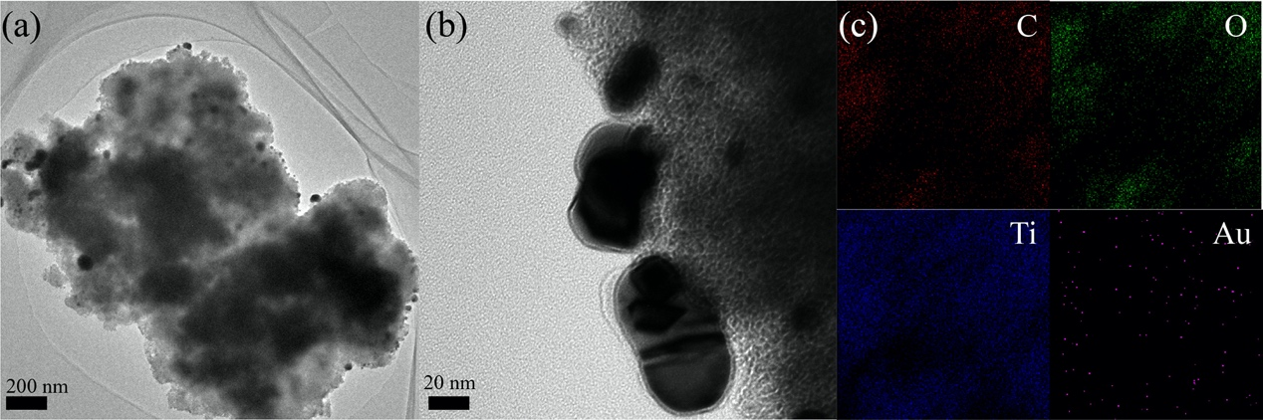
Figure S1. (a-b) HR-TEM images of bio-Au₂@TiO₂. (d) EDS mapping of C, O, Ti, and Au in bio-Au₂@TiO₂.

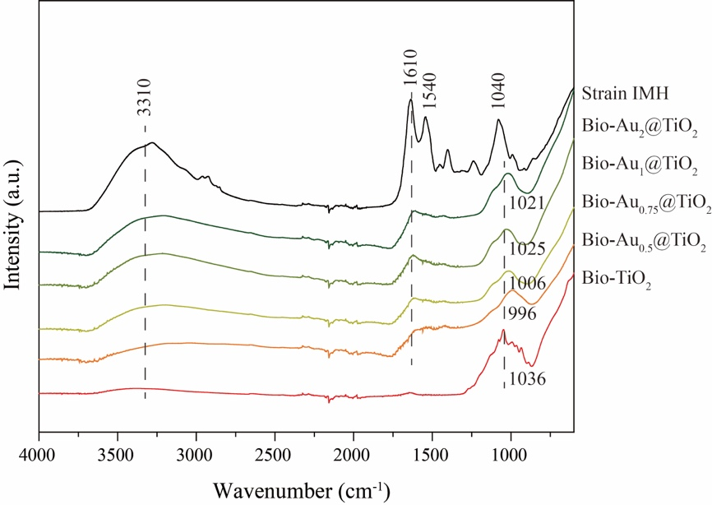
Figure S2. FTIR spectra of bio-TiO₂, bio-Au_{x}@TiO₂ and strain IMH.

Table S1. Assignment of peaks in FTIR spectra of Strain IMH (A), Bio-Au_{x}@TiO₂ and Bio-TiO₂ (B) (Figure S1).
Wavenumbers (cm⁻¹)  A | Wavenumbers (cm⁻¹)  B | Peak assignment
 | -1000 | Ti-O-Ti bond
1040 |  | C-N stretching
1540 |  | N−H bending and C−N stretching
1610 |  | C=C stretching
3310 | 3310 | -OH stretching

Table S2. Pseudo-first-order reaction rate constants of diﬀerent Au@TiO₂-containing catalysts for methylene blue degradation.

Catalyst | k_{app} (min⁻¹) | Reference
Bio-Au₂@TiO₂ | 0.195 | Our work
Bio-Au₁@TiO₂ | 0.113 | Our work
Bio-Au_{0.75}@TiO₂ | 0.0886 | Our work
Bio-Au_{0.5}@TiO₂ | 0.0452 | Our work
Bio-TiO₂ | 0.0197 | Our work
0.25% Au@TiO₂ | 0.0258 | [1]
0.5% Au@TiO₂ | 0.052 | [1]
1.0% Au@TiO₂ | 0.0407 | [1]
2.0% Au@TiO₂ | 0.0321 | [1]
4.0% Au@TiO₂ | 0.0224 | [1]
Au-TiO₂@NPSt | 0.0122 | [2]
Au@TiO₂ | 0.00303 | [3]
Au_{NPS}@TiO_{2NWS} | 0.0058 | [4]
Au/TiO₂–HAP-300 | 0.0955 | [5]
Fe₃O₄@C–Au@void@TiO₂–Pd | 0.06923 | [6]
Au/TiO₂/RGO | 0.0112 | [7]
Au/CeO₂-TiO₂ | 0.3336 | [8]
Au@Ag@TNF | 0.0291 | [9]

[1] X.Z. Li, F.B. Li, Study of Au/Au3+-TiO2 photocatalysts toward visible photooxidation for water and wastewater treatment, Environmental Science and Technology, 35 (2001) 2381-2387.
[2] E.D. Sultanova, I.R. Nizameev, K.V. Kholin, M.K. Kadirov, A.S. Ovsyannikov, V.A. Burilov, A.Y. Ziganshina, I.S. Antipin, Photocatalytic properties of hybrid materials based on a multicharged polymer matrix with encored TiO2 and noble metal (Pt, Pd or Au) nanoparticles, New Journal of Chemistry, 44 (2020) 7169-7174.
[3] M. Misra, S.R. Chowdhury, N. Singh, TiO2@Au@CoMn2O4 core-shell nanorods for photo-electrochemical and photocatalytic activity for decomposition of toxic organic compounds and photo reduction of Cr6+ ion, Journal of Alloys and Compounds, 824 (2020).
[4] F. Fu, Y. Zhang, Z. Zhang, X. Zhang, Y. Chen, Y. Zhang, The preparation and performance of Au loads TiO2 nanomaterials, Materials Research Express, 6 (2019).
[5] J. Guo, F. Dong, S. Zhong, B. Zhu, W. Huang, S. Zhang, TiO2-Hydroxyapatite Composite as a New Support of Highly Active and Sintering-Resistant Gold Nanocatalysts for Catalytic Oxidation of CO and Photocatalytic Degradation of Methylene Blue, Catalysis Letters, 148 (2018) 359-373.
[6] S. Chen, H. Liang, M. Shen, Y. Jin, Yolk-like Fe3O4@C-Au@void@TiO2-Pd hierarchical microspheres with visible light-assisted enhanced photocatalytic degradation of dye, Applied Physics a-Materials Science & Processing, 124 (2018).
[7] L. Zhao, H. Xu, B. Jiang, Y. Huang, Synergetic Photocatalytic Nanostructures Based on Au/TiO2/Reduced Graphene Oxide for Efficient Degradation of Organic Pollutants, Particle & Particle Systems Characterization, 34 (2017).
[8] P. Saikia, A.T. Miah, P.P. Das, Highly efficient catalytic reductive degradation of various organic dyes by Au/CeO (2) -TiO (2) nano-hybrid, Journal of Chemical Sciences, 129 (2017) 81-93.
[9] M. Misra, N. Singh, R.K. Gupta, Enhanced visible-light-driven photocatalytic activity of Au@Ag core-shell bimetallic nanoparticles immobilized on electrospun TiO2 nanofibers for degradation of organic compounds, Catalysis Science & Technology, 7 (2017) 570-580.

