Table of Contents

Supplementary Fig 2a and 2b 2
Supplementary Fig 2c and 2d 3
Supplementary Fig 2e 4

Supplementary Fig 2a.
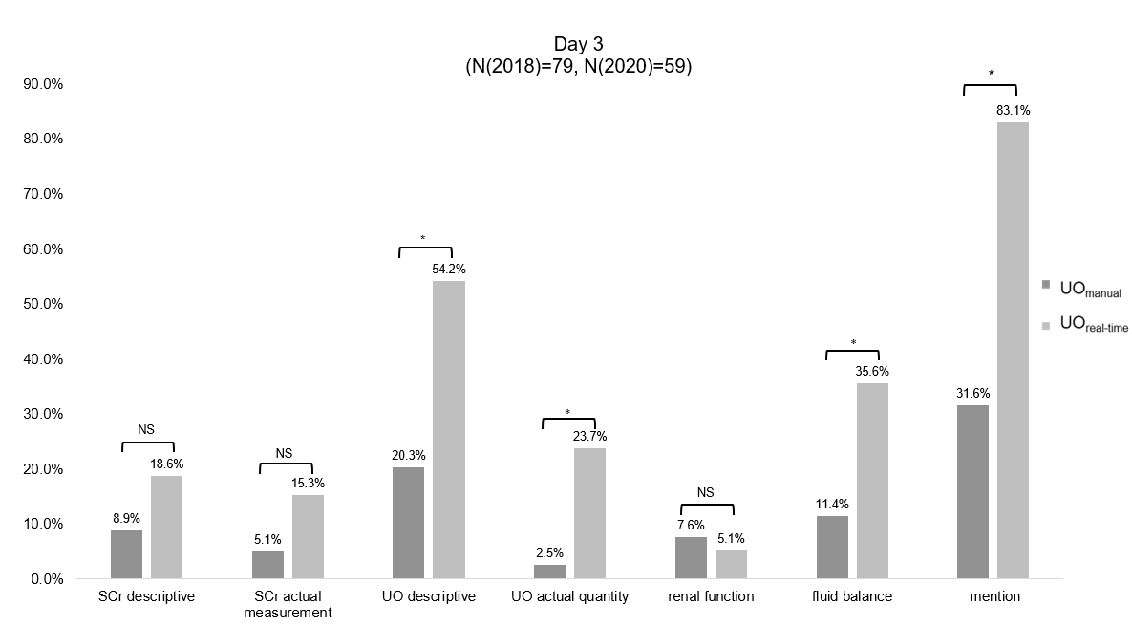

Supplementary Fig 2b.
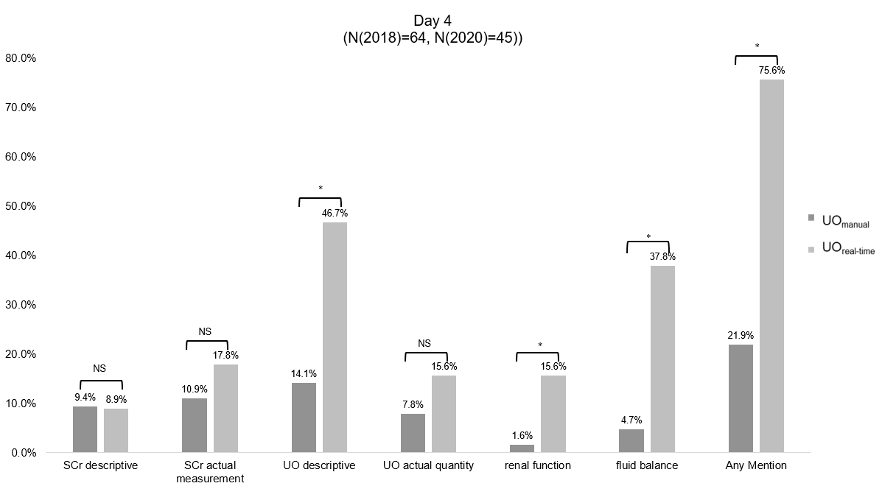

Supplementary Fig 2c.
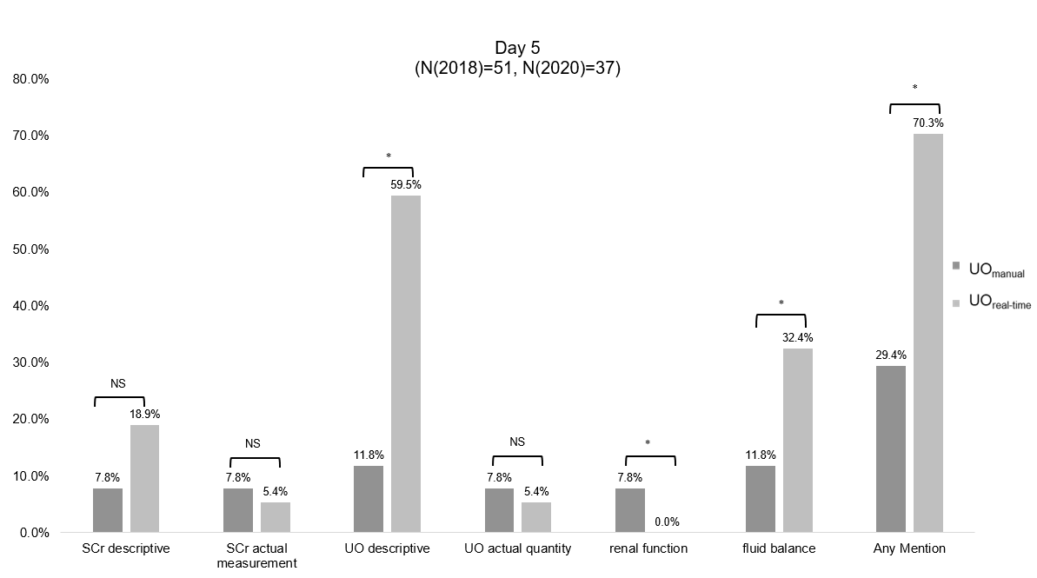

Supplementary Fig 2d.
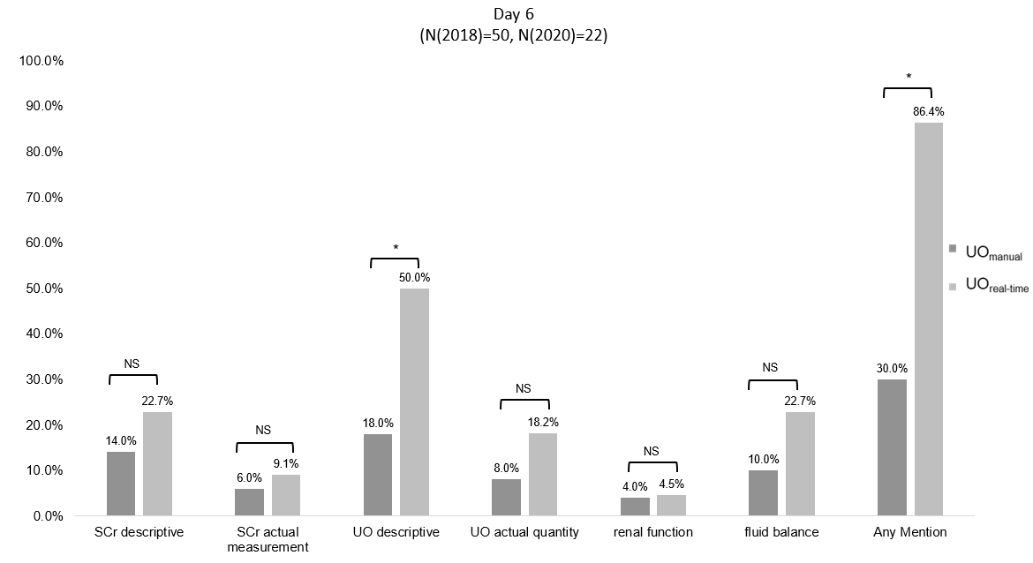

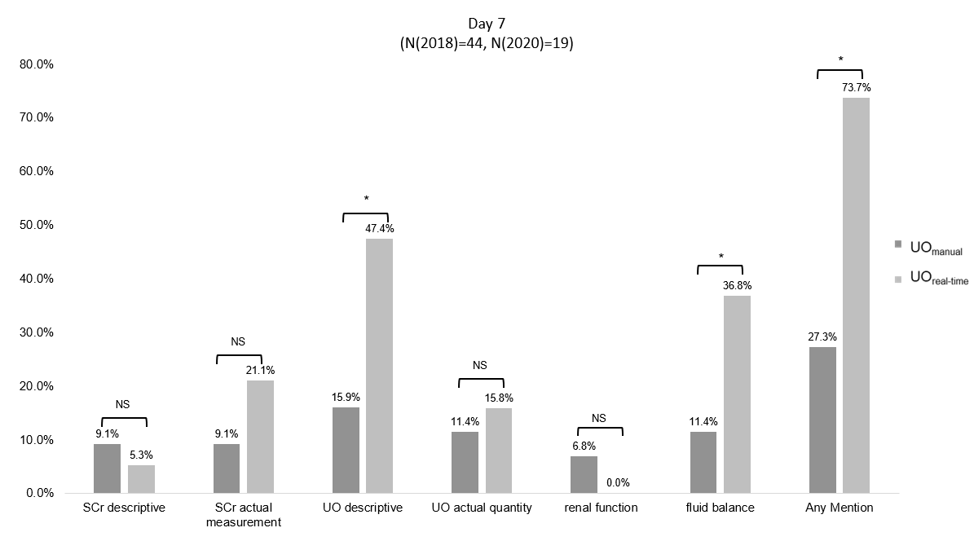
Supplementary Fig 2e.

