Table of Contents

Supplementary Fig 1a and 1b 2
Supplementary Fig 1c and 1d 3
Supplementary Fig 1e 4

Supplementary Fig 1a.
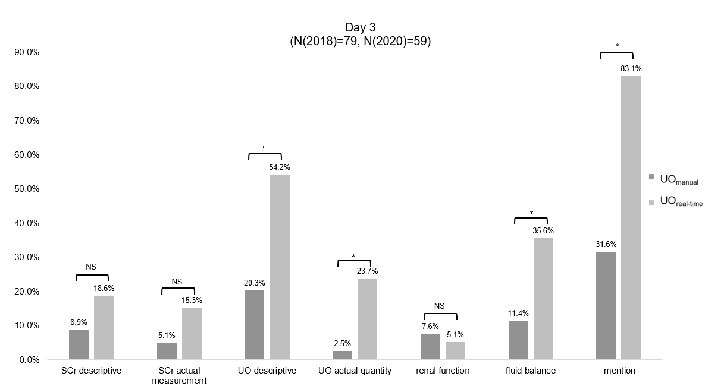

Supplementary Fig 1b.
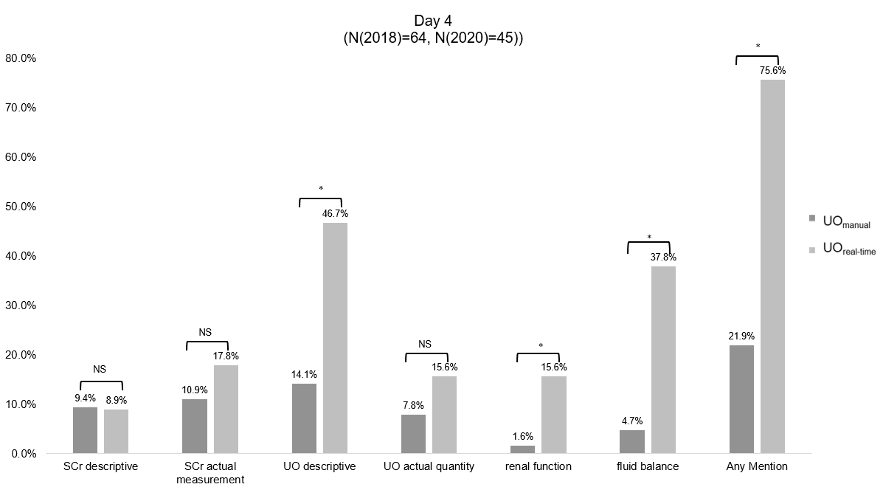

Supplementary Fig 1c.
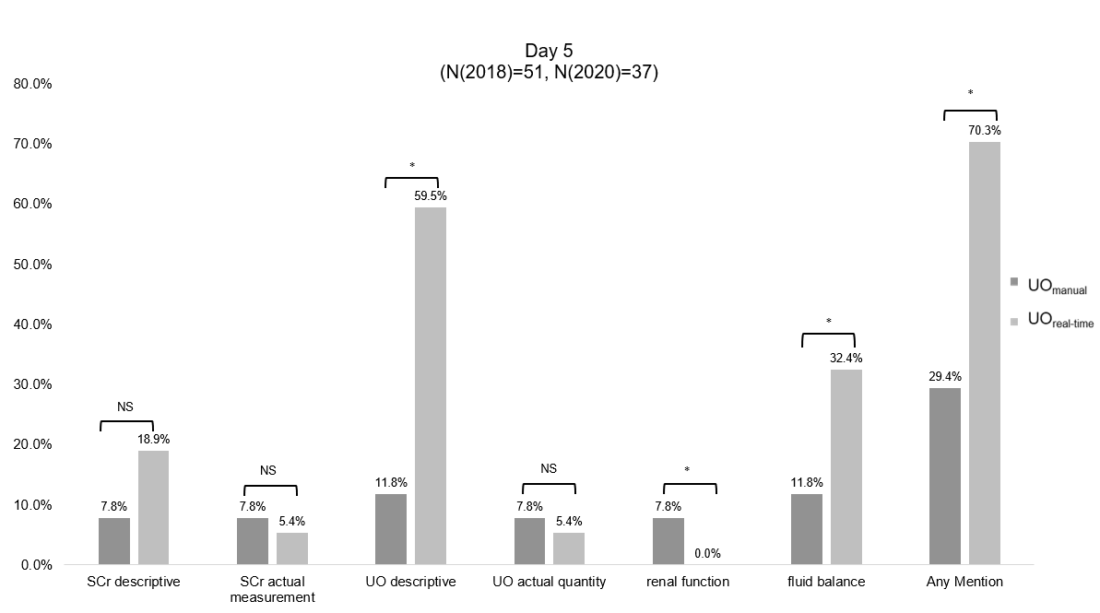

Supplementary Fig 1d.
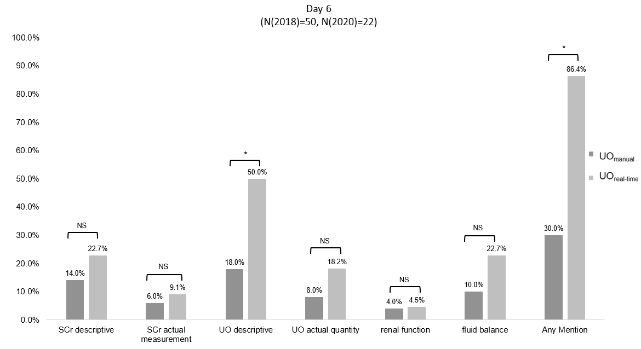

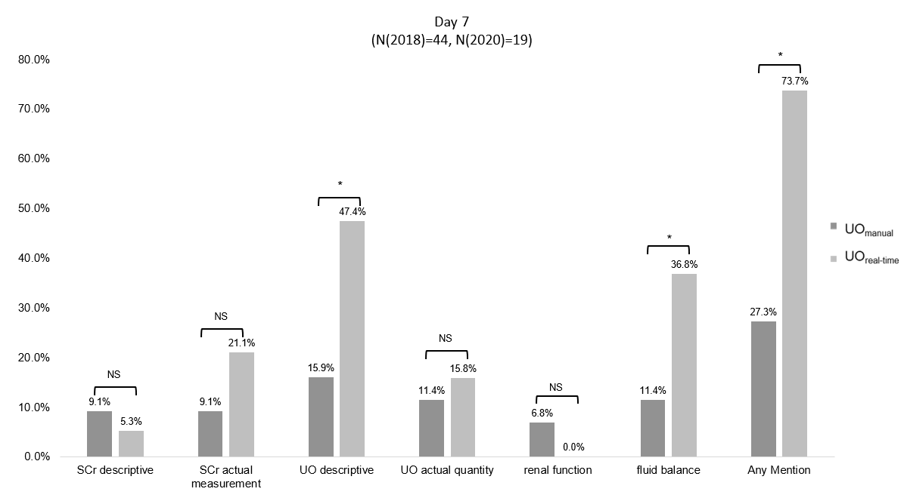
Supplementary Fig 1e.

