Supplementary Information
Population study reveals genetic variation and introgression of four deciduous oaks at the junction between Taihang Mountain and Yanshan Mountain
Ziqi Pei^{1,2#}, Qinsong Yang^{1,2#}, Xining Chen^{1,2}, Yu Zong³,Jinjin Li^{1,2}, Xiong Yang^{1,2}, Chenrui Huo^{1,2}, Yixin Chen^{1,2}, Qian Zhang^{1,2}, Na Luo^{1,2}, Jialu Kang^{1,2}, Xiaoqian Meng^{1,2}, Wenjie Jiang^{1,2}, Yining Li^{1,2}, Huirong Zhou^{1,2}, Jiaxi Wang^{1,2}, Yong Liu^{1,2}, Guolei Li^{1,2}*

¹ Research Center of Deciduous Oaks, Beijing Forestry University, Beijing, 100083, China
² Key Laboratory for Silviculture and Conservation, Ministry of Education, Beijing Forestry University, Beijing 100083, China
³ College of Life and Chemistry Sciences, Zhejiang Normal University, Jinhua 321000, China

# These authors contributed equally to this work.
* Corresponding author: Guolei Li, glli226@163.com

Supplementary Figures
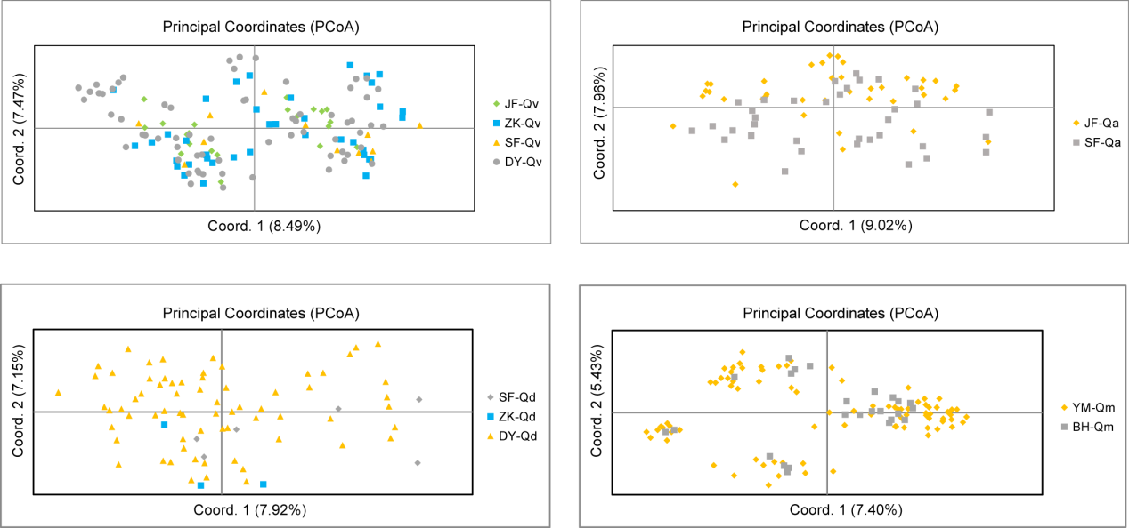Fig. S1 PCoA analysis of different populations within the same species. Different color and shape of the dots indicate the different populations.

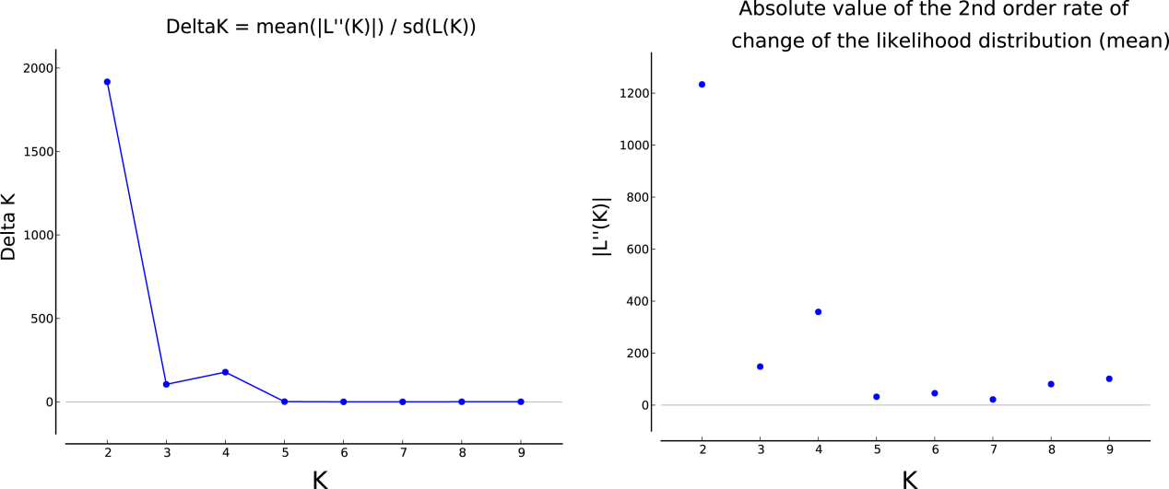
Fig. S2 ΔK and lnPPK values were showed with blue dot. The values were calculated according to K = 1 to 10.

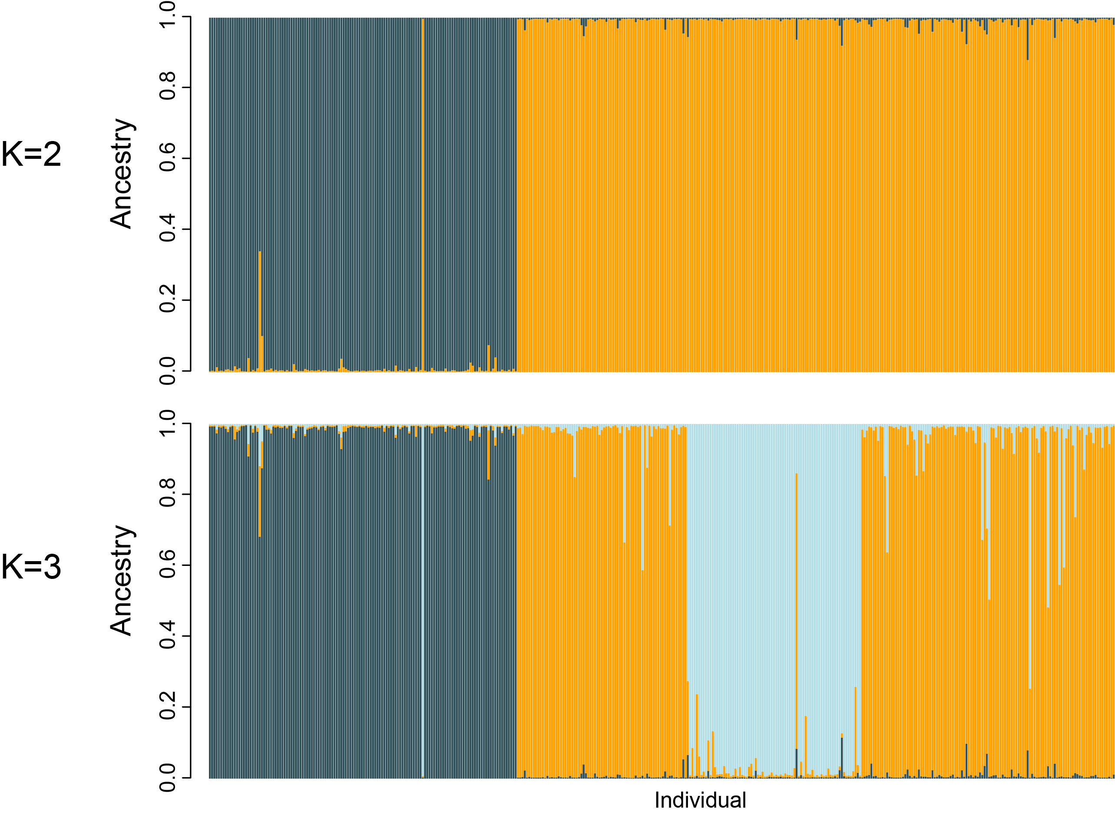
Fig. S3 STRUCTURE analysis of populations when K = 2 and K = 3. Dark blue background showed Q. variabilis cluster.

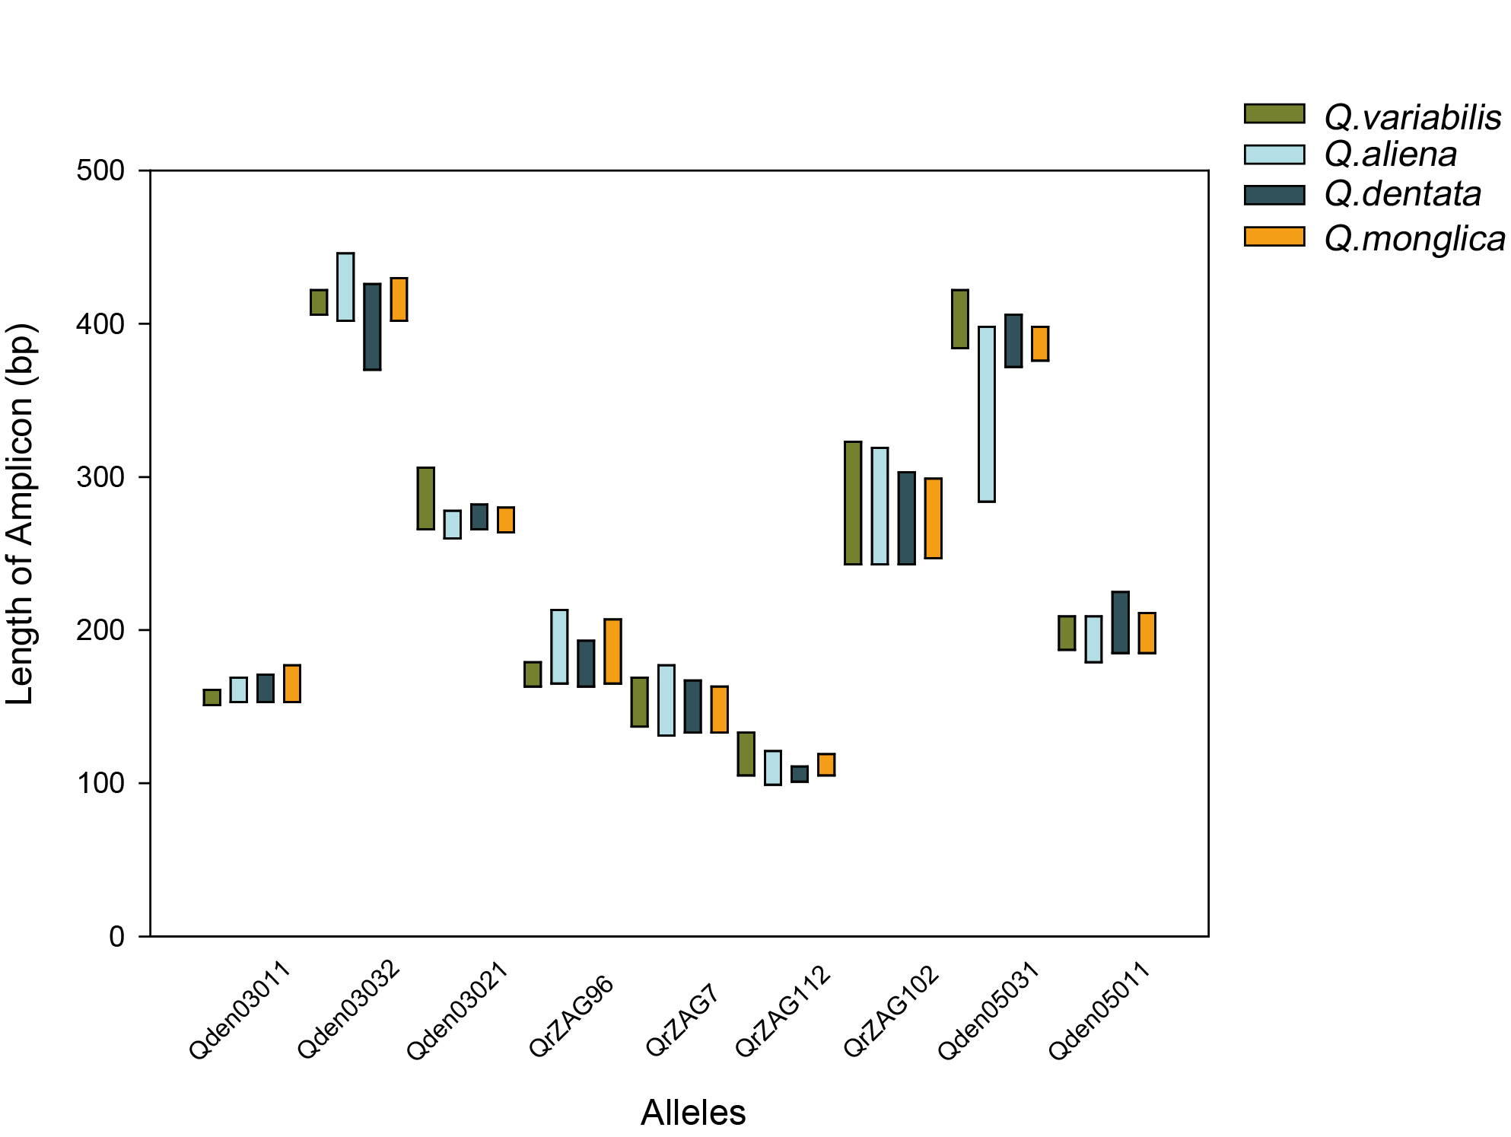
Fig. S4 Length variety of the amplicons of each allele in different oak species. Green, blue, dark blue and orange bars indicate length variety of each allele in Q. variabilis, Q. aliena, Q. dentata and Q. mongolica respectively.

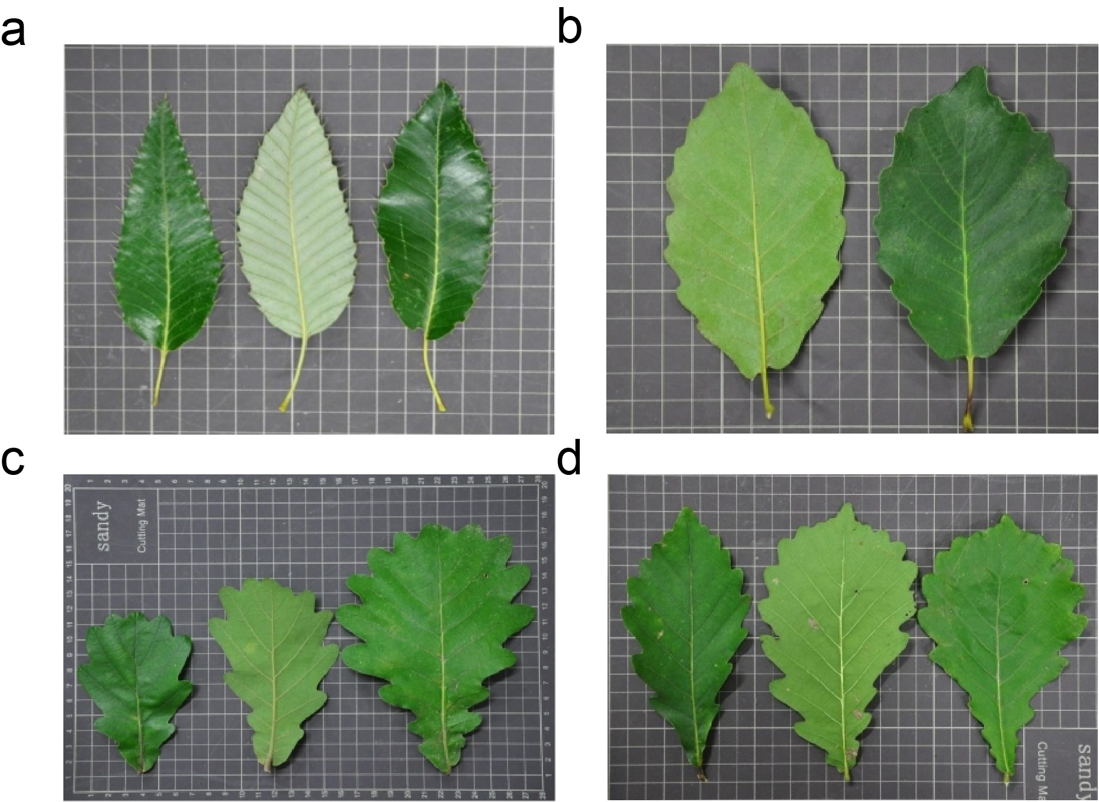
Fig. S5 Leaf surface and back of Q. variabilis (A), Q. aliena (B), Q. dentata (C)and Q. mongolica (D) respectively.

Table S1 Sample information
 | Q. variabilis | Q. aliena | Q. dentata | Q. mongolica | Total
Dayang Mountain  (40°18'50"N, 116°25'26"E) | 65  (DY-Qv) | - | 68  (DY-Qd) | - | 133
Yunmeng Mountain  (40°32'55"N, 116°41'18"E) | - | - | - | 88  (YM-Qm) | 88
Baihua Mountain  (39°49'59"N, 115°34'43"E) | - | - | - | 25  (BH-Qm) | 25
Jiufeng  (40°03'25"N, 116°04'55"E) | 21  (JF-Qv) | 39  (JF-Qa) | - | - | 60
Shangfang Mountain  (39°40'18"N, 115°48'59"E) | 12  (SF-Qv) | 35  (SF-Qa) | 6  (SF-Qd) | - | 53
Zhoukoudian  (39°44'44"N, 115°54'3"E) | 38  (ZK-Qv) | - | 3  (ZK-Qd) | - | 41
Total | 136 | 74 | 77 | 113 | 400
Note: Samples from Jiufeng are artificial populations.

Table S2 Information of the 9 SSR primers
Primer Name | Primer Sequence（5' to 3'） | Motif
QrZAG96-F  QrZAG96-R | CCCAGTCACATCCACTACTGTCC | (TC)₂₀
QrZAG96-F  QrZAG96-R | GGTTGGGAAAAGGAGATCAGA | (TC)₂₀
QrZAG102-F  QrZAG102-R | GCCTACACTCTTCAATCTACATGA | (GA)₂₉
QrZAG102-F  QrZAG102-R | GACTTGTAACACCTTAAGCATTATCT | (GA)₂₉
QrZAG112-F  QrZAG112-R | TTCTTGCTTTGGTGCGCG | (GA)₃₂
QrZAG112-F  QrZAG112-R | GTGGTCAGAGACTCGGTAAGTATTC | (GA)₃₂
QrZAG7-F  QrZAG7-R | CAACTTGGTGTTCGGATCAA | (TC)₁₇
QrZAG7-F  QrZAG7-R | GTGCATTTCTTTTATAGCATTCAC | (TC)₁₇
Qden03011-F  Qden03011-R | AACCCAACCTTCCCTTCATC | (AG)₈
Qden03011-F  Qden03011-R | GCAGTGGTGCCTAATGTAGAC | (AG)₈
Qden03021-F  Qden03021-R | ACAGCAAACCAGACTCCAC | (AG)₈
Qden03021-F  Qden03021-R | CCCCAAAGTTTCGGCTAATAC | (AG)₈
Qden03032-F  Qden03032-R | AGTTGTGGTCCTGCTCGC | (CT)₁₂
Qden03032-F  Qden03032-R | GAAAAGTGCGATGACGGTTG | (CT)₁₂
Qden05011-F  Qden05011-R | CCCACTCCCTGTCCATTGT | (CT)₈
Qden05011-F  Qden05011-R | CACTGTGTGCTGCGACTTG | (CT)₈
Qden05031-F  Qden05031-R | CCCCGATTCGCCATCATTGT | (GT)₁₂
Qden05031-F  Qden05031-R | GTAACGCCGTTTTTCTCCACC | (GT)₁₂

Table S3 DNA fingerprints of 40 samples
No. | Sample | DNA Fingerprint
1 | JF_SP041 | A165-167B119C139-169D245-247E153-157F268G406H195-199
2 | JF_SP059 | A165-167B119-125C137-139D249-271E153-155F268G406H189-199
3 | JF_SP100 | A165-167B119-129C137-151D249-271E153F270-272G406H193-197I400
4 | JF_SP101 | A167B125C137-141D245-247E151-155F266G406H189-193I400-404
5 | JF_SP106 | A165-167B117-131C139E151-155F266G406H189-199
6 | JF_SP103 | A167B109-119C137-139D273E157-159F268G406H195I402-410
7 | ZK_SP017 | A165-167B109-122C139D291F272-274G416H187-195I400
8 | ZK_SP018 | B105-119C137-139D255E155F268H189-193
9 | DY_SP109 | A167B111-117C137D243E157G406-412H189
10 | DY_SP112 | A165-167B117-125C137-139D265E155F274G406H189-195I384-400
11 | JF_HL009 | A173-179B105C157-165D255-267E163-169F272-274G412H193-199
12 | JF_HL016 | A173B105-109C155-157D255-269E161-169F268-272G412H193
13 | JF_HL020 | A171B105C135-165D277-279E161-169F272-282G410H187-217I390
14 | JF_HL024 | A171-177B105C147D269-291E161F268-274G412H187-193I384
15 | JF_HL025 | A173-179B105C155-157D265-269E161F268G412H193-203
16 | JF_HL021 | A167B105C135D253-277E157-159F268-274G412-418H193-225I390
17 | SF_HL002 | A169B101-105C149-153D265E161-163F268G412H207
18 | SF_HL023 | A165B105C141-149D267-269E157-171G422H193-199
19 | SF_HL031 | A167B105C137-143D265-283E159-167G412H185-195I386-388
20 | SF_HL040 | A167-191B111C135-139D267-281E159F268G412-414I388
21 | DY_HS011 | A203B105-109C139-149D251-289E161-163F268-274G418-422H197I384-386
22 | DY_HS018 | A179B105-109C141D249-285E157F266-268G418-422H189-199I386-388
23 | DY_HS022 | A179B107-109C141-151D273-285E157F264-268G422-428H187-189I384-386
24 | DY_HS028 | A177-179B105-107C133-155D273E159-161F270-272G422-428H197-199I384-386
25 | DY_HS076 | A183-205B105C133-143D273-275E161-163F268-274G420-422H187-189
26 | SF_HS007 | A181B105-117C139-151D253E163-167G416-420H187-199
27 | DY_HS014 | A203-205B105-109C149-151D253-289E155-171F270-272G422-424H197-201I388-392
28 | DY_HS033 | A165B107C133-141D271E161-163F272G416-422H199
29 | DY_HS052 | A167-169B105C137-147E153-157F268-274G424-430H191-203I384
30 | DY_HS056 | A179-181B107C149-157D293-295E157-159F268-270G422-430H187-197I384
31 | YM_MG002 | A165-185B101-113C133-135D251-257E157-161G420H191-207I390
32 | YM_MG010 | A165-177B101-111C133-153D297-301E161-163F268-270G414-420H197I390
33 | YM_MG017 | A165-169B101-113C143-145D253E161-163F268G418H191-197I386-390
34 | YM_MG066 | A169-181B111-119C149-157D253E159-161F268-274G414H205-209I388
35 | YM_MG076 | A165-213B111C145-161D285-287E157-161F268-272H187-199I390
36 | YM_MG008 | A167-169B105C157E155-161F270G412H189-197I372-384
37 | YM_MG045 | A175-191B113-115C147D255E165-169G416-424H195-197I372-386
38 | BH_MG009 | A171-205B105C137-155D263-301E155-161G412-424H195-199I388-398
39 | BH_MG022 | A175-179B107-111C143-159D255-261E159F268-272G412H193-199
40 | BH_MG024 | A171-183B105C149-153D297E157-163F270G418-422H187-197I384-388
Note: Letters represent alleles: A: Qden03011; B: Qden03032; C: Qden03021; D: QrZAG96; E: QrZAG7; F: QrZAG112; G: QrZAG102; H: Qden05031; I: Qden05011. Samples 1~10 are Q. variabilis; 11~20 are Q. aliena; 21~30 are Q. dentata; 31~40 are Q. mongolica.

