Use of an Ultraviolet Light activated Persulfate Process to Degrade Humic Substances: Effects of Wavelength and Persulfate Dose
Yiming Fang, Hiroshi Sakai
Department of Civil and Environmental Engineering, Graduate School of Urban Environmental Sciences, Tokyo Metropolitan University, 1-1, Minami-osawa, Hachioji City, Tokyo, 192-0397, JAPAN

Corresponding Author
Name | Dr. Hiroshi SAKAI
Postal Address | Department of Civil and Environmental Engineering, School of Urban Environmental Sciences, Tokyo Metropolitan University, 1-1-1, Minami-osawa, Hachioji-city, Tokyo, 192-0397
E-mail | h_sakai@tmu.ac.jp
TEL/FAX | +81-42-677-2789

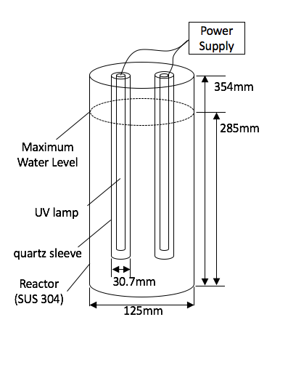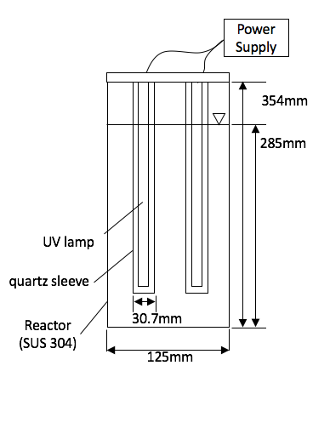
Fig. S1. The irradiation reactor
Two 185-nm (QGL8W-31, Iwasaki Electric) or 254-nm (QGL8W-21, Iwasaki Electric) UV lamps were installed in a 125-mm stainless steel cylindrical reactor. Arrangement of the experimental apparatus is shown in the figure. Basic structures are common to 185 nm lamp and 254 nm lamp; both lamps emit both wavelength but 185 nm is cut off at 254 nm lamp by surface quartz. Output energy at 254 nm is almost same for these two lamps; fluence at the surface and center of the lamp is 5.94 mW/cm² for 254 nm lamp and 6.14 mW/cm² for 185 nm lamp. Input energy are 8W for both lamps.

