Supplement
Table S1: Metrics of movement patterns among participants, stratified by track number and peak vector biting hours.
 | Track 1 |  | Track 2+
 | Median (IQR) | Range | Median (IQR) | Range | P value*
OVERALL
Total distance traveled (km) | 98.5 (33.6 – 235.2) | 1.6 – 2,313.1 | 91.0 (13.1 – 219.9) | 1.3 – 2,360.3 | 0.2
Average distance per day (km) | 2.9 (1.1 – 7.7) | 0.1 – 77.5 | 2.6 (0.6 – 6.5) | 0.04 – 90.5 | 0.1
Maximum distance from home (km) | 5.2 (2.5 – 18.2) | 0.1 – 518.0 | 3.4 (1.3 – 16.4) | 0.1 – 518.0 | 0.08
Average hours away from home per day (>50m) | 4.9 (2.1 – 9.9) | 0.01 – 23.9 | 3.1 (1.0 – 7.0) | 0.01 – 23.8 | 0.02
PEAK MOSQUITO BITING HOURS^
Total distance traveled | 12.4 (4.1 – 38.2) | 0.2 – 1,214.1 | 13.4 (2.8 – 35.2) | 0.4 – 1,298.0 | 0.6
Average distance per day | 0.4 (0.1 – 1.2) | 0.01 – 33.6 | 0.4 (0.1 – 0.9) | 0.01 – 49.8 | 0.6
Maximum distance from home | 2.5 (0.6 – 13.1) | 0.02 – 517.1 | 1.1 (0.3 – 3.9) | 0.02 – 517.9 | 0.07
Average hours away from home per night (>50m) | 1.4 (0.4 – 3.7) | 0.01 – 12.0 | 0.9 (0.4 – 1.6) | 0.06 – 12.0 | 0.1
*Wilcoxon rank sum test
^Peak biting hours from 6 pm to 6 am

Figure S1: Intensity maps of population movement in Mutasa District from June 2016 – May 2017 by month: A) Jun 2016; B) July 2016; C) August 2016; D) Septembers 2016; E) October 2016; F) November 2016; G) December 2016; H) January 2017; I) February 2017; J) March 2017; K) April 2017; L) May 2017
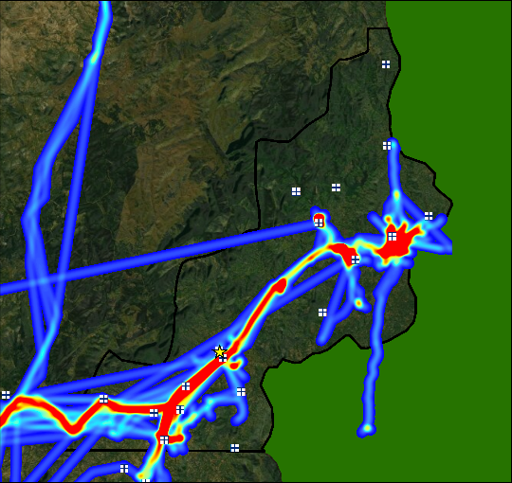
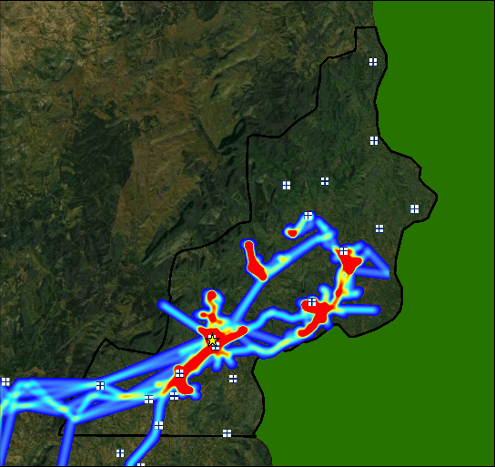
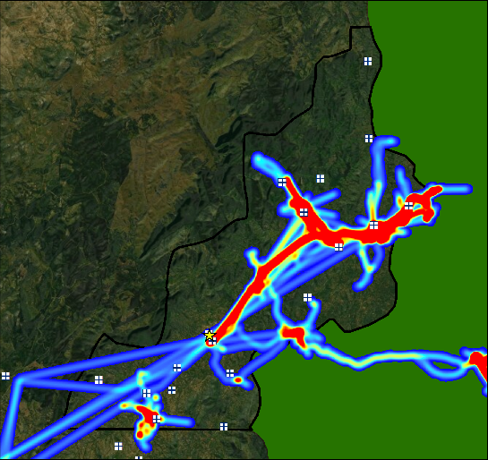
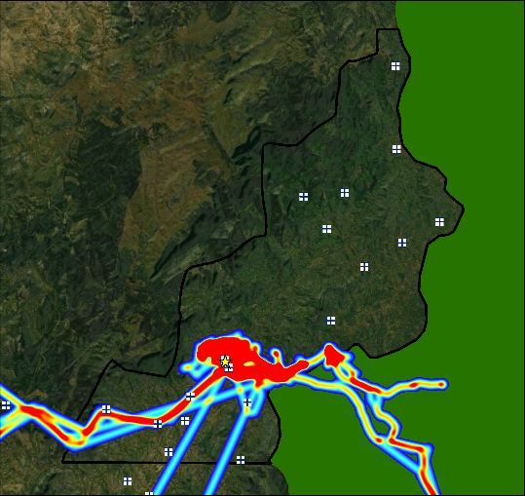
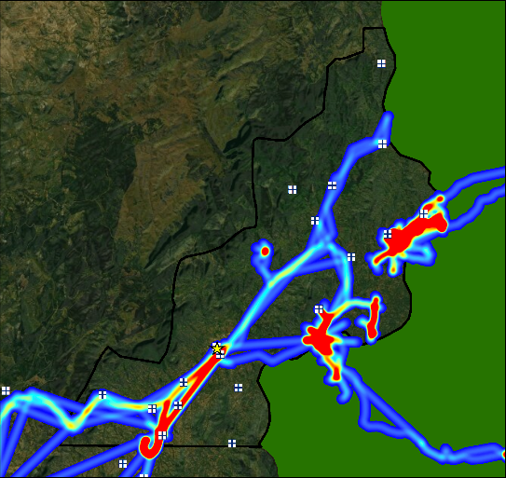
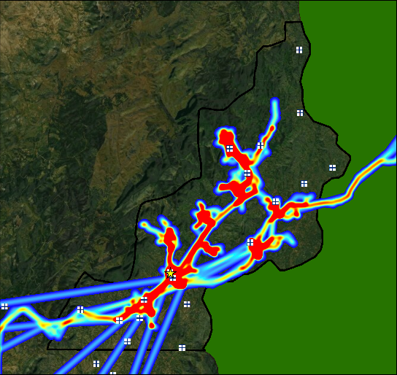
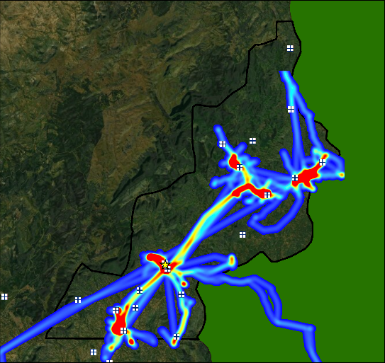
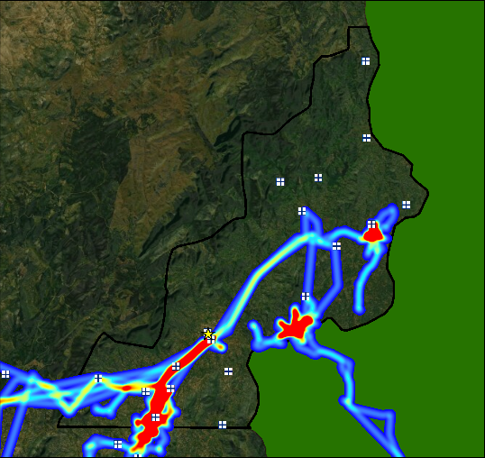
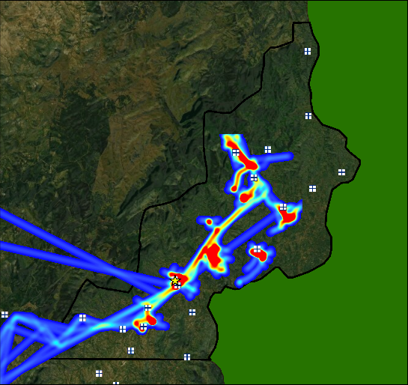
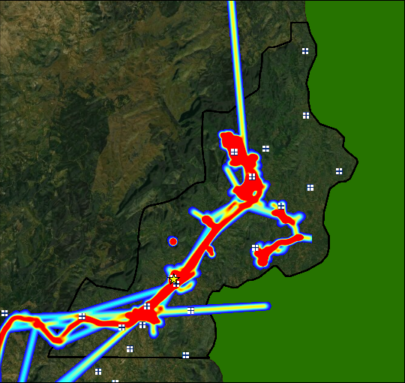
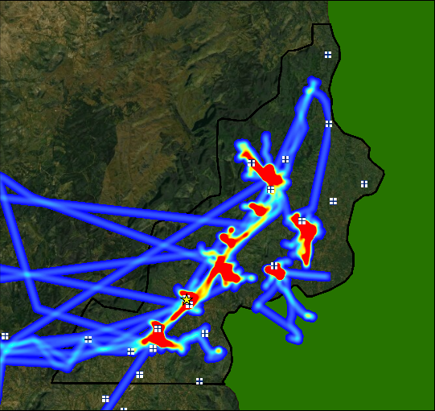
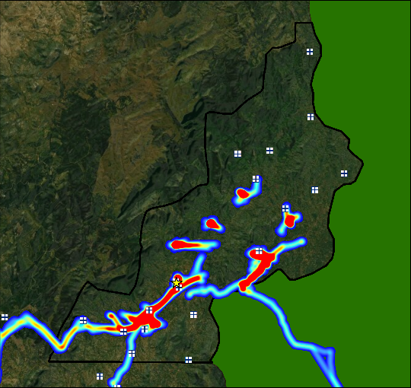
D
C
B
A

H
G
F
E

L
K
J
I

Figure S2: Intensity maps of population movement in Nchelenge District from June 2016 – May 2017 by cohort and season: A) longitudinal cohort, dry season [June, August, October], B) cross-sectional cohort, dry season [July, September, November], C) longitudinal cohort, rainy season [December, February, April], D) cross-sectional cohort, rainy season [January, March, May].
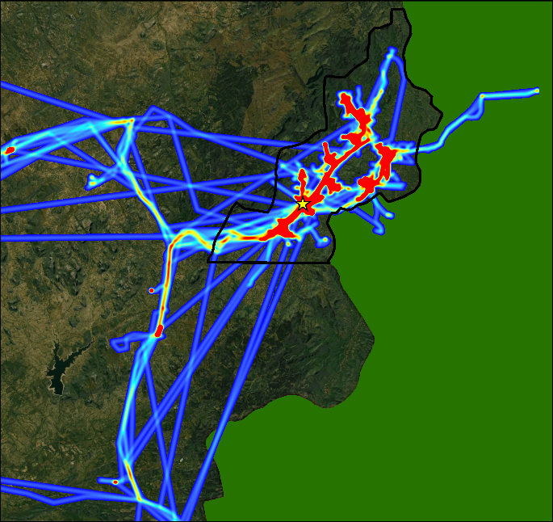
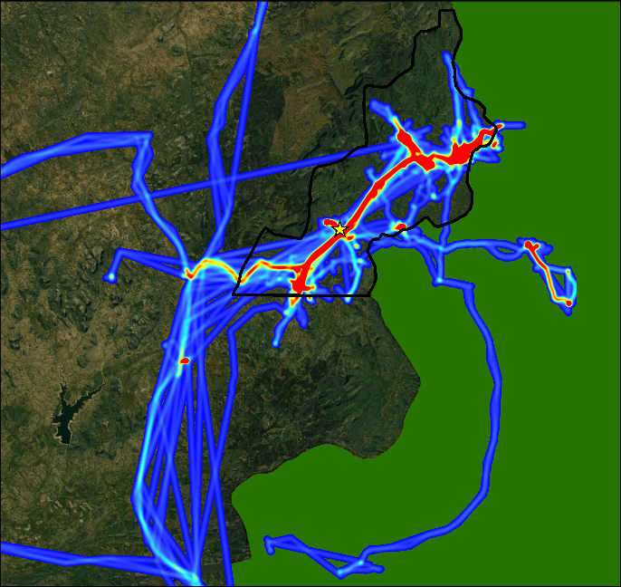
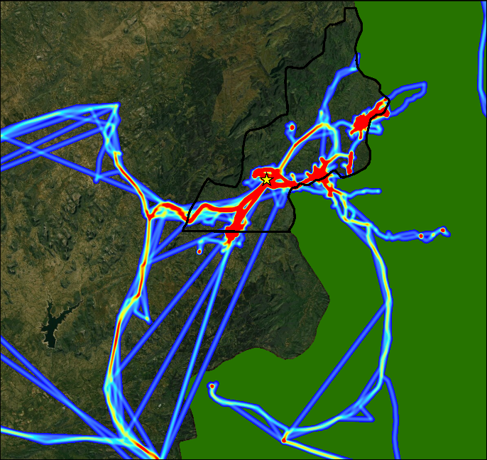
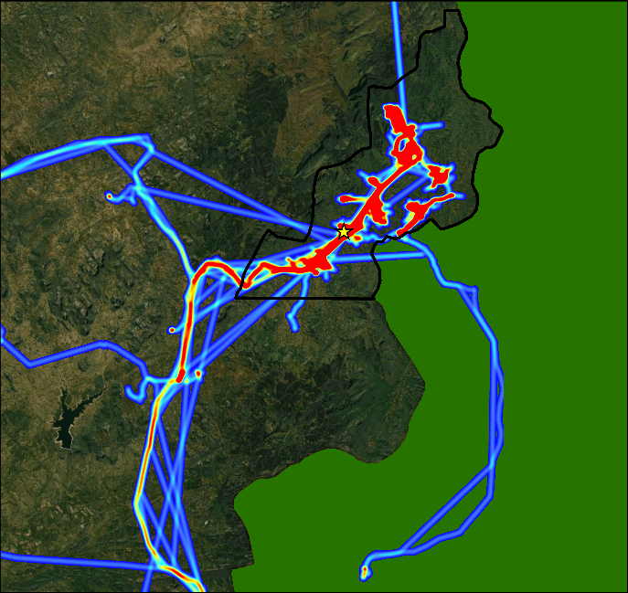
A
B
C
D

