Research Article
Genome-wide association study identifies candidate genes and favorable haplotypes for seed yield in Brassica napus
Haijiang Liu^{1,2#}, Maoyan Zou^{1,2#}, Bingbing Zhang^{1,2}, Xinyu Yang^{1,2}, Pan Yuan^{1,2}, Guangda Ding ^{1,2}, Fangsen Xu^{1,2}, Lei Shi^{1,2}*
1 National Key Lab of Crop Genetic Improvement, Huazhong Agricultural University, Wuhan, 430070, Hubei Province, China
2 Key Lab of Cultivated Land Conservation, Ministry of Agriculture and Rural Affairs/ Microelement Research Centre, Huazhong Agricultural University, Wuhan, Hubei Province, 430070, China

*Corresponding Author：E-mail Address: leish@mail.hzau.edu.cn
# These authors contributed equally to this work

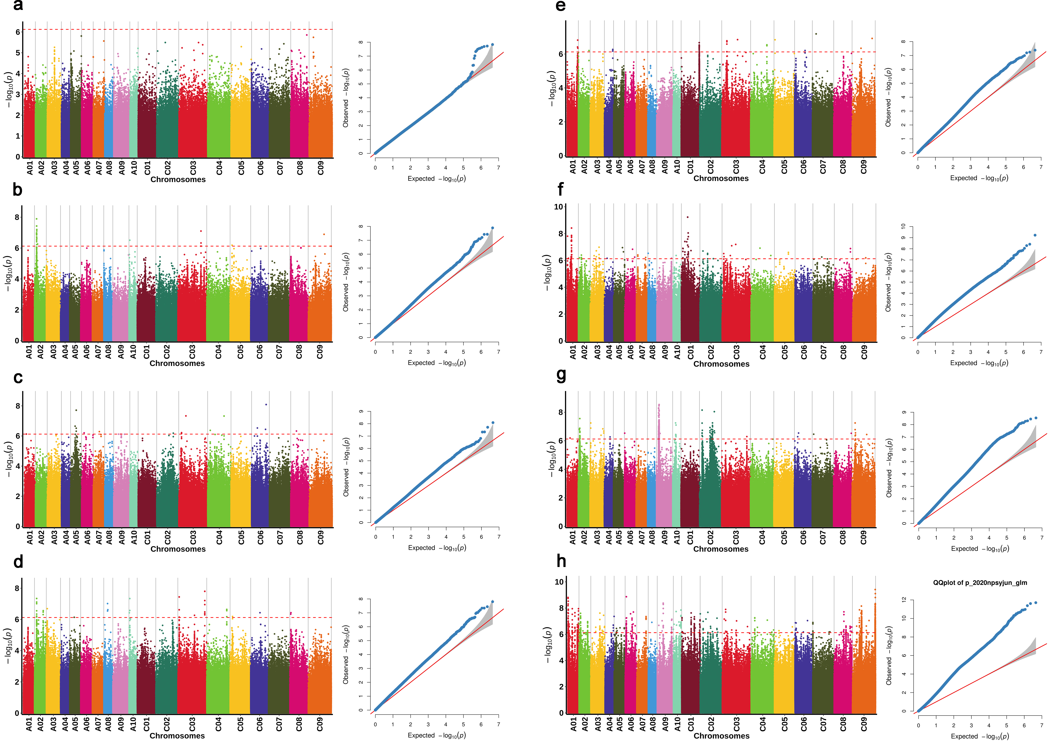
Fig. S3. Genome wide association study for seed yield in an association panel of B. napus under GLM model. (a) Seed yield in Trial 1_1. (b) Seed yield in Trial 1_2. (c) Seed yield in Trial 1_3. (d) Seed yield in Trial1_mean value. (e) Seed yield in Trial 2_1. (f) Seed yield in Trial 2_2. (g) Seed yield in Trial 2_3. (h) Seed yield in Trial 2_mean value.

